EXAMINER TECHNICAL REPORT • 18 AUGUST 2026

VSA Advisor Bot:
Data, Training, Live Prediction
and MetaTrader 5 Integration
  - A code-mapped explanation of how two years of XAUUSD M5 data become a trained Logistic Regression advisor and how new MT5 candles are scored, displayed and notified.

Student | Syed Abdullah Humayun
Project template | 4.2 Financial Advisor Bot
System scope | XAUUSD • M5 • VSA scenarios • LR/RF • Streamlit • MT5

Educational and demo prototype — not personal financial advice and not evidence of guaranteed profitability

Executive answer
The one-sentence pipeline
Two years of MT5-origin XAUUSD M5 candles are loaded from data/bars.csv for offline Python training; the VSA state machine converts candles into labelled setups, LR and RF learn from the same 24 setup features, LR is selected and saved, and the live worker later applies that saved LR model to newly completed candles exported by MT5 before the website and MT5 show the same advice.

The most important correction for an examiner is that the system does not continuously retrain on every live candle. Training and prediction are separate. Historical bars are used to estimate model parameters once during an offline backend run. Live MT5 bars are then transformed in exactly the same way and passed through the frozen model for inference. This is the normal deployment pattern for supervised machine learning and avoids leakage, latency and unstable recommendations.
Table 1. Direct answers to the examiner's recurring questions.
Examiner question | Verified answer | Primary implementation evidence
Where does historical training data come from? | The training script reads data/bars.csv. The project identifies it as a two-year MT5 XAUUSD M5 export; at code level, the immediate source is this CSV. | backend_training/train_models.py; modules/ml_pipeline.py::read_mt5_bars
Where is live data pulled? | MT5 CopyRates exports completed M5 bars to Common Files/xauusd_m5_bars.csv; Python reads that file. | mt5/VSA_M5_Bar_Exporter_EA.mq5::ExportCompletedM5Bars
Where is training performed? | In Python/scikit-learn, not inside MT5 and not inside the website request. | backend_training/train_models.py::main
Where is Logistic Regression used? | The fitted pipeline is loaded from selected_model.joblib and predict_proba produces probability of VALID_TRADE. | modules/ml_pipeline.py::load_selected_model; predict_vsa_setup_row
Where is VSA? | The canonical mirrored state machine is scan_vsa_scenarios; MT5 has a matching visual indicator for chart evidence. | modules/vsa_strategy.py; mt5/VSA_Live_Visual_Indicator.mq5
What happens after training? | Scaler, coefficients, intercept and class mapping are persisted; new setup features are passed through them to generate a probability. | models/*.joblib; models/model_metadata.json
How does advice reach users? | Python writes a 29-field ml_signal.csv; Streamlit reads the project copy and the MT5 bridge reads the Common Files copy for chart/desktop/mobile output. | modules/live_pipeline.py; app.py; mt5/VSA_ML_Signal_Bridge_EA.mq5
Is it logic-only? | No. Logic finds a valid VSA candidate and risk geometry; the trained LR probability decides TRADE_CANDIDATE versus WATCH_ONLY before safety gates. | predict_proba + threshold; test_trained_model_probability_controls_live_advice

Report map
- Sections 1–2 trace historical and live market data to exact files and functions.
- Sections 3–5 map the VSA algorithm, 24 features, labels, LR equation, RF comparison and saved artefacts.
- Sections 6–7 show how the frozen model scores a new MT5 setup and how one signal reaches website, desktop chart and mobile notification.
- Sections 8–10 separate verified evidence from current limitations, give a demonstration procedure and answer the questions one by one.

1. System boundary and end-to-end architecture
The submitted prototype is a hybrid decision-support system. VSA provides a deterministic definition of a candidate event; machine learning estimates whether candidates with similar measured characteristics historically reached the defined objective. This division is intentional. If VSA were removed, the model would be asked to predict arbitrary price movement rather than the quality of the submitted strategy. If ML were removed, every detected VSA candidate would be accepted without learned discrimination.
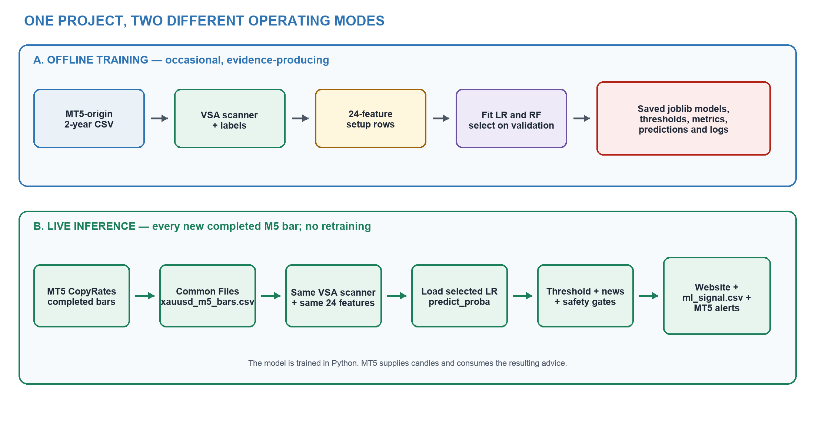
Figure 1. Offline training and live inference are separate pipelines. Arrows show the actual implemented data flow; the deployed LR model remains in Python while MT5 exports bars and consumes advice. Source: author-generated from current code.

1.1 Responsibility of each technology
Table 2. Clear system responsibilities prevent the phrase 'the bot' from hiding where computation occurs.
Component | Responsibility | What it does not do
MetaTrader 5 | Provides broker XAUUSD M5 OHLC, tick volume and spread; visualises VSA; validates and displays the signal; can alert and has a disabled-by-default demo order gate. | It does not fit scikit-learn LR/RF in the submitted deployment.
Python backend | Cleans bars, applies VSA, creates features and labels, trains LR/RF, persists models and performs live predict_proba inference. | It does not invent a direction without a formal VSA candidate.
Streamlit website | Explains the latest persisted advice, risk, probability and learning pipeline to novice users. | It does not retrain models when a page opens.
CSV bridge | Carries completed bars from MT5 to Python and a narrow 29-field advice record back to MT5. | It is not itself a model or trading algorithm.

Viva wording
Say: 'MT5 is the live market-data and presentation/execution endpoint. Python is the learning and inference engine. The CSV files are inspectable integration contracts between them.'

2. Market data: historical training source and live pull

2.1 Historical data used for training
The current training run does not call MT5 directly. backend_training/train_models.py loads data/bars.csv through build_vsa_setup_dataset(), which calls read_mt5_bars(). The file contains 143,020 XAUUSD M5 rows from 1 August 2024 01:00 to 17 August 2026 10:30. The project records this as an MT5-origin export, but the precise code-level answer is: the training program reads a local CSV. This distinction should be stated instead of saying that MT5 trains the model.
Historical source
Immediate training input: data/bars.csv. Documented market origin: MT5 XAUUSD M5. Training location: Python/scikit-learn backend.

Implementation reference: modules/ml_pipeline.py, lines 70–117. The same reader validates and normalises historical and live MT5-style CSV fields.

2.2 Where live data is pulled in the code
The live pull is implemented in MQL5, not in app.py. VSA_M5_Bar_Exporter_EA.mq5 runs on an XAUUSD chart. On its timer it uses CopyRates with start position 1, which deliberately excludes position 0—the still-forming candle. It exports at least 250 and normally 2,500 completed bars to the terminal-wide Common Files folder. On the recorded Mac/Wine installation the live file path is:
Implementation reference: Live file path. The bridge location shared by MT5 and the Python worker.

Implementation reference: mt5/VSA_M5_Bar_Exporter_EA.mq5, lines 29–70. This is the exact live market-data extraction point.

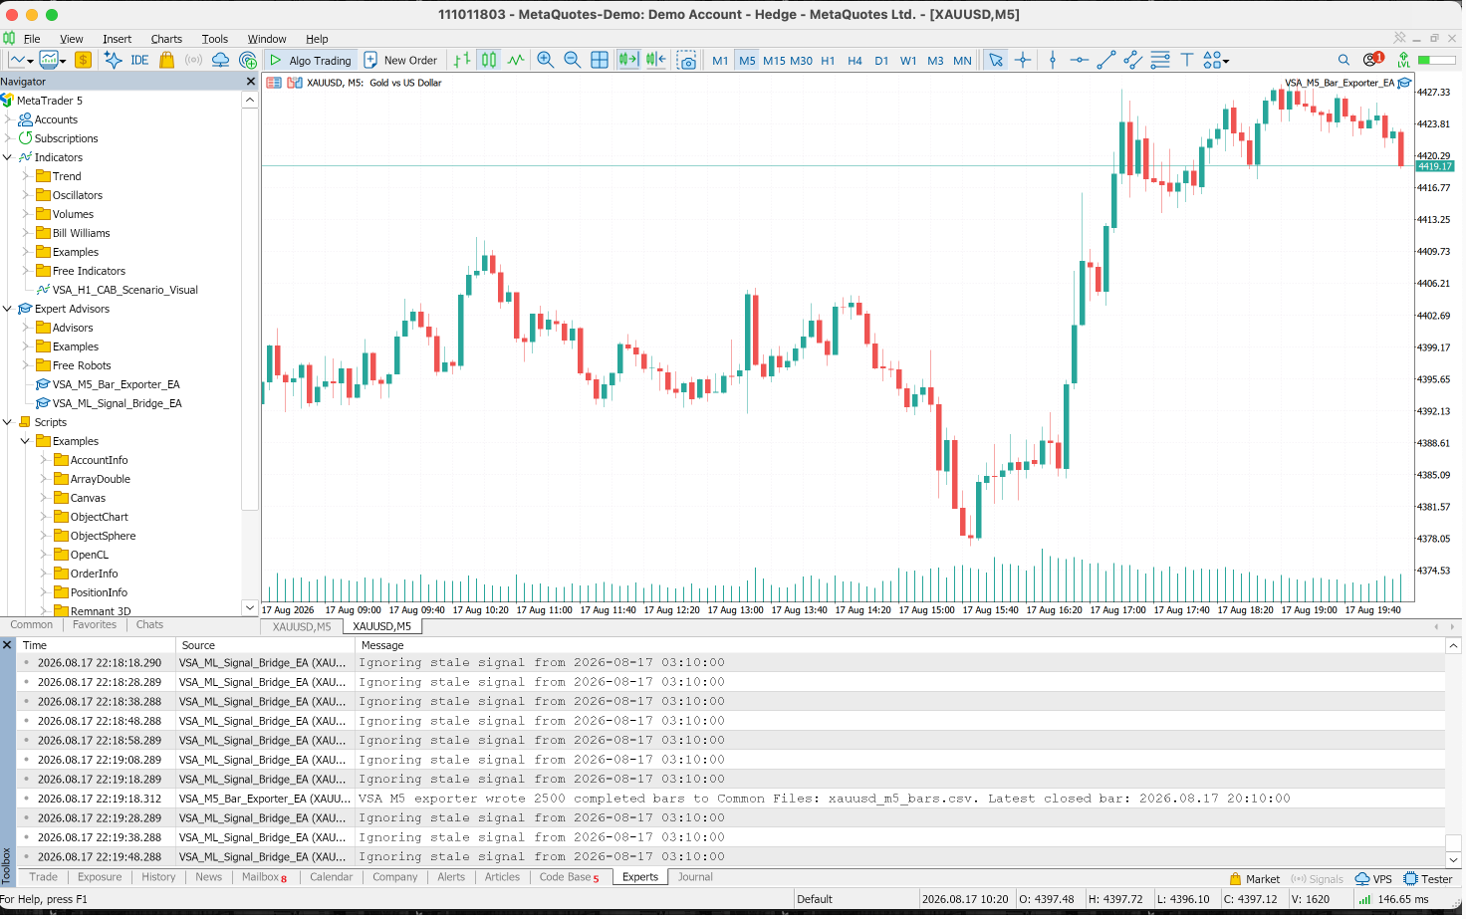
Figure 2. MT5 Experts log showing the exporter wrote 2,500 completed M5 bars to xauusd_m5_bars.csv. The same screenshot also shows stale-signal rejection by the separate bridge, demonstrating fail-closed behaviour. Source: captured project evidence.

2.3 Where the live data goes
- MT5 CopyRates → Common Files/xauusd_m5_bars.csv.
- scripts/run_live_advisor.py repeatedly calls modules/live_pipeline.py::run_live_cycle().
- run_live_cycle() calls read_mt5_bars(..., tail_rows=2500), calculates VSA features and checks for a setup on the latest completed bars.
- If no new formal setup exists, status becomes NO_NEW_VSA_SETUP and no new advice file is written.
- If a new setup exists, the saved LR model scores it and Python writes outputs/ml_signal.csv plus Common Files/ml_signal.csv.
Current live status
At 2026-08-18 14:21:54 the worker read 2,500 bars through 12:15, found that the latest formal setup was at 10:35, and correctly recorded output_written=false / NO_NEW_VSA_SETUP. This is evidence that live data is being consumed even when no trade-quality event exists.

2.4 Direct pull or CSV?
Both descriptions need qualification. The broker data is directly pulled by the MT5 EA through CopyRates. Python does not call the MetaTrader5 Python API; it receives that live-origin data through a CSV file. Therefore the implementation is a file-mediated live integration. This is valid and inspectable for assessment, but it is not an in-process API connection.

3. VSA algorithm and exact mapping
The canonical VSA algorithm is modules/vsa_strategy.py::scan_vsa_scenarios(). It is a state machine, not a paragraph shown only on the website. Both historical dataset construction and live inference call this function, so the same VSA thresholds define past training examples and new live candidates.

3.1 CAB and momentum definitions
Implementation reference: modules/vsa_strategy.py, lines 86–114. Operational thresholds used by the formal scanner; rolling references use earlier completed bars.

3.2 Scenario state machine
Table 3. Implemented mirrored VSA transitions and scenario-specific risk.
Scenario | BUY-side sequence | SELL mapping | Stop and risk
1 | Break above CAB high; return inside without low sweep/close; second bullish momentum close above high on volume below CAB. | Every comparison is mirrored around CAB low/high and bullish/bearish direction. | CAB opposite trigger; 0.5% maximum risk.
2 | Wick below CAB low but close back at/above low; later bullish momentum close above high on lower volume. | Wick above CAB high but close back at/below high; bearish breakout below low. | Sweep-candle extreme; 1.0% maximum risk.
3 | Close below CAB low; track post-break extreme; later bullish momentum close above high on lower volume. | Close above CAB high; later bearish momentum close below low. | Post-break extreme; 1.0% maximum risk.

Implementation reference: modules/vsa_strategy.py, lines 145–187. Representative BUY transitions; the SELL branch directly above/below mirrors the comparisons.

3.3 Entry, stop, targets and historical label
When a scenario confirms, entry is the completed signal candle close. scenario_stop() chooses the CAB trigger, sweep extreme or post-break extreme. The first objective is 1R and the runner objective is 4R. Historical future bars are inspected only after all signal-time features are fixed. A stop before 1R is −1R; 70% at 1R with the runner stopped at breakeven is +0.7R; runner to 4R is +1.9R. Same-bar ambiguity is scored conservatively as stop first.
Implementation reference: modules/vsa_strategy.py, lines 192–230. The classifier target is the managed outcome of a confirmed VSA setup, not the direction of the next candle.

3.4 Where VSA is visible in MT5
VSA_Live_Visual_Indicator.mq5 mirrors the CAB and scenario conditions to draw the CAB zone, trigger levels, direction and scenario arrow on the XAUUSD M5 chart. It is deliberately read-only: its purpose is visible rule mapping and parity checking. The Python scanner remains the canonical data/training implementation, while the indicator lets an examiner see that the website description is represented in MT5.
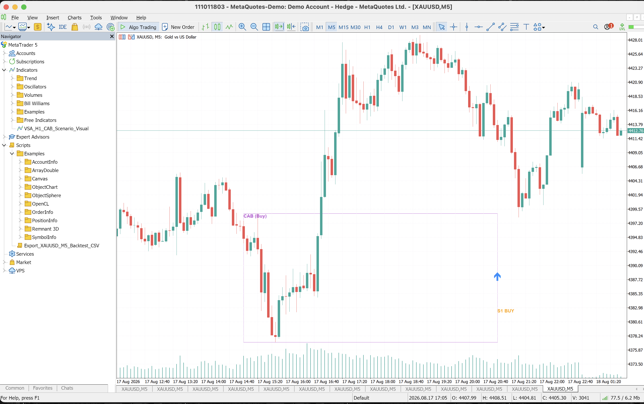
Figure 3. MT5 XAUUSD M5 chart with the CAB (Buy) region and a confirmed S1 BUY arrow produced by the visual scenario indicator. Source: captured project evidence.

4. From candles to a 24-feature learning dataset
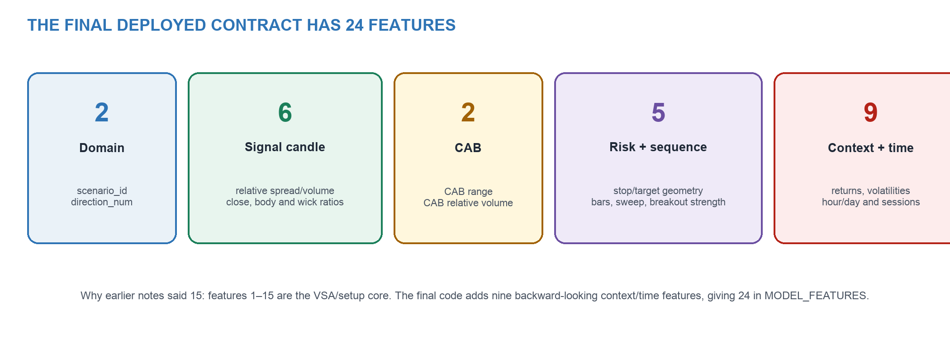
Figure 4. The final MODEL_FEATURES contract. The first 15 variables correspond to the earlier core VSA/setup pseudocode; nine backward-looking context/time variables extend the deployed model to 24. Source: current code.

4.1 The five basic candle calculations
Implementation reference: modules/ml_pipeline.py, lines 120–145. Feature references are shifted so the current bar is not included in its own historical average.

4.2 Complete feature table
Table 4. All variables in modules/ml_pipeline.py::MODEL_FEATURES.
# | Feature | Group | Meaning at signal time
1 | scenario_id | Domain | Which formal VSA sequence confirmed: 1, 2 or 3.
2 | direction_num | Domain | BUY = +1; SELL = −1.
3 | relative_spread | Signal candle | Signal range divided by earlier 20-bar mean range.
4 | relative_volume | Signal candle | Signal tick volume divided by earlier 20-bar mean.
5 | close_location | Signal candle | Close position normalised within high–low.
6 | body_ratio | Signal candle | Absolute body divided by full range.
7 | upper_wick_ratio | Signal candle | Upper wick divided by range.
8 | lower_wick_ratio | Signal candle | Lower wick divided by range.
9 | cab_range | CAB | CAB high minus CAB low.
10 | cab_relative_volume | CAB | CAB activity relative to earlier bars.
11 | entry_to_stop_distance | Risk | Price distance from signal entry to scenario stop.
12 | risk_reward_distance | Risk | Price distance from entry to 1R target.
13 | bars_after_cab | Sequence | Completed bars between CAB and confirmation.
14 | had_opposite_sweep | Sequence | Whether the opposite trigger was wick-swept.
15 | breakout_strength | Sequence | Break magnitude normalised by CAB range.
16 | return_3 | Context | Backward three-bar return at signal time.
17 | return_6 | Context | Backward six-bar return.
18 | return_12 | Context | Backward twelve-bar return.
19 | volatility_12 | Context | Shifted standard deviation of one-bar returns over 12 bars.
20 | volatility_48 | Context | Shifted standard deviation over 48 bars.
21 | hour | Time | Broker-time hour of the signal candle.
22 | day_of_week | Time | Monday–Friday encoded as 0–4.
23 | london_session | Time | Indicator for configured London-session hours.
24 | newyork_session | Time | Indicator for configured New York-session hours.

4.3 Why the learning row is a setup, not a candle
The original bar file has 143,020 candles, but the supervised dataset has 431 rows because only completed Scenario 1/2/3 confirmations become learning examples. There are 144 positive and 287 non-positive outcomes. This is critical: the LR is not trained to guess the next candle across 143,020 independent rows. It learns a conditional question—given that the submitted VSA strategy has just confirmed, how similar is this setup to historically successful or failed setups?
About the 15-versus-24 wording
There is no hidden set of fifteen different features. In the current code, the first 15 are the VSA/setup core and features 16–24 are context/time additions. The deployed LR and RF both receive all 24 in the exact order stored in model metadata.

5. Where LR and RF are trained, selected and saved

5.1 Chronological split and leakage control
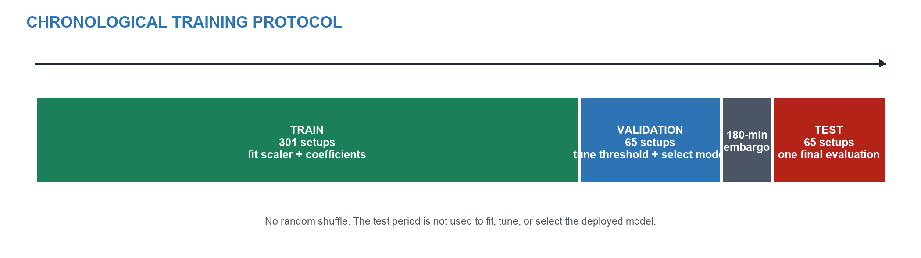
Figure 5. Purged 70/15/15 temporal design. Model fitting uses training only; thresholds and required-model selection use validation only; the test period is evaluated once. Source: current metadata and code.
The 431 setup rows are time-sorted. The resulting periods are: train 1 August 2024–30 March 2026 (301 rows), validation 31 March–12 June 2026 (65 rows), and test 16 June–17 August 2026 (65 rows). A 180-minute embargo corresponds to the 36-candle outcome horizon and prevents labels near a boundary from examining price action belonging to the next split.
Implementation reference: modules/ml_pipeline.py, lines 384–418. No random shuffle and no test-based model selection.

5.2 LR and RF training implementation
Implementation reference: backend_training/train_models.py, lines 228–249. Both candidates learn from identical training rows and identical MODEL_FEATURES.

StandardScaler is inside the LR Pipeline. This matters after training: the saved object contains the training mean and standard deviation as well as the learned coefficient vector and intercept. A live feature row is therefore transformed exactly as the historical rows were transformed. RF is saved independently and does not borrow LR predictions.

5.3 Logistic Regression equation and where it appears in code
Mathematical model
For feature j: zⱼ = (xⱼ − μⱼ)/σⱼ. The fitted log-odds are s = β₀ + Σⱼ βⱼzⱼ. The probability is p(VALID_TRADE|x) = 1/(1 + e⁻ˢ). Advice passes the ML gate when p ≥ 0.35.

The training script does not manually re-implement the optimiser because sklearn.linear_model.LogisticRegression is the tested library implementation. The equation is represented by its learned intercept_, coef_ and predict_proba(). The project also writes the sigmoid explicitly in audit_lr_explanations(), proving that the saved model probability can be reconstructed from the equation.
Implementation reference: modules/ml_pipeline.py, lines 600–610. This is the explicit equation and the numerical faithfulness comparison.

Examples of fitted standardised coefficients include hour −0.796, New York session +0.781, London session +0.362, volatility_48 −0.344 and entry-to-stop distance +0.339. These describe association in the fitted sample, not causal market laws. Their utility is in the combined log-odds, not in interpreting one coefficient as a guaranteed rule.

5.4 Threshold tuning and selected model
Each candidate's probability threshold is swept only on validation data. LR selects 0.35 and RF selects 0.46. The required decision rule then selects the higher validation F1: LR 0.515 versus RF 0.508. Test results are reported after selection: LR F1 0.556 and RF F1 0.540. The small difference supports LR as the transparent selected candidate for this project; it does not prove universal superiority.
Table 5. Model-selection evidence from results/model_comparison.csv.
Model | Validation threshold | Validation F1 | Test F1 | Test precision | Test recall | Decision
LR + VSA | 0.35 | 0.515 | 0.556 | 0.444 | 0.741 | Selected
RF + VSA | 0.46 | 0.508 | 0.540 | 0.472 | 0.630 | Stored comparison
VSA rule-only | accept all | 0.471 | 0.587 | 0.415 | 1.000 | Baseline, not deployment
Majority avoid | reject all | 0.000 | 0.000 | 0.000 | 0.000 | Baseline

Why VSA-only can have a higher test F1
The rule-only baseline labels every candidate positive, so recall is 1.0. That inflates F1 while balanced accuracy remains 0.5. Trading utility is evaluated separately: on the same unseen setups, the cost-adjusted simulation is 4.208R for VSA-only and 7.374R for LR-filtered VSA.

6. What happens after training: utility of the trained model
Training data itself is not copied into MT5 and repeatedly replayed for every prediction. Its utility is compressed into learned parameters and preprocessing state. In LR, the saved scaler contributes μ and σ for every feature and the classifier contributes β₀ and 24 β coefficients. In RF, the saved artefact contains the fitted ensemble of decision trees. joblib serialises these objects so a later Python process can reproduce inference without fitting again.
Table 6. Persisted evidence and model artefacts.
Artefact | Created by | Runtime utility
models/lr_vsa_bot.joblib | train_models.py | Independent fitted StandardScaler + LogisticRegression pipeline.
models/rf_vsa_bot.joblib | train_models.py | Independent fitted Random Forest comparison model.
models/selected_model.joblib | train_models.py | Deployment alias loaded by live inference; currently LR_VSA_BOT.
models/selected_vsa_ml_bot.joblib | train_models.py | Named duplicate of the selected deployment pipeline for traceability.
models/model_metadata.json | train_models.py | Feature order, thresholds, periods, class counts, versions and selection reason.
results/model_comparison.csv | train_models.py | Validation/test metrics and baselines.
results/lr_coefficients.csv | train_models.py | Auditable fitted LR coefficient table.
results/*predictions.csv | train_models.py | Row-level validation/test probabilities and decisions.
results/training_log.txt | train_models.py | Human-readable run trace and saved paths.

6.1 Exact post-training inference
Implementation reference: modules/ml_pipeline.py, lines 428–490. This is where historical learning is utilised on a new setup.

Direction is not guessed independently by LR. The VSA state machine supplies BUY or SELL and scenario geometry. LR supplies the probability that this confirmed setup reaches the labelled objective. Entry is the completed confirmation close; stop and risk come from the scenario; 1R and 4R targets come from the stop distance. The output is therefore an ML-filtered VSA recommendation rather than a free-form forecast.

6.2 Example of the utility
The saved example signal is Scenario 3 BUY at entry 4378.82 with stop 4276.43, 1R target 4481.21 and 4R runner target 4788.38. The selected LR returns p = 0.928, which exceeds the validation-selected threshold 0.35, so the raw ML result is TRADE_CANDIDATE. Because the live economic calendar was unverified, the safety layer changes the final displayed output to WATCH_ONLY. This proves that model inference and safety policy are separate stages.

7. Live prediction and novice-facing website

7.1 Live worker sequence
Implementation reference: modules/live_pipeline.py, lines 80–140. One completed-bar inference cycle; retraining_executed is explicitly false in runtime status.

A live candle has an effect only if it changes rolling measurements or advances the VSA state machine. Most completed bars do not complete one of the three scenarios, so no advice should be generated. When a new setup confirms, the worker derives the same 24 features, calls the frozen LR and writes a signal exactly once. Duplicate and stale setups are suppressed.

7.2 How the website loads and uses the selected model
app.py loads model_metadata.json for the selected learner and reads outputs/ml_signal.csv for the latest advice. On a live refresh, page_recommendation() calls run_live_cycle() with Common Files/xauusd_m5_bars.csv. The model remains in Python; Streamlit is the user interface around that backend. The default navigation is deliberately novice-facing: Live Advisor, How the Bot Learns, Why This Advice?, Risk & Safety, Learning Hub, About and Feedback. Technical audit pages are optional.
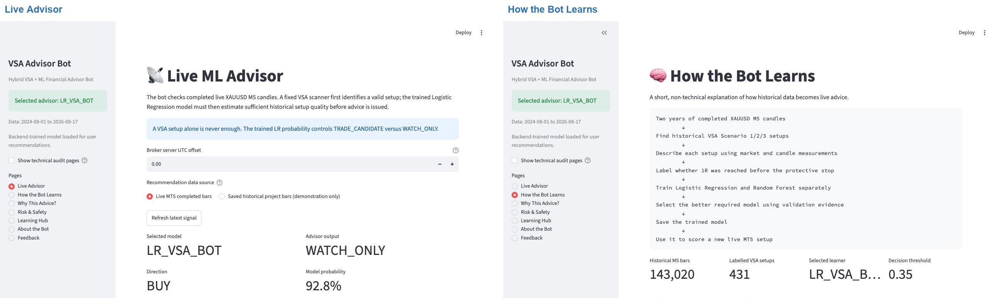
Figure 6. Current novice-facing website. Left: the Live Advisor exposes the selected LR, raw probability, direction and safety-controlled output. Right: How the Bot Learns distinguishes two-year training from live scoring. Source: fresh local captures, 18 August 2026.
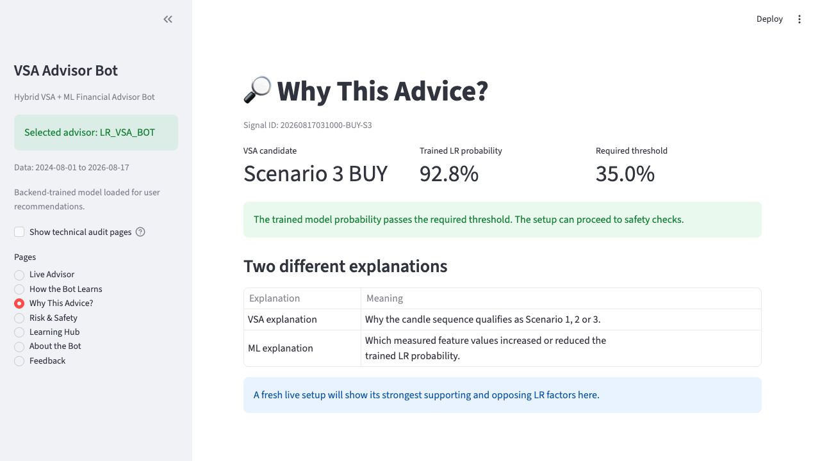
Figure 7. Why This Advice? separates the VSA candidate from the trained LR probability and its selected threshold. The shown 92.8% example is the persisted integration example; it is not claimed as a new 18 August live setup. Source: fresh local capture.

7.3 Advice decision table
Table 7. How model inference and safety state determine final advice.
Condition | Raw ML result | Final user output
No new confirmed Scenario 1/2/3 setup | Model is not called | NO_NEW_VSA_SETUP / no new alert
New setup and p < 0.35 | WATCH_ONLY | WATCH_ONLY
New setup and p ≥ 0.35; news clear | TRADE_CANDIDATE | TRADE_CANDIDATE advice with entry/stop/targets/risk
New setup and p ≥ 0.35; news blocked or unverified | TRADE_CANDIDATE | WATCH_ONLY after safety gate
Duplicate or stale signal | Previous calculation retained for audit | No duplicate/stale MT5 action

7.4 Explainability
explain_lr_setup() multiplies every standardised live value by its corresponding fitted coefficient and ranks the log-odds contributions. The audit recomputes all 65 unseen probabilities with maximum absolute error 1.665×10⁻¹⁶, below the 10⁻¹² tolerance. This is faithful to the saved LR calculation. It remains an association-based explanation, not proof that changing one feature would cause profit.

8. How the same advice appears in MT5 and mobile

8.1 The 29-field signal contract
save_ml_signal_csv() atomically writes a fixed 29-column row. Important fields include signal_time, cab_time, symbol, timeframe, selected_model, direction, scenario_id, ml_probability_valid, recommendation_threshold, advisor_output, entry, stop, 1R/4R targets, measured VSA features, risk and news state. The same logical record is stored in the project outputs folder for the website and in MT5 Common Files for the EA.
Implementation reference: mt5/VSA_ML_Signal_Bridge_EA.mq5, lines 173–292. MT5 validates and renders the Python ML result rather than inventing a separate recommendation.

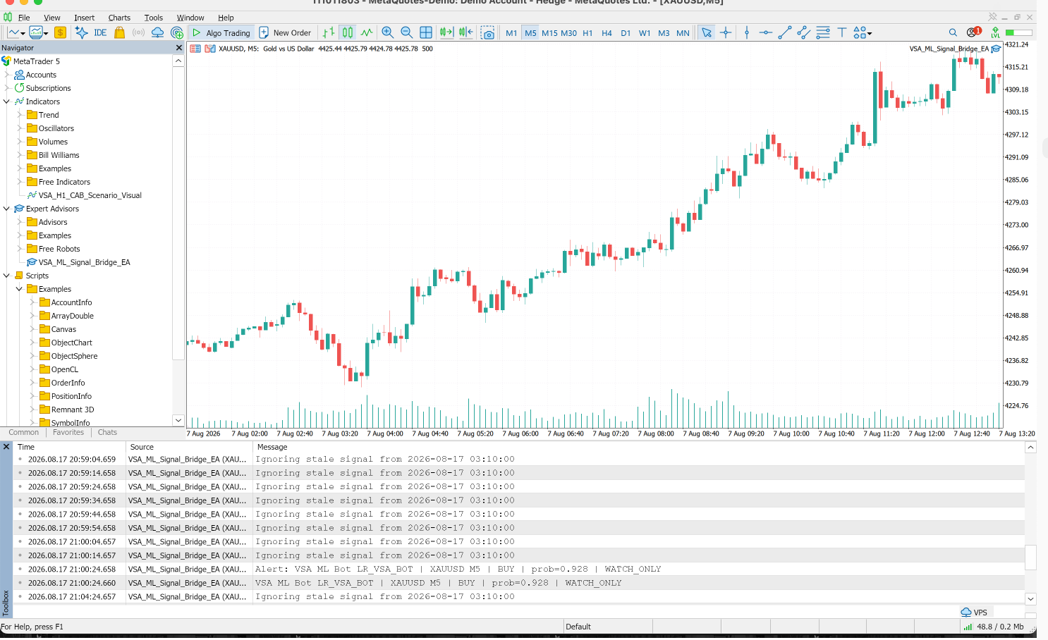
Figure 8. MT5 consumes ml_signal.csv in WATCH_ONLY mode. The Experts log shows LR_VSA_BOT, XAUUSD M5, BUY and prob=0.928; the chart-side bridge is attached. Source: captured project evidence.
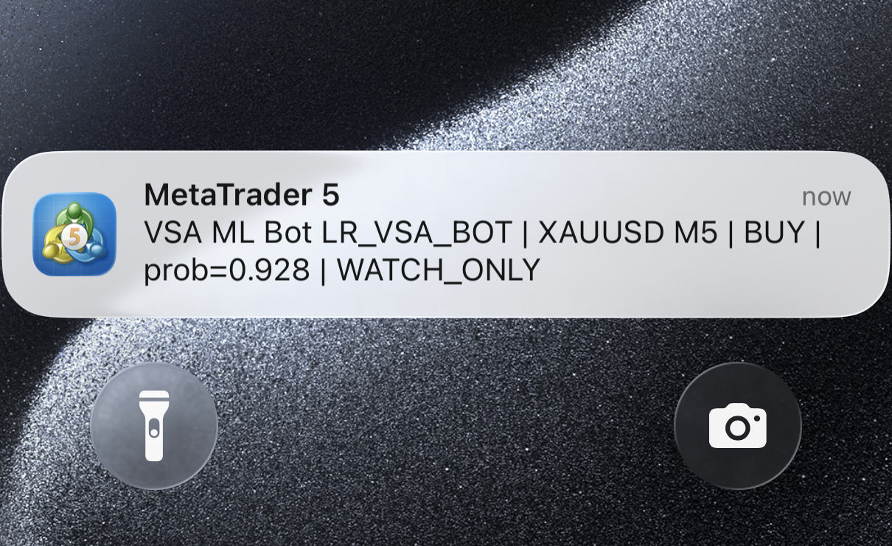
Figure 9. Configured MetaTrader 5 mobile push notification carrying the same LR model name, XAUUSD M5 direction, probability and WATCH_ONLY state. Source: captured project evidence.

8.2 Same signal identity across channels
The project derives a stable human-auditable identifier from signal time, direction and scenario, for example 20260817031000-BUY-S3. The website displays this ID and the enhanced MT5 bridge draws and logs it. This allows an examiner to match one recommendation across Python status, CSV row, website, desktop alert and mobile notification instead of comparing unrelated screenshots.

8.3 Advisory scope versus automatic trading
EnableDemoTrading defaults to false. When enabled deliberately on a demo account, the bridge additionally requires TRADE_CANDIDATE, probability above threshold, clear news and no existing position. RiskBasedVolume calculates position size and the EA contains 70% partial-close/breakeven management. For the final project position requested by the user, automatic trading should be described as future work and the submitted demonstration should remain advisory/watch-only. Real-money automation is not claimed.
Important technical truth
The trained LR is not executed natively inside MQL5. Python performs predict_proba and MT5 consumes the scored signal. Native MT5 execution would require exporting the model to ONNX or reproducing the fitted scaler, intercept and 24 coefficients in MQL5, followed by parity tests. That is not necessary for the current advisory architecture but should not be misrepresented.

9. Evidence that machine learning controls the advice

9.1 Automated and compile evidence
The current suite was rerun with the project's pinned Python 3.11.7 / scikit-learn 1.9.0 environment: 23 tests passed. The tests cover data cleaning, mirrored outcome/stop logic, embargo splitting, saved-model version checks, LR equation reconstruction, news gating, duplicate suppression, the 29-column bridge contract, shared signal identity, novice-page defaults and—most importantly—the fact that trained-model probability changes live advice.
Table 8. Current implementation verification.
Evidence | Verified result | Why it matters
Automated unit/integration suite | 23 passed | Shows the pipeline's contracts and fail-safe states are executable.
test_trained_model_probability_controls_live_advice | Passed | Proves identical VSA setup with different fitted LR probabilities changes TRADE_CANDIDATE/WATCH_ONLY.
LR faithfulness audit | 65/65; max error 1.665×10⁻¹⁶ | Proves explanations reconstruct predict_proba numerically.
MQL5 compilation evidence | 0 errors / 0 warnings | Exporter, bridge and visual indicator compile.
Live replay integration summary | All checks passed | Verifies model name, threshold, duplicate gate, news override, local explanation and 29 columns.

9.2 Counterfactual proof that it is not logic-only
The strongest test changes only the fitted model's output while keeping the same VSA setup. A low-probability fitted classifier produces WATCH_ONLY; a high-probability fitted classifier produces TRADE_CANDIDATE. If the program were logic-only, both cases would have the same result. The existence of VSA rules therefore does not remove ML; the rules define the prediction population and the classifier filters it.

9.3 Predictive and strategy evidence
On the unseen chronological test, LR F1 is 0.556, precision 0.444, recall 0.741 and balanced accuracy 0.541. RF F1 is 0.540. Under the implemented cost-adjusted managed-outcome simulation, VSA-only produces 4.208R, LR-filtered VSA 7.374R and RF-filtered VSA 1.887R. These results justify that the learned filter has utility within the evaluated period but are not evidence of future profit. Only 65 unseen setups and mixed walk-forward performance demand cautious claims.
Responsible conclusion
The project demonstrates a real, persisted and utilised predictive model. It does not demonstrate that the model will remain profitable in future market regimes.

10. What is implemented, what is partial and what remains
Table 9. Honest completion matrix for examiner discussion.
Requirement | Status | Evidence / boundary
Two-year XAUUSD M5 training data | Implemented | 143,020 CSV bars; 431 labelled VSA setups.
Formal mirrored VSA algorithm | Implemented | Canonical Python state machine; MT5 visual mirror.
LR and RF trained separately | Implemented | Separate fit calls, artefacts, thresholds, predictions and metrics.
LR equation and utilisation | Implemented | Scaler + coefficients + intercept persisted; predict_proba live path; exact reconstruction audit.
Live MT5 completed-bar ingestion | Implemented, file-mediated | CopyRates → Common Files CSV → Python worker.
Website live advice | Implemented | Uses the live cycle and persisted output; novice pages default.
MT5 chart/desktop/mobile visibility | Implemented | Visual indicator, bridge drawing/log/alert and push evidence.
Continuous retraining on live bars | Not implemented by design | Frozen deployment is safer; retraining remains an offline controlled command.
Native LR inference inside MQL5 | Not implemented | Current architecture scores in Python; ONNX/MQL5 coefficient port is future work.
Production automatic/live-money trading | Out of submitted scope | Demo gate exists but defaults false; advisory mode is the final-project claim.
Long live-forward profitability proof | Incomplete | Requires a frozen demo-forward window across regimes and brokers.
Broker-independent volume | Not available | MT5 tick volume is a broker activity proxy, not centralised gold volume.

10.1 What true production integration would add
- A monitored process manager so the exporter and Python live worker restart automatically.
- A predetermined retraining schedule with drift checks, model versioning and rollback—not online learning on every candle.
- Longer demo-forward evaluation with measured spread, slippage, latency and broker disconnects.
- An optional direct API or ONNX path if native MT5 inference becomes an explicit requirement.
- Clear stale-state labelling on every user interface and a record of every no-setup/blocked decision.
- Only after those checks: controlled demo execution; real-money automation should remain beyond the current project claim.

11. Examiner demonstration procedure
The demonstration should show evidence in dependency order. A short, reproducible sequence is stronger than navigating every website page.
- Open MT5 XAUUSD M5 and show VSA_M5_Bar_Exporter_EA attached. In Experts, show 'wrote 2500 completed bars'.
- In Visual Studio Code, open mt5/VSA_M5_Bar_Exporter_EA.mq5 at CopyRates and modules/live_pipeline.py at run_live_cycle to trace where the file goes.
- Open modules/vsa_strategy.py and point to CAB thresholds and Scenario 1/2/3 state transitions. Then show the MT5 visual indicator marking a CAB and scenario arrow.
- Run the backend training command and show training_log.txt, model_metadata.json and the separate lr_vsa_bot.joblib / rf_vsa_bot.joblib artefacts.
- Open train_models.py at lr.fit/rf.fit and modules/ml_pipeline.py at the explicit sigmoid reconstruction and predict_proba call.
- Start the live advisor worker; explain that NO_NEW_VSA_SETUP is a valid output when the latest completed bar has no new scenario.
- Open the website Live Advisor and How the Bot Learns pages; match the selected LR and signal ID to the MT5 bridge alert.
- End by showing EnableDemoTrading=false and state that automatic trading is future work; the assessed system is an ML advisory prototype.

11.1 Processes to start
Run the backend-training script once when demonstrating how artefacts were produced. Start the live-advisor script with the broker UTC offset in one terminal, and start the website script in a second terminal. Training is an occasional offline process; the live worker and website are separate runtime processes.

11.2 Suggested concise viva statement
Teacher-ready answer
'The two-year MT5 export is not repeatedly sent back to MT5 after training. Python converts its historical VSA setups into 24 features and learns LR coefficients. Those coefficients and the scaler are saved in selected_model.joblib. For every new completed MT5 M5 bar, the same VSA and feature code runs; only a newly confirmed setup is passed to predict_proba. The probability decides candidate versus watch-only, safety gates can still block it, and one 29-field signal is shown by both the website and the MT5 bridge.'

12. Direct answers, one by one

1. How is live data being pulled?
The MQL5 exporter calls CopyRates(_Symbol, PERIOD_M5, 1, requested, rates). Start position 1 excludes the forming candle. It writes completed OHLC, tick volume, real volume and spread to Common Files/xauusd_m5_bars.csv.

2. Where in Visual Studio Code is that pull?
Open mt5/VSA_M5_Bar_Exporter_EA.mq5, function ExportCompletedM5Bars(), especially lines 29–70. Python consumption is modules/live_pipeline.py::run_live_cycle(), lines 80–100.

3. Is training done in MT5?
No. The current model is trained in Python by backend_training/train_models.py using scikit-learn. MT5 originates the market data and later receives the scored advice.

4. What role does the two-year data play?
It supplies historical examples. The VSA scanner extracts 431 setups, their 24 signal-time features and managed outcome labels. LR uses these examples to learn a scaler, intercept and 24 coefficients; RF learns trees.

5. What happens after training?
The fitted objects are serialised to joblib files. Live inference loads selected_model.joblib rather than fitting again. A new feature row is transformed and scored with predict_proba.

6. Where is the Logistic Regression equation?
The library implementation is instantiated in train_models.py lines 231–235. The explicit equation is reconstructed in modules/ml_pipeline.py lines 600–610: intercept + sum(scaled value × coefficient), followed by the sigmoid.

7. What does the model predict?
It predicts the conditional probability that a newly confirmed VSA setup reaches the 1R objective before its protective stop. It does not directly predict every next candle or guarantee direction.

8. Where is the VSA algorithm?
modules/vsa_strategy.py::prepare_strategy_features and scan_vsa_scenarios contain CAB thresholds, mirrored state transitions, stops, targets and labels. VSA_Live_Visual_Indicator.mq5 displays the mapping in MT5.

9. Why were 15 features previously mentioned?
The first 15 deployed variables are the core domain/candle/CAB/risk/sequence features. The final MODEL_FEATURES list adds nine backward-looking context/time variables, so LR and RF actually use 24.

10. How does live data affect advice?
Each completed bar updates rolling features and the VSA state. If it confirms a recent scenario, the frozen LR scores its 24-feature row. If it does not, no new alert is produced. Live bars are not automatically added to training.

11. How is advice shown in MT5?
Python writes Common Files/ml_signal.csv. VSA_ML_Signal_Bridge_EA reads 29 fields, validates symbol/timeframe/scenario/age, draws the evidence, logs it and optionally sends desktop/mobile notifications.

12. Is the project machine learning or logic based?
It is a hybrid ML system. VSA logic defines a meaningful candidate and risk geometry; the fitted LR probability controls acceptance. A passing automated test proves that changing the fitted model probability changes the advice for the same VSA setup.

Appendix A. File and function traceability
Table 10. Repository map for examiner inspection.
Pipeline stage | Filename | Function / evidence
Historical input | data/bars.csv | 143,020 XAUUSD M5 rows used by the recorded training run.
Bar cleaning | modules/ml_pipeline.py | read_mt5_bars; add_candle_features
VSA candidate generation | modules/vsa_strategy.py | prepare_strategy_features; scan_vsa_scenarios
Managed labels | modules/vsa_strategy.py | managed_exit_outcome; scenario_stop
Dataset construction | modules/ml_pipeline.py | build_vsa_setup_dataset
Temporal split | modules/ml_pipeline.py | purged_chronological_split
LR/RF training | backend_training/train_models.py | lr.fit; rf.fit; validation threshold sweep; model selection
Artefact persistence | backend_training/train_models.py | joblib.dump; metadata and result CSV outputs
Live MT5 bar export | mt5/VSA_M5_Bar_Exporter_EA.mq5 | ExportCompletedM5Bars; CopyRates; FILE_COMMON
Live scoring | modules/live_pipeline.py | run_live_cycle
LR deployment | modules/ml_pipeline.py | load_selected_model; predict_vsa_setup_row; predict_proba
Website | app.py | page_recommendation; page_how_bot_learns; page_why_this_advice
MT5 rendering | mt5/VSA_ML_Signal_Bridge_EA.mq5 | OnTimer; DrawSignalEvidence; Alert; SendNotification
MT5 VSA visual | mt5/VSA_Live_Visual_Indicator.mq5 | CAB zone/trigger/scenario chart objects and parity output
Verification | tests/test_ml_pipeline.py | 23 automated behavioural and integration tests

Appendix B. Evidence provenance and interpretation
This technical report was prepared from the supplied Pages draft as background and from the current project code, metadata, result files, logs and screenshots as implementation evidence. Text inside the supplied document was treated as source material rather than instructions. Fresh Streamlit captures were taken on 18 August 2026. MT5 screenshots are existing project evidence captured during exporter, bridge, indicator and mobile-notification demonstrations.
The displayed 92.8% Scenario 3 BUY record is a controlled persisted integration example dated 17 August 2026. The most recent recorded live cycle on 18 August consumed current bars but found no new qualifying setup. The report preserves that distinction to avoid presenting a stale example as a fresh market recommendation.
Model metrics and R-based outcomes are historical evaluation results. They do not establish future profitability, and the system is educational/demo software rather than personal financial advice.

