VSA + MACHINE LEARNING
FINANCIAL ADVISOR BOT
A transparent XAUUSD M5 advisory system combining
Volume Spread Analysis, Logistic Regression and MetaTrader 5
Final Project Report
Project template: 4.2 Financial Advisor Bot
Student: Syed Abdullah Humayun
Student ID: [insert before submission]
University of London
September 2026
Educational prototype — not financial advice and not a claim of future profitability

Abstract
This report presents a financial advisor prototype for non-technical gold traders. The system converts a precisely specified Volume Spread Analysis (VSA) strategy into candidate setups, then uses supervised machine learning to estimate whether each candidate will reach its labelled objective. It therefore does not attempt to predict every future price movement. It predicts the probability of success for a strategy-defined event. Two required candidate models—Logistic Regression (LR) and Random Forest (RF)—are trained and evaluated separately on the same chronological partitions. LR is selected using development-set F1 (0.515 versus 0.508), then evaluated once on an unseen test set where it records F1 0.556. A rule-only baseline reaches a higher raw test F1 because it accepts every candidate, but produces a lower simulated trading result: 4.208R compared with 7.374R for VSA+LR. A matched MetaTrader 5 replay gives VSA+LR a 2.85% return and 1.31% maximum equity drawdown, compared with 0.23% and 1.69% for VSA-only. The web interface explains VSA context, model probability and feature contributions; a numerical audit reconstructs all 65 unseen LR probabilities with maximum error 1.67×10⁻¹⁶. An MT5 CSV bridge provides alerts while demo execution remains disabled by default. Results are encouraging but limited by 431 extracted setups, broker tick volume, uncertain transaction costs, and incomplete target-user evaluation.

Keywords
Financial advisor bot; Volume Spread Analysis; Logistic Regression; explainable AI; XAUUSD; MetaTrader 5; Streamlit; chronological evaluation.

Table of Contents
Chapter 1 — Introduction 3
Chapter 2 — Literature Review 6
Chapter 3 — Design 10
Chapter 4 — Implementation 16
Chapter 5 — Evaluation 24
Chapter 6 — Conclusion and Future Work 30
References 32
Appendices 34

Chapter 1: Introduction

1.1 Project concept and template
Retail trading platforms make complex market data easy to access, but access is not the same as understanding. A beginner can see candlesticks, volume and automated strategies yet still struggle to identify why a setup matters, how uncertainty should be expressed, or how much capital should be exposed. This project addresses that gap through a financial advisor bot for XAUUSD (gold against the US dollar) on five-minute data. The advisor combines a formalised Volume Spread Analysis strategy with machine learning, a web explanation layer and a MetaTrader 5 (MT5) integration. Its purpose is decision support and education, not guaranteed profit or unrestricted autonomous trading.
The work follows University of London project template 4.2, Financial Advisor Bot. The template expects financial-data analysis, an AI/ML workflow, an interface usable by non-technical users, tested advice and an integrated prototype. The implementation meets these expectations by separating offline data preparation and training from the runtime advisor. Python extracts and labels VSA candidates, trains LR and RF independently, selects a model using development data and saves evidence. Streamlit presents recommendations and explanations. MT5 exports completed bars and consumes a narrow CSV signal contract. This division avoids retraining when a user opens the website and makes each component testable.

1.2 Personal and user motivation
My motivation comes from approximately three years of personal interest in trading. At the beginning, my learning was not properly structured. Like many beginners, I was attracted by the possibility of extra income and encountered signal groups, shortcuts and unrealistic promises before receiving a clear explanation of risk management, stop-loss placement or why a setup might be valid. This experience showed me that access to a trading signal is not the same as understanding a trading decision.
The intended users are beginners, including students and people in full-time work, who cannot watch charts for many hours. They may copy social-media signals, paid groups or automated bots without understanding candle behaviour, confirmation, news risk or the amount they could lose. The project was therefore designed as a responsible monitoring and learning tool. It identifies a strategy-defined opportunity, estimates its historical probability and explains the setup, uncertainty and risk controls. It is not intended to give blind directions or promise profit.

1.3 Problem statement
The central problem is not simply whether the next candle rises or falls. The strategy first defines a meaningful event—a VSA change-in-behaviour (CAB) candle and one of three confirmation scenarios—and the model estimates whether that event is likely to achieve the labelled outcome. This is a conditional prediction problem. It is also imbalanced: only 144 of 431 extracted setups are labelled positive. Accuracy alone could therefore reward a model that mainly rejects trades. The project uses precision, recall, F1 and balanced accuracy alongside trading and risk measures.
The second problem is trust. A probability without an account of its origin can encourage automation bias. The project distinguishes four layers: the VSA domain explanation, the LR model explanation, the action recommendation and the safety controls. Logistic Regression is attractive because each standardised input contributes directly to the log-odds, making local numerical reconstruction possible. This is more faithful than attaching a generic natural-language reason after prediction, although it remains an association rather than a causal explanation.

1.4 Aim, objectives and research questions
The aim is to design, implement and critically evaluate a transparent VSA-based machine-learning financial advisor for beginner XAUUSD traders.
- Formalise the three mirrored VSA scenarios, thresholds, stop-loss rules and 70/30 trade management so that Python and MT5 implement the same specification.
- Create a reproducible XAUUSD M5 setup dataset from two years of completed bars and prevent temporal leakage through chronological, embargoed partitions.
- Train LR and RF separately, store their artefacts and results separately, compare them under equivalent conditions, and justify the selected advisor.
- Provide faithful LR explanations, accessible domain explanations, calibrated safety language and a non-technical Streamlit interface.
- Integrate the advisor with MT5 through a validated CSV bridge and evaluate software behaviour, predictive performance, simulated trading and robustness.
The report asks: RQ1—does a learned filter improve a fixed VSA strategy on unseen chronological data? RQ2—does LR or RF provide the better development-set balance between predictive performance and explainability? RQ3—can the selected model’s outputs be explained faithfully and communicated safely? RQ4—does the integrated system operate reliably across Python, Streamlit and MT5?

1.5 Scope, contribution and ethical position
The scope is deliberately narrow: XAUUSD, M5 bars, tick volume, three VSA scenarios, binary outcome prediction, LR and RF as the required comparison, and advisory/demo integration. The main contribution is the connection between a trader-defined CAB state machine to a transparent event-quality model, then carrying the same evidence into a beginner-facing explanation and an MT5 bridge. The project does not claim that VSA is universally profitable, that tick volume equals centralised traded volume, or that a historical result predicts future performance. Live-money automation, multi-asset deployment and reinforcement learning remain outside the evaluated scope.
The system communicates educational status, probability, risk and rejection states. Demo trading is disabled by default; stale signals are rejected; one-position and age controls are available; and the news filter can block recommendations. The target-user study requires informed consent. At the time of submission the information sheet, questionnaire and analysis workbook exist, but signed forms and genuine responses have intentionally not been invented. They will be appended after collection.

Chapter 2: Literature Review

2.1 Technical analysis, volume and VSA
Weak-form market efficiency proposes that current prices already reflect information in past prices, challenging systematic returns from chart rules (Fama, 1970). Later empirical work complicates a simple dismissal. Brock, Lakonishok and LeBaron (1992) found that moving-average and trading-range rules contained information in the Dow Jones series, while Lo, Mamaysky and Wang (2000) argued that technical patterns can be formalised and tested rather than treated only as visual folklore. These studies do not validate any specific VSA strategy. They do, however, justify converting discretionary rules into explicit algorithms and evaluating them out of sample.
Volume can add information that is absent from price alone. Blume, Easley and O’Hara (1994) developed a model in which market statistics that include volume can improve inference about information quality. The current project uses that idea cautiously. XAUUSD in MT5 commonly supplies broker tick volume rather than consolidated exchange volume. Tick volume records quote activity and is therefore a proxy whose meaning depends on the broker feed. A CAB candle is consequently treated as an operational feature—relative activity against the previous 30 bars—not as direct evidence of institutional accumulation or distribution.
Volume Spread Analysis is popularised in practitioner literature as the joint reading of volume, spread and close location (Coulling, 2013). Practitioner sources are useful for eliciting the domain strategy but provide less reliable evidence of profitability than peer-reviewed tests. The project therefore separates domain provenance from statistical evidence. The CAB and three scenarios are translated into explicit thresholds, while performance claims are based only on held-out project data. This keeps the study focused on a small, reproducible core rather than expanding the strategy with unsupported concepts.

2.2 From trading rules to supervised learning
A rule-based bot and a machine-learning advisor answer different questions. The VSA state machine determines whether a candidate structurally exists. The classifier estimates the conditional probability that this candidate reaches its labelled objective. This hybrid design preserves the strategy while allowing historical cases to influence acceptance. It also provides a meaningful baseline: the same VSA candidates can be replayed with and without the learned filter.
Logistic Regression models the log-odds of a binary response as a linear combination of features (Cox, 1958). With standardisation and regularisation, it is computationally efficient and its coefficient structure supports direct explanation. Its limitation is structural: nonlinear interactions must be represented explicitly, and correlated features can make individual coefficients unstable. A model may therefore be transparent yet still poorly specified.
Random Forests average many decision trees grown from resampled data and feature subsets, reducing the variance of an individual tree and capturing nonlinear interactions (Breiman, 2001). They can perform well without a linear decision surface but are harder to explain at the level of a single recommendation. Global impurity importance is not a faithful local explanation and can be biased. RF is therefore retained as a separately trained comparison model rather than being described as intrinsically explainable. Comparing it under the same split tests whether added complexity produces enough benefit to justify its interpretability cost.
Large-scale finance studies show that flexible ML can reveal nonlinear relationships, but gains depend on careful regularisation and evaluation (Gu, Kelly and Xiu, 2020). This project is much smaller and does not reproduce asset-pricing research. The relevant lesson is methodological: model complexity must be earned by out-of-sample evidence. A HistGradientBoosting classifier is included as contextual evidence, not as the deployment decision. Its development F1 of 0.524 is only marginally above LR’s 0.515 on 65 rows, while its unseen-test F1 is 0.542 versus LR’s 0.556. The result does not support replacing the transparent candidate.
Table 1. Critical comparison of model families used in the study.
Approach | Strength in this project | Main limitation | Decision
VSA rules only | Exact domain fidelity; clear baseline | Accepts every detected candidate; no learned discrimination | Retained as baseline
Logistic Regression | Direct probability; faithful additive contributions; fast inference | Linear log-odds; sensitive to specification | Selected from required LR/RF candidates
Random Forest | Nonlinear interactions; robust tree ensemble | Local reasoning is less direct; importance is not full XAI | Stored comparison model
Gradient boosting context | Tests whether greater flexibility changes conclusions | Less transparent; small validation advantage may be noise | Context only, not deployed

Source: author’s own work unless otherwise stated.

2.3 Evaluation under temporal dependence
Random shuffling is inappropriate when examples occur through time because later information can leak into training and adjacent observations can share market conditions. Time-respecting evaluation is therefore central. Bergmeir, Hyndman and Koo (2018) show that cross-validation assumptions for time-series models require attention to dependence. The present study uses an earlier training block, a later development block for thresholds and model choice, a 180-minute embargo and a final unseen test block. Walk-forward folds provide additional evidence about regime variation.
Backtesting introduces another source of optimism. Trying many indicators, thresholds or periods and reporting the winner can select noise. White’s (2000) reality check and the probability-of-backtest-overfitting work of Bailey et al. (2017) demonstrate why repeated search must be treated sceptically. The project limits candidate families, records validation thresholds, preserves the unseen test and reports negative walk-forward folds rather than hiding them. This does not remove selection bias, because the strategy itself was developed before formal evaluation, but it makes the remaining threat explicit.
Class imbalance also changes metric choice. Saito and Rehmsmeier (2015) show that precision–recall views can be more informative than ROC-style summaries when positive cases are rare. The project reports F1, precision, recall and balanced accuracy. F1 is the development selection metric because both missed valid setups and false acceptances matter. Trading outcomes are reported separately: predictive classification and financial utility are related, but neither is a substitute for the other.

2.4 Explainable AI and responsible advice
Explainable AI is not a single property. Barredo Arrieta et al. (2020) distinguish interpretability, post-hoc explanation and audience-dependent requirements. Ribeiro, Singh and Guestrin (2016) likewise emphasise explaining individual predictions rather than trusting model accuracy alone. For this project, a useful explanation must answer three different questions: why the VSA scanner found a scenario; which variables increased or decreased LR probability; and why the system recommends act, watch or avoid.
The deployed explanation is intrinsic to the fitted LR pipeline. For a standardised feature vector z, the log-odds equal the intercept plus the sum of coefficient–feature products. Each local contribution is therefore zⱼβⱼ. Adding all 24 contributions and the intercept reconstructs the model probability. This is a faithful computational account. It is not causal: a positive contribution does not prove that changing that input would cause success. It is also not automatically understandable to beginners, so the interface pairs numeric contributions with domain definitions and safety advice.
Random Forest feature importance is retained only as global context. Describing that chart as full XAI would conflate global importance, local attribution, domain explanation and action advice. A later version could add SHAP values, which provide an additive feature-attribution framework for many models (Lundberg and Lee, 2017), followed by a user study to test whether explanations improve comprehension rather than merely appearing technical.

2.5 Web-mediated financial advice and synthesis
A non-technical advisor must reduce cognitive load without presenting uncertainty as certainty. The Streamlit interface therefore separates recommendation, probability, model evidence, VSA narrative, risk plan and limitations. Model training is moved out of the request path; the page loads saved metadata, the current signal and compact result tables. This improves response time and prevents the interface from silently changing the deployed model.
Taken together, the literature shaped four practical design choices. Technical patterns should be specified and tested, not assumed. Volume is informative in theory but broker tick volume is a proxy. Complex models are not automatically superior. Time order and selection bias dominate evaluation design. XAI must be faithful to computation and understandable to its audience. These principles directly shape the architecture, model choice, testing strategy and claims in the following chapters.

Chapter 3: Design

3.1 Requirements and design principles
The functional requirements are to ingest completed XAUUSD M5 bars, detect mirrored CAB scenarios, derive pre-outcome features, train LR and RF separately, select a model using development evidence, issue an advisory probability, explain that probability, and transfer a validated signal to MT5. Non-functional requirements include reproducibility, low-latency page opening, traceable artefacts, readable explanations, safe defaults and consistent rules across Python and MQL5.
Five design principles follow: separation of training from inference; chronological rather than random evaluation; one canonical strategy specification; evidence saved as CSV/JSON rather than only displayed; and advice bounded by safety gates. The web layer never becomes the source of model truth. It reads artefacts produced by the backend, which makes the recommendation reproducible and the interface faster.
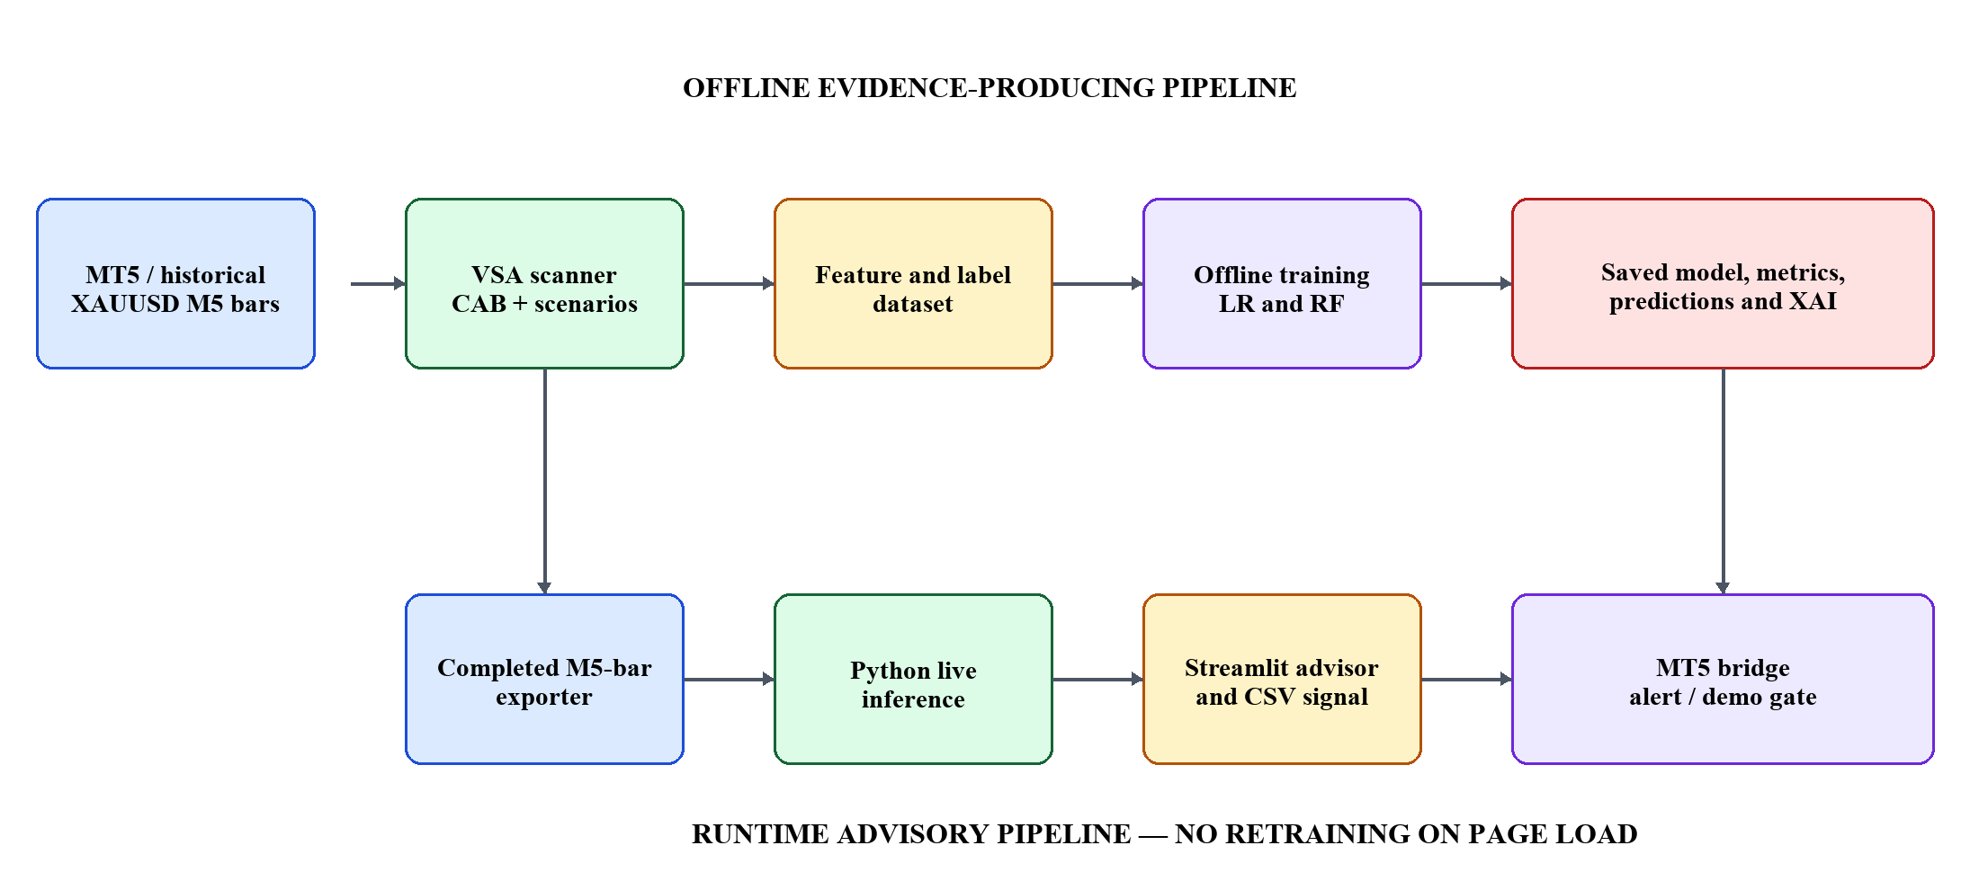
Figure 1. System architecture and data flow. Source: author’s own design.

3.2 Formal VSA strategy
A buy-side CAB is a bearish candle in a downward EMA context whose tick volume is at least 1.5 times the arithmetic mean tick volume of the preceding 30 completed bars. The current CAB candle is excluded from that rolling average. Its high is the upper trigger and its low the lower trigger. A valid breakout requires a momentum candle with body-to-range ratio at least 0.60, range at least 1.20 times its recent reference and volume lower than the CAB. Sell logic mirrors every condition around a bullish CAB in an upward context. These fixed definitions replace ambiguous phrases such as ‘high volume’ and ‘momentum’ and are used by the dataset generator and advisor.
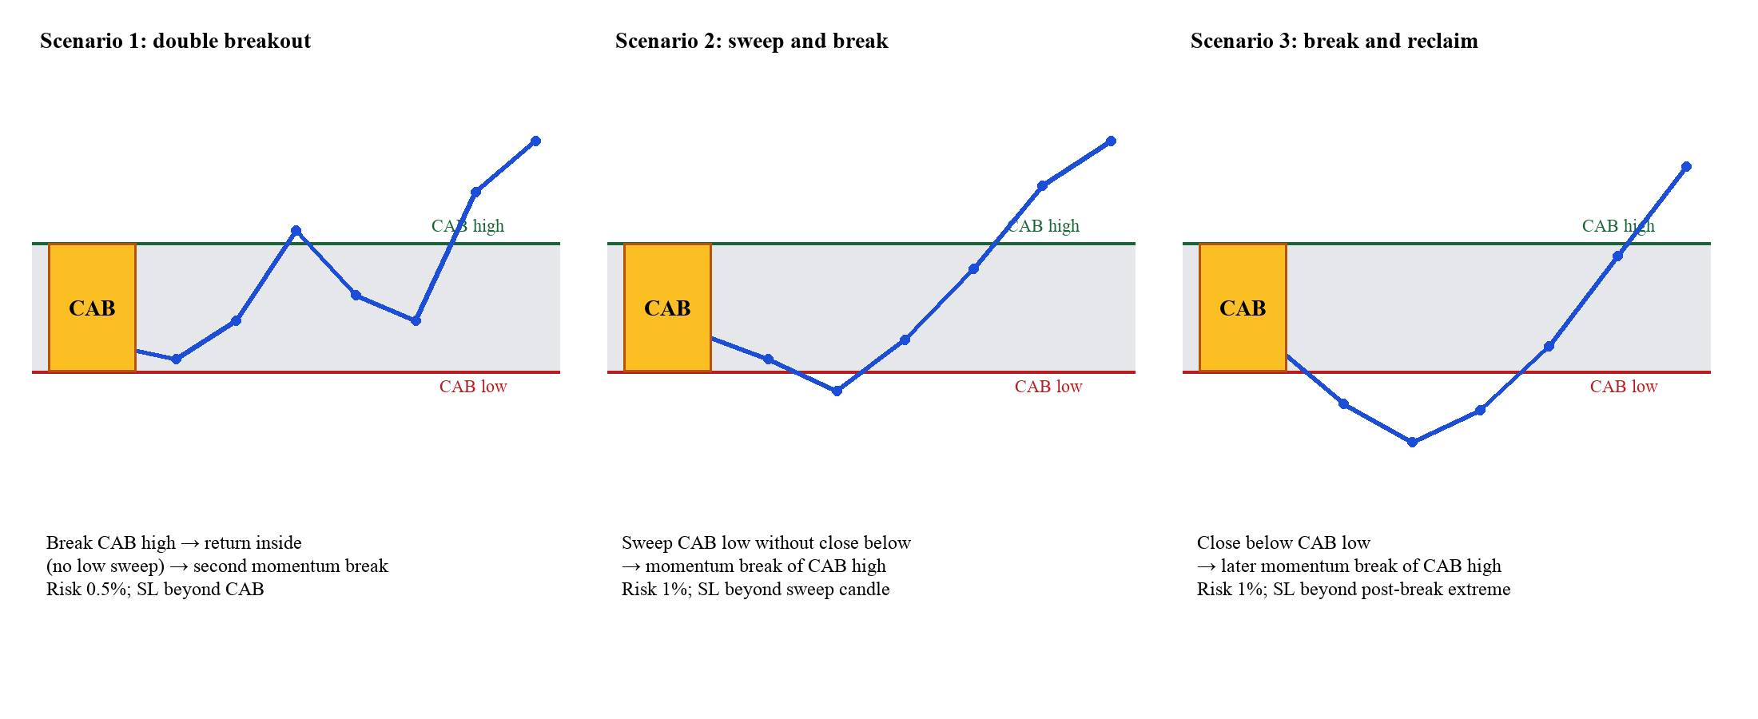
Figure 2. Formalised buy-side VSA scenarios; sell logic is mirrored. Source: author’s own strategy specification.
Table 2. Canonical scenario, risk and exit specification.
Scenario | Confirmation | Risk | Stop-loss anchor | Management
1 | First high break, return inside without low sweep, then second lower-volume momentum high break | 0.5% | Opposite side of CAB | Close 70% at 1R; move SL to entry; run 30% to 4R or breakeven
2 | Sweep—not close—beyond opposite CAB trigger, followed by lower-volume momentum break | 1.0% | Beyond the sweep candle | Same 70/30 management
3 | Close beyond opposite CAB trigger, then reverse lower-volume momentum break | 1.0% | Extreme formed after the CAB break | Same 70/30 management

Source: author’s own work unless otherwise stated.

3.3 Learning problem and features
The unit of learning is a completed VSA setup, not a single market bar. Each row contains only information available at the signal time. The label valid_trade is one when the setup reaches the predefined outcome before invalidation under the labelling horizon and zero otherwise. This formulation avoids claiming that the model predicts an unconstrained market future; it estimates strategy-conditional success.
Table 3 lists the exact 24 inputs supplied to both classifiers. Their names and order form a fixed contract: the historical pipeline calculates them for model training, and the live worker recalculates the same fields from completed MT5 candles before calling the saved model. Outcome information is never included among these inputs.
Table 3. Fixed 24-feature contract shared by offline LR/RF training and live MT5 inference. All values are available at signal time and exclude the future outcome label.
# | Feature | Group | Meaning at signal time
1 | scenario_id | Domain | Scenario 1, 2 or 3 code
2 | direction_num | Domain | Buy = 1; sell = −1
3 | relative_spread | CAB | Candle spread against its recent reference
4 | relative_volume | Confirmation | Signal-candle volume ratio
5 | close_location | Candle | Normalised close position within the range
6 | body_ratio | Candle | Body divided by complete candle range
7 | upper_wick_ratio | Candle | Upper wick divided by candle range
8 | lower_wick_ratio | Candle | Lower wick divided by candle range
9 | cab_range | CAB | CAB high minus CAB low
10 | cab_relative_volume | CAB | CAB volume relative to earlier bars
11 | entry_to_stop_distance | Risk | Planned distance from entry to stop-loss
12 | risk_reward_distance | Risk | Target geometry relative to stop distance
13 | bars_after_cab | Sequence | Completed bars from CAB to confirmation
14 | had_opposite_sweep | Sequence | Whether the opposite trigger was swept
15 | breakout_strength | Confirmation | Magnitude of the valid trigger break
16 | return_3 | Context | Backward-looking three-bar return
17 | return_6 | Context | Backward-looking six-bar return
18 | return_12 | Context | Backward-looking twelve-bar return
19 | volatility_12 | Context | Backward twelve-bar variability
20 | volatility_48 | Context | Backward forty-eight-bar variability
21 | hour | Time | Hour of the completed signal candle
22 | day_of_week | Time | Weekday of the signal
23 | london_session | Time | London-session indicator flag
24 | newyork_session | Time | New York-session indicator flag

Source: author’s own work unless otherwise stated.
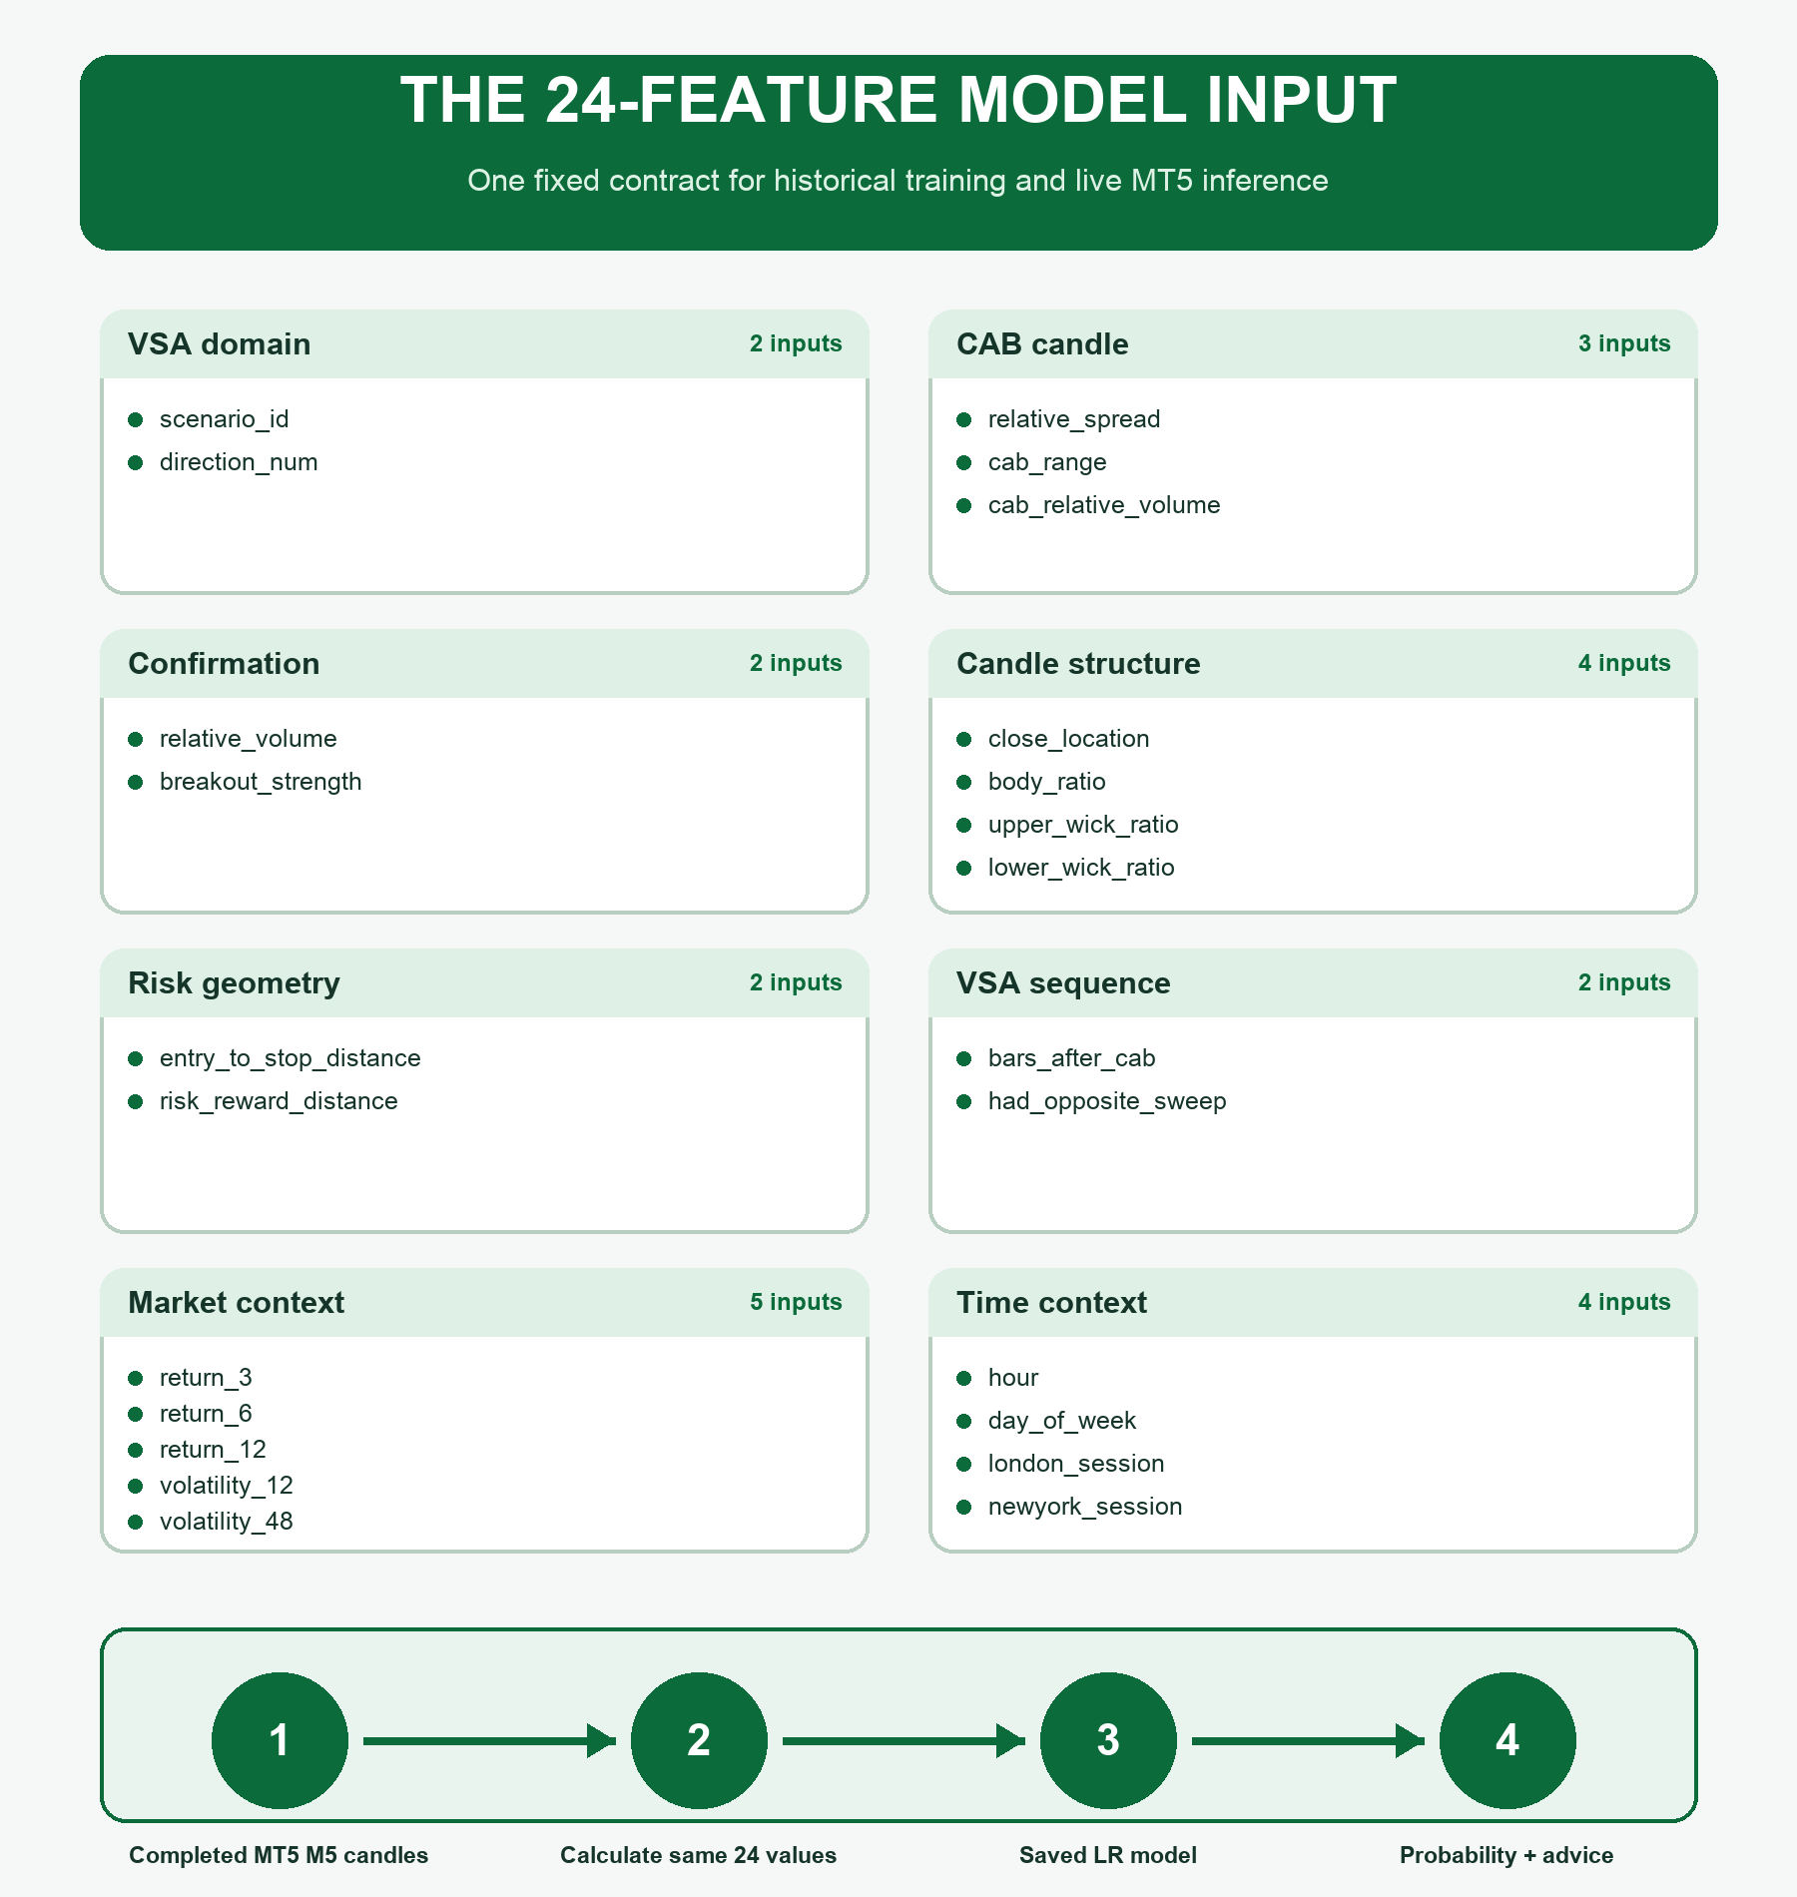
Figure 3. Visual map of the fixed 24-feature contract used for historical LR/RF training and live MT5 inference. Source: author’s own design.

3.4 Data partition and model-selection protocol
The source dataset contains 143,020 XAUUSD M5 bars from 1 August 2024 to 17 August 2026. The scanner extracts 431 setups: 144 positives and 287 negatives. Setups are ordered by signal time and divided 70/15/15 into 301 training, 65 development and 65 unseen-test rows. A 180-minute embargo separates development from test to reduce boundary contamination. Scaling and model fitting use training only. Probability thresholds are selected on development only. Test labels are opened once for final comparison.
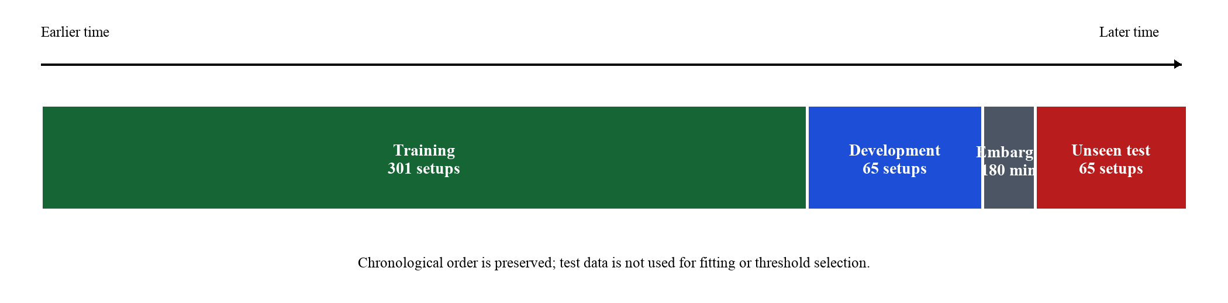
Figure 4. Chronological 70/15/15 partition with embargo. Source: author’s own dataset design.
LR and RF are trained as separate pipelines and stored as lr_vsa_bot.joblib and rf_vsa_bot.joblib with separate metrics, predictions and confusion matrices. The predefined decision rule selects the higher development F1 among these candidates. Explainability is a secondary design criterion: if predictive evidence is approximately equal, LR is preferable because its local decision can be reconstructed exactly. The threshold itself is not a trading certainty; it is a development-tuned operating point.

3.5 Explanation and safety design
The interface presents four explanation layers. The domain layer identifies CAB direction, trigger levels and scenario sequence. The model layer displays the selected probability and positive/negative LR contributions. The action layer maps probability and safety gates to BUY, SELL, WATCH or AVOID. The safety layer shows risk percentage, stop and target geometry, freshness and news state. Keeping these layers separate prevents a domain narrative from being misrepresented as model XAI.
MT5 integration uses a 29-field CSV schema and a file in the MT5 Common Files area. The bridge validates header/data boundaries, symbol, timeframe, signal age and action. Alerts and push notifications are permitted independently of demo execution. EnableDemoTrading defaults to false. This fail-closed design allows integration evidence without risking an unintended order.

3.6 Workplan and risk management
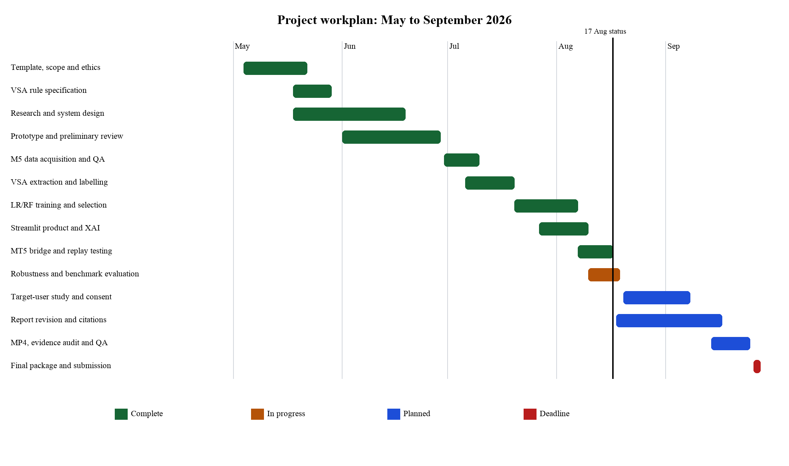
Figure 5. May–September 2026 workplan and Gantt chart. The vertical line is the 17 August status date; the final deadline is 28 September. Source: author’s own project workbook.
The remaining critical path is user evaluation, final report revision, the required MP4 demonstration and submission QA. Key risks are insufficient genuine participants, late evidence capture, unreported data leakage and inconsistency between Python and MT5. Mitigations are a consent-led 10–15 participant study, a fixed evidence index, automated regression tests, matched benchmark settings and a final rule-to-code audit. Profitability is not a completion criterion; defensible evaluation and honest limitations are.

Chapter 4: Implementation

4.1 Technology stack and implementation sequence
The prototype is implemented in Python 3 with pandas and NumPy for data processing, scikit-learn for supervised-learning pipelines, joblib for model persistence, Streamlit for the web interface and the standard Python test framework for automated verification. The machine-learning implementation follows established scikit-learn pipeline practice (Pedregosa et al., 2011). MT5 components are written in MQL5. CSV and JSON are used at the integration boundary because they are transparent, reproducible and supported by MT5 without requiring an external network service.
The repository separates data ingestion, domain logic, model training, runtime inference, user presentation and evaluation. The modules directory contains the reusable VSA, feature, news and live-pipeline logic; backend_training contains offline training and robustness scripts; models stores serialised estimators and metadata; results stores metrics and row-level evidence; scripts contains live and replay entry points; mt5 contains the exporter, visual indicator, signal bridge and replay EA; tests contains automated checks; and docs contains evaluation and demonstration evidence.

Implemented data-to-advice sequence
- Acquire completed XAUUSD M5 candles from the two-year project CSV for training or from the MT5 exporter for live inference.
- Clean timestamps and OHLCV fields, remove invalid and duplicate rows, and calculate backward-looking candle measurements.
- Run the mirrored CAB state machine and emit a row only when Scenario 1, 2 or 3 reaches confirmation.
- For historical rows only, evaluate the managed 1R/4R outcome to create the binary supervised-learning label.
- Apply the purged chronological train, development and unseen-test partition.
- Fit LR and RF independently on identical training rows, and tune their probability thresholds using development F1.
- Select the required candidate with the stronger development F1 and save the complete fitted pipeline and metadata.
- For a newly completed live setup, derive the same 24 features and use the saved model to estimate valid-trade probability.
- Apply freshness, news and risk controls before writing one 29-field recommendation record.
- Present the same recommendation on the novice website and through the MT5 desktop/mobile bridge.

4.2 Step 1 — Historical and live M5 data ingestion
Offline training starts in backend_training/train_models.py. It reads data/bars.csv through modules/ml_pipeline.py::read_mt5_bars. The recorded input contains 143,020 XAUUSD five-minute bars between 1 August 2024 and 17 August 2026. The reader accepts MT5-style date/time, OHLC, tick-volume, real-volume and spread fields, converts numeric columns, removes incomplete records, sorts by time and removes duplicate timestamps. The training program therefore receives a reproducible local snapshot rather than changing whenever the website is opened.
Live ingestion is a separate runtime path. VSA_M5_Bar_Exporter_EA uses MT5 CopyRates to export 2,500 completed M5 candles to the terminal Common Files area. The request begins at bar position one, excluding the forming candle. scripts/run_live_advisor.py repeatedly calls modules/live_pipeline.py::run_live_cycle, which reads the exported xauusd_m5_bars.csv file. This is a file-mediated live integration: MT5 directly obtains broker candles, while Python consumes their CSV representation.

4.3 Step 2 — Feature calculation and VSA state detection
modules/ml_pipeline.py calculates range, body, upper and lower wick, shifted rolling range and volume references, relative spread, relative volume, close location, body and wick ratios, backward returns, volatility and time/session indicators. Shifted references prevent the current candle from being included in its own historical benchmark. The final MODEL_FEATURES contract contains 24 ordered variables, matching the feature table in Chapter 3.
modules/vsa_strategy.py is the canonical strategy implementation. It calculates a 30-bar activity reference, EMA50 trend and five-bar EMA slope, then identifies a bearish high-activity CAB in a downtrend or the mirrored bullish CAB in an uptrend. A bounded state object records the CAB high and low, first breakout, return inside, wick sweep, close beyond the opposite trigger and post-break extreme. A candidate is emitted only when one of the three precise confirmation sequences completes with the required momentum and lower-than-CAB volume. Buy and sell conditions are mirrored so the threshold meaning is consistent in both directions.
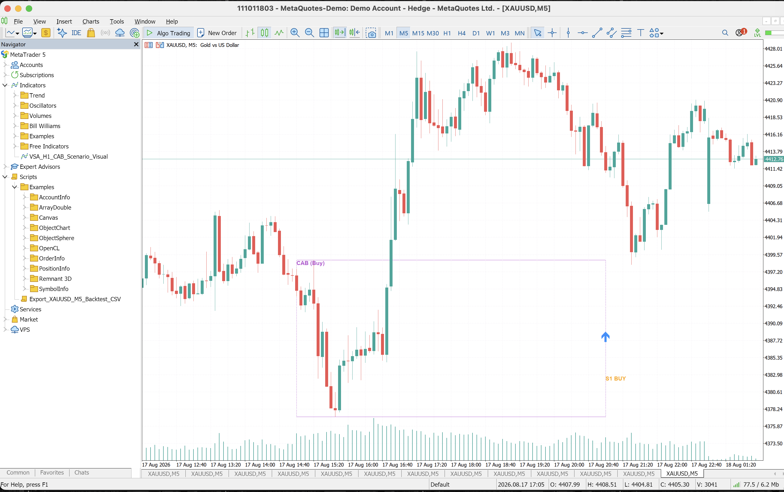
Figure 6. MT5 XAUUSD M5 visual indicator showing the CAB zone and a confirmed Scenario 1 BUY event. The visual component mirrors the submitted VSA definition for chart inspection. Source: author-captured prototype screen.

4.4 Step 3 — Historical outcome labelling and chronological partitions
At the signal candle, the implementation fixes direction, entry, scenario stop, 1R first target, 4R runner target and risk percentage. Future bars are then examined only by the historical label evaluator. A stop before 1R produces −1R. If 1R is reached, 70% is realised and the runner stop moves to entry; a breakeven runner produces +0.7R and a 4R runner produces +1.9R. Same-bar target/stop ambiguity is treated conservatively as stop first. Live inference does not execute this future-label stage because the future outcome is not yet known.
The resulting 431 setup rows are divided chronologically rather than randomly. Scaling and estimator fitting use only the first 301 rows. The following 65 development rows determine each model threshold and the LR/RF selection. A 180-minute embargo prevents development labels from overlapping the final 65 unseen rows. The test labels are opened once for final evaluation, so later test performance does not influence the deployed model choice.

4.5 Step 4 — Independent LR and RF training
LR and RF receive the same 24 columns and the same training labels. The LR pipeline contains a StandardScaler followed by class-balanced Logistic Regression. In mathematical terms, each live value is standardised using the training mean and standard deviation; the fitted intercept and 24 coefficient contributions produce a log-odds score; and the logistic function converts that score to the probability of VALID_TRADE (Cox, 1958). RF is fitted independently as a class-balanced ensemble of decision trees and can model nonlinear interactions (Breiman, 2001).
Validation threshold sweeps select 0.35 for LR and 0.46 for RF. Separate joblib files, predictions, confusion matrices, metrics and explanation artefacts are written for each candidate. Selection is then performed only between these required candidates using development F1. LR is chosen because its development F1 is 0.515 compared with 0.508 for RF, while also supporting direct numerical reconstruction of individual probabilities.
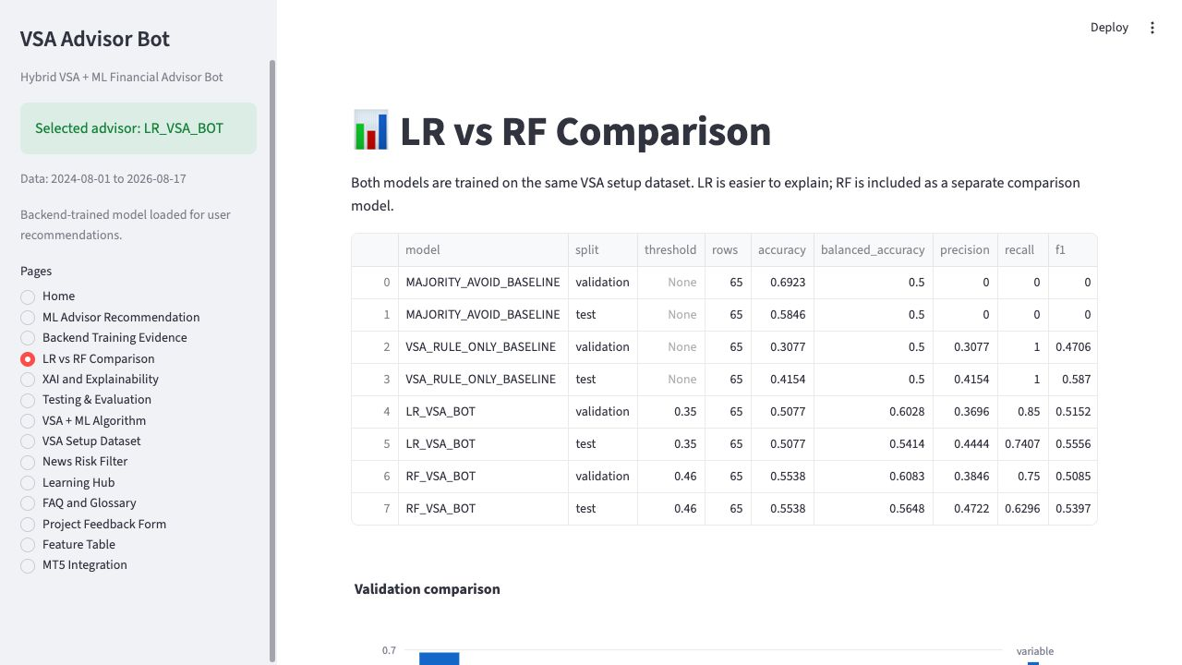
Figure 7. Separate LR and RF validation/test evidence and the rule/majority baselines. Source: author-captured prototype screen.

4.6 Step 5 — Model persistence and live predictive utility
Training compresses the historical evidence into fitted artefacts rather than returning the historical file to MT5. models/lr_vsa_bot.joblib stores the LR scaler, intercept, coefficients and class mapping; models/rf_vsa_bot.joblib stores the fitted tree ensemble; models/selected_model.joblib stores the chosen deployment pipeline; and model_metadata.json records feature order, thresholds, split periods, versions and the selection reason. These artefacts allow a later process to reproduce the trained transformation and prediction without retraining.
During a live cycle, the worker loads selected_model.joblib, scans recent completed bars using the same VSA implementation and derives the same ordered feature vector. If the latest bars do not complete a new scenario, the worker records NO_NEW_VSA_SETUP and writes no new alert. If a recent setup exists, predict_proba estimates the probability that it reaches 1R before its scenario stop. A probability at or above 0.35 passes the LR gate; a lower value remains WATCH_ONLY. Direction and price geometry come from VSA, while acceptance comes from the learned classifier.

4.7 Step 6 — Novice-facing Streamlit advisor
The website is organised around seven default novice pages: Live Advisor, How the Bot Learns, Why This Advice?, Risk & Safety, Learning Hub, About the Bot and Feedback. Training tables, model comparisons, XAI audits, test evidence, feature details and MT5 proof are hidden behind an optional technical-audit control. This keeps the first experience focused on action, uncertainty and learning while preserving detailed evidence for assessment and maintenance.
The Live Advisor can request the live MT5 completed-bar path or use the frozen historical demonstration path. It displays selected model, direction, raw model probability, final advice, entry, protective stop, 1R/4R targets, maximum capital risk, news status and a shared signal identifier. How the Bot Learns shows the separation between two-year offline learning and live scoring. Why This Advice? separates the VSA scenario explanation from the LR probability and threshold.
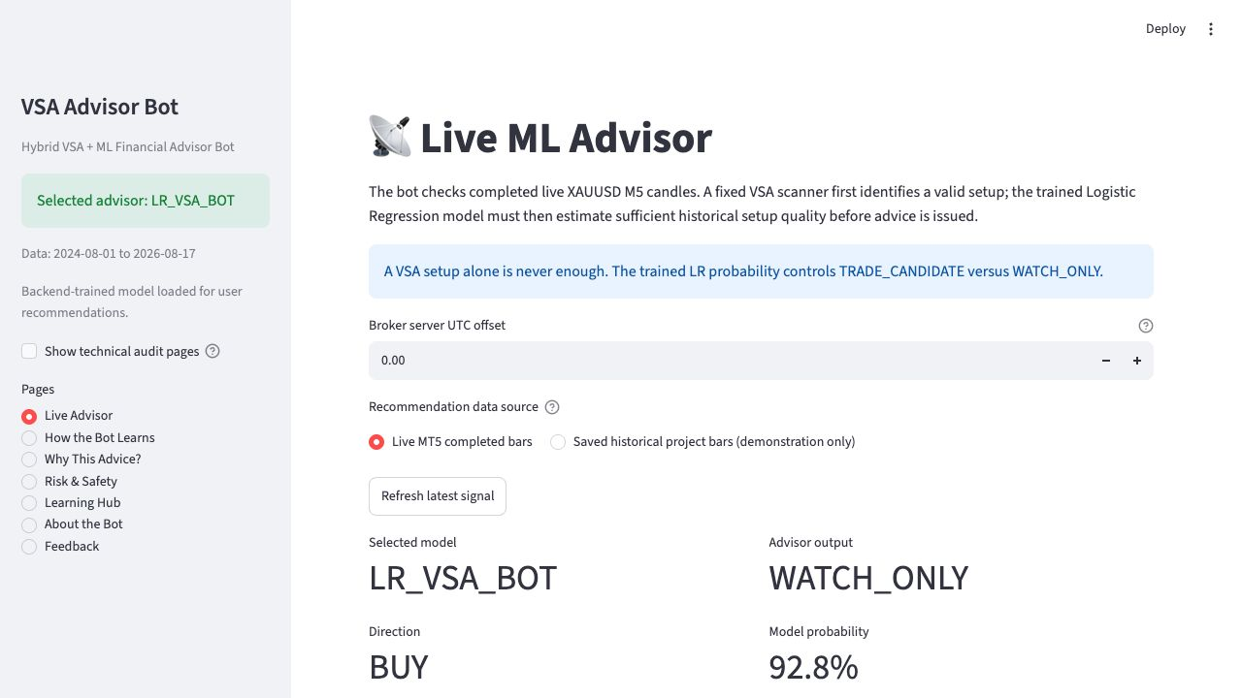
Figure 8. Current novice-facing Live Advisor showing the selected LR model, WATCH_ONLY state, direction and probability. Source: author-captured prototype screen.
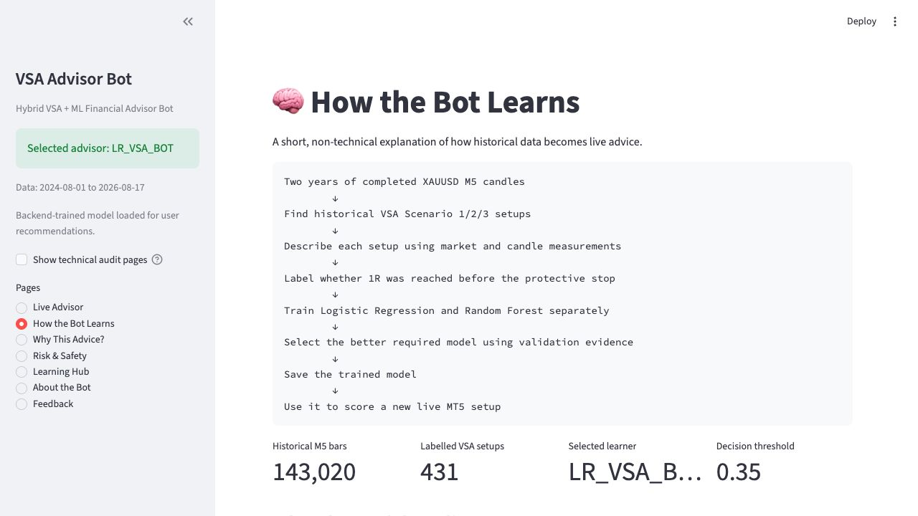
Figure 9. How the Bot Learns page presenting the historical-training-to-live-inference sequence. Source: author-captured prototype screen.

4.8 Step 7 — MT5 visualisation, alerts and replay
Python writes a fixed 29-field ml_signal.csv record to both the project output directory and MT5 Common Files. VSA_ML_Signal_Bridge_EA validates the field count, symbol, timeframe, scenario, timestamp and signal age before drawing the scenario, model name, probability, threshold, entry, stop and targets on the chart. The same record can produce a desktop alert and configured mobile push notification. A stable identifier derived from signal time, direction and scenario allows one recommendation to be matched across website, CSV, desktop and mobile evidence.
EnableDemoTrading defaults to false. Advice and notifications can therefore be demonstrated while the Trade tab remains empty. VSA_LR_Backtest_Replay_EA replays fixed unseen predictions in Strategy Tester and can toggle the learned filter while holding the VSA setup, symbol, period and lot size constant. This creates a more defensible internal comparison than testing unrelated strategies under different conditions.
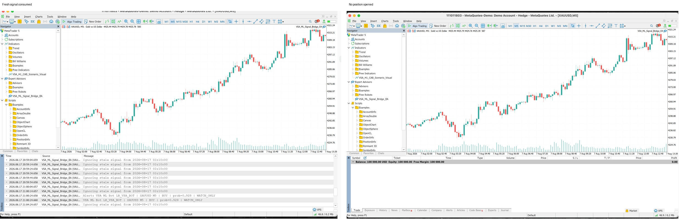
Figure 10. MT5 bridge evidence: the model signal is consumed in WATCH_ONLY mode while no position is opened. Source: author-captured MT5 evidence.

4.9 Step 8 — Explanation and safety layers
The implementation distinguishes domain explanation, intrinsic model attribution, action policy and safety control. For LR, every standardised feature is multiplied by its fitted coefficient; the contributions and intercept reconstruct the deployed probability. The audit performs this calculation for all 65 unseen rows. VSA narrative explains why the candle sequence is Scenario 1, 2 or 3, but it is not presented as model attribution. The action layer compares probability with threshold, and the safety layer can still change a model-approved setup to WATCH_ONLY when the signal is stale, duplicated or exposed to unverified/high-impact news.
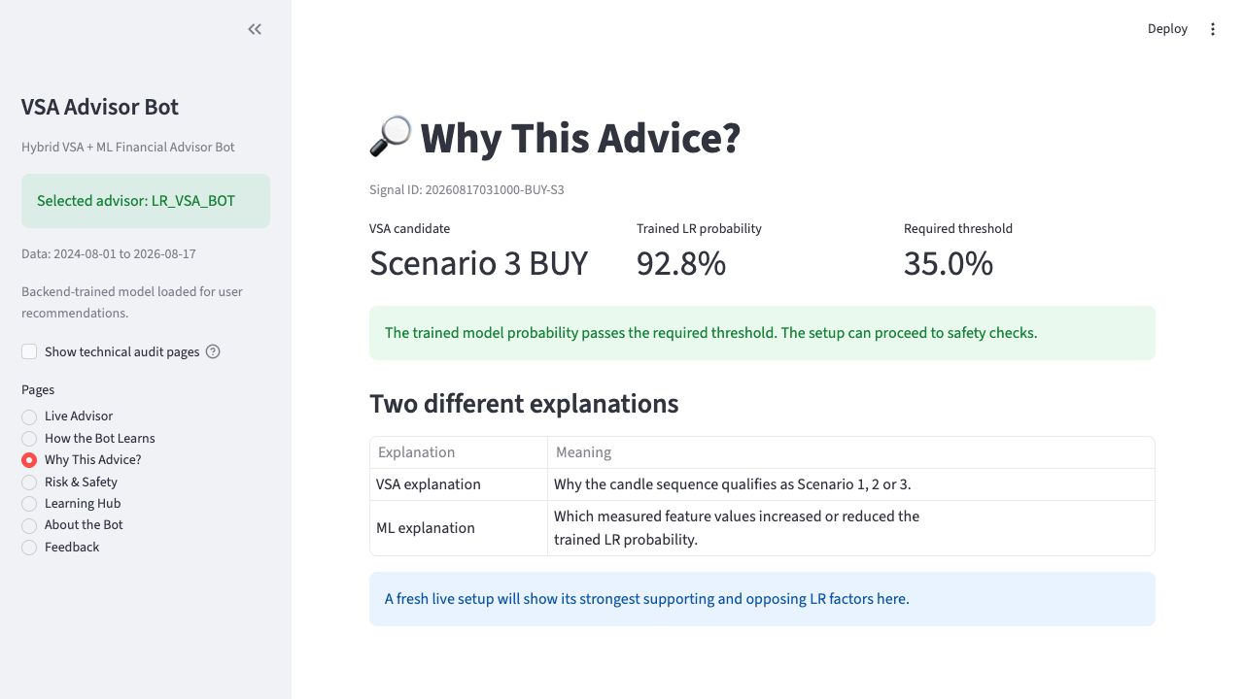
Figure 11. Why This Advice? separates the VSA candidate, trained LR probability, operating threshold and explanation type. Source: author-captured prototype screen.

Chapter 5: Evaluation

5.1 Evaluation strategy
Evaluation is organised at four levels. Unit and integration tests examine software correctness. Chronological classification metrics assess the learned filter. R-based simulation and matched MT5 replays assess strategy behaviour. Robustness tests examine sensitivity to time, features and transaction costs. A target-user study will assess usability and explanation comprehension after consent; it is not yet reported. This layered design avoids treating one profitable backtest or one accuracy value as proof of a successful advisor.
Table 4. Evaluation framework mapped to the project aims.
Evaluation layer | Question | Evidence | Decision criterion
Software | Do components obey their contracts? | 23 automated tests; MT5 compile and bridge logs | All automated tests pass; invalid/stale signals fail closed
Predictive | Does ML discriminate valid VSA setups? | Development and unseen metrics, confusion matrices | Select on development F1; report test once
Trading | Does filtering change outcomes under fixed rules? | R simulation; matched MT5 replay | Compare VSA+LR with identical VSA-only baseline
Robustness | Are results stable to period, features and costs? | Walk-forward, bootstrap, cost sensitivity | Report dispersion and negative folds
Human factors | Can target users understand and use advice? | Consent-led questionnaire/tasks | Pending genuine participant data

Source: author’s own work unless otherwise stated.

5.2 Software testing and integration evidence
The automated suite contains 23 passing tests. Coverage includes feature construction, chronological splitting, no-overlap assertions, model artefact compatibility, signal-schema fields, stale and duplicate handling, explanation reconstruction, shared signal identity, novice-page defaults, mirrored strategy behaviour and the decisive check that changing a fitted model probability changes live advice for the same VSA setup. The MT5 bridge, exporter and visual indicator compile with zero errors and zero warnings. Runtime evidence preserves missing-file, delimiter/header and stale-signal states as well as successful consumption, showing that the integration was tested at its boundaries rather than only on a happy path.
The bridge test produced a desktop alert and mobile push notification for XAUUSD M5 with probability 0.928 in WATCH_ONLY mode. The contemporaneous Trade tab remained empty. This demonstrates that Python-to-MT5 communication worked while the default execution gate prevented a trade. It does not demonstrate live profitability or order-management reliability; those require controlled demo-forward testing.

5.3 Predictive model results
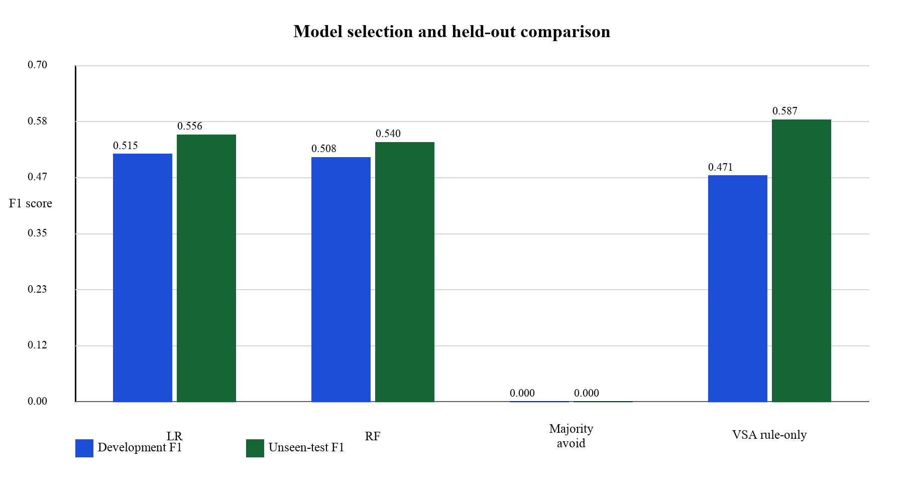
Figure 12. Development and unseen-test F1 for candidate models and baselines. Source: author’s own results.
Table 5. Classification performance on 65-row development and 65-row unseen-test sets.
Model | Threshold | Development F1 | Test F1 | Test precision | Test recall | Test balanced accuracy
Majority avoid | — | 0.000 | 0.000 | 0.000 | 0.000 | 0.500
VSA rule-only | — | 0.471 | 0.587 | 0.415 | 1.000 | 0.500
Logistic Regression | 0.35 | 0.515 | 0.556 | 0.444 | 0.741 | 0.541
Random Forest | 0.46 | 0.508 | 0.540 | 0.472 | 0.630 | 0.565
HistGradientBoosting (context) | development-tuned | 0.524 | 0.542 | — | — | —

Source: author’s own work unless otherwise stated.
LR is selected because it narrowly beats RF on the predefined development F1 criterion (0.515 versus 0.508) and offers direct local explanations. On unseen test data LR reaches F1 0.556 and RF 0.540. RF has slightly higher test precision and balanced accuracy, whereas LR accepts more true positives. The differences are small relative to the test size; the evidence supports LR as the project’s chosen transparent operating point, not a universal claim that LR is the better classifier.
Raw accuracy is also reported but is not used alone because the class distribution is imbalanced. On the unseen set RF accuracy is 0.554 and LR accuracy is 0.508; however, using these test values to choose the model would invalidate the held-out design. The predetermined selection uses development F1, where LR is stronger. This distinction prevents the phrase ‘more accurate’ from replacing a justified metric and split protocol.
The VSA rule-only baseline has a higher raw test F1 of 0.587 because it predicts every detected candidate as positive, giving recall 1.0 and balanced accuracy 0.5. This result needs careful interpretation: classification F1 is not a direct measure of trading value. The learned filter rejects candidates, lowering recall but changing the distribution of realised outcomes. The report therefore evaluates the same predictions under the strategy payoff separately.

5.4 Strategy outcome and matched MT5 comparison
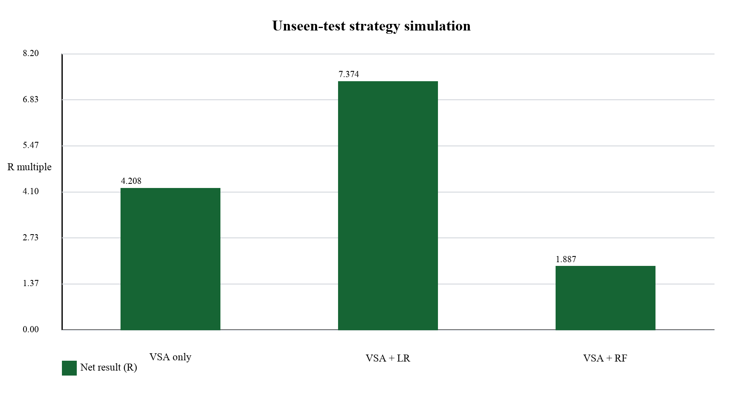
Figure 13. Unseen-test net result under the fixed VSA trade-management simulation. Source: author’s own results.
Across the 65 unseen setups, VSA-only produces 4.208R. The LR filter accepts 45 setups (69.2%) and produces 7.374R; RF accepts 36 and produces 1.887R. The LR result is a 3.166R improvement over the unfiltered baseline under the implemented assumptions. Because setups may overlap and costs are estimated rather than broker-executed, R results are evidence of comparative behaviour, not a forecast of account return.
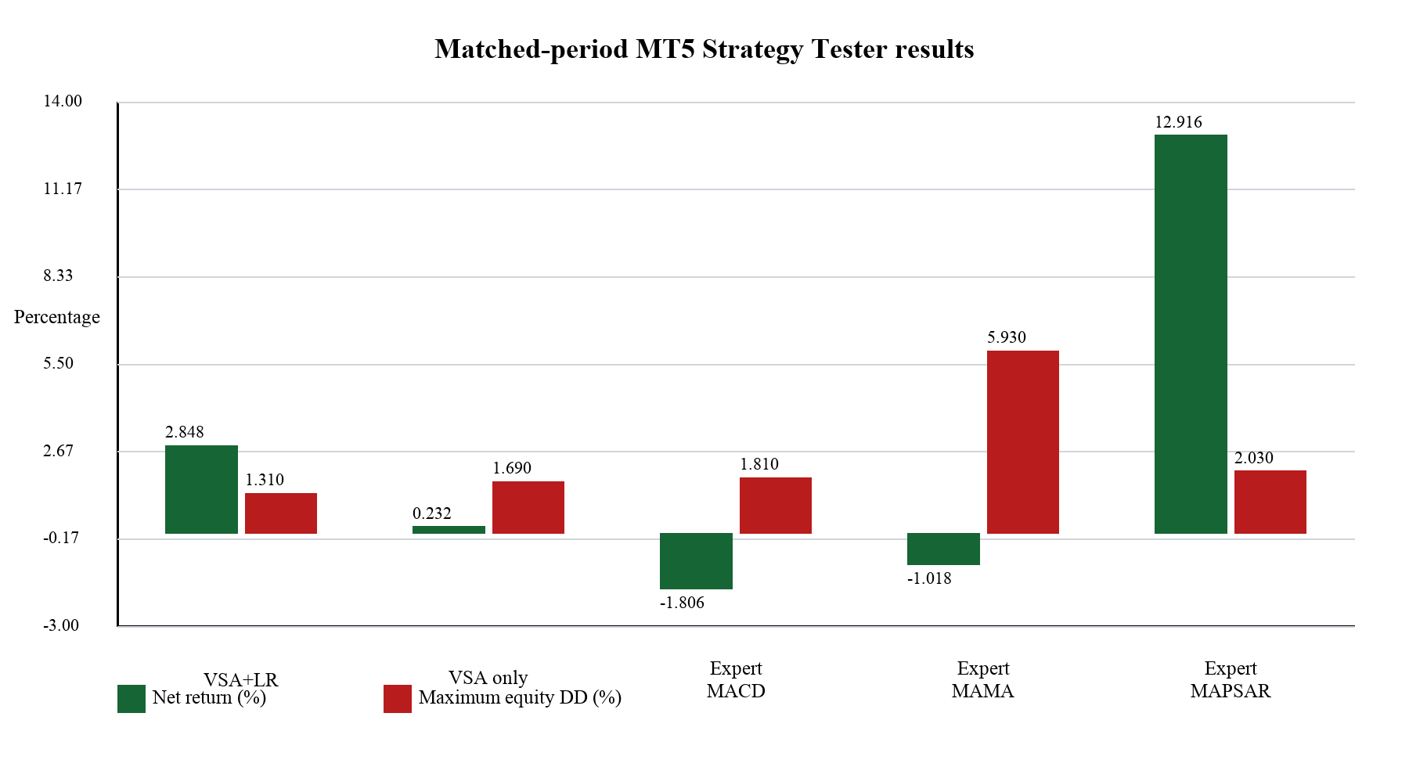
Figure 14. MT5 matched-period net return and maximum equity drawdown. Source: author’s own Strategy Tester reports.
Table 6. Matched XAUUSD M5 Strategy Tester comparison, 1 June–17 August 2026, USD 10,000, 1:100, real ticks and 0.01 lots.
EA | Net profit | Return | Max equity DD | Profit factor | Sharpe | Trades | Win rate
VSA + LR | $284.84 | 2.85% | 1.31% | 1.74 | 5.97 | 35 | 31.43%
VSA only | $23.21 | 0.23% | 1.69% | 1.04 | 0.40 | 46 | 21.74%
ExpertMACD | −$180.58 | −1.81% | 1.81% | 0.30 | −5.00 | 1,118 | 12.34%
ExpertMAMA | −$101.80 | −1.02% | 5.93% | 0.39 | −0.39 | 22 | 90.91%
ExpertMAPSAR | $1,291.65 | 12.92% | 2.03% | 15.13 | 6.02 | 80 | 96.25%

Source: author’s own work unless otherwise stated.
The fairest internal comparison is VSA+LR against VSA-only, because the replay EA changes only the ML gate. LR increases net profit from $23.21 to $284.84, improves profit factor from 1.04 to 1.74 and reduces maximum equity drawdown from 1.69% to 1.31%, while taking fewer trades. This supports RQ1 for this test period.
The built-in EAs are contextual rather than causal baselines. ExpertMAPSAR performs best in this two-and-a-half-month window, while MACD and MAMA lose money. Their entries, exits and effective risk differ from the VSA system despite matched symbol, period, deposit, modelling and lot size. It would be misleading to claim that ExpertMAPSAR proves or disproves the learning design. The comparison instead shows that results are strategy- and regime-dependent and that one short period cannot establish superiority.

5.5 Robustness, limitations and threats to validity
Walk-forward evaluation is mixed: some chronological folds are positive and others negative. The mean result is therefore not stable enough for a profitability claim. A core ten-feature model and the full 24-feature model were also compared using bootstrap confidence intervals; the intervals for their difference cross zero. The study cannot conclude that all additional features improve generalisation. The correct development direction is therefore to validate the smaller core more deeply before introducing additional strategy concepts.
Transaction-cost sensitivity reduces outcomes as assumed spread/slippage increases. Exact simulated values depend on the replay convention, but the direction is consistent: marginal setups are the first to lose value. The MT5 comparison uses zero-latency Strategy Tester execution and should be interpreted as a controlled technical benchmark rather than a live execution estimate. Future evaluation should repeat the frozen pipeline across longer periods, multiple brokers, realistic variable spreads and a demo-forward window.
Internal validity is threatened by possible errors in translating discretionary VSA descriptions, overlapping setup horizons and threshold choices. The canonical table, mirrored tests, embargo and saved predictions mitigate but do not eliminate these issues. Construct validity is limited because valid_trade represents the implemented 1R/4R outcome, not general market correctness. External validity is limited to one instrument, timeframe and broker tick-volume feed. Statistical conclusion validity is limited by only 65 unseen setups. Any numerical advantage should therefore be reported with uncertainty and replicated.

5.6 Explainability evaluation
The LR faithfulness audit covers every unseen row and all 24 features. Maximum probability reconstruction error is 1.665×10⁻¹⁶ against a tolerance of 10⁻¹², and passes the stated tolerance. This is stronger evidence than a selected example because it confirms the explanation formula over the complete test set. Global coefficients describe overall model direction; local contributions describe one prediction; the CAB narrative explains the rule detector; and action advice describes system policy. The interface labels these separately.
What remains unknown is whether a beginner understands the explanation, notices uncertainty or changes a risky decision. Faithfulness is a technical property, while usefulness is a human-factor property. The prepared target-user study is designed for 10–15 novice or developing traders. Each participant must receive the information sheet and provide a manually signed consent form before completing recommendation-interpretation tasks, Likert questions and open-text feedback. Planned outcomes include task accuracy, confidence, explanation usefulness, risk comprehension and qualitative themes.
At the time of submission, the participant information sheet, manual consent form, questionnaire and analysis workbook are prepared, but genuine signed forms and target-group responses have not yet been inserted. No participant results are reported before data collection. When data collection is complete, the evaluation will report recruitment, completed consent count, participant characteristics, descriptive summaries, qualitative themes and negative as well as positive findings.

Chapter 6: Conclusion and Future Work

6.1 Conclusion
The project delivers a complete educational financial-advisor prototype that connects a formal VSA strategy, supervised learning, faithful model explanation, a non-technical web interface and MT5. In practical terms, the system gathers financial data, trains outside the interface, saves its evidence and produces advice that can be inspected. The three CAB scenarios and risk rules are explicit, mirrored and testable. LR and RF are trained and stored separately; LR is selected on development F1 and retained because its predictive result is competitive and its individual decisions can be reconstructed exactly.
On the unseen set, LR achieves F1 0.556 and the VSA+LR simulation yields 7.374R compared with 4.208R for unfiltered VSA. The matched MT5 replay shows the same directional conclusion: 2.85% versus 0.23% net return, with lower maximum equity drawdown. These findings support a learned VSA filter within the evaluated period. They do not establish future profitability. Mixed walk-forward folds, overlapping confidence intervals for feature sets and the strong period-specific ExpertMAPSAR result show why the conclusion must remain bounded.
Explainability was assessed separately from predictive performance. The system does not use ‘explainable’, ‘advice’ and ‘XAI’ interchangeably. It separates model attribution, domain rationale and action policy, and verifies all unseen LR probabilities numerically. The integration also fails safely: a valid current CSV can trigger desktop and mobile advice while demo execution remains disabled and the Trade tab stays empty.

6.2 Future work
Future work should strengthen the reliability of the existing VSA+ML system rather than adding unnecessary features. Although the current project uses approximately two years of XAUUSD M5 data, further evaluation should use additional unseen periods, different market conditions and multiple broker tick-volume feeds. The frozen Logistic Regression model should also be tested through longer demo-account forward testing, repeated walk-forward evaluation and sensitivity analysis of the CAB volume, momentum, breakout and probability thresholds. The same pipeline could later be evaluated on other gold timeframes and financial instruments, but only after the XAUUSD M5 implementation has been validated more rigorously.
The target-user evaluation should be expanded to include a larger group of novice traders and a smaller comparison group of experienced traders. This would help assess whether the recommendation, VSA explanation, probability, news warning and risk information are understandable and useful.
Because Logistic Regression already provides directly auditable feature contributions, SHAP or LIME is not currently necessary. These methods may become useful if a nonlinear model such as Random Forest is deployed in a future version and demonstrates meaningfully better unseen performance. The Streamlit website could also be deployed publicly for education and advisory access, while MT5 integration remains local, demo-only and disabled by default. Further improvements could include guided video lessons, a structured Learning Hub pathway, an explanation-comprehension quiz, a detailed recommendation journal and stronger monitoring of model and data drift.

References
Bailey, D.H., Borwein, J.M., López de Prado, M. and Zhu, Q.J. (2017) ‘The probability of backtest overfitting’, Journal of Computational Finance, 20(4), pp. 39–69. doi: 10.21314/JCF.2016.322.
Barredo Arrieta, A. et al. (2020) ‘Explainable Artificial Intelligence (XAI): Concepts, taxonomies, opportunities and challenges toward responsible AI’, Information Fusion, 58, pp. 82–115. doi: 10.1016/j.inffus.2019.12.012.
Bergmeir, C., Hyndman, R.J. and Koo, B. (2018) ‘A note on the validity of cross-validation for evaluating autoregressive time series prediction’, Computational Statistics & Data Analysis, 120, pp. 70–83. doi: 10.1016/j.csda.2017.11.003.
Blume, L., Easley, D. and O’Hara, M. (1994) ‘Market statistics and technical analysis: The role of volume’, Journal of Finance, 49(1), pp. 153–181. doi: 10.1111/j.1540-6261.1994.tb04424.x.
Breiman, L. (2001) ‘Random forests’, Machine Learning, 45, pp. 5–32. doi: 10.1023/A:1010933404324.
Brock, W., Lakonishok, J. and LeBaron, B. (1992) ‘Simple technical trading rules and the stochastic properties of stock returns’, Journal of Finance, 47(5), pp. 1731–1764. doi: 10.1111/j.1540-6261.1992.tb04681.x.
Coulling, A. (2013) A Complete Guide to Volume Price Analysis. CreateSpace Independent Publishing Platform.
Cox, D.R. (1958) ‘The regression analysis of binary sequences’, Journal of the Royal Statistical Society: Series B, 20(2), pp. 215–232. doi: 10.1111/j.2517-6161.1958.tb00292.x.
Fama, E.F. (1970) ‘Efficient capital markets: A review of theory and empirical work’, Journal of Finance, 25(2), pp. 383–417. doi: 10.2307/2325486.
Gu, S., Kelly, B. and Xiu, D. (2020) ‘Empirical asset pricing via machine learning’, Review of Financial Studies, 33(5), pp. 2223–2273. doi: 10.1093/rfs/hhaa009.
Lo, A.W., Mamaysky, H. and Wang, J. (2000) ‘Foundations of technical analysis: Computational algorithms, statistical inference, and empirical implementation’, Journal of Finance, 55(4), pp. 1705–1765. doi: 10.1111/0022-1082.00265.
Lundberg, S.M. and Lee, S.-I. (2017) ‘A unified approach to interpreting model predictions’, Advances in Neural Information Processing Systems, 30.
Pedregosa, F. et al. (2011) ‘Scikit-learn: Machine learning in Python’, Journal of Machine Learning Research, 12, pp. 2825–2830.
Ribeiro, M.T., Singh, S. and Guestrin, C. (2016) ‘Why should I trust you? Explaining the predictions of any classifier’, Proceedings of the 22nd ACM SIGKDD International Conference on Knowledge Discovery and Data Mining, pp. 1135–1144. doi: 10.1145/2939672.2939778.
Saito, T. and Rehmsmeier, M. (2015) ‘The precision-recall plot is more informative than the ROC plot when evaluating binary classifiers on imbalanced datasets’, PLOS ONE, 10(3), e0118432. doi: 10.1371/journal.pone.0118432.
White, H. (2000) ‘A reality check for data snooping’, Econometrica, 68(5), pp. 1097–1126. doi: 10.1111/1468-0262.00152.

Appendix A — Report Word-Count Control
Table 7. Automated count of narrative text generated for the six chapters. Captions, tables, references and front matter are excluded, matching the stated exclusions where applicable.
Section | Calculated words
Chapter 1 — Introduction | 867
Chapter 2 — Literature Review | 1,174
Chapter 3 — Design | 645
Chapter 4 — Implementation | 1,453
Chapter 5 — Evaluation | 1,095
Chapter 6 — Conclusion and Future Work | 430
Total chapters | 5,664

Source: author’s own work unless otherwise stated.

Appendix B — Target-User Evaluation Materials
Status at submission: the participant information and consent form and the target-user questionnaire are included below as the instruments prepared for the consent-led study. They are unsigned templates. Completed consent forms must be collected before participation and stored separately from coded questionnaire responses. No participant result is claimed in this version.

Appendix B1 — Participant Information and Consent Form
Unsigned template included as evaluation evidence; participant-completed copies are stored separately and are not reproduced in the report.




Appendix B2 — Target-User Evaluation Questionnaire
Unsigned template included as evaluation evidence; participant-completed copies are stored separately and are not reproduced in the report.








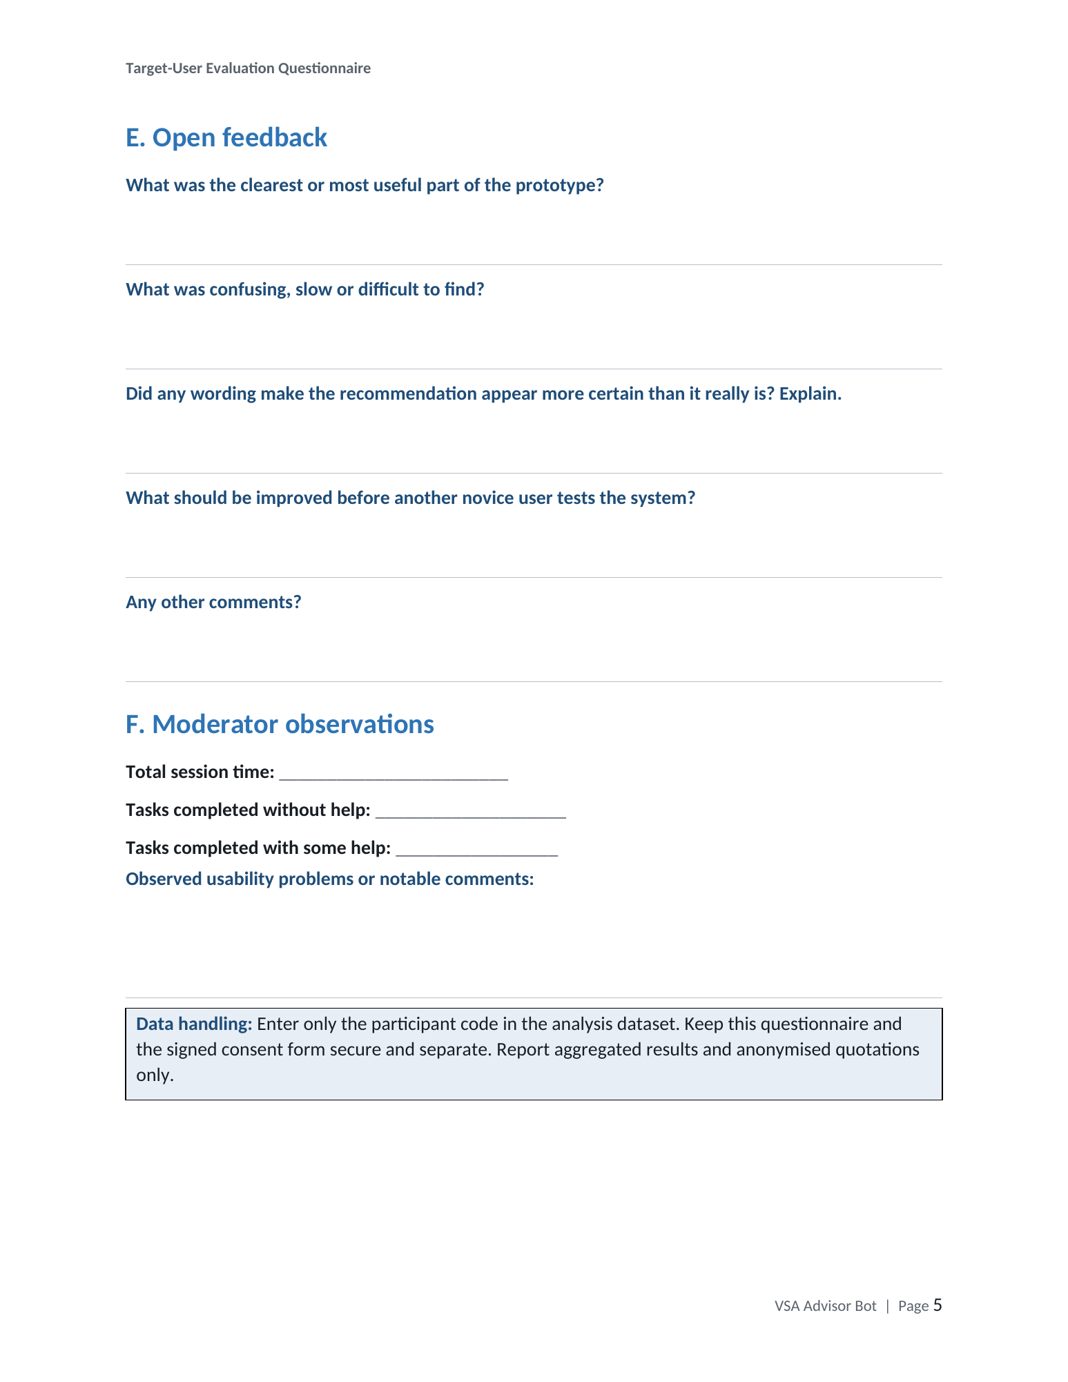

Appendix C — Demonstration and Evidence Checklist
- Backend training terminal and generated artefacts.
- VSA setup dataset and 24-feature table.
- Separate LR/RF development and unseen-test comparison.
- Selected LR model and faithful local explanation.
- Streamlit recommendation, news-risk gate and learning pages.
- MT5 M5 exporter, fresh CSV consumption, desktop/mobile alert and empty Trade tab.
- Strategy Tester VSA+LR versus VSA-only plus contextual built-in EAs.
- User-study evidence after signed consent, followed by final limitations.
Required video: 3–5 minutes, MP4 format, showing the end-to-end prototype and evidence rather than only slides.

