## 

## Batch Code

PR2-202407F

## Group Members

|  |  |  |
| --- | --- | --- |
| Serial Number | Enrollment Number | Student Name |
| 1 | Student 1588670 | Mr. Abdullah Humayun Aziz |
| 2 | Student 1588648 | Mr. Adil Humayun Aziz |
| 3 | Student 1588593 | Ms. Syeda Areej Fatima |
| 4 | Student 1588139 | Mr. Saqib Ali |

# **ACKNOWLEDGEMENT**

## 

The first, we would like to express my special thanks of gratitude to my teacher **Miss: Nimrah Khalid**, who helped us a lot in finalizing this project within the limited time frame, valuable counselling and assistance for the accomplishment of this project.

Secondly, we would also like to thank the e-Project team at Aptech Head Office, who gave us the golden opportunity to do this wonderful project about brand of Chairs and thirdly, we also thank the e-Project team, some of the benefits are as under:

* Re-enforcement of skills happens in the experiential learning process.
* A mentor, ensuring that we do not get drifted, constantly guides us.
* It gives us a lot of confidence to face an interview as we have worked on a project. We can explain virtually everything on the subject we have learnt.

# **PROBLEM STATEMENT**

# **Green Groves is a website dedicated to providing essential information and resources for gardening enthusiasts focusing on small-scale gardening such as balcony, terrace, and home gardens. The website aims to address the lack of knowledge and exact information about gardening, enabling users to engage in gardening activities with confidence and ease.**

# **You are supposed to create a Single-Page-Application and responsive Website with the below mentioned requirement specifications.**

# **The website should work well in all leading browsers including Chrome, IE, Firefox etc.**

# **Requirement Specification**

**The portal will be designed as a Single-Page-Application and responsive Website with a set of pages and menus that represent choice of activities to be performed. The pages, menus, and other visual elements must be designed in a visually appealing manner with attractive fonts, colors, and animations. All of these should also be laid out in a responsive manner.**

**The Web site is to be created based on the following requirements.**

**Home Page:**

1. Logo and Banners: A visually appealing logo representing Green Groves, accompanied by banners highlighting key gardening concepts and visuals.
2. Menu and Submenu: A user-friendly navigation menu with submenus linking to different sections of the website.

**Gardening Techniques and Tips:**

1. Detailed articles and guides on various gardening techniques.
2. Tips for better gardening practices tailored for small-scale gardens.

**Gardening Tools:**

1. Tools List: Comprehensive list of gardening tools with descriptions and usage instructions.
2. Sample Videos: Short, informative videos demonstrating the use of various gardening tools.

**Gardening Essentials:**

1. Soil & Fertilizers: Information on different types of soil and fertilizers suitable for small gardens.
2. Pesticides for Plants: Guidelines on using pesticides safely and effectively.
3. Seeds Details: Information about various seeds, their planting seasons, and care instructions.

**Pots and Containers:**

1. Selection Guide: Tips on choosing proper pots, pot plates, wall-mounted brackets, pot hangers, and railing brackets for different types of plants.

**Gardening Accessories:**

1. Miniature Garden Toys: Suggestions for adding decorative elements to gardens.
2. Gardening Accessories: List of useful accessories to enhance gardening activities.
3. Decorative Pebbles: Ideas for using decorative pebbles to beautify small gardens.

**Product Suggestions:**

A curated section providing recommendations for buying various gardening-related products, including tools, accessories, and books.

**Educational Videos:**

A collection of informative and illustrative videos on gardening topics, optimized for quick loading and viewing.

**Related Books:**

A section where users can explore and check for books related to gardening, with options to purchase or borrow.

**About Us & Contact Us:**

Information about the team behind Green Groves and the mission of the website.

Display contact details and location using Geolocation API (e.g., Google Maps or any other).

**Design and Usability:**

Well-designed menu with necessary sub-menu options.

Uniform color combination throughout the website.

Smooth navigation across all pages.

**Over and above this, the portal should implement the following functionalities:**

* Display a continuous scrolling ticker at the bottom of the page with current date, time, and location (hint: Use geolocation features of HTML5).
* Display a visitor count at the top right corner of the page beside a logo image.
* The menu options should change color on hover and after clicking.
* Fade in and fade out options can be used for the menus.

# **Hardware/ Software Requirements**

**Hardware :**

* Intel Core i3/i5 Processor or higher
* 8 GB RAM or above
* Color SVGA
* 500 GB Hard Disk space
* Mouse
* Keyboard

**Software:**

**Technologies to be used:**

* Frontend: HTML5, CSS, Bootstrap, JavaScript, jQuery, React/AngularJS, Figma, XML
* Data Store: JSON files or TXT files

**Other Requirements:**

* Operating Portal: Windows
* Browsers: Edge, Chrome, Mozilla Firefox, Safari

**Project Deliverables**

You will design and build the project and submit it along with a complete project

report that includes:

• Problem Definition

• Design specifications

• Diagrams such as flowcharts for various activities, Data Flow Diagrams etc.

• Source Code

• Test Data Used in the Project

• Project Installation Instructions (if any)

Documentation is considered as a very important part of the project. Ensure that documentation is complete and comprehensive. The consolidated project will be submitted as a zip file with a ReadMe.doc file listing assumptions (if any) made.

**Submit a video clip demonstrating the working of the Website.** Optionally, a live hosted URL can be supplied for the site. Over and above the given specifications, you can apply your creativity and logic to improve the portal.

# **SCOPE OF THE WORK**

The website is to be developed for the Windows Platform using HTML5, JavaScript and bootstrap 5.1.3. The site should work well in all leading browsers including Chrome, IE, Firefox etc.

Every content direct to relative content.

# ***Screen Shots***

## Home Page:

## 

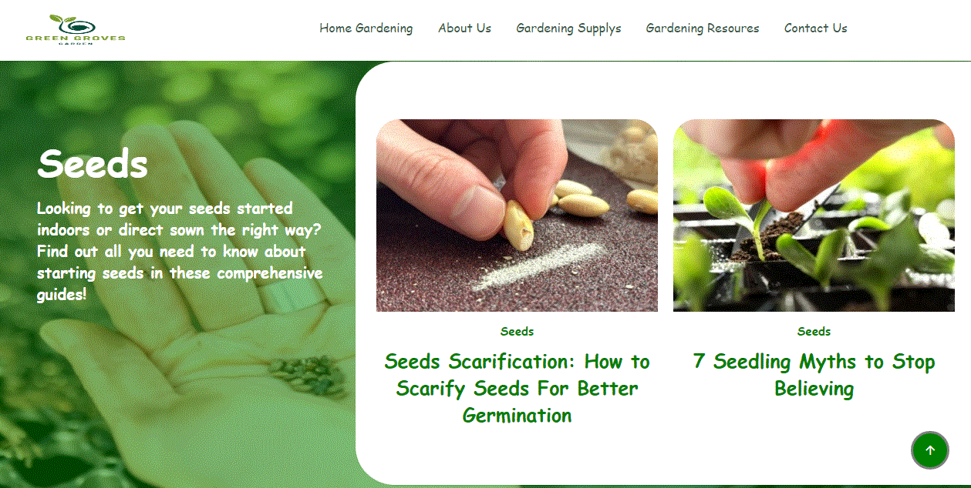

***Gardening Accessories:***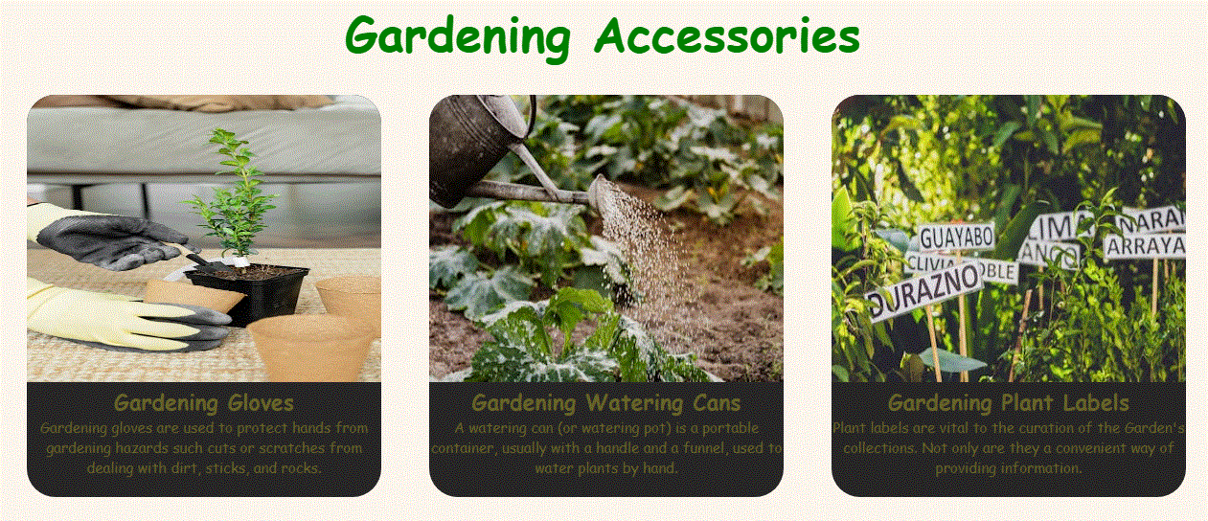

***Pots & Containers:***

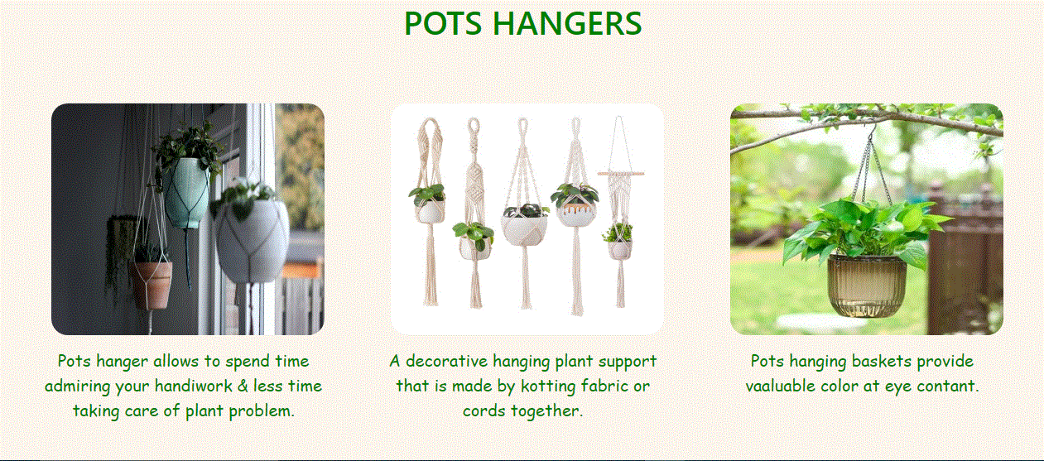

***About Us:***

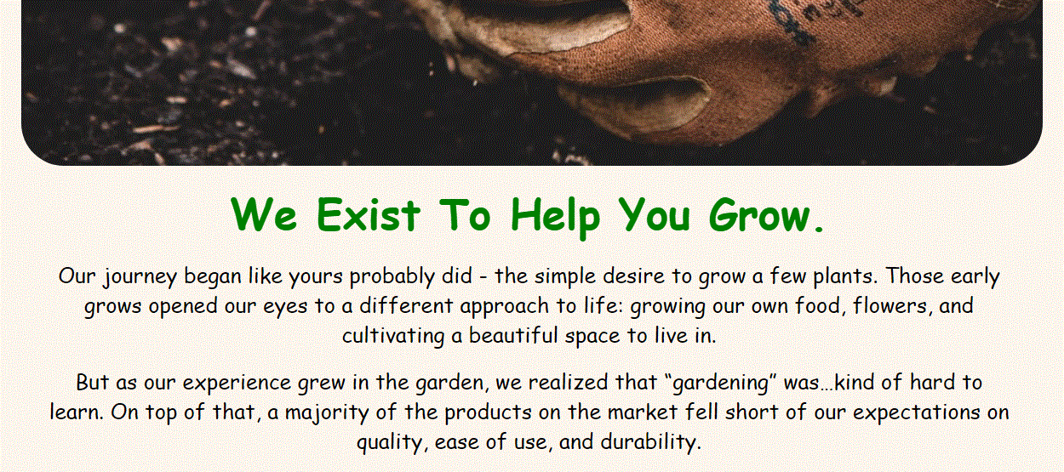

***About Us:***

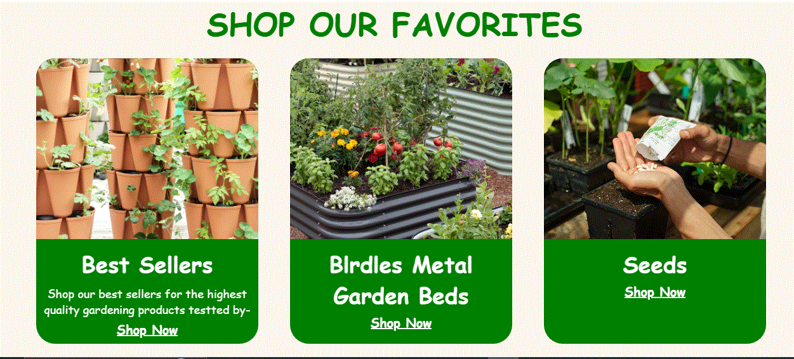

***Contact Us:***

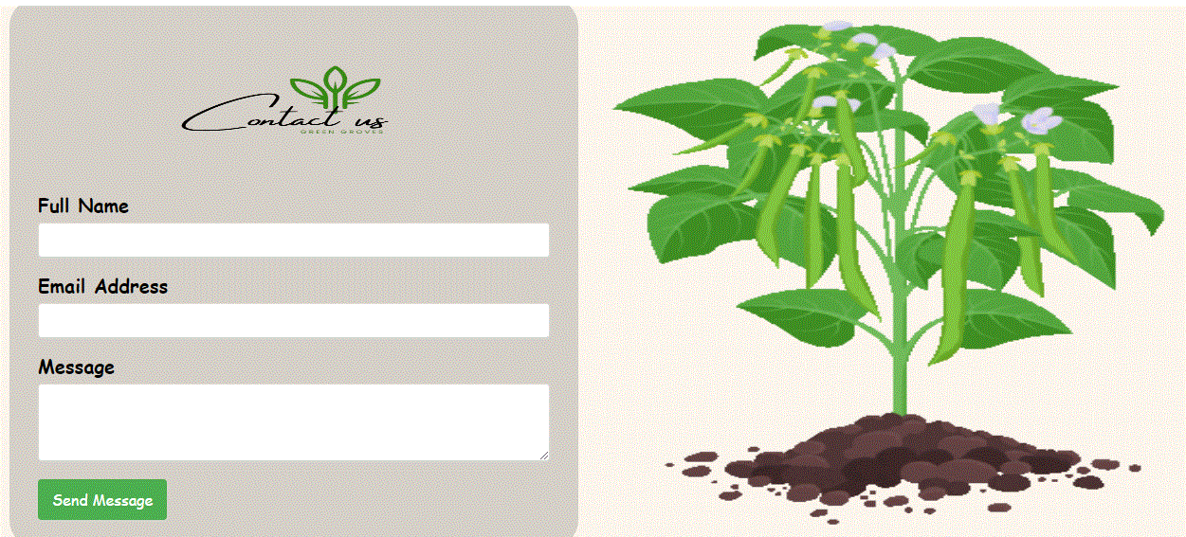

***Contact Us:***

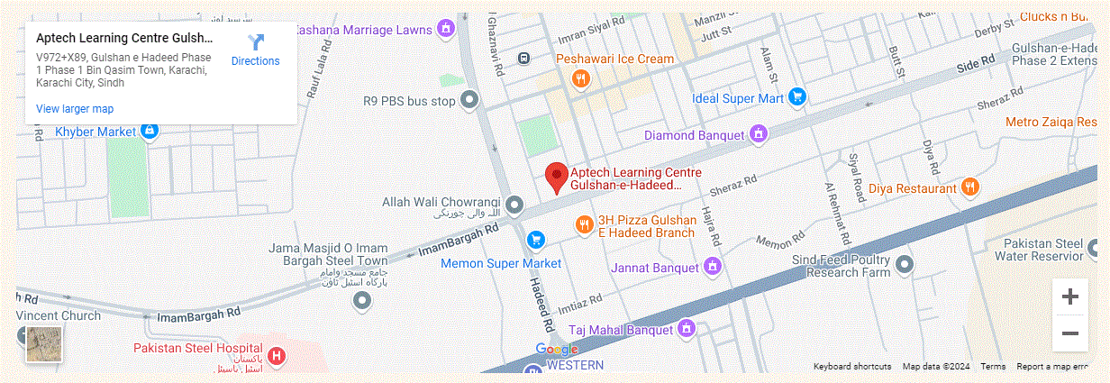

***Gardening Essentials:***

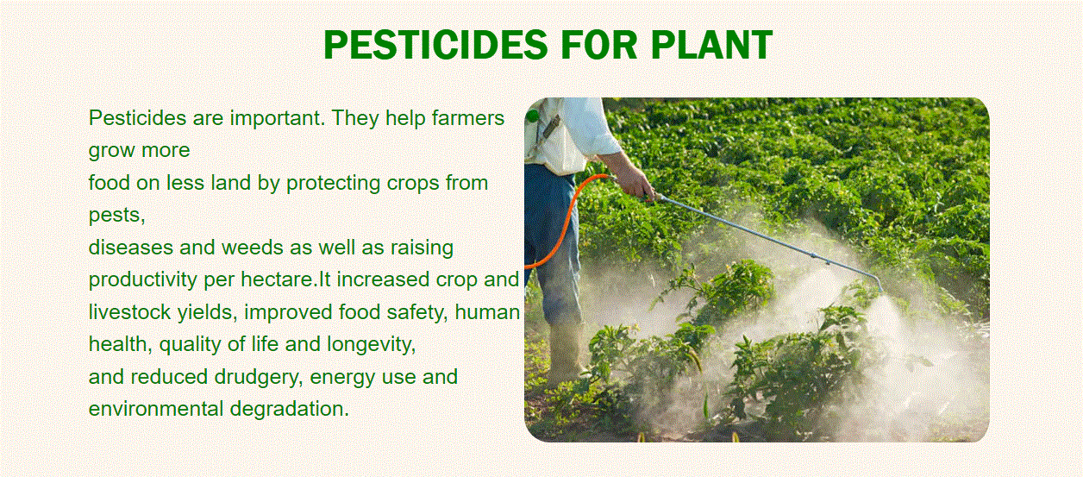

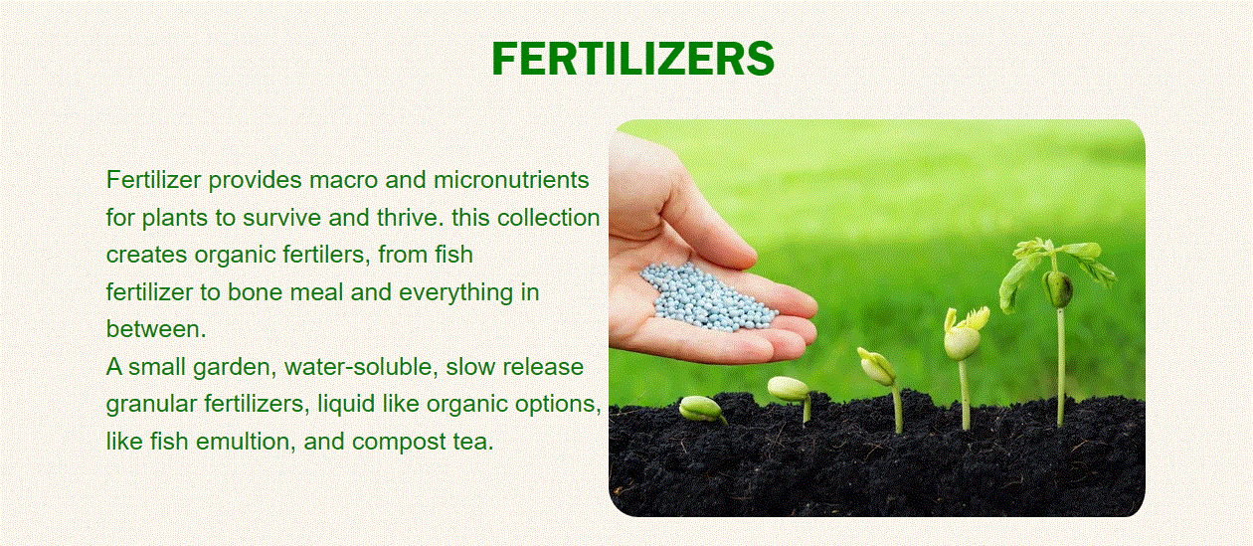

***Footer:***

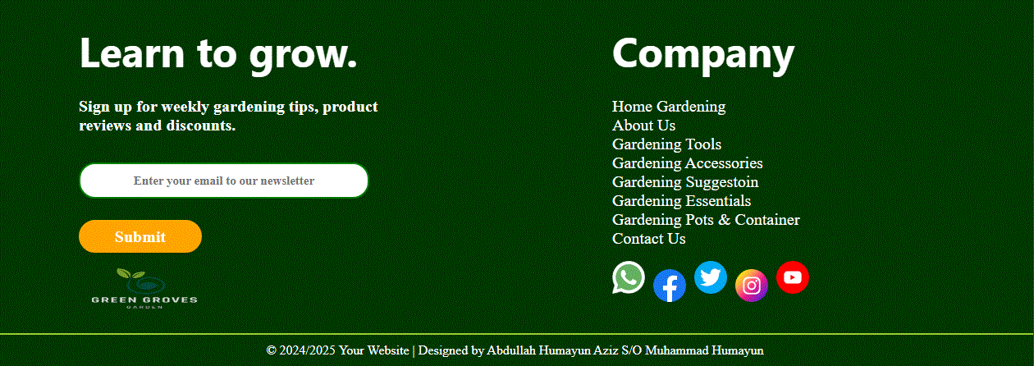

**WIRE FRAME**

1. **Main Layout**

**Navbar**

**Logo**

**Background Image**

Products

**Image**

**Image**

**Content**

**Image**

**Image**

**Image**

**Image**

**Image**

**Image**

**Image**

**Image**

**Image**

**Image**

**Content Content**

**Background Image**

**Content**

**Footer**

**Image**

2.**About Us Page**

z

**Content**

Contact U

**Content**

**Content**

**Content**

**Image**

**Image**

**Image**

**Map**

**GIF Image**

**Form**

3.**Contact Us**

**Image**

**Image**

**Image**

**Image**

**Image**

**Image**

**Image**

**Image**

**Image**

4**.Gerdening Accessories**

## ­­Text Sheet Review

|  |  |  |  |
| --- | --- | --- | --- |
| **Serial Num** | **Names** | **Project Title** | **Task** |
| 1. | Mr. Abdullah Humayun Aziz | Green Groves | Logo, Navbar, Footer, Home Page, Gardening Accessories Page. |
| 2. | Mr. Adil Humayun Aziz | Green Groves | Contact Us Page, About Us Page. |
| 3. | Ms. Syeda Areej Fatima | Green Groves | Gardening Essentials Page, Gardening Pots & Containers Page. |
| 4. | Mr. Saqib Ali | Green Groves | Gardening Tools Page, Gardening Suggestion Page. |