PENETRATION TESTING REPORT
FOOTPRINTING & NETWORK SCANNING PHASES
W2-PM-FINAL | CYBERSECURITY | NETWORKWALKS

Pentester Name | Abdullah Husnain
Program/Batch | B084-Networkwalks
Date | 11 November 2026
Modules completed | W2-PM1 (Multiple Kali Tools)  W2-PM2(GHDB)  W2-PM5 (nmap Scanning)
Client/Target | - Networkwalks (secured written permission already)  - Google Hacking Database  - My own local LAN Network
Permission secured from client? | Yes
Phases covered | Phase 1: Reconnaissance & Footprinting  Phase 2: Scanning & Network Discovery  Phase 3-5: In Progress

Liability Disclaimer
All activities demonstrated in this material have been conducted exclusively on systems and devices that I personally own or for which I have obtained explicit written authorization.This content is intended strictly for educational, training, and research purposes. It must not be used for any illegal, unauthorized, or harmful activities.The instructor, authors, and Networkwalks accept no responsibility for any misuse of the information provided. I am solely responsible for my actions and their consequences.
.

Introduction
This report covers footprinting the networkwalks.com domain using multiple Kali Linux tools, including the Google Hacking Database (GHDB) ,and scanning my own local network using nmap (W2-PM5).The footprinting module focuses on gathering publicly available information about the target domain through various reconnaissance techniques, including GHDB searches to identify potentially exposed information indexed by search engines. The scanning module focuses on discovering live hosts and identifying network services within my own local network. Together, these modules demonstrate the different stages of network reconnaissance, from collecting publicly available information to mapping active hosts and services within an authorized network environment. This report represents Week 2 of my ongoing internship program at Networkwalks.

Tools Used
The table below lists each tool used in this report and its purpose.
Tool | Purpose
Kali Linux & Windows | Operating systems used for reconnaissance activities
WHOIS | Find domain registration details (owner, dates, name servers).
whatweb | Fingerprint web technologies (server, CMS, plugins, IP).
nslookup | Resolve the domain name to its IP address using DNS.
curl -I | Read the HTTP response headers of the website.
wafw00f | Detect whether a Web Application Firewall protects the site.
dnsrecon | Enumerate all DNS records (NS, MX, SPF, TXT, SRV).
Google Hacking Database | Find publicly indexed information and potentially exposed files or directories using advanced Google search operators.
nmap (Nmap GUI) | Scan the local subnet to find live hosts, IPs and MAC addresses.
Windows CMD | Local IP and MAC address identification

Activities Performed

4.1 Footprinting & Reconnaissance

I performed reconnaissance against the networkwalks.com domain using six Kali Linux tools: WHOIS, WhatWeb, Nslookup, Curl, Wafw00f and DNSRecon. Each tool was used to collect a different type of information about the target.
First, I used WHOIS to obtain publicly available domain registration information and identify the domain’s name servers. The results provided information about the domain registration and hosting infrastructure.
After used WhatWeb to identify technologies used by the website. The results identified WordPress 7.0.4 and WP Download Manager 3.3.58, along with other information exposed by the website.
Then Nslookup, I resolved the domain name to its IP address. The provided result identified 192.232.216.135.
I used Curl with the -I option to inspect the HTTP response headers. This provided additional information about the web application and exposed the WordPress REST API endpoint /wp-json/.
Next, I used Wafw00f to determine whether a Web Application Firewall was protecting the website. The result identified ModSecurity (SpiderLabs).
Finally, I used DNSRecon to enumerate DNS records. The results provided information relating to name servers, mail servers, SPF/TXT records, service records and DNS software information.

Google Hacking Database
During this task, I used the Google Hacking Database (GHDB) to research webcam-related information indexed by Google. The objective was to understand how publicly accessible webcam interfaces or exposed camera-related pages can appear in search engine results. This exercise helped me learn how Google search operators can be used during the footprinting phase to identify potential information exposure and understand the importance of securing webcam devices with proper authentication and access controls.

Network Scanning with nmap
For the third activity, I used nmap to perform network discovery on my local network. The practical required me to identify my local IP address and subnet, discover live hosts, identify their IP and MAC addresses, and generate a network topology.
I first used the Windows ipconfig command to identify my local IP address and LAN subnet. I then entered the subnet into nmap and selected Ping Scan to identify active hosts.
The example results provided in the practical identified four live hosts:
- 192.168.100.1
- 192.168.100.41

After completing the scan, I opened the Topology section in nmap, enabled the legend and saved the network topology in PDF format as required by the practical task.

Risk Analysis / Impact
Based on the information collected during the footprinting and network scanning activities, I identified the following potential risks.
# | Risk / Finding | Evidence / Observation | Potential Impact | Risk Level
1 | Web technology information exposed | WhatWeb identified WordPress and WP Download Manager | Attackers may use exposed technology/version information to identify software requiring further security review | Medium
2 | Server IP address identifiable | Nslookup resolved the domain to 192.232.216.135 | Provides information about the network location of the web service | Low
3 | HTTP technical information exposed | Curl returned HTTP response headers and exposed /wp-json/ | May assist technology fingerprinting and further enumeration | Low
4 | WAF technology identifiable | Wafw00f identified ModSecurity (SpiderLabs) | Reveals information about the web application’s security architecture | Low
5 | DNS infrastructure information exposed | DNSRecon identified DNS, mail and service-related records | DNS information can help build a broader infrastructure profile | Medium
6 | Multiple live hosts visible on local network | nmap identified four live hosts in the example network | Unknown or unauthorized devices may potentially be present on a network | Medium

Recommendations
Based on the findings of the footprinting and network scanning activities, the following recommendations are suggested to improve security:
1. Update Website Technologies: Keep WordPress, WP Download Manager, themes, and plugins updated to their latest secure versions.
2. Protect Server Information: Avoid exposing unnecessary server and technical information publicly.
3. Secure HTTP Headers: Configure proper HTTP security headers to improve website protection.
4. Strengthen WAF Security: Keep ModSecurity properly configured and updated to help protect against common web attacks.
5. Secure DNS Records: Regularly review DNS records and remove outdated or unnecessary entries.
6. Monitor Local Network Devices: Regularly scan the local network using nmap and ensure that only authorized devices are connected.
7. Secure Webcam Access: Use strong passwords, enable authentication, update webcam firmware, and ensure camera interfaces are not publicly accessible without proper authorization.

Conclusion
This Week 2 internship task helped me understand the basics of network footprinting and scanning. I used different Kali Linux tools to gather publicly available information about the networkwalks.com domain. I also used GHDB to explore webcam-related information indexed by Google. With nmap, I successfully identified live devices on my own local network. These activities improved my understanding of DNS records, website technologies, server information, and network discovery. Overall, this practical work enhanced my cybersecurity and ethical hacking skills and taught me the importance of performing security testing with proper authorization.

Evidences Collected

1.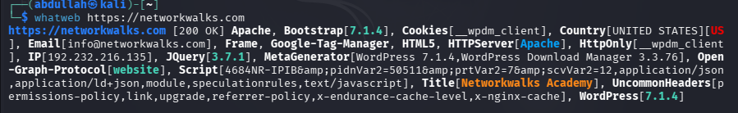

2.
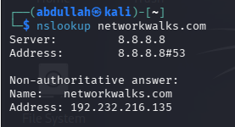

3.
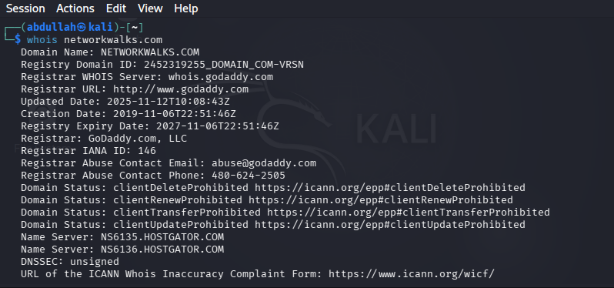

4.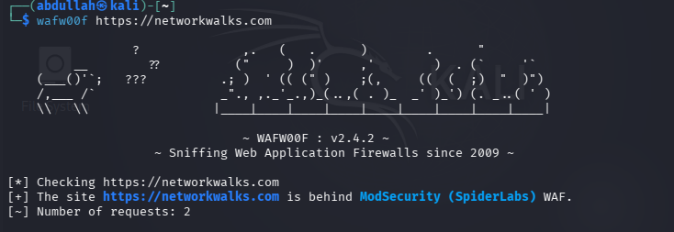

5.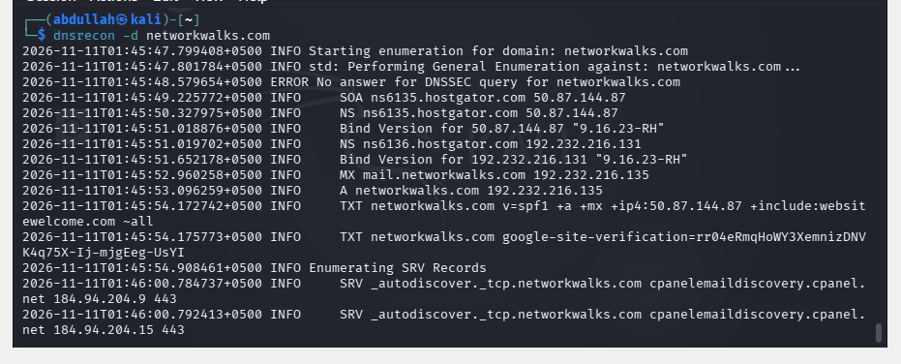6.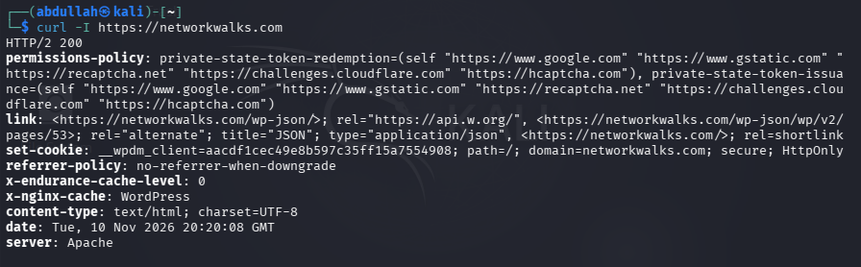

7.
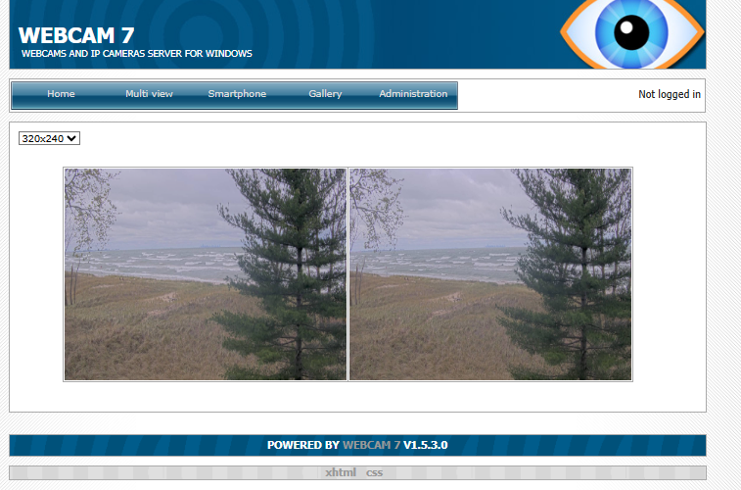

8.
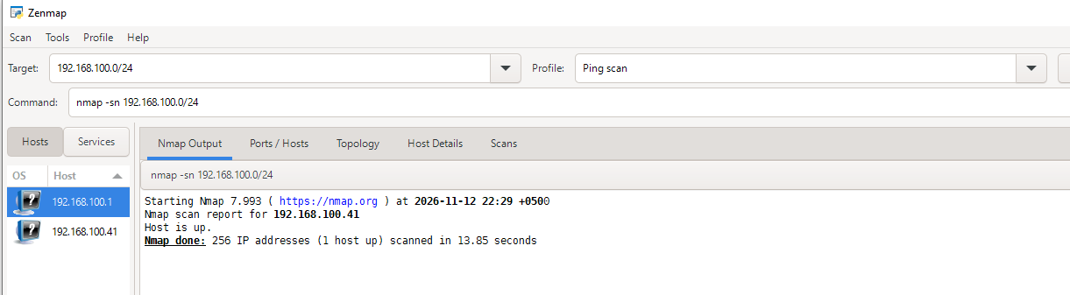
9.
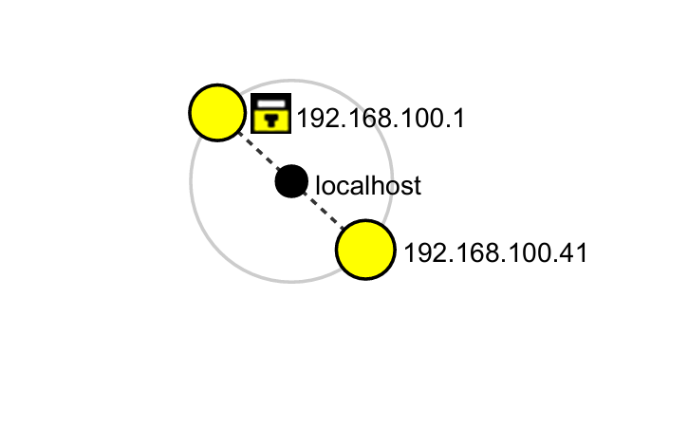

Author
Abdullah Husnain
Cybersecurity Professional B084
LinkedIn: https://www.linkedin.com/feed/update/urn:li:activity:7526723341999759360/

Project Information
Program Name: Cybersecurity program at Networkwalks | Week: 02 | Repository:
GitHub: https://github.com/abdullahhusnain/W2/tree/main

