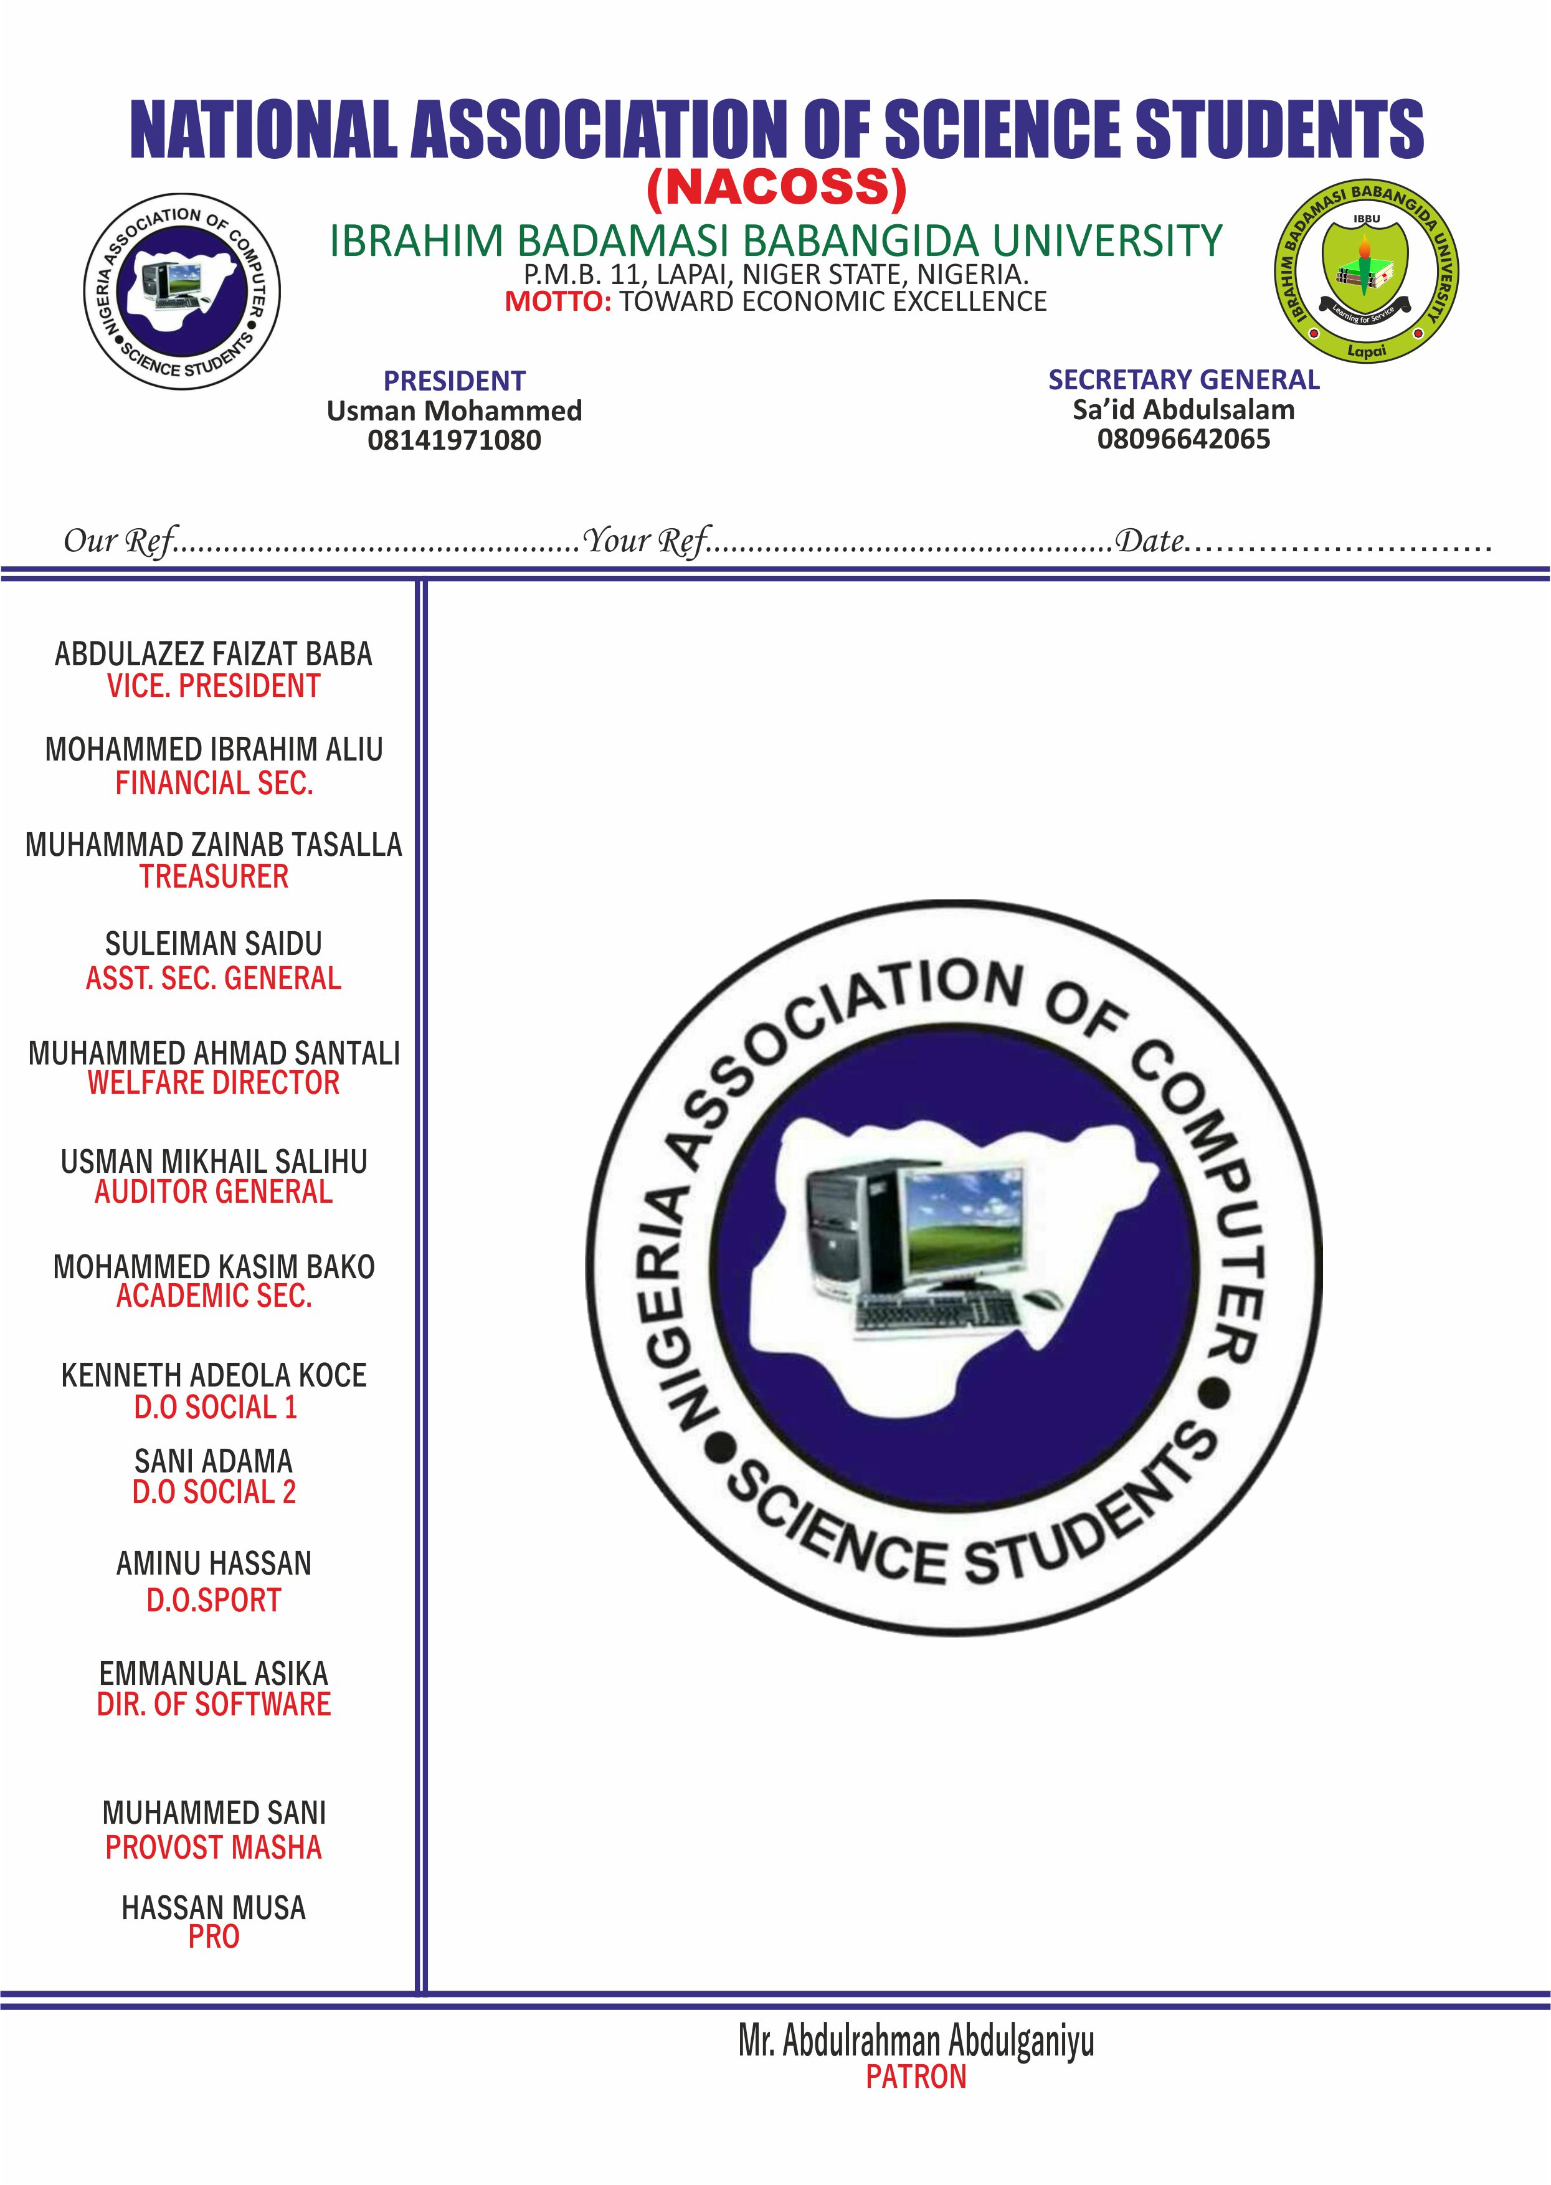

NATIONAL ASSOCIATION OF COMPUTER SCIENCE STUDENTS

The Manager,

Micro Finance Bank,

IBBU,

LAPAI NIGER STATE.

Dear Sir,

**REQUEST FOR WITHDRAWAL**

We hereby write to withdraw a sum of Fifty Two Thousand Naira (N52,000) from the Association Account(NACOSS) with account number 1100005388.

Yours Truly

NACOSS PATRON