BIT3208: Advanced Web Design and Development
Logbook Report
Student Name: Abdullahi Mohammed Mahid.
Admission Number: BSCCS/2024/38409
Course/Class:
Unit Code: BIT3208
Unit Name: Advanced Web Design and Development
Lecturer Name:
Semester/Year: Sem II ,Year IV

Project Title: Smart E-Commerce Web Application
Technologies: PHP + MySQL, HTML5, CSS3, JavaScript, Bootstrap
GitHub Repository: https://github.com/abdullahimahid95/BIT3208-Ecommerce-Project

Table of Contents

Week 1: Local Environment Setup
Title: Installation and Testing of Local Development Environment
Fig 1: XAMPP Installation Success
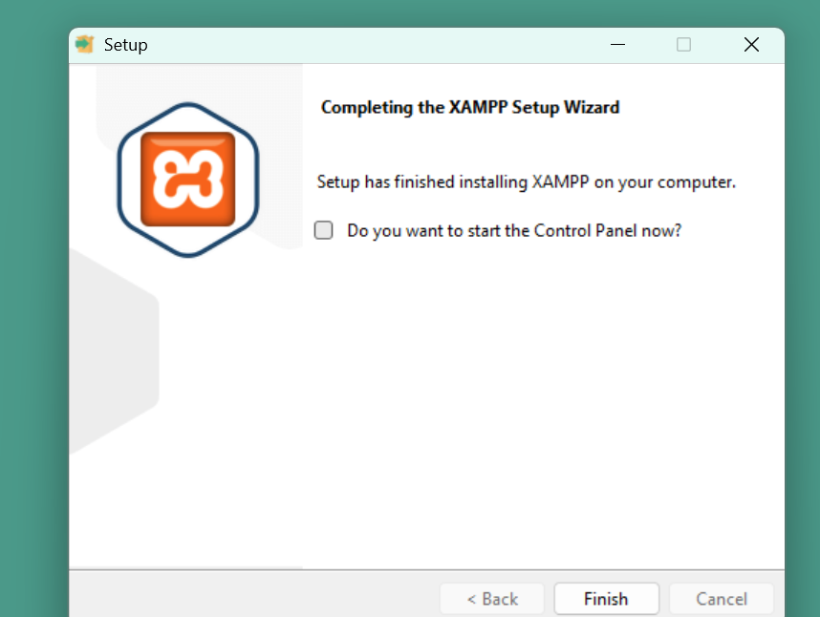
Fig 1: XAMPP installation wizard showing successful setup .

Fig 2: Apache and MySQL Running
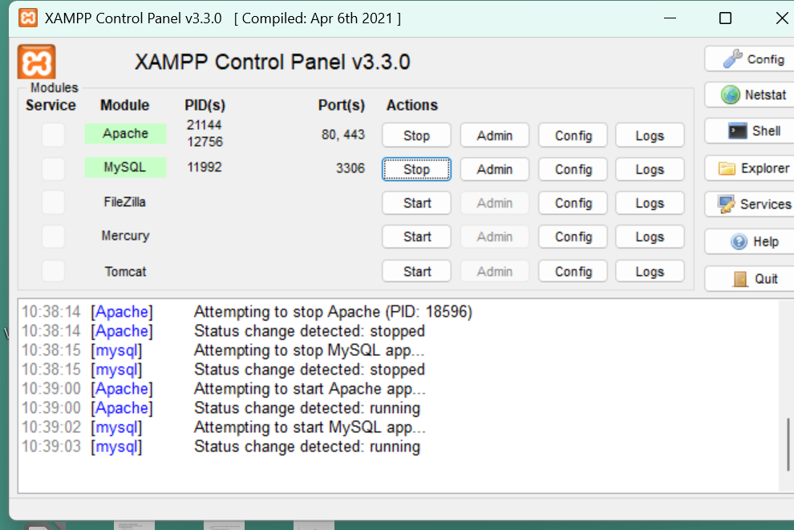
Fig 2: XAMPP Control Panel showing Apache and MySQL running successfully.

Fig 3: Localhost Test Page
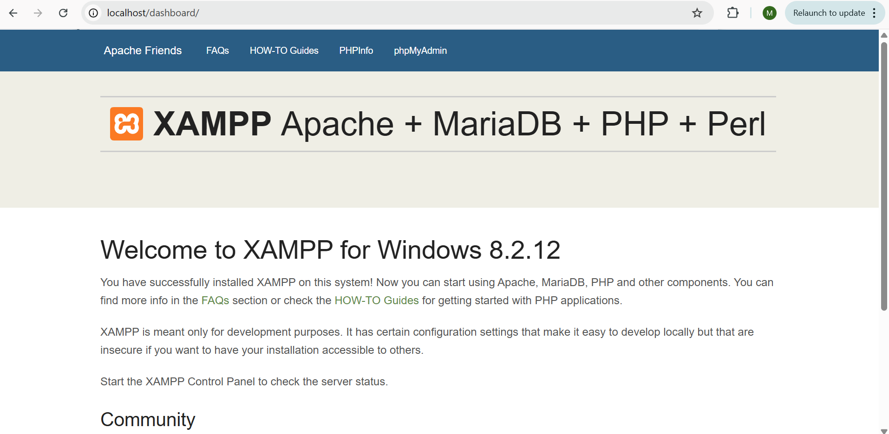
Fig 3: Browser displaying the XAMPP localhost welcome page confirming server is active.
Fig 4: Hello World Test Page
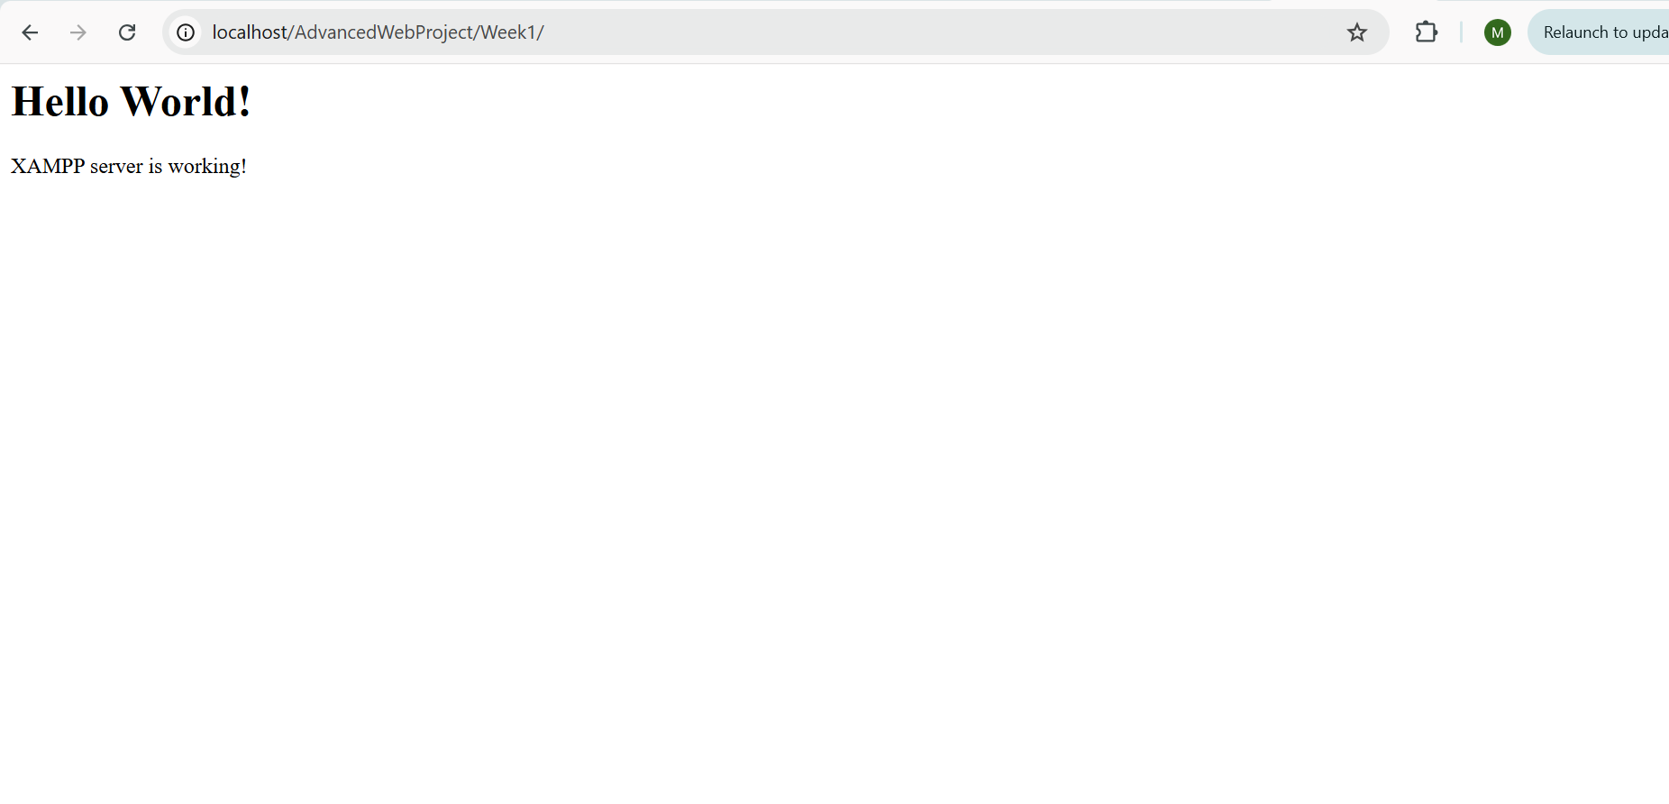
Fig 4: Browser displaying Hello World output from index.php confirming PHP is working.

Fig 5: Database Connection Test
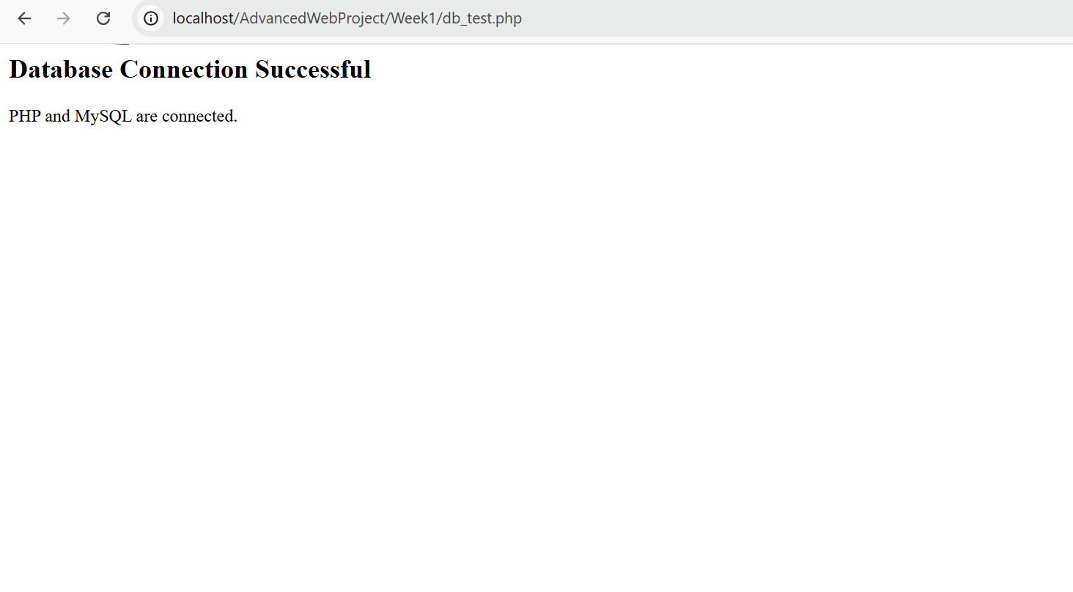
Fig 5: Browser displaying successful database connection message using mysqli_connect() in PHP.
Reflection: This week I installed XAMPP and configured Apache and MySQL services on my local machine. I tested the local server by accessing localhost on my browser and confirmed it was running correctly then I also created a basic PHP Hello World page to verify server-side scripting was functional. Finally I tested database connectivity using mysqli_connect() which confirmed PHP and MySQL were properly linked. The main challenge was a UAC installation warning which was solved by installing XAMPP directly to C:\xampp instead of Program Files.
Week 2 : Wireframes and UI Design
Title: Designing the Blackline Supply E-Commerce Interface .

Fig 1: Hand-Drawn Wireframe
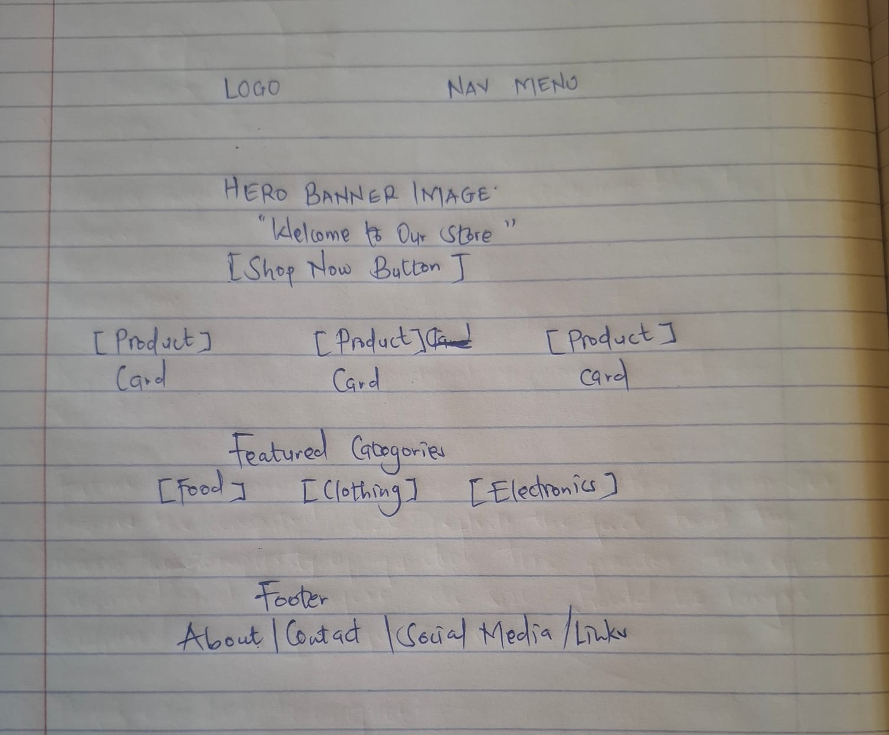
Fig 1: Hand-drawn wireframe showing the initial layout plan for the Blackline Supply homepage.

Fig 2: Desktop Mockup
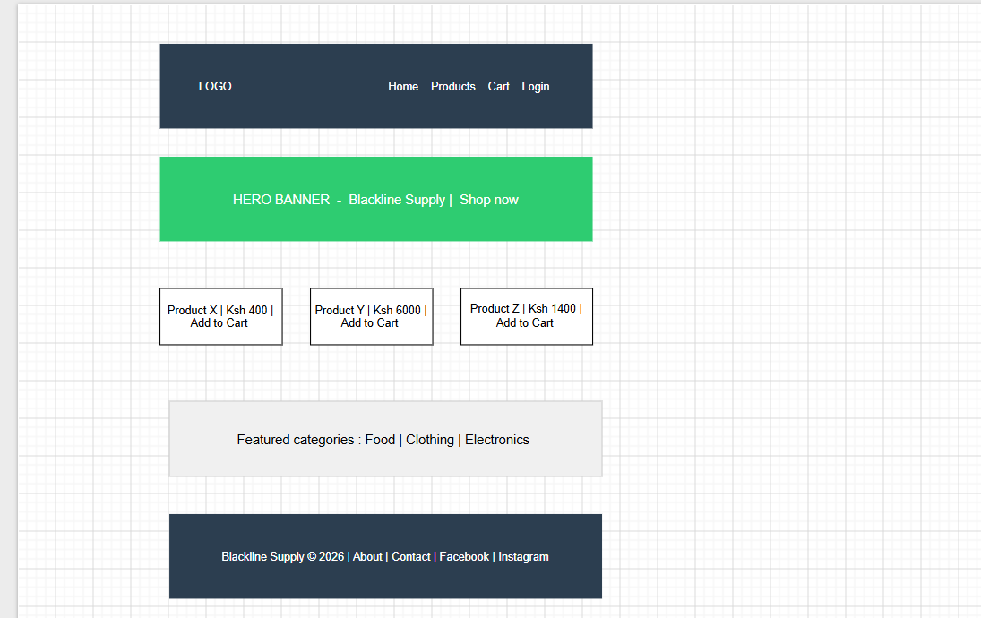
Fig 2: Draw.io desktop mockup showing the homepage layout of Blackline Supply at 1440x1024 resolution.

Fig 3: Mobile Mockup
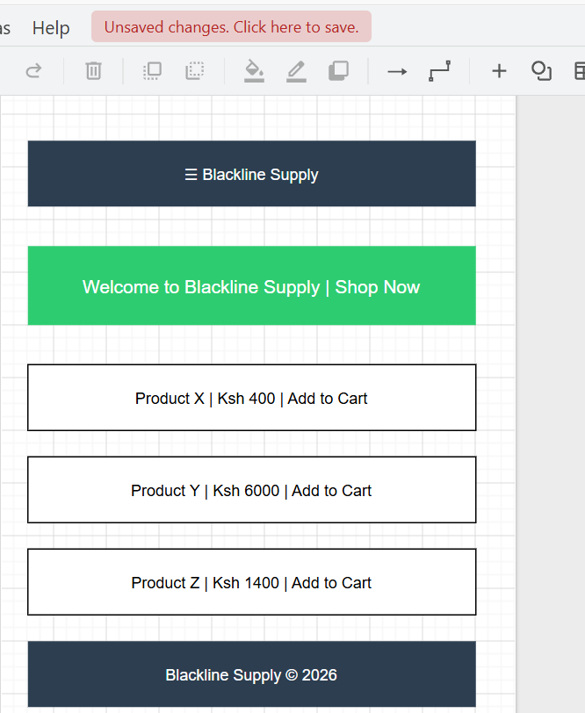
Fig 3: Draw.io mobile mockup showing the responsive layout of Blackline Supply at 390x844 resolution.

Fig 4: Color Scheme
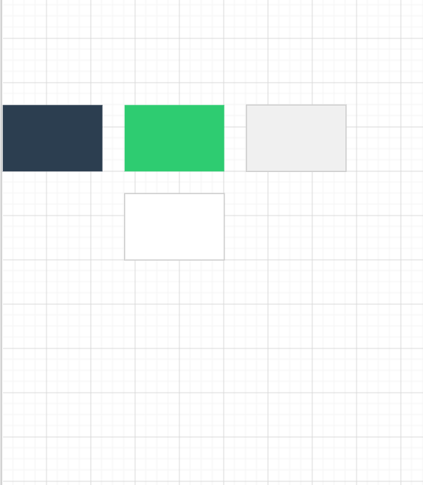
Fig 4: The colour palette for Blackline Supply showing primary, secondary, accent and background colours.

Fig 5: Navigation Structure
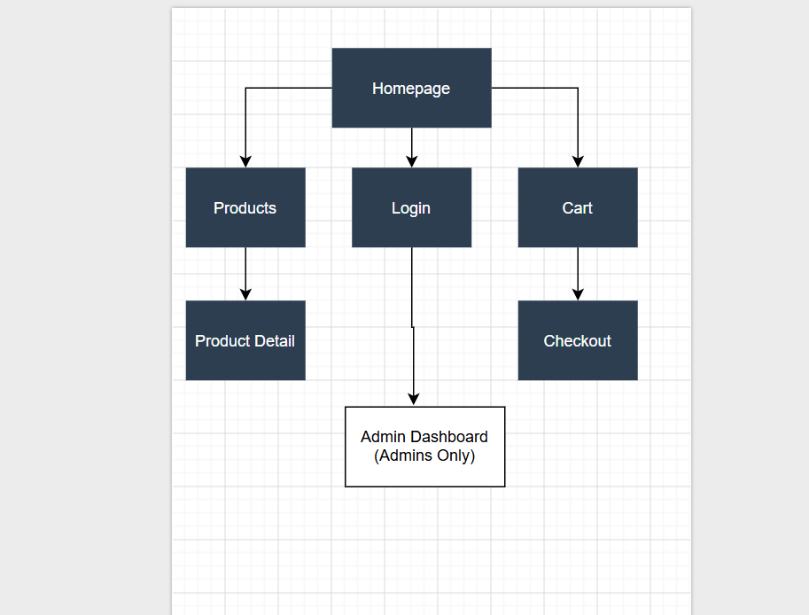
Fig 5: Flowchart showing the navigation structure and page connections of the Blackline Supply .

Reflection: This week I designed the visual layout of the Blackline supply ecommerce platform . This helped me get a clearer picture of what the frontend structure would look like before beginning coding . I began with a handrawn wireframe to plan the homepage layout then moving to the desktop and mobile mockups using draw.io . I also designed the colour palette for the web application and finally the flowchart showing the navigation structure through also using draw.io .
Week 3: Javascript and PHP basics
Title :Implementing client-side validation and and testing server side scripting.
Fig 1: Registration form
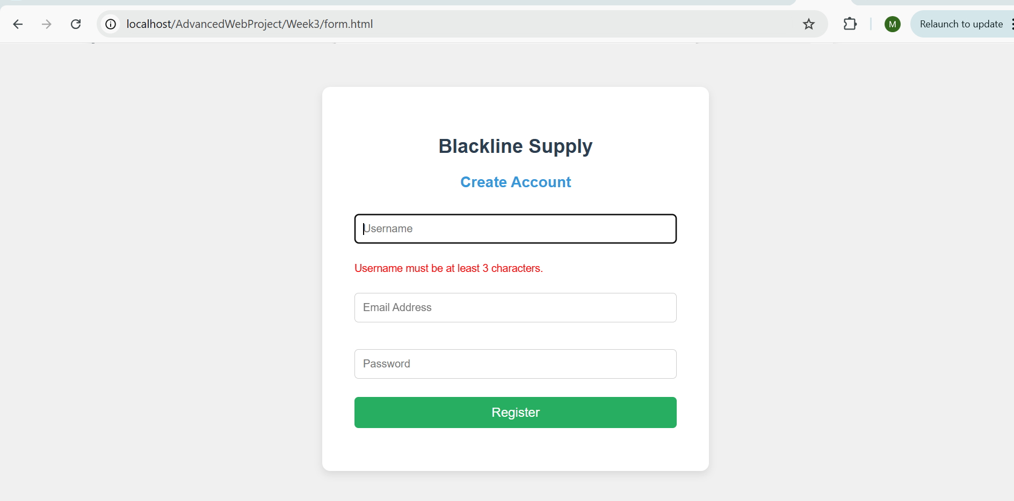
Fig 1 showing registration form for blackline supply with validation .
Fig 2: Password Strength checker
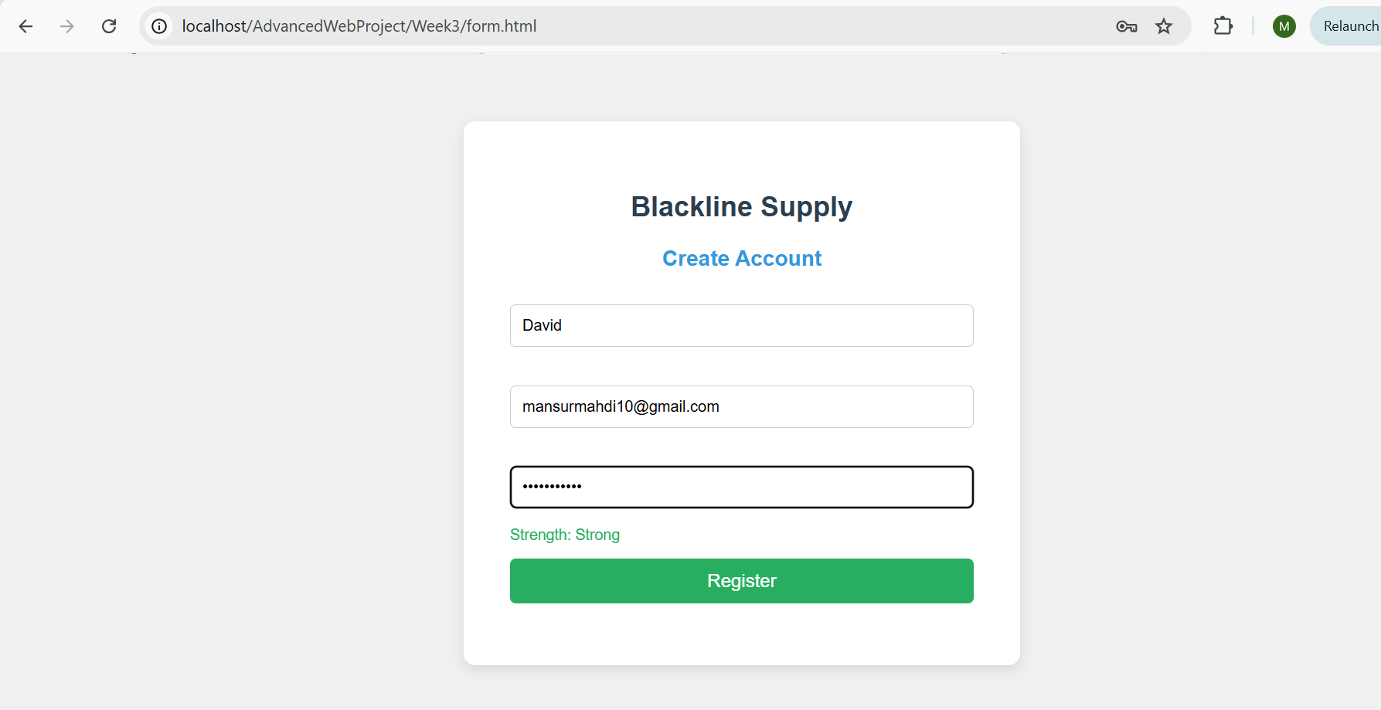
fig 2: showing password strength checker working
Fig 3:DOM manipulation demo
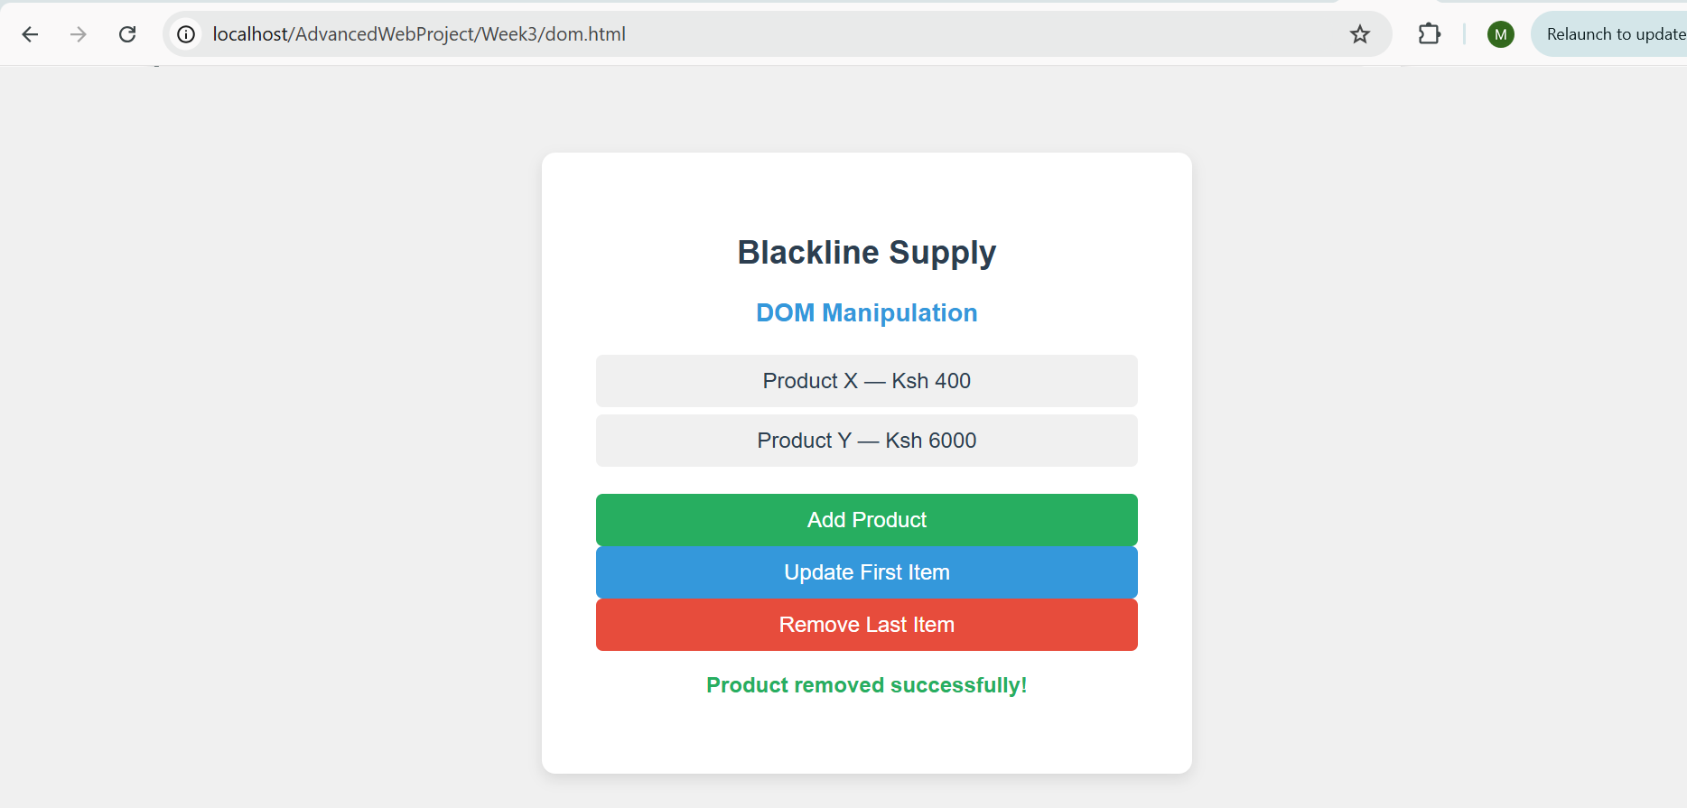
fig 3 showing dom manipulation and products can be added and removed .
Fig 4:PHP basics syntax page .
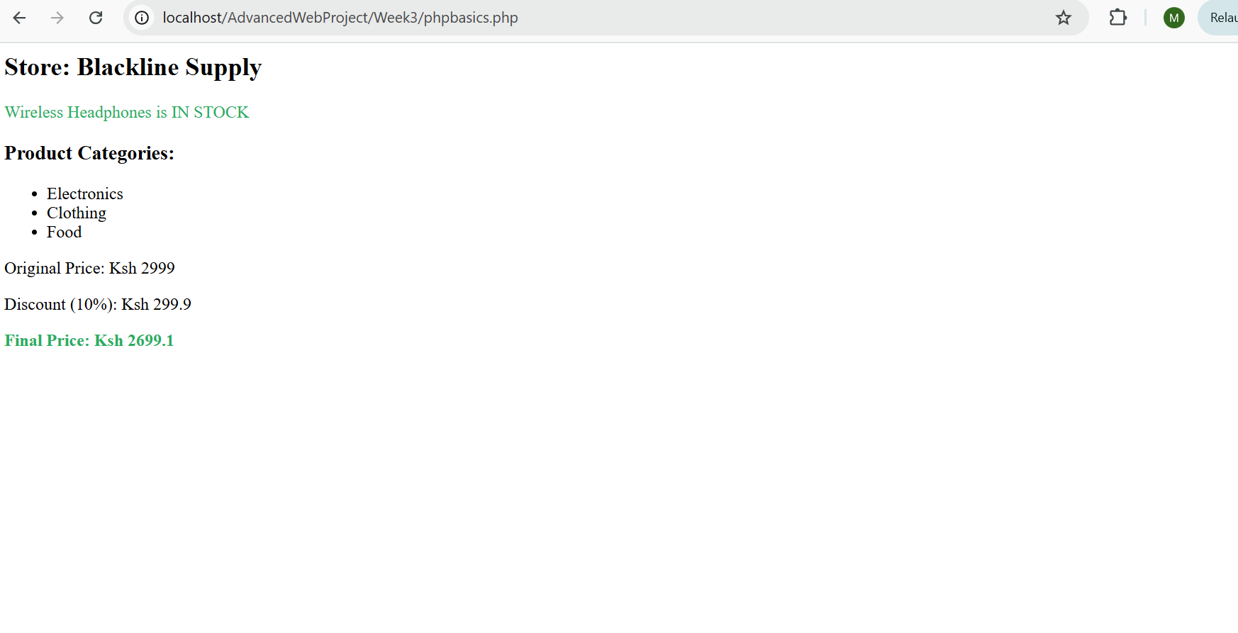
Fig 4 Php basics page showing variables , conditionals and arrays

Fig 5 : Improved Database connection
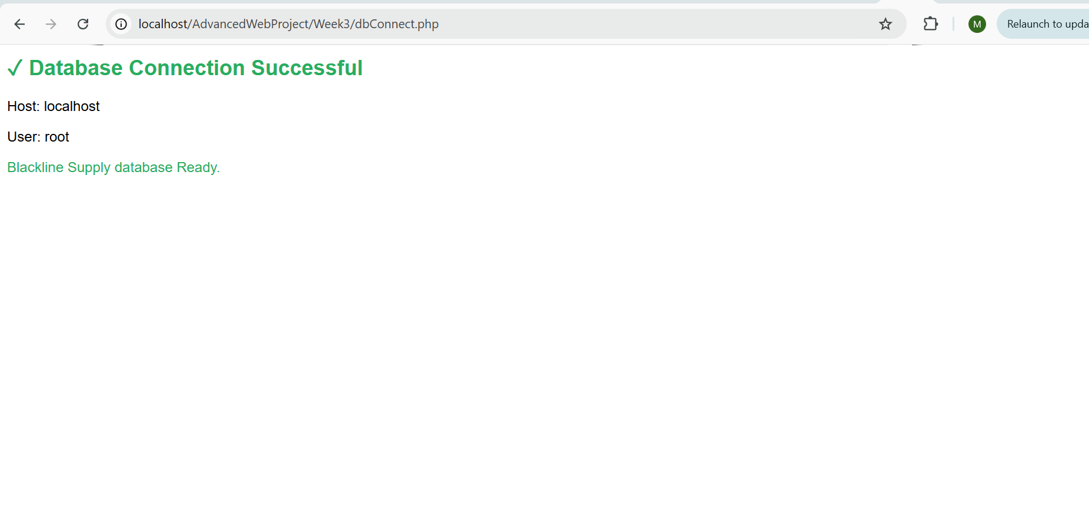
Fig 5 showing php database connection confirming succesful connection to the database.
Reflection - This week I implemented JavaScript form validation and a password strength checker for the Blackline Supply registration page. I also built a DOM manipulation demo showing how to dynamically add, update and remove elements and I alsotested PHP syntax using variables, conditionals, arrays and loops, and improved the database connection script with detailed output confirmation.
Week 4: Backend Development and Authentication
Fig 1: Login Form UI
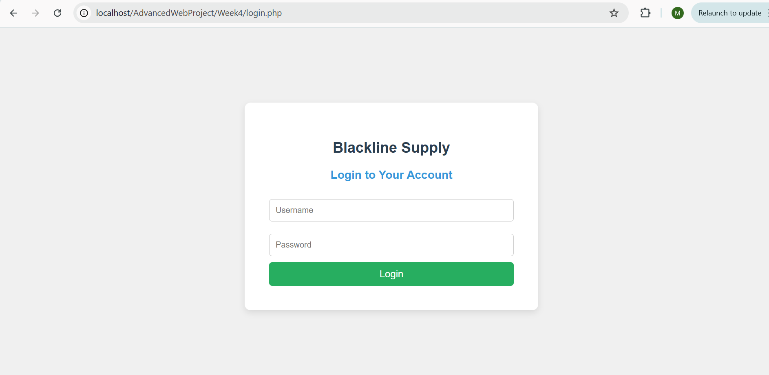
fig1:Blackline login form showing username and password fields.

Fig 2: Form Validation Error
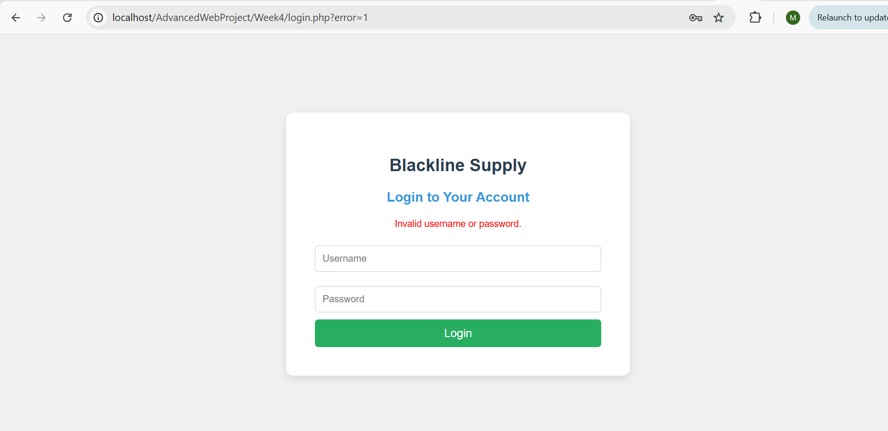
fig 2:login form showing error message after wrong credentials entered

Fig 3: PHP Form Processing Output
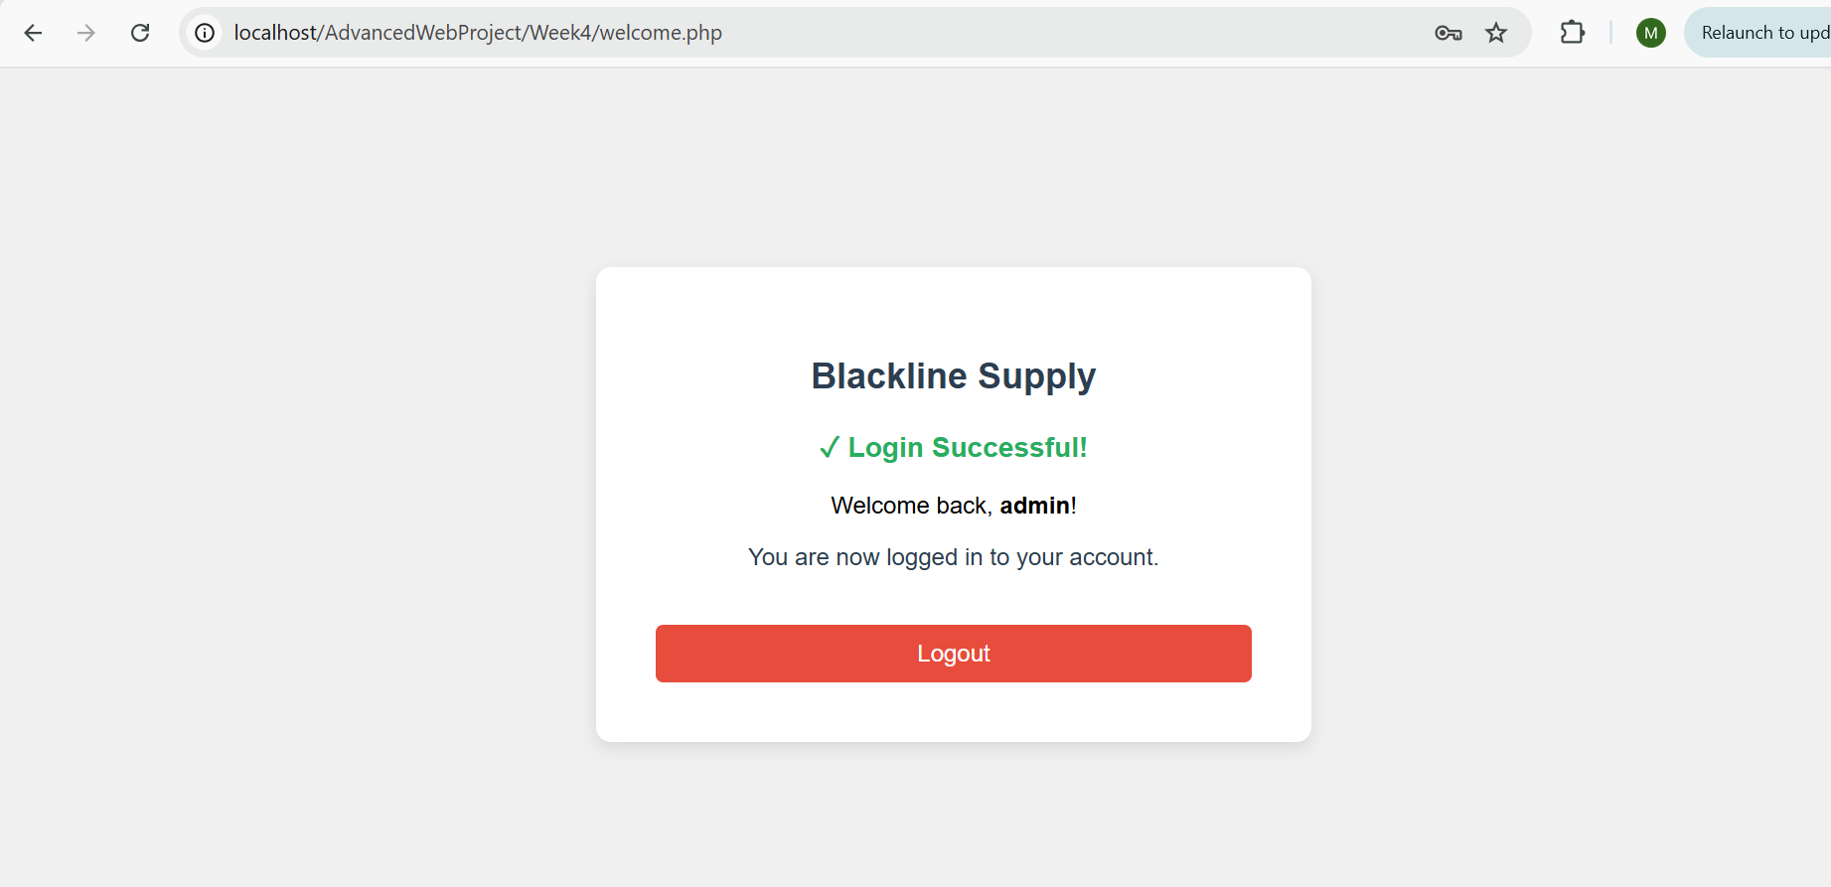
fig 3: Welcome page confirming successful PHP form processing after successful login.

Fig 4: Session Check Page
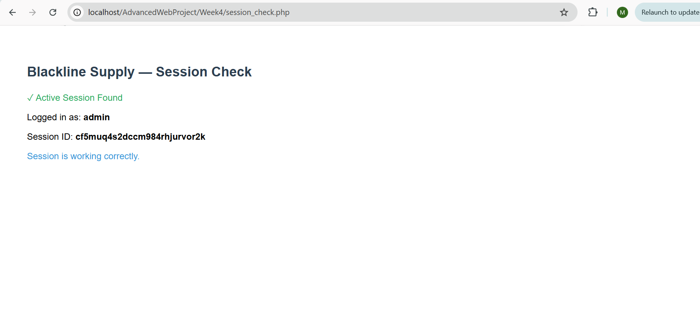
fig 4:Session check page showing the active session ID and logged in user confirming sessions are working correctly.

Fig 5: Professional Folder Structure
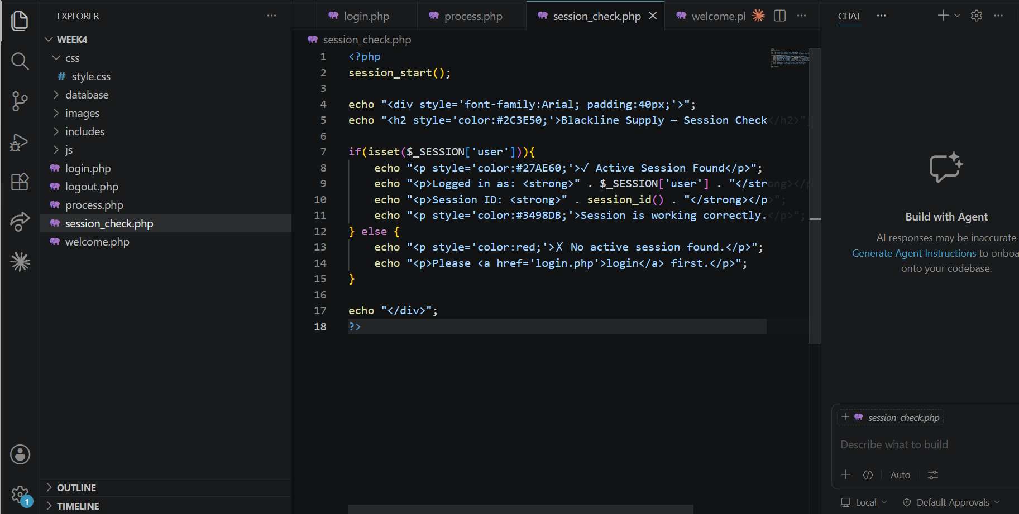
Fig 5: VS Code showing the professional folder structure of the Week 4 backend project.

Reflection: This week I built a session-based authentication system for Blackline Supply. I created a login form that submits credentials to a PHP processing page which validates input and creates a session on success. Invalid credentials redirect back with an error message while valid credentials grant access to a welcome page. I also implemented a logout system that ends the session and a session check page to verify active sessions. Files were organized using a professional folder structure separating CSS, JavaScript, images, database and includes.

