BIT3208: Advanced Web Design and Development
Logbook Report
Student Name: Abdullahi Mohammed Mahid.
Admission Number: BSCCS/2024/38409
Course/Class:
Unit Code: BIT3208
Unit Name: Advanced Web Design and Development
Lecturer Name:
Semester/Year: Sem II ,Year IV

Project Title: Smart E-Commerce Web Application
Technologies: PHP + MySQL, HTML5, CSS3, JavaScript, Bootstrap
GitHub Repository: https://github.com/abdullahimahid95/BIT3208-Ecommerce-Project

Table of Contents

Week 1: Local Environment Setup
Title: Installation and Testing of Local Development Environment
Fig 1: XAMPP Installation Success
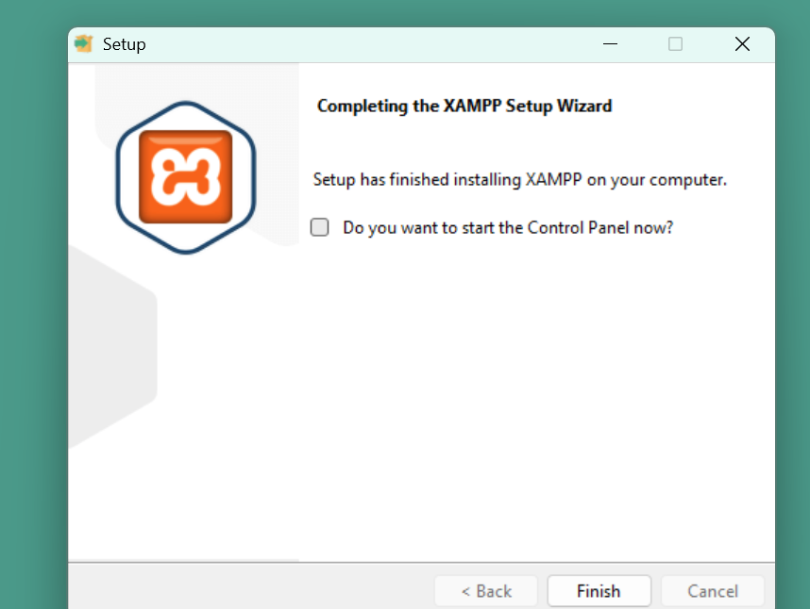
Fig 1: XAMPP installation wizard showing successful setup on Windows.

Fig 2: Apache and MySQL Running
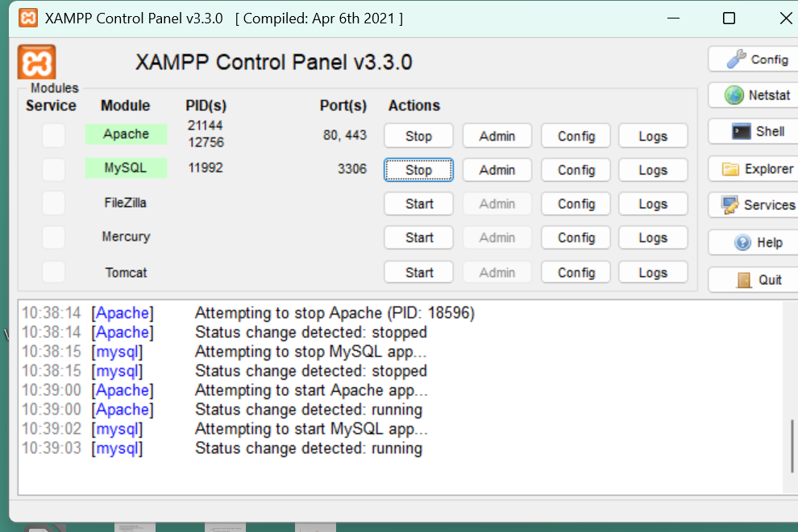
Fig 2: XAMPP Control Panel showing Apache and MySQL services running successfully.

Fig 3: Localhost Test Page
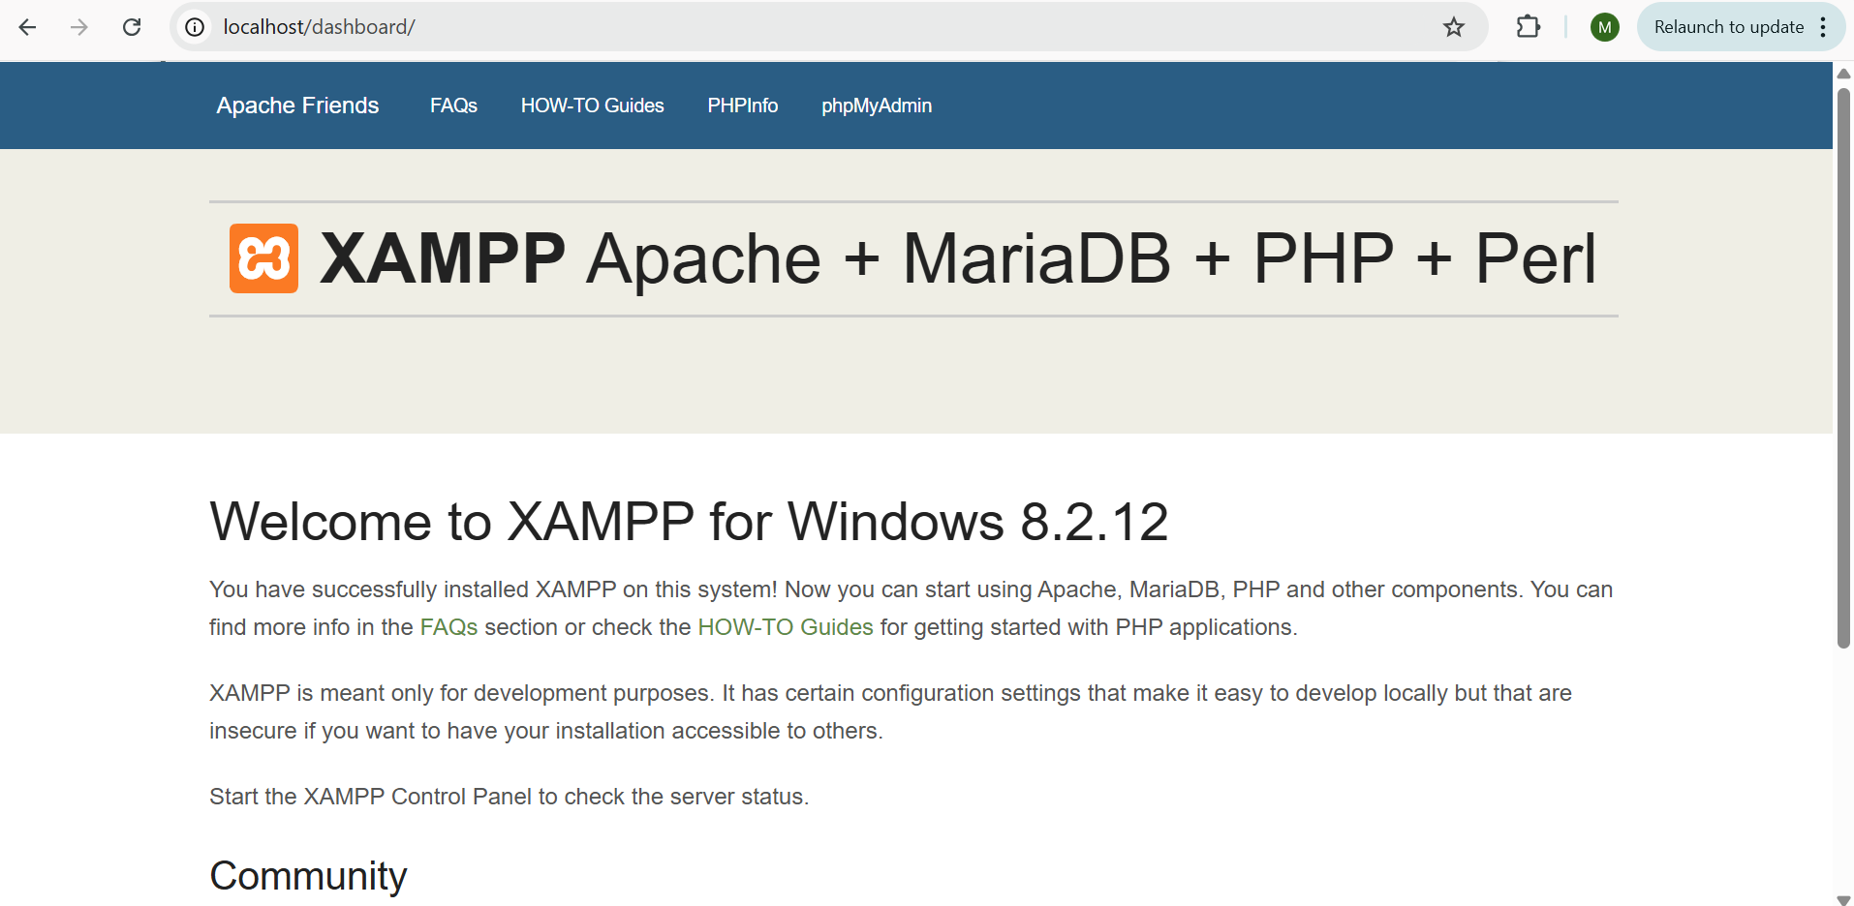
Fig 3: Browser displaying the XAMPP localhost welcome page confirming the server is active.
Fig 4: Hello World Test Page
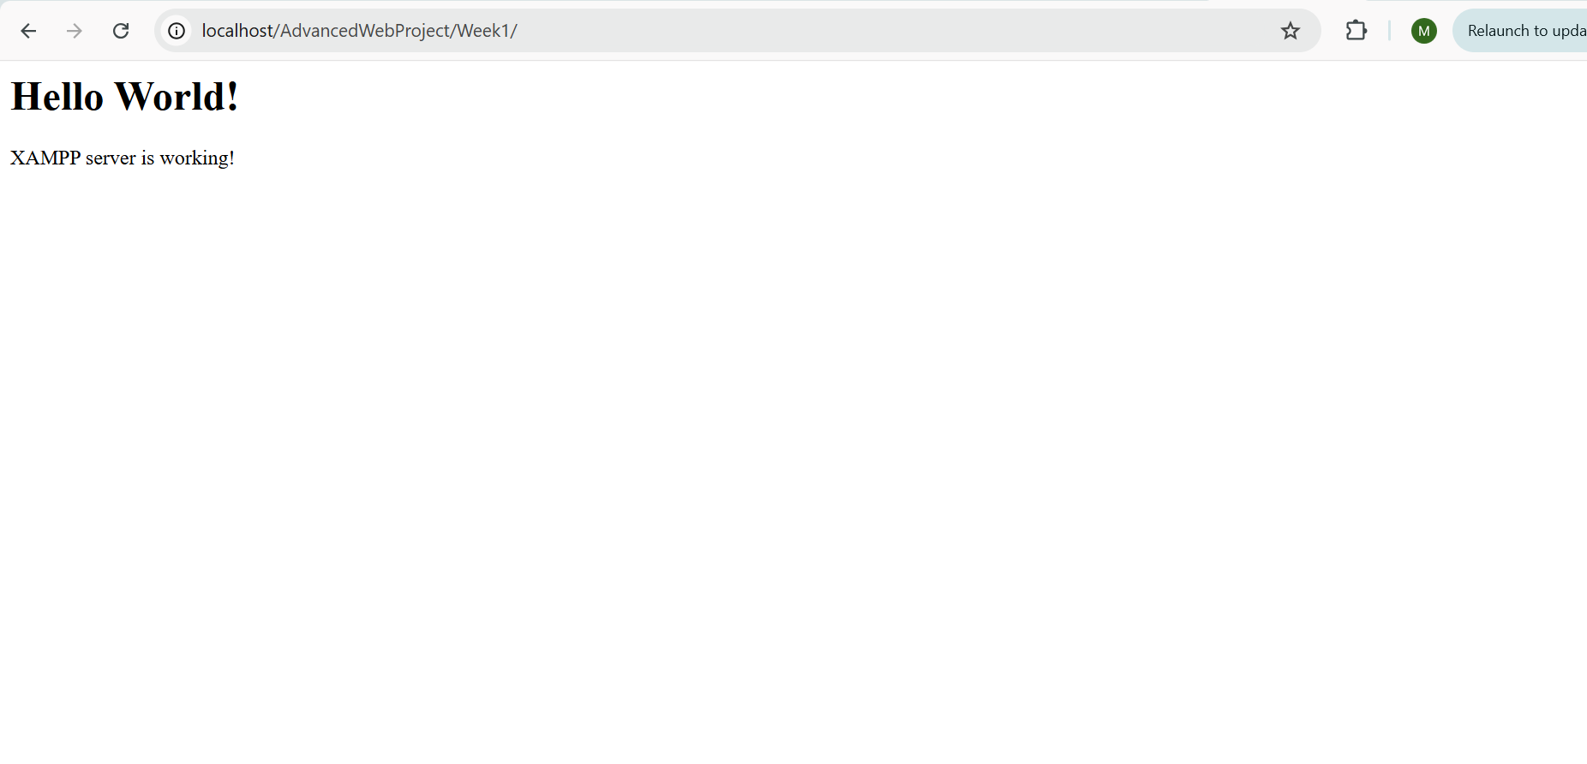
Fig 4: Browser displaying Hello World output from index.php confirming PHP is working.

Fig 5: Database Connection Test
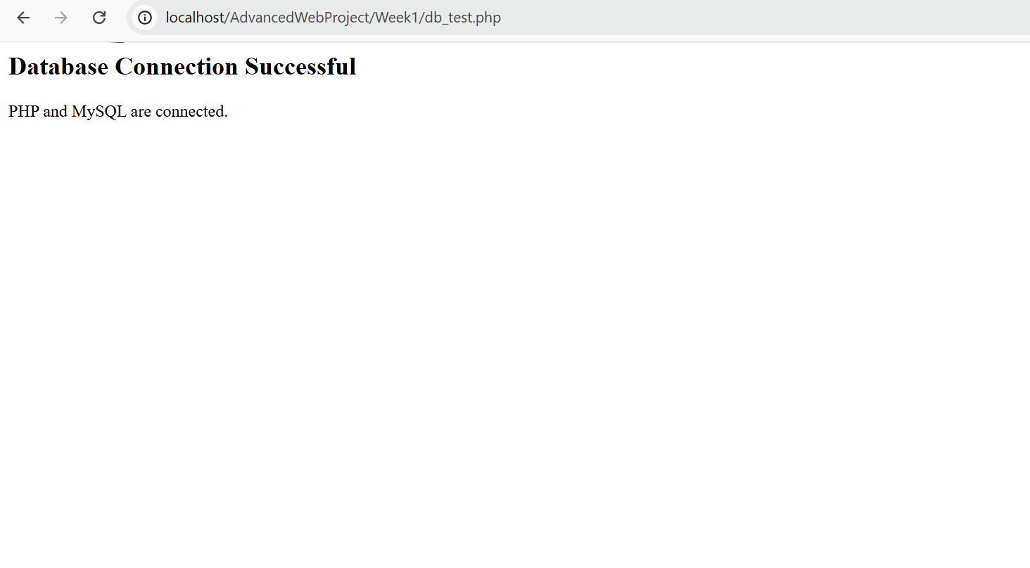
Fig 5: Browser displaying successful database connection message using mysqli_connect() in PHP.
Student Reflection: This week I installed XAMPP and configured Apache and MySQL services on my local machine. I tested the local server by accessing localhost on my browser and confirmed it was running correctly. I created a basic PHP Hello World page to verify server-side scripting was functional. Finally I tested database connectivity using mysqli_connect() which confirmed PHP and MySQL were properly linked. The main challenge was a UAC installation warning which was resolved by installing XAMPP directly to C:\xampp instead of Program Files.

