**21L-7512 Abdullah Dar BSCS-5G**

**Software Design and Analysis**

**Assignment no: 3**

**Question no: 1: Swim-lane activity diagram**

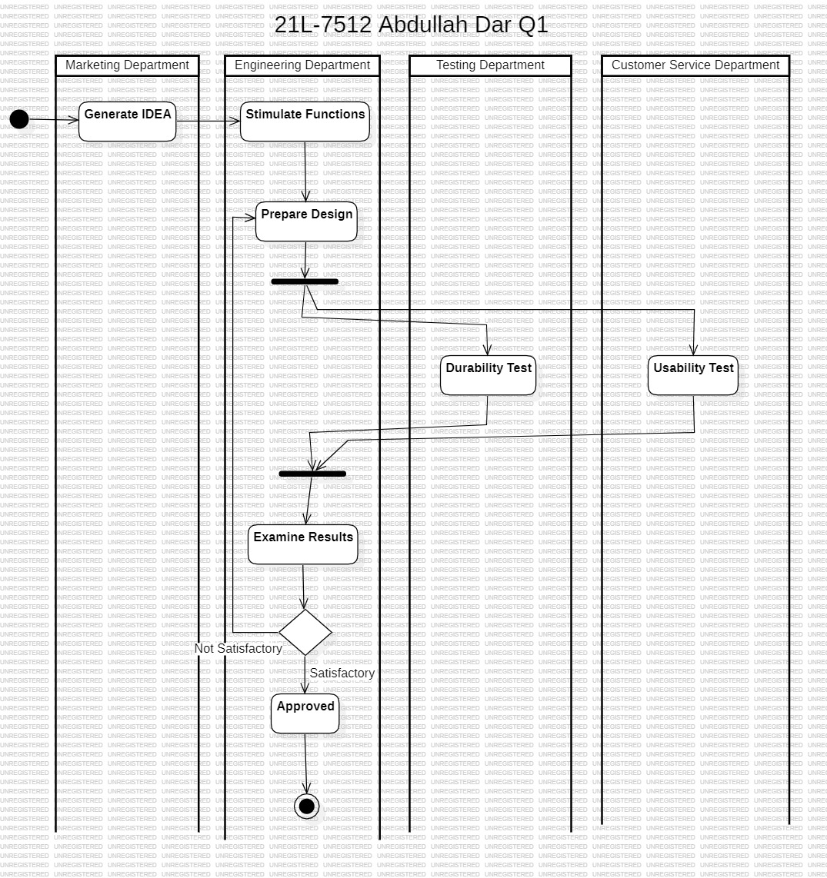

**Question no: 2:** **State diagram for the any automatic washing machine near you.**

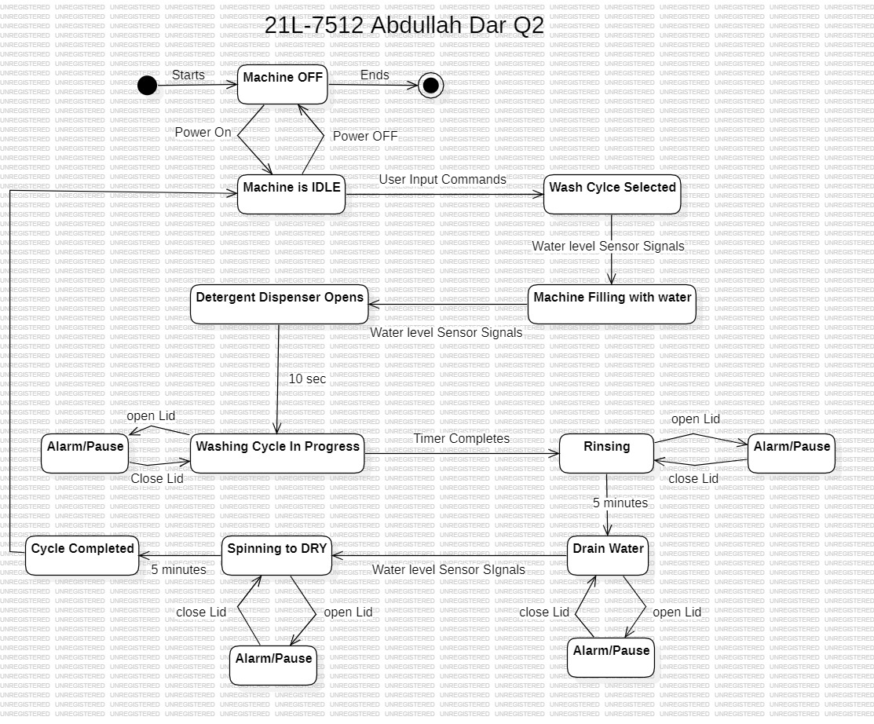

**Question no :3: Activity Diagram**

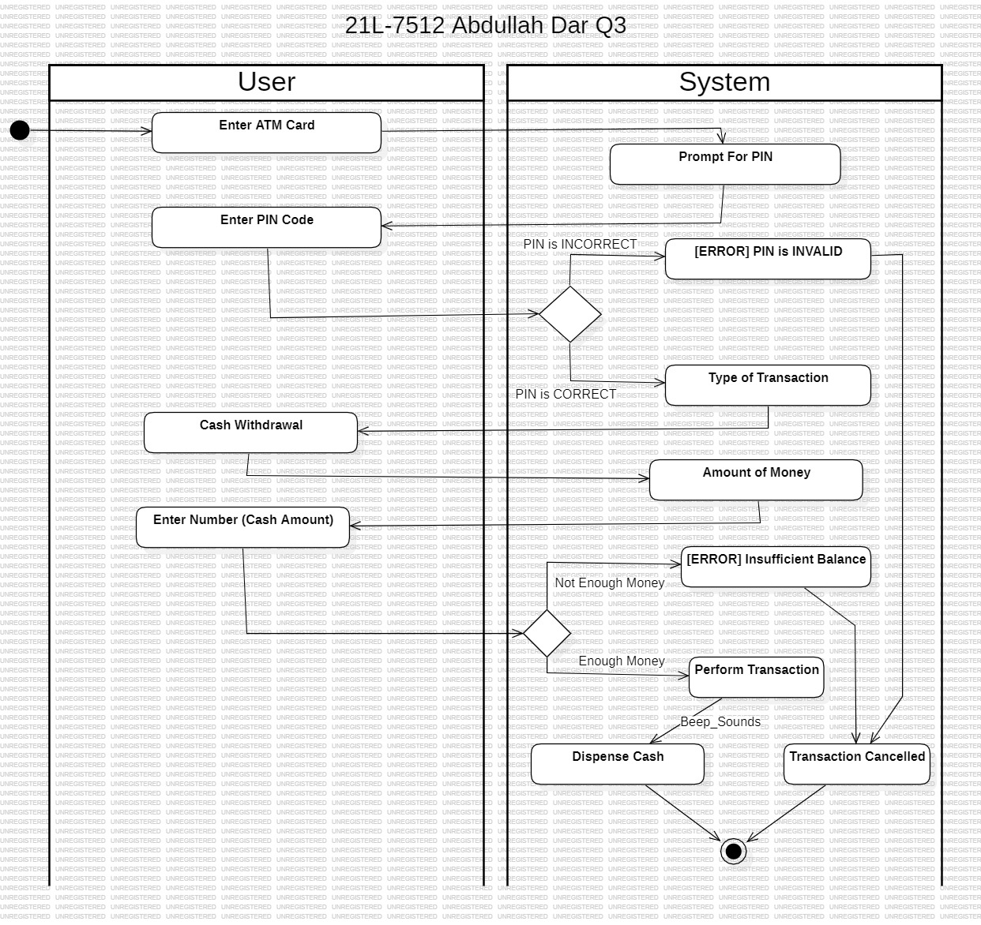

**Question no: 4: State Diagram**

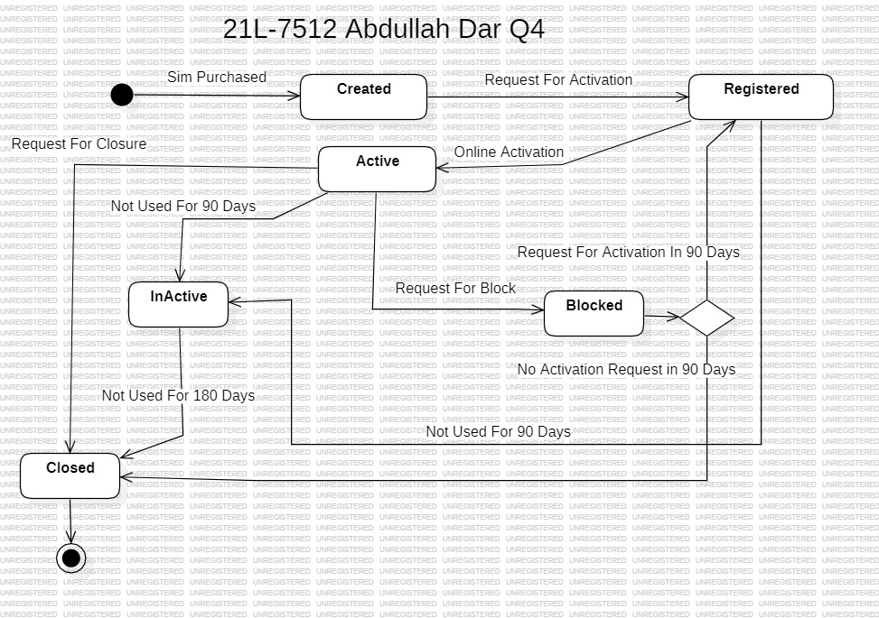

**Question no: 5: Use virtual inheritance to resolve the diamond problem.**

**Code:**

**OUTPUT:**

