Assignment 2 solution:

**Q1. Palindrome Question (for question statement refer to assignment2 document:**

(Duke final 2001) A palindrome is a string that reads the same from front and back. Any

string can be viewed as a sequence of palindromes if we allow a palindrome to consist of one

letter.

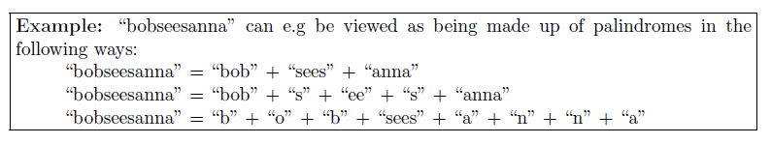We are interested in computing MinPal(s) defined as the minimum number of palindromes

from which one can construct s (that is, the minimum k such that s can be written as

w1w2 . . . wk where w1,w2, . . . ,wk are all palindromes).

We can compute MinPal(s) using the following formula



which can be implemented as follows:

MinPal(i,j)

b=i, e=j

WHILE b<e and s[b]=s[e] DO

b=b+1

e=e-1

OD

IF b>=e THEN RETURN 1 /* s[i,j] is not palindrome */

min=j-i+1

FOR k=i to j-1 DO

r=MinPal(i,k)+MinPal(k+1,j)

IF r<min THEN min=r

END

RETURN min

END

**Q4: (refer to my slides on Dynamic Programming, Maximum Sum subsarray)**

**Q5: Coin Change Problem:**

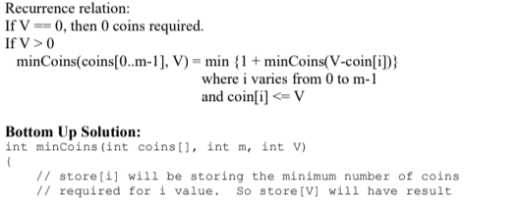

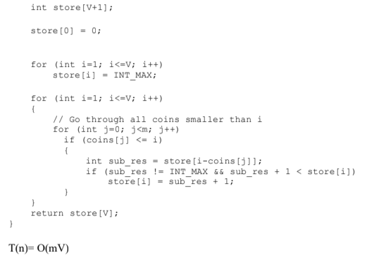

**Q6:**

