Name: Abdullah Khan
Roll No: 031

AI Lab 1 — Task 1
Timeline of Artificial Intelligence
Objective: To understand the historical development of Artificial Intelligence through important milestones.
Year / Period | Milestone | Significance | Source
1950 | Alan Turing’s paper | Alan Turing published Computing Machinery and Intelligence, introducing the idea of evaluating machine intelligence through conversation. | https://academic.oup.com/mind/article/LIX/236/433/986238
1956 | Dartmouth AI Workshop | The Dartmouth Summer Research Project helped establish Artificial Intelligence as a recognized research field. | https://home.dartmouth.edu/about/artificial-intelligence-ai-coined-dartmouth
1974–1980s | AI Winter | Disappointment with AI progress contributed to reduced funding, interest, and expectations during periods known as AI winters. | https://en.wikipedia.org/wiki/AI_winter
1980s | Expert Systems | Expert systems became a prominent commercial AI approach, using human-defined rules to solve specialized problems. | https://www.computerhistory.org/timeline/ai-robotics/
2012 | AlexNet and Deep Learning | AlexNet achieved strong image-classification results using deep neural networks and GPUs, highlighting the importance of data and computing power. | https://papers.nips.cc/paper_files/paper/2012/hash/c399862d3b9d6b76c8436e924a68c45b-Abstract.html

Conclusion
AI developed from early theories and symbolic rules toward modern data-driven systems. Improved algorithms, larger datasets, and powerful computing resources contributed to recent progress. However, better hardware alone cannot fix an unclear objective or poorly designed rules.

Name: Abdullah Khan | Roll No: 031

AI Lab 1 — Task 2
Modified Rule-Based Example

Objective
To modify the rule-based scholarship screening program to keep the score of at least 70 and confirm document completeness, include two new conditions, and test exactly four main cases.

1. Conditions and Assumptions
- The score needs to be 70 or higher.
- All required documents must be fully submitted.
- Identity needs to be confirmed (new condition 1).
- Income proof should be included (new condition 2).
These conditions and score limit are for the lab’s use, not real scholarship rules. “Review” means marking the application to be checked by a person, not giving the scholarship automatically. If any condition is not met, the system returns “Hold”.

2. Python Code (lab1_rules.py)
def scholarship_review(
score,
documents_complete,
identity_verified,
income_proof_attached
):
if (
score >= 70
and documents_complete
and identity_verified
and income_proof_attached
):
return "Review"
else:
return "Hold"
test_cases = [
{
"name": "Pass Case",
"input": (82, True, True, True),
"expected": "Review",
"reason": "All four conditions are satisfied."
},
{
"name": "Identity Verification Failure",
"input": (82, True, False, True),
"expected": "Hold",
"reason": "Identity verification is False."
},
{
"name": "Income Proof Failure",
"input": (82, True, True, False),
"expected": "Hold",
"reason": "Income proof is missing."
},
{
"name": "Threshold Boundary",
"input": (70, True, True, True),
"expected": "Review",
"reason": "A score of exactly 70 satisfies score >= 70."
}
]
for case in test_cases:
actual = scholarship_review(*case["input"])
print("Test:", case["name"])
print("Input:", case["input"])
print("Expected:", case["expected"])
print("Actual:", actual)
print("Reason:", case["reason"])
print("Result:", "PASS" if actual == case["expected"] else "FAIL")
print("-" * 40)

3. Four Core Test Cases
Test case | Input | Expected | Actual | Reason
Pass Case | (82, True, True, True) | Review | Review | All four conditions are satisfied.
Identity Verification Failure | (82, True, False, True) | Hold | Hold | Identity verification is False.
Income Proof Failure | (82, True, True, False) | Hold | Hold | Income proof is missing.
Threshold Boundary | (70, True, True, True) | Review | Review | A score of exactly 70 satisfies score >= 70.
The screenshots below show the Python code and terminal output provided for this task.

Screenshot 1 — Python function and test cases
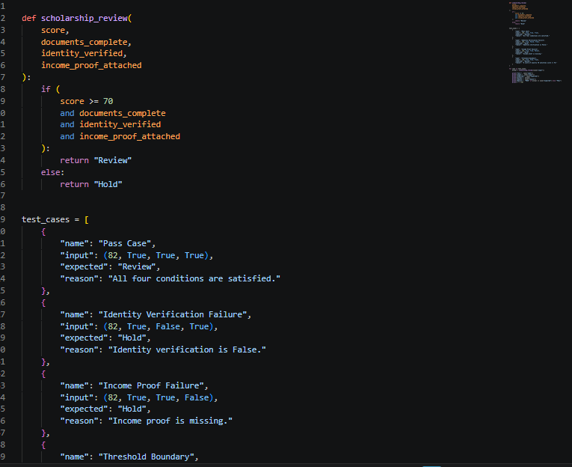

Screenshot 2 — Remaining code and test loop
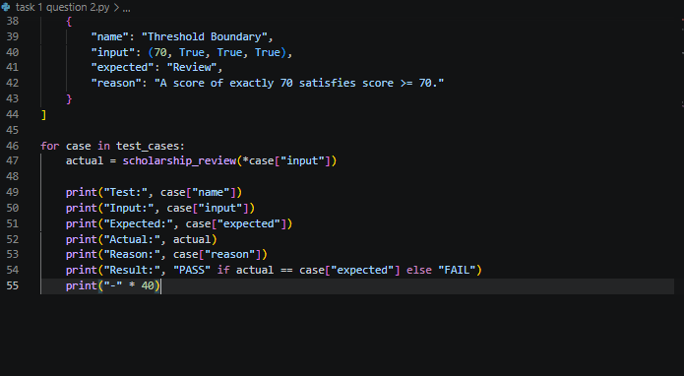

Screenshot 3 — Terminal output showing all four tests passed
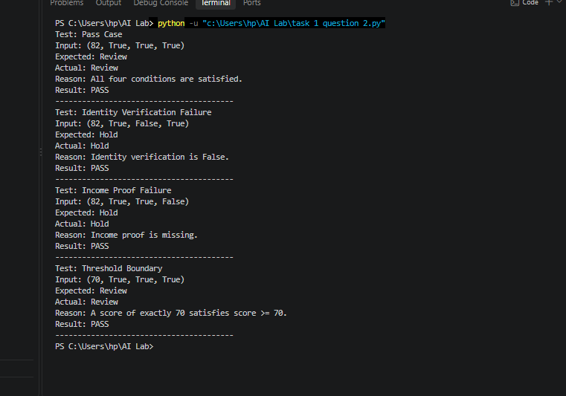

4. Captured Program Output

5. How the Test Cases Were Selected
Exactly four main cases were chosen for this task. The pass case tests the normal path where all conditions are true. The identity verification failure case sets only identity_verified to False, while other conditions are correct. The income proof failure case makes income_proof_attached False. The threshold boundary case uses a score of 70 with all other conditions true, to ensure that the >= operator includes 70.

6. Results and Interpretation
The actual outcomes matched the expected ones for all four test cases. The program shows Review only when all four conditions—score, documents, identity, and income proof—are satisfied. It returns Hold if either of the added conditions fails. A score of exactly 70 is acceptable because the condition is score >= 70.

7. Edge Case, Limitation, and Improvement
An application with a score of 91 but incomplete documents should result in Hold since document completeness is required. A system that only checks for a high score may incorrectly flag such cases. The likely mistake is not checking the mandatory document requirement. To improve, policies should be clearly stated, edge cases must be tested, and a human reviewer should be involved in the final decision.
This is a classroom example using made-up assumptions. It does not represent real scholarship eligibility or accuracy. Real applications require approved policies, accurate data, privacy protection, and ongoing monitoring.

What I Understood
I understood that the program checks four conditions before giving “Review”: the score must be at least 70, all documents must be complete, identity needs to be verified, and income proof must be included. I didn’t fully understand the test cases at first, so I learned by analyzing the inputs step by step. In the pass case, all values are true and the score is 82, so the result is Review. In the identity verification failure case, identity_verified is false, and the result is Hold. In the income proof failure case, income_proof_attached is false, so the result is Hold. In the boundary case, the score is exactly 70; since the rule uses >= 70, the result is Review. This helped me understand how each condition influences the decision.

Where Improvement Is Needed
- Add a test for incomplete documents, as document completeness is one of the original required conditions.
- Add a test for a score below the threshold, such as 69, to confirm that the program returns Hold.
- Check for invalid inputs, such as a negative score or a missing value, so the program can handle incorrect data safely.
- Improve the output by showing which condition failed, rather than only displaying Hold.
- In a real scholarship process, confirm the rules with the official policy and ensure a human reviewer is responsible for the final decision.

Conclusion
The modified rule-based program retains the score >= 70 and document completeness, and adds identity verification and income proof. Exactly four core cases cover a successful application, failure of each new condition, and the score boundary. All four captured tests show PASS, and each decision has a traceable reason.

Name: Abdullah Khan | Roll No: 031

AI Lab 1 — Task 3
Conversational Test and Reliable Task Performance

Objective
To explain why passing a conversational test does not prove general intelligence, using the scholarship screening example, and to suggest an additional test for reliable task performance.

1. What the Conversational Test Observes
The Turing Test, proposed by Alan Turing in 1950, considers whether a machine’s text conversation can be distinguished from a human’s under the test conditions. It focuses on conversational behaviour. A system that performs well in this test may produce responses that sound human, but the result alone does not prove that the system can perform every task correctly or reliably.

2. Why It Does Not Prove General Intelligence
A conversation is only one type of task. A system may give fluent and confident answers while making factual mistakes, missing important details, or failing to follow a written rule. Therefore, passing a conversational test does not establish broad competence, reliable reasoning, correct decision-making, or success in all real-world situations.

3. Scholarship Case Study
Suppose an applicant has a score of 91, but a required document is missing. The rule-based scholarship checker returns Hold because document completeness is mandatory. However, a probability-threshold system with a supplied probability of 0.88 returns Review because 0.88 is greater than or equal to 0.70. This disagreement shows that a high probability does not automatically mean the application meets every required condition.
A chatbot could confidently say, “The applicant scored 91, so the application should be reviewed,” while ignoring the missing document. The response sounds reasonable but is incorrect under the stated rule. This is an example of fluent but incorrect reasoning.

4. Focused Comparison
Approach | Decision rule | Limitation
Rule-based checker | Review only if score >= 70 and documents are complete. | It follows explicit rules, but it can only check conditions that have been programmed.
Probability-threshold checker | Review if supplied probability >= 0.70. | It does not itself enforce document completeness; the source of the probability is not validated in this lab.
Conversational test | Observes whether a machine’s conversation seems distinguishable from a human’s. | Conversational fluency does not prove the system follows policy or completes practical tasks reliably.

5. Python Demonstration (lab1_compare.py)
def symbolic(score, complete):
return "Review" if complete and score >= 70 else "Hold"
def threshold(probability):
return "Review" if probability >= 0.70 else "Hold"
cases = [
("complete_high", 82, True, 0.81),
("complete_low", 68, True, 0.74),
("incomplete_high", 91, False, 0.88),
("boundary", 70, True, 0.70)
]
print("case | symbolic | threshold | disagreement")
for name, score, complete, probability in cases:
rule_result = symbolic(score, complete)
probability_result = threshold(probability)
print(
name, rule_result, probability_result,
rule_result != probability_result,
sep=" | "
)

6. Expected Output
case | symbolic | threshold | disagreement
complete_high | Review | Review | False
complete_low | Hold | Review | True
incomplete_high | Hold | Review | True
boundary | Review | Review | False

7. Interpretation of the Results
In complete_high, both approaches return Review. In complete_low, the rule-based checker returns Hold because the score is below 70, while the probability threshold returns Review because 0.74 is above 0.70. In incomplete_high, the rule-based checker returns Hold because documents are incomplete, but the threshold method returns Review because 0.88 is above 0.70. In boundary, both methods return Review because the score and probability meet their respective thresholds.
The probability values are invented demonstration inputs. This code does not train a model, and these results do not prove which method is more accurate. Without ground-truth outcomes, this is a comparison of behaviour, not an accuracy experiment.

8. Additional Test for Reliable Task Performance
A useful additional test is a fixed policy-compliance test suite. Prepare applications that vary in score, document completeness, identity verification, and income proof. Include normal cases, incomplete applications, and boundary scores such as 69 and 70. For every input, write the correct result based on an approved policy, run the system, and compare actual results with expected results. Record every failure and have a human reviewer check the cases. This evaluates whether the system follows the task requirements rather than merely sounding convincing.

9. Edge Case and Improvement
Edge case: score = 91, documents_complete = False, probability = 0.88. The rule-based method returns Hold, while the probability-threshold method returns Review. The likely cause is that the threshold method does not include a mandatory document check. Improve the system by enforcing required policy checks before a case is sent for review, validating any model using labelled data, testing edge cases, and keeping a human involved in final decisions.

10. Conclusion
Passing a conversational test only provides evidence about conversational behaviour; it does not prove general intelligence or reliable task performance. In the scholarship example, a fluent answer or high probability can still overlook an incomplete application. Systems should also be tested against explicit requirements and expected results, including edge cases, and important decisions should remain under human oversight.

11. Sources
- Alan Turing (1950), “Computing Machinery and Intelligence.” https://academic.oup.com/mind/article/LIX/236/433/986238
- Stanford CS221 lecture notes, “The Turing Test (1950).” https://web.stanford.edu/class/archive/cs/cs221/cs221.1192/lectures/overview-6pp.pdf

