AI LAB 2 — TASK 1
PEAS Specifications for Intelligent Agents
Name: Abdullah Khan
Roll No: 031
Course: CAI601400 — Artificial Intelligence Lab

Task 1: PEAS Specifications
Objective: Create separate PEAS specifications for a delivery robot and an LLM-based student-support agent. PEAS describes the Performance measure, Environment, Actuators, and Sensors or inputs of an intelligent agent.

1. Delivery Robot
System description: The delivery robot transports parcels from a pickup point to the correct destination while avoiding obstacles and protecting people and packages.
PEAS Component | Concrete entries
Performance Measure | 1. Deliver the parcel to the correct location.  2. Avoid collisions and keep pedestrians safe.  3. Complete delivery within a reasonable time.  4. Protect the parcel from damage.
Environment | 1. Campus paths, corridors and roads.  2. Pickup and delivery locations.  3. Pedestrians, students and other robots.  4. Doors, stairs, weather and temporary obstacles.
Actuators | 1. Drive motors and wheels to move or turn.  2. Brakes to stop safely.  3. Robotic compartment/locker to secure and release the parcel.  4. Speaker or display to notify the recipient.
Sensors | 1. Camera to detect people and obstacles.  2. GPS or indoor positioning to estimate location.  3. Ultrasonic/LiDAR distance sensor to measure nearby objects.  4. Wheel encoders to estimate movement.

Constraint / Performance Trade-off
The robot should deliver quickly, but it must not sacrifice safety to save time. If a person crosses its path, it should slow down or stop even if the delivery is delayed. Safety and correct delivery take priority over speed.

Operational Assumptions
The robot has a digital map of the permitted delivery area, a charged battery, working sensors, and permission to use campus paths. Its position estimate may be imperfect, and people or obstacles can appear unexpectedly. The robot cannot assume every path is clear.

2. LLM-Based Student-Support Agent
System description: The agent answers students' questions about courses, deadlines, university procedures and learning resources. It should provide useful answers based on accessible, reliable information and acknowledge when it does not know.
PEAS Component | Concrete entries
Performance Measure | 1. Give accurate answers supported by available sources.  2. Explain information clearly and helpfully.  3. Protect student privacy and avoid exposing personal data.  4. Admit uncertainty and direct students to staff when needed.
Environment | 1. Students asking questions through a chat interface.  2. Course outlines, lecture notes and approved FAQs.  3. University rules, deadlines and support services.  4. Questions may be incomplete, ambiguous or based on outdated information.
Actuators | 1. Generate a text response in the chat.  2. Ask a clarifying question.  3. Provide links or citations to approved course resources.  4. Refer a student to a teacher or university office when necessary.
Sensors / Inputs | 1. Student's typed question and follow-up messages.  2. Course documents and approved FAQ content available to the agent.  3. Relevant conversation context in the current session.  4. Tool results returned by an authorized search of approved resources.

Tools the Agent Can Access
For this lab scenario, assume the agent can search approved course documents, lecture notes, university FAQs and public university webpages. It can return source links and refer students to staff. It cannot access private student records, grades, passwords or restricted systems unless explicit authorization and a secure, approved integration are provided. These are stated design assumptions, not claims about a real university system.

Constraint / Performance Trade-off
The agent should answer promptly, but speed must not be more important than correctness. If the available documents do not support an answer, it should say that the information is uncertain or refer the student to the relevant office instead of inventing a policy or deadline.

Comparison and Design Notes
Aspect | Delivery Robot | LLM Student-Support Agent
Main inputs | Camera, distance sensors, location and movement data. | Student messages, approved documents and authorized search results.
Main actions | Move, turn, stop, secure parcel and notify recipient. | Answer, clarify, cite resources and refer to staff.
Main risk | Collision, injury, lost or damaged parcel. | Incorrect or unsupported advice, or privacy exposure.
Priority | Safe and correct delivery before speed. | Accurate, supported and privacy-respecting help before response speed.

Conclusion
PEAS helps define what an intelligent agent is expected to achieve, where it works, what actions it can take, and what information it receives. The delivery robot needs safe physical movement, while the LLM-based student-support agent needs reliable information, clear communication and privacy protection. In both systems, performance measures should include safety or reliability rather than rewarding speed alone.

End of Task 1

AI LAB 2 — TASK 2
Environment Classification of Intelligent Agents
Name: Abdullah Khan
Roll No: 031
Course: CAI601400 — Artificial Intelligence Lab

Task 2: Environment Classification
This task classifies the delivery robot and the LLM-based student-support agent on two dimensions: (1) fully observable or partially observable, and (2) deterministic or stochastic. The classification depends on the stated assumptions and on whether we are describing a real environment or a simplified simulator.

1. Delivery Robot
Dimension | Classification | Justification and example
Observability | Partially observable | In a real campus, the robot cannot observe every relevant fact at all times. A camera or distance sensor may not detect an obstacle behind a corner, and GPS/indoor positioning may be inaccurate. The robot receives sensor readings, but some relevant information remains hidden.
Action outcomes | Stochastic | In the real environment, the result of movement is not perfectly predictable. A pedestrian may suddenly cross the path, wheels may slip, or an obstacle may appear. The same move command may therefore lead to different outcomes.

Simplified simulator: If the simulator provides the complete map and fixed positions for all obstacles, the simulated environment may be fully observable. If movement follows exact rules with no random events, it may also be deterministic. These labels apply only under those simplified assumptions.

2. LLM-Based Student-Support Agent
Dimension | Classification | Justification and example
Observability | Partially observable | The agent sees the student's messages and the approved documents or tool results it can access, but it may not know the student's full situation, intent, or the latest policy if that information is not provided. For example, it may not know a student's personal deadline extension unless the student or an authorized source supplies it.
Action outcomes | Stochastic | The response is not perfectly predictable in every case. A question may be ambiguous, retrieved documents may be incomplete, and language generation can vary. The same question can produce different wording or an answer with different levels of detail.

Simplified simulator: If the agent is tested with a fixed set of questions and a fixed lookup table that always returns the same answer, that specific model can be treated as deterministic. Its information is fully observable only if all information needed for each test is supplied to it.

Comparison Summary
System | Real-world observability | Real-world action outcomes | Example of hidden / uncertain information
Delivery robot | Partially observable | Stochastic | A pedestrian may be hidden around a corner; movement may be affected by unexpected obstacles.
LLM student-support agent | Partially observable | Stochastic | The student's full context or a current policy may be unavailable; generated answers can vary.

Why assumptions matter
Environment labels depend on the model boundary. A simplified simulator can remove uncertainty by giving the agent complete information and fixed action rules. Real systems usually have missing information or unexpected outcomes. Therefore, the classifications above describe the real-world versions of the two systems, while the simulator notes explain how the labels may change under controlled assumptions.

Conclusion
Under the assumptions stated in this report, both the delivery robot and the LLM-based student-support agent are partially observable and stochastic in real use. The robot has incomplete sensor information and uncertain physical outcomes. The student-support agent may lack relevant context or current documents, and its generated responses are not guaranteed to be identical. A fixed, simplified simulator may be classified differently.

AI LAB 2 — TASK 3
Stateful Classroom Agent: Previous Mode and Command Trace
Name: Abdullah Khan
Roll No: 031
Course: CAI601400 — Artificial Intelligence Lab

1. Objective
Extend the classroom agent to remember the previous target mode and avoid sending identical control commands repeatedly. The original temperature thresholds and occupancy priority remain unchanged.

2. Rules Used
Condition | Target mode
Room is empty (occupied is False) | ECO
Room is occupied and temperature > 26°C | COOL
Room is occupied and temperature < 20°C | WARM
Otherwise, including exactly 20°C or 26°C | IDLE

3. Code Logic
The agent first calculates the target mode. It compares the target with the stored previous mode. If the modes differ, it sends a command and updates the stored mode. If they are the same, it returns NO COMMAND. The initial previous mode is set to IDLE for this test.
Source file used: labtask2c.py
class ClassroomAgent:
def __init__(self, previous_mode="IDLE"):
self.previous_mode = previous_mode
def act(self, temp, occupied):
if not occupied:
target_mode = "ECO"
elif temp > 26:
target_mode = "COOL"
elif temp < 20:
target_mode = "WARM"
else:
target_mode = "IDLE"
previous_mode = self.previous_mode
send_command = target_mode != previous_mode
if send_command:
self.previous_mode = target_mode
return previous_mode, target_mode, send_command
agent = ClassroomAgent(previous_mode="IDLE")
percepts = [
(29, True),
(29, True),
(20, True),
(26, True),
(19, True),
(29, False),
(29, False)
]
print("Step | Previous | Percept | Target | Command")
print("-" * 55)
for step, (temp, occupied) in enumerate(percepts, 1):
previous, target, send = agent.act(temp, occupied)
result = "SEND COMMAND" if send else "NO COMMAND"
print(step, "|", previous, "|", (temp, occupied), "|", target, "|", result)

4. Test Trace
Step | Previous mode | Percept | Target mode | Outcome
1 | IDLE | (29, True) | COOL | SEND COMMAND
2 | COOL | (29, True) | COOL | NO COMMAND
3 | COOL | (20, True) | IDLE | SEND COMMAND
4 | IDLE | (26, True) | IDLE | NO COMMAND
5 | IDLE | (19, True) | WARM | SEND COMMAND
6 | WARM | (29, False) | ECO | SEND COMMAND
7 | ECO | (29, False) | ECO | NO COMMAND

5. Screenshot Evidence
Figure 1. Python code in Visual Studio Code.
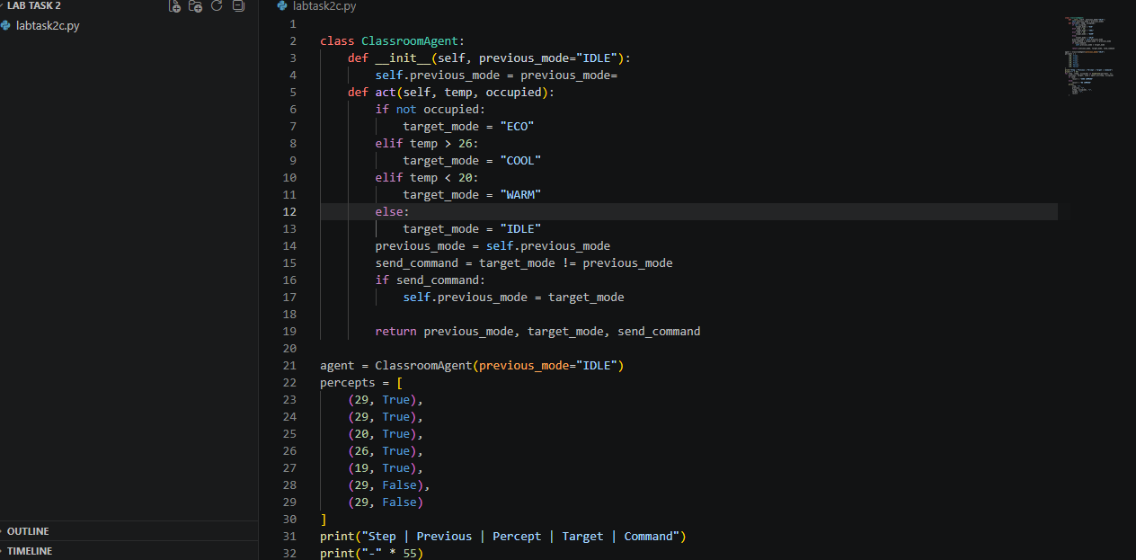
Figure 1: Code implementation showing previous-mode storage and command comparison.
Figure 2. Program output in the terminal.
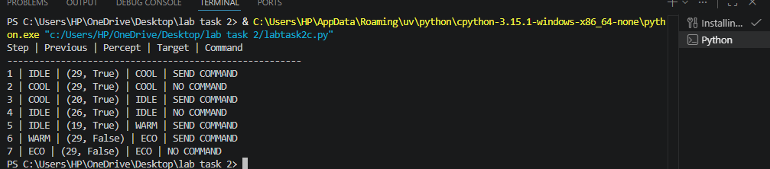
Figure 2: Actual terminal output for repeated percepts, boundary temperatures, mode transition, and empty-room priority.
Figure 1. Python code in Visual Studio Code.
Figure 1: Code implementation showing previous-mode storage and command comparison.

Figure 2. Program output in the terminal.
Figure 2: Actual terminal output for repeated percepts, boundary temperatures, mode transition, and empty-room priority.

6. Interpretation and Edge Cases
The repeated (29, True) percept produces COOL twice, but the command is sent only on the first occurrence. At 20°C and 26°C, an occupied room targets IDLE because the original comparisons are strictly less than 20 and strictly greater than 26. When occupied is False, ECO takes priority even at 29°C.

7. Limitation and Improvement
The agent prevents repeated identical commands, but it does not handle noisy readings that fluctuate around a threshold. A future improvement could use hysteresis or sensor-noise filtering. Any improvement should preserve the required occupancy priority and existing thresholds for this task.

8. Conclusion
The code remembers the previous mode and returns the previous mode, target mode, and whether a command should be sent. The provided screenshots document the implementation and its observed terminal output.

