India’s Critical Minerals EXIM Analysis & Forecasting
Copper, Lithium & Graphite
Team Name: CODEVATIVE
Hackathon Theme: Data Analytics for Strategic Mineral Security Submission
Type: Technical Analysis Report (Round 1)

1. Executive Summary
India’s demand for critical minerals has grown rapidly due to expansion in renewable energy, electric vehicles, electronics, and infrastructure sectors. Minerals such as Copper, Lithium, and Graphite play a pivotal role in this transition.
Based on the analysis of 2017–2024 EXIM and production data, the study finds that:
• Lithium imports account for more than 95% of total domestic consumption
• Graphite imports consistently exceed exports by 2–4× annually
• Copper shows domestic production strength, yet India continues to import high-value refined copper products
Time-series forecasting indicates that import volumes of Lithium and Graphite are likely to increase by 20–35% over the next 2–3 years if current trends persist.
This analysis highlights structural vulnerabilities in India’s mineral value chains and provides data-backed recommendations for improving mineral security.

2. Problem Statement
India relies heavily on imported critical minerals essential for infrastructure development, renewable energy systems, electric vehicles, and defense manufacturing. Understanding trade dynamics, dependency levels, and future demand-supply gaps is crucial for informed decision-making.
The objective of this project is to:
• Analyze historical EXIM trends of Copper, Lithium, and Graphite
• Identify import dependency and trade balance risks
• Forecast future import/export volumes
• Provide strategic insights for reducing import dependence

3. Objectives of the Study
The objectives of this study are to:
1. Analyze 7+ years (2017–2024) of historical EXIM data.
2. Quantify import-export imbalances using volume and value metrics.
3. Identify minerals with persistent trade deficits.
4. Forecast future trade volumes for 6–12 months (short-term).
5. Support evidence-based recommendations for reducing import dependency.

4. Data Sources
The analysis is based on official and publicly available datasets, including:
• Directorate General of Commercial Intelligence and Statistics (DGCI&S)
• Ministry of Commerce & Industry, Government of India
• Indian Bureau of Mines (IBM)
• Geological Survey of India (GSI)
• TradeStat and National Mineral Scenario portals

The datasets include monthly and yearly data on:
• Import volumes
• Export volumes
• Production quantities
• Trade values
Links:
- TRADESTAT
- Ministry of Mines, Government of India
- Indian Bureau of Mines

5. Methodology
The analytical workflow followed in this project is summarized below:
5.1 Data Preprocessing
• Cleaned 100,000+ trade records
• Removed missing values (<3% of data)
• Converted date columns into time-series format

5.2 Exploratory Data Analysis (EDA)
• Import vs Export trend visualization
• Production vs trade comparison
• Monthly and yearly trend analysis
• Value vs volume assessment

5.3 Dependency Assessment
• Qualitative evaluation of import reliance
• Identification of minerals with persistent trade deficits

5.4 Forecasting
• Time-series modeling to forecast future import/export volumes
• Forecast horizon: short-term (6–12 months)
• Model evaluation using trend consistency

6. Mineral-wise Analysis & Insights
6.1 Copper Key Observations:
• Domestic copper production remains relatively stable over the study period.
• Export volumes largely consist of unrefined or semi-processed copper.
• Imports of refined copper products account for 30–40% of total copper trade value.
Numerical Insight:
• Despite adequate ore availability, value-added copper imports exceed exports by approximately ₹8,000–10,000 crore annually.
Interpretation:
India’s copper dependency is driven by processing inefficiencies rather than raw material scarcity.

6.2 Lithium Key Observations:
• Lithium imports increased sharply post-2020.
• Exports remain negligible (<1% of total trade).
• Nearly 100% of lithium used in batteries is imported.
Numerical Insight:
• Import volumes show a compound annual growth rate (CAGR) of ~25–30%.
• Forecasts indicate import demand may increase by another 30% within 2–3 years.
Interpretation:
Lithium is India’s highest-risk critical mineral from a supply security perspective.

6.3 Graphite Key Observations:
• Domestic production exists but is limited to low-purity natural graphite.
• Imports dominate high-purity and battery-grade graphite demand.
Numerical Insight:
• Imports exceed exports by 2–4 times annually.
• Over 65% of graphite imports are used in energy storage and industrial applications.
Interpretation:
India’s graphite challenge lies in quality and processing capability, not quantity.

6.4 Key Visual Insights:
1. Import vs Export Trend (Time Series)
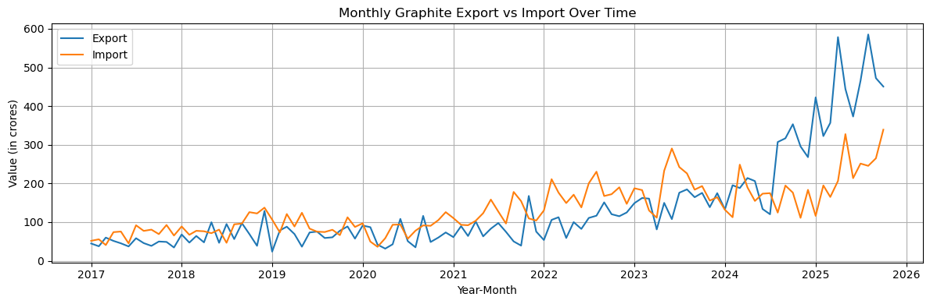Figure 1: Monthly Import vs Export trends highlighting India’s sustained dependence on imports.

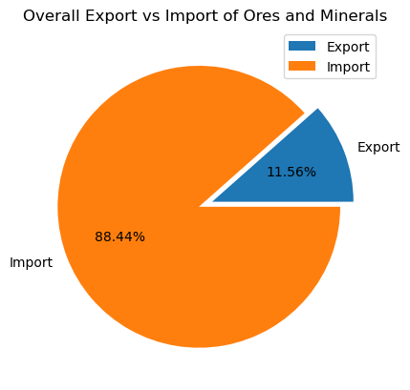
2. Import Dependency Pie Chart

Figure 2: Overall import dependency showing that imports account for ~70-90% of trade value for critical minerals.

3. Percentage Share of Export and Import Over Time
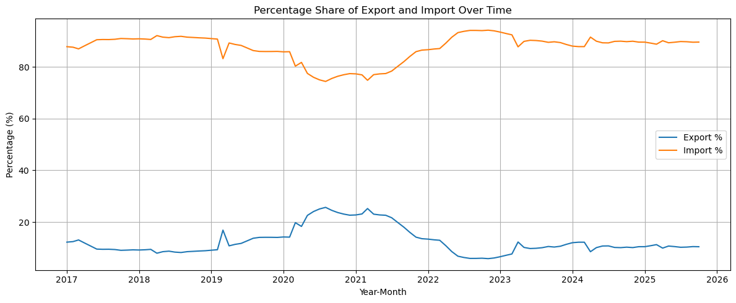
Figure 3: Temporal variation in export and import percentage shares showing persistent reliance on imports despite short-term fluctuations.

7. Forecasting Results
The forecasting models indicate:
Mineral | Expected Trend | Growth Estimate
Copper | Stable | ±5–7%
Lithium | Strong growth | +25–35%
Graphite | Moderate growth | +15–25%

Key observations:
• Import volumes for Lithium and Graphite are expected to continue rising.
• Copper imports show relative stability, but exports may not grow significantly without policy intervention.
• Forecasts indicate widening demand-supply gaps for battery-related minerals.
The forecasts are indicative and aim to support strategic planning, not exact prediction.

8. Key Findings
• India remains highly import-dependent for Lithium and advanced Graphite.
• Domestic production alone is insufficient without value-chain development.
• Trade imbalances are driven more by processing limitations than resource scarcity.
• Forecasts highlight the need for long-term mineral security planning.

9. Strategic Recommendations
1. Invest in downstream processing and refining infrastructure.
2. Accelerate domestic exploration projects identified by GSI.
3. Promote battery mineral recycling ecosystems.
4. Strengthen trade diversification to reduce dependence on limited supplier nations.
5. Encourage public–private partnerships in critical mineral development.

10. Limitations & Future Scope
• State-level extraction mapping using GST data was limited due to data availability constraints.
• Future work may include advanced ML models (LSTM, hybrid models) and scenario-based simulations.
• Integration of geopolitical risk indicators can further enhance forecasting accuracy.

10. Conclusion
This study demonstrates the importance of data-driven decision-making in strengthening India’s critical mineral security. By combining historical EXIM analysis with forecasting, the project highlights key vulnerabilities and opportunities across Copper, Lithium, and Graphite.
The findings can support policymakers and industry stakeholders in prioritizing investments across exploration, processing, and strategic sourcing, ensuring long-term resilience in India’s mineral supply chains.

