***Institute of Space Technology***

***Assignment of Operating System***

***(Assignment No.4)***

**Tittle: Multithreading & Types of Thread**

***Submitted by:******Submitted To:***

***Abdullah Ahmad Mrs. Asia Anam 200901057***

***Due Date: 04-01-2023***

***BSCS-01-B***

**Question 1:**

**You have to create four threads other than main thread.**

**1. Input thread**

**2. Reverse thread**

**3. Capital thread**

**4. Shift thread**

**Input thread will take string input from user, reverse thread will reverse the string and output it, capital thread will capitalize the characters of string and output it and shift thread will shift each characters of the string two time (e.g. a will become c) and output it. All the threads wait for input thread when input thread finishes his task all the waiting thread start their work simultaneously. You also have to handle the exceptions of input thread. Also take care the state of each thread. Do not waste your memory resources.**

**Answer:**

**Thread:**

The smallest group of programmed instructions that may be independently controlled by a scheduler, which is often a component of the operating system, is known as a thread of execution in computer science.

**Types of Threads:**

* Kernel level thread
* User- Level Thread:

**Types of User- Level Thread:**

* **Input Thread:**

The input Thread is used to collect user input for Input String. The input function creates a string from whatever you provide as input. Using the input() function, a string is created from an input parameter that you enter.

* **Reverse thread:**

Reverse threads and left-handed threads are synonyms. When applying pressure might cause a right-handed screw or bolt to come loose, these threads are employed in specialized applications.

* **Capital thread:**

This Type of thread turns the string to a uppercase string.

* **Shift Thread:**

This Type of thread turns the string to a Shuffled string with a mix up of input value.

**Code:**

import threading

def input_thread():

  while True:

    try:

      # Take input from user

      input_str = input("Enter a string: ")

    except EOFError:

      # If the input thread receives an EOFError, break out of the loop

      break

    except Exception as e:

      # If any other exception is raised, print the exception and continue the loop

      print(e)

      continue

    # Set the input string as a global variable so that the other threads can access it

    global input_string

    input_string = input_str

    # Notify the other threads that the input is ready

    input_ready.set()

def reverse_thread():

  while True:

    # Wait for the input to be ready

    input_ready.wait()

    # Reverse the input string

    reversed_string = input_string[::-1]

    # Print the reversed string

    print("Reversed string:", reversed_string)

    # Clear the input_ready event

    input_ready.clear()

def capital_thread():

  while True:

    # Wait for the input to be ready

    input_ready.wait()

    # Capitalize the input string

    capitalized_string = input_string.upper()

    # Print the capitalized string

    print("Capitalized string:", capitalized_string)

    # Clear the input_ready event

    input_ready.clear()

def shift_thread():

  while True:

    # Wait for the input to be ready

    input_ready.wait()

    # Shift the characters in the input string by two

    shifted_string = ""

    for c in input_string:

      shifted_string += chr(ord(c) + 2)

    # Print the shifted string

    print("Shifted string:", shifted_string)

    # Clear the input_ready event

    input_ready.clear()

# Create a global event to signal when the input is ready

input_ready = threading.Event()

# Create the input, reverse, capital, and shift threads

input_t = threading.Thread(target=input_thread)

reverse_t = threading.Thread(target=reverse_thread)

capital_t = threading.Thread(target=capital_thread)

shift_t = threading.Thread(target=shift_thread)

# Start the threads

input_t.start()

reverse_t.start()

capital_t.start()

shift_t.start()

# Wait for the input thread to finish

input_t.join()

# Notify the other threads to exit

input_ready.set()

# Wait for the other threads to finish

reverse_t.join()

capital_t.join()

shift_t.join()

**Output:**

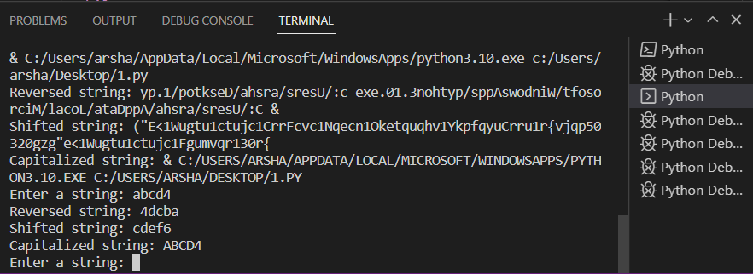

**Girhub Link:**

[**https://github.com/abdullahmad12/Multithreading-Types-of-Thread**](https://github.com/abdullahmad12/Multithreading-Types-of-Thread)