Azure Administrator Project

Prepared By:
Abdullah Majid
Role:
Azure Administrator Trainee
Project:
Project 01 - Production Environment
Platform:
Microsoft Azure

Project Overview:
This project demonstrates the deployment and management of a production-style Azure environment. The environment was designed to simulate real-world Azure Administrator responsibilities, including infrastructure deployment, networking, monitoring, and backup configuration.
The project consists of Azure Virtual Machines, Virtual Networks, Subnets, Azure Monitor, Recovery Services Vault, Azure Backup, Data Collection Rules (DCR), and Alert Monitoring.
The objective of the project was to gain hands-on experience with Azure administration tasks and understand how Azure resources work together in a production environment.

Architecture:
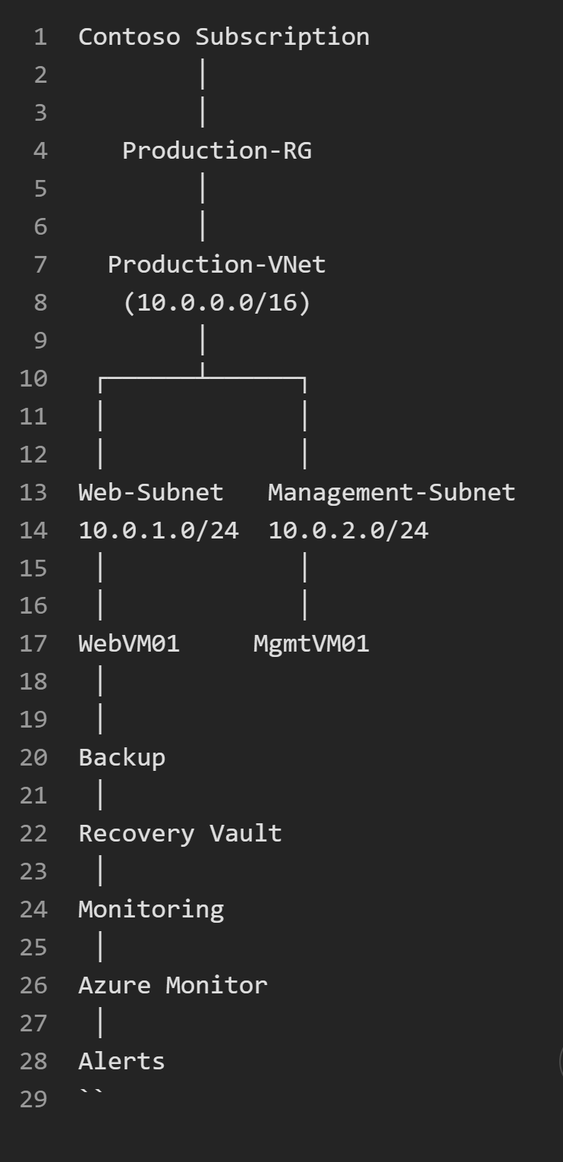

Architecture Description:
The environment was deployed inside a dedicated resource group named Production-RG. A virtual network called Production-VNet was created with an address space of 10.0.0.0/16.

Two subnets were created:
• Web-Subnet for production workloads.
• Management-Subnet for administrative and management tasks.

Two Windows Server virtual machines were deployed:
• WebVM01
• MgmtVM01
Azure Monitor was configured to collect health and performance information. Azure Backup was configured using a Recovery Services Vault to protect both virtual machines.

Resources Deployed:
Resource Group
• Production-RG
Virtual Network
• Production-VNet
• Address Space: 10.0.0.0/16
Subnets
• Web-Subnet (10.0.1.0/24)
• Management-Subnet (10.0.2.0/24)
Virtual Machines
• WebVM01
• MgmtVM01
Backup
• Recovery Services Vault
• Azure Backup Enabled
Monitoring
• Azure Monitor
• DCR
• Recommended Alerts
• Email Notifications

Monitoring Implementation:
Azure Monitor was configured to monitor the deployed virtual machines. Recommended alert rules were enabled to detect performance and availability issues.

The following monitoring services were configured:
• Azure Monitor
• Data Collection Rule (DCR)
• OpenTelemetry Metrics
• Recommended Alerts
• Email Notifications

Monitoring metrics included:
• CPU Usage
• Disk Usage
• Network Activity
• VM Availability

Backup Implementation:
A Recovery Services Vault was deployed to provide backup and recovery capabilities for the production environment.
Backup was enabled for:
• WebVM01
• MgmtVM01
Features configured:
• Azure Backup
• Recovery Services Vault
• Enhanced Backup Policy
• Recovery Point Creation
• Backup Monitoring

Skills Demonstrated:
• Azure Virtual Machines
• Azure Virtual Networking
• Subnet Design
• Windows Server Deployment
• Azure Monitor
• Azure Alerts
• Azure Backup
• Recovery Services Vault
• Data Collection Rules (DCR)
• Infrastructure Monitoring
• Resource Organization

Project Summary:
This project successfully implemented a production-style Azure environment containing multiple virtual machines, networking components, monitoring solutions, and backup protection.
The project provided hands-on experience with core Azure Administrator responsibilities including infrastructure deployment, monitoring configuration, alert management, backup administration, and operational validation.
This project strengthened practical Azure administration skills and provided experience similar to real-world cloud operations environments.

