DevBench
Backend System Design
A developer assessment platform: timed coding, MCQ and written tests, integrity checks and candidate insights for hiring teams.
Author: Abdullah Mamun
Stack: Express 5, TypeScript, Prisma 7, PostgreSQL, Upstash Redis, Stripe
Source: github.com/abdullahmamun1/devbench-backend-api
Date: October 2026

Contents
1. Project Overview
2. Core Features and User Roles
2.1 Core features
2.2 User roles
3. SDA Workflow Diagram and Explanation
4. Backend Architecture
5. API List
Auth (/auth)
Users (/users)
Companies (/companies)
Problems (/problems)
Assessments (/assessments)
Invitations (/invitations)
Attempts (/attempts)
Evaluations (/evaluations)
Insights (/insights)
Payments (/payments)
Admin (/admin)
Public (/public, /contact)
6. Detailed Design of 10 APIs
1. Register: POST /api/v1/auth/register
2. Login: POST /api/v1/auth/login
3. Create a problem: POST /api/v1/problems
4. Create an assessment: POST /api/v1/assessments
5. Invite a candidate: POST /api/v1/assessments/:id/invitations
6. Start an attempt: POST /api/v1/assessments/:id/attempts/start
7. Save an answer: POST /api/v1/attempts/:id/submissions
8. Submit an attempt: POST /api/v1/attempts/:id/submit
9. Grade an answer: PATCH /api/v1/evaluations/:id
10. Buy credits: POST /api/v1/payments/create-session

1. Project Overview
Project name: DevBench, a developer assessment platform.
Main purpose: let companies hire developers based on what they can actually do. A company builds a bank of coding, multiple-choice and written problems, bundles them into timed assessments, and invites candidates by email. Candidates take the test in the browser against a server-set deadline. MCQs are graded automatically, while coding and written answers go to the company's evaluators. The result is a ranked, evidence-backed view of every candidate, with an integrity check that catches copied answers.
Target users:
- Hiring companies: founders, hiring managers and technical interviewers who screen developers.
- Developer candidates applying for a role.
- The platform operator, who oversees companies, payments and abuse.

2. Core Features and User Roles

2.1 Core features
- Authentication: email and password registration with an OTP sent to verify the email, Google sign-in, rotating refresh tokens in httpOnly cookies, and password reset.
- Problem bank: CODING problems with visible and hidden test cases, MCQ problems with options, and WRITTEN problems. Problems are reusable across assessments.
- Assessment builder:
  - Lifecycle: DRAFT → PUBLISHED → CLOSED.
  - Each assessment has a duration and a passing score, and problems are attached with per-assessment points.
  - "Smart pick" suggests problems to fill the duration.
- Candidate invitations: each invitation costs 1 credit, debited atomically. Invitations go by email, can be resent, and revoking one refunds the credit.
- Timed attempts:
  - The server sets expiresAt when the attempt starts, and answers autosave.
  - Submitting finalizes the attempt; an expired attempt is finalized automatically on its next request.
- Grading and evaluation:
  - MCQs are graded on submit.
  - Coding and written answers wait in a review queue, oldest first, until an evaluator scores them with feedback.
- Integrity and insights:
  - Similarity detection (winnowing, the technique behind MOSS) and exam signals (tab switches, pastes).
  - Candidate ranking and percentile, plus item analysis of each question.
- Billing and administration: credits are bought through Stripe Checkout and confirmed by a signed webhook. Admins can suspend or reactivate accounts and adjust credits, and every sensitive action is written to an audit log.

2.2 User roles
Role | Who | What they can do
CANDIDATE | A developer being assessed | Accept an invitation, take a timed attempt, save answers, submit, see their own results
COMPANY_OWNER | Creates the company account | Everything in the company, plus team management and buying credits
ASSESSMENT_CREATOR | Company member | Build problems and assessments, publish them and invite candidates
EVALUATOR | Company member | Review and score coding and written answers, see results and insights
ADMIN | Platform operator | See and manage all companies, users and payments, adjust credits, read the audit log

Every non-admin request is scoped to the caller's own company. An admin sees across companies.

3. SDA Workflow Diagram and Explanation
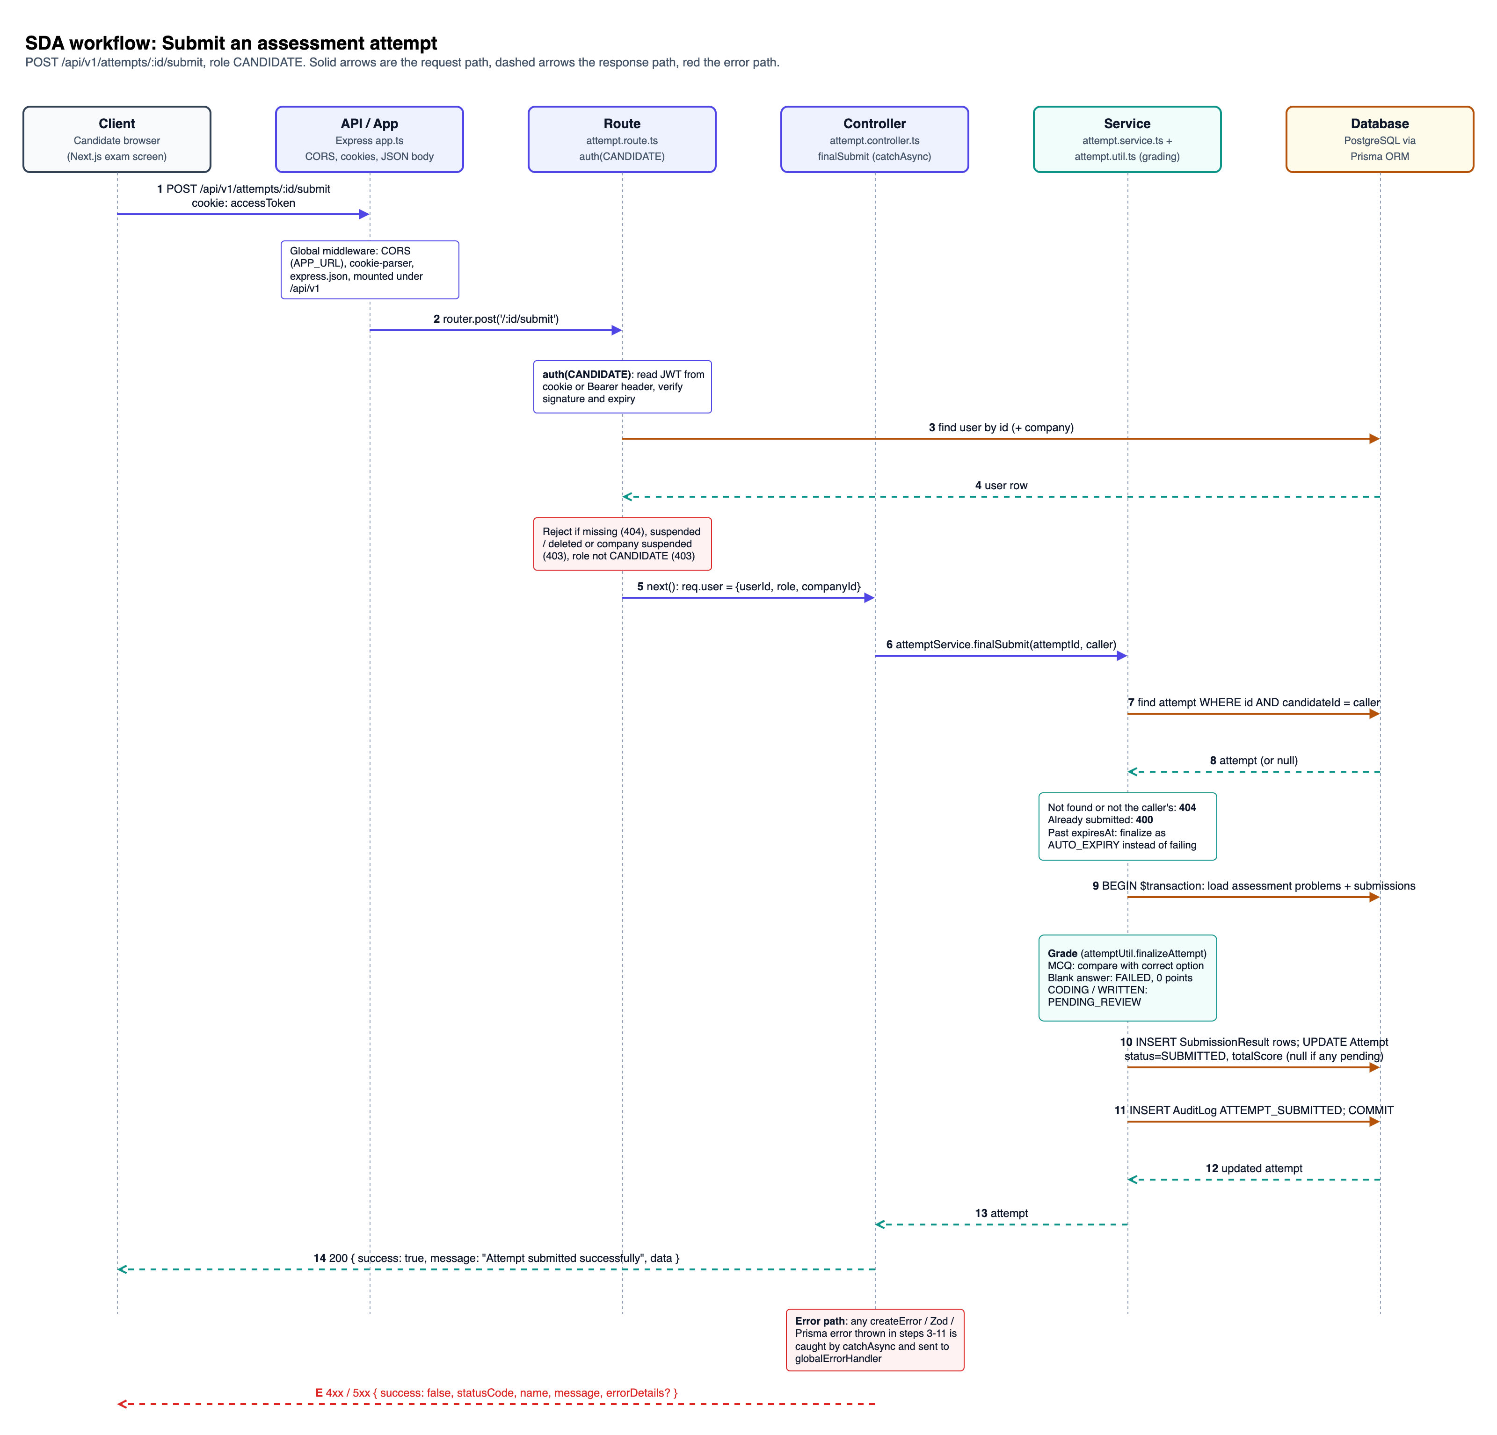
SDA workflow
General flow: User → API request → Route → Controller → Service / business logic → Database → API response → User.
Feature shown: a candidate submits their attempt. The request is POST /api/v1/attempts/:id/submit, role CANDIDATE. It is the most involved write in the system: it checks ownership and the deadline, grades every answer, and updates several tables in one transaction.
Step | Layer | What happens
1 | Client → API | The exam screen sends POST /api/v1/attempts/:id/submit. The accessToken httpOnly cookie travels with it, through the frontend's same-origin /api/v1 rewrite.
– | API (app.ts) | Global middleware runs: CORS, limited to the frontend origin; cookie-parser; express.json. The request is then routed to the attempt module.
2 | Route | attempt.route.ts matches POST /:id/submit and runs auth(UserRole.CANDIDATE).
3–4 | Route ↔ Database | Authentication: auth reads the JWT from the cookie or a Bearer header and verifies it, then loads the user and their company.
– | Route | Authorization: the request is rejected with 404 if the user is missing, 403 if the user is suspended or deleted or the company is suspended, and 403 if the role is not CANDIDATE. If all checks pass, req.user = { userId, role, companyId }.
5–6 | Controller → Service | attemptController.finalSubmit runs inside catchAsync. It builds the caller and calls attemptService.finalSubmit(attemptId, caller). The controller holds no business logic.
7–8 | Service ↔ Database | The service loads the attempt with WHERE id = :id AND candidateId = caller. Ownership is part of the query, so another candidate's attempt is simply "not found" (404).
– | Service | Business rules: an already-submitted attempt is rejected with 400. If expiresAt has passed, the attempt is finalized as AUTO_EXPIRY instead of failing, so late requests still count.
9 | Service → Database | A $transaction begins: it loads the assessment's problems with their points, plus the candidate's saved answers.
– | Service (grading) | attemptUtil.finalizeAttempt grades each problem. MCQ: full points if the chosen option is correct, otherwise 0. Blank answer: FAILED with 0 points. Coding / written: PENDING_REVIEW for an evaluator.
10 | Service → Database | Inserts one SubmissionResult per problem. Updates the Attempt to status = SUBMITTED and sets totalScore, or leaves it null while any answer awaits review.
11 | Service → Database | Writes an AuditLog entry ATTEMPT_SUBMITTED inside the same transaction, then commits. Either everything is saved or nothing is.
12–13 | Database → Service → Controller | The updated attempt is returned up the stack.
14 | Controller → Client | sendResponse replies 200 { success: true, message: "Attempt submitted successfully", data }.
E | Error path | Any error thrown in steps 3–11 (createError, Zod or Prisma) is caught by catchAsync and passed to globalErrorHandler, which replies with the standard error envelope.

4. Backend Architecture
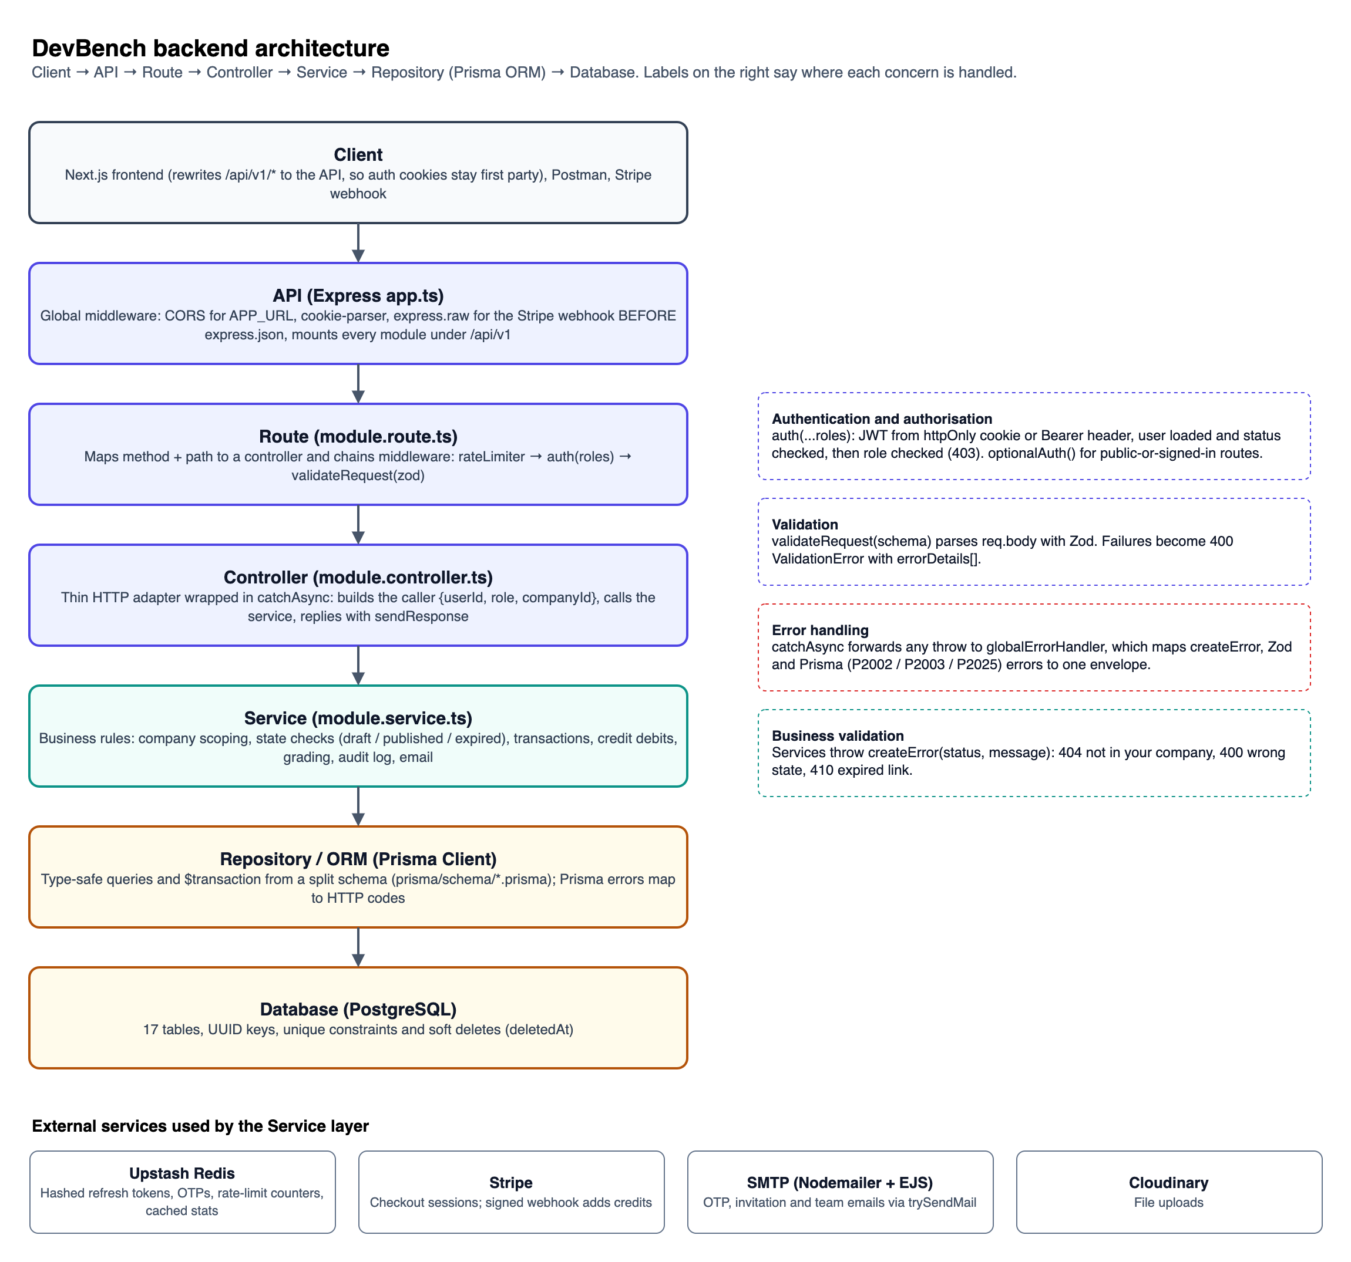
Backend architecture
Client → API → Route → Controller → Service → Repository / ORM → Database. Each module in src/modules/<name>/ follows these layers in the same files: .route.ts, .controller.ts, .service.ts, .validation.ts, .interface.ts.
Layer | Where | Responsibility
Client | Next.js frontend, Postman, Stripe | Sends HTTP requests. The frontend calls /api/v1/* on its own origin and Next.js rewrites to the API, so auth cookies stay first party.
API | src/app.ts, src/server.ts | Express 5 application. Applies global middleware: CORS limited to APP_URL, cookie-parser, express.raw for the Stripe webhook (registered before express.json so the signature can be verified), and express.json. Mounts every module under /api/v1 and registers globalErrorHandler last.
Route | <module>.route.ts | Maps method and path to a controller and chains per-route middleware in a fixed order: rateLimiter → auth(...roles) → validateRequest(zodSchema) → controller.
Controller | <module>.controller.ts | A thin HTTP adapter wrapped in catchAsync. Reads params, query and the validated body, builds the caller { userId, role, companyId } from req.user, calls one service function, and replies through sendResponse with the standard envelope. No business logic.
Service | <module>.service.ts, .util.ts | All business rules, and the only layer that talks to the ORM:  - Company scoping: resolveCompanyScope(caller).  - State checks: for example, publish needs problems, and an expired link returns 410.  - Transactions: credit debit with invitation, grading with result rows.  - Audit log and email: writeAuditLog(…, tx); trySendMail, where failures are logged, not thrown.  - Caching: Redis.
Repository / ORM | Prisma Client (src/lib/prisma.ts), prisma/schema/*.prisma | Type-safe data access and $transaction. The schema is split by domain and migrated with prisma migrate. Prisma takes the place of a hand-written repository layer.
Database | PostgreSQL | 17 tables with UUID keys, unique constraints that enforce the business rules, and soft deletes.

Where cross-cutting concerns happen:
- Authentication: in the route layer, through auth() in src/middleware/auth.ts.
  - It reads the JWT from the accessToken cookie or a Bearer header and verifies it.
  - It loads the user, then rejects deleted or suspended users and members of suspended companies.
  - optionalAuth() serves routes that work both signed in and out, such as accepting an invitation.
  - Refresh tokens are hashed in Redis, one per user, and rotated on every refresh.
- Authorization:
  - Role: auth(UserRole.X, …) returns 403 You do not have permission to access this resource for any other role.
  - Ownership: handled in the service. Every query includes the caller's companyId (or candidateId), so another tenant's record reads as 404, not 403, and its existence isn't revealed.
- Validation:
  - Request shape: in the route layer. validateRequest(schema) parses req.body with Zod (types, lengths, enums, cross-field rules) and replaces it with the cleaned value; query parameters are parsed with Zod in the controller.
  - Business validation: in the service, for example "Only published assessments can receive invitations".
- Error handling: centralized.
  - Services throw createError(status, message). catchAsync forwards any thrown error to globalErrorHandler (src/middleware/globalErrorHandler.ts).
  - The handler maps errors to the envelope: ZodError → 400 with errorDetails[]; Prisma P2002 → 400 duplicate key, P2003 → 400 foreign key, P2025 → 404.
  - Stack traces are included only outside production.
- Rate limiting: Upstash Redis sliding windows, applied per route. Rate limiting fails open if Redis is unreachable, so an outage never blocks logins.

5. API List
Base URL /api/v1. 72 endpoints across 13 modules. "Auth" means a valid access token, sent as the httpOnly accessToken cookie or as Authorization: Bearer <token>. If the caller's role is not listed, the request fails with 403.
"Company roles" = COMPANY_OWNER, ASSESSMENT_CREATOR, EVALUATOR. "Builders" = ADMIN, COMPANY_OWNER, ASSESSMENT_CREATOR.

Auth (/auth)
Method | Endpoint | Purpose | Auth | Roles
POST | /auth/register | Create an unverified account and email a 6-digit OTP | No (rate-limited) | –
POST | /auth/verify-email | Verify the OTP, activate the account, sign in | No (rate-limited) | –
POST | /auth/resend-otp | Send a new registration OTP, with a 60-second cooldown | No (rate-limited) | –
POST | /auth/login | Email and password login, sets auth cookies | No (rate-limited) | –
POST | /auth/google | Sign in or sign up with a Google ID token | No | –
POST | /auth/refresh-token | Rotate the refresh token and issue a new access token | Refresh cookie | –
POST | /auth/forgot-password | Email a password-reset OTP | No (rate-limited) | –
POST | /auth/reset-password | Reset the password with the OTP | No (rate-limited) | –
POST | /auth/logout | Revoke the refresh token and clear cookies | Yes | Any

Users (/users)
Method | Endpoint | Purpose | Auth | Roles
GET | /users/me | Current user, with company and profile | Yes | Any
PATCH | /users/me | Update name, plus headline, resume URL and skills for candidates | Yes | Any

Companies (/companies)
Method | Endpoint | Purpose | Auth | Roles
POST | /companies | Create a company; the caller becomes its owner | Yes | Any (without a company)
GET | /companies/me | Company profile and team members | Yes | Company roles
GET | /companies/me/activity | Dashboard charts: monthly activity, outcomes, average score by type | Yes | Company roles
PATCH | /companies/me | Rename the company | Yes | COMPANY_OWNER
GET | /companies/credits | Credit balance and the last 20 transactions | Yes | COMPANY_OWNER
POST | /companies/team/invite | Invite an assessment creator or evaluator | Yes | COMPANY_OWNER
POST | /companies/team/accept/:token | Accept a team invitation (signed in, or register on accept) | Optional | –

Problems (/problems)
Method | Endpoint | Purpose | Auth | Roles
POST | /problems | Create a CODING, MCQ or WRITTEN problem | Yes | Builders
GET | /problems | List with type, search, pagination and sorting | Yes | Builders + EVALUATOR
GET | /problems/:id | Problem detail with test cases and options | Yes | Builders + EVALUATOR
PATCH | /problems/:id | Update a problem | Yes | Builders
DELETE | /problems/:id | Soft-delete a problem | Yes | Builders

Assessments (/assessments)
Method | Endpoint | Purpose | Auth | Roles
POST | /assessments | Create a draft assessment | Yes | Builders
GET | /assessments | List with status, search, pagination | Yes | Builders + EVALUATOR
GET | /assessments/:id | Detail with attached problems | Yes | Builders + EVALUATOR
PATCH | /assessments/:id | Update; the duration locks once invitations exist | Yes | Builders
DELETE | /assessments/:id | Soft-delete an assessment | Yes | Builders
POST | /assessments/:id/problems | Attach one problem with order and points | Yes | Builders
POST | /assessments/:id/problems/bulk | Attach up to 50 problems at once | Yes | Builders
DELETE | /assessments/:id/problems/:problemId | Detach a problem | Yes | Builders
POST | /assessments/:id/publish | DRAFT → PUBLISHED; needs at least one problem | Yes | Builders
POST | /assessments/:id/close | PUBLISHED → CLOSED | Yes | Builders
POST | /assessments/:id/invitations | Invite a candidate, debiting 1 credit atomically | Yes | Builders
GET | /assessments/:id/invitations | List with status, search (email), pagination | Yes | Builders
POST | /assessments/:id/invitations/:invitationId/resend | Resend the invitation email | Yes (rate-limited) | Builders
GET | /assessments/:id/results | Every attempt with its score and verdict | Yes | Builders + EVALUATOR
POST | /assessments/:id/attempts/start | Start (or resume) the timed attempt | Yes | CANDIDATE

Invitations (/invitations)
Method | Endpoint | Purpose | Auth | Roles
GET | /invitations/me | The candidate's own invitations | Yes | CANDIDATE
GET | /invitations/accept/:token | Public preview of an invitation (assessment, company, expiry) | No | –
POST | /invitations/accept/:token | Accept: link a signed-in candidate, or register a new one | Optional | –
PATCH | /invitations/:id/invitations/:invitationId/revoke | Revoke a pending invitation and refund the credit | Yes | Builders

Attempts (/attempts)
Method | Endpoint | Purpose | Auth | Roles
GET | /attempts/me | The candidate's attempts, with max and passing score | Yes | CANDIDATE
GET | /attempts/:id | Attempt with problems; answer keys and hidden tests removed | Yes | CANDIDATE
POST | /attempts/:id/submissions | Save or overwrite the answer to one problem (autosave) | Yes | CANDIDATE
POST | /attempts/:id/events | Record up to 50 integrity events per request | Yes (rate-limited) | CANDIDATE
POST | /attempts/:id/submit | Finalize and grade the attempt | Yes | CANDIDATE

Evaluations (/evaluations)
Method | Endpoint | Purpose | Auth | Roles
GET | /evaluations/pending | Review queue, oldest first, with type and search filters | Yes | Builders + EVALUATOR
GET | /evaluations/:id | One answer with its problem, test cases and candidate | Yes | Builders + EVALUATOR
PATCH | /evaluations/:id | Grade with score, status and feedback; final | Yes | Builders + EVALUATOR

Insights (/insights)
Method | Endpoint | Purpose | Auth | Roles
GET | /insights/submissions/:id/similarity | Top 3 similar answers, with matching line ranges | Yes (rate-limited) | ADMIN + Company roles
GET | /insights/attempts/:id/signals | Tab switches, time away, pastes, question views | Yes | ADMIN + Company roles
GET | /insights/attempts/:id | Rank, percentile, score by type, written summary | Yes | ADMIN + Company roles
GET | /insights/assessments/:id | Ranking, histogram and item analysis | Yes | ADMIN + Company roles
GET | /insights/assessments/:id/suggestions | Smart pick: problems that fill the remaining time | Yes (rate-limited) | Builders

Payments (/payments)
Method | Endpoint | Purpose | Auth | Roles
POST | /payments/create-session | Create a Stripe Checkout session for N credits | Yes | COMPANY_OWNER
POST | /payments/webhook | Stripe checkout.session.completed; adds credits idempotently | Stripe signature | –
GET | /payments/history | The company's payments, with a status filter | Yes | COMPANY_OWNER

Admin (/admin)
Method | Endpoint | Purpose | Auth | Roles
GET | /admin/stats | Platform totals (cached) | Yes | ADMIN
GET | /admin/stats/trends | Monthly trends for companies, candidates, attempts and revenue | Yes | ADMIN
GET | /admin/companies | All companies, with search, status and pagination | Yes | ADMIN
PATCH | /admin/companies/:id/suspend | Suspend a company | Yes | ADMIN
PATCH | /admin/companies/:id/reactivate | Reactivate a company | Yes | ADMIN
GET | /admin/candidates | All candidates, with search, status and pagination | Yes | ADMIN
PATCH | /admin/users/:id/suspend | Suspend a user | Yes | ADMIN
PATCH | /admin/users/:id/reactivate | Reactivate a user | Yes | ADMIN
DELETE | /admin/users/:id | Soft-delete a user | Yes | ADMIN
GET | /admin/payments | All payments | Yes | ADMIN
POST | /admin/credits/adjust | Add or remove credits, with a reason | Yes | ADMIN
GET | /admin/audit-logs | The audit log, with entity filters | Yes | ADMIN

Public (/public, /contact)
Method | Endpoint | Purpose | Auth | Roles
GET | /public/stats | Landing-page totals (cached) | No (rate-limited) | –
POST | /contact | Contact form, sent by email | No (rate-limited) | –

Rate limits (per IP, Redis sliding window):
- 10 requests per minute on the "rate-limited" auth routes and on invitation resend.
- 5 per hour on the contact form.
- 100 per minute on the other limited routes.

6. Detailed Design of 10 APIs
Every response uses one envelope. Success responses carry { success, statusCode, message, data, meta? }, where meta = { page, limit, total } on lists. Error responses carry { success: false, statusCode, name, message, errorDetails? }. Validation errors also list each failing field in errorDetails.

1. Register: POST /api/v1/auth/register
Auth: none. Rate-limited to 10 per minute.
{
"name": "Jane Doe",
"email": "jane@acme.com",
"password": "Str0ng!Pass",
"role": "COMPANY_OWNER",
"companyName": "Acme Corp"
}
role is CANDIDATE (default) or COMPANY_OWNER. companyName is required for an owner. The password needs 8+ characters, with an uppercase letter, a lowercase letter, a number and a symbol.
200 OK. The account stays unverified until POST /auth/verify-email, which returns 201.
{
"success": true,
"statusCode": 200,
"message": "OTP sent to your email — verify to complete registration",
"data": { "email": "jane@acme.com", "otpExpiresInSeconds": 300 }
}
400 Validation error
{
"success": false,
"statusCode": 400,
"name": "ValidationError",
"message": "Password must contain at least one special character.",
"errorDetails": [{ "field": "password", "message": "Password must contain at least one special character." }]
}
Other errors: 409 An account with this email already exists.

2. Login: POST /api/v1/auth/login
Auth: none. Rate-limited to 10 per minute.
{ "email": "jane@acme.com", "password": "Str0ng!Pass" }
200 OK. Sets the httpOnly accessToken and refreshToken cookies.
{
"success": true,
"statusCode": 200,
"message": "User logged in successfully",
"data": {
"user": {
"id": "7f1c…",
"name": "Jane Doe",
"email": "jane@acme.com",
"role": "COMPANY_OWNER",
"companyId": "c41a…",
"emailVerified": true
}
}
}
Outside production, data also contains accessToken and refreshToken for Postman. In production the tokens travel only in the cookies.
401 Unauthorized
{ "success": false, "statusCode": 401, "name": "Error", "message": "Invalid password credentials" }
Other errors:
- 404 User not found with this email
- 403 Please verify your email before logging in
- 403 Your account has been suspended

3. Create a problem: POST /api/v1/problems
Auth: yes. Roles: ADMIN, COMPANY_OWNER, ASSESSMENT_CREATOR.
{
"title": "Two Sum",
"description": "Return the indices of the two numbers that add up to the target.",
"type": "CODING",
"points": 20,
"testCases": [
{ "input": "[2,7,11,15]\n9", "expectedOutput": "[0,1]" },
{ "input": "[3,3]\n6", "expectedOutput": "[0,1]", "isHidden": true }
]
}
An MCQ sends mcqOptions: [{ "text", "isCorrect", "order" }] instead.
201 Created
{
"success": true,
"statusCode": 201,
"message": "Problem created successfully",
"data": {
"id": "9b2e…",
"type": "CODING",
"title": "Two Sum",
"points": 20,
"companyId": "c41a…",
"testCases": [{ "id": "…", "isHidden": false }, { "id": "…", "isHidden": true }]
}
}
400 Validation error
{
"success": false,
"statusCode": 400,
"name": "ValidationError",
"message": "Coding problems must include at least one test case",
"errorDetails": [{ "field": "testCases", "message": "Coding problems must include at least one test case" }]
}
Other errors: 403 You do not have permission to access this resource (for example, a candidate).

4. Create an assessment: POST /api/v1/assessments
Auth: yes. Roles: ADMIN, COMPANY_OWNER, ASSESSMENT_CREATOR.
{
"title": "Frontend Developer Screening",
"description": "JavaScript and CSS basics, two coding problems and one written answer.",
"durationMinutes": 45,
"passingScore": 40
}
201 Created
{
"success": true,
"statusCode": 201,
"message": "Assessment created successfully",
"data": {
"id": "77730d67…",
"status": "DRAFT",
"title": "Frontend Developer Screening",
"durationMinutes": 45,
"passingScore": 40,
"companyId": "c41a…"
}
}
400 Bad request
{ "success": false, "statusCode": 400, "name": "ValidationError", "message": "Duration must be a positive integer",
"errorDetails": [{ "field": "durationMinutes", "message": "Duration must be a positive integer" }] }
Other errors: 400 You must belong to a company to create an assessment.

5. Invite a candidate: POST /api/v1/assessments/:id/invitations
Auth: yes. Roles: ADMIN, COMPANY_OWNER, ASSESSMENT_CREATOR.
Path: id is the assessment ID.
{ "candidateEmail": "amina.rahman@example.com" }
In one transaction, the company's balance is debited by 1 using UPDATE … WHERE creditBalance > 0, the invitation and a DEDUCTION ledger row are created, and the action is written to the audit log.
201 Created
{
"success": true,
"statusCode": 201,
"message": "Invitation sent successfully",
"data": {
"id": "e45a…",
"candidateEmail": "amina.rahman@example.com",
"status": "PENDING",
"expiresAt": "2026-11-01T10:00:00.000Z",
"emailSent": true
}
}
400 Bad request
{ "success": false, "statusCode": 400, "name": "Error", "message": "Insufficient credit balance to send this invitation" }
Other errors:
- 400 Only published assessments can receive invitations
- 400 This candidate has already been invited to this assessment
- 404 Assessment not found, which is also what another company's assessment returns

6. Start an attempt: POST /api/v1/assessments/:id/attempts/start
Auth: yes. Role: CANDIDATE.
Path: id is the assessment ID. There is no body. Calling it again resumes the same in-progress attempt.
200 OK
{
"success": true,
"statusCode": 200,
"message": "Attempt started successfully",
"data": {
"id": "a9d2…",
"assessmentId": "77730d67…",
"status": "IN_PROGRESS",
"startedAt": "2026-10-25T09:00:00.000Z",
"expiresAt": "2026-10-25T09:45:00.000Z",
"totalScore": null
}
}
403 Forbidden
{ "success": false, "statusCode": 403, "name": "Error", "message": "You have not been invited to this assessment" }
Other errors:
- 404 Assessment not found or not published
- 400 You have already submitted this assessment

7. Save an answer: POST /api/v1/attempts/:id/submissions
Auth: yes. Role: CANDIDATE.
Path: id is the attempt ID. The body shape depends on the problem type:
{ "problemId": "9b2e…", "code": "function twoSum(nums, target) { … }", "language": "javascript" }
- MCQ: { "problemId", "selectedOptionId" }
- Written: { "problemId", "answerText" }
The answer is upserted, so saving again overwrites the previous answer.
200 OK
{
"success": true,
"statusCode": 200,
"message": "Answer saved successfully",
"data": { "id": "5c7f…", "attemptId": "a9d2…", "problemId": "9b2e…", "language": "javascript", "updatedAt": "2026-10-25T09:12:31.000Z" }
}
400 Bad request
{ "success": false, "statusCode": 400, "name": "Error", "message": "Your time expired and this attempt was automatically submitted" }
Other errors:
- 400 code is required for a CODING problem
- 400 MCQ submissions only accept selectedOptionId
- 404 This problem is not part of this assessment

8. Submit an attempt: POST /api/v1/attempts/:id/submit
Auth: yes. Role: CANDIDATE. There is no body. This is the flow drawn in Section 3.
200 OK
{
"success": true,
"statusCode": 200,
"message": "Attempt submitted successfully",
"data": { "id": "a9d2…", "status": "SUBMITTED", "totalScore": null, "updatedAt": "2026-10-25T09:38:04.000Z" }
}
totalScore is null while any coding or written answer is PENDING_REVIEW. It is filled in when the last answer is graded.
400 Bad request
{ "success": false, "statusCode": 400, "name": "Error", "message": "This attempt is already submitted" }
Other errors: 404 Attempt not found, which is also what another candidate's attempt returns.

9. Grade an answer: PATCH /api/v1/evaluations/:id
Auth: yes. Roles: ADMIN, COMPANY_OWNER, ASSESSMENT_CREATOR, EVALUATOR.
Path: id is the SubmissionResult ID.
{ "score": 15, "status": "PARTIAL", "feedback": "Correct approach; misses the empty-array case." }
status is PASSED, FAILED or PARTIAL. Grading is final. When this was the attempt's last pending answer, the attempt's totalScore is computed.
200 OK
{
"success": true,
"statusCode": 200,
"message": "Submission graded successfully",
"data": { "id": "3e11…", "score": 15, "maxScore": 20, "status": "PARTIAL", "feedback": "Correct approach; misses the empty-array case.", "evaluatedAt": "2026-10-25T11:02:00.000Z" }
}
400 Bad request
{ "success": false, "statusCode": 400, "name": "Error", "message": "Score cannot exceed the maximum of 20" }
Other errors:
- 400 This submission has already been graded and cannot be changed
- 404 Submission not found

10. Buy credits: POST /api/v1/payments/create-session
Auth: yes. Role: COMPANY_OWNER.
{ "credits": 25 }
The price is computed on the server from CREDIT_PRICE_IN_CENTS, never sent by the client. A PENDING Payment row is created. Credits are added only when Stripe's signed webhook confirms the payment.
200 OK
{
"success": true,
"statusCode": 200,
"message": "Checkout session created successfully",
"data": {
"checkoutUrl": "https://checkout.stripe.com/c/pay/cs_test_…",
"payment": { "id": "f02b…", "status": "PENDING", "amount": 2500, "creditsPurchased": 25 }
}
}
400 Validation error
{ "success": false, "statusCode": 400, "name": "ValidationError", "message": "Cannot purchase more than 1000 credits in a single session",
"errorDetails": [{ "field": "credits", "message": "Cannot purchase more than 1000 credits in a single session" }] }
Other errors:
- 403 You do not have permission to access this resource (not the owner)
- 401 No token provided

