Apache Airflow Setup On Multi Node Kubernetes Cluster With Kubernetes Executor

All of the required files to setup apache airflow on Kubernetes using Kubernetes Executor are uploaded to this repository.

Kubernetes executor is used when you need to run tasks as separate kubernetes pods. Tasks can be orchestrated as separate pods and will die after completion.

Step 1 folders setup on worker for Persistent Volumes:
Persistent volumes are required for dags, logs and postgresql DB these folders will be used as local volume mounts by airflow. Network shared storage can also be used but this documentation setup uses local storage.

- Airflow is configured by default to look for DAGs in /opt/airflow/dags
- This path is hardcoded in the Airflow container image
- The AIRFLOW_HOME environment variable is set to /opt/airflow

As airflow is being setup on worker1 so all of the related folders will be made on worker1 with read/write access using these commands:
sudo mkdir -p /opt/airflow/dags
sudo mkdir -p /opt/airflow/logs
sudo mkdir -p /opt/airflow-postgres

sudo chmod -R 777 /opt/airflow/dags
sudo chmod -R 777 /opt/airflow/logs
sudo chmod -R 777 /opt/airflow-postgres

Step 2 Postgres Container Deployment:

PostgreSQL serves as the metadata database for Apache Airflow, which is crucial for several key reasons:

- Apache Airflow User Creation with Role
- Stores DAG run history
- Keeps track of task states
- Maintains scheduling information
- Stores variables and connections

All of the airflow related tables are created by migration pod which runs while setting up apache airflow.

All of the files regarding postgres deployment are added to this repository you just need to follow these commands:
kubectl create namespace airflow

kubectl apply -f postgres-pv.yaml
kubectl apply -f postgres-deployment.yaml -n airflow

These commands will deploy a postgres stateful set that can be seen using command:
kubectl get pods -n airflow

Wait till the pod is ready and status is running.

Note: For troubleshooting you can always use kubectl describe pod and kubectl logs command.

Step 3 Airflow PV Setup:

Use the following command to set up PV for airflow that will be used for dags and logs.

kubectl apply -f airflow-pv.yaml

To check PVs use command:

kubectl get pv

Step 4 Airflow installation using Helm Charts:

Add Helm Repo:
helm repo add apache-airflow https://airflow.apache.org
helm repo update

Values.yaml contains configurations required for setup of apache airflow these can be changed according to requirements:
Install Airflow:
helm install airflow apache-airflow/airflow -n airflow -f values.yaml

Use this command to check pods:
kubectl get pods -n airflow

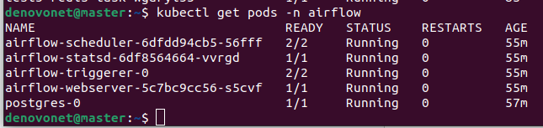

If all of the pods are running then then airflow is successfully deployed.

Use this command to check airflow node port:

kubectl get svc -n airflow

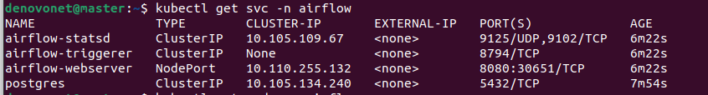

Now open your web browser and enter api-advertise-address of kubernetes along with webserver port that is 30651 for this case. You will be able to see UI.

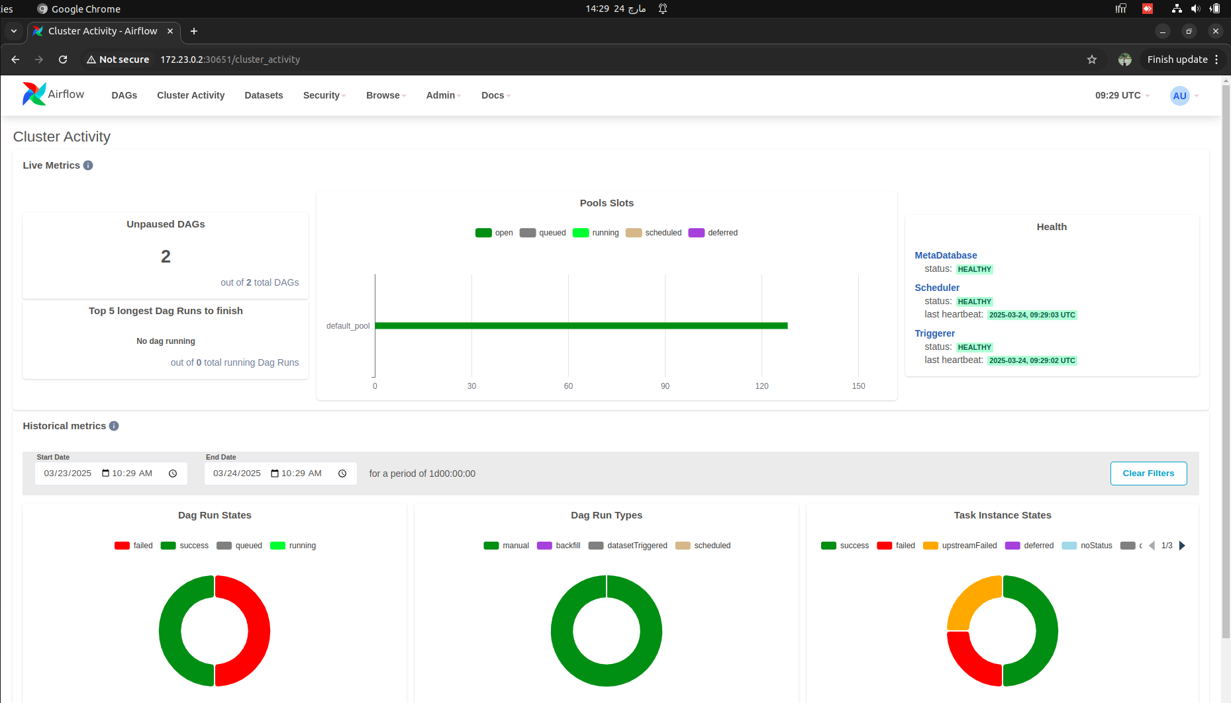

Troubleshooting Apache Airflow Deployment on Kubernetes
1. Check Pod Logs and Status
If pods are stuck in the Running stage but are not fully operational, use the following commands to inspect logs and pod descriptions:
kubectl logs <pod-name> -n <namespace>
kubectl describe pod <pod-name> -n <namespace>

Airflow follows a specific startup sequence where the first migration step completes, and then the Webserver and Scheduler become available.
2. Check Persistent Volume Binding
Sometimes, Persistent Volumes (PVs) do not bind to Persistent Volume Claims (PVCs) correctly. Verify their status with:
kubectl get pvc -n <namespace>
kubectl describe pvc <pvc-name> -n <namespace>

If PVCs are stuck in a Pending state, ensure that matching PVs exist and are available.
3. Address Unstable Webserver or Scheduler
If the Webserver or Scheduler is unstable, it may be due to insufficient resource allocation. Adjust CPU and memory limits in the values.yaml file:
resources:
requests:
memory: "512Mi"
cpu: "250m"
limits:
memory: "1Gi"
cpu: "500m"

After making changes, apply them by upgrading your Helm deployment:
helm upgrade <release-name> apache-airflow/airflow -f values.yaml

Then, restart the affected pods:
kubectl delete pod <pod-name> -n <namespace>

This should resolve common issues related to Airflow deployment stability.

Note: After making changes it is advised to delete namespace,pv and uninstall helm and redo the deployment to avoid any inconsistencies.

Airflow Test Task using KubernetesPodOperator
Below is a test task that runs a hello-world image using KubernetesPodOperator in an Airflow DAG:
from datetime import datetime
from airflow import DAG
from airflow.providers.cncf.kubernetes.operators.pod import KubernetesPodOperator

dag = DAG(
'test',
default_args={
'owner': 'bsce20007',
'start_date': datetime(2025, 3, 24),
},
schedule_interval=None, # Manual triggers only
catchup=False
)

t1 = KubernetesPodOperator(
task_id='t1',
name='t1',
namespace='airflow',
image='hello-world',
dag=dag,
is_delete_operator_pod=True,
get_logs=True
)

How to Run the Task
- Ensure that your Airflow setup is running with Kubernetes Executor enabled.
- Deploy the DAG in the appropriate DAGs folder made in worker1 node.
- Trigger the DAG manually from the Airflow UI or using the following CLI command:
airflow dags trigger test
- Monitor the task logs using:
kubectl logs -n airflow <pod-name>
- This task runs a simple hello-world container inside a Kubernetes pod and logs the output.

