

**“DATABASE PRJOJECT”**

**SUBMITTED BY:**

MUHAMMAD ABDULLAH ZAHID - 017

**SUBMITED TO:**

MA’AM ZAINAB GHAZANFAR

**UNIVERSITY MANAGEMENT SYSTEM**

1. **Student Table:**

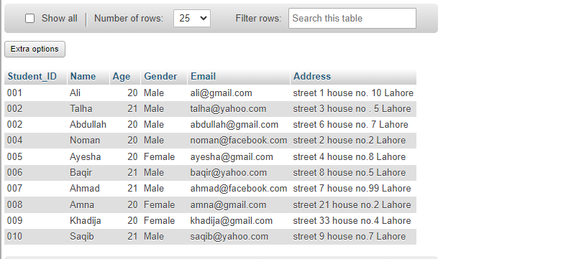

1. **Department Table:**

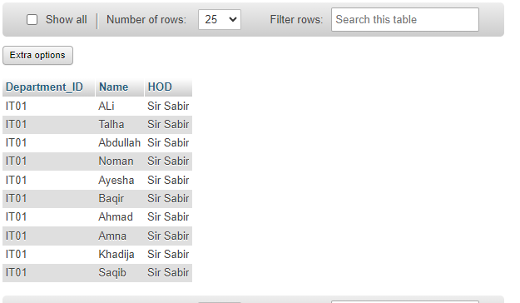

1. **Course Table:**

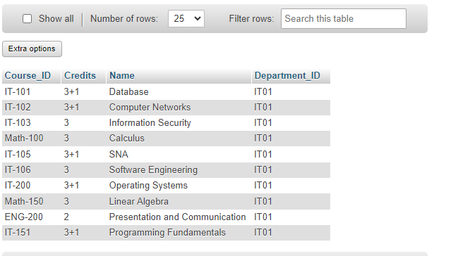

1. **Instructor Table:**

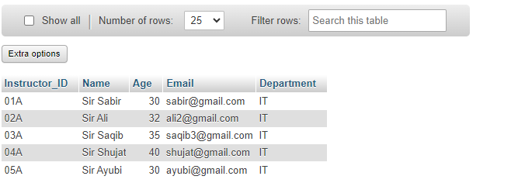

1. **Subject Table:**

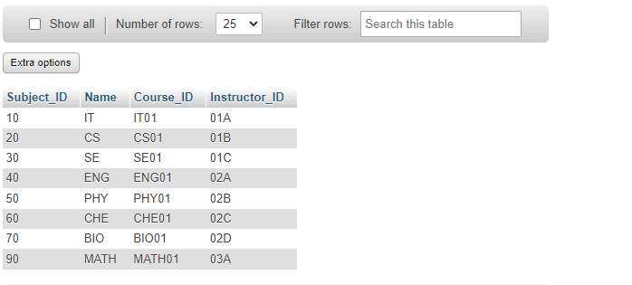

1. **Batch Table:**

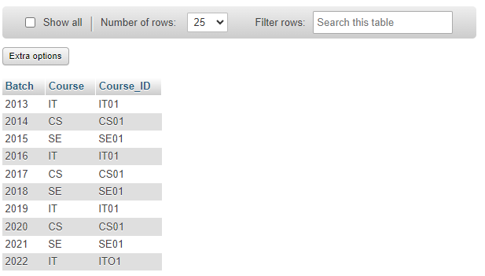

1. **Enrollment Table:**

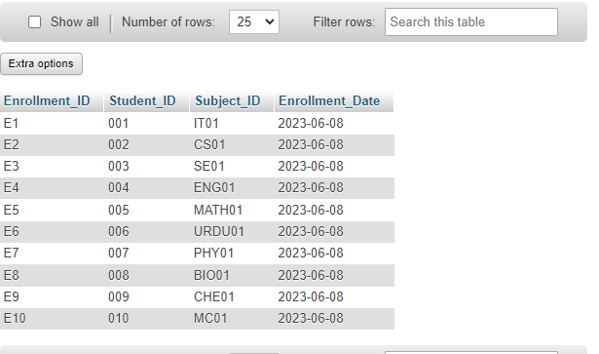

1. **Result Table:**

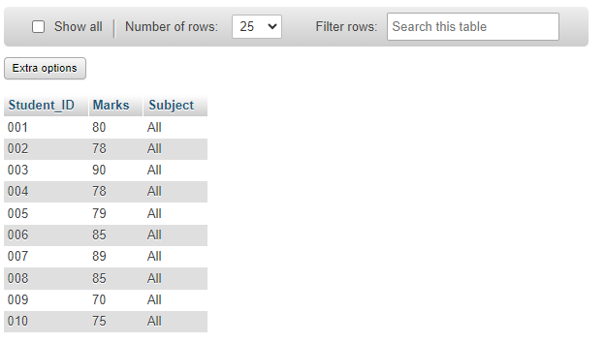

1. **Exam Table:**

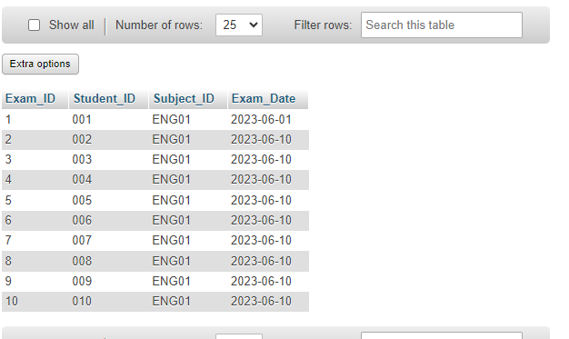

1. **Attendance Table:**

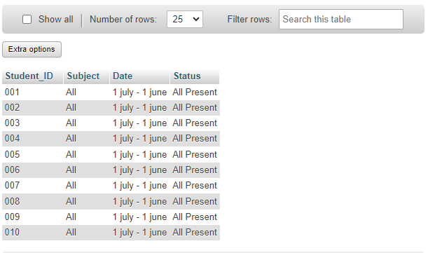

1. **Library Table:**

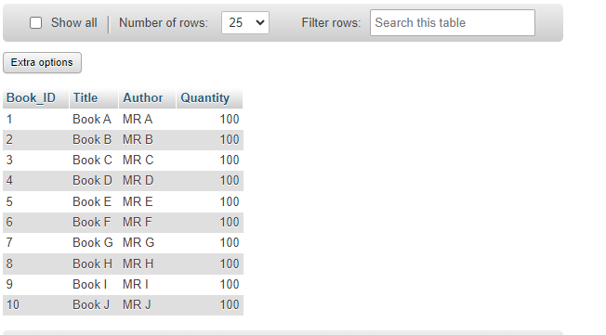

1. **Library Transaction Table:**

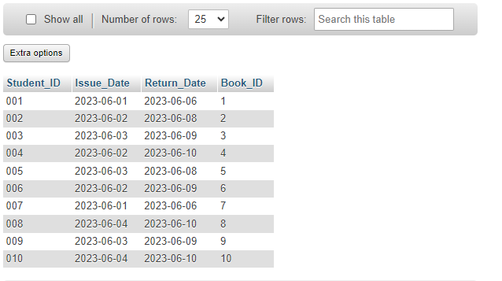

**RELATIONS:**

**1:**

A one-to-one relationship between a student and a department refers to the association between a student and their chosen department of study.

In this type of relationship, each student is assigned to only one department, and each department can have only one student associated with it. This means that a student can belong to only one department at a time, and each department can have only one student assigned to it.

**2:**

A one-to-many relationship between a student and a course in a university management system, a student can be associated with multiple courses, while each course can have multiple students enrolled in it. This relationship allows for a flexible and dynamic connection between students and the courses they participate in.

**3:**

A one-to-one relationship between a student and an instructor in a university management system means that each student is associated with one specific instructor, and vice versa. In this relationship, a student is assigned to a single instructor for their academic guidance and support, while an instructor is responsible for mentoring and teaching a specific student.

**4:**

A one-to-one relationship between an instructor and a subject in a university management system means that each instructor is associated with one specific subject, and vice versa. In this relationship, an instructor is responsible for teaching and overseeing a particular subject, while a subject is exclusively taught by one instructor.

**5:**

A one-to-many relationship between an instructor and a batch in a university management system means that one instructor can be associated with multiple batches, but each batch is associated with only one instructor. This relationship allows an instructor to teach multiple batches of students simultaneously.

**6:**

A many-to-many relationship between enrollment and attendance in a university management system signifies that multiple enrollments can be associated with multiple attendance records, and vice versa. This relationship allows for tracking the attendance of multiple students across various enrollments.

**7:**

In a one-to-many relationship between the result and exam entities in a university management system, a single exam can have multiple results associated with it. This relationship allows for the storage and management of individual students' results for a particular exam.

**8:**

In a one-to-many relationship between a library and library transactions in a library management system, a library can have multiple library transactions associated with it. This relationship allows for the tracking and management of various transactions that occur within the library.

**QUERIES:-**

**ALIAS:**

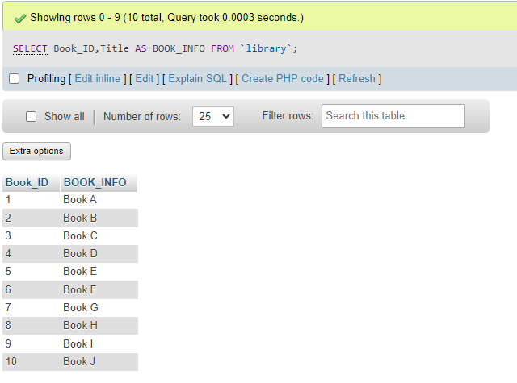

**AND:**

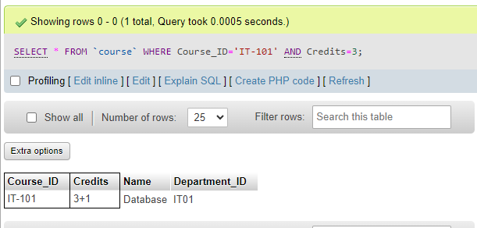

**AVG:**

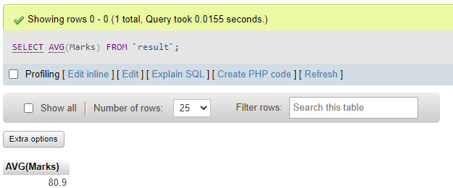

**BETWEEN:**

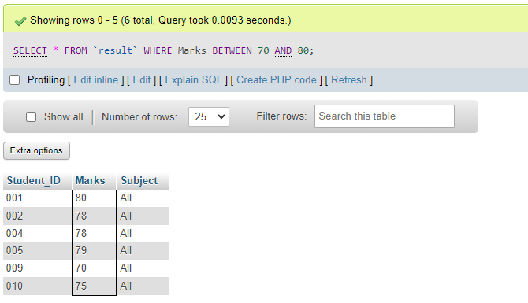

**COUNT:**

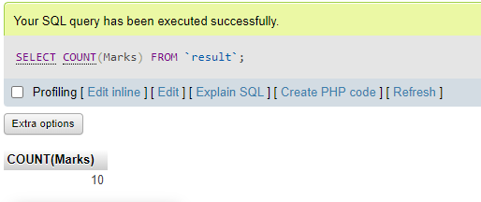

**DELETE:**

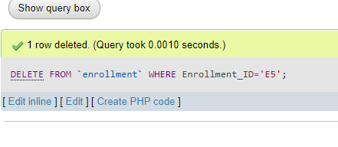

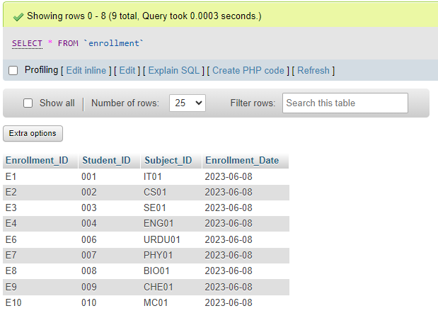

**DISTINCT:**

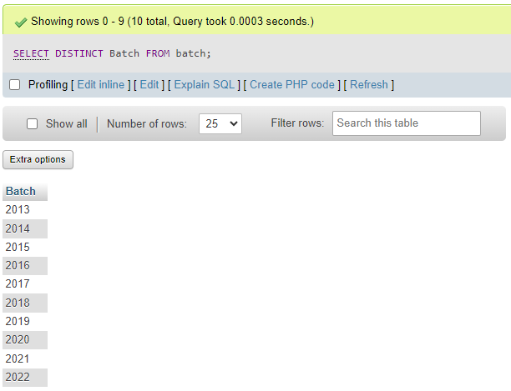

**IN:**

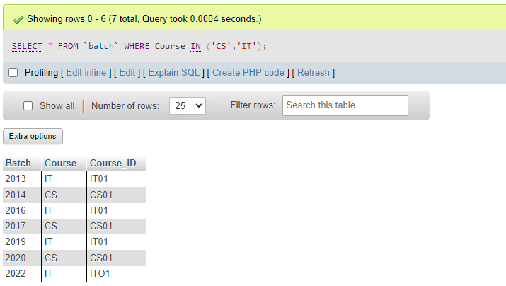

**INSERT INTO:**

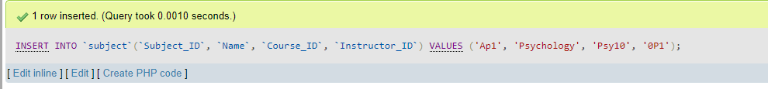

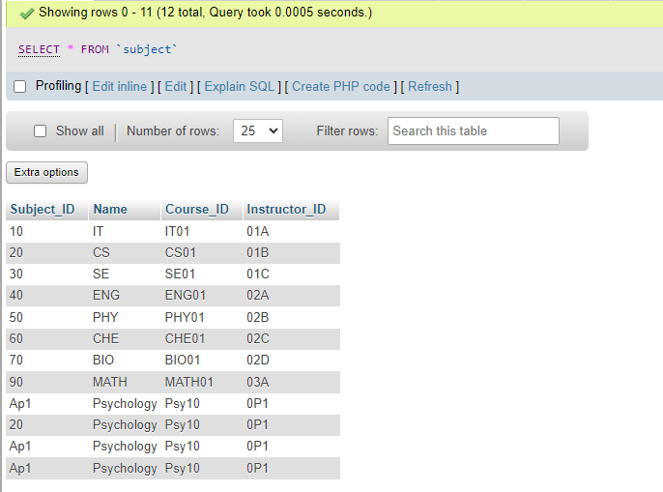

**LIKE:**

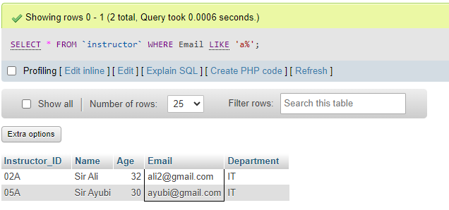

**MAX:**

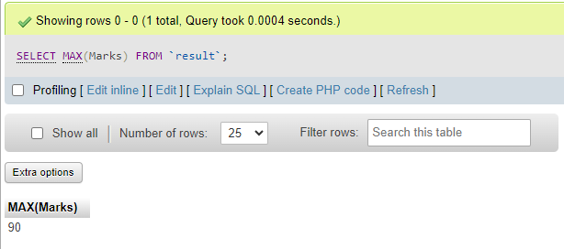

**MIN:**

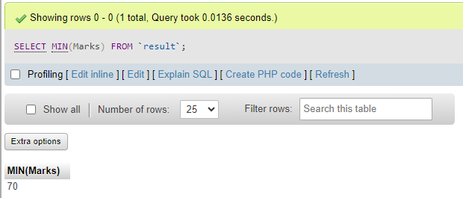

**NOT:**

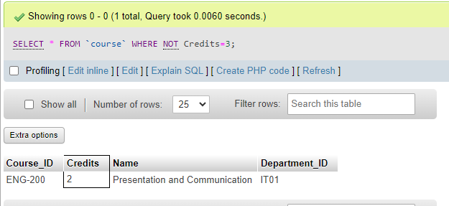

**NULL:**

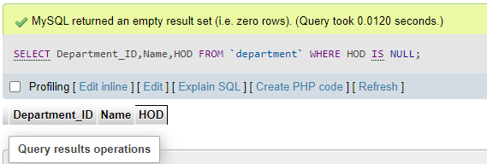

**OR:**

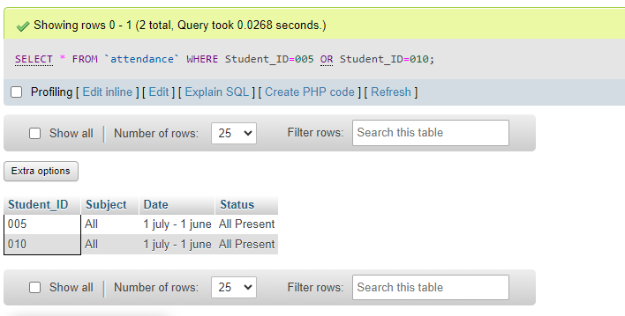

**ORDER BY ASCENDING:**

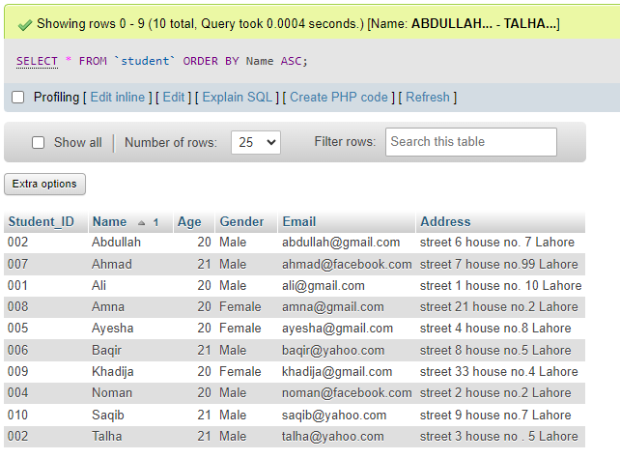

**ORDER BY DESCENDING:**

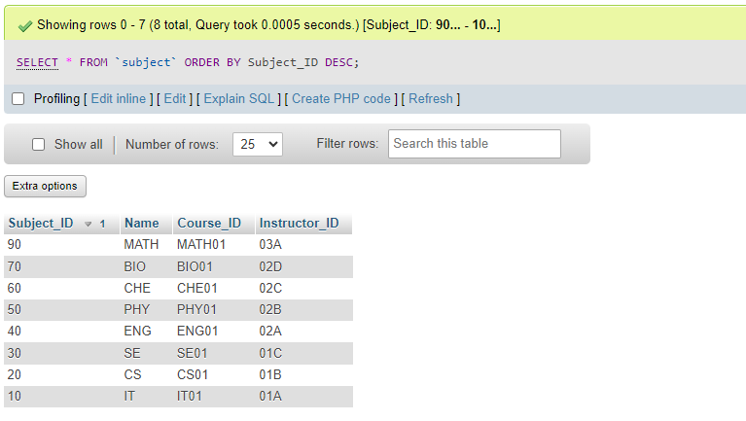

**SELECT:**

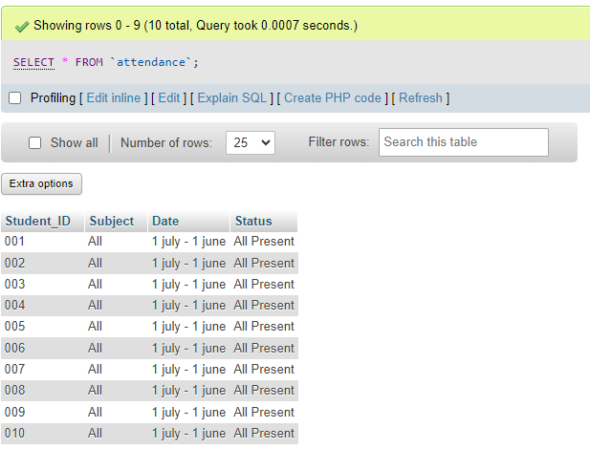

**SUM:**

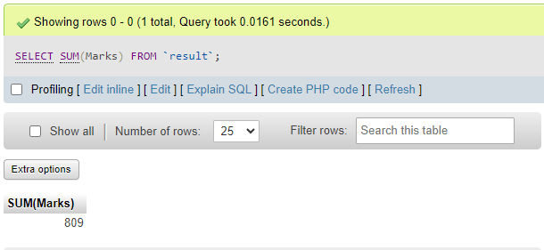

**UPDATE:**

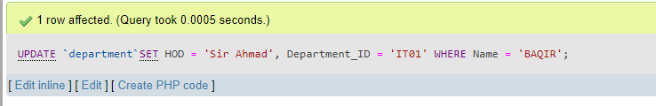

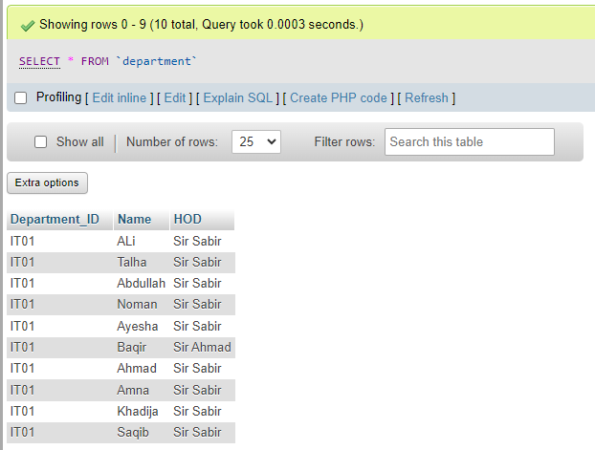

**WHERE:**

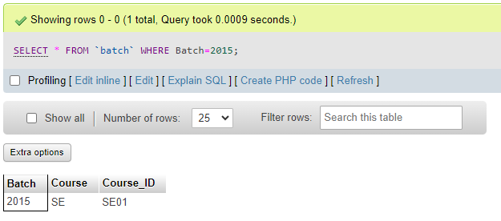

**WILDCARD:**

