**PIZZA SALES REPORT SQL QUERIES  
  
1-** Total Revenue

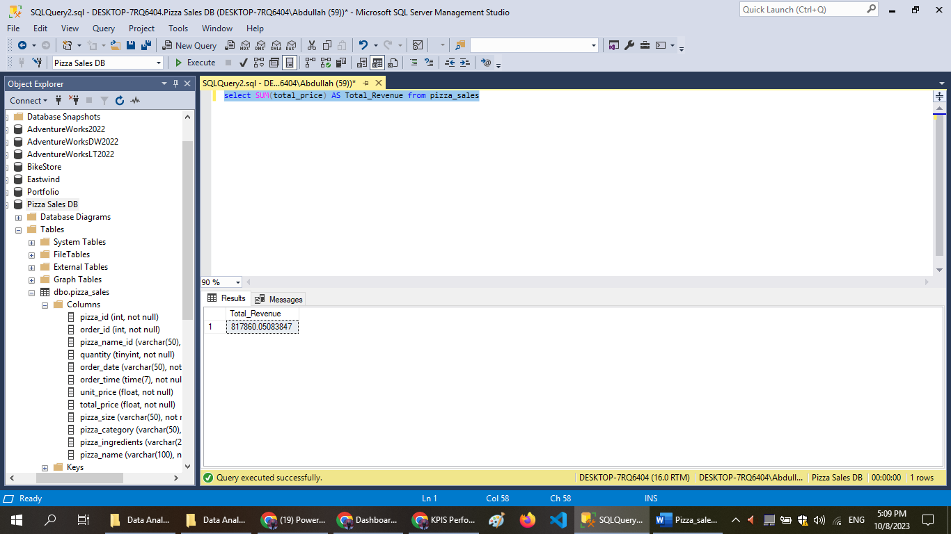  
  
2- Average order value

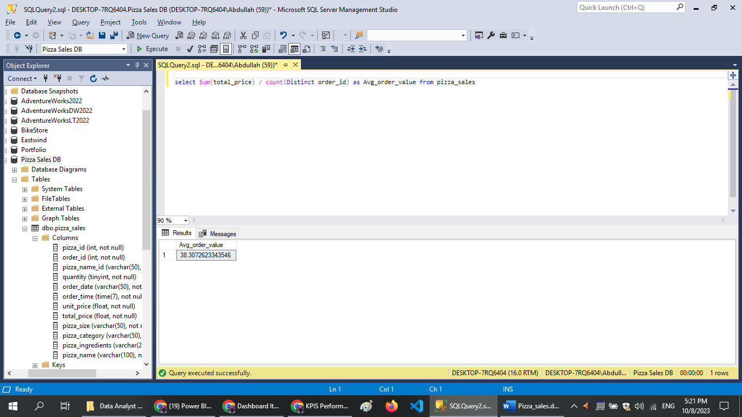  
  
3- Total Pizza Sold   
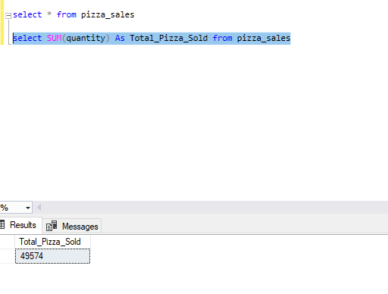  
  
4- Total Orders

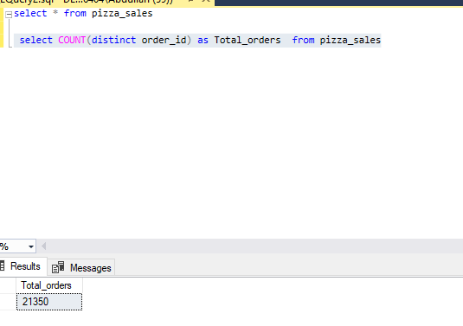  
  
5- AVG_Pizza_Per_Order  
  
