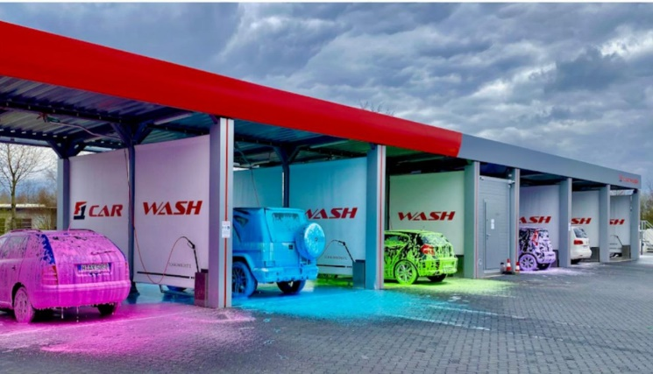**Tiba Swiss International**

**شركه طيبه سويس العالميه**

**Car washing Machine Model T.S.I 103**

**General Contractor Company**

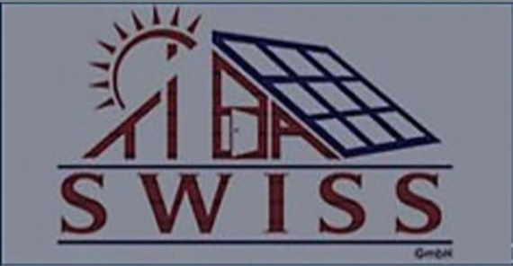**Schlosslistrasse 2**

**2504 Bie/Bienne**

**Tel . +41763435938**

**info@tibaswiss.ch**

**Benefits of automatic washingفوائد الغسيل الآلي**

**Maintain the car تحافظ علي السيارة**

**More clean for the clean نظافه اكثر للسيارة**

**Save time only five minutesتوفير الوقت فقد خمس دقائق**

**Car rust preventionالوقايه من الصدأ للسيارة**

**Friendly and maintain proofصديقه ومحافظه علي البيئه**

**of ease of payment and useسهوله الدفع والاستخدام**

**Laundry at any time الغسيل في اي وقت**

**Technical Data T.S.I 103 معلومات تقنيه عن**

|  |  |  |  |
| --- | --- | --- | --- |
| **No.** | **Type1** | **Function Specifications** | **Remarks First** |
| Frist | **OREGINAL MACHINE**  **Machine Code CA -100A**  **Normal temperature type**  **Machine Code:CA-100B Warm Water type**  **Materials inland**  **Transpiration Charges Subtotal** | **High pressure water shampoo**  **Wax**  **High pressure water**  **Shampoo**  **Wax** | **3-phase/380v**  **2.2KW**  **50m/mm**  **100Kg 10Mpa**  **-10c----40c**  **150Kgs** |
| **Second** | **Additional Charges---When You Need You Could add accordingly**  **New Voltage 110v/60bz.United States Standards**  **Special packing**  **Installation Allowance**  **Mainboard development**  **Banknots acceptor**  **Subtotal** | **60mm’’40mm’180 Mains voltage**  **3.5m Max working po**  **2000mm Water/Shampoo supply**  **All kinds of cars Water pressure**  **Shampoo spraying gun working weight**  **Wax spraying** |  |
| **Third** | **Freight Charges**  **Freight Charges**  **Insurance premium**  **Subtotal**  **Total project Value (USD)**  **PQ-109 Type**  **Main Fealures**  **High Pressure Water Washing System**  **Shampoo Springking Wash System**  **Vacumn Car Cleaner System**  **Recharge Car Collect system or coin collector system**  **Charged according to Washing time**  **Remote Control system**  **Winterization system**  **Hot-dip galvanized steel frame**  **Specifications**  **Machine dimensions**  **Hight of swing arm swing arm**  **Length of water pipe**  **Length of Electricity pipe**  **Available car to wash**  **100Kgs=high pressure pump and water gun**  **Double-Arm touchless 360 car Washing Machine** |  |  |
|  |  |  |  |
|  |  |  |  |

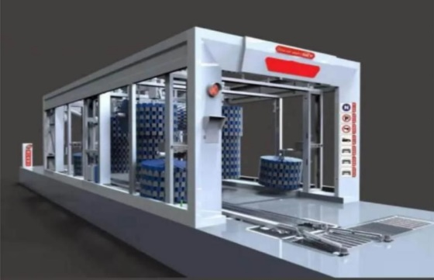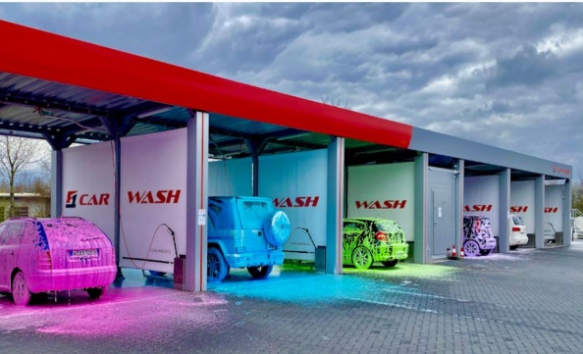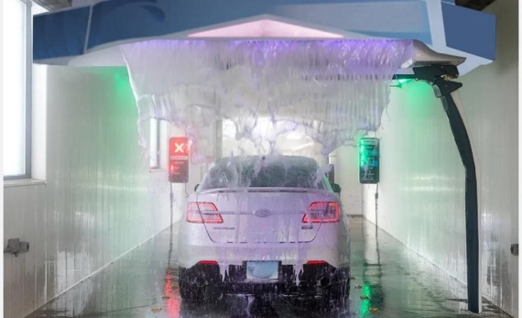

**Taiba Swiss International General شركه طيبه سويس العالميه**

**Trading and Contracting Company للتجاره العامه والمقاولات**

**Schlosslistrasse 2**

**2504 Bie/Bienne**

**Tel . +41763435938**

**info@tibaswiss.ch**