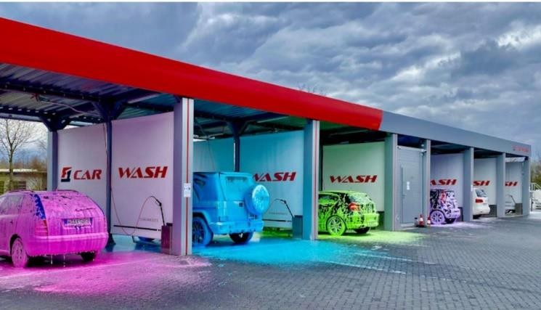International Swiss Tiba شركه طيبه سويس العالميه

Car washing Machine Model T.S.I 601

General Contractor Company

**Schlosslistrasse 2**

**2504 Bie/Bienne**

**Tel . +41763435938**

[**info@tibaswiss.ch**](mailto:info@tibaswiss.ch)

فوائد الغسيل اآللي washing automatic of Benefits

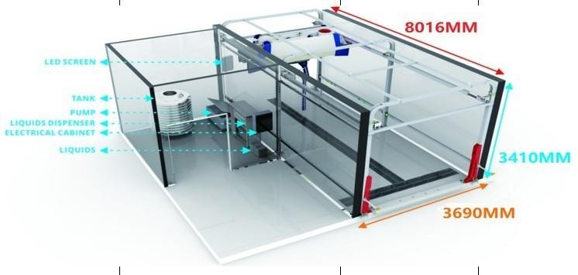

**Maintain the car**

**More clean for the clean Save time only five minutes Car rust prevention Friendly and maintain proof of ease of payment and use**

**Laundry at any time**

**تحافظ علي السيارة**

**نظافه اكثر للسيارة توفير الوقت فقد خمس دقائق الوقايه من الصدأ للسيارة صديقه ومحافظه علي البيئه سهوله الدفع واالستخدام**

**الغسيل في اي وقت**

**معلومات تنبيه عن 601 T.S.I Data Technical**

|  |  |  |  |
| --- | --- | --- | --- |
| **No.** | **Type1** | **Type2** | **Remarks** |
| **First**  **1**  **2**  **3**  **4**  **5**  **6** | **Garbage Truck AUTOMATIC CLEANING EQUIPMENT**  **Drive through type prewash equipment for big vehicles**  **Heavy duty vhiecle chassis & tyre washing equipment.**  **Rollover type big vehicle automatic washing machine**  **Drive through type blower dryer for big vehicles**  **BRUSH DRY EQUIPMENT FOR BUS AND TRUCK**  **Drive through type anti- virus chemical spraying equipment** | **EQUIPMENTS**  **CAR WASH EQUIPMENTS PARAMETERS**  **ITEM PARAMETERS (RISENSE) REMARKS**  **Applicable models**  **Garbage transportation sanitation vehicles, biomass material transportation vehicles**  **Fully meet the bidding requirements Maximum size of cleaning vehicle (mm) 2800（width**  **）×4200（height） larger than required "2600（width**  **）×4000height**  **cleaning choice "water cleaning,**  **shampoo cleaning, wax spraying""**  **cleaning models "Drive- through ,**  **Travelling rollover (brush wash,touchless wash)" brush number "Two groups of side brushes**  **(nylon filament brushes)" drying brushes "Two groups of brushes**  **(nylon filament brushes)" operation model**  **automatically and**  **munually** | **Fully meet the bidding**  **requirements**   1. **The Risen tender car washing device has the**   **function of spraying water wax, which can play a hydrophobic effect and improve the drying effect.**   1. **Excellent than the requirements of the bidding documents"**   **Excellent than the requirements of the bidding documents**  **Fully meet the bidding requirements Fully meet the bidding requirements Fully meet the bidding requirements Fully meet the bidding requirements Fully meet the bidding requirements Fully meet the bidding requirements Fully meet the bidding requirements Fully meet the bidding requirements**  **"Excellent than the requirements of 3kg/cm²**  **"Excellent than the requirements of 3kg/cm²** |

|  |  |  |  |
| --- | --- | --- | --- |
| **7**  **8**  **9**  **10**  **Second**  **1**  **2**  **3** | **special packing charges**  **installation allowance**  **materials inland transporation charges**  **Subtotal**  **Additional charges**  **freight charges insurance premium subtotal** | **cleaning capacity**  **rollover model, 1 truck/5 minutes**  **power 75kw**  **water consumption about 850L/Minute**  **air pressure ≥0.7Mpa power resource 33m (automatical cleaning area) wheel washing machine**  **"Flushing pressure: 3- 4kg/cm²**  **Cleaning range: vehicle chassis, wheels and hubs Start mode: automatic photoelectric induction start"**  **in the bidding documents" drying equipments "1.The total motor power is 6 fans * 5.5, each with a total of 33KW, 2.using the top drying**  **+ side drying method;**  **3.When the vehicle passes through the equipment for 1 minute, the air-drying rate is**  **≥90%"**  **in the bidding documents" Sewage treatment system**  **vehicle guidance system**  **DOCUMENTS**  **Software System Garage truck washing**  **information management system**  **Unattended car wash system** |  |

|  |  |  |  |
| --- | --- | --- | --- |
|  |  | **Monitoring room hardware equipment**  **Server-Dell Brand** |  |
| **Third** | **Total project value (USD)** |  |  |
| **Fourth**  **A B**  **C** | **Garbage Truck AUTOMATIC CLEANING EQUIPMENT**  **General Introductions**  **Project Name:Domestic waste emergency comprehensive treatment project**  **Overall rendering of the car wash fields (13 lines)**   1. **Our garbage truck washing machines can also wash buses and trucks** 2. **Based on original CB- 730,We** |  |  |

|  |  |  |  |
| --- | --- | --- | --- |
| **C1**  **C2** | * 1. **remain the side brushes to wash the truck sides**   2. **delete top brush,**   3. **PROFILED wash the front and rear of the garbage truck with high-pressure water."**   **the Bus Washing Machine CB-730 can't wash the garbage trucks,**  **because the tail of garbage trucks is irregular. "** |  |  |

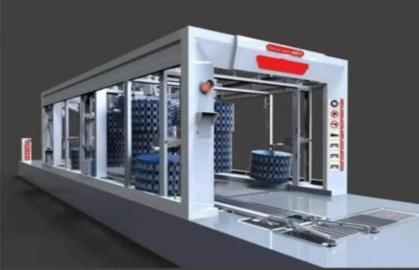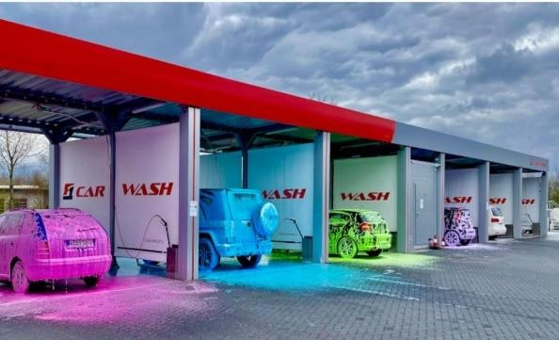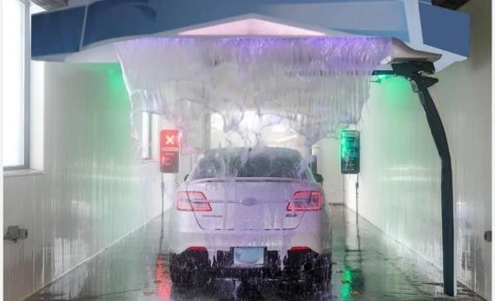

شركه طيبه سويس العالميه General International Swiss Taiba للتجاره العامه والمقاوالت Company Contracting and Trading

**Schlosslistrasse 2**

**2504 Bie/Bienne**

**Tel . +41763435938**

[**info@tibaswiss.ch**](mailto:info@tibaswiss.ch)