Individual Embedded Assignment #1
Abdullah Mortada 202200659

Table of Contents
Design Architecture 2
Software Implementation 3
Test Cases 4
Bill of Materials 5

Design Architecture

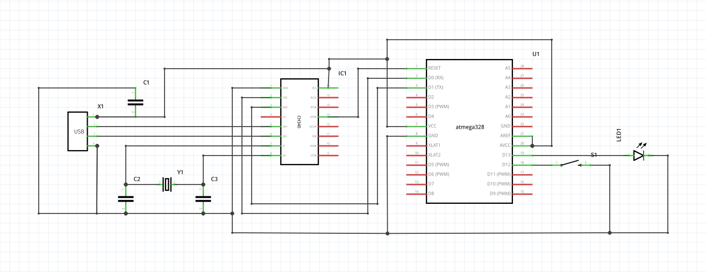
Above are the internal connections between components. Most of these components come pre-soldered onto the Arduino dev board.

The USB connector is used to power the whole system, and to interface by using the data pins on the connector. These pins are connected to a CH340 serial chip, which is necessary to enable communication between our system and a computer or other device.
The CH340 encodes the data into serial format, which is the format used for flashing Arduino ROM, and is the format needed for UART protocol, our protocol of choice for this project. The CH340’s clock signal is set by the crystal oscillator (keep in note some ch340 chips have a built-in crystal) , and it’s internal reset is controlled by the atmega328’s reset pin. The RX and TX pins on the CH340 are connected to the TX and RX pins on the atmega328 respectively to enable full-duplex data transmission.
For our application, the atmega328 needs to be connected to an LED, and to a push button. The button is connected to a digital pin with the internal pull-up resistor and grounded on the other terminal.

Software Implementation

All code and documents used are available on the github repo: https://github.com/abdullahmortada/EmbeddedProject1-23

The program runs using two interrupts, one which triggers when the button’s pin value changes, and the other is assigned to the RX pin, meaning it triggers when new data is loaded into the UDR register and clears when the buffer is flushed.

Button Interrupt handler: Simply checks if the button is pressed ( which would be value 0 as we are using a pull-up resister ), and sends the string “button pressed\n” over UART if it is pressed.

RX Interrupt handler: Receives the new data from UDR, then adds it to a character array, as long as the data received is not a newline character or end character, in which case the data is not added to the buffer but instead sets a flag for the main loop to handle.

Main loop: Waits for the “received” flag, then disables the flag and compares the data in the character array to the strings “led on” and “led off” using the standard library function “strncmp”. If the string is a match the appropriate action to turn the led on or off is taken.

uart.c: Simple helper functions to complete UART protocol related functions, like setting the baud rate in UBRR register, enabling RX and TX modes and transmitting and receiving data.

Test Cases

Test Case | Action | Test Data | Expected Result | Actual Result | Pass/Fail
LED normal usage | Type “led on” in serial monitor | “led on\n” | LED turns on | LED turns on | pass
 | Type “led off” in serial monitor | “led off\n” | LED turns off | LED turns off | pass
 | Do not type anything |  | nothing happens | nothing happens | pass
LED incorrect usage | Misspell commands | eg. “ledop\n” or “led offf\n” | nothing happens | nothing happens | pass
 | Type “led on” while on or off while off |  | LED stays in current state | LED stays in current state | pass
 | Type random characters of correct length | eg. “eef zq” or “beg hr” | Data ignored | Data ignored | pass
 | Insert an end character CR or new line character |  | nothing happens | nothing happens | pass
Button normal usage | Press button |  | “button pressed\n” shows in serial monitor | “button pressed\n” shows in serial monitor | pass
 | Do not press button |  | nothing happens | nothing happens | pass
Button incorrect usage | Press button repeatedly |  | text printed in serial monitor the same number of times as there were pressed | text printed in serial monitor the same number of times as there were pressed | pass
 | Hold button down |  | text printed one time only | text printed one time only | pass
 | Press button while inputting “led on” in serial monitor |  | text printed on serial monitor and LED turns on | text printed on serial monitor and LED turns on | pass

Bill of Materials
Un-optimized Samples During Development:

Part Name | Description | Price / LE | Link
Arduino Dev Board | Arduino rev3 board with atmega328p mcu and ch340 serial chip | 240 | https://makerselectronics.com/product/arduino-uno-rev3-smd
LED | LED | 1 | https://makerselectronics.com/product/led-green-8mm
Breadboard | small size breadboard | 23 | https://makerselectronics.com/product/breadboard-400-points
Button | 2-terminal push button | 0.75 | https://makerselectronics.com/product/mini-push-button-2-pin-6x6x7-3mm
 | Total / Unit | 264.75

Optimized BOM for production:
Part Name | Description | Price / LE | Link
ATMEGA328PB SMD | microcontroller chip to be soldered on PCB | 55 (1.78 $) | https://www.tme.eu/eg/en/details/atmega328pb-au/8-bit-avr-family/microchip-technology/?brutto=1&currency=USD&gclid=EAIaIQobChMI847QsojngQMVqDkGAB17fQjXEAQYASABEgIbbvD_BwE
CH340 | USB to UART converter IC | 27 | https://uge-one.com/ch340g-usb-to-uart-ttl-converter-ic-smd-sop-16.html?gclid=EAIaIQobChMI0NvC6ITngQMVvUNBAh03KwwgEAYYAiABEgKP2_D_BwE
Custom PCB board | 20 custom 2x4 PCB boards for 176 LE | 9 | https://www.nti.sci.eg/pcblab/
SMD 5V LDO voltage regulator | 100mA 5V solderable voltage regulator to power MCU | 1 | https://uge-one.com/voltage-regulator-78l05-5v-100ma-smd-sot89.html
SMD push button | solderable push button | 2 | https://uge-one.com/smd-micro-push-button-switch-2p-3x4x2mm.html
SMD led | solderable led | 1 | https://uge-one.com/led-smd-1206-green.html
USB connector | USB connector to be soldered | 3 | https://makerselectronics.com/product/usb-connector-on-pcb-a-type-male-smd
Capacitor | SMD 10uF capacitor | 1 x 3 | https://uge-one.com/smd-chip-ceramic-capacitor-size-0805-10uf.html
Crystal oscillator | Quartz oscillator 16 mhz | 5 | https://uge-one.com/hc49-smd-quartz-crystal-oscillator-16mhz.html
 | Total / Unit | 106

