**Final Year Project Report**

**Project Name**



**Project Advisor:**

**Mr. Rana Waqas Ali**

**Submitted by:**

**F2017266203 Abdullah Mujahid**

**F2017266236 Amna Ramzan**

**F2017266241 Rahib Nazir Butt**

**F2017266351 Habiba Naeem**

**Session**

**2017-2021**

**University of Management and Technology**

**C-II Johar Town Lahore Pakistan**

**Dedication**

All the praise to all mighty ALLAH for bestowing us with the courage, knowledge, health and wisdom to carry out this project and for his love, mercy and grace in our life and specially during our four years in university. We are greatly indebted to our parents, without their endless financial moral support, patience and prayer the very idea of this project was impossible.

We would like to pay our humble gratitude to our project advisor Mr. Rana Waqas Ali for guiding us and providing us the opportunity to work under his guidance. His encouragement was the main source and strength to stimulate us to complete the project for their valuable guidance co-corporation and constant inspiration. We are also grateful to all faculty members of University of Management and Technology for the facilities that were provided to us even in the period of pandemic because every complete successful assignment is the result of many hands joined together.

## 

**Final Approval**

**Panel of Examiners**

* **Head of Department**  ______________________

Department of Computer Science

UMT Lahore

* **Program Director ( Final Year Projects)** ______________________

Department of Computer Science

UMT Lahore

* **Supervisor** ______________________

Department of Computer Science

UMT Lahore

* **Co-Supervisor** ______________________

**Acknowledgment**

**Project Title Big Brains**

**Objective** To fill the online education study gap for certain subjects whose resources weren’t available, searchers have to go through a single platform and use the e-learning social network to get help anytime anywhere.

**Undertaken by** Abdullah Mujahid, Amna Ramzan, Rahib Nazir Butt, Habiba Naeem

**Supervised by** Mr. Rana Waqas Ali

**Starting Date** Monday, 16 November 2020

**Completion Date** N.A

**Tools Used** NodeJS v.12, MongoDB Community Server, Visual Studio Code.

**Operating System** Windows & MacOS

**Documentation** Microsoft Word

**Plagairism ReportAbstract**

No matter which educational sector you belong to from time to time every student

encounters divergent problems and the only option they have other than the institute is to look

it up over the internet, sometimes they do find the solution to their problem and sometimes

they don’t and when comes to subjects like chemistry, biology, linguistics there’s a slight

chance that they can get help most of the time they don’t get the required help they were

looking for. Sometimes they have to pay for something that isn’t that much worth of work. In

our lives, we all have been there and above all, up till today, there exists no such platform

which is subject-categorized and helps students with zero cost. Several platforms are

dedicated to a single subject sector, such subjects include Computer Science, Mathematics,

and a few others but there’s no collective resource network for a student that highlights

subjects like Biology, Chemistry, Linguistics, etc. Moreover, sometimes user creates multiple

same questions and sometimes the question is already answered but the student is unable to

find that question so he/she post that again which is not a good thing for both student and the

system.

The proposed solution “Big-Brains” will provide a cost-free tribune that will allow the

questioner to post his question or to share insightful ideas, resources, or his/her exploration

related to the concerned subject. Big-Brains is not just dedicated to a single subject. The

mission of the big-brains is to cover the maximum subject group so that a questioner doesn’t

have to wander to other internet resources to find the solution to his/her problem. At Big-

Brains not only students help each other out but industrial and educational professionals will

strive hard to help the questioner to find the solution. As in this current year, we have seen a

steep incline towards the online education system at this point Big-Brains is a Lightbringer

for the students.

Revision Chart

| Version | Primary Author(s) | Description of Version | Date Completed |
| --- | --- | --- | --- |
| *Draft* | Abdullah Mujahid, Amna Ramzan,  Rahib Nazir Butt,  Habiba Naeem | The 1st five chapters of the documentation have been created for distribution and review comments. | (To be decided) TBD |
| *Preliminary* | Abdullah Mujahid, Amna Ramzan,  Rahib Nazir Butt,  Habiba Naeem | Second draft incorporating initial review comments, distributed for final review | TBD |
| *Final* | Abdullah Mujahid, Amna Ramzan,  Rahib Nazir Butt,  Habiba Naeem | First complete draft, which is placed under change control | TBD |

# Contents

*New paragraphs formatted as Heading 1, Heading 2, and Heading 3 will be added to the table automatically. To update this table of contents in Microsoft Word, put the cursor anywhere in the table and press F9. If you want the table to be easy to maintain, do not change it manually.*

Contents 1

Definitions and Acronyms 3

List of Figures 4

List of Tables 5

1. Introduction 6

1.1 Motivations 6

1.2 Project Overview 6

1.3 Problem Statement 6

1.4 Objectives 6

2. Domain Analysis 7

2.1 Customer 7

2.2 Stakeholders 7

2.3 Affected Groups with social or economic impact 7

2.4 Dependencies/ External Systems 7

2.5 Reference Documents 7

2.5.1 Related Projects 7

2.5.2 Feature Comparison 8

3. Requirements analysis 9

3.1 Requirements 9

3.2 List of Actors 10

3.3 List of use cases 10

3.4 System use case diagram 10

3.5 Extended use cases 10

3.6 User interfaces (mock screens) 12

4. Data flow diagram (optional) 13

4.1 Data Flow Diagram Level 0 13

4.2 Data Flow Diagram Level 1 13

4.3 Data Flow Diagram Level 2 13

5. System Design 15

5.1 System Architecture Diagram 15

5.2 Class Diagram 16

5.3 Collaboration Diagrams 17

5.4 Other UMLs 18

5.5 ERD 18

5.6 Data Dictionary 18

6. Implementation details 19

6.1 Development Setup 19

6.2 Deployment setup 19

6.3 Algorithms 19

6.4 Constraints 19

6.4.1 Assumptions 19

6.4.2 System constraints 19

6.4.3 Restrictions 19

6.4.4 Limitations 19

7. Testing 20

7.1 Extended Test Cases 20

7.2 Decision Table 20

7.2.1 Code snippet 20

7.2.2 Decision coverage table 20

7.3 Traceability Matrix 21

7.3.1 RID vs UCID (requirements vs use cases) 21

7.3.2 Prototypes (RID vs PID) 22

7.3.3 Test Cases (RID vs TID) 22

7.3.4 Coverage (UCID vs TID) 22

8. Results/Output/Statistics 23

8.1 %completion 23

8.2 %accuracy 23

8.3 %correctness 23

9. Conclusion 24

10. Future work 25

11. Bibliography 26

11.1 Books 26

11.2 Journals 26

11.3 Articles 26

11.4 Research papers 26

11.5 Other References 26

12. Appendix 27

12.1 Glossary of terms 27

12.2 Pre-requisites 27

## Definitions and Acronyms

*Provide definitions or references to all the definitions of the special terms and acronyms used within this document*

e.g

|  |  |
| --- | --- |
| **Acronym** | **Definition** |
| UMT | University of Management and Technology |
| POS | Point of Sale |

Table 1: table of acronyms and definitions

## List of Figures

New figures that are given captions will be added to the table automatically.

* **Insert caption:**
  1. select picture
  2. right click
  3. select “insert caption”
  4. under “options”, choose label as “figure”
  5. Under “caption”, an automatic insertion of “figure no” will appear. Give your figure an appropriate caption
* **Update list of figures:**To update this list in Microsoft Word, put the cursor anywhere in the table and press F9.
* **Note:**  If you want the table to be easy to maintain, do not change it manually.

Figure 1: sample use case diagram with explanation 10

Figure 2: System Architecture 15

## List of Tables

New Tables that are given captions will be added to the table automatically.

* **Insert caption:**
  1. select picture
  2. right click
  3. select “insert caption”
  4. under “options”, choose label as “table”
  5. Under “caption”, an automatic insertion of “table no” will appear. Give your table an appropriate caption
* **Update table:** To update this table of contents in Microsoft Word, put the cursor anywhere in the table and press F9.
* **Note:**  If you want the table to be easy to maintain, do not change it manually.

Table 1: table of acronyms and definitions 3

Table 2: list of stakeholders 7

# Introduction

## Motivations

The sole purpose behind this application is to quickly capture and equalized the distributed educational market not just in Pakistan but throughout the world, as up till now there’s no specific cost free platform that offers help regarding studies over the internet. Free services up till now are either restricted to a single subject domain or doesn’t have the authenticity of the solution produced the other paid services charges abundance amount of money to offer something that sometimes doesn’t have enough value and there’s a guilt of doubt still left that whether we are getting the worth of an answer with that amount! Big Brains aims to provide a complete package which will serve as a gift for all its user which will help every searcher from every subject domain.

## Project Overview

Big-Brains is an e-learning social network that will provide a student interconnected learning platform that is backed up by students and educational professionals helping each other to solve problems and exploring new things. Big-brains is not restricted to a single educational domain; it is a collective network which offers students from different domains to ask questions or share their explorations with the world. Providing follower and adherent features attract a lot of learning communities as profile building is the most overpowered thing in the social world. With dynamic subject routing new and new subjects can be added by users increasing the scope of Big-Brains and expanded its resources. No matter which educational sector you belong to from time to time every student encounters divergent problems and the only option they have other than the institute is to look it up over the internet, sometimes they do find the solution to their problem and sometimes they don’t and when comes to subjects like chemistry, biology, linguistics there’s a slight chance that they can get help most of the time they don’t get the required help they were looking for. Sometimes they have to pay for something that isn’t that much worth of work. In our lives, we all have been there and above all, up till today, there exists no such platform which is subject-categorized and helps students with zero cost. Several platforms are dedicated to a single subject sector, such subjects include Computer Science, Mathematics, and a few others but there’s no collective resource network for a student that highlights subjects like Biology, Chemistry, Linguistics, etc. Moreover, sometimes user creates multiple same questions and sometimes the question is already answered but the student is unable to find that question so he/she post that again which is not a good thing for both student and the system.

The proposed solution “Big-Brains” will provide a cost-free tribune that will allow the questioner to post his question or to share insightful ideas, resources, or his/her exploration related to the concerned subject. Big-Brains is not just dedicated to a single subject. The mission of the big-brains is to cover the maximum subject group so that a questioner doesn’t have to wander to other internet resources to find the solution to his/her problem. At Big- Brains not only students help each other out but industrial and educational professionals will strive hard to help the questioner to find the solution. As in this current year, we have seen a steep incline towards the online education system at this point Big-Brains is a Light bringer for the students.

The developed product will fill the huge gap that exists on the internet where there is a lack of resources available for all subject groups. With the trend going where the traditional method of receiving an education is overtaken by online methods at the same time we can see the increased use of the internet, according to the Statista survey 59% of the global population actively uses the internet and Pew Research said in a survey that roughly every 6 in ten students access the internet to do homework which is 58% of the total youth and up till now no cost-free platform is giving proper exposure to the need. Big-Brains on the other hand key focus is to fill the gap. Big-Brains will be covering the maximum audience by offering a network of different subjects which will help all the student body now they don’t have to visit different websites and to pay for anything.

There’s no specific audience of Big-Brains as discussed earlier Big-Brains customer or the target market is every person who’s using internet and studying. So the segmentation of customers isn’t based on demographic or any other factor there’s a great and vast extend of the user base these users comes under the three of the major categories primary, secondary and tertiary. These categories involve users that are frequent user such users are primary users they can be students who are studying a certain chapter or a certain subject and frequently uses this application to get help. Then comes users who just uses this platform rarely such users can be like a software developer who’s stuck on a problem and need guidance to how he can solve this problem such user’s cases only uses application to solve their problem than there can be no next time for that particular user so such users come in the category of secondary users. Just like other two categories there can be tertiary users of this application as this user category is immersive.

The main goal of the application is to develop a web-based application that can capture the audience and provide them ease with a complete set of education network resources free of cost at initial however there will be certain features which will be comprehended in future allows user to access resources that are beyond the scope of a normal user however this standard features are still going to help users as the general services are free at cost and as promised the application won’t be holding any vault system the only achieves will be posts that are old and doesn’t hold enough information to be forward. There’s no need for any special hardware for Big-Brains. It is a web application so there’s no special hardware requirement so for the development. Coming towards the software, as Big-Brains is a MERN (MongoDB, Express, React Node) based application there won’t be much software dependencies because the whole application is based on JavaScript so for the local development environment.

Following are the sample artifacts for this section:

* Problems or Overview Statement
* Customer
* Goals
* System functions
* System attributes

## Problem Statement

The

## Objectives

What objectives (outcomes) do you expect to achieve on the completion of this project. e.g.

* Give precise allocation of class rooms
* Generate an image analysis system for suspect identification
* Analysis of data for fraud detection
* …

# Domain Analysis

## Customer

A brief description of the client with whom you are working (or the potential customers). The organization, its products/services etc.**You will fill this section only if you have a client (contracted) .**

## Stakeholders

List of all stakeholders along with their roles in making of the system e.g

|  |  |
| --- | --- |
| **Stakeholder** | **Role in System** |
| Class coordinator | He is responsible for allocating classrooms for different department. In case of clash/missed classes, he is responsible for entering the details in the system. At the end of the week, he can request the system to generate appropriate reports on no. of clashes reported or missed classes. |

Table 2: list of stakeholders

## Affected Groups with social or economic impact

Those impacted by the deployment of the system. This can be a simple list as well as a bulleted one with short explanations. **Link them with your objectives**

e.g.

* Sales staff

There will be reduced paper work for them. Also they will be able to provide better customer care as system will help them respond to queries quickly.

This may include users as well as support groups

## Dependencies/ External Systems

Systems and/ or products, this project depends upon for its completion.

e.g.

* Cyber Cash

## Reference Documents

Provide references to all documents that have been consulted during the analysis phase.

### Related Projects

List of all the documents/ projects that you have looked up as reference material for this project along with their links/references. E.g

In order to develop UMTmanagementSystem, we looked up several similar systems. Their details are given below

1. FastManagementSystem(FMS)

Developed by XYZ. The partial documentation was obtained by the XYZ development team and the working of this management software was observed from abcFAST.com.pk

1. BeaconHouse Management System (BHMS)

Developed by ABC. the working of this management software was observed from abcbeaconhouse.com.pk. no relevant documentation was available.

1. “constructing and ideal academic system” (CIAS)

Research paper published by IEEE. The research paper is not available for free. It is only available to IEEE members

### Feature Comparison

|  |  |  |  |  |  |
| --- | --- | --- | --- | --- | --- |
| Sr No. | Comparison Feature | FMS | BHMS | CIAS | remarks |
| 1 | ABC | FMS covers the feature ABC completely as desired | BHMS does not support feature ABC | CIAS suggests that maximum efficiency can be achieved if ABC is implemented using algorithm abc. | Using the ABC feature from FMS and improving it with abc algorithm can provide maximum efficiency |

# Requirements analysis

## Requirements

*This section is can be skipped, if Requirement Specifications document has been developed for the project. Otherwise this section is mandatory.*

*This section may contain*

*End user, operator, support, or integration functions,*

*Performance requirements,*

*Design constraints,*

*Programming language, and*

*Interface requirements.*

*System functions are descriptions of what a system is supposed to do. They should be identified and listed in logical cohesive groups, with their category (priority) assigned. These system functions will be identified as a result of the requirement gathering process conducted with the client. However, in some cases, prior to the development of the Functional Specifications the requirements may already have been listed in a document: if this is so then a reference to the document may suffice.*

*To verify that some* ***X*** *is indeed a system function; it should make sense in the following sentence:*

*The system should do <****X****>*

*The table below gives an example of how system functions can be listed:*

*The Functions column gives a brief one-line description of the required functionality.*

*The Category column refers to the status of the functionality for the proposed system. The options for the Category are defined below.*

*The Attribute column defines the system characteristics. The Details and Constraints column specifies the conditions within which the attribute is applicable. Section 1.12 defines the default Attributes and the related Constraints. In case, the default conditions are to be over-ridden then the conditions can be defined in this table.*

*Function Categories*

|  |  |
| --- | --- |
| ***Functional Requirements*** | ***The services requested by the user*** |
| *Non-Functional Requirements* | *The supporting requirements for functional requirements. Theses include the* ***measureable*** *quality attribute.* |
| *Data Requirements* | *How your data will be stored* |
| *Constraints* | *by the client On your system* |
| *External interface requirements* | *How will your system connect to other software/components* |

|  |  |  |  |  |
| --- | --- | --- | --- | --- |
| *RID* | *description* | *Category* | *Attribute* | *Details & Boundary Constraints* |
| *R1.1* | *Record the underway sale – the items purchased* | *non-functional* | *System Response time* | *Price listing within 3 seconds*  *Availability agreement in less than 10 sec* |
| *R1.2* | *Reduce inventory quantities when a sale is committed* | *non-functional* | *Concurrent user load* |  |

## List of Actors

Define the system boundary and list all actors with the use cases.**all the actors must also be mentioned in your list of stakeholders**

For example:

Cashier; this person performs all the financial activities

Account Manager; this person supervises all financial activities

## List of use cases

List all the use cases, with a brief description (should not exceed two lines):

Buy Item; captures a sale and its payment

Log In; allow user to provide account information and access the restricted services

## System use case diagram

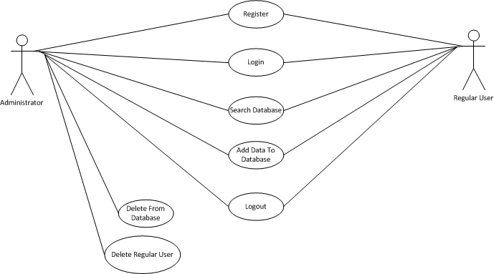

Figure 1: sample use case diagram with explanation

## Extended use cases

Every use case form the list must be elaborated here. E.g

|  |  |  |  |  |
| --- | --- | --- | --- | --- |
| **Use Case ID:** | Enter a unique numeric identifier for the Use Case. e.g. UC-1.2.1 | | | |
| **Use Case Name:** | Enter a short name for the Use Case using an active verb phrase. e.g. Withdraw Cash | | | |
| **Created By:** |  | | **Last Updated By:** |  |
| **Date Created:** |  | | **Last Revision Date:** |  |
| **Actors:** | | [An actor is a person or other entity external to the software system being specified who interacts with the system and performs use cases to accomplish tasks. Different actors often correspond to different user classes, or roles, identified from the customer community that will use the product. Name the actor that will be initiating this use case (primary) and any other actors who will participate in completing the use case (secondary).] | | |
| **Description:** | | [Provide a brief description of the reason for and outcome of this use case.] | | |
| **Trigger:** | | [Identify the event that initiates the use case. This could be an external business event or system event that causes the use case to begin, or it could be the first step in the normal flow.] | | |
| **Preconditions:** | | [List any activities that must take place, or any conditions that must be true, before the use case can be started. Number each pre-condition. e.g.   1. Customer has active deposit account with ATM privileges 2. Customer has an activated ATM card.] | | |
| **Post conditions:** | | [Describe the state of the system at the conclusion of the use case execution. Should include both *minimal guarantees* (what must happen even if the actor’s goal is not achieved) and the *success guarantees* (what happens when the actor’s goal is achieved. Number each post-condition. e.g.   1. Customer receives cash 2. Customer account balance is reduced by the amount of the withdrawal and transaction fees] | | |
| **Normal Flow:** | | [Provide a detailed description of the user actions and system responses that will take place during execution of the use case under **normal, expected** conditions. This dialog sequence will ultimately lead to accomplishing the goal stated in the use case name and description.   1. Customer inserts ATM card 2. Customer enters PIN 3. System prompts customer to enter language performance English or Spanish 4. System validates if customer is in the bank network 5. System prompts user to select transaction type 6. Customer selects Withdrawal From Checking 7. System prompts user to enter withdrawal amount 8. … 9. System ejects ATM card] | | |
| **Alternative Flows:**  **[Alternative Flow 1 – Not in Network]** | | [Document **legitimate** branches from the main flow to handle special conditions (also known as extensions). For each alternative flow reference the branching step number of the normal flow and the condition which must be true in order for this extension to be executed. e.g. Alternative flows in the *Withdraw Cash* transaction:  4a. In step 4 of the normal flow, if the customer is not in the bank network   1. System will prompt customer to accept network fee 2. Customer accepts 3. Use Case resumes on step 5   4b. In step 4 of the normal flow, if the customer is not in the bank network   1. System will prompt customer to accept network fee 2. Customer declines 3. Transaction is terminated 4. Use Case resumes on step 9 of normal flow   Note: Insert a new row for each distinctive alternative flow. ] | | |
| **Exceptions:** | | [Describe any anticipated **error conditions** that could occur during execution of the use case, and define how the system is to respond to those conditions.  e.g. Exceptions to the Withdraw Case transaction  2a. In step 2 of the normal flow, if the customer enters and invalid PIN   1. Transaction is disapproved 2. Message to customer to re-enter PIN 3. Customer enters correct PIN 4. Use Case resumes on step 3 of normal flow] | | |
| **Includes:** | | [List any other use cases that are included (“called”) by this use case. Common functionality that appears in multiple use cases can be split out into a separate use case that is included by the ones that need that common functionality. e.g. steps 1-4 in the normal flow would be required for all types of ATM transactions- a Use Case could be written for these steps and “included” in all ATM Use Cases.] | | |
| **Frequency of Use:** | | [How often will this Use Case be executed. This information is primarily useful for designers. e.g. enter values such as 50 per hour, 200 per day, once a week, once a year, on demand etc.] | | |
| **Special Requirements:** | | [Identify any additional requirements, such as nonfunctional requirements, for the use case that may need to be addressed during design or implementation. These may include performance requirements or other quality attributes.] | | |
| **Assumptions:** | | [List any assumptions that were made in the analysis that led to accepting this use case into the product description and writing the use case description.  e.g. For the *Withdraw Cash* Use Case, an assumption could be:  The Bank Customer understands either English or Spanish language.] | | |
| **Notes and Issues:** | | [List any additional comments about this use case or any remaining open issues or TBDs (To Be Determined) that must be resolved. e.g.   1. What is the maximum size of the that a use can have?] | | |

## User interfaces (mock screens)

Initial mockup screens (even hand drawn drafts) will be inserted here. Each screen will be given an appropriate prototype id.e.g.

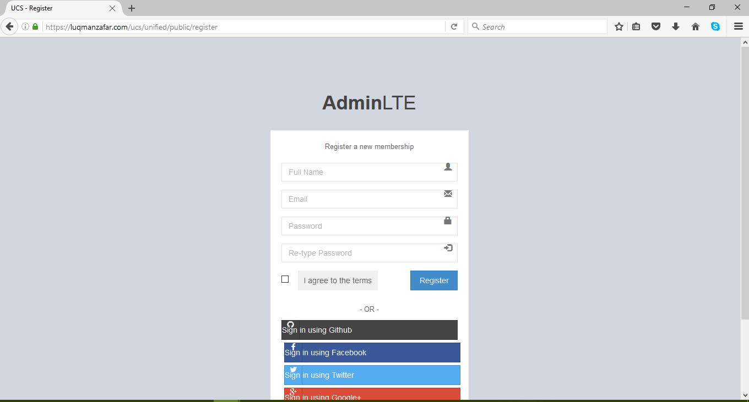

Prototype1: (P1) register a new member

# Data flow diagram (optional)

## Data Flow Diagram Level 0

Identifies sources and sinks only e.g

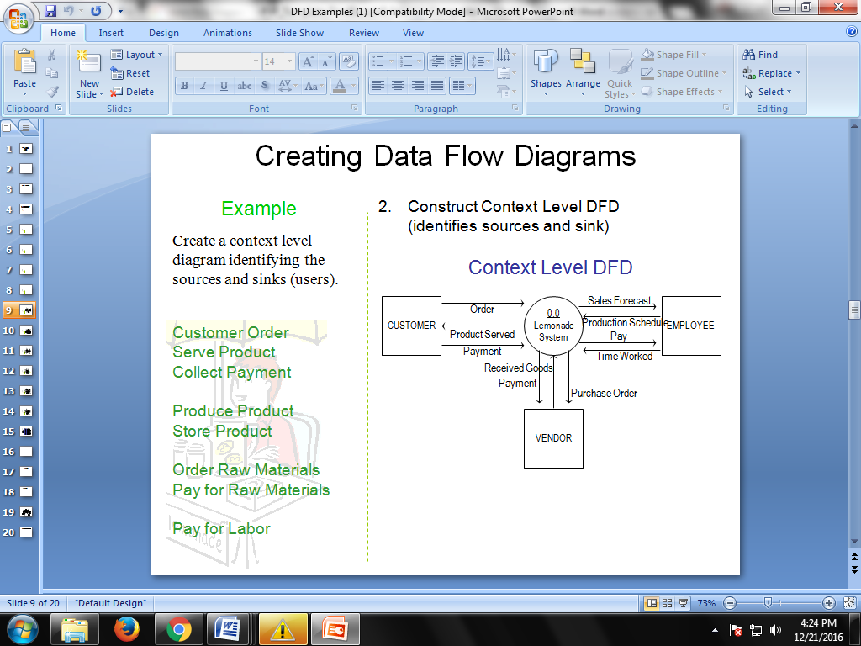

## Data Flow Diagram Level 1

Identifies actual data flows and data storese.g

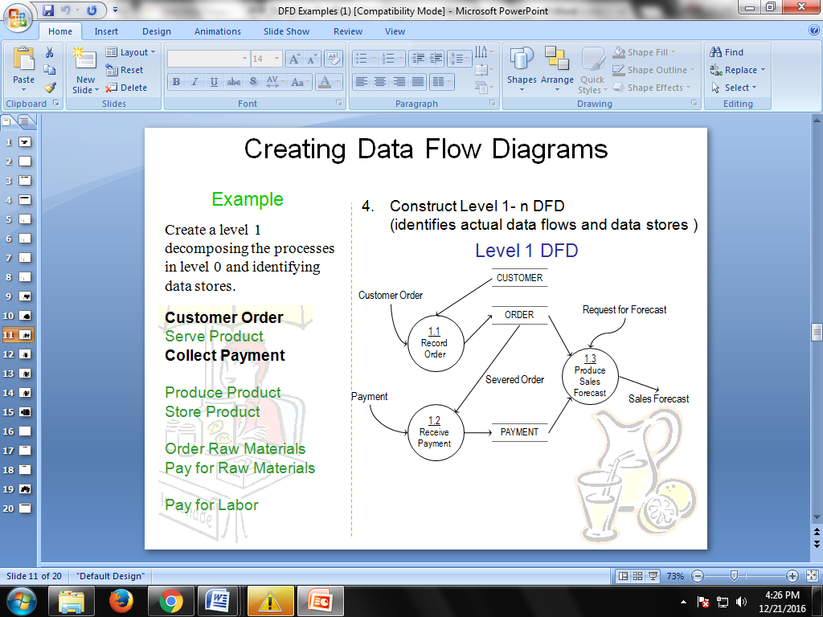

## Data Flow Diagram Level 2

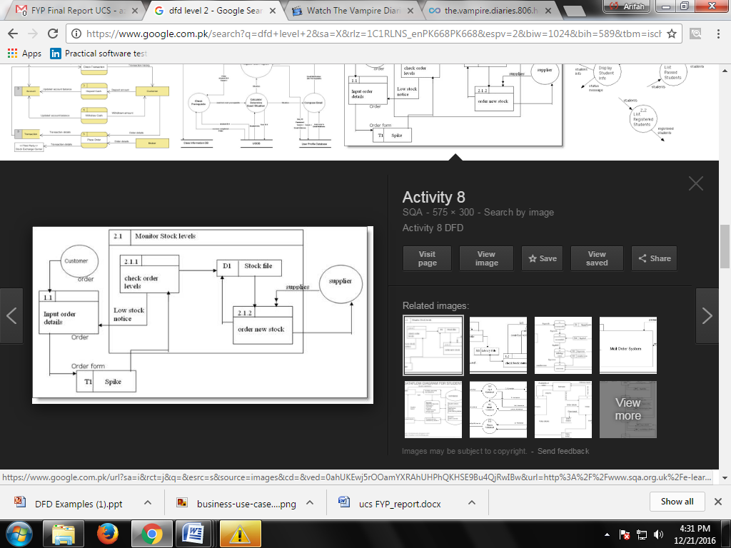

# System Design

Describe the system architecture, or simply provide the architecture diagram. For School system it may include web based front end, webserve , database etc. Don’t worry too much about it just give a simple diagram of a typical web based project.

## System Architecture Diagram



Figure 2: System Architecture

## Class Diagram

## class-example-online-shopping-domain

## Sequence Diagrams

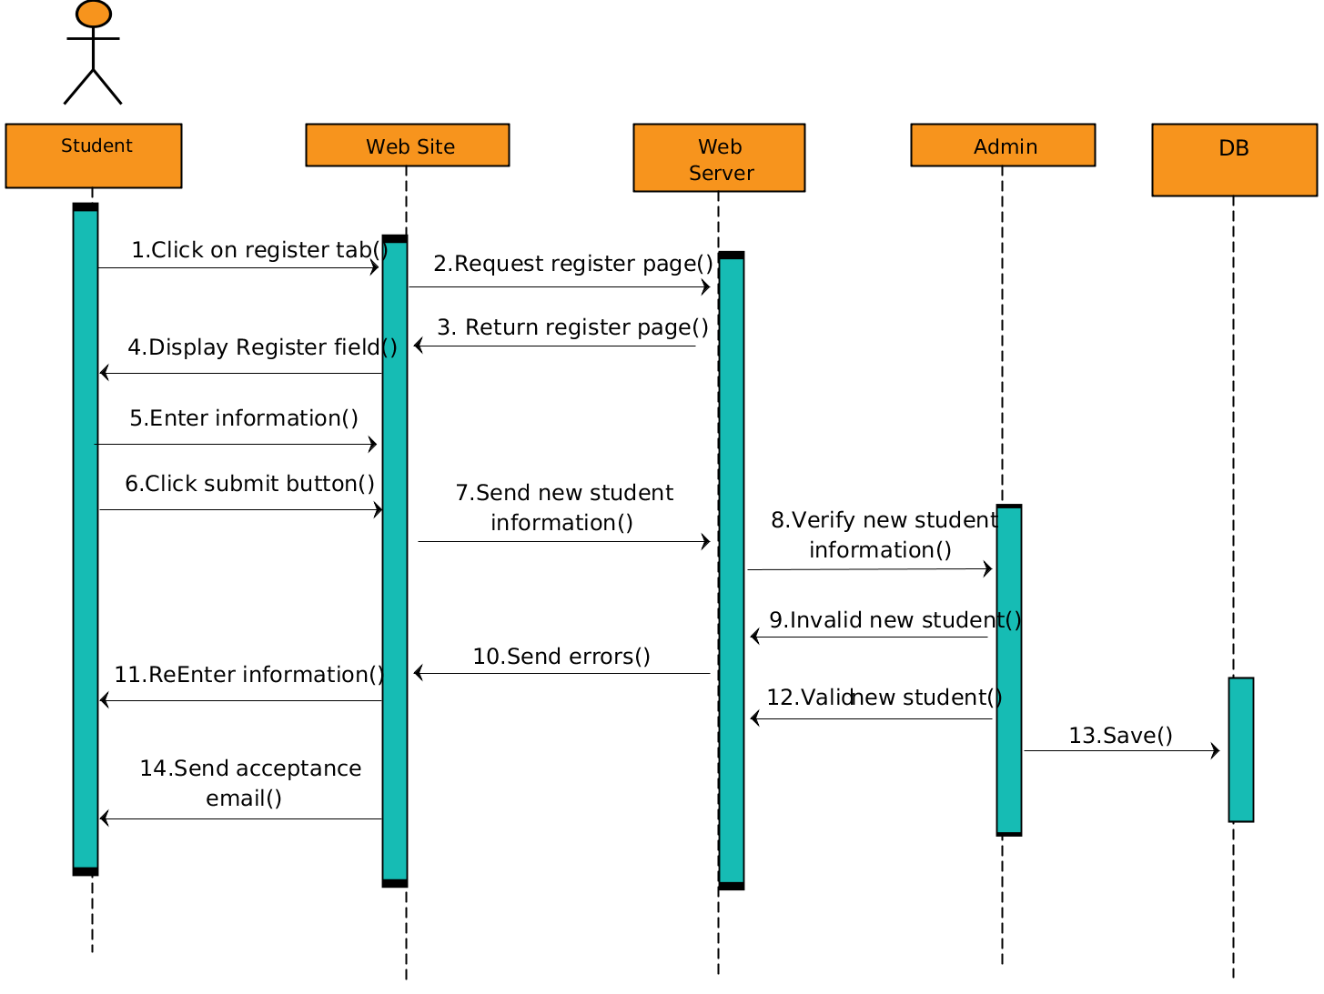

## Collaboration Diagrams

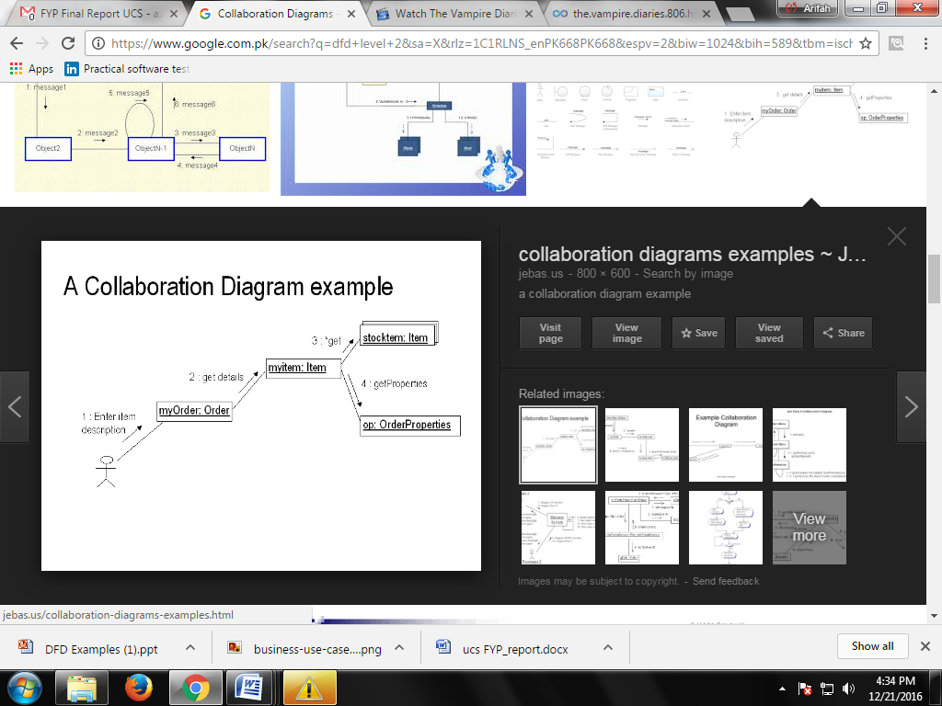

## Other UMLs

This is optional. You may include any other UML to support your system.

## ERD

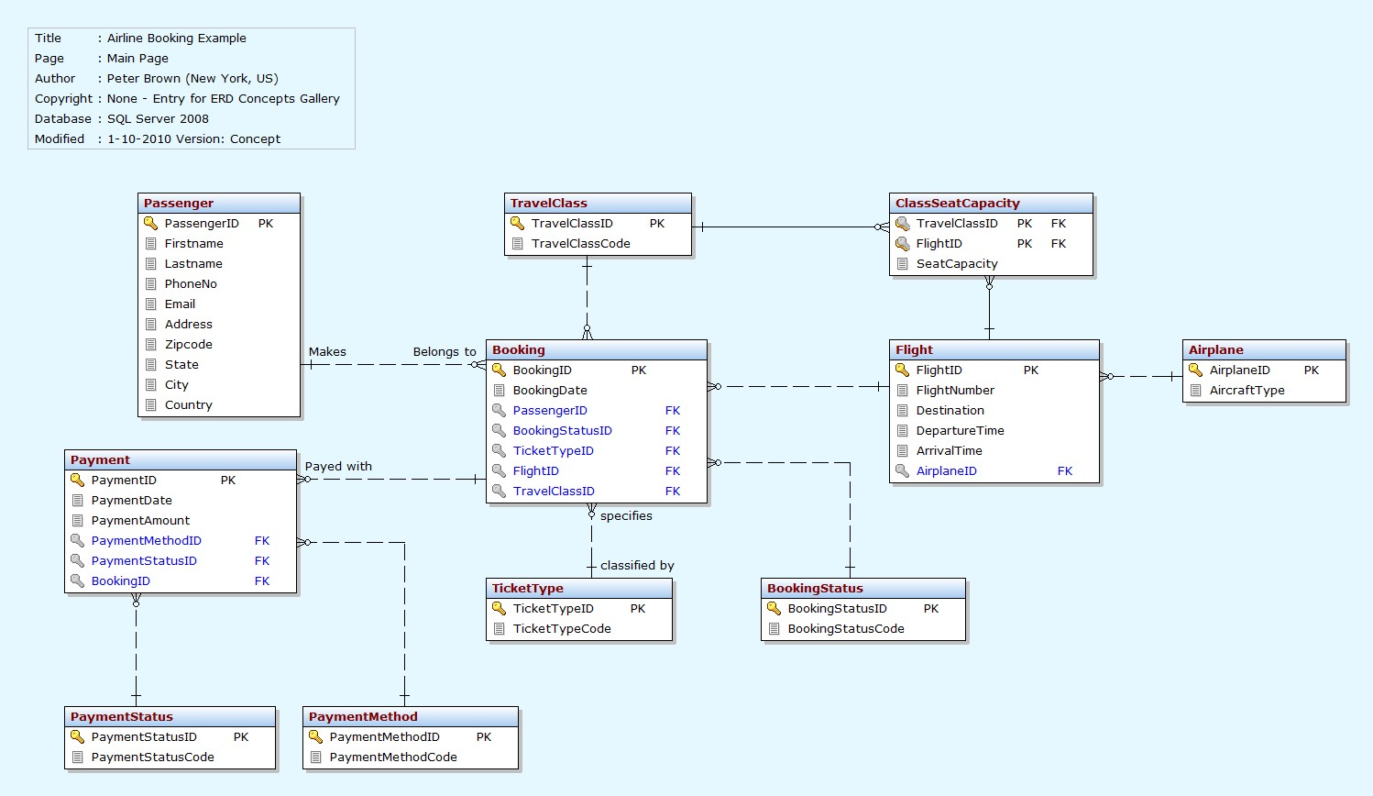

## Data Dictionary

This section may be used to provide the details of interface elements that are present on the screenshots.

|  |  |  |  |  |
| --- | --- | --- | --- | --- |
| Element Name | Type | Validation | Mandatory | Remarks |
|  |  |  |  |  |

# Implementation details

## Development Setup

List your tools and technologies and their role in development.

## Deployment setup

How and where was your software deployed? Did you face any problems, how did you overcome these problems.

## Algorithms

Entire code of software is not required. Just highlight your important (user defined/ improved) algorithms.

## Constraints

### Assumptions

Things we assume will be true.

e.g.:

* *We will receive all necessary technical support from the engineers at cMeRun, Select and Mellon Bank to help design the interfaces between their systems and enGyro.*
* *All database maintenance will be handled by the client.*
* *There will be no real-time interfacing with any accounting systems.*

### System constraints

 A constraint specifies how the system must operate or how it must be built

### Restrictions

Constraints applied on the system by the client

### Limitations

Services your software is unable to provide

# Testing

## Extended Test Cases

## 

## Decision Table

### Code snippet

### Decision coverage table

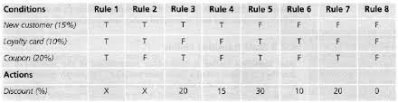

## Traceability Matrix

### RID vs UCID (requirements vs use cases)

|  |  |  |  |  |  |  |  |  |  |  |  |  |  |  |  |  |  |  |  |  |  |
| --- | --- | --- | --- | --- | --- | --- | --- | --- | --- | --- | --- | --- | --- | --- | --- | --- | --- | --- | --- | --- | --- |
| **UCID/RID** | **R**  **1** | **R**  **2** | **R**  **3** | **R**  **4** | **R**  **5** | **R**  **6** | **R**  **7** | **R**  **8** | **R**  **9** | **R**  **10** | **R**  **11** | **R**  **12** | **R**  **13** | **R**  **14** | **R**  **15** | **R**  **16** | **R**  **17** | **R**  **18** | **R**  **19** | **R**  **20** | **R**  **21** |
| UC 1 | ✓ | ✓ |  |  |  |  |  |  |  |  |  |  |  |  |  |  |  |  |  |  |  |
| UC 2 |  | ✓ |  |  |  |  |  |  |  |  |  |  |  |  |  |  |  |  |  |  |  |
| UC 3 | ✓ | ✓ |  |  |  |  |  |  |  |  |  |  | ✓ |  |  |  |  |  |  |  |  |
| UC 4 | ✓ | ✓ |  |  |  |  |  |  |  |  |  |  |  | ✓ |  |  |  |  |  |  |  |
| UC 5 | ✓ | ✓ | ✓ |  | ✓ |  |  |  |  |  |  |  |  |  |  |  |  |  |  |  |  |
| UC 6 | ✓ | ✓ |  | ✓ |  | ✓ |  |  |  |  |  |  |  |  |  |  |  |  |  |  |  |
| UC 7 | ✓ | ✓ | ✓ |  |  |  |  |  | ✓ |  |  |  |  |  |  |  |  |  |  |  |  |
| UC 8 | ✓ | ✓ |  | ✓ |  |  |  |  |  | ✓ |  |  |  |  |  |  |  |  |  |  |  |
| UC 9 | ✓ | ✓ | ✓ |  | ✓ |  |  |  |  |  | ✓ |  |  |  |  |  |  |  |  |  |  |
| UC 10 | ✓ | ✓ |  | ✓ |  | ✓ |  |  |  |  |  | ✓ |  |  |  |  |  |  |  |  |  |
| UC 11 | ✓ | ✓ | ✓ |  | ✓ |  | ✓ |  |  |  |  |  |  |  |  |  |  |  |  |  |  |
| UC 12 | ✓ | ✓ |  | ✓ |  | ✓ |  | ✓ |  |  |  |  |  |  |  |  |  |  |  |  |  |
| UC 19 | ✓ | ✓ | ✓ |  | ✓ |  |  |  |  |  |  |  |  |  | ✓ |  |  |  |  |  |  |
| UC 20 | ✓ | ✓ |  | ✓ |  | ✓ |  |  |  |  |  |  |  |  |  | ✓ |  |  |  |  |  |
| UC 21 | ✓ | ✓ | ✓ |  |  |  |  |  |  |  |  |  |  |  |  |  |  |  |  |  |  |
| UC 22 | ✓ | ✓ |  | ✓ |  |  |  |  |  |  |  |  |  |  |  |  |  |  |  |  |  |
| UC 23 | ✓ | ✓ | ✓ |  |  |  |  |  |  |  |  |  |  |  |  |  | ✓ |  |  |  |  |
| UC 24 | ✓ | ✓ |  | ✓ |  |  |  |  |  |  |  |  |  |  |  |  |  | ✓ |  |  |  |
| UC 25 | ✓ | ✓ | ✓ | ✓ |  |  |  |  |  |  |  |  |  |  |  |  |  |  | ✓ |  |  |
| UC 26 | ✓ | ✓ | ✓ | ✓ |  |  |  |  |  |  |  |  |  |  |  |  |  |  |  | ✓ |  |
| UC 27 | ✓ | ✓ | ✓ | ✓ |  |  |  |  |  |  |  |  |  |  |  |  |  |  |  |  | ✓ |

### Prototypes (RID vs PID)

### Test Cases (RID vs TID)

### Coverage (UCID vs TID)

# Results/Output/Statistics

## %completion

Use the matrix & values from 7.3.1 to show that all requirements are being fulfilled.

## %accuracy

Use the matrix & values from 7.3.3 to show that all requirements have been implemented correctly.

## %correctness

Use the matrix & values from 7.3.4 to show that all requirements have been tested to be conforming to requirements.

# Conclusion

# Future work

# Bibliography

Use IEEE or ACM format for citations

## Books

## Journals

## Articles

## Research papers

## Other References

# Appendix

## Glossary of terms

## Pre-requisites

Must use contents of development/ deployment setup & external system dependencies