EMBEDDED IoT SYSTEMS
HOMEWORK-01 REPORT
GPIO, Timers, Interrupts, Debouncing & OLED Display
Student Name | M Abdullah Nasir
Registration No. | 24-NTU-CS-FL-1043
Class / Section | BSCS-B 5th
Submission Date | 14 October 2026
Course | Embedded IoT Systems

Part A — Technical Theory

Q1. GPIO configuration and operation
A GPIO (General Purpose Input/Output) pin can be configured in software as an input or an output. The three common modes on the ESP32 are:
Mode | Behaviour | Typical use
INPUT | High-impedance input with no internal resistor. If nothing drives the pin it "floats" and reads random values. | Reading sensors/modules that actively drive HIGH and LOW; buttons with an external pull-up/pull-down resistor.
INPUT_PULLUP | Input with the ESP32's internal pull-up resistor (tens of kΩ) to 3.3 V. An idle pin reads HIGH. | Push buttons wired between the pin and GND, with no external resistor needed.
OUTPUT | The pin actively drives 3.3 V (HIGH) or 0 V (LOW) with a push-pull driver. | LEDs (with a resistor), transistor/relay drivers, logic signals.

Button wiring with INPUT_PULLUP: one leg of the button goes to the chosen GPIO (GPIO 18) and the other leg goes to GND. The internal pull-up holds the pin HIGH while the button is open; pressing the button connects the pin directly to GND. Therefore released = HIGH (1) and pressed = LOW (0) (active-low logic).
pinMode(18, INPUT_PULLUP);
bool pressed = (digitalRead(18) == LOW);

Why GPIO selection and voltage limits matter: ESP32 pins use 3.3 V logic and are not 5 V tolerant, so applying 5 V can permanently damage the chip. Current per pin is also limited (a few mA to ~12 mA is the safe working range), so loads like motors or relays need a driver. Not every pin is suitable: GPIO 34–39 are input-only and have no internal pull-up; GPIO 6–11 are connected to the flash memory and must not be used; and strapping pins (0, 2, 5, 12, 15) affect boot behaviour, so a button or load on them can stop the board from booting. GPIO 18 is a safe general-purpose pin, which is why it is used here.

Q2. Timers and non-blocking design
A timer is a hardware (or software-derived) counter that measures time independently of the main program. In an embedded system it is used to generate delays, schedule periodic tasks (sampling a sensor every 100 ms), measure intervals, and produce PWM or timeouts, all without wasting CPU cycles.
 | delay()-based timing | millis() / timer-based timing
Behaviour | Blocks the CPU; nothing else runs during the wait. | Checks elapsed time and continues; the CPU stays free.
Responsiveness | Button presses and display updates can be missed or delayed. | Multiple tasks run "at the same time" in the loop.
Scalability | Hard to add more tasks. | Easy: each task keeps its own timestamp.

Practical example: in a button-counter system, an LED blinks every 500 ms, the OLED refreshes when the count changes, and the button is read continuously. With delay(500) the button would be ignored for half a second, but with millis() each task runs only when its own interval has elapsed:
if (millis() - lastBlink >= 500) { // task 1: LED
lastBlink = millis();
digitalWrite(LED, !digitalRead(LED));
}
readButton(); // task 2: runs every loop()
if (countChanged) updateDisplay(); // task 3: OLED

Q3. Interrupts and ISR
Interrupt: a hardware signal that makes the CPU pause its current work to handle an urgent event (such as a pin changing state or a timer expiring). ISR (Interrupt Service Routine): the short function that runs in response to that interrupt.
Sequence: (1) the event occurs (e.g. a falling edge on GPIO 18); (2) the interrupt controller flags it; (3) the CPU finishes the current instruction and saves its context; (4) it jumps to the ISR address; (5) the ISR runs; (6) the context is restored and the main program resumes exactly where it stopped.
Good ISR practices for ESP32 Arduino code:
- Keep the ISR very short and fast: set a flag or update a counter and return.
- Mark the function with IRAM_ATTR so it is placed in internal RAM and can run even when flash is busy.
- Declare variables shared with loop() as volatile (and protect multi-byte updates if needed).
- Do not use delay(), and avoid Serial printing, I²C/display calls or dynamic memory allocation inside an ISR.
volatile bool pressFlag = false;
void IRAM_ATTR onButton() { pressFlag = true; }
attachInterrupt(digitalPinToInterrupt(18), onButton, FALLING);

Display updates and Serial printing should not be done in an ISR because they are slow (an OLED refresh sends about 1 KB over I²C, and Serial printing waits on buffers), they depend on interrupts and timing themselves, and they are not interrupt-safe. A long ISR blocks other interrupts, can trigger the watchdog timer, and may crash or corrupt the I²C transaction already in progress. The correct pattern is to set a flag in the ISR and do the slow work in loop().

Q4. Switch debouncing
A mechanical push button contains metal contacts that physically bounce against each other for a few milliseconds when pressed or released. Instead of one clean HIGH→LOW transition, the microcontroller sees a burst of rapid transitions. Because the ESP32 reads the pin in microseconds, it can interpret this burst as several separate presses.
Ideal : HIGH ───────┐ ┌───── HIGH
└─────────────────┘ (LOW = pressed)
Actual : HIGH ───┐ ┌┐ ┌┐┌─┐ ┌┐ ┌─── HIGH
└─┘└─┘└┘ └─────────────┘└─┘
|<- bounce ->| |<->| (about 1–20 ms)

 | delay()-based debounce | millis()-based debounce
Method | On the first edge, call delay(50) and read again. | Record the time of the last change and accept it only after it stays stable.
CPU | Blocks everything for the delay time. | Non-blocking; the loop keeps running.
Result | Display and other tasks freeze; presses can be missed. | Responsive and scalable to many buttons.

Reliable state-based method: keep three variables: the last raw reading, the stable (accepted) state, and the time of the last raw change.
- Read the pin. If it differs from the last raw reading, save the new reading and restart the timer (lastDebounceTime = millis()).
- If the reading has stayed unchanged for at least DEBOUNCE_MS (50 ms) and differs from the stable state, accept it as the new stable state.
- Count a press only when the new stable state is LOW (a falling edge), so one physical press gives exactly one count, even if it is held down.

Q5. OLED display and I²C
The SSD1306 OLED (128×64) is a slave on the I²C bus, and the ESP32 is the master. I²C uses only two shared wires: a data line and a clock line. The master generates the clock and starts each transfer by sending the 7-bit device address; only the device with the matching address responds.
Pin | Purpose
VCC | Power supply for the display (3.3 V on the ESP32 kit).
GND | Common ground reference for the ESP32 and the OLED.
SDA | Serial Data: bidirectional line carrying addresses and pixel data.
SCL | Serial Clock: clock generated by the ESP32 master to synchronise data.

Usual connections in our lab: VCC → 3V3, GND → GND, SDA → GPIO 21, SCL → GPIO 22. The I²C address is 0x3C (some modules use 0x3D). In the code: Wire.begin(21, 22) starts the bus and OLED_ADDR is defined as 0x3C.
Roles in the code:
- Initialization: display.begin(SSD1306_SWITCHCAPVCC, 0x3C) configures the controller (charge pump, contrast, scan direction) and returns false if the display does not answer.
- Drawing text: clearDisplay(), setTextSize(), setCursor(), print()/println() only write pixels into a RAM buffer on the ESP32; nothing is shown yet.
- display.display(): transfers the whole buffer to the OLED over I²C, so the screen updates. Without this call the changes stay invisible.

Part B — Practical Lab

1. Task
ESP32 OLED status display with a debounced push button. The OLED shows a title, the button status (PRESSED / RELEASED) and a press counter that starts at 0. Each valid press increments the counter exactly once, using a non-blocking millis() debounce.

2. Wiring / pin table
Component / Pin | ESP32 connection | Notes
SSD1306 OLED VCC | 3V3 | 3.3 V supply
SSD1306 OLED GND | GND | Common ground
SSD1306 OLED SDA | GPIO 21 | I²C data
SSD1306 OLED SCL | GPIO 22 | I²C clock
Push button (leg 1) | GPIO 18 | INPUT_PULLUP; pressed = LOW
Push button (leg 2) | GND | Completes the active-low circuit

3. Implementation explanation
- Setup: Serial starts at 115200 baud, I²C starts on GPIO 21/22, GPIO 18 is set to INPUT_PULLUP and the OLED is initialised at address 0x3C. If initialisation fails, an error is printed and the program stops. The initial button state is read so a press is not counted at startup, and the first screen shows Count: 0.
- Debounce (non-blocking): every loop() the raw pin is read. When it differs from lastRawState, lastDebounceTime is reset to millis(). Only when the reading has stayed the same for DEBOUNCE_MS = 50 ms and differs from stableButtonState is it accepted as the new stable state. No delay() is used, so the loop runs freely.
- Counting: pressCount is incremented only when the new stable state is LOW (a press), so one physical press gives exactly one count regardless of how long it is held. The accepted count is printed on the Serial Monitor.
- Display: updateDisplay() is called only when the stable state changes (press or release). It clears the buffer, draws the title, the "Button: PRESSED/RELEASED" status and the large "Count: N" value, then calls display.display().

4. Source code (src/main.cpp)

#include <Arduino.h>
#include <Wire.h>
#include <Adafruit_GFX.h>
#include <Adafruit_SSD1306.h>

#define SCREEN_WIDTH 128
#define SCREEN_HEIGHT 64
#define OLED_SDA 21
#define OLED_SCL 22
#define OLED_ADDR 0x3C

#define BUTTON_PIN 18
#define DEBOUNCE_MS 50

Adafruit_SSD1306 display(
SCREEN_WIDTH,
SCREEN_HEIGHT,
&Wire,
-1
);

int pressCount = 0;

int lastRawState = HIGH;
int stableButtonState = HIGH;

unsigned long lastDebounceTime = 0;

void updateDisplay() {
display.clearDisplay();

display.setTextSize(1);
display.setTextColor(SSD1306_WHITE);

display.setCursor(0, 0);
display.println("ESP32 BUTTON COUNTER");

display.println("---------------------");

display.print("Button: ");

if (stableButtonState == LOW) {
display.println("PRESSED");
} else {
display.println("RELEASED");
}

display.println();

display.setTextSize(2);
display.print("Count: ");
display.println(pressCount);

display.display();
}

void setup() {
Serial.begin(115200);

Wire.begin(OLED_SDA, OLED_SCL);

pinMode(BUTTON_PIN, INPUT_PULLUP);

if (!display.begin(
SSD1306_SWITCHCAPVCC,
OLED_ADDR
)) {
Serial.println("OLED initialization failed!");

while (true) {

}
}

lastRawState = digitalRead(BUTTON_PIN);
stableButtonState = lastRawState;

updateDisplay();

Serial.println("OLED initialized successfully.");
Serial.println("Button counter ready.");
Serial.println("Press count: 0");
}

void loop() {

int reading = digitalRead(BUTTON_PIN);

if (reading != lastRawState) {
lastDebounceTime = millis();
lastRawState = reading;
}

if (millis() - lastDebounceTime >= DEBOUNCE_MS) {

if (reading != stableButtonState) {
stableButtonState = reading;

if (stableButtonState == LOW) {
pressCount++;

Serial.print("Accepted press! Count: ");
Serial.println(pressCount);
}

updateDisplay();
}
}

}

5. platformio.ini
[env:esp32dev]
platform = espressif32
board = esp32dev
framework = arduino
monitor_speed = 115200

lib_deps =
adafruit/Adafruit GFX Library
adafruit/Adafruit SSD1306

6. diagram.json

{
"version": 1,
"author": "Abdullah Nasir",
"editor": "wokwi",
"parts": [
{
"type": "board-esp32-devkit-c-v4",
"id": "esp",
"top": 0,
"left": 0,
"attrs": {}
},
{
"type": "board-ssd1306",
"id": "oled",
"top": -100,
"left": 250,
"attrs": {
"i2cAddress": "0x3c"
}
},
{
"type": "wokwi-pushbutton",
"id": "btn",
"top": 150,
"left": 250,
"attrs": {
"color": "green",
"label": "Press"
}
}
],
"connections": [
["esp:TX0", "$serialMonitor:RX", "green", []],
["oled:VCC", "esp:3V3", "red", []],
["oled:GND", "esp:GND.1", "black", []],
["oled:SDA", "esp:21", "blue", []],
["oled:SCL", "esp:22", "yellow", []],
["btn:1.l", "esp:18", "green", []],
["btn:2.l", "esp:GND.1", "black", []]
],
"dependencies": {}
}

6. Test records
Press the button 10 times in each environment and record the OLED count after every press. Fill in the Observed and Pass columns while testing.
Wokwi simulation
Press # | Expected count | Observed count | Pass / Fail
1 | 1 | 1 | Pass
2 | 2 | 2 | Pass
3 | 3 | 3 | Pass
4 | 4 | 4 | Pass
5 | 5 | 5 | Pass
6 | 6 | 6 | Pass
7 | 7 | 7 | Pass
8 | 8 | 8 | Pass
9 | 9 | 9 | Pass
10 | 10 | 10 | Pass

Physical hardware
Press # | Expected count | Observed count | Pass / Fail
1 | 1 | 1 | Pass
2 | 2 | 2 | Pass
3 | 3 | 3 | Pass
4 | 4 | 4 | Pass
5 | 5 | 5 | Pass
6 | 6 | 6 | Pass
7 | 7 | 7 | Pass
8 | 8 | 8 | Pass
9 | 9 | 9 | Pass
10 | 10 | 10 | Pass

Summary
Environment | Presses | Expected final | Observed final | Pass?
Wokwi | 10 | 10 | 10 | Pass
Hardware | 10 | 10 | 10 | Pass

7. Simulation vs hardware comparison
So, the results of both wokwi and physical simulations were identical. But during physical ESP32 configuration, i was having some problem with tactile button functioning because even though i was pressing there was no effect on OLED display, so after some debugging i came to the conclusion that the button was placed wrong, so i positioned it correctly on breadboard and then it was working fine.

Evidence and Proof

W1 — Wokwi circuit

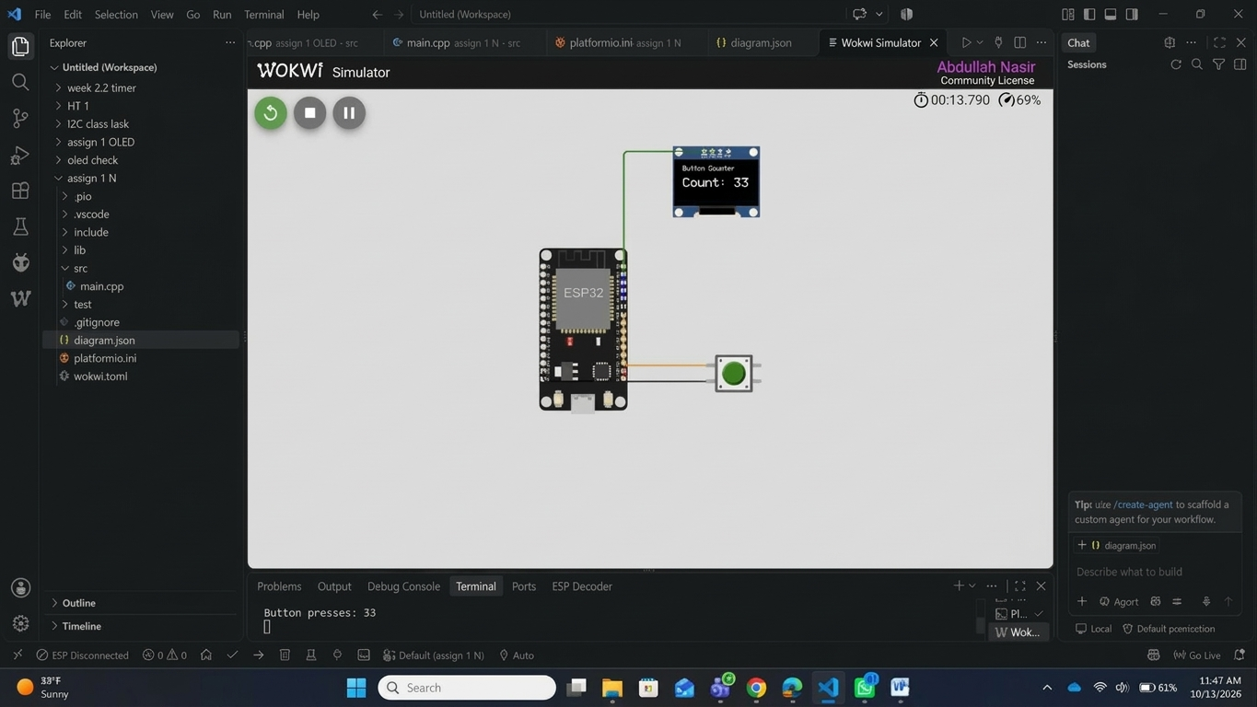
Figure W1: Complete Wokwi circuit showing the ESP32, SSD1306 OLED and push button wired to GPIO 21, 22 and 18.

W2 — Wokwi output

f
Figure W2: Wokwi simulation running, OLED showing the title, button status and a non-zero press count.

W3 — VS Code / PlatformIO build

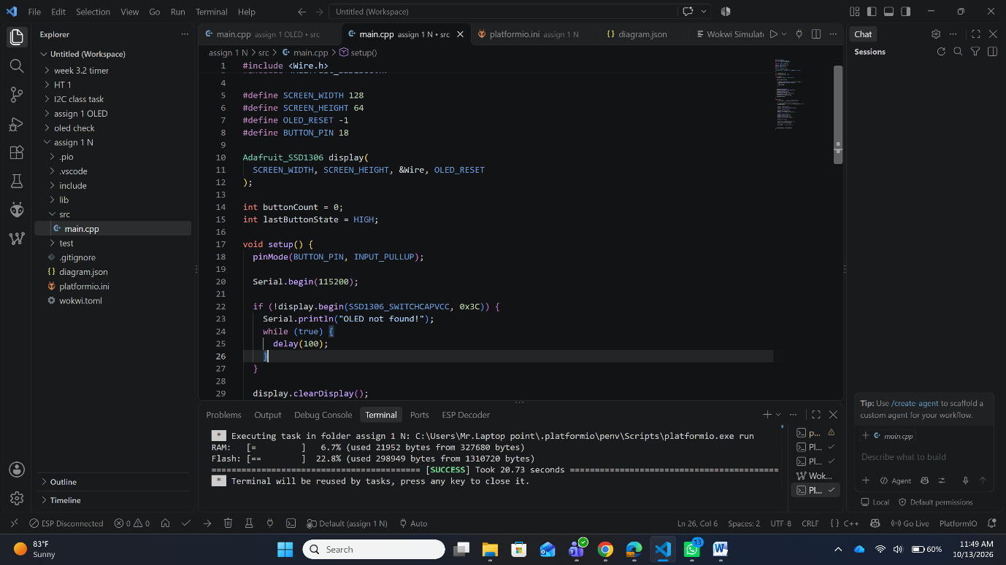
Figure W3: VS Code project structure with a successful PlatformIO build.

H1 — Hardware setup

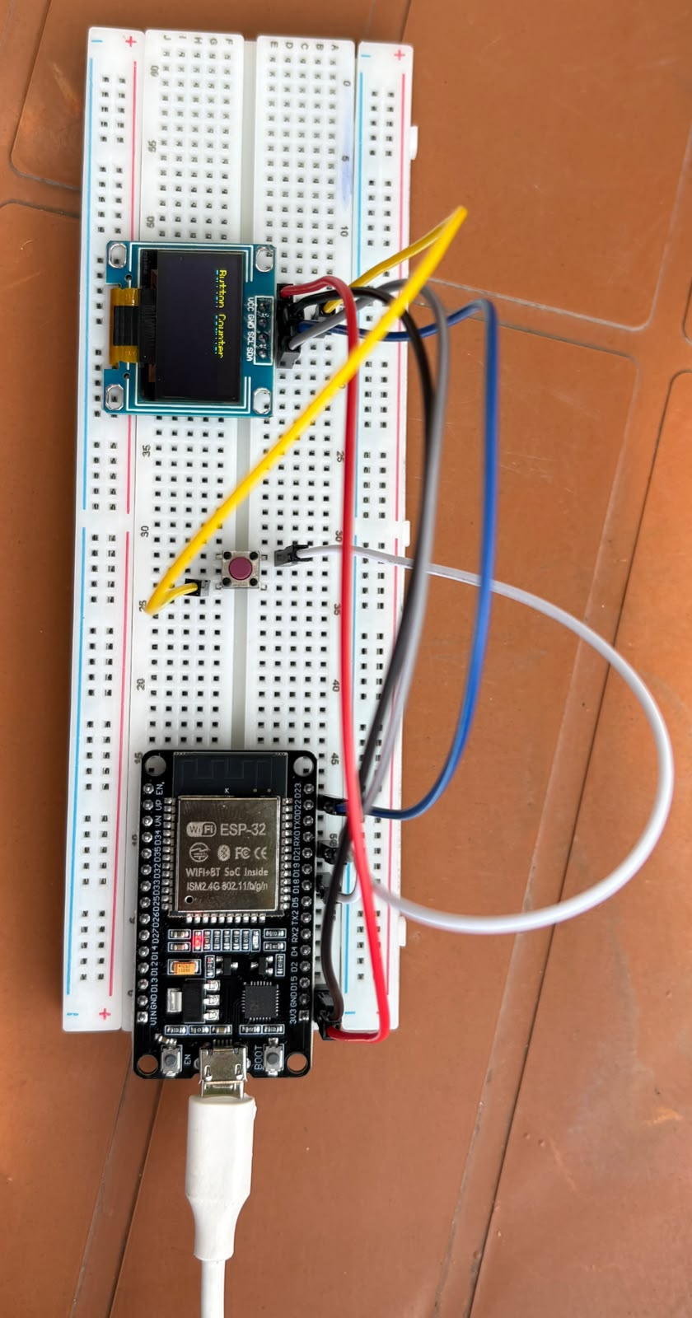

H2 — Hardware output

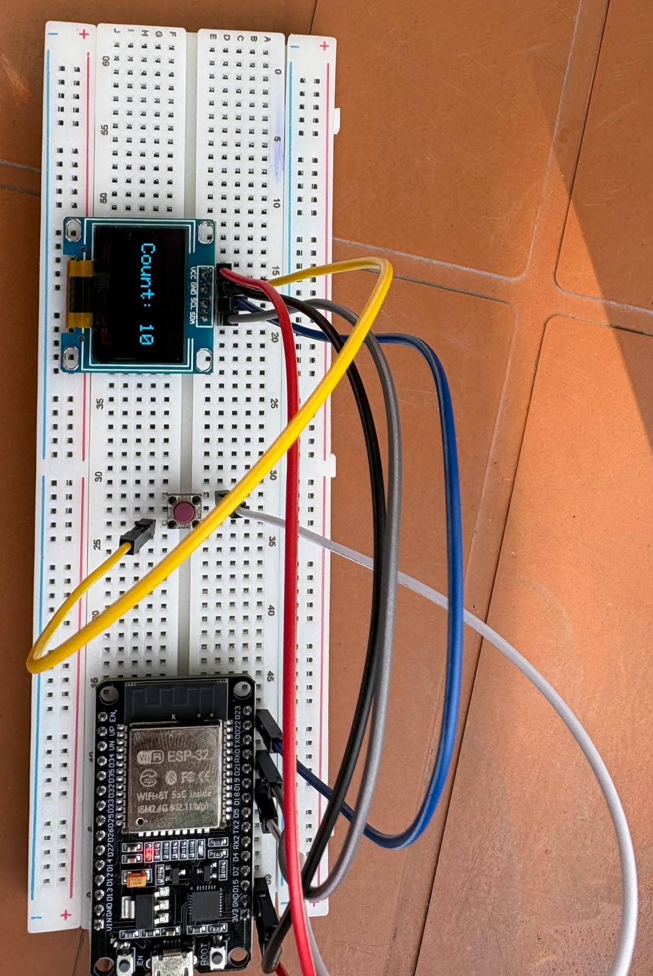
Figure H2: Physical OLED displaying the project screen with a non-zero press count.

H3 — Hardware test
Figure H3: Serial Monitor showing "Accepted press!" messages with the incrementing count.

