GPS-Free Autonomous UAV for Secure Aerial Operations

SDP 1st Progress Report

BY

Abdullah Malik 2022026
Muhammad Ans 2022681
Faiz Jilani 2022160
Faareh al Rehman (Late) 2022155

Supervised by
Dr. Babar Zaman
Co-Supervisor: Engr. Hamza Naeem



Faculty of Engineering Sciences
GIK Institute of Engineering Sciences & Technology
April 2026

ABSTRACT

Conventional unmanned aerial vehicles depend almost entirely on Global Navigation Satellite Systems (GNSS) and a continuous radio-control link for safe operation. Both dependencies fail catastrophically in modern operational environments: GNSS signals are weak, easily jammed, and trivially spoofed; radio links are attenuated by terrain and walls; and pure inertial navigation drifts uncontrollably within seconds. This project, named A.E.T.H.E.R. (Autonomous Environment-aware Terrain-Hovering Edge Robot), addresses that vulnerability by designing and implementing a low-cost autonomous quadrotor that navigates without GPS, using only on-board perception.
The system is built on an F450 airframe driven by four 15T-930 KV brushless motors through a SpeedyBee BLS 55 A four-in-one electronic-speed-controller (DShot300), commanded by a DakeFPV H743 flight controller running ArduCopter 4.6.x with EKF3 configured for GPS-denied operation, and supervised by an NVIDIA Jetson Nano 4 GB companion computer. State estimation fuses two streams: a MicoAir MTF-02P combined optical-flow-and-rangefinder module that delivers OPTICAL_FLOW and DISTANCE_SENSOR MAVLink messages directly to the flight controller over a dedicated UART, and the flight controller's internal IMU. The MTF-02P collapses what was originally specified as two separate sensors (an ADNS-3080 optical-flow chip and a VL53L0X laser rangefinder) into a single production-grade module, eliminating the companion-computer SPI and I²C bridges that proved unreliable on the Jetson Nano during integration. A bimodal navigation strategy is adopted: between waypoints the drone dead-reckons in ArduCopter's GUIDED mode using the EKF-fused optical-flow and rangefinder estimate; at each waypoint a YOLOv8-Nano model running inside an NVIDIA Ultralytics Docker container on the Jetson detects one of four pre-trained colour-coded landmark boxes (white, green, red, blue) and centres the airframe over the target through a proportional-derivative pixel-error controller before yawing ninety degrees and proceeding to the next leg.
The complete software stack is validated end-to-end in a Gazebo + ArduPilot SITL simulation before any physical flight. A multi-threaded Python control architecture (camera-and-inference producer thread, MAVLink command consumer thread) is used on the Jetson to keep variable-latency YOLO inference out of the deterministic flight loop. The autonomous mission is launched through a pilot-handoff procedure: the pilot manually arms the drone, takes off in Stabilize mode, transitions through AltHold for a five-second stability check, and then switches the FlySky FS-i6X mode knob to Guided, at which point the on-board controller takes authority. The mission then visits four colour-coded waypoint boxes arranged at the corners of a ten-metre square (white start, then green, red, blue, return to white), centring over each waypoint to within thirty pixels of the camera centre, hovering for five seconds, and yawing ninety degrees clockwise before the next leg. The pilot retains an unconditional manual-override path: switching the mode knob back at any moment causes the on-board controller to release authority within one hundred milliseconds. The project delivers a documented, reproducible reference design for resource-constrained autonomous flight in GPS-denied environments together with a corresponding standard operating procedure for safe student operation.

Keywords: GPS-denied navigation, autonomous UAV, optical flow, MTF-02P, EKF3, YOLOv8, MAVLink, visual servoing, ArduCopter, Jetson Nano.

ACKNOWLEDGEMENTS

All praise is due to Allah, the Most Gracious and the Most Merciful, who granted us the strength, patience, and clarity to see this project through to completion.
We extend our deepest gratitude to our supervisor, Dr. Babar Zaman, for his continuous guidance, technical insight, and unwavering support throughout the duration of this Senior Design Project. His door was always open, and his willingness to engage with every detail of the work shaped the project at every stage. We are equally indebted to our co-advisor, Engr. Hamza Naeem, for his hands-on practical advice, and his patience.
We are grateful to the Faculty of Engineering Sciences at the GIK Institute of Engineering Sciences & Technology, and in particular to the SDP coordinator and the laboratory staff, for providing the workspace, instrumentation, and a safe testing environment for our flight experiments. We thank the open-source communities behind ArduPilot, ROS, MAVLink, Gazebo, and Ultralytics YOLOv8: this project was made possible by their work.
We dedicate this report to the memory of our team-mate and friend, Faareh al Rehman, who passed away during the course of the project. Faareh's contribution to the early design discussions and his enthusiasm for the technical challenges we faced are woven through the work that follows. He is remembered with deep affection and respect by everyone on the team. May Allah grant him the highest place in Jannah.
Finally, we thank our parents and families for their patience, prayers, and quiet sacrifices during the long evenings and weekends that this work demanded. Whatever is correct in this report is by their support; whatever is in error is our own.

TABLE OF CONTENTS

Abstract ii
Acknowledgements iv
Table of Contents v
Chapter 1 Introduction 1
1.1 Background and Motivation 1
1.2 Problem Statement 2
1.3 Scope of the Work and Expected Outcomes 3
1.4 Report Outline 4
Chapter 2 Literature Review 6
2.1 Literature Review 6
2.2 Inferences Drawn from the Literature 9
2.3 Summary 9
Chapter 3 Design and Analysis 11
3.1 Design Methodology 11
3.2 Governing Equations and Mathematical Modelling 13
3.3 Analysis, Codes and Standards 16
3.4 Summary 20

Chapter 1

INTRODUCTION

1.1 Background and Motivation
The history of unmanned aerial vehicle (UAV) development can be summarised as a steady migration of intelligence away from the ground operator and into the air vehicle itself. Early radio-controlled aircraft demanded the unbroken visual attention of a human pilot. The first generation of "autonomous" multirotors, which gained mass adoption in the early 2010s, replaced the human pilot's eye with the Global Positioning System: a quadrotor with a healthy GPS lock could hold its position in the sky, follow a programmed waypoint list, and return to the launch point on command. This single capability — accurate, drift-free position fixing from satellites — is the foundation on which most modern UAV applications, from agricultural mapping to package delivery, currently rest.
That foundation, however, is far less secure than its widespread adoption suggests. The signals from GPS satellites in medium Earth orbit reach the surface of the planet at a power level so weak that the noise floor of any inexpensive software-defined radio is enough to overpower them. Low-cost commercial jamming devices, available for less than the cost of the drones themselves, can blanket an entire airfield in interference and disable the position estimator of every conventional UAV in flight. Spoofing — the deliberate transmission of fake but stronger satellite signals — can convince an autopilot that it is several kilometres from its true location and induce a controlled crash. In urban environments multipath reflections from buildings produce position errors of tens of metres without any malicious intent at all. In short, the assumption that GPS is always available is no longer safe in any operationally serious context.
The motivation for this Senior Design Project arises from these practical limitations. A UAV that loses its GPS lock — whether through deliberate jamming, signal occlusion in an urban canyon, indoor flight, or simple satellite geometry — falls back on its inertial sensors, and an inexpensive Micro-Electromechanical-Systems (MEMS) inertial measurement unit accumulates position error at a rate of hundreds of metres per minute. Within seconds the airframe is, for navigational purposes, blind. The objective of this project is to design and build a low-cost autonomous quadrotor that does not rely on GPS at all, but instead perceives its environment using a combination of on-board cameras, a downward optical-flow sensor, a laser rangefinder, an inertial measurement unit, and a small companion computer running a deep-learning model. The result is a vehicle whose autonomy is preserved in jammed, denied, or simply GPS-poor environments — including the indoor corridors and densely-built quadrangles of the GIK Institute campus on which our prototype is tested.
A second, equally important motivation is educational. The project is intentionally constructed from inexpensive, locally-available, off-the-shelf components: an F450 plastic quadrotor frame; four 15T-930 KV brushless motors driven by a SpeedyBee BLS 55 A four-in-one ESC over DShot300; a DakeFPV H743 flight controller; an NVIDIA Jetson Nano 4 GB companion computer; a MicoAir MTF-02P combined optical-flow + LiDAR rangefinder module; a Logitech Brio 100 USB webcam; a FlySky FS-i6X transmitter with FS-iA10B receiver; and a 3-cell lithium-polymer battery. The design therefore demonstrates that GPS-denied autonomous flight, traditionally treated as a high-end research problem requiring research-grade hardware, can be brought within the budget and time-frame of an undergraduate Senior Design Project. The complete software stack, the standard operating procedure document, and the simulation environment we have produced are intended as a reusable reference for future GIKI cohorts working in autonomous robotics.
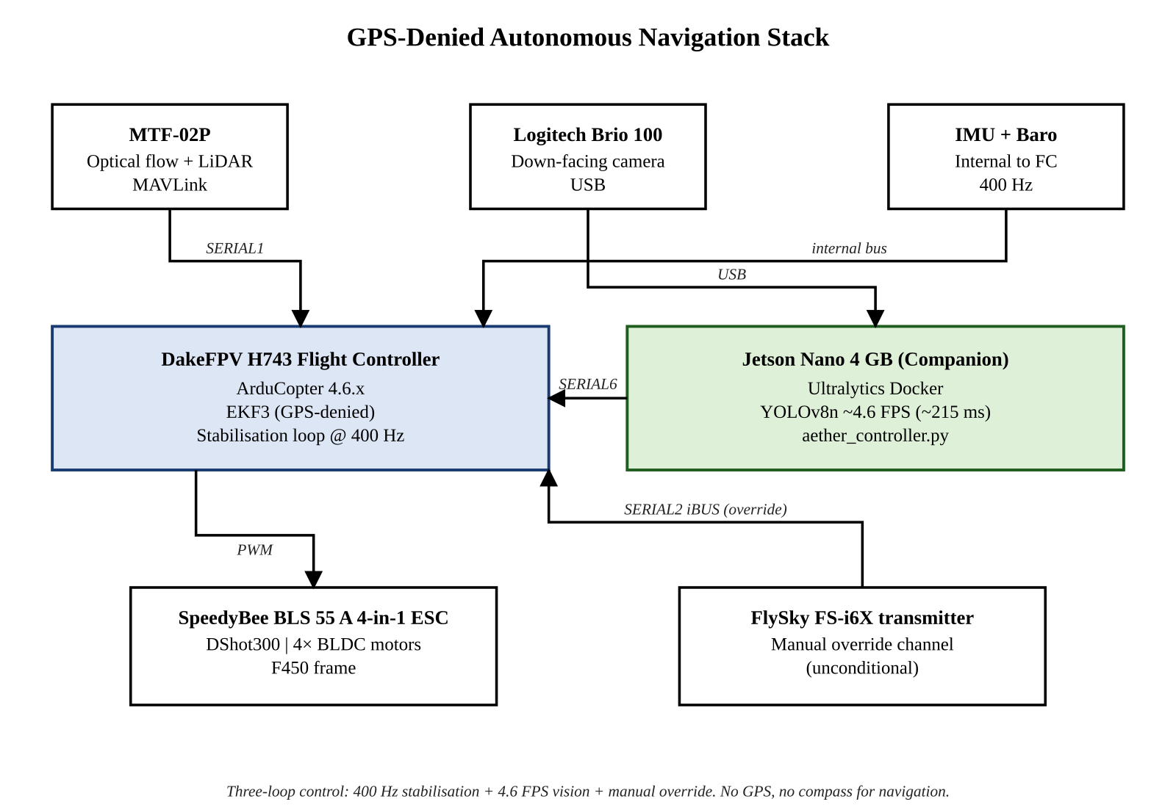
Fig 1-1: Conceptual block diagram of the GPS-denied autonomous navigation architecture.

1.2 Problem Statement
Conventional autonomous quadrotors rely on a tightly coupled triad of (i) a Global Navigation Satellite System receiver for absolute position, (ii) an inertial measurement unit for short-term motion sensing, and (iii) a continuous radio-control link for human override. The failure modes of this triad are well known: GPS signals can be jammed, spoofed, attenuated by buildings, blocked indoors, or simply degraded by poor satellite geometry; the radio-control link is attenuated by terrain and obstacles and introduces variable latency; and a standalone inertial measurement unit drifts in a quadratic fashion with elapsed time, producing position errors of hundreds of metres within a single minute of flight. In any operational scenario where the radio-frequency environment is contested — military reconnaissance, search-and-rescue inside collapsed buildings, infrastructure inspection in urban canyons, or even routine flight over the densely-built quadrangles of the GIKI campus — a conventional commercial UAV becomes, at best, unreliable, and at worst, uncontrollable.
The problem this project addresses is therefore the design and physical realisation of a quadrotor that performs the four classical autonomous-flight tasks — stable hover, waypoint-to-waypoint translation, drift correction, and safe automated landing — without any reliance on GNSS, and with the radio-control link restricted to a manual safety-override role only. The system must achieve this on a strictly limited undergraduate budget, using only commercially available off-the-shelf components, and must demonstrate the capability in both a software-in-the-loop simulation and on the physical airframe within the academic timeline of the Senior Design Project.
The detailed technical sub-problems that follow from this overall statement, and which are addressed in the remainder of this report, are: (a) replacing the GPS-driven horizontal-velocity input to the flight controller's Extended Kalman Filter with an optical-flow source; (b) replacing the GPS-driven absolute-position fix with a vision-based landmark-recognition correction loop; (c) performing the entire perception pipeline on a 4 GB Jetson Nano without exceeding the latency budget that horizontal flight imposes; (d) preserving full manual-override safety at all times through a transmitter switch; and (e) packaging the entire effort as a reproducible reference design with documentation suitable for a future student to rebuild from scratch.

1.3 Scope of the Work and Expected Outcomes
The scope of the project is defined by two boundaries: the scope of the engineering activity, and the scope of the demonstration. The engineering scope encompasses the mechanical assembly of the airframe and propulsion system; the electrical wiring of the power, sensor, and communication harnesses; the firmware configuration of the DakeFPV H743 flight controller running ArduCopter 4.6.x; the software development of the multi-threaded mission controller (aether_controller.py) and the YOLOv8 landmark-detection pipeline on the Jetson Nano, the latter run inside the official NVIDIA / Ultralytics Docker container in order to bridge the Jetson's legacy Python 3.6 base image to the modern Ultralytics requirements; the integration of the MicoAir MTF-02P combined optical-flow and rangefinder module with the flight controller's EKF3 over a dedicated UART; the construction of an ArduPilot software-in-the-loop simulation in Gazebo; the training of a custom YOLOv8 Nano model on a four-class colour-coded waypoint-box dataset; and the authoring of a complete standard operating procedure document covering pre-flight, in-flight, and emergency conditions.
The demonstration scope is more narrowly defined. The prototype is required to demonstrate (i) stable autonomous hover at approximately one metre altitude using only optical-flow and rangefinder feedback, with the GPS module physically disabled and the magnetometer not used for navigation; (ii) successful execution of a four-waypoint demonstration mission inside a level open area on the GIKI campus, in which the drone visits four colour-coded boxes (white, green, red, blue) placed at the corners of a ten-metre square, centring over each one to within thirty pixels of the camera centre, hovering for five seconds, yawing ninety degrees clockwise, and proceeding to the next leg; and (iii) automated, soft return of authority to the manual pilot on either programmed mission completion or operator command from the FlySky FS-i6X transmitter mode knob. Long-range outdoor flight, multi-vehicle coordination, payload delivery, and operation in adversarial GPS-jammed environments are explicitly outside the scope of this academic prototype, although the design is structured so that each of these capabilities can be added without redesigning the navigation stack.
The expected outcomes of the project are: (a) a flight-tested airframe demonstrating the three demonstration objectives above; (b) a documented, version-controlled software repository containing all bridges, controllers, training scripts, and simulation launch files; (c) the present report; and (d) the accompanying SOP playbook that allows a future student to reproduce the build from a bare frame in approximately a working week. The contribution to scientific and engineering knowledge is therefore not a novel algorithm but a successfully integrated and documented reference design that demonstrates GPS-denied autonomy on hardware that is, by deliberate design choice, an order of magnitude cheaper than the research-grade platforms typically associated with this capability.
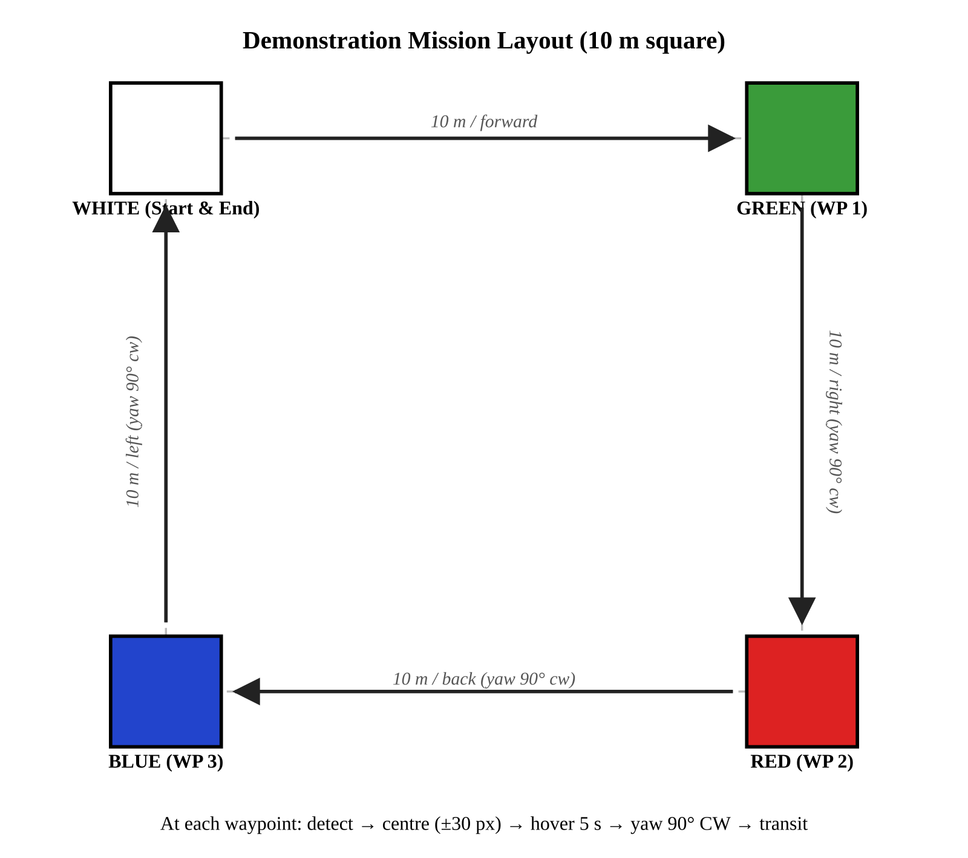
Fig 1-3: Mission layout — four colour-coded waypoint boxes at the corners of a 10 m square.

1.4 Report Outline
The remainder of this report is organised as follows. Chapter 2 reviews the literature on GPS-denied autonomous navigation, surveying the major approaches to visual-inertial odometry, visual terrain-relative navigation, and optical-flow-aided dead-reckoning, and concludes by motivating the particular hybrid strategy adopted in this work. Chapter 3 explains the design methodology and the governing equations and analytical work involved in the selection of EKF3 parameters, latency budget and safe mission profile horizontal velocity. Each integration step has been documented during the process described in Chapter 4, which details the physical integration of airframe, electronics, sensors, companion computer and software stack. The experimental results are presented and discussed in Chapter 5. The data used for the SITL simulation and the live flight demonstrations. Chapter 6 examines the Social, Environmental and Sustainability effects of the work, and explicitly links the project to the United Nations Sustainable Development Goals. The project management section (Chapter 7) covers the project schedule, contributions from individual team members and the bill of materials. The report is finished in chapter 8, which includes a list of recommendations for future directions. Future work that directly extends and extends the foundation laid here.
Chapter 2

LITERATURE REVIEW

2.1 Literature Review
The literature on GPS-denied autonomous flight has grown rapidly over the past decade, driven both by the proliferation of consumer multirotors and by a renewed military interest in autonomy under contested radio-frequency conditions. The body of work can be grouped into four broad categories: (a) survey papers that map the GPS-denied problem space and the available sensor modalities; (b) papers proposing complete visual-inertial odometry (VIO) frameworks; (c) papers on visual terrain-relative navigation (VTRN) and cross-view image matching; and (d) papers describing concrete integrated systems on specific airframes. The four categories are not mutually exclusive, and the most useful integrated-system papers — for our purposes — combine results from all three of the others.

2.1.1 Surveys of GPS-Denied Navigation
Several recent survey papers establish the operational case for GPS-denied flight and enumerate the sensor modalities available to address it. The MDPI review of vision-based navigation techniques for UAVs (2023) is particularly comprehensive: it taxonomises GPS-denied navigation into purely inertial, optical-flow-aided, monocular-visual, stereo-visual-inertial, LiDAR-inertial, and map-based variants, and contrasts each on the dimensions of cost, weight, computational requirement, drift behaviour, and indoor versus outdoor robustness. The same paper notes a consistent finding across the literature: pure inertial navigation is unusable beyond a few seconds, optical flow alone is sufficient for hover but accumulates yaw and translational drift, and visual-inertial fusion is the consensus minimum-viable architecture for drift-bounded hover-and-translate flight on cost-constrained platforms.
Earlier survey work, including the widely-cited ResearchGate review on UAV navigation in GPS-denied environments, frames the same problem in terms of integration drift: the central engineering challenge is not measuring motion (every component of the vehicle dynamics is observable), but bounding the integrated error of those measurements over an operationally useful time window. Every GPS-denied architecture in the literature can be read as a strategy for periodically resetting that integrated error using some external reference — be it visual landmarks, a map, a known-pattern target, or a beacon.

2.1.2 Visual-Inertial Odometry Frameworks
The dominant family of GPS-denied solutions in the open-source robotics community is Visual-Inertial Odometry. VINS-Mono (Qin et al., 2018) introduced a tightly-coupled, optimisation-based sliding-window estimator that fuses monocular camera features and IMU pre-integrated measurements. VINS-Fusion extended the same approach to support stereo cameras and loop-closure correction. ORB-SLAM3 (Campos et al., 2021) is an alternative feature-based system that additionally constructs a reusable map and supports re-localisation against it. OpenVINS (Geneva et al., 2020) is an EKF-based VIO that prioritises modularity and computational efficiency, and is therefore frequently the choice for embedded platforms. Comparative evaluations on standard datasets (EuRoC, TUM-VI) consistently show that the optimisation-based methods (VINS-Fusion, ORB-SLAM3) produce slightly tighter trajectory error than the filter-based methods, at the cost of approximately two-to-five times the computational load.
Table 2-1: Algorithmic comparison of leading open-source VIO frameworks.
Framework | Approach | Compute | Distinguishing Property
VINS-Mono / VINS-Fusion | Optimisation (sliding window) | Heavy | Mature, supports loop closure; standard research baseline.
ORB-SLAM3 | Feature-based SLAM | Heavy | Builds a reusable feature map; supports re-localisation.
OpenVINS | EKF (filter-based) | Light | Modular, embedded-friendly, good fit for Jetson-class hardware.
Isaac ROS VSLAM | Hardware-accelerated | Light (on Orin) | NVIDIA-optimised, leverages CUDA + DLA.
MTF-02P + EKF3 (this work) | Optical flow + LiDAR + IMU | Very light | Sufficient for hover and short translations on Jetson Nano.
Two practical observations from this literature directly inform our design. First, full-blown VIO frameworks such as VINS-Fusion and ORB-SLAM3 require global-shutter stereo cameras and a hardware-synchronised IMU; the rolling-shutter Logitech webcam on our airframe does not satisfy these requirements, and the additional cost of a global-shutter stereo head (Intel RealSense D435i, Luxonis OAK-D Pro) was incompatible with the project budget. Second, on a 4 GB Jetson Nano running concurrently with a YOLOv8 inference workload, even the lightest VIO implementation competes for memory and GPU cycles to a degree that can introduce variable latency in the control loop. We therefore adopt a deliberately simpler scheme: a single integrated optical-flow-and-rangefinder module (the MicoAir MTF-02P) feeds horizontal-velocity and altitude data directly into the flight controller's EKF3 over a dedicated UART, and the camera is reserved exclusively for the YOLOv8 landmark-correction loop. This is, in effect, the minimum sensor configuration that retains drift-bounded hover, and is appropriate for the demonstration scope of this project.

2.1.3 Visual Terrain-Relative Navigation
Visual Terrain-Relative Navigation provides the second half of the GPS replacement: an absolute, drift-free position fix obtained by matching a downward-looking camera image against a pre-loaded geo-referenced map. The earliest practical work on this problem (Viswanathan, CMU, 2015) used hand-crafted feature descriptors (SIFT, SURF) to match drone images against satellite tiles, and reported that the approach failed dramatically under seasonal and illumination variation. The Caltech VTRN paper (Fragoso et al., 2021) introduced a deep transform that learns season-invariant descriptors and demonstrated robust localisation across summer-to-winter image pairs. More recent work uses transformer-based image matchers — SuperPoint plus SuperGlue, and the detector-free LoFTR — which combine local descriptor extraction with a learned attention-based matching network and are robust to texture-poor regions and repetitive patterns common in aerial imagery.
For the present project, full VTRN with a satellite tile database was assessed and ultimately deemed out-of-scope on three grounds: (i) the reliable execution of LoFTR or SuperGlue at useful frequency (≥1 Hz) requires a TensorRT-accelerated path that is well within reach of the Jetson Orin Nano but not of the older Jetson Nano available to the team; (ii) the mission profile is restricted to short ranges within the GIKI campus, where the cumulative drift over a complete mission is small enough to be corrected by a single landmark recognition rather than by continuous map matching; and (iii) the VTRN problem is most valuable when the operational area is large enough that a finite landmark set cannot cover it, which is not the case for this academic demonstration. We therefore replace continuous VTRN with a discrete waypoint-based variant: a YOLOv8 model trained on a small, curated set of physical landmarks — four colour-coded waypoint boxes, with a documented roadmap to a future expansion that replaces them with permanent campus features — acts as the drift-correction trigger, and the position estimate is reset whenever a high-confidence landmark detection is centred in the camera frame.

2.1.4 Optical Flow and Range-Aided Hover
The third strand of literature relevant to this work is the use of inexpensive optical-flow sensors and time-of-flight rangefinders for stable indoor hover. The PX4 and ArduPilot autopilot communities have published extensive parameter guides for the use of the PMW3901 and ADNS-3080 optical-flow chips, and for laser rangefinders such as the VL53L0X and VL53L1X. The performance envelope of an optical-flow + rangefinder hover stack is well documented: in textured indoor lighting, horizontal drift of less than 15 cm/min and vertical drift of less than 2 cm are routinely achieved at altitudes of 0.3-2 m. These figures are well within the requirements of our demonstration mission. The MicoAir MTF-02P module adopted in this work consolidates a PMW3901-class flow sensor and a single-zone laser rangefinder into a single board with native MAVLink output; this consolidation eliminates the SPI/I²C-on-Jetson companion-computer bridges that consume significant integration effort in the older two-chip designs, and is the principal reason the module was selected after early integration experiments with the discrete sensor pair revealed driver and bus-conflict issues on the Jetson Nano L4T 32.7 platform.

2.1.5 Edge-Compute Object Detection
The final relevant strand of literature concerns the deployment of modern object-detection networks on edge hardware. The Ultralytics YOLOv8 family extends the YOLO line with anchor-free heads and a redesigned backbone that produces consistently better mAP at lower parameter counts than the YOLOv5 generation. The Nano variant (≈3.2M parameters) is the smallest member and the most appropriate for a 4 GB Jetson; published benchmarks on the Jetson Nano (and corroborated by our own measurements during model-selection trials) place its inference latency at approximately 200-230 ms per 640 × 480 frame in raw PyTorch on CUDA, falling to approximately 80-120 ms after TensorRT optimisation. This latency is well above the ArduPilot inner-loop period of 2.5 ms, which directly motivates the producer-consumer threading architecture documented in Chapter 3 of this report: YOLO inference must run on its own thread, not inside the flight-control loop. The Jetson Nano furthermore ships with Ubuntu 18.04 and Python 3.6, while modern Ultralytics releases require Python 3.8 or newer; our deployment therefore runs the inference stack inside the official NVIDIA / Ultralytics Jetson Docker image (ultralytics/ultralytics:latest-jetson-jetpack4), which is the community-standard solution to this version-skew problem.

2.2 Inferences Drawn from the Literature
Three concrete design inferences follow from the literature reviewed above. First, the consensus minimum sensor set for drift-bounded GPS-denied hover on cost-constrained hardware is an IMU, a downward optical-flow sensor, and a downward rangefinder; this is precisely the configuration we adopt, with the IMU residing on the DakeFPV H743 and the optical-flow + rangefinder pair provided by a single MicoAir MTF-02P module that talks to the flight controller in native MAVLink. Second, the gold-standard solution for absolute drift-free positioning — full visual-inertial odometry combined with continuous terrain-relative map matching — is incompatible with the compute and budget envelope of the project, but a discrete YOLO-based landmark-correction loop preserves the same architectural property (drift correction by external visual reference) at a small fraction of the computational cost. Third, any architecture that runs deep-network inference on the same processor as the flight-control loop must isolate the two through a producer-consumer queue, so that the variable inference latency cannot stall the deterministic control loop. Each of these three inferences becomes a load-bearing element of the design described in Chapter 3.

2.3 Summary
The literature review establishes that GPS-denied autonomous flight is a mature research area with a well-understood sensor-modality space and a clear hierarchy of cost-versus-capability trade-offs. The most ambitious published systems combine full VIO with deep-learning terrain matching on research-grade compute. The most economical published systems achieve stable hover and limited translation using inexpensive optical-flow + rangefinder + IMU fusion. This project sits between those two extremes: it adopts the economical sensor stack as its foundation — refined into a single MAVLink-native combined optical-flow + LiDAR module to minimise companion-computer integration risk — and adds a discrete YOLOv8-based landmark-recognition loop as a proxy for full terrain-relative navigation. The architecture is therefore deliberately positioned as an undergraduate-feasible reference design, demonstrating GPS-denied autonomy without the cost of research-grade sensors and compute. The detailed design and analysis that realise this position are presented in the next chapter.
Chapter 3

DESIGN AND ANALYSIS

3.1 Design Methodology
The design methodology adopted in this project is a hierarchical, three-loop control architecture combined with a producer-consumer software model on the companion computer. The overall workflow follows the classical V-model: requirements were derived from the problem statement of Chapter 1, decomposed into subsystem specifications (flight controller, optical-flow bridge, rangefinder bridge, vision pipeline), implemented and unit-tested individually, then integrated and tested at the system level — first in a Gazebo + ArduPilot software-in-the-loop (SITL) simulation and finally on the physical airframe. The method is justified because (i) flight is unforgiving of integration errors discovered late, (ii) the physical airframe and the simulation share the same firmware and the same MAVLink interface, so software validated in simulation transfers almost directly to hardware, and (iii) the V-model's emphasis on early sub-system testing is exceptionally well suited to a multi-person undergraduate team in which different members own different sub-systems.
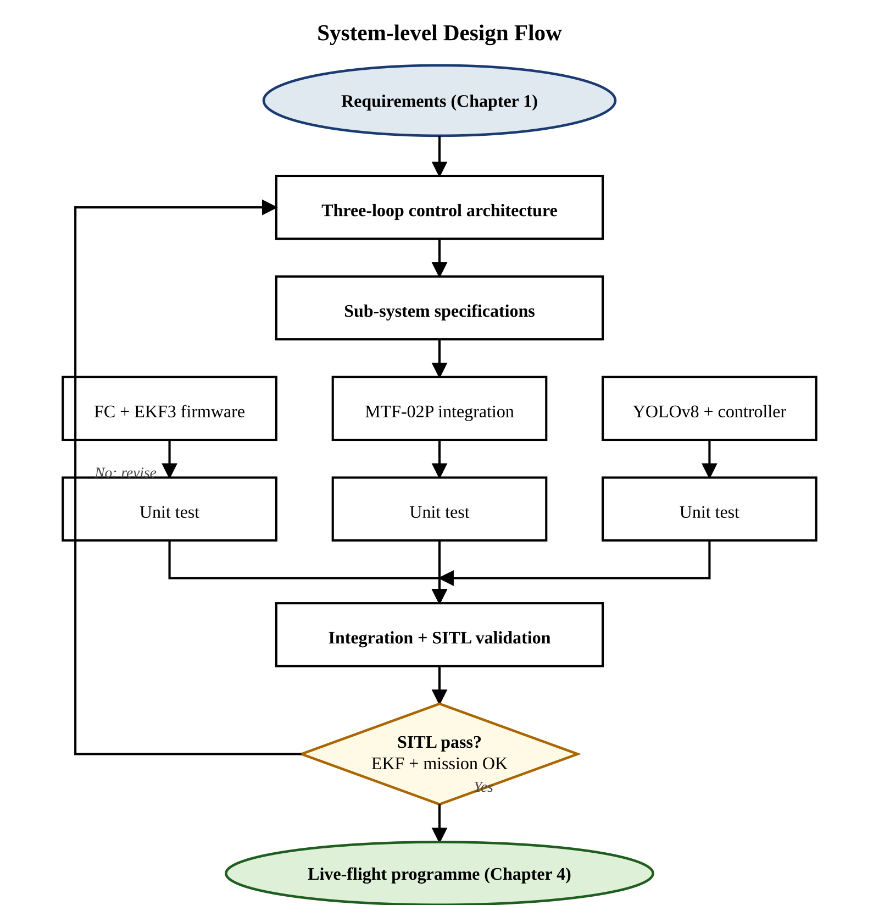
Fig 3-1: System-level design flow chart of Project A.E.T.H.E.R.
At the architectural level, the navigation stack is decomposed into three nested control loops running at different rates on different processors:
Table 3-1: Three-loop control architecture summary
Loop | Runs On | Rate | Source Data | Output
Stabilisation | DakeFPV H743 (ArduPilot) | 400 Hz | IMU + EKF3 | Motor PWM (DShot300)
State Estimation | DakeFPV H743 (EKF3) | 400 Hz internal | IMU + MTF-02P (UART) | EKF3 fused state
Mission / AI | Jetson Nano (Docker) | 4–5 FPS | YOLOv8n + ArduPilot pose | SET_POSITION_TARGET (MAVLink)

The stabilisation loop runs on the DakeFPV H743 flight controller at the IMU sample rate of 400 Hz and produces motor pulse-width-modulation commands (DShot300) for the SpeedyBee BLS 55 A four-in-one ESC. It is, by deliberate design choice, identical to the stabilisation loop that ArduCopter would run on a GPS-equipped airframe; the difference is purely in the source of its position and velocity inputs. The state-estimation loop is integrated into the same flight controller: the MicoAir MTF-02P module talks directly to the H743 over a dedicated UART (SERIAL1 in our wiring) using the MAVLink OPTICAL_FLOW and DISTANCE_SENSOR messages, and the on-board EKF3 fuses these with the IMU at the controller's native rate. This is the principal architectural simplification relative to the original two-bridge design (described in Chapter 4 as the abandoned ADNS-3080 / VL53L0X path): no separate Python sensor bridges run on the Jetson, the SPI and I²C buses on the Jetson Nano are not loaded with timing-sensitive sensor traffic, and the optical-flow and rangefinder data path bypasses the companion computer entirely. The mission-and-AI loop runs on the Jetson Nano inside an NVIDIA / Ultralytics Docker container at the rate of YOLOv8 inference (typically 4-5 FPS, ≈215 ms per 640 × 480 frame, on the Jetson Nano's 128-core Maxwell GPU under CUDA), and translates landmark detections into MAVLink SET_POSITION_TARGET_LOCAL_NED velocity vectors that are sent to the H743 over a separate UART (SERIAL6 in our wiring). The three loops are deliberately decoupled in both rate and processor so that a stall or excursion in any one of them — most importantly a YOLO inference stall — cannot propagate into the time-critical stabilisation loop.
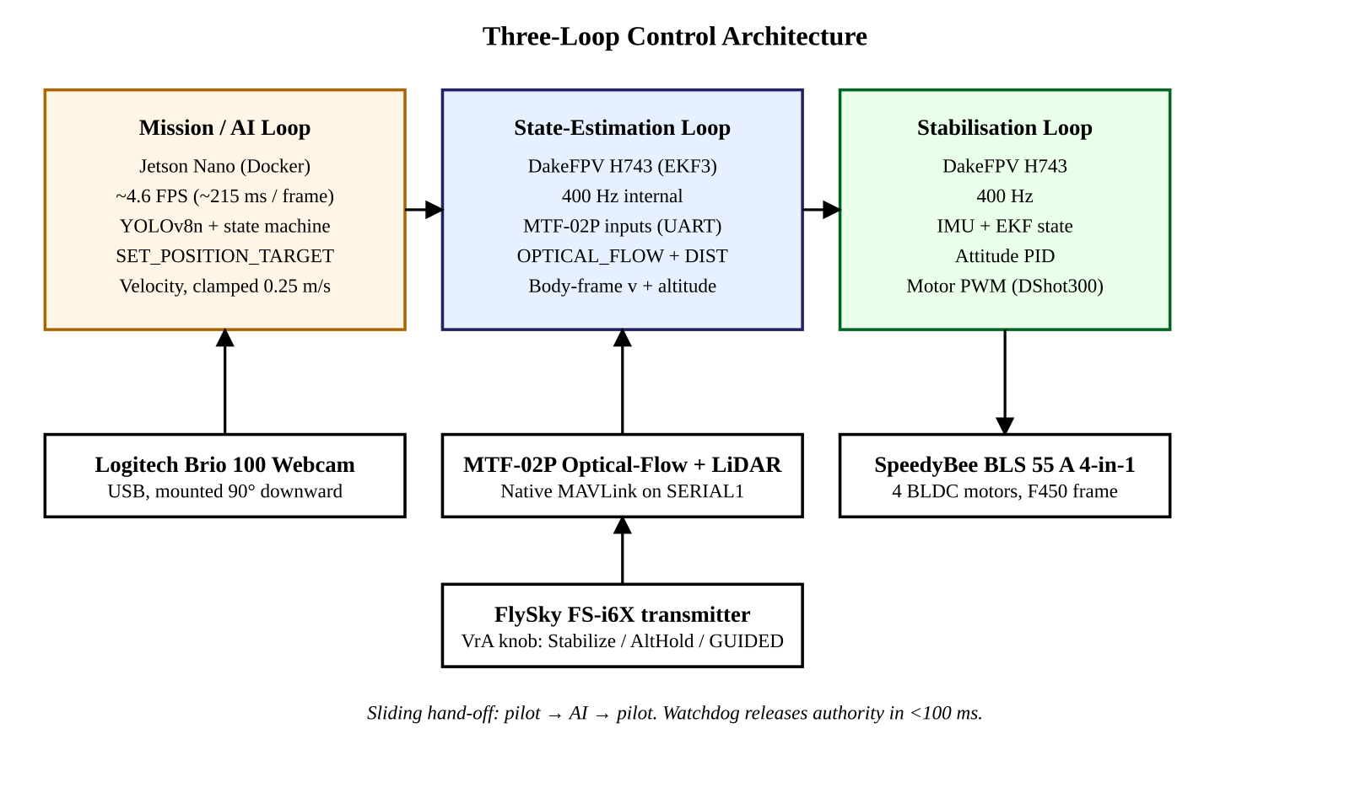
Fig 3-2: Three-loop control architecture (stabilisation, state estimation, mission/AI).

3.2 Governing Equations and Mathematical Modelling
The mathematical model of the system is built up from four governing equation groups: (i) the optical-flow rate equation, (ii) the EKF3 measurement-model expressions for the optical-flow and rangefinder updates, (iii) the proportional-derivative pixel-error controller that converts a landmark bounding-box centroid into a velocity command, and (iv) the latency-budget calculation that bounds the maximum safe horizontal velocity. Each is presented in turn.

3.2.1 Optical-Flow Rate Equation
The MTF-02P module performs the optical-flow computation on its on-board PMW3901-class sensor and outputs the result directly as a MAVLink OPTICAL_FLOW message containing integrated angular-flow values ωₓ and ωᵧ in radians per second. Internally, the sensor measures incremental displacements Δx and Δy in pixel counts between successive frames and converts them through the standard relation
ω_{x} = Δx / (C · Δt), ω_{y} = Δy / (C · Δt) (3.1)
where C is the counts-per-radian conversion factor for the sensor lens, given by C = f / p with f the lens focal length and p the sensor pixel pitch. Multiplying ω by the altitude h yields the linear horizontal velocity in metres per second:
v_{x} = h · ω_{x}, v_{y} = h · ω_{y} (3.2)
with h supplied by the laser rangefinder built into the same MTF-02P module (8 m maximum range; we operate at h ≈ 1 m). Because (3.2) requires h, optical-flow velocity estimation degrades at altitudes outside the rangefinder's reliable envelope, which justifies the deliberate choice of a low-altitude (≈1 m) operating profile for the demonstration. From the perspective of our software, no Jetson-side computation of (3.1) or (3.2) is required: the EKF3 estimator on the flight controller subscribes to the OPTICAL_FLOW and DISTANCE_SENSOR streams and performs the fusion internally.

3.2.2 EKF3 Measurement Updates
ArduPilot's EKF3 maintains a state vector that includes position, velocity, attitude, and IMU biases. The relevant measurement updates for the present project are the optical-flow update and the rangefinder update. The optical-flow update has measurement model
z_{flow} = (1/h) · R_{bv} (v_{b} − ω × r_{cb}) (3.3)
where Rₚᵥ is the body-to-vision rotation matrix, vₚ is the body-frame velocity, ω is the body-rate vector, and rᴄₚ is the camera offset from the body-frame origin. The form of (3.3) makes explicit the tight coupling between altitude, attitude rate, and translational velocity: any error in h directly scales the velocity estimate. The rangefinder update is comparatively simple,
z_{range} = h_{estimated} + n_{range} (3.4)
with nᵣₐₙₘ a zero-mean Gaussian noise term whose covariance is configured through the ArduPilot RNGFND parameters. Both updates are gated by the EKF3 source-selection parameters EK3_SRC1_VELXY and EK3_SRC1_POSZ, which are set in the project's parameter blueprint to use the MTF-02P optical-flow stream as the horizontal-velocity source (EK3_SRC1_VELXY = 5) and the MTF-02P rangefinder as the primary altitude source (EK3_SRC1_POSZ = 2). The barometer is deliberately not used for navigation in this build because the H743's onboard barometer is sensitive to motor down-wash at the low hover altitudes (≈1 m) used in the demonstration, whereas the laser rangefinder delivers cm-level altitude noise across the same envelope.

3.2.3 Pixel-Error Proportional-Derivative Controller
When a landmark of class c with confidence above the confidence threshold τ_c is detected by YOLOv8 with bounding-box centroid (cₓ, cᵧ), the controller computes a pixel error relative to the image centre (Cₓ, Cᵧ):
e_{x} = c_{x} − C_{x}, e_{y} = c_{y} − C_{y} (3.5)
The pixel error is then mapped to a velocity command in the body-offset NED frame through a discrete proportional-derivative law:
v_{x} = clamp(K_{P} e_{x} + K_{D} ė_{x}, −V_{max}, V_{max}) (3.6a)
v_{y} = clamp(K_{P} e_{y} + K_{D} ė_{y}, −V_{max}, V_{max}) (3.6b)
v_{z} = clamp(−K_{z} (h − h_{ref}), −V_{z,max}, V_{z,max}) (3.6c)
The pixel-error coefficients Kₚ and K​_D are not metric quantities — they are tuned empirically such that, at the design altitude of 1 m, a centred bounding box produces a near-zero velocity command and a maximally off-centre target produces exactly the saturated command Vₘₐₓ. The clamp operator is a hard, non-negotiable safety bound on commanded velocity. Numerical values are listed in Section 3.3.

3.2.4 Latency-Budget Calculation
The end-to-end pipeline from camera exposure to motor response consists of camera capture, USB transfer to the Jetson, OpenCV pre-processing, YOLOv8 inference, Python control logic, MAVLink UART serialisation at 115 200 baud, ArduPilot EKF3 update, and ESC update. Empirically measured per-stage latencies on our hardware are summarised in Table 3-2.

Table 3-2: Latency-budget calculation for the camera-to-motor pipeline.
Pipeline Stage | Latency | Notes
Camera capture (Logitech Brio 100, 640×480) | ~33 ms | 30 fps capture rate; one-frame buffering.
USB transfer + OpenCV decode | ~5 ms | USB 2.0; YUYV native pixel format.
YOLOv8n inference (PyTorch + CUDA, 640×480) | ~215 ms | Measured on Jetson Nano under nominal thermal load.
Python control logic (PD + state machine) | ~2 ms | Negligible compared to inference.
MAVLink UART serialisation (115 200 bd) | ~10 ms | Round-trip handshake measured.
ArduPilot EKF3 + ESC update | ~5 ms | 400 Hz inner loop on the H743.
Total worst-case latency T_lat | ≈ 270 ms | Used as the design bound for V_max.

To prevent the drone from overshooting a 12 inch (≈0.30 m) waypoint target between successive corrections, the maximum safe horizontal velocity must satisfy V_max · T_lat ≤ d_target / 2, which with d_target = 0.30 m and T_lat = 0.255 s gives V_max ≤ 0.59 m/s. Because the dominant pipeline stage on our hardware is the YOLOv8n inference itself (≈215 ms per frame, 4-5 FPS), the latency budget is in practice driven by inference rate rather than UART or EKF stages. We adopt V_max = 0.25 m/s as the hard clamp in the controller of equation (3.6) and set the corresponding ArduPilot waypoint speed (WPNAV_SPEED = 25 cm/s, LOIT_SPEED = 25 cm/s); this preserves a comfortable safety factor of approximately 2.4 against the latency-derived bound and matches the physical box-spacing of the demonstration mission, where each waypoint leg is approximately ten metres and a 0.25 m/s cruise gives roughly a forty-second transit during which YOLO has more than 150 inference opportunities to acquire the next box.

3.3 Analysis, Codes and Standards
The detailed analysis of the design proceeds along four axes: EKF3 source selection, optical-flow and rangefinder calibration, controller-gain tuning, and the social and environmental impact of the engineering choices. Each is presented below.

3.3.1 EKF3 Source Selection
The ArduPilot EKF3 estimator supports per-source configuration through the EK3_SRC parameter family. The deliberate departure from the default (GPS-driven) configuration is the central firmware-level choice of this project. The exact parameter set adopted is:
Table 3-3: EKF3 source-selection parameters for GPS-denied flight.
ArduPilot Parameter | Value | Reason / Effect
AHRS_EKF_TYPE | 3 | Use EKF3 (not EKF2). EKF2 cannot fuse external optical flow correctly.
EK3_ENABLE | 1 | Enable the EKF3 estimator.
EK3_SRC1_POSXY | 0 | Horizontal position source: NONE (no GPS).
EK3_SRC1_VELXY | 5 | Horizontal velocity source: OpticalFlow (from MTF-02P).
EK3_SRC1_POSZ | 2 | Vertical position source: Rangefinder (MTF-02P LiDAR).
EK3_SRC1_VELZ | 0 | Vertical velocity source: NONE (derived internally).
EK3_SRC1_YAW | 0 | Yaw source: gyro integration (compass disabled for navigation).
EK3_FLOW_USE | 1 | Enable optical-flow fusion in EKF3.
EK3_GPS_CHECK | 0 | Skip GPS pre-arm check (no GPS present).
EK3_RNG_USE_HGT | 70 | Use rangefinder for height when below 70 % of max range.
EK3_RNG_USE_SPD | 2 | Use rangefinder for height up to 2 m/s ground speed.
GPS_TYPE | 0 | Disable GPS so EKF does not wait for satellite lock.
FLOW_TYPE | 10 | Optical-flow source = MAVLink (from MTF-02P on SERIAL1).
RNGFND1_TYPE | 10 | Rangefinder source = MAVLink (from MTF-02P on SERIAL1).
RNGFND1_ORIENT | 25 | Sensor orientation: downward.
RNGFND1_MIN_CM | 10 | Minimum reliable range 10 cm.
RNGFND1_MAX_CM | 800 | Maximum reliable range 8 m (MTF-02P specification).
SERIAL1_PROTOCOL | 2 | MAVLink2 on the UART used for the MTF-02P.
SERIAL1_BAUD | 115 | 115 200 baud per MTF-02P specification.
SERIAL1_OPTIONS | 1024 | Bit 10: do not forward MAVLink on SERIAL1 (avoids loop-back conflict).
COMPASS_USE | 0 | Compass disabled for navigation; magnetometer hardware left enabled.
WPNAV_SPEED | 25 | Autonomous waypoint speed clamp = 0.25 m/s.
LOIT_SPEED | 25 | Loiter horizontal speed clamp = 0.25 m/s.
MOT_PWM_TYPE | 6 | DShot300 ESC protocol for SpeedyBee BLS 55 A 4-in-1.
ARMING_CHECK | 66 | Arming bitmask: INS + battery + RC only (skip GPS, compass, RF check).

3.3.2 Coordinate-Frame Mapping
A frequent source of catastrophic crashes in vision-controlled drones is sign error in the mapping from image-plane pixel error to body-frame velocity command. The convention adopted in our controller, and verified during props-off testing, is given in Table 3-4. The frame chosen is MAV_FRAME_BODY_OFFSET_NED, meaning velocity commands are interpreted relative to the drone's current heading rather than to magnetic North; this is the correct frame for a visual-tracking application because a yaw rotation must not swap the X and Y commands.

Table 3-4: Camera-to-NED body-frame coordinate-mapping convention.
Image Direction | Pixel Sign | NED Body Frame | Velocity Sign
Target moves RIGHT | +e_x | Drone moves +V_y (rightward) | +v_y
Target moves LEFT | −e_x | Drone moves −V_y (leftward) | −v_y
Target moves DOWN | +e_y | Drone descends (altitude drops) | +v_z
Target moves UP | −e_y | Drone climbs | −v_z
Target far (small bbox) | area < threshold | Drone moves +V_x (forward) | +v_x
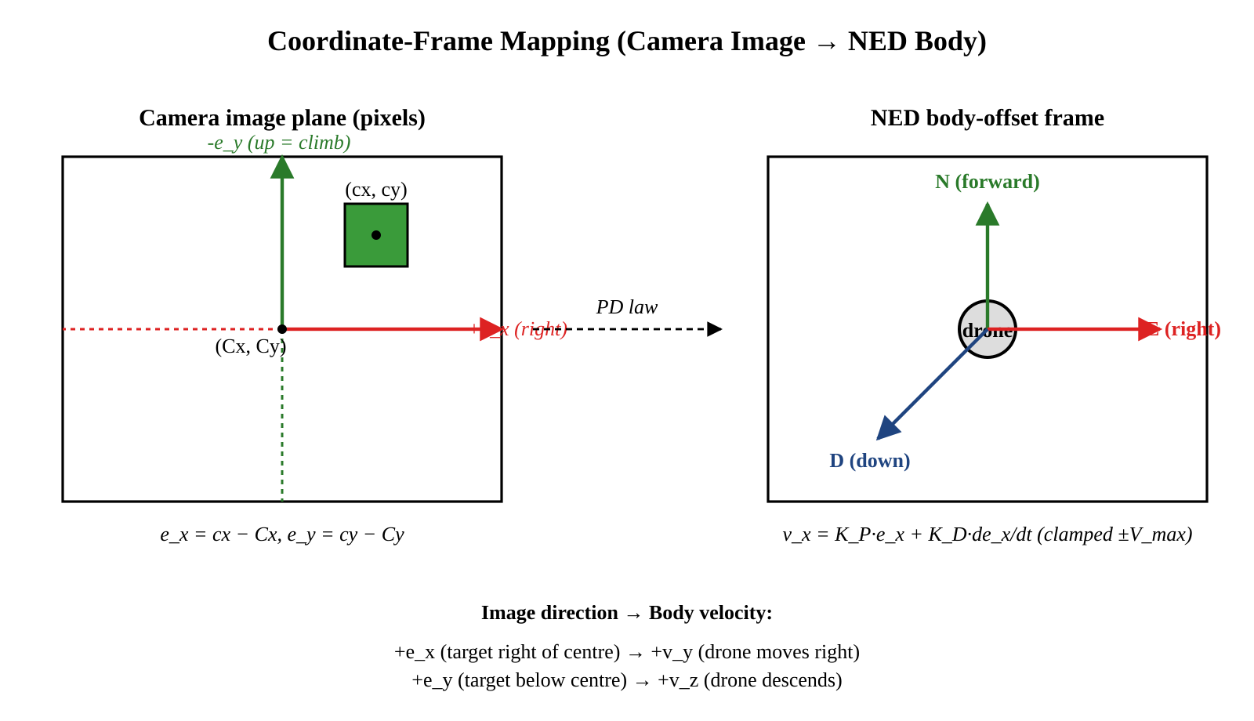
Fig 3-3: Coordinate-frame transformation from camera image plane to NED body frame.

3.3.3 Producer-Consumer Software Model
Because YOLOv8 inference latency is variable (≈215 ms typical, with a 30-50 % thermal-throttling tail) on the Jetson Nano, running it inside the same Python thread as the MAVLink command loop would couple control-loop jitter directly to inference jitter. The chosen architecture is a two-thread producer-consumer model implemented inside the aether_controller.py script: Thread 1 (the producer) captures camera frames at 30 fps over USB, runs YOLOv8 inference at the GPU-bound rate of approximately 4-5 FPS, applies a multi-frame voting filter on detection class and confidence (a six-of-ten majority rule with τ_c = 0.60), and pushes the most recent winning detection onto a Python queue.Queue(maxsize=1); Thread 2 (the consumer / mission state machine) reads the queue (non-blocking), runs the WAIT_FOR_GUIDED → TRANSIT → SEARCH → COMMIT → CENTER → HOVER → YAW state machine, applies the proportional-derivative law of (3.6) with hard saturation at V_max = 0.25 m/s, and emits MAVLink SET_POSITION_TARGET_LOCAL_NED messages with type-mask 0x0FC7 (use velocity, ignore position, ignore acceleration, ignore yaw) at 10 Hz. The maxsize = 1 queue is the critical detail: when Thread 1 produces a new detection, it overwrites the previous one, guaranteeing that the consumer always sees the freshest perception result rather than a stale buffered frame. Note that no separate sensor-bridge threads are required: the MTF-02P optical-flow and rangefinder data goes directly into the flight controller's EKF3 over UART, completely outside the Jetson process.
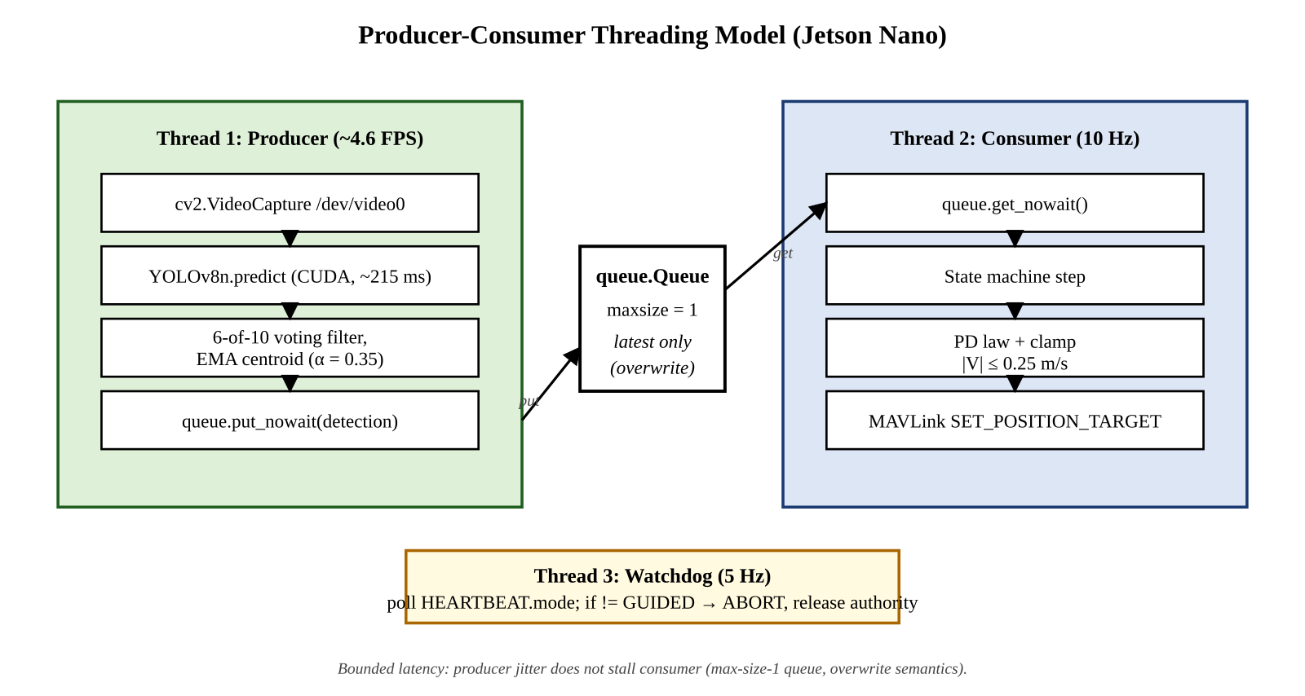
Fig 3-4: Producer-consumer threading model on the Jetson Nano companion computer.
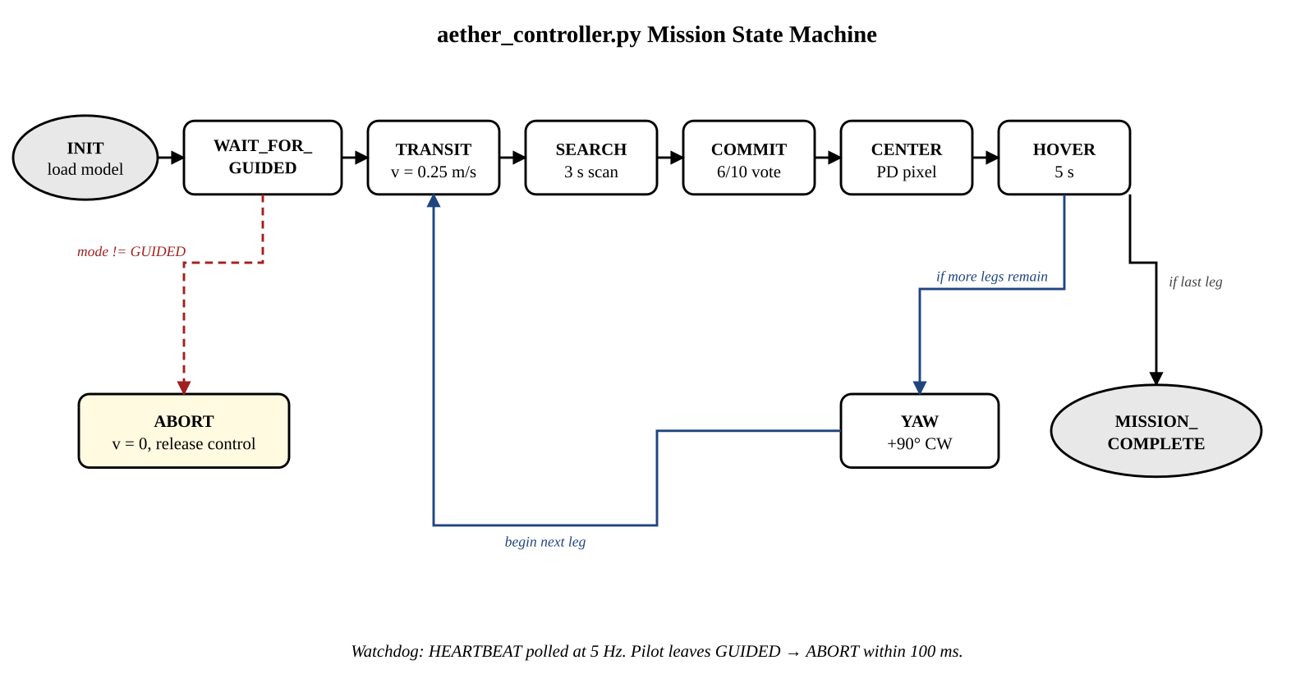
Fig 3-5: Mission state machine — INIT → WAIT_FOR_GUIDED → TRANSIT → SEARCH → COMMIT → CENTER → HOVER → YAW → next leg.

3.3.4 Environmental and Social Impact of the Design
The engineering choices made in this design have specific impacts on the environment and the community that should be stated explicitly. The deliberate use of an existing 4 GB Jetson Nano and the F450 frame instead of newer more energy-efficient options (Jetson Orin Nano, carbon-fibre frame) is an example of a reuse over replacement decision to reduce the amount of embodied carbon in the prototype. The 3-cell LiPo battery is recyclable through standard channels, but does present an end-of-life hazard if punctured or discarded improperly; the SOP playbook accompanying this project specifies a battery-disposal procedure. On the social side, GPS-denied autonomous flight has plainly dual-use character — the same capability that supports legitimate search-and-rescue and infrastructure inspection can be misapplied to autonomous reconnaissance with reduced accountability. The project addresses this by (i) restricting demonstration flights to the GIKI campus, (ii) preserving an unconditional manual-override path through the FlySky transmitter at all times, and (iii) documenting safety procedures in a manner that emphasises responsible experimental practice.

3.4 Summary
This chapter has described how to design, use, and develop a project from an engineering perspective. The three-loop control architecture splits the stabilization loop (400 Hz) from the variable latency YOLO loop (4-5 FPS) via a producer-consumer queue. The optical flow rate equation, the EKF3 measurement model equations, and the pixel error proportional-derivative controller provide the definition of how to convert raw sensor data into a safe velocity command using YOLO bounding box data. The analysis of the latency budget puts a limit of 0.25 m/s on the maximum safe horizontal velocity that can be achieved during the demonstration mission. The full ArduPilot parameter blueprint and the camera-to-NED coordinate-mapping convention are documented and reproduced verbatim in the project's SOP playbook to allow future students to rebuild the configuration without rederivation. With the analysis complete, Chapter 4 turns to the physical development, integration, and testing of the prototype.

