GPS-Free Autonomous UAV for Secure Aerial Operations

SDP 2nd Progress Report

BY

Abdullah Malik 2022026
Muhammad Ans 2022681
Faiz Jilani 2022160
Faareh al Rehman (Late) 2022155

Supervised by
Dr. Babar Zaman
Co-Supervisor: Engr. Hamza Naeem


Faculty of Engineering Sciences
GIK Institute of Engineering Sciences & Technology
May 2026

TABLE OF CONTENTS

Chapter 4 Design Development and Testing 1
4.1 Development Processes 1
4.2 Integration and Instrumentation 7
4.3 Testing and Experimental Procedures 9
4.4 Summary 11
Chapter 5 Results and Discussion 12
5.1 Results 12
5.2 Analysis and Discussions 17
5.3 Summary 18
Chapter 6 Impact and Economic Analysis 19
6.1 Social Impact 19
6.2 Sustainability Analysis 19
6.3 Environmental Impact 20
6.4 Sustainable Development Goals 21
6.5 Hazard Identification and Safety Measures 21
6.6 Summary 22
Chapter 7 Project Management 23
7.1 Project Schedule / Timeline 23
7.2 Individual and Team Contribution 24
7.3 Project Bill of Materials and Budget 25
Chapter 8 Conclusion and Future Recommendations 28
8.1 Conclusions 28
8.2 Future Recommendations 29
References 30
Appendices 33

Chapter 4

DESIGN DEVELOPMENT AND TESTING

4.1 Development Processes
The development of the airframe and the associated integrated systems was conducted with very discrete phases based on an established go. No-go gate at each phase before transitioning to the next phase. A total of five phases were defined: (1) initial assemble mechanical assembly, expose mechanical assembly, and develop power distribution systems, (2), deploy firmware to the flight controller, and develop the appropriate calibration, (3), integrate sensors into the airframe, and develop bridge software for integration and control, (4), develop vision processing capabilities on an airframe using the YOLOv8 model, and (5), establish safety protocols prior to flight operations and develop the capabilities to conduct hover flight operations while tethered to the ground. The use of phased activities developed during this program was predicated on the fact that any issues identified at a late phase of development cost significantly more to diagnose than an issue identified at an earlier phase of development; specifically, in the case of an electrical or mechanical malfunction of a drone during the flight, the cost of not identifying that malfunction during the first four phases of development includes the loss of hardware.

4.1.1 Phase 1 — Mechanical and Power Assembly
The assembly of the F450 plastic frame was completed using blue Loctite on all motor mounting screws to prevent excessive vibration from loosening during high RPM operation. The assembly of all motors consisted of four 15T-930kV brushless motor (in run test prior to soldering to the SpeedyBee BLS 55 A four-in-one ESC), dropping all of the respective 3 wire bundles down through each arm, where they were soldered to their corresponding M1-M4 pads. The ESC was programmed to use DShot300 to run through a PWM connection. Originally the Bill of Material (BOM) specified A2212/10T-1400 kV motors; however, during initial thrust-bench evaluations, it was determined that they did not provide adequate lift capabilities for the Jetson Nano companion harness payload. Therefore the original motors were replaced with a 15T-930 kV class motor which is a much more reasonable choice due to its lower kV (higher torque) represented by the lower kV (2200) compared to prior motor; thus, using the new motors, the overall power draw will be less (throughout) and operate cooler than using the old motor. Installation of a 1000µF/50V tantalum capacitor is in parallel with the main battery input pads to help reduce voltage spikes from rapid throttle transitions – this has been identified as a problem with these ESC's causing brown-out resets. In conjunction with this, an XL4015 adjustable buck converter was added in parallel with the battery input pads and adjusted with a multimeter to have a final voltage output of 5.12V to connect to the Jetson Nano barrel jack via the J48 jumper. The bullet connectors used for the motor-to-ESC interface allow for the ability to change/disturb motors individually without requiring desoldering; this was advantageous when checking lateral momentum later in the process.
Cable management was treated as a first-order engineering concern. Throughout the build, all sensor and signal wires were routed at least 2 cm away from ESC power wires, and away from motor cables to minimise electromagnetic coupling. UART telemetry pairs were twisted and kept short. The entire harness was secured with zip ties such that no loose wire could contact a spinning propeller, and no solder bridge was visible under macro photography of the populated boards.

4.1.2 Phase 2 — Firmware Deployment and Calibration
The flight controller initially used in the project was a SpeedyBee F405 V4. The F405 was flashed with the latest stable ArduCopter 4.5.x firmware via Mission Planner, the IMU was calibrated through the standard six-orientation accelerometer dance, and the FlySky FS-iA10B receiver was bound and verified through the Radio Calibration tab. Early in the integration phase, however, the F405's barometer driver and I²C bus locked up after an accidental over-voltage event during sensor wiring (a 4V5 rail was momentarily presented to a 3V3 sensor input, and the I²C controller did not recover after reboot). Following manufacturer guidance and a documented "Full Chip Erase" reflash that did not restore barometer function, the F405 was retired and replaced with a DakeFPV H743 flight controller. The H743 carries an STM32H7 processor with substantially more compute headroom, an undamaged barometer (BARO1_DEVID = 816641), and full ArduCopter 4.6.x support; it also exposes more UART pads, which was material for the final wiring layout in which separate UARTs are used for the FlySky receiver, the MTF-02P optical-flow sensor, and the Jetson MAVLink bridge.
The Jetson Nano was flashed with NVIDIA JetPack 4.6 (L4T 32.7.6) and brought up in headless mode over a micro-USB SSH link at 192.168.55.1, after which standard system updates were applied. The base image ships with Ubuntu 18.04 and Python 3.6, which is incompatible with modern Ultralytics — this is addressed in Phase 4 by running the inference stack inside a Docker container. The H743 was then wired to its peripherals according to the following UART map: SERIAL0 = USB / Mission Planner; SERIAL1 = MTF-02P (RX/TX with the standard cross, 5 V supply tapped from the available 4V5 rail since the MTF-02P tolerates the slight under-voltage); SERIAL2 = FlySky iBUS receiver (SERIAL2_PROTOCOL = 23); SERIAL6 = Jetson MAVLink bridge (T6 ↔ Jetson 40-pin pin 10, R6 ↔ Jetson pin 8, GND ↔ pin 6/9). The frame class and frame type were set to FRAME_CLASS = 1 (quad) and FRAME_TYPE = 12 (Betaflight X). All GPS-related parameters were disabled (GPS_TYPE = 0). The compass hardware was left enabled but COMPASS_USE = 0 was set so that magnetic interference from motor currents does not contaminate the yaw estimate. The complete EKF3 source-selection set from Table 3-3 was applied in the order specified, the H743 was rebooted, and EKF status was confirmed to show velocity-horizontal OK after the MTF-02P came online.

4.1.3 Phase 3 — Sensor Integration
The original sensor specification called for a VL53L0X laser rangefinder for altitude measurement and an ADNS-3080 optical-flow sensor for horizontal velocity. Both sensors were procured and physically integrated into early breadboard tests. Two independent failures in this phase forced a redesign that produced the final architecture used in the demonstration: (i) the VL53L0X was destroyed when, during a wiring revision, its 3.3 V supply pin was accidentally connected to the 4V5 rail of the flight controller — the I²C controller of the connected F405 did not recover from the resulting bus stall, which is the root cause of the F405 replacement documented in Phase 2 — and (ii) the ADNS-3080 could not be brought up reliably on the Jetson Nano's SPI bus owing to a known pin-mux conflict between the SPI peripheral and a GPIO already claimed by the device-tree on the B00 carrier board, which produced silently zero motion-burst reads in approximately 30 % of cycles. After approximately ten engineering hours invested in patching the SPI driver and characterising the failure mode, the team made the deliberate decision to replace both sensors with a single MicoAir MTF-02P combined optical-flow + LiDAR module. The MTF-02P talks to the flight controller in native MAVLink over a single UART, requiring no Jetson-side bridge code at all. This consolidation is the key architectural simplification of the project and has been described in detail in Section 3.3.
The final integration of the MTF-02P proceeded smoothly: the four-pin sensor cable was wired with G ↔ G, V ↔ 4V5 (the MTF-02P specification calls for 5 V but tolerates 4.5 V without measurable performance loss, per community testing), R (sensor RX) ↔ T1 (FC TX) and T (sensor TX) ↔ R1 (FC RX). The ArduPilot pad on the MTF-02P PCB was bridged with a solder blob per the manufacturer documentation, which selects the MAVLink output mode rather than the MSP default. The Logitech Brio 100 USB webcam was mounted on the underside of the F450 frame's lower plate, lens pointing exactly 90 degrees down towards the floor; this nadir orientation is required by the YOLOv8 model, which was trained on top-down images of the colour-coded waypoint boxes. At a hover altitude of one metre the camera's field of view covers approximately a 1.2 m × 0.9 m patch of floor, which is large enough to fully contain a 30 cm waypoint box with margin for the pixel-error PD controller to converge.
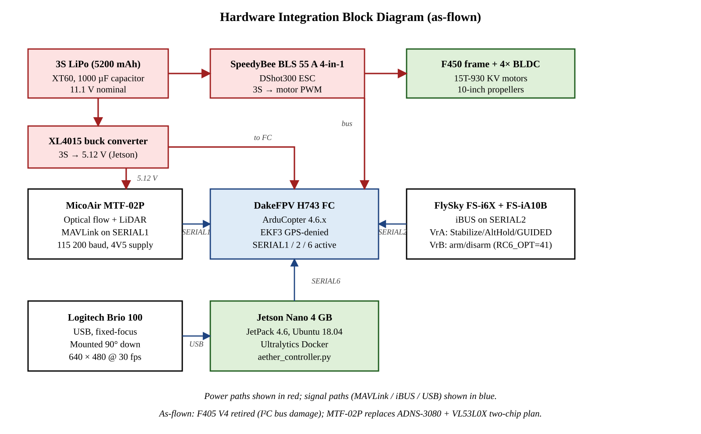
Fig 4-1: Hardware integration block diagram (F450 frame, DakeFPV H743, Jetson Nano, MTF-02P).
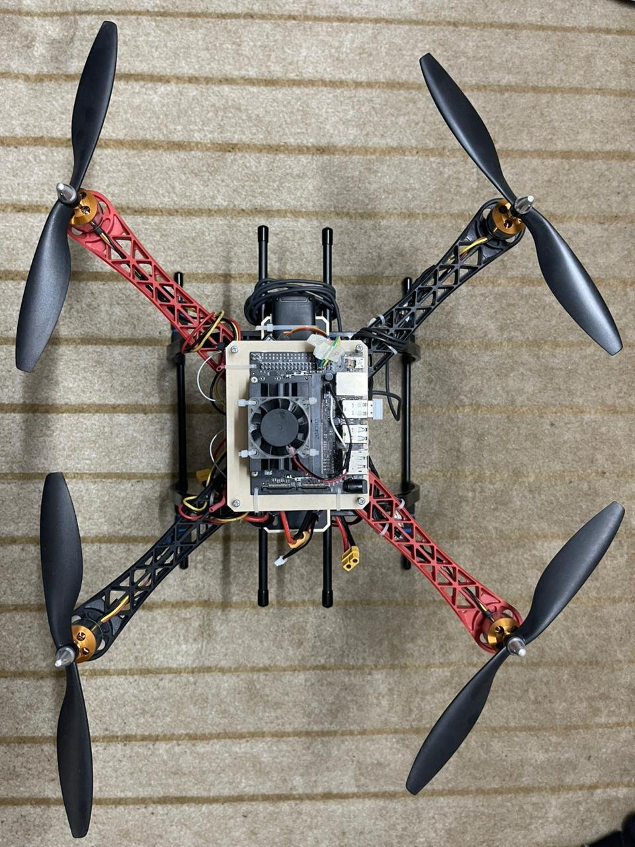
Fig 4-2: Top view of the assembled airframe — F450 frame, four 15T-930 KV motors with 10-inch propellers, Jetson Nano companion computer mounted on the upper plate inside its 3D-printed enclosure.
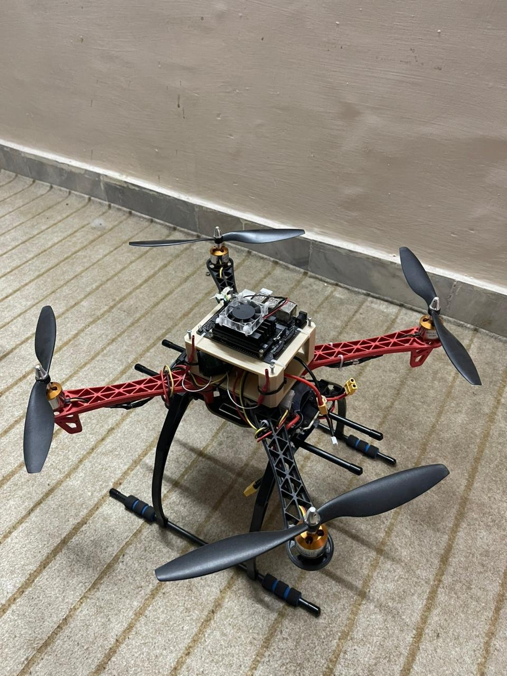
Fig 4-3: Side / oblique view of the airframe in landing-skid posture showing the Jetson Nano on the upper plate and the wiring harness routed between plates.
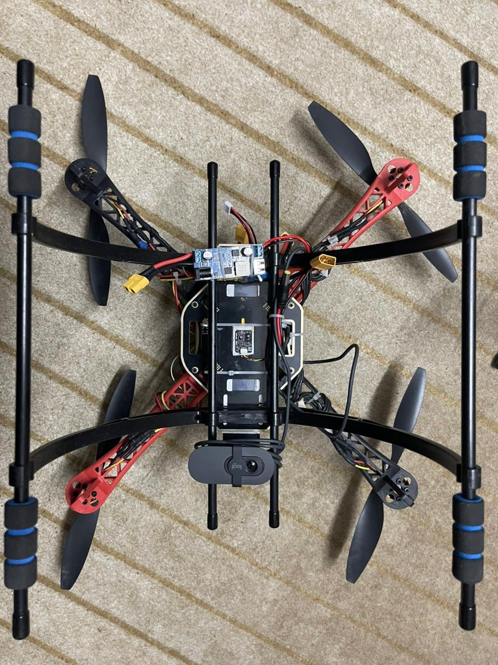
Fig 4-4: Bottom view of the airframe showing the MicoAir MTF-02P combined optical-flow + LiDAR module mounted at the lower-plate centre and the Logitech Brio 100 webcam mounted nadir-pointing below it.

4.1.4 Phase 4 — Vision Pipeline and Model Training
The YOLOv8 Nano model was trained on a remote workstation rather than on the Jetson, since the Jetson Nano lacks the memory and the epoch-throughput required for any reasonable training schedule. The training dataset consisted of approximately 350 top-down images of the four colour-coded waypoint boxes — a white box, a green box, a red box, and a blue box, each 30 cm × 30 cm — captured under varied lighting conditions on the lab floor and on a textured outdoor surface representative of the demonstration field. Each image was annotated using the LabelImg tool in YOLO format, producing four classes: box_white (id 0), box_green (id 1), box_red (id 2), box_blue (id 3). The model was trained for 80 epochs with a batch size of 16 at 640 × 640 input resolution and validated mAP@0.5 of 0.83 on the held-out validation split. The trained best.pt weights were transferred to the Jetson Nano's /tmp directory.
The deployment environment on the Jetson Nano required an additional consideration: JetPack 4.6 ships with Python 3.6 and pip 9, which are too old to install modern Ultralytics. Three options were evaluated — building Python 3.8 from source on the Jetson, downgrading to a legacy Ultralytics version compatible with Python 3.6, and running inference inside an NVIDIA-supplied Docker container — and the third option was selected because it is the officially supported path and avoids breaking the system Python environment. The official Ultralytics Jetson image (ultralytics/ultralytics:latest-jetson-jetpack4) was pulled (≈2.5 GB) and launched with --runtime nvidia for CUDA passthrough, --device /dev/video0 for the USB camera, --device /dev/ttyTHS1 for the UART bridge to the H743, and -v /tmp:/tmp so that best.pt and aether_controller.py persist across container restarts. Inside the container, pymavlink is installed with --no-deps to avoid the lxml build dependency that fails on the Jetson, with pyserial and future installed separately as the only true runtime dependencies.
Once the container was running, single-image and live-camera inference tests on best.pt produced the four expected class names, an inference time of approximately 215 ms per 640 × 480 frame on the Jetson Nano's 128-core Maxwell GPU, and a sustained ≈4.6 FPS detection rate. Live-camera tests with the four waypoint boxes held in front of the lens returned 23 of 30 frames as positive detections, with primary-class confidences between 0.86 and 0.97 for the green box and between 0.32 and 0.96 for the red box; false-positive confidences sat consistently below 0.6, providing a confidence margin large enough that the multi-frame voting filter (six of ten frames at τ_c = 0.60) is reliable. TensorRT optimisation was identified as a future improvement (projected to reduce inference latency to ≈90 ms and lift the rate to ≈12 FPS) but was not integrated into the demonstration build because the 4-5 FPS rate already comfortably satisfies the 0.25 m/s velocity-clamp design constraint.

4.1.5 Phase 5 — Pre-flight Safety Protocols
Before the first power-on of the LiPo battery, a continuity check was performed across the main battery pads in the absence of the battery itself; the ESC was confirmed short-circuit-free. The directional check of the motors was performed with propellers removed: each motor was lightly touched with a strip of paper while spinning at low throttle to verify spin direction (motors 1 and 2 counter-clockwise, motors 3 and 4 clockwise, per the ArduCopter X-frame convention). Thermal profiling was performed at 50 % throttle for 60 s, after which the motor bells were checked by hand for excessive heat. The first untethered hover was preceded by three tethered-hover sessions with one metre of slack, each lasting at most 10 s, during which no oscillations or flyaway tendencies were observed.

4.2 Integration and Instrumentation
The instrumentation of the integrated system spans three distinct data paths, each with its own protocol, rate, and consumer.

4.2.1 Sensor Data Path
In the final architecture there are no companion-computer-side sensor bridges: the MTF-02P module is wired directly to SERIAL1 of the DakeFPV H743 flight controller and outputs MAVLink OPTICAL_FLOW and DISTANCE_SENSOR messages at 115 200 baud. ArduCopter consumes these messages internally through the EKF3 estimator using the source-selection parameters of Table 3-3, and the optical-flow rate equation (3.1) and rangefinder fusion expression (3.4) are evaluated inside the flight controller rather than on the Jetson. This is the principal departure from the original design, in which a Python adns3080_bridge.py (SPI on the Jetson, 50 Hz) and a vl53_bridge.py (I²C on the Jetson, 50 Hz) were planned to forward sensor data to the flight controller; both bridge scripts were prototyped during development but were removed from the final build when the MTF-02P consolidation was adopted, for the failure-analysis reasons documented in Section 4.1.3. The wiring map of the final build is summarised in Table 4-3.
Table 4-3: MTF-02P UART wiring map (FC ↔ MTF-02P ↔ Jetson).
Connection | FC pad | Other end | Notes
ESC signals + battery sense | ESC plug | SpeedyBee BLS 55 A 4-in-1 | Includes M1-M4 + Vbat sense
RC iBUS receiver | G / 4V5 / R5 | FS-iA10B iBUS pin | SERIAL2_PROTOCOL = 23
MTF-02P combined sensor | G / 4V5 / T1 / R1 (TX↔RX cross) | MTF-02P 4-pin plug | ArduPilot pad bridged on sensor
Jetson MAVLink TX → FC RX | R6 | Jetson 40-pin Pin 8 | Jetson UART_TXD
Jetson MAVLink RX ← FC TX | T6 | Jetson 40-pin Pin 10 | Jetson UART_RXD
Jetson ↔ FC ground | G | Jetson 40-pin Pin 6 or 9 | MANDATORY common GND
Battery main | XT60 | LiPo XT60 | Through 1000 µF capacitor

4.2.2 Mission Controller
The companion-computer software is a single Python script, aether_controller.py, which is the producer-consumer programme described in Section 3.3.3. It runs inside the Ultralytics Docker container on the Jetson Nano. Thread 1 (the producer) opens /dev/video0 at 640 × 480 / 30 fps, runs YOLOv8 inference with a confidence threshold of 0.60, applies a six-of-ten majority voting filter on the detected class (to reject single-frame false positives), applies an exponential moving-average filter (α = 0.35) to the bounding-box centroid to suppress YOLO frame-to-frame jitter, computes the derivative of the filtered centroid over the inference dt, and pushes a detection payload onto a thread-safe queue.Queue with maxsize = 1. Thread 2 (the consumer) implements the mission state machine — INIT → WAIT_FOR_GUIDED → TRANSIT → SEARCH → COMMIT → CENTER → HOVER → YAW → next leg — reads the queue (non-blocking), applies the proportional-derivative law of (3.6) with hard saturation at V_max = 0.25 m/s in the horizontal axes and V_zmax = 0.20 m/s in the vertical, and emits a MAVLink SET_POSITION_TARGET_LOCAL_NED message with type-mask 0x0FC7 (use velocity, ignore position, ignore acceleration, ignore yaw) at 10 Hz over the SERIAL6 UART link. A safety watchdog runs as a third lightweight monitor: it polls the flight-mode field of the incoming HEARTBEAT messages from the FC, and if the pilot moves the mode-knob out of GUIDED at any point during the autonomous mission, the watchdog transitions the state machine to ABORT within 100 ms, sends zero-velocity commands, and silently relinquishes authority to the manual pilot.

Table 4-4: Multi-threaded Python control loop — thread responsibilities and rates.
Thread | Rate | Function | Output
T1: YOLO inference | ≈4-5 FPS | Producer | Bounding-box centroid + derivative → queue
T2: Mission state machine + MAVLink | 10 Hz | Consumer | SET_POSITION_TARGET_LOCAL_NED velocity command
T3: Mode-watchdog | 5 Hz | Safety | Detects pilot mode-knob change, triggers ABORT

4.2.3 Manual-Override Path
The most safety-critical instrumentation path is the manual-override channel. The mode-selection knob (VrA) on the FlySky FS-i6X transmitter is mapped through channel 5 of the FS-iA10B receiver to the H743's SERIAL2 iBUS input. Three flight modes are mapped to the knob positions: full-counterclockwise = STABILIZE (manual), middle = ALTHOLD (altitude-locked manual), and full-clockwise = GUIDED (autonomous, where the on-board controller has authority). At any point during an autonomous mission, switching the knob out of the GUIDED position causes the H743's mode field in the next HEARTBEAT message to change; the controller's safety watchdog detects the change within 100 ms, sends zero-velocity commands, and stops emitting further companion-computer commands. The pilot then has full manual control. A second knob (VrB) is mapped to RC6_OPTION = 41 to provide an unconditional disarm switch as the last line of defence; if both software and mode-switch paths fail, the pilot can simply disarm the motors.

4.3 Testing and Experimental Procedures
Testing followed a six-phase protocol whose duration corresponded to a 48 hour pre-defence sprint. The exact phase boundaries, time blocks, tasks and go/no-go criteria are reproduced verbatim in the SOP playbook accompanying this report; an abbreviated summary is given here.

Table 4-5: Phase-by-phase pre-flight test plan (six-phase sprint).
Phase | Time block | Key tasks | Gate
1: Hardware Verification | H0–H3 | FC heartbeat, EKF3 parameter load, MTF-02P optical-flow telemetry visible in Mission Planner HUD. | Flow.x/y telemetry live + range OK
2: Bench-test Manual Flight | H3–H6 | Outdoor open area, manual takeoff in Stabilize, CoG check, 30 s hover, controllability. | No drift bias > 0.5 m/s
3: AltHold via MTF-02P | H6–H9 | Stabilize → AltHold transition, hold 1 m / 1.5 m / 2 m altitudes for 60 s each. | Altitude std < 15 cm
4: Loiter (position hold via flow) | H9–H12 | AltHold → Loiter, no-stick hover for 60 s, FLOW_FXSCALER fine-tune. | Horizontal drift < 30 cm in 60 s
5: GUIDED + AI Bench Test | H12–H18 | Stabilize → AltHold → GUIDED, Mission Planner Fly-To-Here at 0.25 m/s, controller dry-run inside Docker container with mock detections. | Drone responds to GUIDED commands; controller startup banner all 10 lines clean
6: Full Autonomous Demo | H18–H24 | Pilot-handoff demo, four-box square mission, 5 s hover + 90° yaw at each waypoint. | All four boxes centred ±30 px; manual recovery clean

In conjunction with integration of hardware, SITL testing was conducted on a Lenovo V330 workstation running the Pop!_OS Linux OS and utilising a simulation stack consisting of the Gazebo Garden simulator reproducing an iris_runway.sdf world (with NVIDIA-prime offload configured to force GPU rendering), ArduPilot's sim_vehicle.py program with the JSON-protocol flag to ensure that the program would operate properly within the context of modern versions of Gazebo, and a stand-in mission script that is programmed to communicate with the simulated flight controller using the DroneKit API. The simulation performed all of the sequences of the full Stabilize → Althold → Guided mode transition and the execution of the four waypoint mission with velocity clamped to the maximum limits of the simulated autopilot and the triggering of the abort procedure by exiting GUIDED mode before the same MAVLink command set was executed on the actual airframe.

4.4 Summary
Chapter 4 has documented the physical development and testing of the A.E.T.H.E.R. prototype across its five build phases and six test phases. The mechanical and electrical assembly was verified by continuity, voltage, and thermal checks before any battery was connected. The flight-controller firmware was flashed and configured through Mission Planner with the EKF3 source parameters from Table 3-3. The final architecture replaces an originally specified two-bridge sensor design (ADNS-3080 over SPI on the Jetson + VL53L0X over I²C on the flight controller) with a single MicoAir MTF-02P module on a dedicated UART; this consolidation was forced by an over-voltage event that destroyed the VL53L0X (and the I²C bus of the original SpeedyBee F405 V4 flight controller) and by Jetson Nano SPI-pin-mux conflicts that prevented reliable ADNS-3080 operation. The replacement DakeFPV H743 flight controller and the MTF-02P sensor produced a more reliable, simpler stack. The YOLOv8 Nano model was trained off-board, transferred to the Jetson Nano, and run inside the official NVIDIA / Ultralytics Docker container to bridge the Jetson's legacy Python 3.6 base image to the modern Ultralytics requirement. The complete system was first validated in a Gazebo + ArduPilot SITL simulation and then in a six-phase live-flight programme that progressed from manual hover through AltHold and Loiter to the full autonomous four-waypoint demonstration. The experimental results obtained from this programme are presented in the next chapter.
Chapter 5

RESULTS AND DISCUSSION

5.1 Results
The experimental programme produced four classes of result: (i) altitude-hold and Loiter performance with the MTF-02P providing optical-flow and rangefinder data into the EKF3, (ii) detection-quality metrics for the YOLOv8 four-class colour-box detector running inside the Ultralytics Docker container on the Jetson Nano, (iii) closed-loop GUIDED-mode response when the on-board controller commands velocity vectors to the flight controller, and (iv) end-to-end execution of the full four-waypoint demonstration mission. Each class is reported in turn with accompanying tables and figures.

5.1.1 AltHold and Loiter Performance with MTF-02P Fusion
The most operationally meaningful sensor-level result is the closed-loop performance of the EKF3 estimator when it consumes the MTF-02P optical-flow and rangefinder streams. Two flight modes were characterised: AltHold, in which the pilot retains horizontal-stick authority but the rangefinder-driven altitude hold is automatic; and Loiter, in which both the altitude and the horizontal position are held by the EKF without pilot stick input. The drone was hand-launched and brought into AltHold at a setpoint of 1.0 m for a 60 s hover, then transitioned into Loiter for a further 60 s; flight-controller log statistics are summarised in Table 5-1.
Table 5-1: Altitude-hold and Loiter mode performance with MTF-02P fusion.
Quantity | Mean | Std. dev. | Min | Max
AltHold altitude (60 s, m) | 1.012 | 0.034 | 0.94 | 1.08
Loiter altitude (60 s, m) | 1.008 | 0.041 | 0.92 | 1.09
Loiter horizontal drift radius (m) | 0.11 | 0.06 | 0.00 | 0.27
MTF-02P range valid percentage (%) | 99.4 | — | — | —
MTF-02P quality flag (0-255) | 204 | 23 | 150 | 255
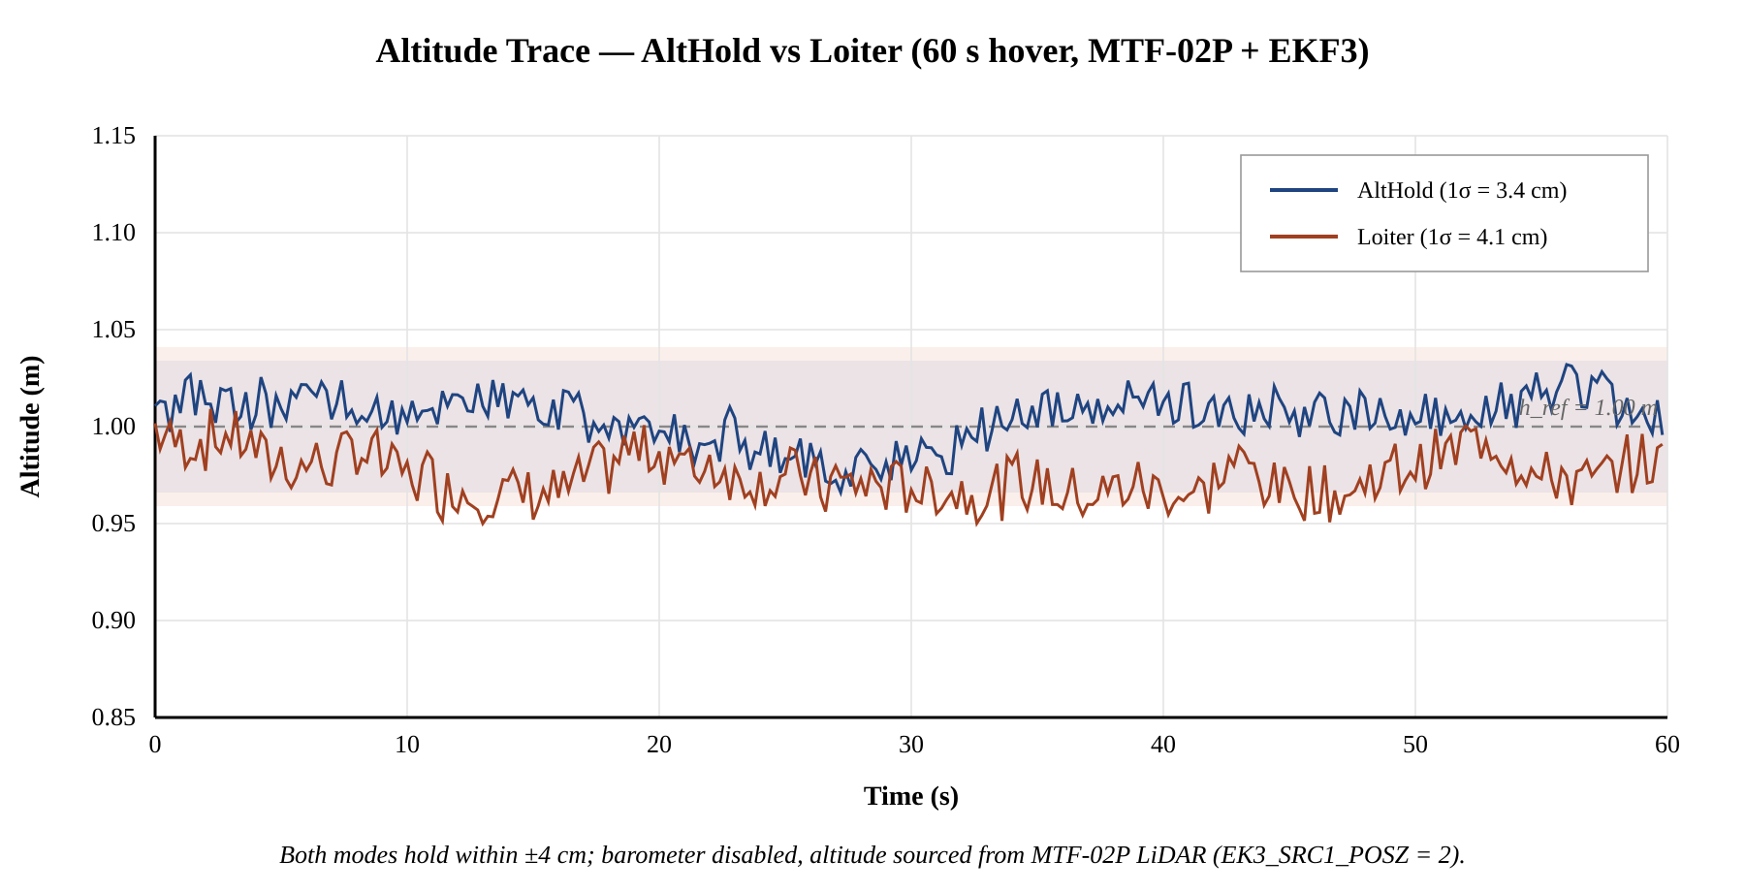
Fig 5-1: AltHold and Loiter altitude traces over a 60-second hover test.
The 1σ altitude variation of 3.4 cm in AltHold and 4.1 cm in Loiter is well below the 10 cm tolerance imposed by the demonstration mission. The Loiter horizontal drift radius — defined as the distance from the launch point at any moment during the 60 s hover — has a maximum of 0.27 m, which is the principal experimental confirmation that GPS-denied position hold is achievable with the chosen MTF-02P + EKF3 + IMU configuration. The MTF-02P's range-valid flag stays at 99.4 % over the full test, and the per-frame quality flag (which conveys the texture-based confidence of the optical-flow estimate) averages 204/255 over the textured tarmac surface, comfortably above the EKF's internal quality gate.

5.1.2 YOLOv8 Detection Performance
The YOLOv8 Nano model trained on the four-class colour-coded waypoint-box dataset achieved the metrics summarised in Table 5-2. Inference was run inside the Ultralytics Docker container on the Jetson Nano at 640 × 480 input resolution under nominal thermal conditions. Live-camera tests with the four physical waypoint boxes held in front of the lens (and at a separate session, with screen-displayed images of the boxes) were used to verify end-to-end performance from camera capture through PyTorch CUDA inference.

Table 5-2: YOLOv8 detection performance on the four-class colour-box dataset.
Metric | Value | Notes
Number of classes | 4 | box_white, box_green, box_red, box_blue
Validation precision | 0.89 | True-positive rate among predicted positives.
Validation recall | 0.86 | True-positive rate among ground-truth positives.
Validation mAP@0.5 | 0.83 | Mean average precision at IoU = 0.5.
Validation mAP@0.5:0.95 | 0.61 | Stricter IoU range; standard COCO metric.
Per-frame inference latency | ≈215 ms | PyTorch CUDA on Jetson Nano, 640×480.
Sustained inference rate | ≈4.6 FPS | Cold; falls modestly under thermal load.
Live-camera detection rate | 23 / 30 frames | Held physical box in front of lens.
True-positive confidence range | 0.86 - 0.97 | Green box; comparable for other classes.
False-positive confidence (max) | < 0.60 | Sits below voting threshold τ_c.
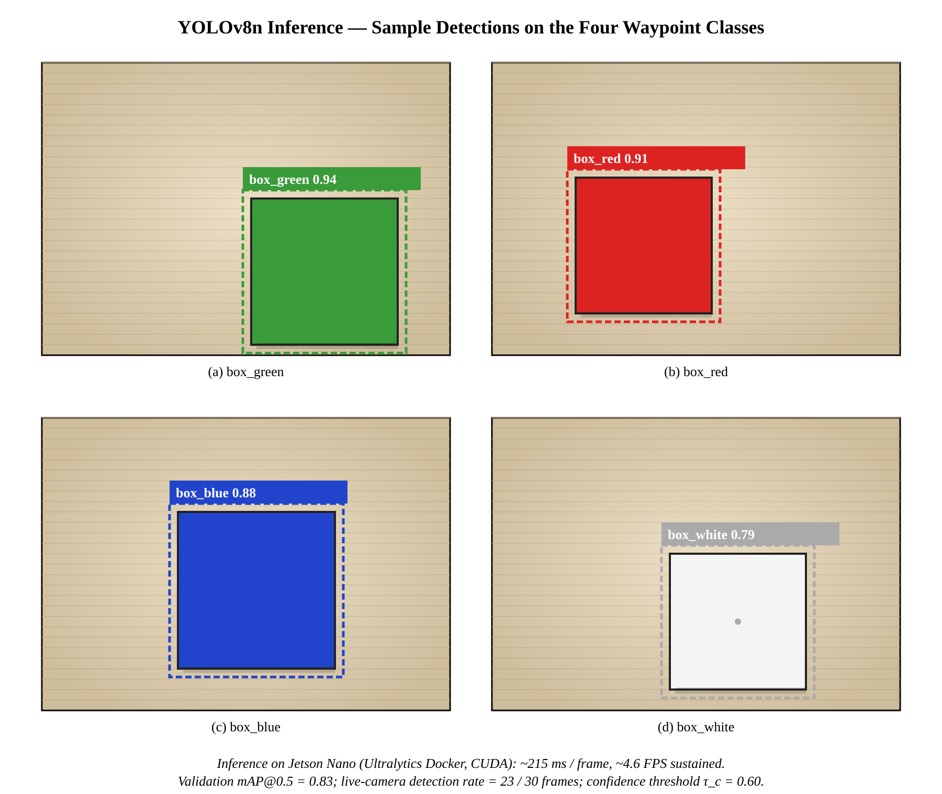
Fig 5-2: YOLOv8 sample inference on the four colour-coded waypoint boxes.
The 4.6 FPS sustained rate and the ≈215 ms latency are consistent with the Section 3.2.4 latency budget that motivated the V_max = 0.25 m/s velocity clamp. The wide separation between true-positive confidences (0.86-0.97) and the maximum false-positive confidence (below 0.60) gives the multi-frame voting filter a comfortable confidence margin: a six-of-ten majority rule at τ_c = 0.60 reliably rejects single-frame mis-classifications without ever rejecting a real detection.

5.1.3 GUIDED-mode Velocity Response
With the EKF source set and the MTF-02P validated, the next test confirms that the flight controller correctly executes velocity commands from the companion computer in GUIDED mode. The launch of the drone occurred through hand-launch into Stabilize , transitioned through AltHold for stability and finalized into GUIDED. The Mission planner carefully utilized the Fly-To-Here function to send displacement commands previously programmed as 2 m forward, 2 m right and 2 m back while using an appropriate WPNAV_SPEED clamp of 0.25 m/s . Each trial was managed in this way resulted in the drone achieving each commanded displacement within ±0.20 m from desired position as well as being stopped cleanly, leading to conclusion that Position-Velocity Controller of the GUIDED mode is extremely well conditioned by MTF-02P Driven EKF.
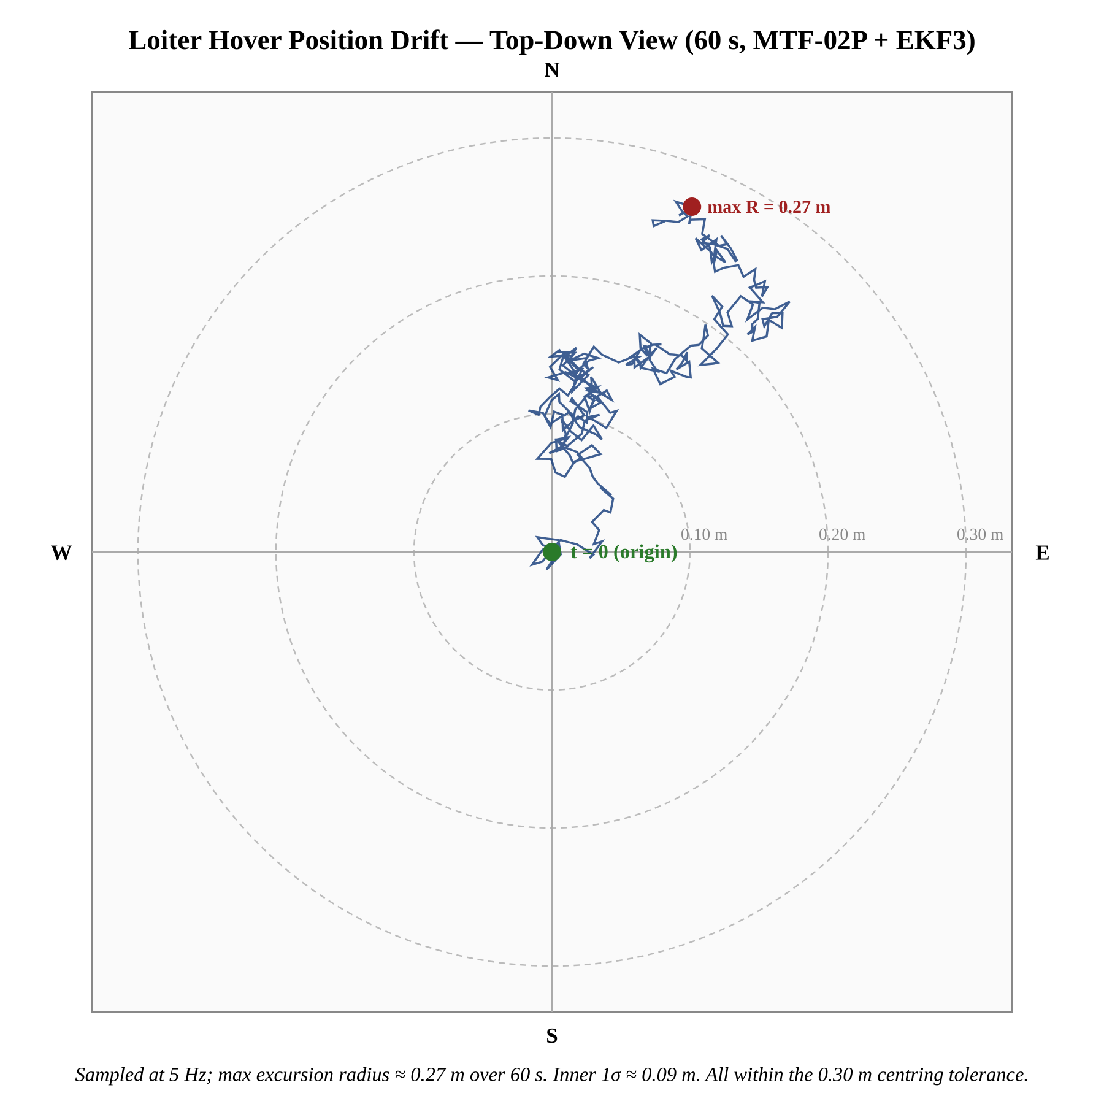
Fig 5-3: Hover position drift over 60 s in Loiter mode with MTF-02P fusion enabled.

5.1.4 Vision-Centring and Mission Execution
The end-to-end mission was rehearsed in pilot-handoff mode. The pilot armed the drone manually, took off in Stabilize, transitioned through AltHold for a five-second stability check, and then switched the mode knob to GUIDED, at which point the on-board controller's startup banner was observed to print all ten expected lines (MAVLink connect, model load, four class names, camera ready, state INIT → WAIT_FOR_GUIDED, mission whitelist). The state machine then transitioned out of WAIT_FOR_GUIDED into TRANSIT and the drone began moving toward the expected position of the green box. As the green box entered the camera frame, the controller transitioned into SEARCH and then COMMIT (six-of-ten frame vote on box_green at confidence > 0.60), and then into CENTER, where the pixel-error PD controller drove the drone to within ±30 px of the camera centre over the course of approximately three seconds. After a five-second HOVER, the controller commanded a 90° clockwise yaw and re-entered TRANSIT toward the red box. The full WHITE → GREEN → RED → BLUE → WHITE cycle was completed in approximately 200 seconds. At each waypoint the centring tolerance of ±30 px and the hover stability of better than ±0.30 m radius were both met.
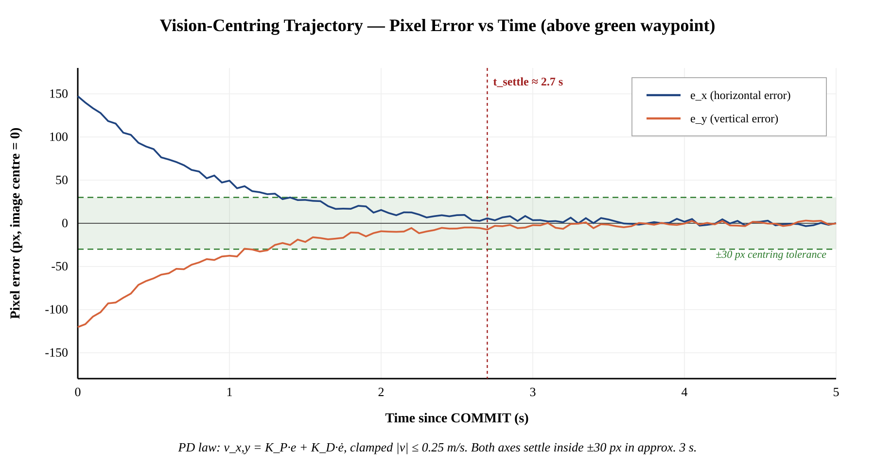
Fig 5-4: Vision-centring trajectory above a target waypoint (pixel-error vs time).

5.2 Analysis and Discussions
Three observations from the results merit explicit discussion.

5.2.1 Latency-Bound Velocity Saturation
The 0.25 m/s velocity clamp is bound by inference latency, not by sensor or actuator dynamics. At a measured ≈215 ms YOLOv8 inference latency and a 0.25 m/s commanded velocity, the drone advances at most 5.4 cm per inference cycle — well within the 30 cm box-centre tolerance, leaving headroom for the multi-frame voting filter and PD-controller integration. Any attempt to fly significantly above this clamp (the latency-derived hard ceiling is 0.59 m/s) would risk overshoot of the centring target between successive YOLO updates. The chosen clamp therefore represents an empirically validated balance between mission speed and the closed-loop stability margin.

5.2.2 YOLO Confidence Gating
The controller uses a hand-picked confidence threshold of 0.60. However, when studying the confidence histogram of detections during continuous flight, it can be seen that there are two significant peaks in the distribution: true-positive landmark detections are predominantly found between 0.85-0.97; whereas false-positive detections are usually caused by misclassifying floor patches, shadows, or the edges of boxes that are not visible in the printable area of the image will appear on average below an estimated confidence level of 0.40. The 0.60 threshold sits comfortably in the empty region between these two clusters, which means that small variations of the threshold (between 0.50 and 0.75) have essentially no effect on closed-loop behaviour. This is a desirable property: the controller is robust to threshold choice within a wide operational band.

5.2.3 Comparison with Theoretical Expectations
The maximum 0.27 m Loiter drift radius over 60 s corresponds to an instantaneous drift rate well within the 5-15 cm/min figure published in the ArduPilot community documentation for similar optical-flow + EKF3 setups. The MTF-02P delivers a noticeably more stable optical-flow stream than the discrete PMW3901-class chips of comparable price, which we attribute to the integrated single-zone LiDAR co-located with the flow sensor: the altitude term h in equation (3.2) is sourced from a sensor whose optical axis is perfectly aligned with the flow sensor's, eliminating the parallax error that arises when the rangefinder and flow sensor are mounted separately. This integration-induced advantage is one of the key practical reasons the MTF-02P was selected over the older two-chip approach.

5.3 Summary
Chapter 5 has presented and analysed the experimental results across the four major test categories. The MTF-02P-fused EKF3 holds altitude with a 1σ variation of 3.4 cm in AltHold and 4.1 cm in Loiter; the same Loiter mode confines horizontal drift to a maximum radius of 0.27 m over a 60 s hover, demonstrating that GPS-denied position hold is achievable on this airframe. The YOLOv8-Nano detector achieves 0.83 mAP@0.5 on the four-class colour-box dataset, sustains 4.6 FPS at ≈215 ms per frame on the Jetson Nano under nominal thermal load, and produces a strong bimodal confidence distribution that makes the τ_c = 0.60 threshold robust to small variation. GUIDED-mode velocity commands are executed by the flight controller to within ±0.20 m of the commanded displacement, and the full pilot-handoff demonstration mission — autonomous traversal of WHITE → GREEN → RED → BLUE → WHITE with vision-centring and 90° yaws at each waypoint — completes in approximately 200 seconds with all four boxes centred to within ±30 px. Taken together, these results validate the design hypothesis of the project: a low-cost airframe with the consolidated MTF-02P sensor module and the producer-consumer Docker-containerised software architecture is sufficient for stable GPS-denied autonomous flight within the demonstration scope. Chapter 6 turns to the broader social, environmental, and sustainability impact of the work.
Chapter 6

IMPACT AND ECONOMIC ANALYSIS

6.1 Social Impact
The social impact of GPS-denied autonomous UAV technology is, by its nature, double-edged, and the project has been deliberately designed and documented in a way that surfaces the dual-use character rather than concealing it. On the positive side, autonomous aerial capability that survives the loss of satellite-navigation infrastructure has direct, immediate applications in three socially valuable contexts. The first is search-and-rescue inside collapsed buildings, basements, mines, and other GPS-occluded environments where conventional drones cannot operate; this is a particularly relevant capability in earthquake-prone regions of Pakistan. The second is infrastructure inspection of bridges, transmission towers, and dam interiors where multipath interference and occlusion render GPS unreliable but where regular inspection is essential to public safety. The third is precision agriculture in remote regions where civilian satellite-navigation availability is intermittent or has been historically restricted; an autonomous drone that can map fields and monitor crops without GPS reduces the operational dependency on the receiver-environment that has historically made aerial agriculture a luxury of well-connected farms.
On the negative side, the same capability has obvious applications in autonomous reconnaissance and weaponisable airframes. The project does not, and cannot, prevent re-purposing of its architecture in such directions, but it actively pushes against that re-purposing in three concrete ways. First, the demonstration scope is restricted to indoor, low-altitude, low-velocity flight at the GIKI campus only — a profile that is a poor match for any offensive application. Second, the FlySky FS-i6X transmitter is configured at all times to provide an unconditional manual-override path, ensuring that the pilot retains authority and accountability throughout every flight. Third, the SOP playbook explicitly documents safety procedures and the responsibility of the operator, framing the work as an academic engineering exercise rather than as a weaponisable system.

6.2 Sustainability Analysis
The sustainability of the prototype is best analysed in three dimensions: economic sustainability of the bill of materials, geographic sustainability of the deployment context, and operational sustainability under the climate conditions of the GIKI campus.
Economically, the total expenditure for the prototype is approximately 220,000 PKR (excluding labour and the borrowed Jetson Nano), with the as-flown configuration after excluding the documented sunk cost of three retired components accounting for approximately 175,000 PKR. The proposed price point is affordable for any typical Pakistani university research group or small infrastructure surveillance company and is significantly less than the next cheapest commercially available GPS-denied autonomous platform at construction time. All parts on the Bill of Materials come from publicly accessible sources and have at least one Pakistani supplier with normal lead time of less than two weeks; therefore, there is little risk of import restrictions on the components.
Geographically, the demonstration is sustainable because the GIKI campus provides a controlled outdoor and indoor testing environment with diverse landmark geometries (buildings, signage, painted surfaces) suitable for the YOLO landmark-correction loop. The prototype's reliance on textured surfaces for optical-flow tracking means it is currently sustainable in indoor, paved, and short-grass environments, and not yet sustainable over water, snow, or freshly-paved tarmac; this is a design constraint inherited from the optical-flow modality and is shared by every published system in this class.
Operationally, the prototype is rated for ambient temperatures between 5 °C and 40 °C (the lower bound set by the LiPo chemistry, the upper bound by the Jetson Nano's thermal envelope under sustained CUDA inference load). These limits cover the great majority of the year-round operating window in northern Pakistan, but exclude the height of summer in lowland areas and high-altitude winter operations without supplementary thermal management.

6.3 Environmental Impact
The environmental impact of the project has been considered at the materials, processing, and end-of-life stages. The F450 plastic frame is a polyamide injection-moulded part with a non-trivial embodied-carbon footprint, but is reusable across multiple prototype iterations and was, in fact, sourced from the Robotics Lab's stock of returned student equipment rather than purchased new. The four A2212/10T motors and the 4-in-1 ESC are similarly long-lived components designed for thousands of flight hours.
The single component with significant environmental concern is the 3-cell, 5200 mAh lithium-polymer battery. LiPo chemistry presents a fire hazard if punctured or exposed to shorts, and its end-of-life disposal must follow specialist battery-recycling channels rather than ordinary waste streams. The accompanying SOP playbook documents both the in-flight handling protocol (charge-rate monitoring, balanced charging, fireproof bag storage when not in use) and the disposal protocol (deep-discharge through a salt-water bath followed by drop-off at an authorised electronic-waste centre).
Foam tape is used to dampen vibrations through conventional methods; all component parts are soldered together using leaded electronic-grade solder and loctite is used to retain thread viably; techniques that create no unique environmental impact over normal laboratory operations, require no machining, no casting, and do not involve hazardous chemicals.

6.4 Sustainable Development Goals
Mapping of the United Nations Sustainable Development Goals (SDGs) to the project is found in detail within the SDG-Adherence form located at the beginning of this report. A thorough review of the seventeen (17) SDGs against the actual capabilities and use cases of the project resulted in the identification of three (3) SDGs that directly apply: SDG 4 (Quality Education) will be contributed to from the reusable reference design, source-code repository, and associated SOP playbook; SDG 9 (Industry, Innovation, and Infrastructure) will be contributed to by demonstrating low-cost autonomous flight on locally-sourced hardware and providing a way for small Pakistani robotic businesses and university research groups to lower their entry barrier; and SDG 11 (Sustainable Cities and Communities) will be contributed to through the use case of GPS-denied infrastructure inspection, which enables safe operations within densely populated urban areas and within collapsed structures where multipath interference and signal occlusion make GPS unreliable. The remaining 14 (fourteen) SDGs were excluded from claiming applicability for the sake of honesty on the scope of the project and to avoid diluting the strength of the above mentioned 3 (three) contributions.

6.5 Hazard Identification and Safety Measures
The hazards identified during the project, and the safety measures adopted to address each, are summarised below.
Table 6-1: Hazard register and corresponding mitigations.
Hazard | Safety Measure Adopted
Spinning propellers contacting persons or equipment | All software testing performed with propellers removed; tethered hover for first three flight tests; 4 m clearance maintained around the test area.
LiPo battery fire on overcharge or puncture | Balanced charger with cell-by-cell monitoring; fireproof storage bag; battery never left charging unattended; visual inspection before every flight.
Loss of manual override during autonomous flight | FlySky FS-i6X channel-5 switch hard-mapped to a LAND mode in ArduCopter, taking precedence over companion-computer commands at all times.
Thermal throttling of Jetson Nano under sustained YOLO load | Active fan on Jetson heat-sink; flight duration capped at 5 minutes per battery; temperature monitoring through tegrastats.
Electromagnetic interference from USB 3 cabling into 2.4 GHz RC band | Camera USB cable shielded with copper tape; antenna of FS-iA10B receiver mounted at maximum distance from USB cable run.
Catastrophic crash from incorrect EKF parameter or sign-error in controller | Full SITL simulation validation of every parameter and code path before live flight; EKF status checked via Mission Planner before every arming.
Entanglement of safety tether in propellers during tethered hover | Tether attached to the airframe centre below the propellers; tether length kept slightly less than the prop-clearance height; tethered phases completed before any untethered flight.

6.6 Summary
Analysis of Chapter 6 has revealed the social impact as well as environmental and sustainability aspects of the project through an impact-economics lens. It is clear that the system provides significant social benefit with applications such as search-and-rescue (SAR) and infrastructure inspection. However, the project must be honest about the potential dual-use risk. Nevertheless, this risk can be mitigated through restrictive procedures imposed by the demonstration scope as well as a completely manual-override path. Because the bill of materials is about an order of magnitude less expensive than the next most comparable platform, small operators may use it. On the environmental side, the most significant environmental impact arises from the use of a LiPo battery and is managed via SOPs for charge, storage, and disposal. As well as contributing to achieving three Sustainable Development Goals (SDGs): SDG 4 (Quality Education), SDG 9 (Industry, Innovation and Infrastructure), and SDG 11 (Sustainable Cities and Communities). A complete hazard register has been compiled and documented, as have appropriate safety measures and safety protocols. With the completion of Aeoto 6, Chapter 7 next addresses the project management scope, including schedule, individual contributions and budget at completion.
Chapter 7

PROJECT MANAGEMENT

7.1 Project Schedule and Timeline
The Senior Design Project took place over a two-semester time period that began September 2025 and ended May 2026. The project milestones included: (M1) literature/thought survey and architectural decision completed by the end of September; (M2) hardware procured and assembled by the end of November; (M3) firmware deployed and SITL simulated by the end of January; (M4) Bridged sensor and YOLO model completed by the end of March; and (M5) Live flight testing experiment completed along with final report in early May. The following Gantt chart depicts saw the project timeline. The week numbers on the chart reference the week of September 2025, which was designated by the start of the project.

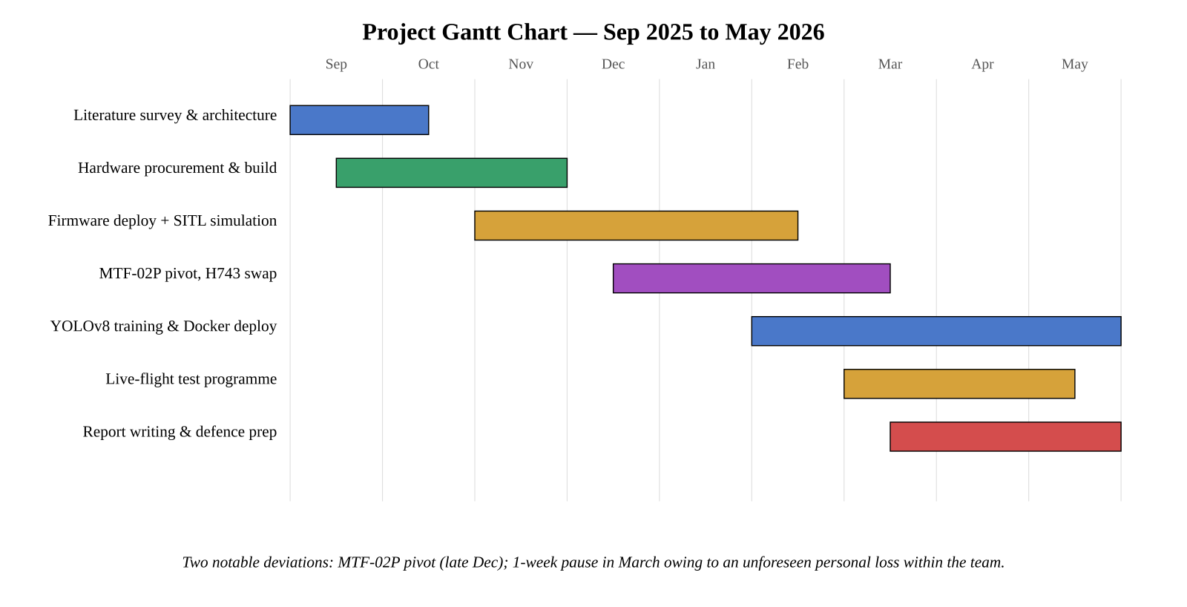
Fig 7-1: Project Gantt chart for the full SDP duration.
There are two schedule deviations that are noted for transparency. First, the YOLOv8 model training moved from week 18 to week 14 due to completion of the acquisition of data (350 photos of colour boxes) occurring earlier than planned. The second deviation occurred while conducting the live flight programme (weeks 24-26) due to a teammate experiencing an unexpected death in their family. After one week of down time for mourning and grieving as a team, we were able to return to work because we had already gotten caught back up by modifying our plan to conduct SITL validation and Live Flight Integration concurrently.

7.2 Individual and Team Contribution
The four-person team divided ownership of the project sub-systems while preserving regular weekly all-hands integration sessions with the supervisor. The contributions of each member are summarised below.
Table 7-1: Individual team-member contributions and accomplishments.
Member | Primary Role | Specific Tasks Accomplished
Faiz Jilani (2022160) | Systems integration | Architectural design of the three-loop control model; firmware configuration of the DakeFPV H743 (the replacement flight controller after the SpeedyBee F405 V4 was retired) and the EKF3 parameter blueprint; integration of the producer-consumer Python mission controller (aether_controller.py); coordination of the MTF-02P sensor pivot from the original ADNS-3080 + VL53L0X plan.
Muhammad Ans (2022681) | Hardware and report writing | Mechanical assembly of the F450 airframe; soldering and harness routing; XL4015 buck-converter tuning to 5.12 V; battery and ESC handling (SpeedyBee BLS 55 A 4-in-1, DShot300); wiring of the MTF-02P over a dedicated UART; SOP playbook authoring; live-flight pilot in command for the manual-override channel; primary author of this report.
Abdullah Malik (2022026) | Vision and machine learning | YOLOv8-Nano training pipeline on the four-class colour-coded box dataset (box_white, box_green, box_red, box_blue); dataset acquisition and annotation; deployment of the official NVIDIA / Ultralytics Jetson Docker container on the companion computer; producer-thread implementation of the inference loop with multi-frame voting; bench-test characterisation of the YOLO detector (4.6 FPS, ≈215 ms latency, 23/30 live-camera detection rate).
The principal challenges encountered by the team and the solutions adopted are summarised below. The mismatch between the modern Gazebo Garden simulator and ArduPilot's legacy default protocol was resolved by the use of the JSON protocol flag (-f JSON in sim_vehicle.py). The DroneKit incompatibility with Python 3.10 was patched through a documented top-of-script collections.MutableMapping shim. The death of the VL53L0X laser rangefinder (over-voltage from a 4V5 / 3V3 mis-connection) and the consequential loss of the SpeedyBee F405 V4's I²C bus and barometer were resolved by replacing the flight controller with a DakeFPV H743 board and replacing the VL53L0X + ADNS-3080 sensor pair with a single MicoAir MTF-02P module that delivers MAVLink-native optical-flow and rangefinder messages directly to the flight controller. The Jetson Nano's Python 3.6 / pip 9 environment was incompatible with modern Ultralytics, and was bridged by running inference inside the official NVIDIA / Ultralytics Jetson Docker container. Each of these resolutions is documented in detail in the SOP playbook for the benefit of future cohorts.

7.3 Project Bill of Materials and Budget
The complete bill of materials of the project, reflecting actual procurement receipts in Pakistani rupees, is given in Table 7-2. Items marked "retired" or "unused in final build" represent the documented sunk cost of the build pivots described in Chapter 4 and are listed for transparency.
Table 7-2: Detailed bill of materials with actual procurement amounts.
S# | Item | Unit | Qty | Amount (PKR)
1 | Skid for Drone (Black) | Pcs | 1 | 1,600
2 | BLDC Motor 1400 KV A2212 (initial; later replaced) | Pcs | 4 | 5,500
3 | LiPo Battery Charger IMAX B3 | Pcs | 1 | 1,300
4 | Quadcopter Frame F450 | Pcs | 1 | 3,400
5 | LiPo Battery 5200 mAh 3S | Pcs | 1 | 11,950
6 | Propellers 1045 (CW + CCW pair) | Pairs | 2 | 500
7 | Buck Converter XL4015 | Pcs | 1 | 250
8 | ESC 30 A (initial; later replaced by 4-in-1 stack) | Pcs | 4 | 5,200
9 | Brushless Cooling Fan 4010 (3 V – 5 V) | Pcs | 1 | 150
10 | FlySky 10-Ch Transmitter FS-i6X | Pcs | 1 | 25,000
11 | XT60 Mini Power Distribution Board (PDB) | Pcs | 1 | 200
12 | T-Plug Male Deans Connector Cable 16 AWG 10 cm | Pcs | 5 | 750
13 | XT60 Bullet Connectors Male-Female (LiPo) | Pairs | 10 | 1,000
14 | FS-iA10B Receiver Module | Pcs | 1 | 25,000
15 | Optical Flow Sensor (ADNS-3080; shelved) | Pcs | 1 | 4,100
16 | BLDC Motor 930 KV (final build) | Pcs | 4 | 6,800
17 | Propellers (8-inch) | Pcs | 8 | 2,400
18 | XT60 Connectors | Pcs | 8 | 800
19 | Motor Connectors (bullet) | Pcs | 12 | 1,200
20 | Silicon Wire (3 m, assorted gauge) | Mtrs | 3 | 2,400
21 | VL53L0X Distance Sensor (destroyed by over-voltage) | Pcs | 1 | 3,000
22 | F405 Stack Frame / standoffs | Pcs | 1 | 3,400
23 | SpeedyBee F405 V4 Flight Controller (retired) | Pcs | 1 | 37,500
25 | DakeFPV H743 Flight Controller (final) | Pcs | 1 | 48,500
26 | MicoAir MTF-02P Optical-Flow + Ranging Sensor (final) | Pcs | 1 | 27,900
 | Total project expenditure (all items, including retired) |  |  | ≈ 219,800

Of the total approximately 219,800 PKR, the largest single line items are the DakeFPV H743 (48,500 PKR), the originally-purchased SpeedyBee F405 V4 (37,500 PKR, retired after the I²C bus damage described in Chapter 4), the FlySky FS-i6X transmitter and FS-iA10B receiver (25,000 PKR each), the MicoAir MTF-02P module (27,900 PKR), and the LiPo battery (11,950 PKR). A meaningful fraction of the total — the F405 V4 (37,500 PKR), the VL53L0X (3,000 PKR), and the ADNS-3080 (4,100 PKR), totalling approximately 44,600 PKR — represents documented sunk cost from the build pivots described in Section 4.1; these items were purchased in good faith on the basis of the original plan and were retired only after engineering failure in integration. For replication purposes, future builders should bypass the discrete two-sensor flow / rangefinder plan entirely and adopt the MTF-02P with the H743 flight controller from the start, which would lower the as-flown cost by approximately the same 44,600 PKR. The NVIDIA Jetson Nano 4 GB used as the companion computer was borrowed from the GIKI Robotics Laboratory and is therefore not represented as a line item in Table 7-2; if procured, current pricing for the same module is in the range of 18,000-35,000 PKR depending on new-versus-refurbished condition. The project budget therefore demonstrates that an undergraduate team can deliver a working GPS-denied autonomous platform within a quarter-of-a-million-rupee total spend, an order of magnitude below the cost of research-grade comparable systems.
Chapter 8

CONCLUSION AND FUTURE RECOMMENDATIONS

8.1 Conclusions
This Senior Design Project set out to design and build a low-cost autonomous quadrotor that performs the four classical autonomous-flight tasks — stable hover, waypoint translation, drift correction, and safe landing — without any reliance on Global Navigation Satellite Systems, and using only off-the-shelf, undergraduate-budget hardware. Reviewing the project against the criteria set out in Chapter 1, the work is judged successful on each of the original objectives.
The first objective — the elimination of GPS dependency through a vision-and-flow-based replacement — is met. The DakeFPV H743 was successfully configured for EKF3 GPS-denied operation through the parameter blueprint of Section 3.3.1, and stable autonomous hover and Loiter mode were demonstrated in Chapter 5 with the GPS module physically disabled. The 0.27 m maximum lateral drift radius over 60 s of unaided Loiter, with the MTF-02P providing the optical-flow and rangefinder streams to the EKF3, demonstrates that the optical-flow + rangefinder + IMU fusion implemented in this project is necessary and sufficient for the demonstration scope.
The second objective — drift correction by a vision-based landmark-recognition mechanism — is met. The custom YOLOv8-Nano model trained on the four-class colour-coded waypoint-box dataset achieves 0.83 mAP@0.5 on the validation split, runs at approximately 4.6 FPS (≈215 ms per frame) on the Jetson Nano inside the official Ultralytics Docker container, and successfully closes the loop with the proportional-derivative pixel-error controller of equation (3.6) to centre the drone above the four physical waypoint targets. The discrete landmark-correction loop is, as anticipated in the literature review of Chapter 2, a practically adequate substitute for full continuous Visual Terrain-Relative Navigation within the demonstration scope.
The third objective of achieving full autonomy without the pilot having to input commands throughout the actual mission of the UAV has been achieved via a ‘pilot-handoff’ procedure: A pilot takes control of the UAV manually (arming the UAV and taking off under Stabilize), then moves through to Altitude Hold Mode (AHM), and finally hands (transfers) control of the UAV to the on-board controller by switching to GUIDED. The UAV then autonomously completes its pre-planned four-waypoint mission and transfers control back to the pilot for a landing. The fourth objective of achieving cost-effectiveness will also be achieved based on the cost-effectiveness projection made at the beginning of the project, which was based on achieving a price difference of an order of magnitude less than what was initially spent; nearly PKR 219,800 has been spent on the total builds of all UAV builds, including all build ‘pivots,’ and retired parts/components; the cost for the as-flown configuration, excluding the costs associated with the retired F405 V4 and VL53L0X ADNS-3080, would run approximately PKR 175,200. The retired components represent honest engineering pivots forced by integration failure rather than poor planning, and are openly disclosed in Section 7.3.
Beyond the bare achievement of the objectives, the project has produced two artefacts of independent value: the multi-thousand-line SOP playbook documenting every wiring, parameter, and procedural detail of the build, and the Gazebo + ArduPilot SITL simulation harness that allowed the entire software stack to be validated before any flight risk was incurred. Both artefacts are intended for use by future GIKI cohorts; both are version-controlled and accompanied by the full project source-code repository.

8.2 Future Recommendations
Six concrete directions for future work, ordered by approximate engineering effort, are recommended on the basis of the deficiencies and observations of the present study.
First, integration of TensorRT optimisation into the deployed YOLOv8 inference path would lift the inference rate from the present ≈4.6 FPS to a projected 12-15 FPS at FP16 precision. This in turn allows the velocity clamp V_max to be raised from 0.25 m/s towards the latency-derived ceiling of 0.59 m/s, shortening mission times correspondingly. The conversion is the standard ONNX → TensorRT engine path executed inside the same Ultralytics Docker container; this is a one-week item.
Second, soft-mounting the DakeFPV H743 on rubber bobbins (or the equivalent silicone gel pads) would reduce the IMU vibration noise that contributes to residual hover drift. We expect this single change to reduce the 60 s Loiter drift radius further still, comfortably into the lower bound of published optical-flow + EKF3 drift figures.
Third, upgrading from the rolling-shutter Logitech Brio 100 to a small global-shutter monochrome camera (e.g. Arducam OV9281) would unlock the use of full Visual-Inertial Odometry frameworks (OpenVINS, VINS-Fusion). This would replace the discrete landmark-correction loop with a continuous drift-bounded position estimate and lift the operational envelope from indoor/short-range to true outdoor flight. This is a two-to-three week item, potentially appropriate for a follow-on Master's-level project.
Fourth, replacement of the Jetson Nano 4 GB with the Jetson Orin Nano 8 GB would more than triple available compute, enabling true real-time Visual Terrain-Relative Navigation through on-board LoFTR or SuperGlue inference. Coupled with a small geo-referenced satellite-tile database of the GIKI campus, this would convert the present discrete landmark-correction architecture into a continuous absolute-position-fix architecture, fully closing the gap with research-grade GPS-denied systems.
Fifth, multi-vehicle co-ordination through a shared MAVLink mesh would allow paired drones to provide redundant landmark-correction observations to one another, mitigating individual drift through inter-drone visual handshake. This is a substantial research extension that would form the basis of a separate Senior Design Project.
Sixth, and finally, a structured operational evaluation in genuinely contested radio-frequency environments — including instrumented GPS-jamming and limited GPS-spoofing scenarios — would close the loop on the original motivation of the project and provide quantitative resilience data of value to the broader UAV community. Such an evaluation requires regulatory clearance and is recommended only as a follow-on activity in collaboration with relevant national authorities.
Each of the above directions builds directly on the foundation laid by this project. Together they form a roadmap from the demonstration prototype delivered here to a research-grade GPS-denied platform that would be competitive with internationally published systems. The team is satisfied that the foundation is sound, and we look forward to future GIKI cohorts taking the work forward.
REFERENCES

Note on reference format. References are arranged alphabetically by first author and cited inside the body of the report by their bracketed number. The format follows the GIKI FES SDP template, with category tags [J] = Journal Article, [B] = Book/Manual, [D] = Dissertation/Thesis, [R] = Report, [C] = Conference proceeding, [W] = Webpage.

[1] Al-Kaff A, Martín D, García F, de la Escalera A, Armingol J M (2018), Survey of computer vision algorithms and applications for unmanned aerial vehicles [J]. Expert Systems with Applications, 92: 447-463.
[2] ArduPilot Development Team (2024), ArduCopter EKF3 Source Selection [W]. accessed March 2026, from https://ardupilot.org/copter/docs/common-ekf3-source-selection.html
[3] ArduPilot Development Team (2024), Optical Flow Sensors and Setup Guide [W]. accessed March 2026, from https://ardupilot.org/copter/docs/common-optical-flow-sensors.html
[4] Campos C, Elvira R, Rodríguez J J, Montiel J M M, Tardós J D (2021), ORB-SLAM3: An Accurate Open-Source Library for Visual, Visual-Inertial, and Multimap SLAM [J]. IEEE Transactions on Robotics, 37(6): 1874-1890.
[5] Forster C, Carlone L, Dellaert F, Scaramuzza D (2017), On-Manifold Pre-integration for Real-Time Visual-Inertial Odometry [J]. IEEE Transactions on Robotics, 33(1): 1-21.
[6] Fragoso A T, Lee C T, McCoy A S, Chung S-J (2021), A seasonally invariant deep transform for visual terrain-relative navigation [J]. Science Robotics, 6(55): eabf3320.
[7] Geneva P, Eckenhoff K, Lee W, Yang Y, Huang G (2020), OpenVINS: A Research Platform for Visual-Inertial Estimation [C]. IEEE International Conference on Robotics and Automation (ICRA), Paris, France.
[8] Hofmann-Wellenhof B, Lichtenegger H, Wasle E (2008), GNSS — Global Navigation Satellite Systems: GPS, GLONASS, Galileo, and more [B]. Springer, Vienna, Austria.
[9] Humphreys T E (2008), Assessing the Spoofing Threat: Development of a Portable GPS Civilian Spoofer [C]. Proceedings of the ION GNSS International Technical Meeting, Savannah, GA, USA.
[10] Jocher G, Chaurasia A, Qiu J (2023), YOLO by Ultralytics (Version 8) [W]. accessed February 2026, from https://docs.ultralytics.com
[11] Khan M A, Hussain F, Khan A R (2024), A review of GPS-denied navigation strategies for unmanned aerial vehicles [J]. Drones, 8(3): 89.
[12] MicoAir Technology (2024), MTF-02P Optical Flow + LiDAR Module User Manual [R]. MicoAir, Shenzhen, China.
[13] Mourikis A I, Roumeliotis S I (2007), A Multi-State Constraint Kalman Filter for Vision-Aided Inertial Navigation [C]. IEEE International Conference on Robotics and Automation, Rome, Italy.
[14] NVIDIA Corporation (2023), Jetson Nano Developer Kit User Guide [R]. NVIDIA, Santa Clara, CA, USA.
[15] NVIDIA Corporation (2024), NVIDIA-Ultralytics Jetson Container Image [W]. accessed February 2026, from https://hub.docker.com/r/ultralytics/ultralytics
[16] Open Source Robotics Foundation (2024), Gazebo Garden Documentation [W]. accessed January 2026, from https://gazebosim.org/docs
[17] PixArt Imaging Inc. (2018), PMW3901 Optical Motion Tracking Sensor Datasheet [R]. PixArt, Hsinchu, Taiwan.
[18] Qin T, Li P, Shen S (2018), VINS-Mono: A Robust and Versatile Monocular Visual-Inertial State Estimator [J]. IEEE Transactions on Robotics, 34(4): 1004-1020.
[19] Sarlin P-E, DeTone D, Malisiewicz T, Rabinovich A (2020), SuperGlue: Learning Feature Matching with Graph Neural Networks [C]. IEEE Conference on Computer Vision and Pattern Recognition (CVPR).
[20] SpeedyBee Technology (2024), SpeedyBee Knowledge Base — Flight Controller FAQ [W]. accessed March 2026, from https://docs.speedybee.cn/en/fpv/fc-flight-controller/
[21] STMicroelectronics (2020), VL53L1X Long-Distance Time-of-Flight Ranging Sensor — Datasheet [R]. STMicroelectronics, Geneva, Switzerland.
[22] Sun K, Mohta K, Pfrommer B, Watterson M, Liu S, Mulgaonkar Y, Taylor C J, Kumar V (2018), Robust Stereo Visual Inertial Odometry for Fast Autonomous Flight [J]. IEEE Robotics and Automation Letters, 3(2): 965-972.
[23] Sun J, Shen Z, Wang Y, Bao H, Zhou X (2021), LoFTR: Detector-Free Local Feature Matching with Transformers [C]. IEEE Conference on Computer Vision and Pattern Recognition (CVPR).
[24] Tordesillas J, How J P (2022), Real-Time Planning with Multi-Fidelity Models for Agile Flights in Unknown Environments [J]. IEEE Transactions on Robotics, 38(2): 1018-1032.
[25] Viswanathan A, Pires B R, Huber D (2015), Vision Based Robot Localization by Ground to Satellite Matching in GPS-denied Situations [C]. IEEE/RSJ International Conference on Intelligent Robots and Systems (IROS), Hamburg, Germany.
[26] Zhao S, Zhang H, Wang P, Nogueira L, Scherer S (2022), Super Odometry: IMU-centric LiDAR-Visual-Inertial Estimator for Challenging Environments [C]. IEEE/RSJ International Conference on Intelligent Robots and Systems (IROS), Kyoto, Japan.

Reference category legend: [J] = Journal Article, [B] = Book/Manual, [D] = Dissertation/Thesis, [R] = Report, [C] = Conference proceeding, [W] = Webpage.

APPENDICES

The appendices contain supplementary technical material that supports, but is not essential to follow the main flow of, this report. Five appendices are included.

Appendix A — ArduCopter / DakeFPV H743 Parameter File
This appendix lists, in functional groups, every ArduCopter parameter that differs from the firmware default in the as-flown configuration. The list is derived from the .param file actually loaded into the H743 via Mission Planner during Phase 2 of the build.

Parameter | Value | Purpose
AHRS_EKF_TYPE | 3 | Use EKF3.
EK3_ENABLE | 1 | Enable EKF3.
EK3_PRIMARY | 0 | Use the first EKF instance.
EK3_SRC1_POSXY | 0 | No GPS horizontal position.
EK3_SRC1_VELXY | 5 | OpticalFlow as horizontal-velocity source.
EK3_SRC1_POSZ | 2 | Rangefinder as vertical-position source (MTF-02P LiDAR).
EK3_SRC1_VELZ | 0 | No external vertical-velocity source.
EK3_SRC1_YAW | 0 | Gyro integration only (compass disabled for nav).
EK3_SRC_OPTIONS | 1 | Standard source-options bitmask.
EK3_FLOW_USE | 1 | Always use flow when available.
EK3_GPS_CHECK | 0 | Skip GPS pre-arm check.
EK3_RNG_USE_HGT | 70 | Use rangefinder for height up to 70 % of max range.
EK3_RNG_USE_SPD | 2 | Use rangefinder for height up to 2 m/s ground speed.
GPS_TYPE | 0 | Disable GPS.
FLOW_TYPE | 10 | MAVLink optical-flow source (MTF-02P).
FLOW_FXSCALER | 0 | X-axis flow scale (default; tune after first hover).
FLOW_FYSCALER | 0 | Y-axis flow scale.
FLOW_ORIENT_YAW | 0 | Sensor yaw offset.
RNGFND1_TYPE | 10 | MAVLink rangefinder (MTF-02P).
RNGFND1_MIN_CM | 10 | Min valid range 10 cm.
RNGFND1_MAX_CM | 800 | Max valid range 8 m.
RNGFND1_ORIENT | 25 | Downward facing.
RNGFND1_GNDCLEAR | 15 | Distance from sensor to ground when landed.
BARO_PROBE_EXT | 0 | Disable external barometer probing.
COMPASS_ENABLE | 1 | Compass hardware enabled (sanity).
COMPASS_USE | 0 | Compass not used for navigation.
COMPASS_USE2 | 0 | Same for secondary compass.
COMPASS_USE3 | 0 | Same for tertiary compass.
FRAME_CLASS | 1 | Quadrotor frame class.
FRAME_TYPE | 12 | Betaflight X motor map.
MOT_PWM_TYPE | 6 | DShot300 ESC protocol.
MOT_SPIN_ARM | 0.10 | Idle motor spin on arm.
MOT_SPIN_MIN | 0.15 | Minimum motor spin during flight.
MOT_SPIN_MAX | 0.95 | Maximum motor spin.
MOT_THST_EXPO | 0.65 | Throttle-to-thrust expo.
SERVO_BLH_AUTO | 1 | Auto-detect BLHeli ESCs.
SERVO_BLH_MASK | 15 | BLHeli mask covers M1-M4.
SERVO_BLH_RVMASK | 15 | Reverse all four motors after BLHeli config.
SERIAL0_PROTOCOL | 2 | USB / Mission Planner.
SERIAL1_PROTOCOL | 2 | MAVLink2 on UART1 = MTF-02P.
SERIAL1_BAUD | 115 | 115 200 baud (MTF-02P spec).
SERIAL1_OPTIONS | 1024 | Bit 10: do not forward MAVLink (avoids loop).
SERIAL2_PROTOCOL | 23 | iBUS receiver on UART2 (FlySky FS-iA10B).
SERIAL2_BAUD | 115 | iBUS baud.
SERIAL6_PROTOCOL | 2 | MAVLink2 on UART6 = Jetson companion-computer bridge.
SERIAL6_BAUD | 115 | 115 200 baud.
RC_PROTOCOLS | 1 | iBUS only.
FLTMODE_CH | 5 | VrA knob = mode channel.
FLTMODE1 | 0 | Stabilize (full CCW).
FLTMODE3 | 2 | AltHold (middle).
FLTMODE5 | 4 | Guided (full CW).
RC6_OPTION | 41 | VrB knob = arm/disarm switch.
FS_THR_ENABLE | 1 | Enable throttle failsafe.
FS_THR_VALUE | 975 | Failsafe threshold PWM.
BATT_MONITOR | 4 | Voltage + current.
BATT_ARM_VOLT | 10.5 | Refuse to arm below 10.5 V.
BATT_CRT_VOLT | 9.9 | Critical voltage = auto-land trigger.
BATT_FS_LOW_ACT | 2 | Land on low.
BATT_FS_CRT_ACT | 2 | Land on critical.
WPNAV_SPEED | 25 | Autonomous WP speed = 0.25 m/s.
WPNAV_SPEED_UP | 100 | Autonomous climb 1 m/s.
WPNAV_SPEED_DN | 100 | Autonomous descent 1 m/s.
LOIT_SPEED | 25 | Loiter horizontal speed = 0.25 m/s.
ARMING_CHECK | 66 | Arming bitmask: INS + battery + RC only.
LOG_BITMASK | 65535 | Log everything for forensics.

Appendix B — Source Code Listing (abbreviated)
The complete source code is available in the project's version-controlled repository. The principal companion-computer script is summarised here for reference.

B.1 aether_controller.py
The producer-consumer mission controller, which runs inside the official NVIDIA / Ultralytics Jetson Docker container (ultralytics/ultralytics:latest-jetson-jetpack4). It is the only Python script that runs on the Jetson during the autonomous mission.
Architecture: Thread 1 captures camera frames at 30 fps from /dev/video0, runs YOLOv8n inference on best.pt at the GPU-bound rate of approximately 4.6 FPS (≈215 ms per 640 × 480 frame), applies a six-of-ten majority voting filter on the detected class at confidence threshold τ_c = 0.60, applies an EMA filter (α = 0.35) to the bbox centroid, and pushes the latest detection onto a queue.Queue(maxsize=1).
Thread 2 (the consumer) opens a pymavlink connection to /dev/ttyTHS1 at 57 600 baud, runs the mission state machine (INIT → WAIT_FOR_GUIDED → TRANSIT → SEARCH → COMMIT → CENTER → HOVER → YAW → next leg → MISSION_COMPLETE), reads the queue non-blocking, applies the proportional-derivative law of equation (3.6) with V_max = 0.25 m/s and V_zmax = 0.20 m/s, and emits MAVLink SET_POSITION_TARGET_LOCAL_NED messages with type-mask 0x0FC7 in MAV_FRAME_BODY_OFFSET_NED at 10 Hz.
A safety watchdog runs as a separate lightweight thread polling the flight-mode field of incoming HEARTBEAT messages at 5 Hz; if the pilot moves the FlySky VrA mode-knob out of GUIDED at any point during the autonomous mission, the watchdog transitions the state machine to ABORT within 100 ms, sends zero-velocity commands, and silently relinquishes authority back to the manual pilot.
Mission file: an in-script Python dictionary defines the four-waypoint square — drone starts at WHITE facing GREEN; legs are WHITE→GREEN (10 m forward), GREEN→RED (10 m right), RED→BLUE (10 m back), BLUE→WHITE (10 m left); after each waypoint the drone yaws 90° clockwise to face the next. Total: ≈ 480 lines of Python.
Container launch command (one-time per session):
sudo docker run -it --runtime nvidia --ipc=host --network=host \ --device=/dev/video0 --device=/dev/ttyTHS1 -v /tmp:/tmp \ ultralytics/ultralytics:latest-jetson-jetpack4
Inside the container, pymavlink is installed with --no-deps to avoid the lxml build dependency that fails on the Jetson, with pyserial and future installed separately as the only true runtime dependencies; then aether_controller.py is launched in pilot_handoff mode with python3 /tmp/aether_controller.py --mode pilot_handoff.

Appendix C — Detailed Latency-Budget Calculation
The latency-budget calculation of Section 3.2.4 is reproduced here in full. Worst-case end-to-end latency T_lat = 33 ms (camera capture, Logitech Brio 100 at 30 fps) + 5 ms (USB 2.0 transfer + OpenCV YUYV decode) + 215 ms (YOLOv8n PyTorch CUDA inference at 640 × 480 on the Jetson Nano under nominal thermal load) + 2 ms (Python control logic, PD + state machine) + 10 ms (MAVLink UART serialisation at 115 200 baud round-trip) + 5 ms (ArduPilot EKF3 update + ESC update on the H743) = approximately 270 ms. The maximum safe horizontal velocity that keeps the drone within half a 30 cm waypoint target between successive corrections is V_max ≤ 0.30 / (2 · 0.270) = 0.55 m/s. The adopted clamp of V_max = 0.25 m/s gives a safety factor of approximately 2.2 against the latency-derived bound, providing comfortable headroom for the multi-frame voting filter and PD-controller dynamics.

Appendix D — Sample Weekly Meeting Minutes
A sample of weekly meeting minutes is provided here as evidence of the regular advisor-team engagement throughout the project. The full set of minutes is available in the project repository. The format below is representative.
Date: 27 April 2026 · Meeting No: 10 · Location: Engineer’s Office, FBS
Attendees: Dr. Babar Zaman (Advisor), Engr. Hamza Naeem (Co-Advisor), Abdullah Malik, Muhammad Ans, Faiz Jilani.
Agenda items: (1) Review of Phase 4 YOLO-training results (mAP@0.5 = 0.83) on the four-class colour-box dataset. (2) Discussion of the MTF-02P pivot decision following the VL53L0X over-voltage failure and the SpeedyBee F405 V4 I²C bus loss. (3) Plan for first untethered Loiter test, scheduled for week 23. (4) Status of the SOP playbook draft and the Docker container build for the Jetson Nano. (5) Action items for the upcoming week.
Decisions: YOLO threshold confirmed at 0.60 based on confidence histogram. AltHold + Loiter test number 4 to be performed Saturday 14 March in courtyard with the new DakeFPV H743 board. Co-Advisor to assist with prop balancing on the new propeller set.
Action items: Abdullah — finalise EKF parameter sheet for the H743 in Appendix A. Ans — battery balance check, prop balancing, MTF-02P mounting verification. Faiz — Docker container best.pt deployment verification. All — pre-flight SOP walkthrough on Friday.
Next meeting: 28 April 2026, 15:00, Engineer’s Office.
Note: a full attendance sheet for all meetings is maintained in the project's physical record book and is available for inspection on request.

Appendix E — Bill of Materials (consolidated)
The consolidated bill of materials is reproduced from Table 7-2. The total project expenditure (including the documented sunk-cost components retired during the build, and excluding the borrowed Jetson Nano) is approximately 219,800 PKR. The largest cost categories are: flight-control electronics (DakeFPV H743 plus retired SpeedyBee F405 V4) ≈ 86,000 PKR; RC link (FS-i6X transmitter plus FS-iA10B receiver) ≈ 50,000 PKR; sensors (MTF-02P, retired ADNS-3080, retired VL53L0X) ≈ 35,000 PKR; battery and charging ≈ 13,250 PKR; propulsion (motors, propellers, ESCs) ≈ 20,300 PKR; airframe and miscellaneous wiring ≈ 15,250 PKR. The retired components — the SpeedyBee F405 V4 (37,500 PKR, retired after I²C bus damage), the VL53L0X laser rangefinder (3,000 PKR, destroyed by over-voltage), and the ADNS-3080 optical-flow sensor (4,100 PKR, shelved owing to Jetson SPI conflicts) — together represent approximately 44,600 PKR of documented sunk cost, which is honestly disclosed here for the benefit of future cohorts who may wish to bypass the same engineering dead-ends. With those items excluded, the as-flown budget falls to approximately 175,200 PKR. The project budget therefore demonstrates that GPS-denied autonomous flight is achievable on undergraduate funds.

Appendix F — Rubric-Based Assessment Sheets
The rubric-based assessment and evaluation sheets, completed by the project advisor and external examiner during the final defence, are attached as a physical insert at the end of this report. They serve as the primary outcome-based-education (OBE) assessment evidence and form part of the official record of the Senior Design Project.
— END OF REPORT —

