Use this same template every day, for every task, throughout all 6 phases. Fill in every field before submitting.
1 | 📋 Intern & Task Details

Intern Name | Abdullah P I
Phase / Day | Phase 04 / Day 33
Date | 5 August 2026
Task / Topic Title | Backend Finalization — Flask Selected + Portfolio Enhancements
Time Spent (hrs) | 3 hrs

2 | 📝 Summary of Work Done
2–4 sentences: what did you build or learn today?
Compared the Flask and Express versions of the portfolio site from the last two days and decided to lock in Flask as the backend for my final individual project. Extended the Flask portfolio with an additional page and more functionality, and spent time adding proper CSS design - nav bar styling, hover effects, consistent spacing and color, and a basic responsive breakpoint - so the site looks and behaves more like a finished product.

3 | 👣 Steps Followed
List the key steps you completed, in order.
- Reviewed the Day 33 requirements - add more functionality and design, and lock in one backend (Node.js or Flask) for the final project.
- Compared the Flask and Express versions built on Days 31 and 32 with the final project in mind, not just today's task.
- Chose Flask for the final project, since it lets the crop-recommendation model from Phase 2 be reused directly in Python without a separate service.
- Extended the Flask portfolio site with an additional page/route to practice adding functionality beyond the original three pages.
- Added more CSS design - a styled navigation bar, hover effects on links and buttons, and a consistent spacing/color scheme across all pages.
- Added a basic media query so the layout adjusts cleanly on smaller screens instead of breaking.
- Re-tested every route and page after the changes to confirm nothing broke and the new styling applied consistently.
- Pushed the updated Flask project to GitHub along with this report.

4 | 🧩 Challenges Faced & How You Solved Them
The harder part wasn't technical - it was deciding between Flask and Express by thinking ahead to the final project rather than just which felt easier today. Since the final project needs to serve a Python/scikit-learn model, staying in Flask avoids having to bridge two languages later. On the CSS side, some of my new page styles accidentally overrode the original nav bar until I scoped the new rules with more specific selectors.

5 | 💡 Key Learnings
What's the one thing you understand better now than this morning?
Choosing a backend isn't just about which framework is nicer to write in for a single day's task - it's about what fits the rest of the project best. Staying in Python end-to-end with Flask avoids unnecessary complexity later when the ML model gets wired in. Also reinforced that CSS specificity starts to matter a lot more once a stylesheet grows past one or two pages.

Output:
Frontend Enanced:
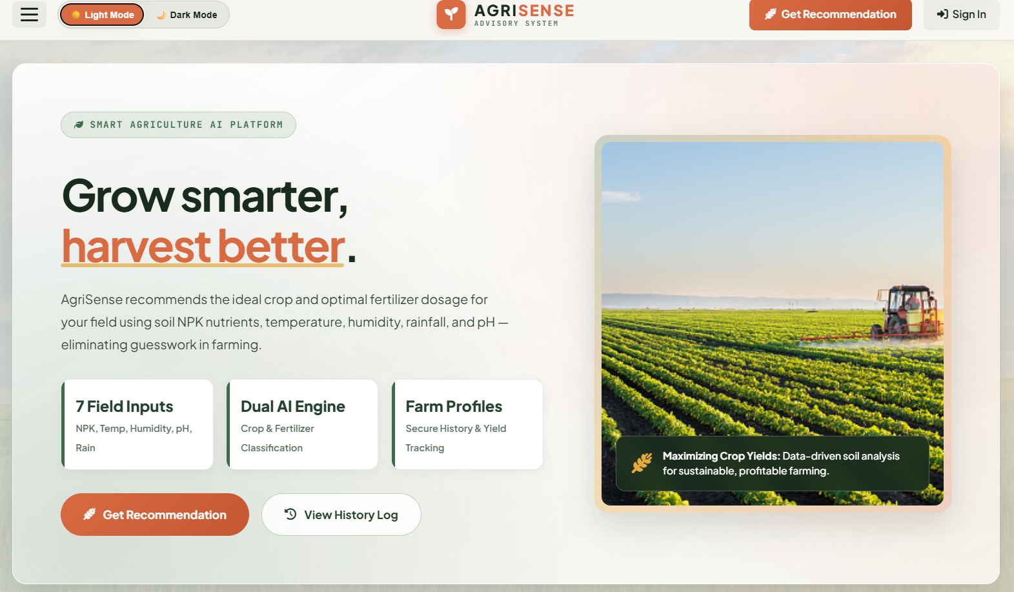

6 | 🔗 Proof of Work

File(s) / Folder Name | Phase-4/Day33
GitHub Repo Link | https://github.com/abdullahpi912/InternshipProgress/blob/main/Phase-4/Day33
Screenshot Attached? | yes
Live/Deployed Link (Later Phase) | N/A

7 | ⭐ Self-Assessment

Star Rating | ★ ★ ★ ★ ☆  (circle or fill in stars — 1 = needs help, 5 = fully confident)
Comments | Comfortable extending Flask routes and adding real CSS design now. Want to get better at structuring a stylesheet from the start (naming conventions, avoiding overly broad selectors) so it doesn't get messy as the project grows.

8 | 🎯 Mentor Feedback (left blank by intern)

Status
Comments

