LAB MIDTERM
DevOps for Cloud Computing

NAME: MUHAMMAD ABDULLAH
ROLL NO: FA23-BCS-091

GITHUB: https://github.com/abdullahqureshi1609/devops-lab-mid.git

DOCKER HUB: https://hub.docker.com/r/abdullahqureshi1609/task-manager-app

AZURE APP URL: http://68.210.40.52/

DOCKER DEPLOYMENT SS:
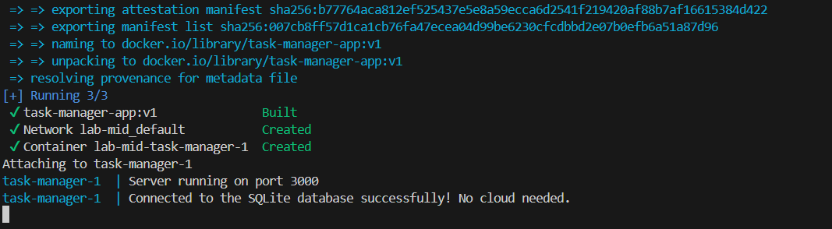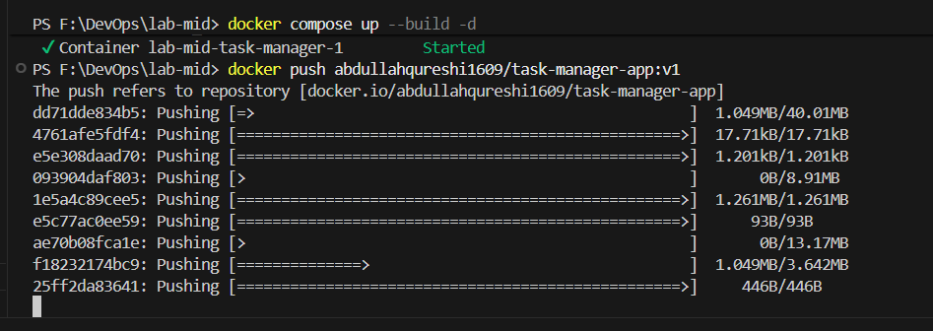

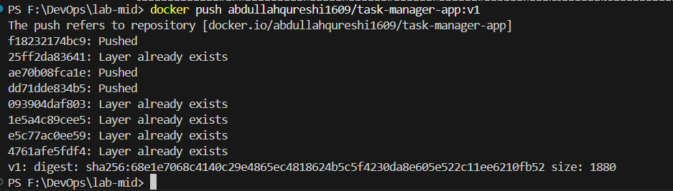

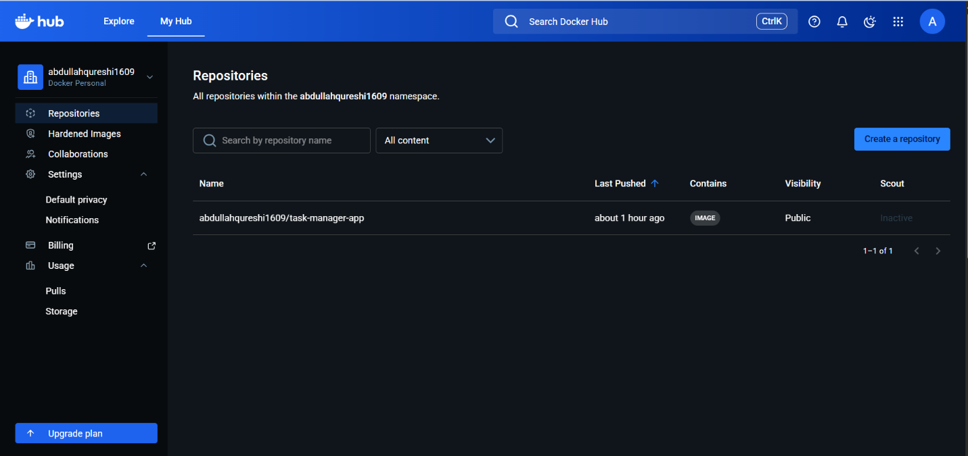
AZURE DEPLOYMENT SS:

