Installtion

Step 1: Install VS Code

Step 2: Intall extention “Live Server”



Step 3: Run script in terminal -> Git clone <https://github.com/abdullahqureshi5050/cg>

Step 4: Install package where needed via script “npm i”

Step 5: Click “Go live” to start the server (see bottom of VS Code)



Step 6: Go to <http://localhost:5500/> to see Demos.

1. Timothy Chan’s Convex Hull Algorithm

For this project I implemented Chan’s O(n.log (h) ) convex hull algorithm. The premise is fairly simple. Take a set of points, divide them up into maxsize n/m subsets, where m is the size of the full convex hull. Since we don’t know what m is, we guestimate it with $2^{2^{t}}$ where t is each iteration (so it goes 4, 16, 256, etc). Once we divide up the points, we then run graham scan on each subset. Once each subset is graham scanned into subhulls, we then find the tangent point of each hull to the most recently added point to the convex hull, and run Jarvis march over the points, keeping the one that give the largest angle.

**Time Complexity**: O(n.log (h))

**Space Complexity**: O( $2^{2^{t}}$)

# **Code/ Snippet**

function grahamScan(points) {

        let v_lowest = points[0];

        //find lowest point

        for (let i = 1; i < points.length; i++) {

            if (points[i].y > v_lowest.y) {

                v_lowest = points[i];

            }

            else if (points[i].y === v_lowest.y && points[i].x < v_lowest.x) {

                v_lowest = points[i];

            }

            //console.log(v_lowest);

        }

        if (v_lowest)

            //sort the array by angle

            points.sort(function (a, b) {

                //a is lowest point

                if (a.y === v_lowest.y && a.x === v_lowest.x) return -1;

                //b is lowest point

                if (b.y === v_lowest.y && b.x === v_lowest.x) return 1;

                //neither

                let ang_a = angleToPoint(v_lowest, a);

                let ang_b = angleToPoint(v_lowest, b);

                if (ang_a > ang_b) return 1;

                else return -1;

            });

        //remove doubles

        let i = 0;

        while (i < points.length - 1) {

            if (points[i].x === points[i + 1].x && points[i].y === points[i + 1].y) {

                points.splice(i + 1, 0);

            }

            i++;

        }

        let stack = [];

        if (points.length < 4) return points;

        //yeah im hardcoding this but we're not doing

        //graham scan with < 4 things anyway i think having

        //2 is ok

        stack[0] = points[0];

        stack[1] = points[1];

        let current = points[2];

        let index = 2;

        let stacklen = 2;

        while (index < points.length) {

            stacklen = stack.length;

            //console.log(stacklen);

            if (stacklen > 1) {//make sure there's at least 2 things before left test

                let l = checkIfLeftTurn(stack[stacklen - 2], stack[stacklen - 1], points[index])

                if (l) {

                    stack.push(points[index]);

                    index++;

                }

                else {

                    stack.pop();

                }

            }

            else {

                stack.push(points[index]);

                index++;

            }

        }

        return stack;

    }

# **Demo Screenshots**

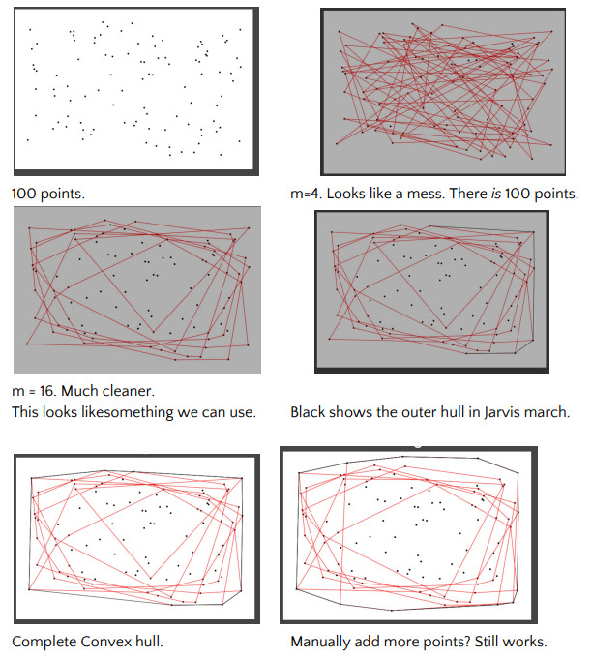

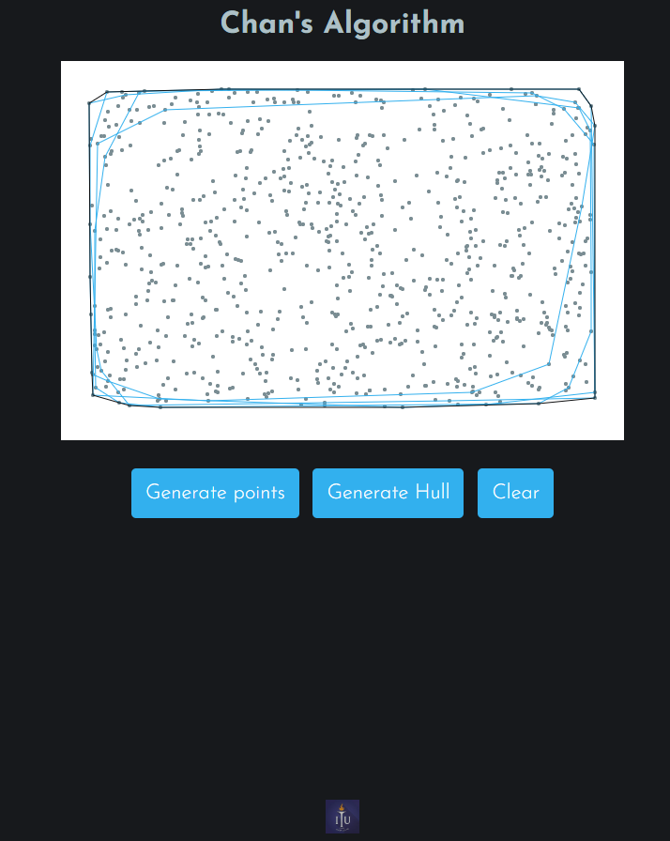

Reference Paper: <https://www.cs.umd.edu/~patras/patra2012_convexhull_report.pdf>

1. Steven Fortune's Voronoi Algorithm

A Javascript implementation of Steven Fortune's algorithm to efficiently compute Voronoi diagrams.

var voronoi = new Voronoi();

var bbox = {xl: 0, xr: 800, yt: 0, yb: 600}; // xl is x-left, xr is x-right, yt is y-top, and yb is y-bottom

var sites = [ {x: 200, y: 200}, {x: 50, y: 250}, {x: 400, y: 100} /* , ... */ ];

// a 'vertex' is an object exhibiting 'x' and 'y' properties. The

// Voronoi object will add a unique 'voronoiId' property to all

// sites. The 'voronoiId' can be used as a key to lookup the associated cell

// in diagram.cells.

var diagram = voronoi.compute(sites, bbox);

Reference Paper: <https://www.cs.umd.edu/class/spring2020/cmsc754/Lects/lect11-vor.pdf>

**Time Complexity:** O(n.log(n))

**Space Complexity:** O(log(n))

# **Demo Screenshots**

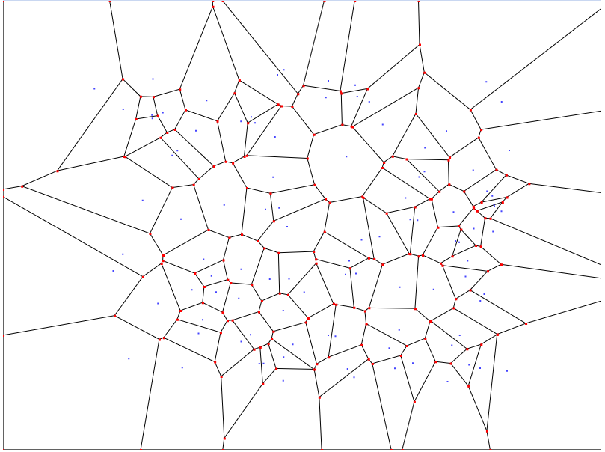

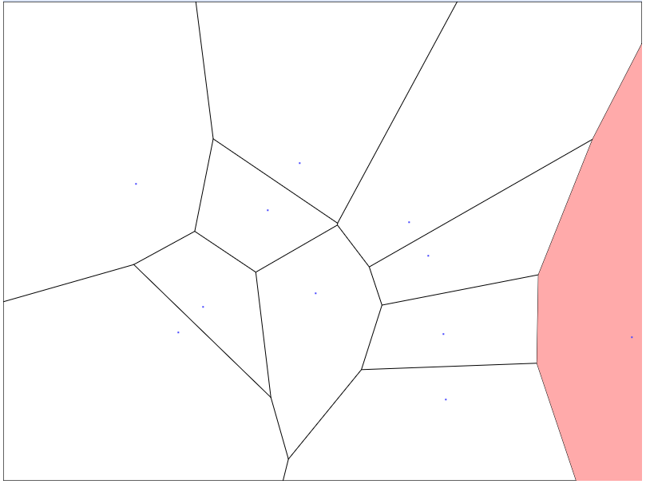

1. Line-segment Intersection

Events points and sweep line status is stored using 2 different data structures Queues and Balanced Binary tree.

# **Code/ Snippet**

    init: function () {

        this.points = new js_cols.RedBlackSet( this.compare );

        this.events = new js_cols.RedBlackSet( this.compare );

        this.status = new js_cols.RedBlackSet( this.compare );

        SWEEP.SVG.init();

        SWEEP.Gui.init();

        SWEEP.Info.init();

        SWEEP.Sweepline.init();

        SWEEP.SVG.resize();

        SWEEP.Input();

        animate();

        function animate() {

            requestAnimationFrame( animate );

            TWEEN.update();

        }

    },

# **Demo Screenshot**

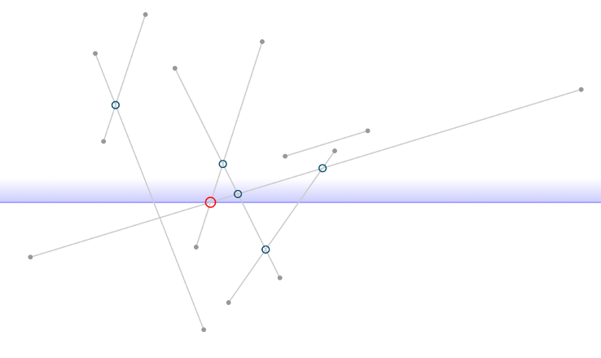

**Time Complexity:** O([n+i].log(n)) [ i – insertion points]

**Space Complexity:** O(n)

**Reference:** sweep.js (npm package)

1. Triangulation of Simple Polygon using x-monotone Subdivisions

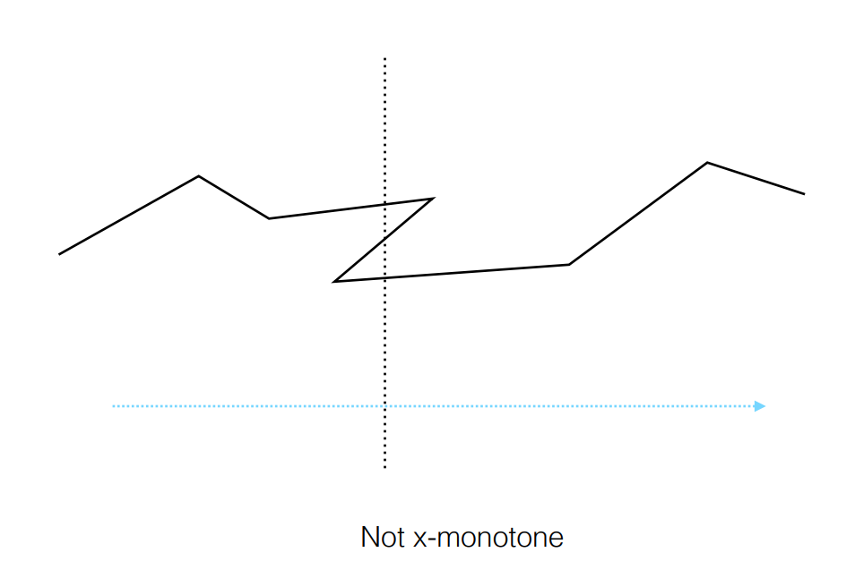

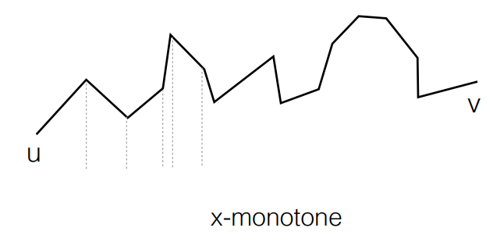

# **Code/ Snippet**

function* triangulatePolygon(polygon) {

  const u = _.sortBy(polygon.vertices, pt => -pt.y);

  const n = polygon.vertices.length;

  const S = [0, 1];

  const chainOf = vertexToChain(polygon);

  console.log({ chainOf });

  const vicinityOf = {};

  function prev(idx) {

    if (chainOf[idx] == "l") return idx - 1 >= 0 ? idx - 1 : n - 1;

    if (chainOf[idx] == "r") return idx + 1 < n ? idx + 1 : 0;

  }

  function next(idx) {

    if (chainOf[idx] == "r") return idx - 1 >= 0 ? idx - 1 : n - 1;

    if (chainOf[idx] == "l") return idx + 1 < n ? idx + 1 : 0;

  }

  for (let i = 0; i < n; ++i) {

    vicinityOf[i] = [prev(i), next(i)];

  }

  function vertexWithId(id) {

    return polygon.vertices[id];

  }

  function* introduceDiagonal(a, b) {

    vicinityOf[a.id].push(b.id);

    vicinityOf[b.id].push(a.id);

    const thirdWheels = _.intersection(vicinityOf[a.id], vicinityOf[b.id]);

    for (let wheel of thirdWheels) {

      const vertices = polygon.vertices;

      yield [a.id, b.id, wheel].map(vertexWithId);

    }

  }

  for (let j = 2; j < n - 1; ++j) {

    console.log(j, "" + S);

    const head = S[S.length - 1];

    if (chainOf[u[j].id] !== chainOf[u[head].id]) {

      console.log("different chain");

      while (S.length) {

        const head = S.pop();

        if (S.length === 0) break;

        yield* introduceDiagonal(u[j], u[head]);

      }

      S.push(j - 1);

      S.push(j);

    } else {

      console.log("same chain");

      let lastPopped = S.pop();

      while (S.length) {

        const head = S[S.length - 1];

        console.log({ S, head });

        if (ccw(u[j], u[lastPopped], u[head]) <= 0)

          break;

        lastPopped = S.pop();

        yield* introduceDiagonal(u[j], u[head]);

      }

      S.push(lastPopped);

      S.push(j);

    }

  }

  S.pop();

  while (S.length > 1) {

    const head = S.pop();

    yield* introduceDiagonal(u[n - 1], u[head]);

  }

  console.log({ S });

}

# **Demo Screenshot**

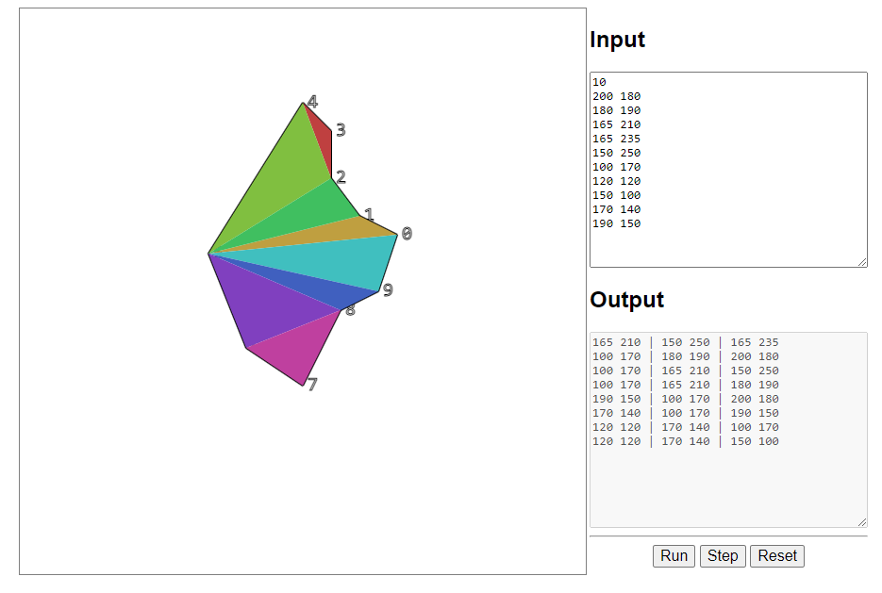

**Time Complexity**

First, the simple polygon is decomposed into a collection of simpler polygons, called monotone polygons. This step takes O(n log n) time.

Second, each of the monotone polygons is triangulated separately, and the result are combined. This step takes O(n) time.

**Reference:**

1. <https://tildesites.bowdoin.edu/~ltoma/teaching/cs3250-CompGeom/spring16/Lectures/cg-polygontriangulation.pdf>
2. <https://www.cs.umd.edu/class/spring2020/cmsc754/Lects/lect05-triangulate.pdf>