My project Research
Project Idea: We are developing an online platform designed to help university students access valuable internship opportunities and structured learning guidance. This website will serve as a hub where students can register for internships by filling out a simple application form. Once submitted, we will personally review each applicant and contact them for recruitment. In addition to internships, the platform will offer detailed roadmaps for various tech fields such as web development, app development, and game development, guiding students from beginner to advanced levels. It will also provide carefully curated learning resources to help them acquire practical skills. Our aim is to bridge the gap between academic learning and real-world experience by offering mentorship, hands-on projects, and clear direction for students early in their careers.
Market Research
Searching for similar platform of my idea
https://interns.pk/interns-program/
https://www.rozee.pk/
https://www.mustakbil.com/
https://pk.indeed.com/
Some platforms are like fiverr where people search for jobs or internship!
https://scholarshipscorner.website/nadra-graduate-internship-program/
Providing internship in vast amount of fields screen shot attach below to check which fields they are providing internship!
Platform related to Nadra Check Screenshot
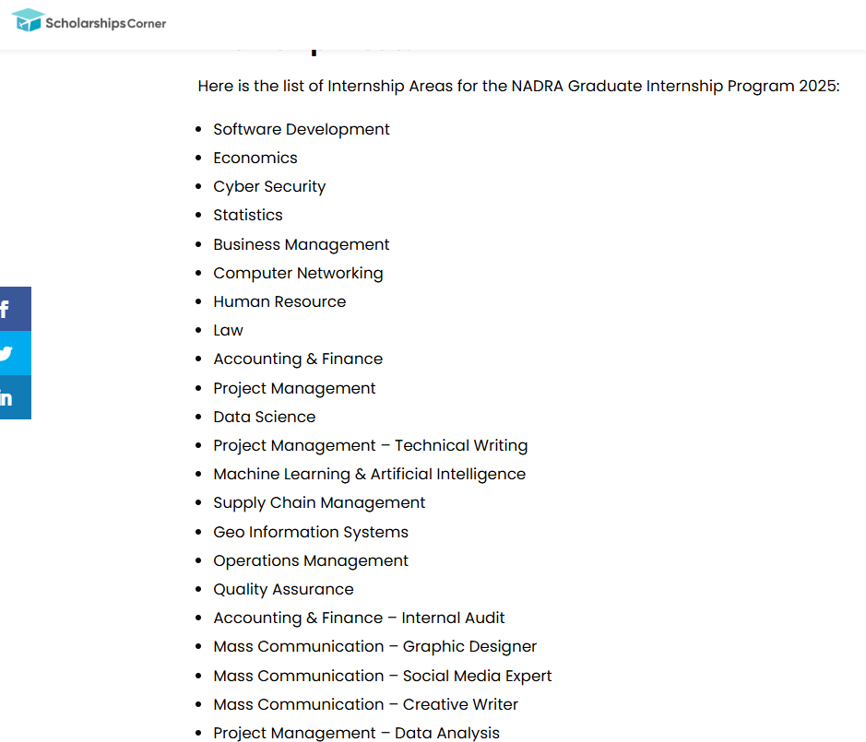
How students find internship in 2025?
From my research many students look for internship online or any other physical platform! The above platforms I have discussed are also a source of finding internship online!
Other resources which I have found during research!
- GitHub + Open-Source Contributions
- Student Communities & Discord Servers
- Facebook groups like Internships Pakistan or Tech Internships 2025
- Now universities are also providing internship e.g. My university TUF also arranging summer internship!
- Leetcode hackerrank and such platforms also offer to apply!
Tech Learning platforms for students
Coursera, Code Academy, Udemy, Hardward University etc.!
Some more sites also available but it is difficult to check quality of a course you can find these sites online!
Main problem I come to know that some people might can’t afford paid courses but they want to learn for free!
Hence free platform like YouTube has bunch of courses but similarly still problem how to find quality? Quantity is available!
What beginner developer struggle with?
https://youtu.be/cvDLNKGZi1Q
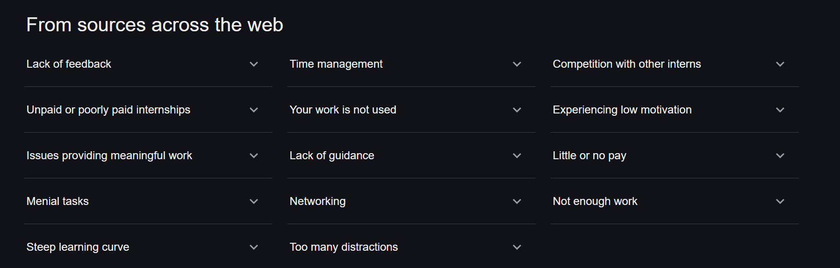
Common problem student face when looking for internship

Best tech stack for roadmap/resource websites
https://pf.com.pk/blogs/a-complete-full-stack-web-application-development-roadmap-for-2023/
https://www.nucamp.co/blog/coding-bootcamp-pakistan-ipak-roadmap-to-becoming-a-frontend-backend-or-fullstack-web-developer-in-karachi-pakistan
https://fullscale.io/blog/top-5-tech-stacks/#h-what-is-a-tech-stack
Currently there is no site in Pakistan which is providing roadmaps + free resources to learn about different IT Fields like Web App ML Game idk about other countries because my currently focus in on just Pakistan!

Imp Note: To Gather more information I am making a google form and we should share this form as much as possible to check the thinking of people what people thinking? What they need? How they want to do? What people want to learn and from where?

