## Information

*© 2022 Alivia Analytics ™*

|  |  |
| --- | --- |
| **Particulars** | **Description** |
| Prepared for | Case Manager™, Product of Alivia Payment Integrity Suite |
| Document Name | User Manual |
| Document Version | [Status] |
| Identifier | Case Manager™ User Manual [Status] |
| Status | Issued |
| Author(s) | Business Analyst Team |
| Approver(s) | Kleber Gallardo |
| Release Date | [Publish Date] |

Document Revision history

|  |  |  |  |
| --- | --- | --- | --- |
| **Author** | **Date** | **Version** | **Description** |
| Waqar Ahmed | 12/15/2019 | 1.0 | Initial Draft |
| Matt Perryman | 06/12/2020 | 2.0 | Added content for new features,  Financials Module  Recovered Claim Tracker |
| Waqar Ahmed | 12/27/2020 | 3.0 | Added Content for; G Modules |
| Waqar Ahmed | 06/19/2021 | 3.2 | Added Content for; Prevented Loss |
| Aamir Saleem Minhas | 12/28/2021 | 3.3.1 | Overall updates and Added Payment Reversal Content |
| Aamir Saleem Minhas | [Publish Date] | 3.5.0 | Added content for new features and enhancements |
| Aamir Saleem Minhas | [Publish Date] | 3.6.3 | Added content for new features and enhancements |
| Zarnab Tahir | 9/7/2022 | 3.7.0 | Added content for new features and enhancements |

Document Review history

|  |  |  |  |
| --- | --- | --- | --- |
| **Reviewer** | **Date** | **Version** | **Description** |
| Kleber Gallardo | 12/18/2019 | 1.0 | V 1.0 Review |
| Kleber Gallardo | 06/13/2020 | 2.0 | V 2.0 Review |
| Kleber Gallardo | 12/27/2020 | 3.0 | V 3.0 Review |
| Kleber Gallardo | 06/19/2021 | 3.2 | V 3.2 Review |

List of figures

ermined pattern.

1. **Modules of Case Manager™**

The application itself is built with a hierarchical tab and module design and allows users to move **ACCESSING THE CASE MANAGER™ APPLICATION**

1. **Application Access**

Users will access the Case Manager™ application through the website URL provided by Alivia Analytics™ for the respective organization. By accessing the provided URL, the user lands on the application's ‘Login Page’ as provided below.

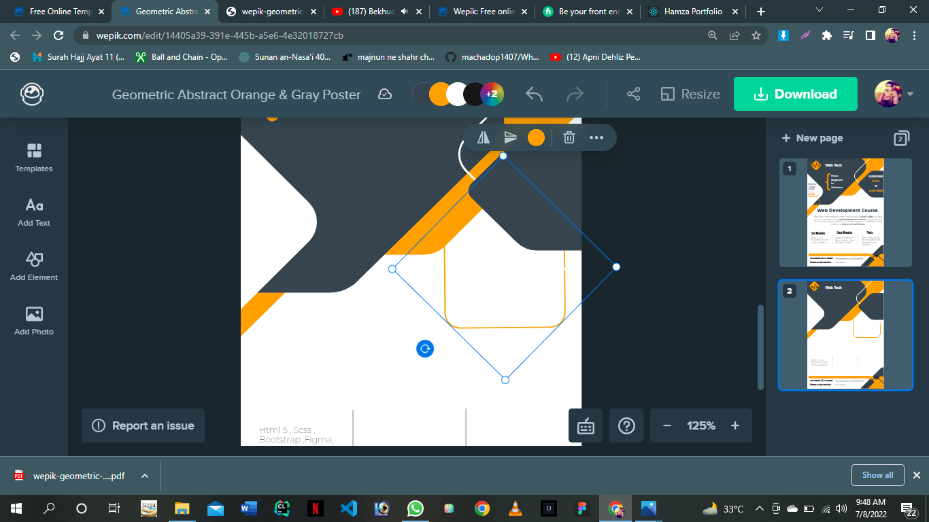

**Figure 1: Login Page**

