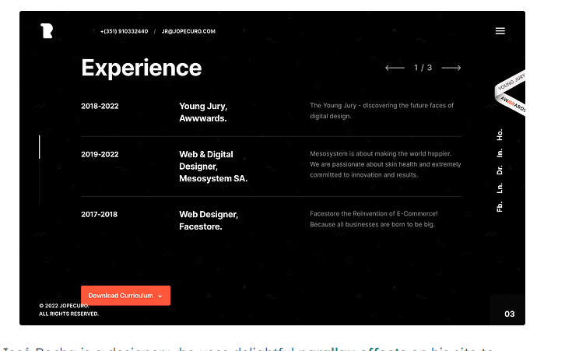

Jazz People

Quick math

Tic Tac Toe

BMI Calculator