1. 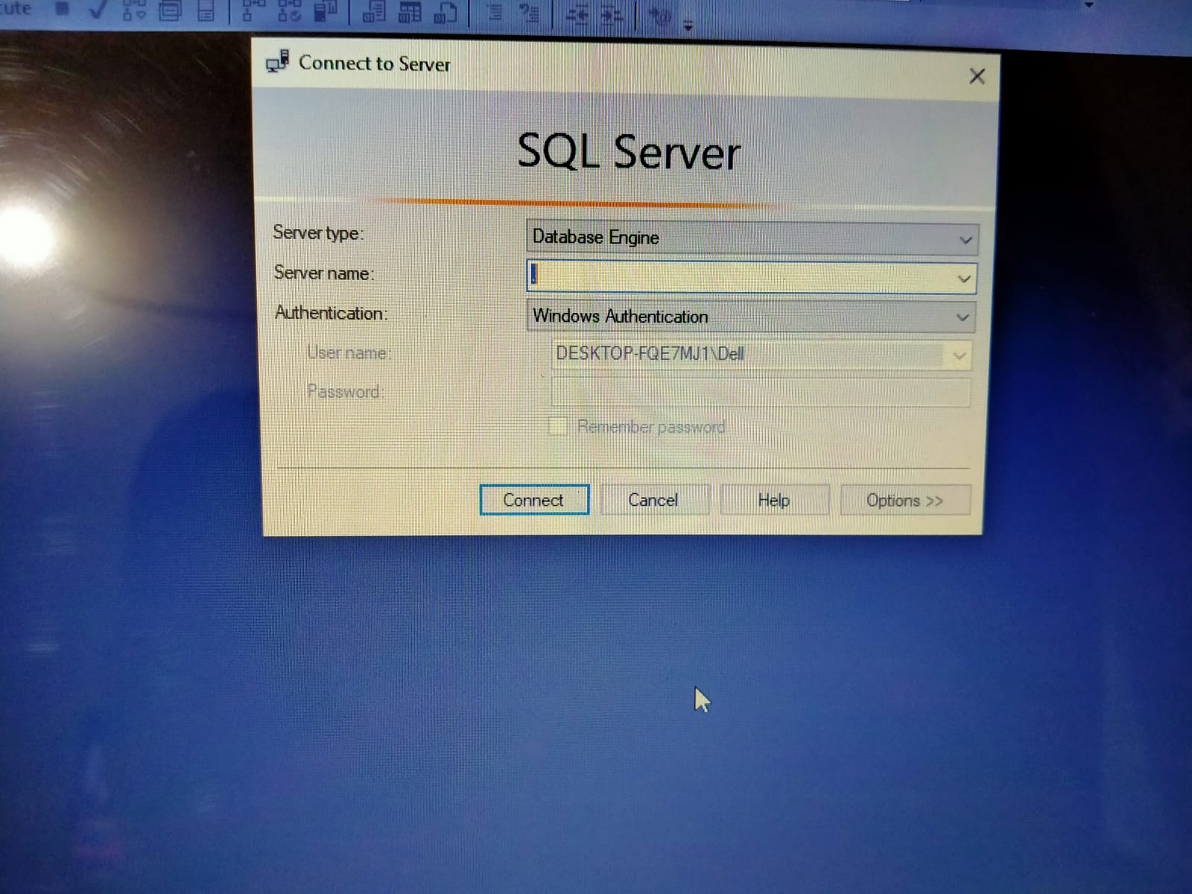
2. Open .sql file

Put . in the server name

1. Run this query create database pharmacyManagment
2. Create users table
3. Run the insert query in ssm
4. Run the .sln file
5. Run the code
6. Only 10 no of user can be added as required
7. All requirmets satisfied