

ABBOTTABAD UNIVERSITY OF SCIENCE AND TECHNOLOGY ABBOTTABAD
BS-SE (3) C

NAME : SYED ABDULLAH SHAH
SUBMITTED TO : SIR.JAMAL ABDUL AHAD
LAB TASK : 4
SUBJECT : DSA
ROLL NO : 12397
DATE OF SUBMISSION : November 5, 2023.

Q1: Modify the merge sort algorithm to count the number of inversions in an array. An inversion is a pair of indices (i, j) such that i < j and arr[i] > arr[j].
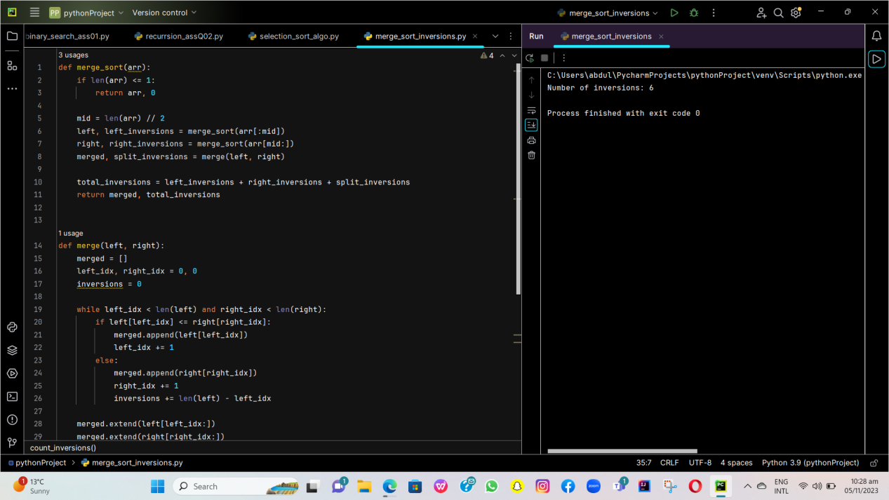

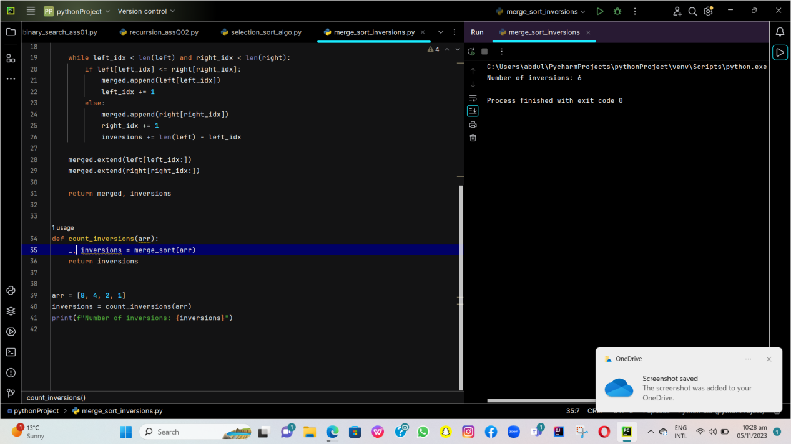

Q2: Implement the merge sort algorithm for sorting linked lists instead of arrays. This exercise will require modifying the merge process.
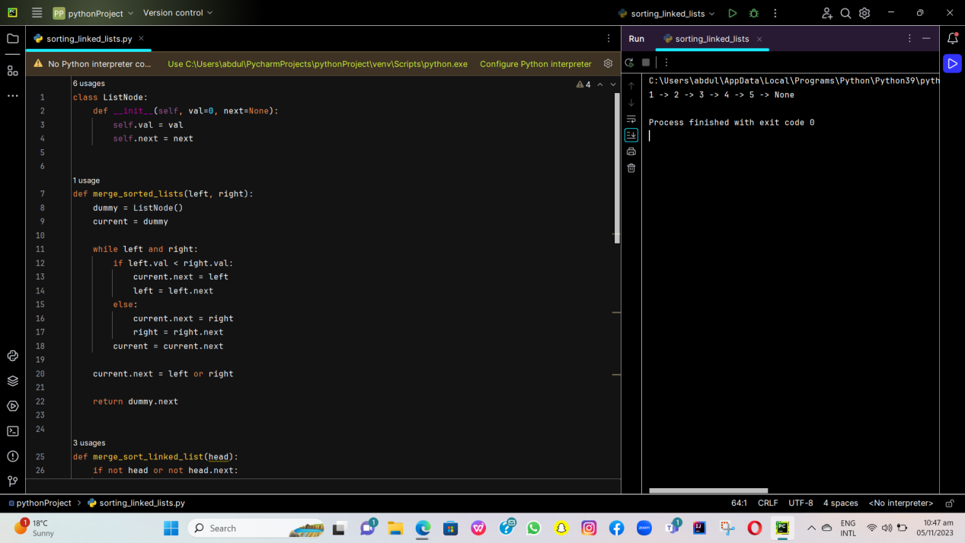

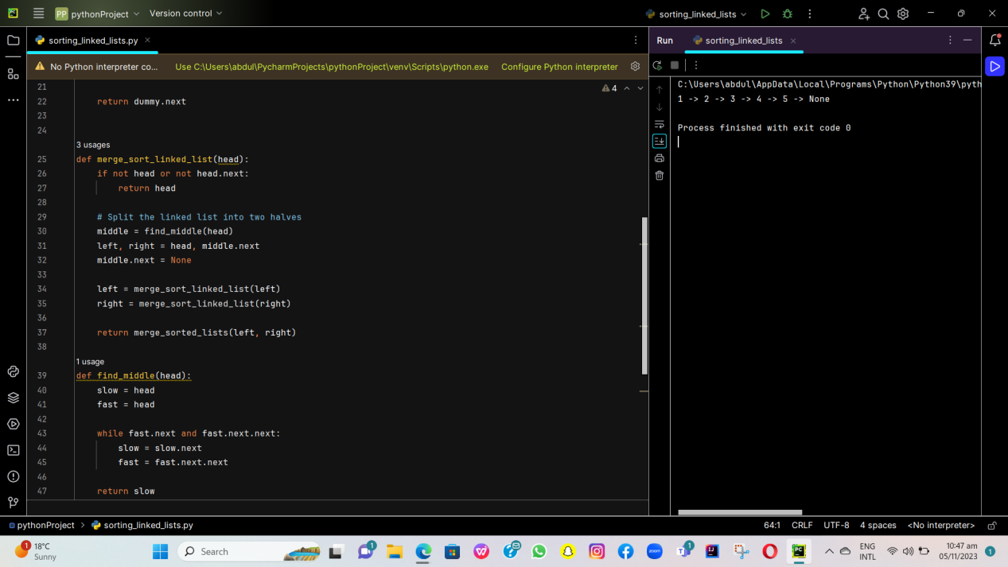

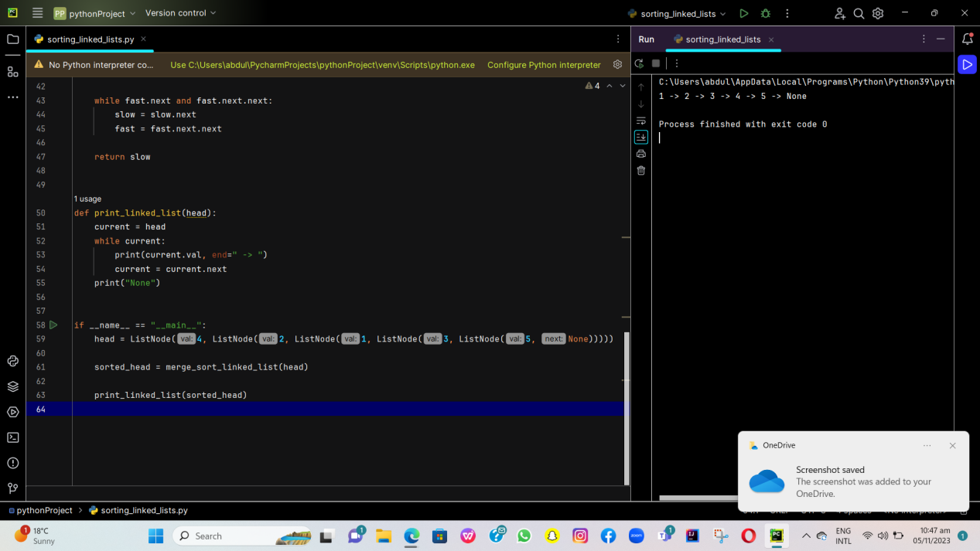

Q3: Modify the merge sort algorithm to sort a list in descending order instead of ascending order. This will require changes to the merging step.

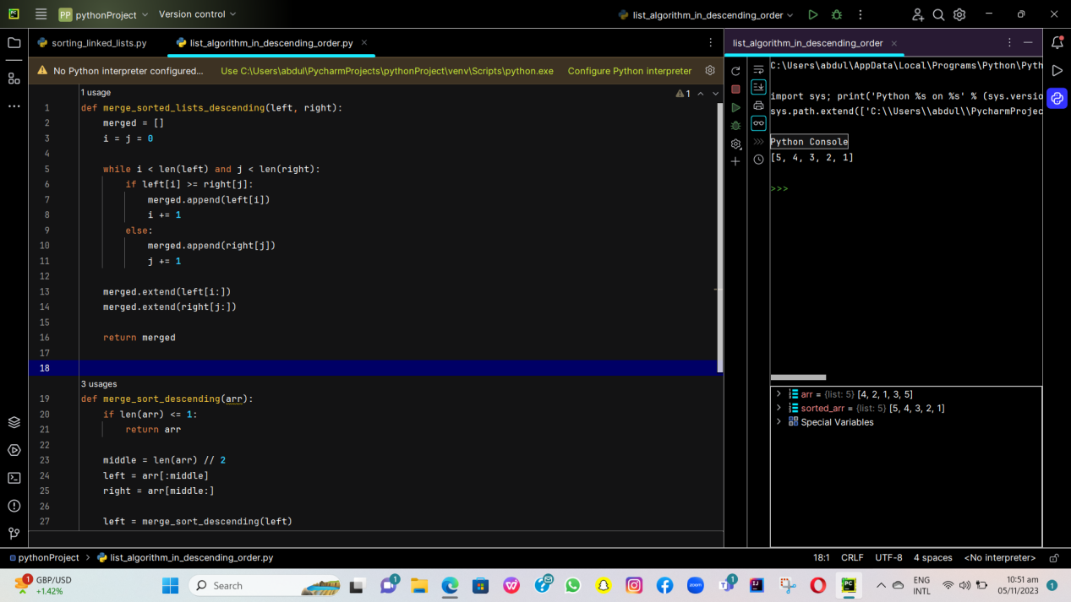
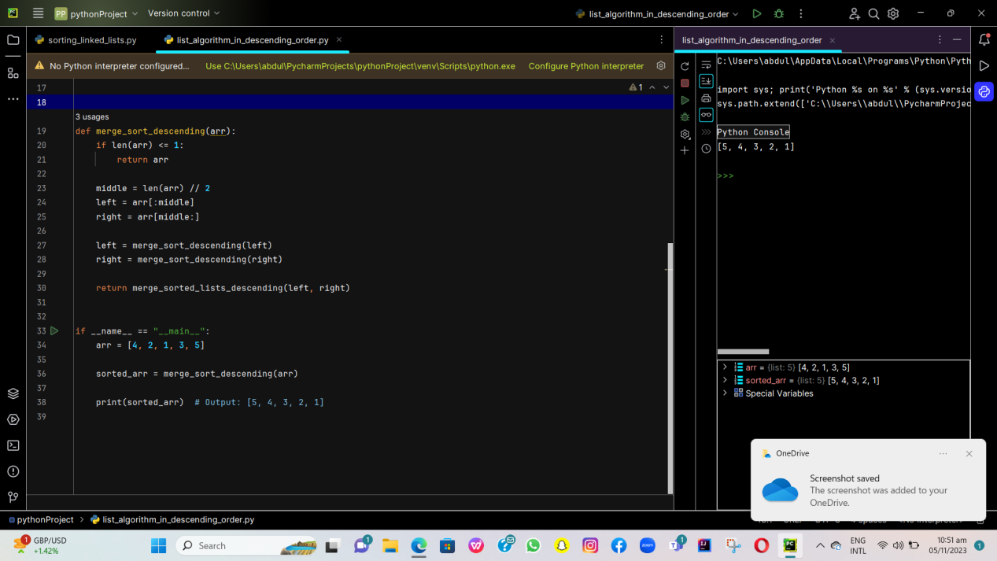

Q4: Extend the merge sort algorithm to work with three or more sublists at each step, not just two. This is called a three-way (or multi-way) merge sort.

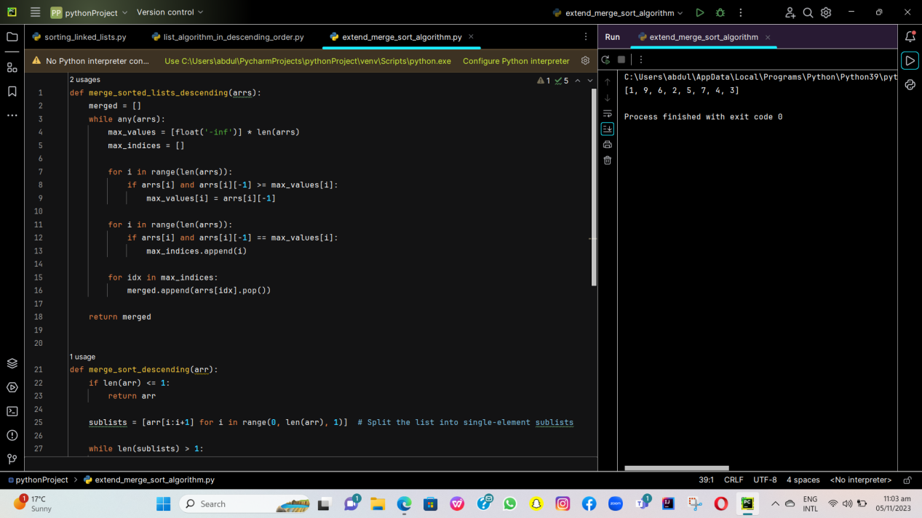

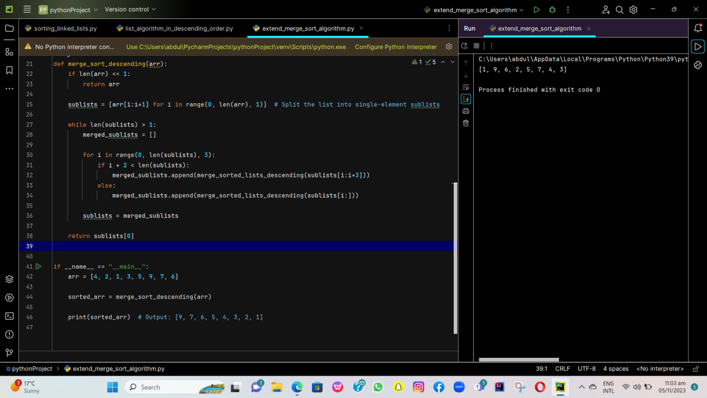

……THE END……

