1.The City School (Pakistan)

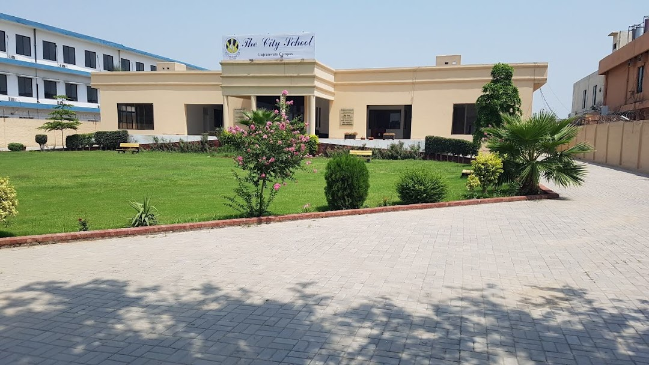

The City School (abbreviated as TCS) ni education company established in 1978, which operates English medium primary and secondary with over 160 schools in 49 cities across Pakistan along with joint venture projects in UAE, Saudi Arabia, Philippines and Malaysia.[1][2] It is one of the largest private educational organisation in Pakistan, with a total of 150,000 students enrolled as of 2018.[3] In 2018, The City School celebrated 40 years of service in the education industry of Pakistan.

Its primary school is based on curriculum derived from the UK's National Curriculum, while its secondary school education is divided between the local Pakistani curriculum and the Cambridge regulated international GCE programs.[4] Founded in Karachi in 1978, the school's head office is based in Karachi with regional offices in Karachi and Lahore.[5]

**Head Office**

* 31-Industrial Area, Gurumangat Road, Gulberg III, Lahore, Pakistan.

**Southern Region**[

**Karachi**[

* PAF Chapter is located at Shaheed-e-Millat Extension, Off Shahrah-e-Faisal, Karachi. It is a co-educational campus and offers education from Playgroup to [A Level](https://en.wikipedia.org/wiki/Advanced_Level_(UK)).

Darakhshan Campus located at Kayabane-e-Bukhari is a co-educational campus, From class 4 up to [O Level](https://en.wikipedia.org/wiki/O_Level).

**ADMISSION PROCEDURE AT THE CITY SCHOOL**

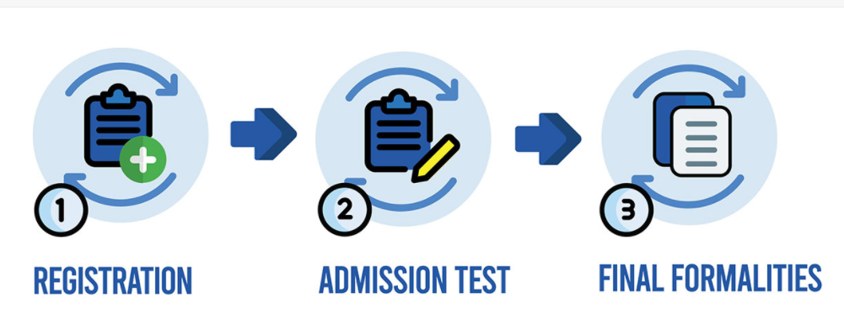

**REGISTRATION**

Parents wishing to admit a child should first register for an admission test by completing the admission form at the school office and taking an appointment card for the test and interview.  
Registration does not in any way confirm or guarantee admission. It is subject to getting through an admission test/ interview and availability of the seat.

The class for which a child is tested is determined according to the child’s age as at 31st July (28th/29th February in case of Baluchistan)

[Click here for Online Registration](https://thecityschool.edu.pk/student-registration-online/)

**ASSESSMENT/ADMISSION TEST**

**Pre-Nursery – Kindergarten**

An informal individual assessment test is taken combined with an interview with both the parents. Generally, the reading level of a child, the vocabulary and concepts of colours and numbers are assessed. In addition, the confidence of the child, the level of spoken English and motor skills are taken into consideration.

**Class-I Onward**

Application for Class I onward are tested in three subjects – English, Urdu and Mathematics.  
The pass percentage is 50%. Duration of each paper is approximately 30 minutes.  
For the written test, the child should come properly equipped with a pencil, eraser, sharpener and ruler.  
The papers are not set from any specific textbooks or syllabus but are of a general nature designed to test the aptitude of the child in the basic subjects.  
The test paper is not shown to anyone and only marks are communicated to the parents/ guardians.  
A candidate caught cheating during the admission test will be rejected.  
The list displaying names of selected candidates will be put up on the notice board of the concerned branch on the date given by the school.

In all cases, merit is the sole criterion for admission. The decision of the school cannot be challenged in any way and will be final.

#### ADMISSION FORMALITIES

* 1. Parents fill in the admission form and pay the registration fees after which they receive:
     + Relevant Fee structure slip
     + Appointment card with testing date & time
     + Registration receipt
     + Prospectus purchase cash receipt
     + Admission and fee payment information
     + Prospectus & newsletter
  2. The documents to be attached with the Admission Form include:
     + A photocopy of Provisional Certificate and Character Certificate from last institution attended
     + 2 recent passport size photographs
     + 2 self-addressed envelopes
     + Attested photocopy of Birth Certificate
     + Report card from last school
  3. Test and interview with both the parents are on the specified date
  4. Result is finalised within a week of the test & displayed on the notice board. Parents are informed about further formalities.
  5. Parents are given the admission fee bill, payable by a certain due date in a specific bank as mentioned on the fee bill.
  6. The following fees are payable:

|  |  |  |
| --- | --- | --- |
| A | Registration Fee | Non-refundable |
| B | Admission Fee | Non-refundable |
| C | Security Fee | Refundable |
| D | Tuition Fee | Payable every  month |
| E | Computer Fee | Payable every  month |

### **RULES OF PAYMENT:**

* Fees are charged for all twelve months of the year and are payable every two months.
* Parents have the option to pay the fee for the whole year as a lump sum.
* The fees payable for the period of the summer vacation are paid in advance and prior to closure.
* Once the fee bill has been issued, payment is made directly to the bank where the school operates its account. Parents must pay the fees by the date specified on the fee bill.
* Fees paid after the due date is subject to a flat surcharge as specified on the fee bill.
* If the tuition fee has not been paid by the end of the second month, the student is withdrawn by The City School.