

University of Engineering and Technology Lahore Department of Computer Science
Course: Gaming and Animation

Project on
Dream Cars Rental Service

Submitted To:
Ms. Ramsha Khalid
(Subject: AICT)

Submitted By:
Muhammad Abdullah 2025-GA-118
Muhammad Abdullah Hafeez 2025-GA-63
Muhammad Hassan Azam 2025-GA-70
Abdullah Bin Tahir 2025-GA-96
Ezza Fatima 2025-GA-82

Semester: 1st
Session: 2025-2029
Course Code: AICT 101 Group: 03

Executive Summary:

This project is a Car Rental Service Website developed as part of the AICT Lab semester project to demonstrate practical skills in web development, data analysis, and project documentation. The website provides users with a clear and user-friendly interface to view available cars, rental prices, and booking status, and includes essential pages such as Home, About, Services, Gallery, and Contact for smooth navigation. To support the website, Microsoft Excel was used to manage raw vehicle data, perform rental income calculations using formulas, and create a summary dashboard with charts for analytical insights. Microsoft Word was used to document the project structure, design decisions, and implementation details, while GitHub enabled version control and live publishing of the website. Overall, the project reflects an integrated and systematic workflow, ensuring consistency across all deliverables while fulfilling the academic and technical requirements of the AICT Lab course.

Project Objectives & Scope:

The primary objective is to create a professional digital presence for a car rental service that:

Showcases Fleet Variety: Highlights specific brands like Toyota, Hyundai, Suzuki, BMW, Audi, and Honda.

Provides Financial Transparency: Tracks daily rent, monthly income, and vehicle status (Available vs. Booked).

Categorizes Inventory: Differentiates between "Luxury" and "Normal" vehicle classes for better market positioning.

Facilitates Bookings: Includes dedicated navigation for user inquiries and reservations.

Site Structure & Navigation:

The website is organized into specialized pages to help users navigate by brand and function:

Page | Purpose
index.html | The homepage featuring a hero section, "Book Now" call-to-action, and brand highlights.
toyota.html | Detailed listings for Toyota models like the Yaris, Fortuner, and Land Cruiser.
hyundai.html | Listings for modern Hyundai vehicles including the Elantra and Sonata.
suzuki.html | Focuses on compact city cars like the Mehran and Swift.
bmw.html | Showcases high-performance luxury models such as the M5 and X7.
audi.html | Features sophisticated German engineering including the Audi A5 and Q7.
honda.html | Displays reliable options like the Civic and Accord.
booking.html | The interface for users to submit rental request. Contact us. Html Customer support and inquiry page.

Design Choices:

Typography: The site utilizes a "luxury-font" class for headers to emphasize the premium nature of the brand.

Color Palette & Layout: The layout uses a "brand-section" design with a reverse class to create a visually engaging, alternating pattern between images and text descriptions.

User Interface: A sticky navigation bar ensures easy access to all brand pages from any point on the site.

Data Sources (Excel/CSV):

The project backend is supported by detailed data tracking:

Total Fleet: 29 vehicles tracked across 6 brands.

Key Metrics: Total monthly income is calculated at 6,221,500 PKR, with an average monthly income per vehicle of 214,534.48 PKR.

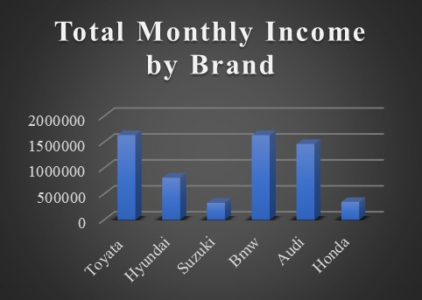

Categorization: 21 Luxury cars and 8 Normal cars.
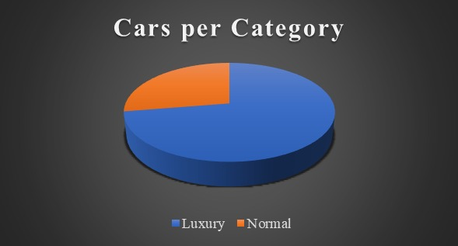

Toyota
Pardo | 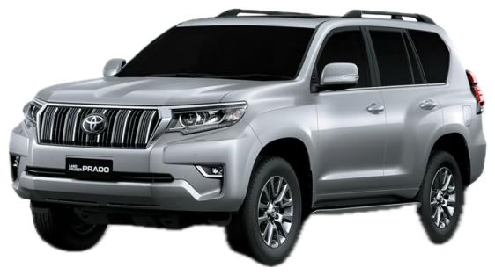
Land cruiser | 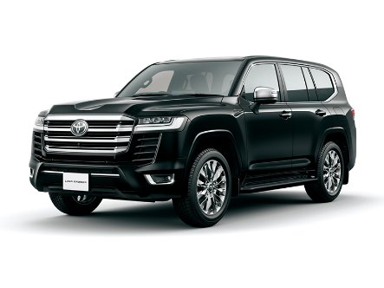
Yaris | 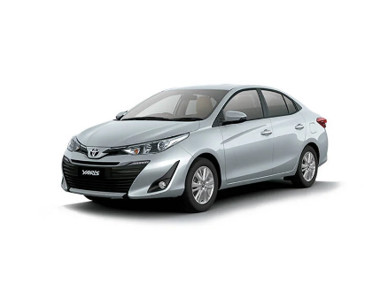
Corolla | 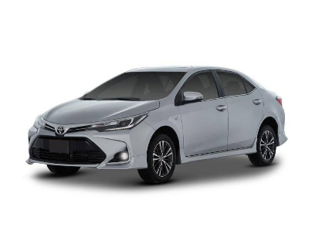
Vigo champ | 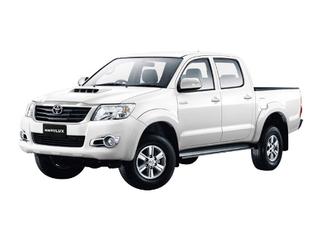
Fortuner | 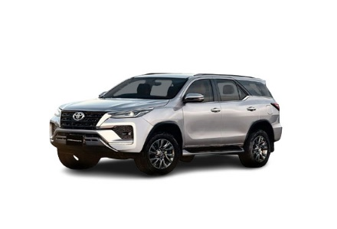

BMW
M5 | 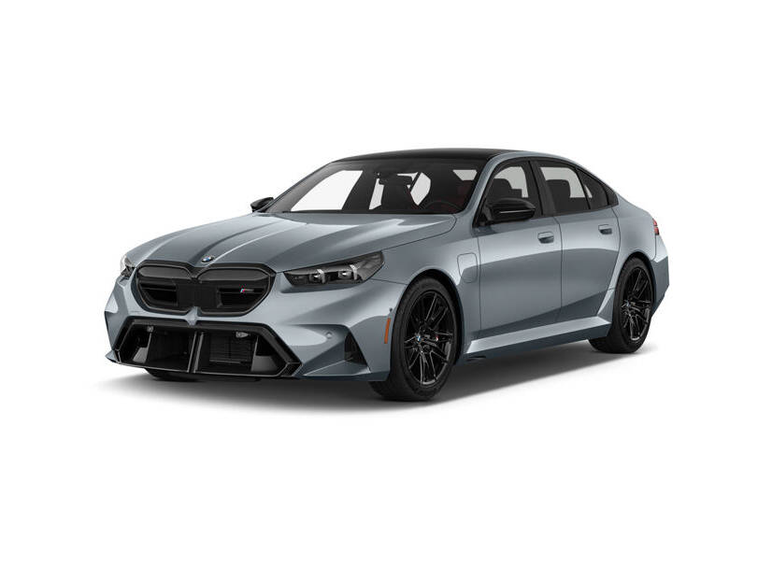
M3 | 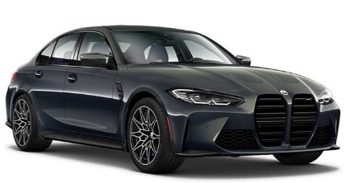
X1 | 
X5 | 
X7 | 

Audi

A5 | 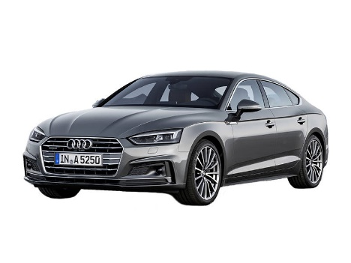
A4 | 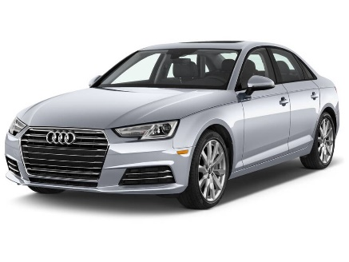
A3 | 
Q5 | 
Q7 | 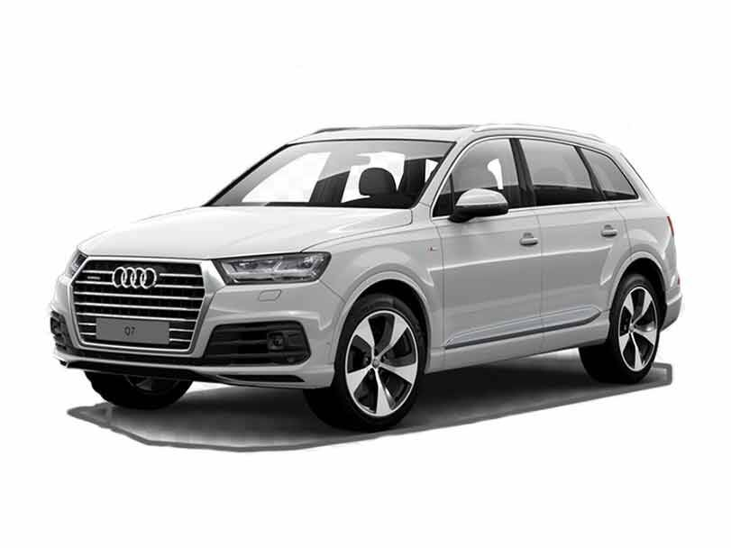

How to Run/Publish:

Local Viewing: Ensure all HTML files and the style.css file are in the same directory. Open index.html in any modern web browser.

Data Management: Use the provided Excel workbooks to update vehicle status (Available/Booked) or adjust "Daily Rent" prices; these changes should then be reflected in the site's manual updates.

Reflection:

What was learned: This project demonstrated the importance of aligning front-end presentation with back-end data. Integrating specific rental rates such as the 60,000 PKR daily rate for a Land Cruiser into the business logic ensures the site remains a realistic business tool.

Future Improvements:

Dynamic Integration: Connecting the HTML front-end directly to a database to update "Available/Booked" status in real-time.

Interactive Dashboard: Embedding the "Summary Dashboard" charts directly into an admin panel on the website.

Excel Description:

This project is based on a Car Rental Service Management System developed using Microsoft Excel. The purpose of this project is to manage car availability, bookings, and income records efficiently by using raw data, calculations, and a dashboard summary.

Raw Data Sheet:

The Raw Data sheet contains the basic information of cars used in the rental service. It includes car names, their availability status, and booking status. This sheet is the foundation of the project, where all data is entered manually. The data clearly shows which cars are available and which cars are currently booked.

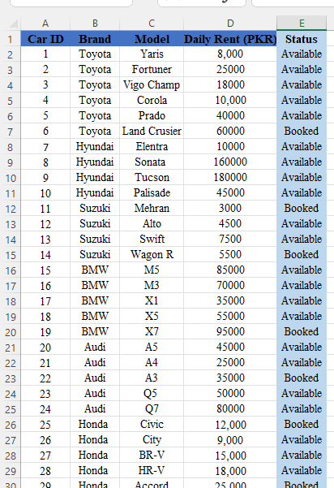

Calculation Sheet:

The Calculation sheet is used to perform different calculations based on the raw data. In this sheet, formulas are applied to calculate the monthly income generated from the rented cars. It also calculates the average income, which helps in analyzing the overall performance of the car rental service. This sheet ensures accurate and automatic calculations.
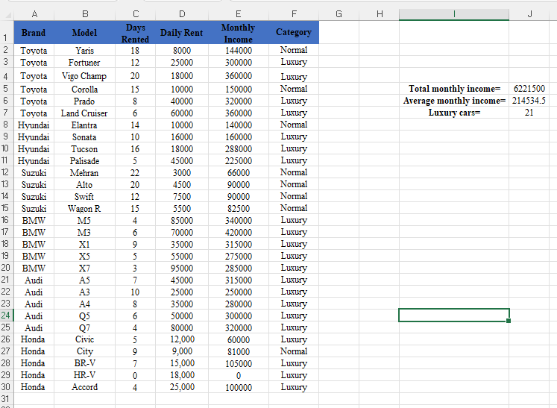

Dashboard Summary:

The Dashboard sheet provides a visual summary of the data using graphs and charts. These graphs represent car availability, booking status, and income analysis in an easy-to-understand format. The dashboard helps users quickly understand the business performance without checking raw data or calculations

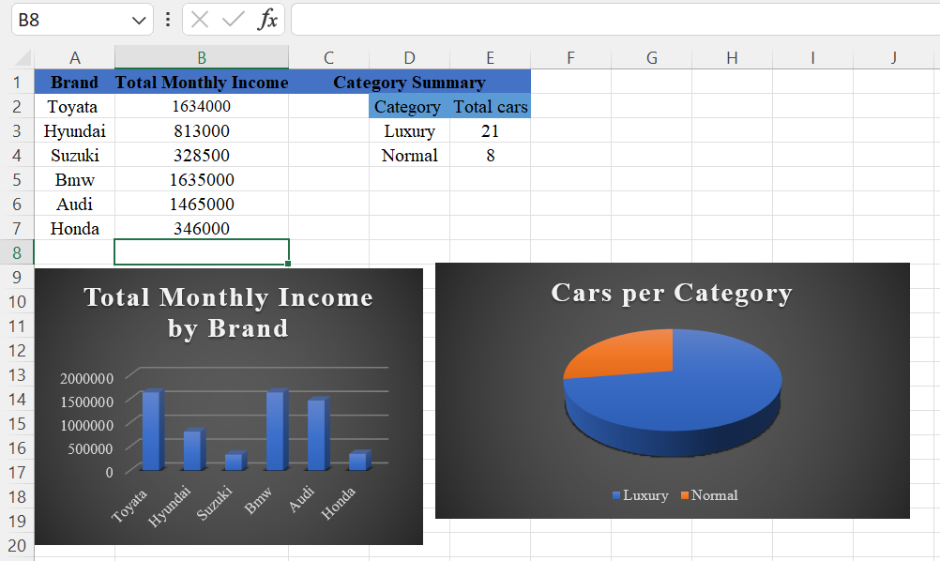

Live website url:

https://abdullahsheikh6471468-byte.github.io/groupno-3-car-rental-service/

