Documentation

|  |
| --- |
| STL-10 (image Data set ) && Titanic ( numerical Data set) |

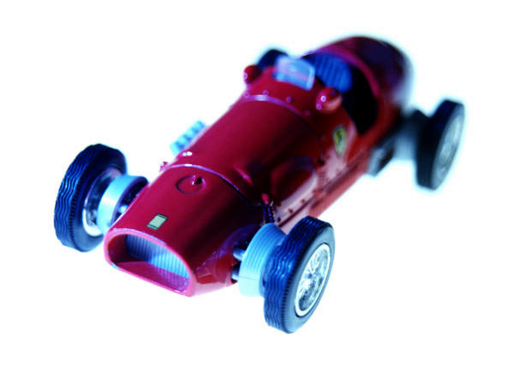

|  |  |
| --- | --- |
|  | machine learning |

A)GENERAL INFORMATION ON DATA SET

*1-numerical data set*

|  |  |
| --- | --- |
| *name* | Titanic data set |
| *Total number of samples(rows)* | 1309 |
| ***features(inputs)*** | 11(PassengerId,Pclass,Name,Sex,Age,SibSp,Parch,Ticket,Fare,Cabin,Embarked) |
| ***target variable (predict)*** | 1(supervised) |
| ***training sample*** | 80% |
| ***validation &testing sample*** | 20% |

*2-IMAGE data set*

|  |  |
| --- | --- |
| name | STL-10 |
| classes and labels | Air plane , bird , car , cat ,deer , dog ,horse , monkey , ship ,truck |
| Total image | 6000 |
| **image size** | 32*32 |
| **training image** | 5000 image  80% |
| **Validation & testing sample** | 1000 image  20% |

*B) IMPELEMENTATION DETAILS*

*1-LOGISTIC REGRATION as a linear*

|  |  |
| --- | --- |
| accuracy | 0.79 |
| Confusion matrix |

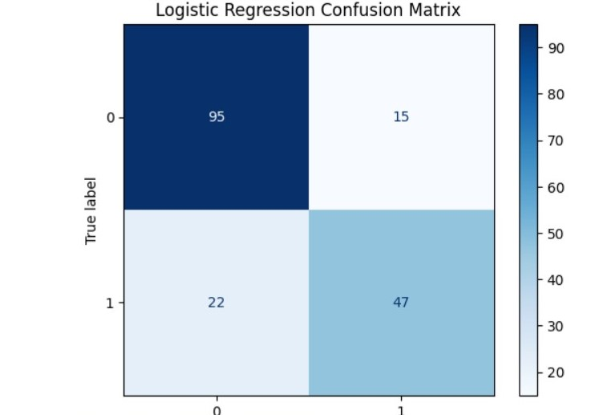

|  |  |
| --- | --- |
| Precision | 0.76 |
| recall | 0.68 |
| Roc curve |

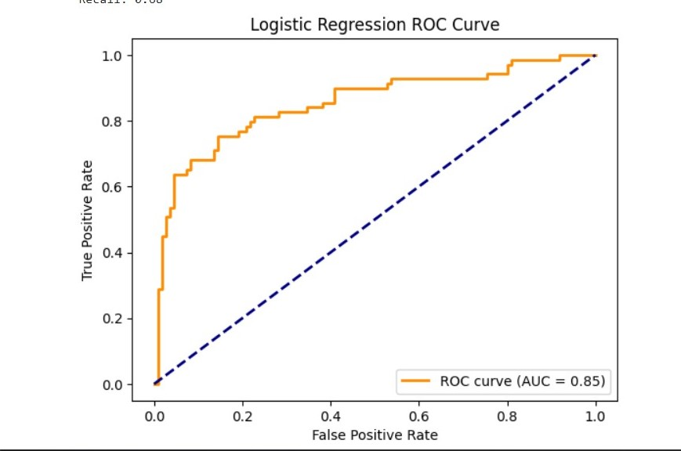

|  |  |
| --- | --- |
| auc graph | 0.85 |

*2-KNN REGRESSOR*

|  |  |
| --- | --- |
| accuracy | 0.66 |
| Confusion matrix |

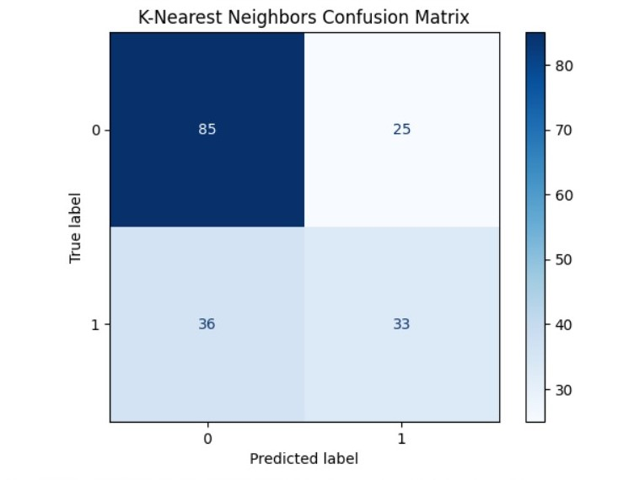

|  |  |
| --- | --- |
| **Precision** | 0.57 |
| **recall** | 0.48 |
| **Roc curve** |

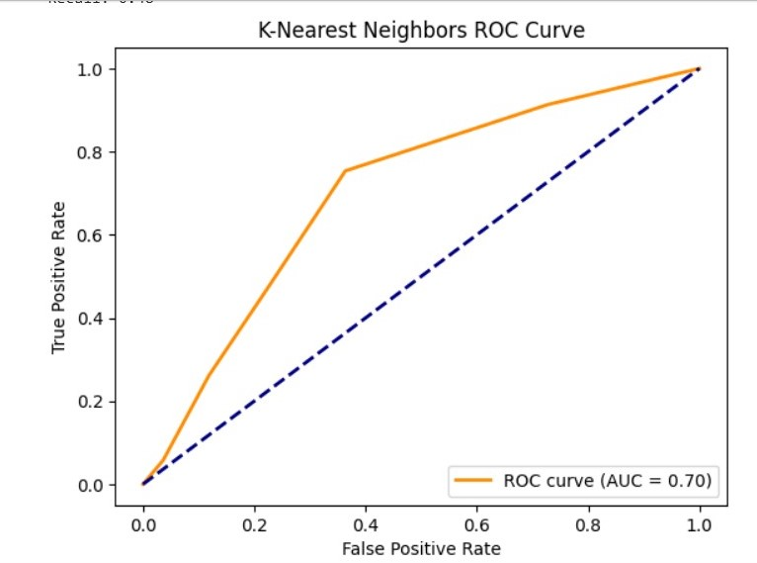

|  |  |
| --- | --- |
| **auc graph** | 0.70 |

*3-LOGISTIC REGRATION*

|  |  |
| --- | --- |
| accuracy | 0.24 |
| Confusion matrix |

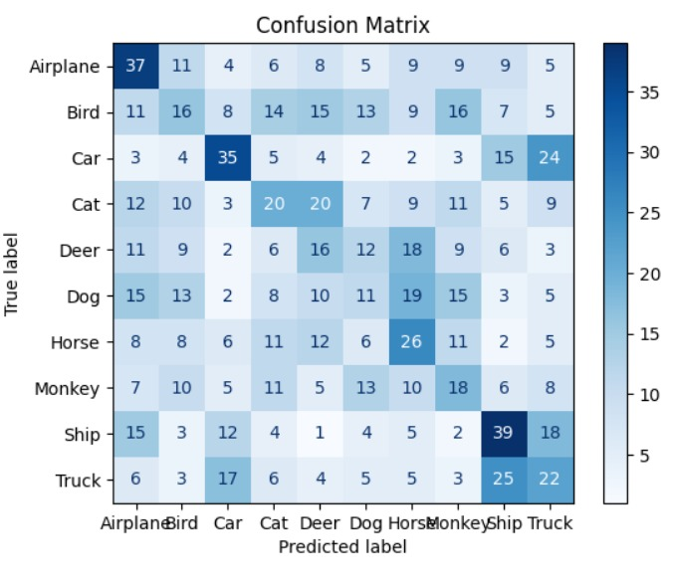

|  |
| --- |
| Precision and recall |

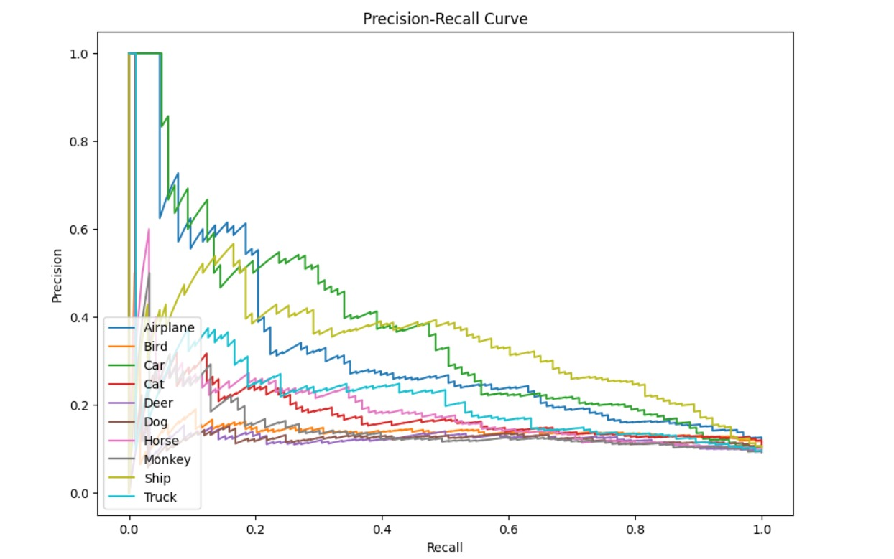

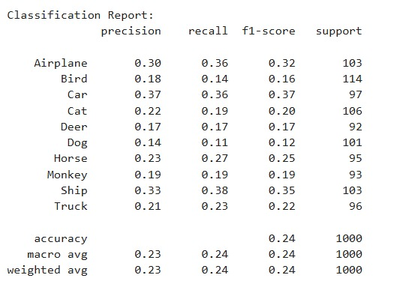

|  |
| --- |
| Roc curve |

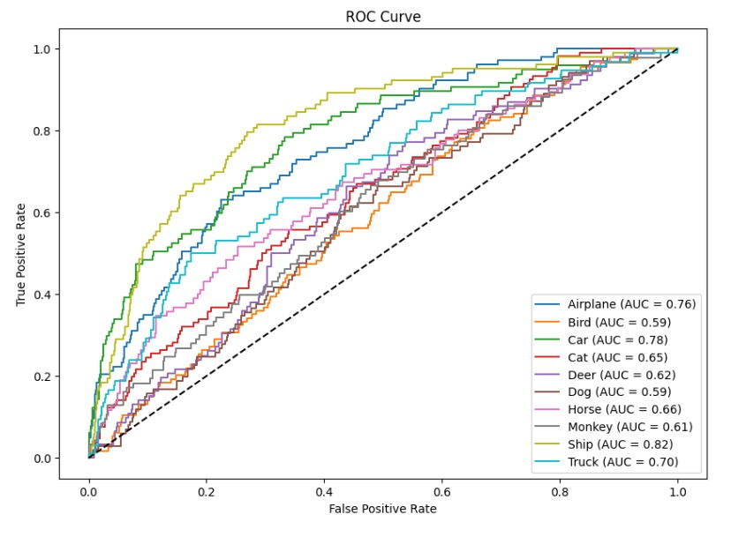

|  |  |
| --- | --- |
| auc graph | Air plane =>0.76 , Bird=>0.59, Car=>0.78  Cat=>0.65, Deer=>0.62, Dog=>0.59  Horse=>0.66 , Monkey=>0.61  Ship=>0.82 , truck=>0.70 |

*4-KNN CLASSIFIER*

|  |  |
| --- | --- |
| accuracy | 0.23 |
| Confusion matrix |

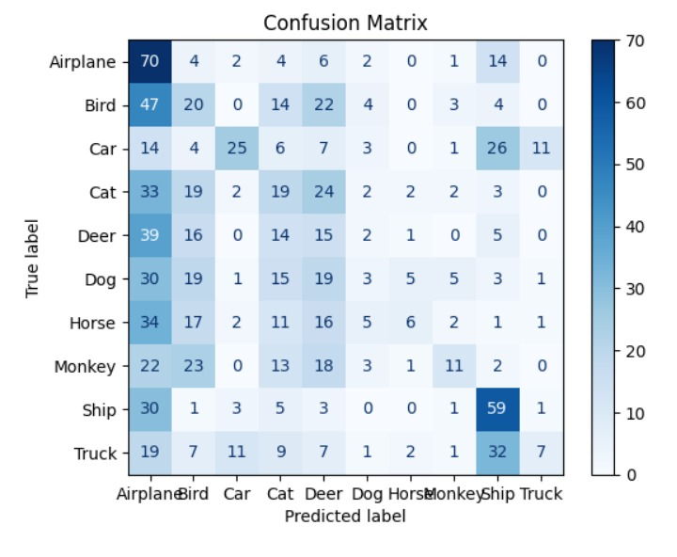

|  |
| --- |
| Precision and recall |

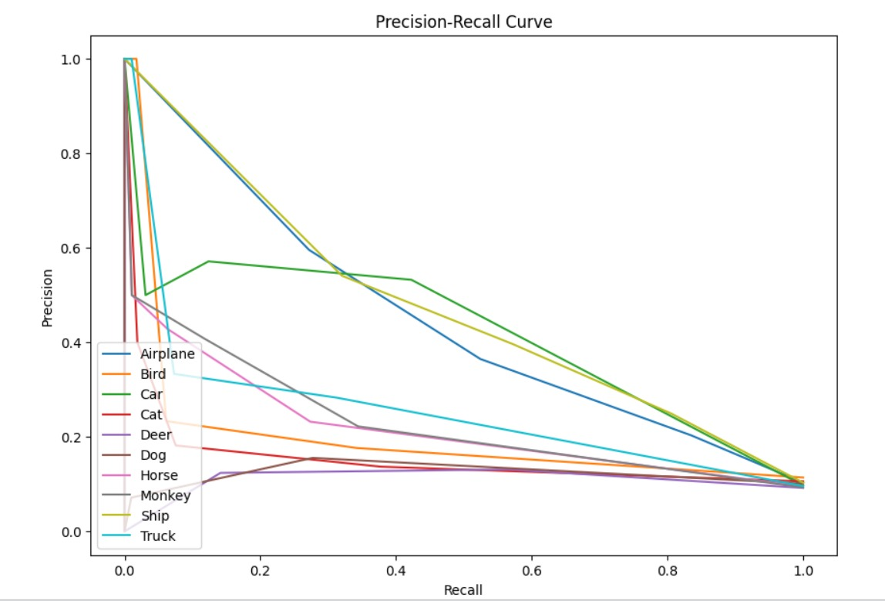

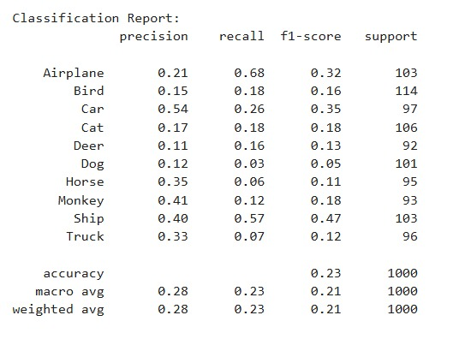

|  |
| --- |
| Roc curve |

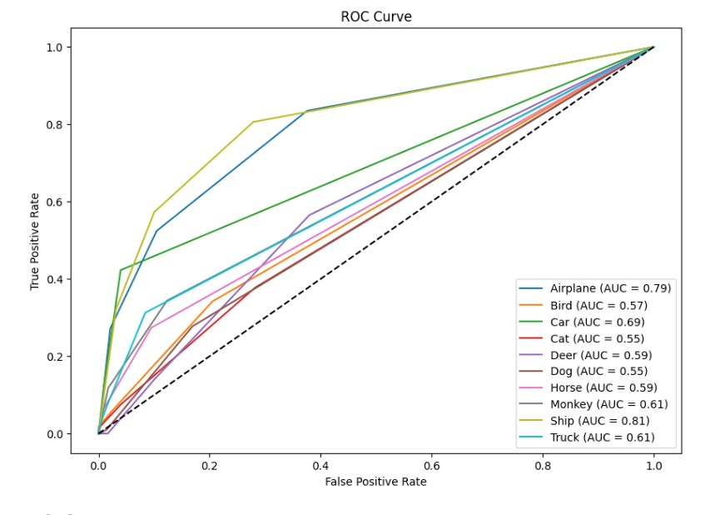

|  |  |
| --- | --- |
| Auc graph | Air plane =>0.79 , Bird=>0.57, Car=>0.69  Cat=>0.55, Deer=>0.59, Dog=>0.55  Horse=>0.59 , Monkey=>0.61  Ship=>0.81 , truck=>0.61 |