**Tarih ve Sayı: 12.04.2021-11484**

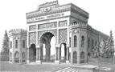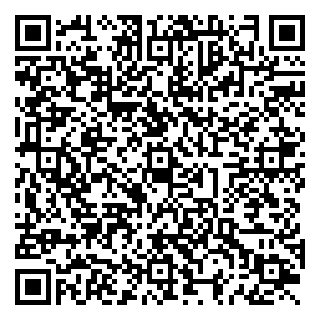

**REPUBLIC OF TURKEY ISTANBUL UNIVERSITY-CERRAHPASA**

**FACULTY OF ENGINEERING**

**STUDENT CERTIFICATE**

**Number: 74933216-302.10.04**

**To Whom It May Concern**

**Identity Number** 99518368436

**Name, Surname :** ABDULLAH ABBARA

**Student Number** 1306180135

**Father's Name :** MOHAMAD JAMAL

**Mother's Name :** HODA

**Place of Birth/Date of Birth :** DAMASCUS / 07.09.1995

**Institute/Faculty/College :** FACULTY OF ENGINEERING

**Department :** COMPUTER ENGINEERING, UNDERGRADUATE PROGRAM,(FORMAL EDUCATION)

**Year / Semester :** 2 / 4

**Date of Registration :** 11 September, 2018

**Registration Type :** Horizontal transfer in special cases Additional Article-2

**Stage :** Course Work

This is to certify that ABDULLAH ABBARA is an Under-Graduate student at COMPUTER ENGINEERING, UNDERGRADUATE PROGRAM,(FORMAL EDUCATION) (2020-2021). This statement is issued

upon student's request to be used whenever deemed necessary.

**e-Signature**

**Assoc. Prof. Muhammed Ali AYDIN Faculty Of Engineering**

**Vice Dean**

# Bu belge 5070 sayılı Elektronik İmza Kanununu Gereğince E-imzaladır.

Doğrulamak için : [https://www.turkiye.gov.tr/istanbul-cerrahpasa-universitesi-ebys?eD=BSUH0JVEHZ&eS=11484](http://www.turkiye.gov.tr/istanbul-cerrahpasa-universitesi-ebys?eD=BSUH0JVEHZ&eS=11484)