DEEP LEARNING SEMESTER PROJECT
Malaria Cell Detection using Deep Learning
Classifying blood cell images as Parasitized or Uninfected with MobileNetV2 transfer learning
Submitted by | Abdullah Sohail
Roll No | SU92-BSCSM-F24-222
Instructor | Dr Munir Ahmad
University | Superior University Lahore
Submission Date | 31 October 2026

1. Introduction
Malaria is a mosquito-borne disease that remains a major health problem worldwide. The standard way to diagnose it in the field is light microscopy of blood films, where a trained expert examines stained blood cells and looks for parasites. This is slow, tiring and depends on the skill of the person looking at the slide.
This project builds a deep learning model that looks at a single blood cell image and decides whether the cell is Parasitized (infected with the malaria parasite) or Uninfected. The trained model is deployed as a Streamlit web application so that anyone can upload a cell image and see the prediction with a confidence score.

1.1 Objectives
- Train a convolutional neural network that classifies blood cell images into two classes.
- Use transfer learning so that a good model can be trained within minutes on a free GPU.
- Save the trained weights and publish code, weights and dataset link in a public GitHub repository.
- Deploy an interactive web interface using Streamlit.

2. Dataset
The project uses the public dataset “Cell Images for Detecting Malaria”, hosted on Kaggle and originally released by the U.S. National Institutes of Health (NIH). It contains segmented red blood cell images taken from Giemsa-stained thin blood smear slides, and was first described by Rajaraman et al. (2018).
Property | Value
Source | Kaggle: iarunava/cell-images-for-detecting-malaria (NIH data)
Total images | 27,558
Classes | 2: Parasitized (13,779) and Uninfected (13,779)
Class balance | Perfectly balanced, 50% each
Image size | Not uniform, so all images are resized to 128 x 128
Split used | 80% training (about 22,046 images), 20% validation (about 5,512 images)

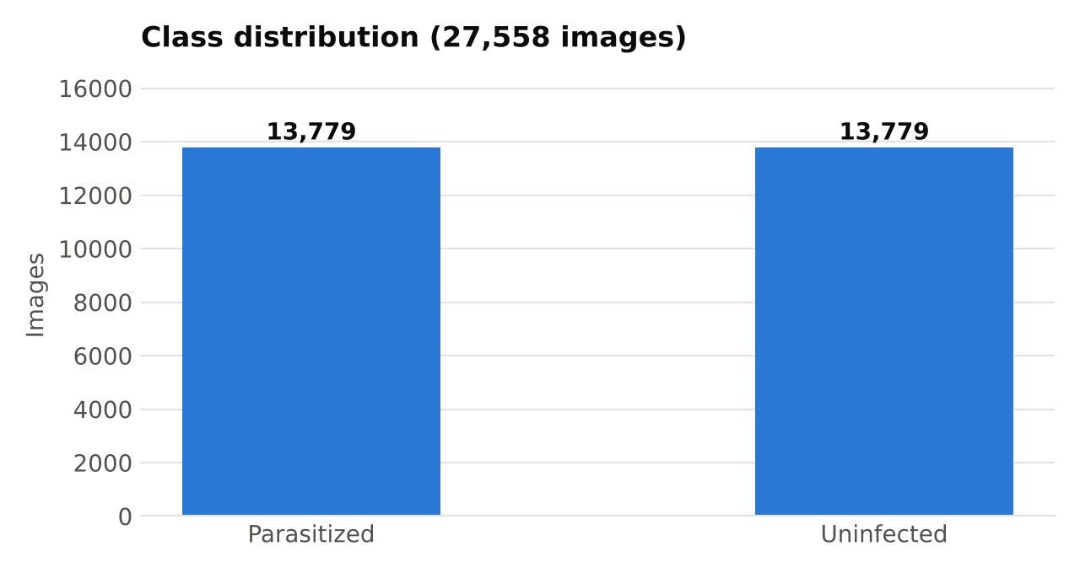
Figure 1: Both classes contain exactly 13,779 images, so accuracy is a fair metric.
One practical detail: the downloaded Kaggle folder contains an extra duplicate directory named cell_images next to the two class folders. Left alone, the data loader counts three classes and doubles the file count to 55,116. The code therefore passes the two class names explicitly.

3. Methodology

3.1 Preprocessing
Every image is resized to 128 x 128 pixels with three colour channels. Pixel values are scaled from the range 0 to 255 into the range -1 to 1, which is the input range MobileNetV2 was trained with. This scaling is built into the model itself, so the web app can send raw pixels. During training, random horizontal and vertical flips are applied as light data augmentation.

3.2 Model architecture
The model uses transfer learning. MobileNetV2, pre-trained on ImageNet, acts as a frozen feature extractor, and a small classification head is trained on top of it. MobileNetV2 was chosen because it is small and fast, which suits both a short training time and a lightweight web deployment.
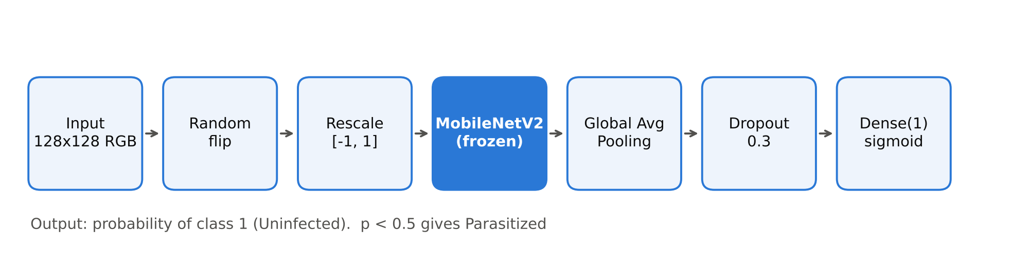
Figure 2: Model pipeline from input image to prediction.
Setting | Value
Base network | MobileNetV2, ImageNet weights, frozen (not trained)
Classification head | GlobalAveragePooling2D, Dropout(0.3), Dense(1, sigmoid)
Loss function | Binary cross-entropy
Optimizer | Adam (default learning rate)
Batch size / Epochs | 64 / 5
Framework / Hardware | TensorFlow and Keras / Google Colab T4 GPU

The output of the sigmoid is the probability of class index 1. Because the classes are sorted alphabetically, index 0 is Parasitized and index 1 is Uninfected. A probability below 0.5 is therefore reported as Parasitized.

4. Results
Training took only a few minutes: the first epoch needed about 118 seconds because it includes downloading the pre-trained weights and warming up, and each later epoch took about 26 seconds. After five epochs the model reached a validation accuracy of 92.85%.
Epoch | Train accuracy | Val accuracy | Train loss | Val loss
1 | 85.32% | 91.36% | 0.3331 | 0.2241
2 | 90.38% | 92.38% | 0.2427 | 0.2008
3 | 91.22% | 92.51% | 0.2277 | 0.1937
4 | 91.41% | 92.78% | 0.2212 | 0.1886
5 | 91.63% | 92.85% | 0.2180 | 0.1877
Table: Metrics logged during training.
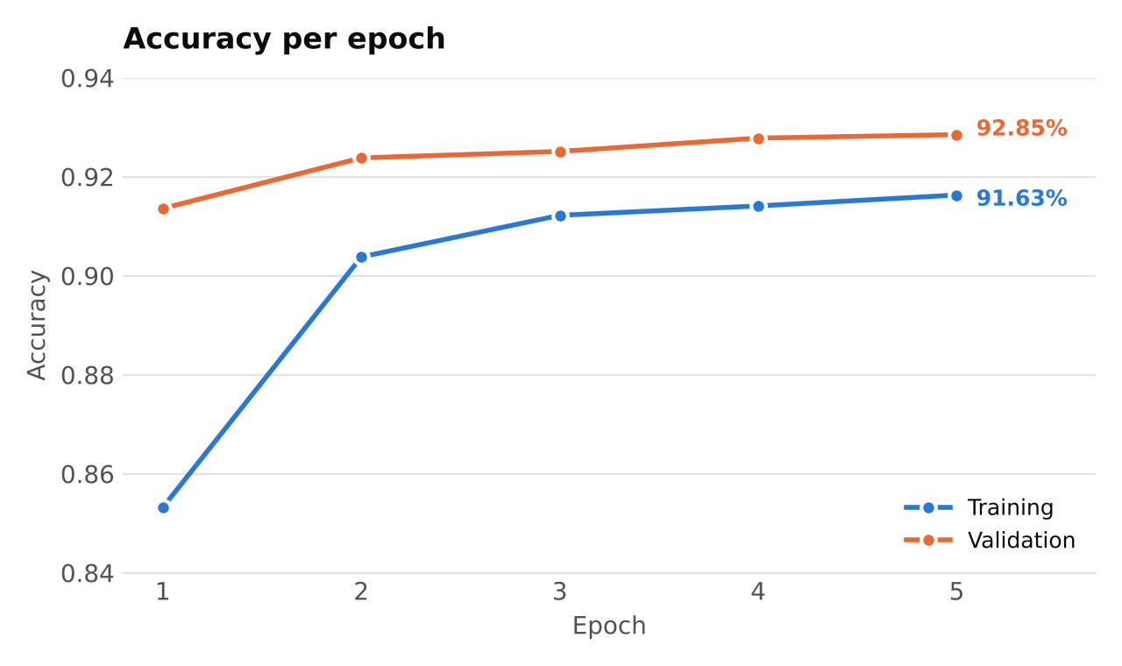
Figure 3: Accuracy rises quickly in the first two epochs and then levels off.
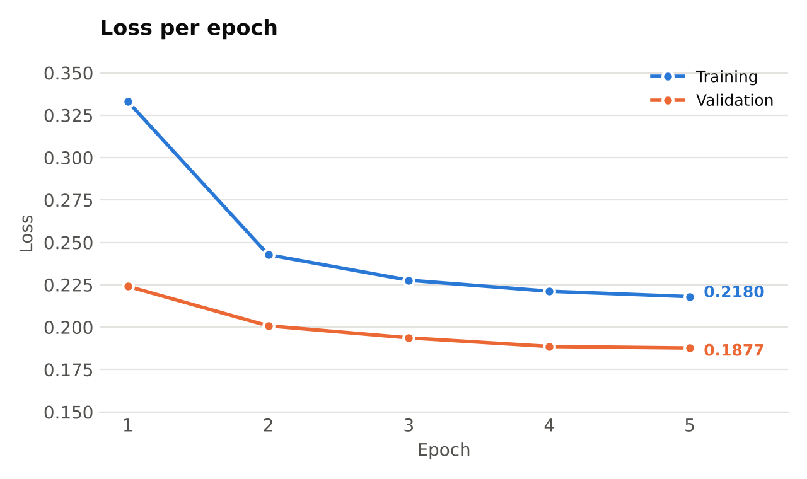
Figure 4: Both training and validation loss decrease steadily.

4.1 Discussion
- Validation accuracy stays slightly above training accuracy. This is expected here, because dropout and random flips are active only during training, which makes the training numbers a little pessimistic.
- Training and validation curves stay close together and keep improving, so there is no sign of overfitting in these five epochs.
- The curves are still flattening rather than fully flat, so more epochs or fine-tuning the top MobileNetV2 layers would probably improve accuracy further.

5. Deployment
The trained model is saved as malaria_model.keras and served through a Streamlit application (app.py). The app has four tabs: a live demo where the user uploads a cell image or picks a sample and gets a prediction with a confidence score; a page describing the dataset, model and code; a results page with the training curves; and a page with links to the GitHub repository, this report, the presentation, the YouTube video and the LinkedIn post. The app is deployed on Streamlit Community Cloud directly from the public GitHub repository.

6. Limitations and Future Work
- Only accuracy and loss were recorded. Precision, recall, a confusion matrix and an ROC curve would give a fuller picture, which matters because missing an infected cell is more costly than a false alarm.
- The dataset contains clean, pre-segmented single cells. Real microscope slides contain noise, overlapping cells and staining differences, so performance on raw slides may be lower.
- The base network was frozen and training lasted only five epochs. Unfreezing the top layers and training longer is the most direct way to improve accuracy.
- Possible extensions: Grad-CAM heat maps to show which part of the cell the model uses, and testing on a second malaria dataset.
This project is for learning purposes and is not a medical diagnostic tool.

7. Conclusion
A MobileNetV2 transfer learning model trained for just five epochs classifies malaria-infected and uninfected blood cells with 92.85% validation accuracy. The project covers the full workflow asked for in the course: dataset selection, training, saved weights, a public GitHub repository and a deployed web application with an interactive prediction demo.

References
- Kaggle. Cell Images for Detecting Malaria. https://www.kaggle.com/datasets/iarunava/cell-images-for-detecting-malaria
- Rajaraman, S., Antani, S. K., Poostchi, M., Silamut, K., Hossain, M. A., Maude, R. J., Jaeger, S., Thoma, G. R. (2018). Pre-trained convolutional neural networks as feature extractors toward improved malaria parasite detection in thin blood smear images. PeerJ, 6, e4568.
- Sandler, M., Howard, A., Zhu, M., Zhmoginov, A., Chen, L.-C. (2018). MobileNetV2: Inverted Residuals and Linear Bottlenecks. IEEE CVPR.
- TensorFlow / Keras documentation, https://www.tensorflow.org and Streamlit documentation, https://docs.streamlit.io

