

Data Analytics

Section (1)

Submitted to
Dr. Raneem.Qaddoura

Submitted by
Abdullah Mahmoud Aldous 23110263

Fall –2024-2025

Descriptive:
Measures of Central Tendency: I used mean and median on biomass in case of existence and inexistence of animals, and I noticed that paddock without animals has quite higher biomass than with animals’ paddock in average. This indicates that animals may cause high forage consumption which leads to low biomass in animals’ paddock. Measures of Dispersion: I used IQR, variance and coefficient variation (CV) on biomass to see the distribution of samples. I found that the biomass in samples have high variation in general. The variance of biomass amount in animals’ paddock is less than the variance in the paddock without animals. This may indicate that animals have a role for preserving biomass in a constant range and balance.
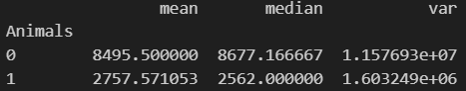 CV:
Measures of Frequency: I find that number of samples in paddock without animals is distributed in two parts, high and medium and there are no low biomass amounts. On the other hand, the number of samples in paddock with animals is distributed among all the parts, especially into the low biomass amount. Also, I found the relative frequency for this data which shows that animals reduce biomass amounts.
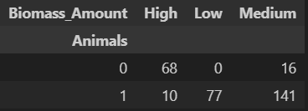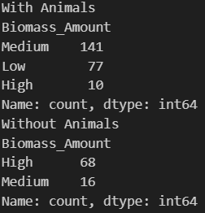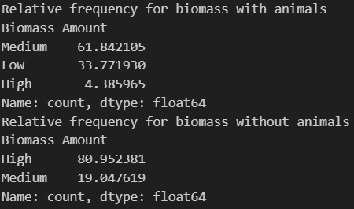
Measures of Position: I used Q1, Q2 and Q3 to divide the biomass feature into three parts. The data that is more than Q3 considered high, less than Q1 considered low, and between them considered medium. 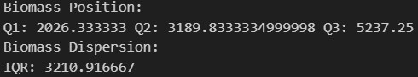
Outlier Detection: I used the two methods for outlier detection and normalization, z – score and upper/lower bounds via the quartiles. After plotting each column to see the shape that the data takes, I determined if the data takes a bill shape or not, to choose the suitable outlier method. But then I used violinplot to see if the outliers are logical or they are really outliers. I found that the only outliers that can be considered to be outliers are the columns B3 and B4 so I handle the outliers using IQR only without z-score.
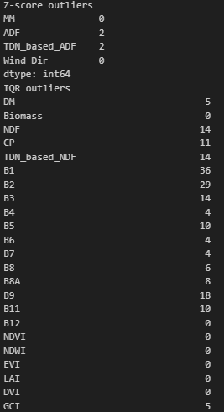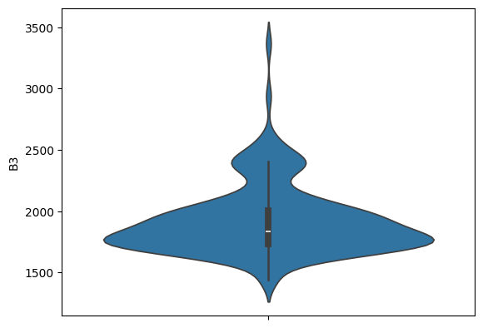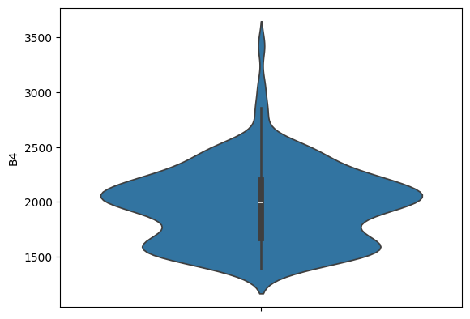
For One Columns:
Histogram:
I used histogram beside (KDE plot and normal distribution using line plot) on all the numerical features to display its shape, and to determine the suitable outlier’s detection method to use. I also excluded the rows where there aren’t animals, because the outliers there are reasonable. Example of skewed data and not skewed data:
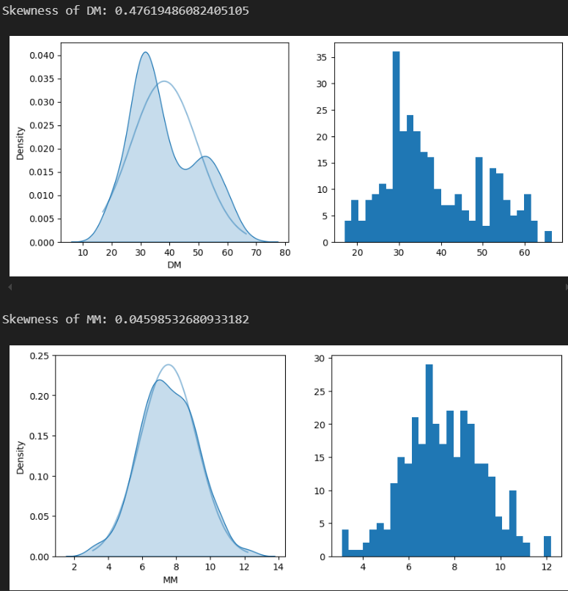
Charts doughnut: I used doughnut chart to visualize the relational frequency of biomass amounts (High, Medium, Low) among the data. High biomass is noticeably more in without animals.
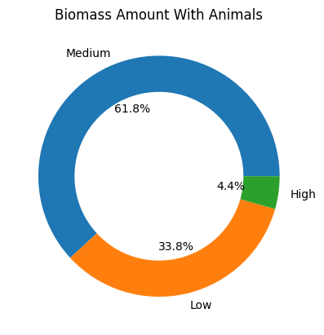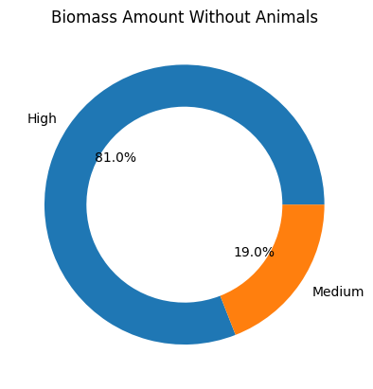
Violin Plot: I used violin plots to see outliers and examine the dispersion, this shows that biomass has high variation in general.
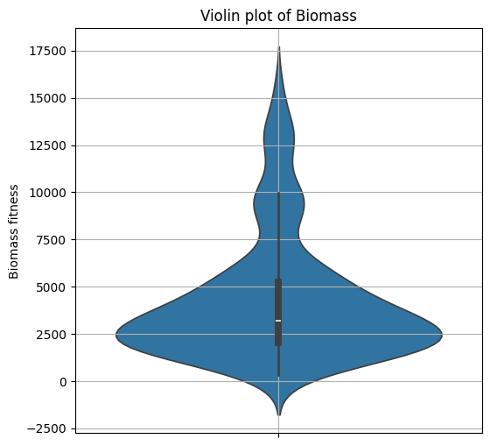
For Multi Columns:
Box Plot: I used box plot to see the variation in each type of paddock (without animals, with animals) along the biomass.
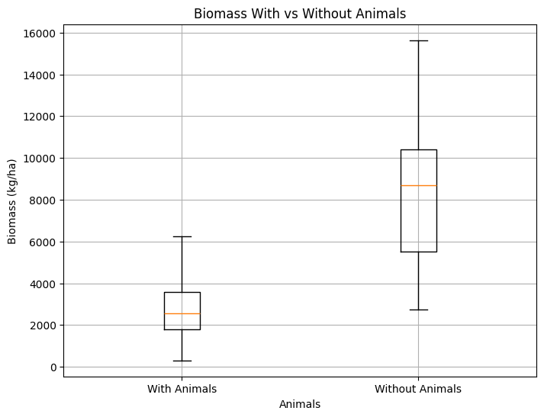
Line Charts and Scatter plot (Bubble): I depend on the line charts along with scatter plot as the main charts in my analysis to find the relations between different variables and the biomass. I visualize biomass along the time (Date) and other features, and then I filtered the best related features. NDVI has a strong relation with biomass as satellites measure the amount of green light in a sample the biomass is more. Also, NDWI measures how moisture and water is in a sample so higher water means higher biomass, Some plots:
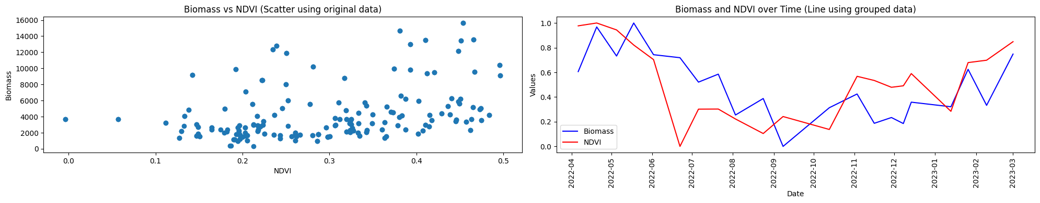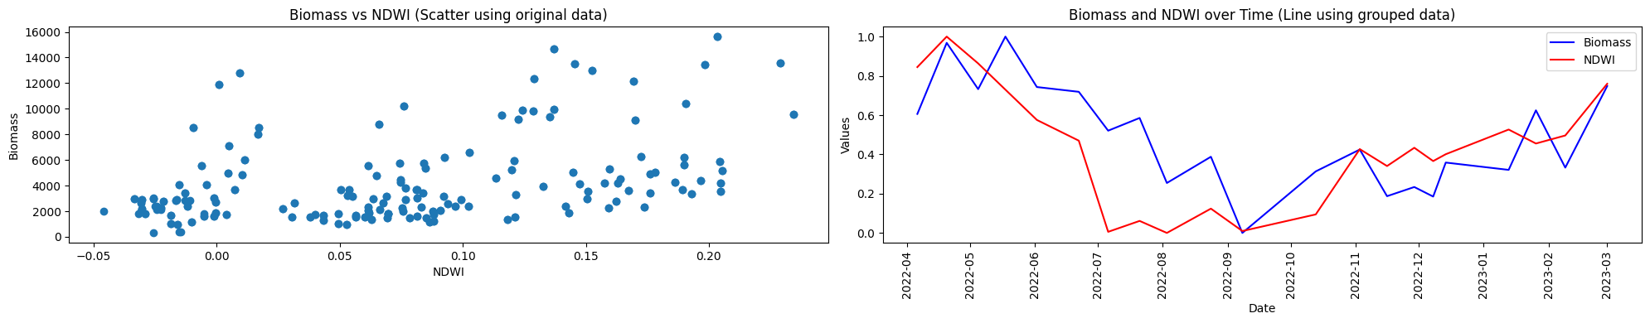
The blue bubbles are generally bigger than the orange bubbles, this shows that the biomass is bigger in the paddock that does not contain animals.
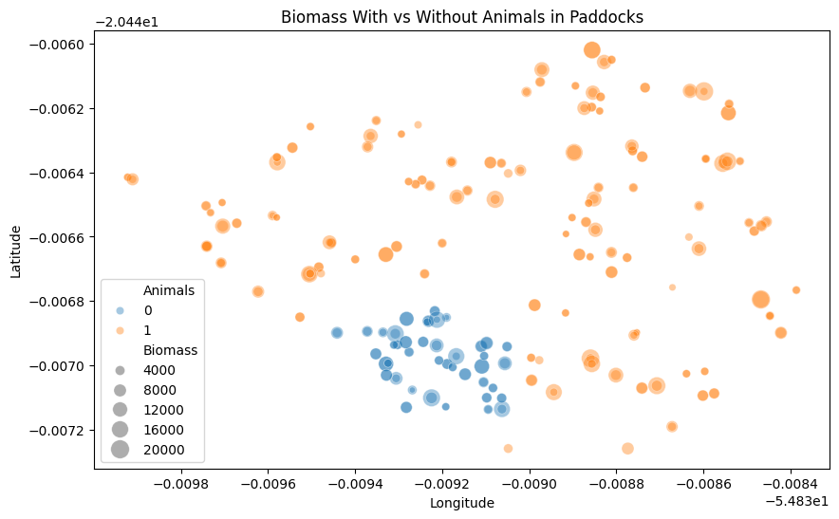
Another usage for this plot is the relation between TEMP_AVG (hue), Biomass (y -axis), Date (x – axis) and line plot to see the meaning of the biomass in each day, to see the general temperature effect on biomass. In average temperatures biomass is the best, but when the temperature becomes extremely cold or high the biomass is less, especially in the coldest temperatures. This may show that plants’ suitable temperature is between (24 – 26 C), and in cold weather, animals need more energy, so they eat more grass and plants which reduce the biomass. In extreme hot weather, the evaporation increases so the animals and plants need more water, so the animals eat more grass. (Green period = good biomass, blue and red are cold and hot)
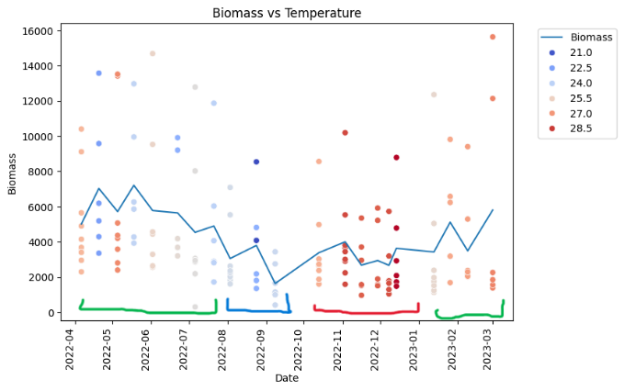
Chart Correlation Heatmap: I used heatmap on the biomass column along all other columns to see the linearity to check if the relation increases or decreases. This moderate linear correlation indicates that there are more suitable functions than linear to present these data with, but there is a relationship. Although, Animals feature is highly oppositely related to biomass as animals exists biomass decreases.
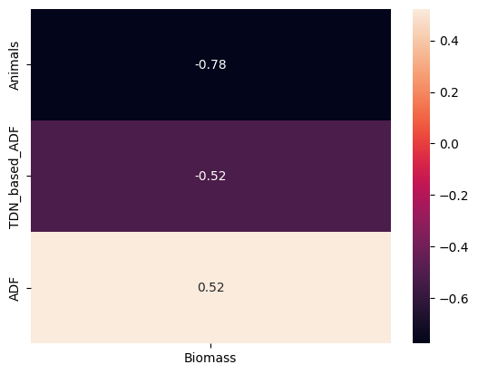
Uncovering Significant Patterns and Relations between biomass and other factors:
After plotting and filtering all the features and remaining just the features that relates to biomass (including ‘Animals’)feature , I found many relations, and these are some of them:
1. NDVI (Normalized Difference Vegetation Index): NDVI measures vegetation health and greenness, which is directly correlated with biomass productivity. Higher NDVI values generally indicate dense, healthy vegetation, which is an indicator of higher biomass. (GIS Geography, 2018)
2. NDWI (Normalized Difference Water Index): NDWI is sensitive to moisture content in vegetation and soil. Biomass typically requires adequate water for growth, so NDWI indicates areas with higher biomass when there's enough moisture.
3. GCI (Green Chlorophyll Index): GCI estimates chlorophyll content in plants, which is a direct indicator of plant health and biomass productivity. Higher GCI values are linked with more chlorophyll and, therefore, higher biomass.
4. HUM_REL (Relative Humidity):
Relation to Biomass: High humidity generally supports better growth conditions, which can lead to higher biomass, while very low humidity can lead to water stress and reduced biomass.
Data analytics techniques are very important to the decision-making process. Decision maker can use my insights to suit his objectives, such as increasing the number of animals if he wants balanced amount of biomass or removing animals to have a land with wealthy land of biomass and nutrition. Data analytics techniques such as time series analysis with trend analysis like and seasonal patterns helped me to find the relations between features and biomass over time. Data visualization like pie chart make the relation between animals and biomass more obvious for me and for the decision maker. I used regression analysis to predict using predictive machine learning models the biomass in the next months, this can help the decision maker to take his procedures.
Predictive:
Time series model: I used exponential smoothing to predict the decreasing of biomass in 2022 November (11) and the $r^{2}$-score is 0.861 for the training data.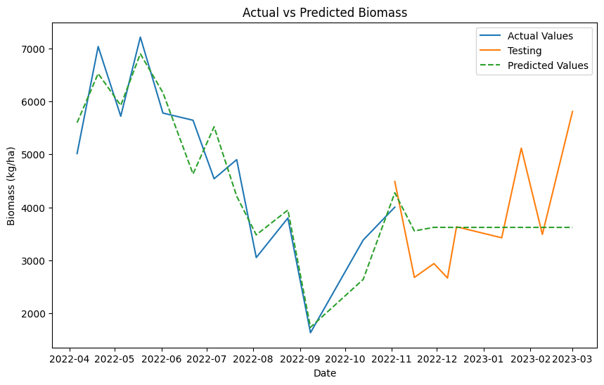
Machine learning regression model: I used backward SequentialFeatureSelector that produced the highest $r^{2}$-score and more consistency with Decision tree as the wrapping model. I also evaluate and learn different models to see which one is the suitable one. I find that the suitable model was also the decision tree even though linear, and SVR performs good. I visualized SequentialFeatureSelector with different based models and with DecisionTree as predictive model to visualize a boxplot. This is the $r^{2}$-score for sequential feature selector using different base models, this shows how Decision tree performs the best.
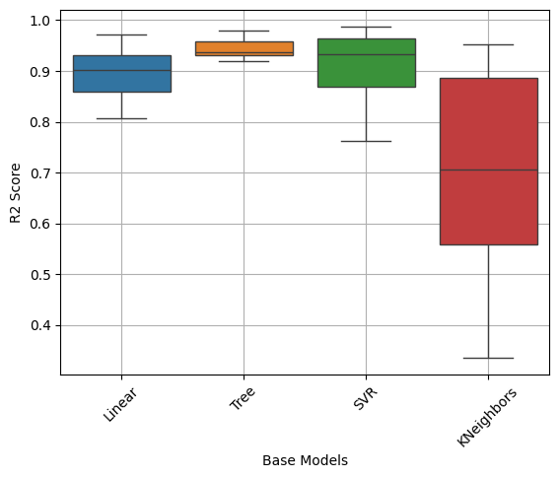

I also compared 2 featrue selection models (SequentialFeatureSelector and SelectFromModel), They both perform extremely good but I find from a table that SequentialFeatureSelector is more consistent than SelectFromModel), using Bar the bellow bar chart shows how $r^{2}$-score become on different Predictive models. This shows that $r^{2}$-score with sequential feature selector is bigger from select from model especially with Decision tree as predictive model. Also, the MAE chart emphasizes that.
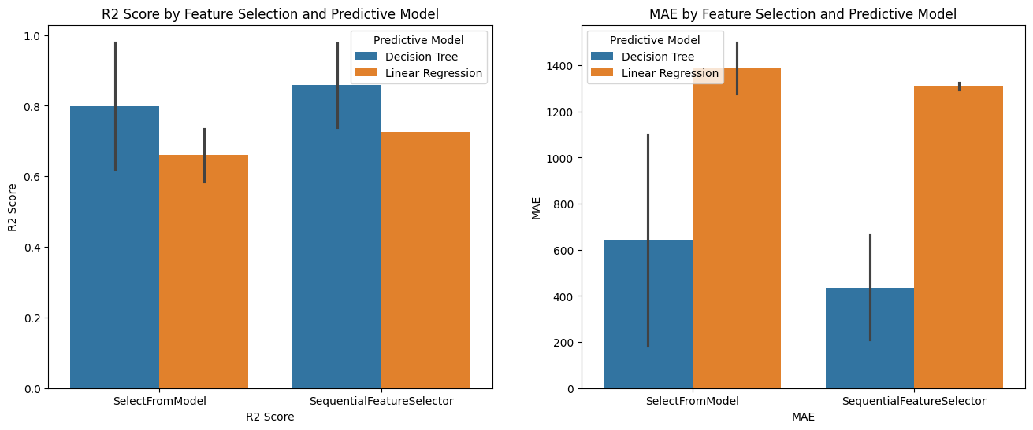
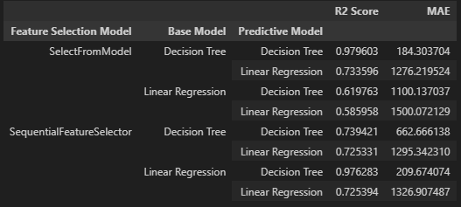
This is also the sequential with linear regression as base model and Decision tree as predictive model, which performs very good. Also, I visualized a line plot between the predicted and actual biomass.
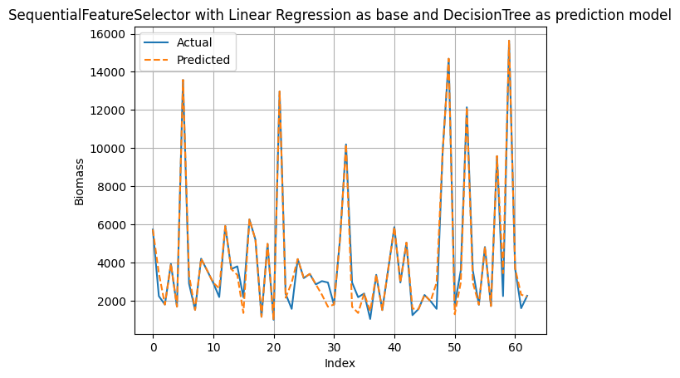
Deep learning models: I used LSTM on the chosen features with a dense layer:
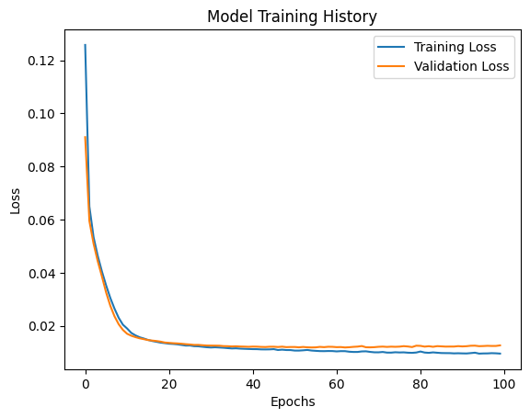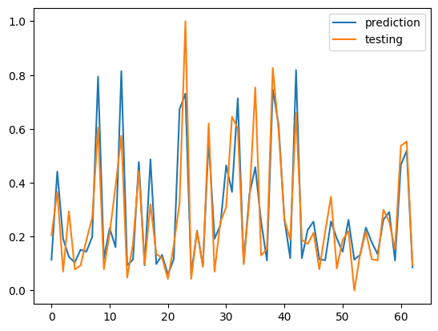
The Best model I found was the SequentialFeatureSelector with Decision tree to as wrapping model and prediction and evaluation.
I compared the $r^{2}$-score of (exponential smoothing) with (sequential feature selection with decision tree and linear regression with Decision tree to predict) with( LSTM) to find the highest $r^{2}$-score, and I found that sequential feature selection with decision tree performance is the best. Also, it is very consistent.
Exponential Smoothing: Decision tree and linear: LSTM:
Perspective:
Genetic algorithm: Is a metaheuristic perspective algorithm that mimics the natural selection for the best genes in chromosomes. When applying it into the code, it has some steps:
Selection and Crossover in one function “crossoverPopulation”:
Select two parents between the population randomly initialed individuals depending on three main things inside the crossoverPopulation function specifically inside pairsSelection function specifically insider rouletteWheelSelectionId which takes the inverted_scores which are the scores for the individual but are subtracted from the max score to invert them. Then make a cumulative percentage for each one of the scores. The three main things are 1- The random probability 2- the position of the score 3- the highest the value is the highest its probability to being chosen. Then from the rouletteWheelSelectionId returns the index of this parent and the pairsSelection use this index and another different one to find the 2 parents. Then inside the crossoverPopulation it tries to alternate some genes in the 2 parents using the crossover method depending on the crossover probability, which is 1 in my case, which returns the 2 offsprings being crossover. The keep variable which is 2 prevent changes for the first 2 individuals for the last iteration in the last run:
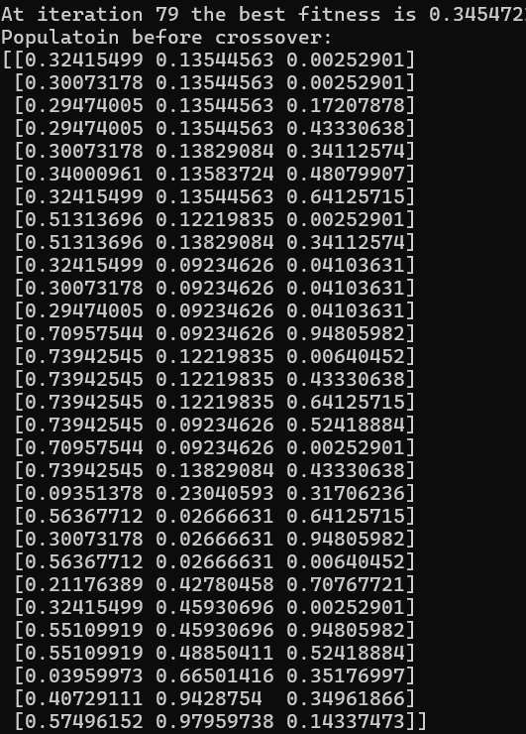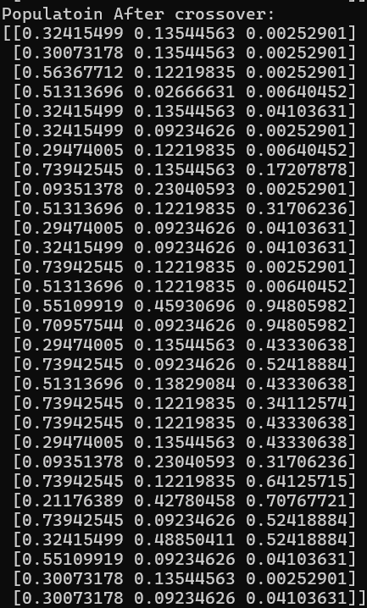
Mutation using “mutatePopulaton”:
After crossover few random changes are implemented in genes to escape local minima, this method is applied for all individuals except the keep ones. Using mutationProbability which is 0.01 in my case. Then a random number Is selected between 0 and 1. So, the higher mutationProbaility the higher the probability that the mutation will happen. Using the mutation method which chose randomly withing the upper and lower bounds a number to replace the mutated value. This method changes on the ga individuals directly.
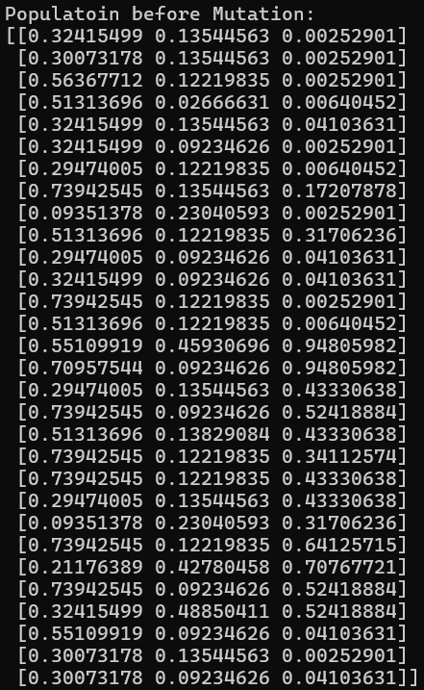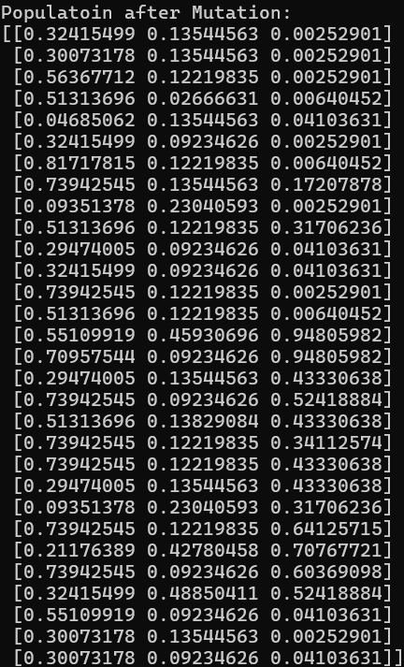
Clear Duplications using “clearDups”:
This method finds the unique individual and replaces the duplicated ones with randomly generated within boundaries individuals. But this method also sorts the individuals ascendingly because np.unique does this.
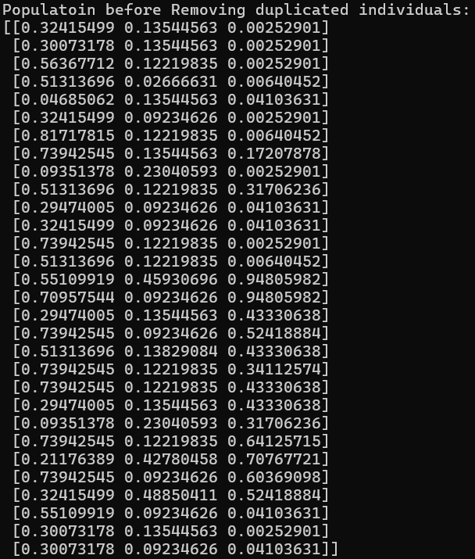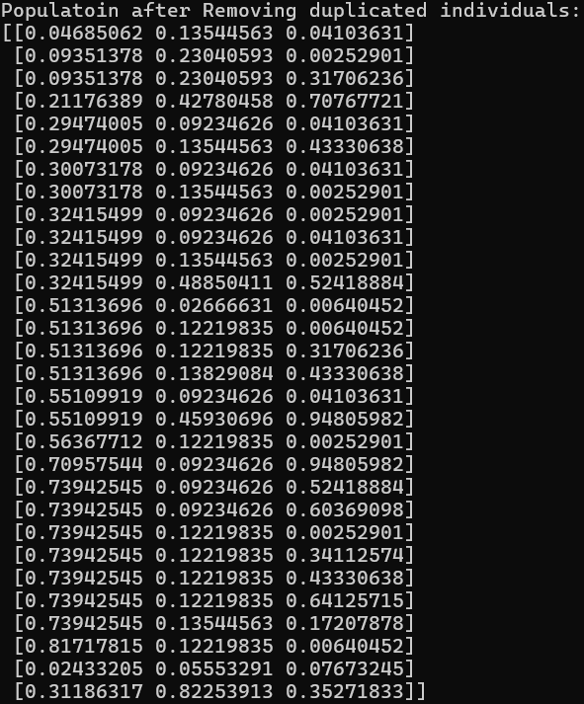
Calculate costs scores using “calculateCosts):
This method initialize the scores to be infinity and then apply the objective function to each individual and map it with the scores array and return it.
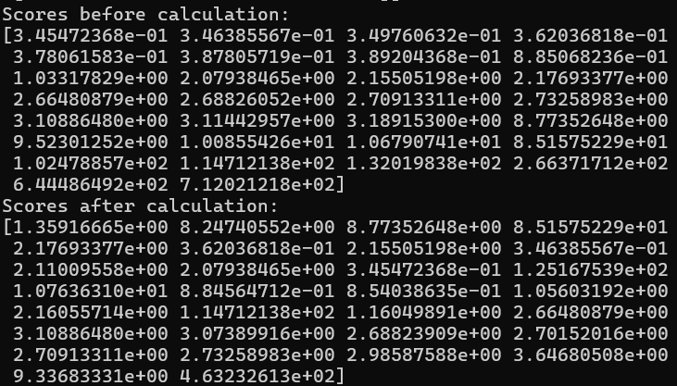
Sort population using “sortPopulation”:
Sort scores and returns their sorted indices using argsort() and then sort the population using this sorted index and return both of population sorted and scores sorted.
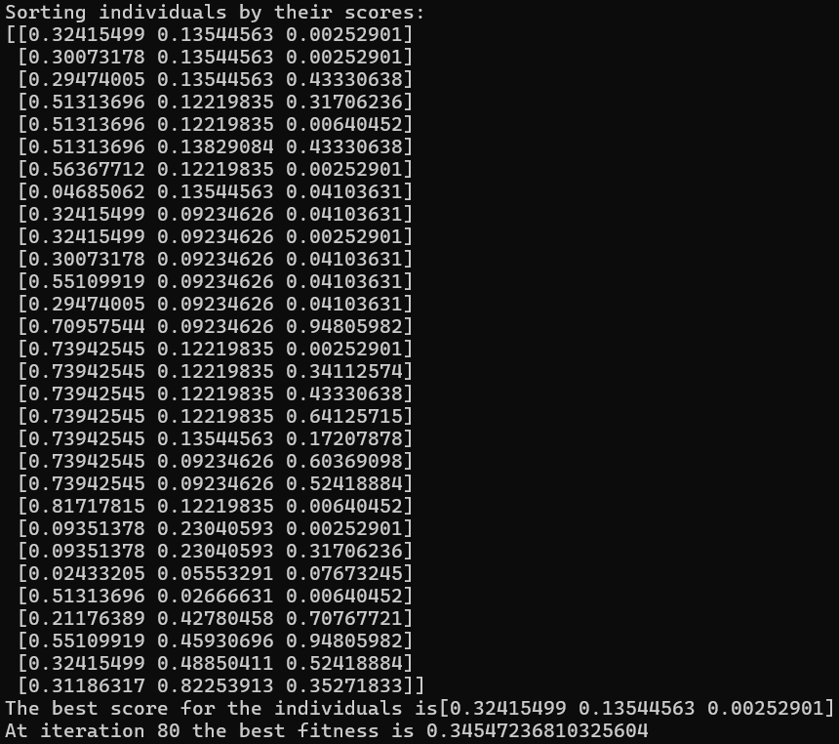
Finally, as you can see the best fitness in iteration 80 is the same as 79 but it differs a lot in the 80 iterations. All the best scores are being saved in convergence_curve to save them in solution object with endTime, executionTime, bestIndividual, optimizer = “GA” and objfname = ‘MSE_ESI”, and then the optimizer class use these outputs to make different runs and save them in csv files, boxplot and convergence curve for different algorithm. As can be seen here in the convergence curve the DE has reached the least fitness curve the first, and it has the least MSE in boxplot then MVO then GA. This shows that it could be the best one. And this plot shows the predicted and actual ESI for the 3 models. The 3 algorithms are all close together.
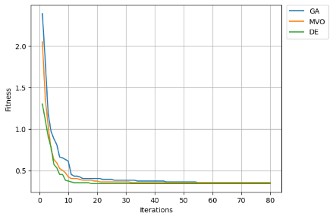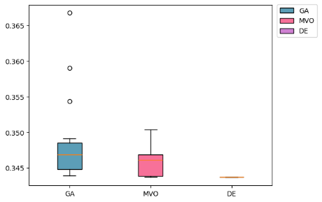
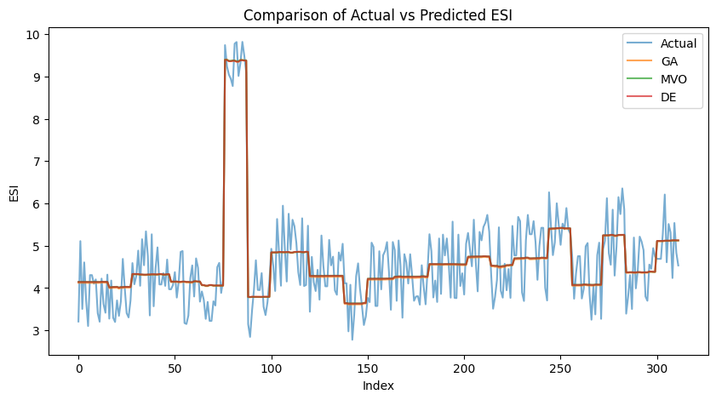

References:
1. GIS Geography (2018). What Is NDVI (Normalized Difference Vegetation Index)? - GIS Geography. [online] GIS Geography. Available at: https://gisgeography.com/ndvi-normalized-difference-vegetation-index/.
2. Faris, Hossam, Ibrahim Aljarah, Seyedali Mirjalili, Pedro A. Castillo, and Juan Julián Merelo Guervós. "EvoloPy: An Open-source Nature-inspired Optimization Framework in Python." In IJCCI (ECTA), pp. 171-177. 2016. Qaddoura, Raneem, Hossam Faris, Ibrahim Aljarah, and Pedro A. Castillo. "EvoCluster: An Open-Source Nature-Inspired Optimization Clustering Framework in Python." In International Conference on the Applications of Evolutionary Computation (Part of EvoStar), pp. 20-36. Springer, Cham, 2020. Ruba Abu Khurma, Ibrahim Aljarah, Ahmad Sharieh, and Seyedali Mirjalili. Evolopy-fs: An open-source nature-inspired optimization framework in python for feature selection. In Evolutionary Machine Learning Techniques, pages 131–173. Springer, 2020

