Prediction Through ARMA/ Arima

UNIT ROOT TEST (1st Difference)

Null Hypothesis: D(PRICE) has a unit root
Exogenous: Constant
Lag Length: 3 (Automatic - based on SIC, maxlag=14)
 |  |  | t-Statistic | Prob.*
Augmented Dickey-Fuller test statistic |  |  | -10.23196 | 0.0000
Test critical values: | 1% level |  | -3.464101
 | 5% level |  | -2.876277
 | 10% level |  | -2.574704

Null Hypothesis: D(PRICE) has a unit root
Exogenous: Constant
Lag Length: 3 (Automatic - based on SIC, maxlag=14)
 |  |  | t-Statistic | Prob.*
Augmented Dickey-Fuller test statistic |  |  | -10.23196 | 0.0000
Test critical values: | 1% level |  | -3.464101
 | 5% level |  | -2.876277
 | 10% level |  | -2.574704

Null Hypothesis: D(PRICE) has a unit root
Exogenous: Constant
Lag Length: 3 (Automatic - based on SIC, maxlag=14)
 |  |  | t-Statistic | Prob.*
Augmented Dickey-Fuller test statistic |  |  | -10.23196 | 0.0000
Test critical values: | 1% level |  | -3.464101
 | 5% level |  | -2.876277
 | 10% level |  | -2.574704
Conclusion: Above Results indicate That Variable is stationary at 1st Difference, Thus ARIMA (p,d,q) will be estimated.

2. Estimation of p and q lags
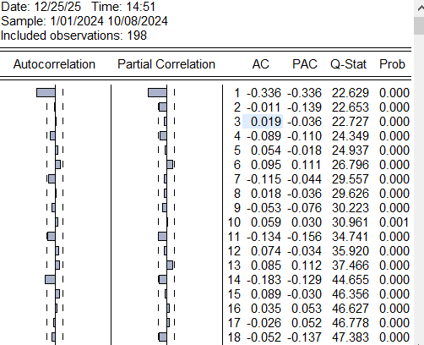
Conclusion: p=1 lag, q=1 lag
Model ARIMA(p,d,q)= ARIMA (1,1,1)
Estimating Models and Selecting Optimal Model:
ARIMA (1,1,1)
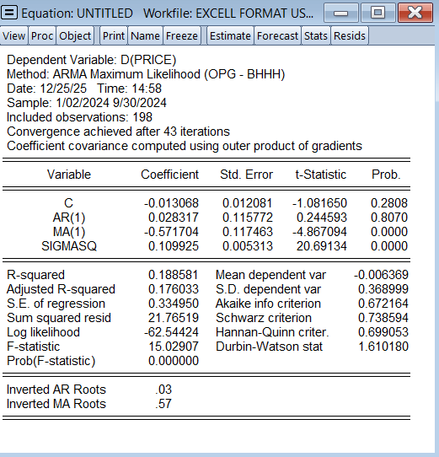
ARIMA (1,1,0)
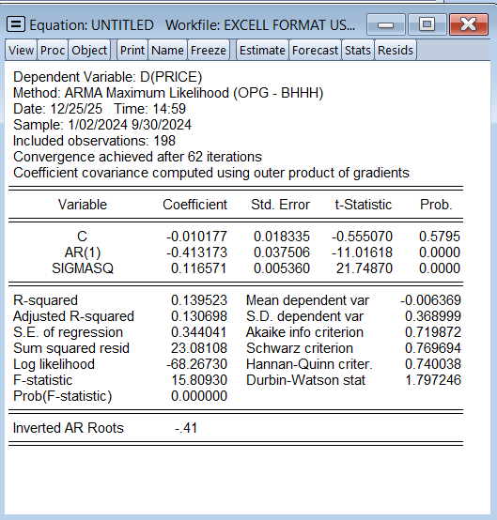
ARIMA (0,1,1)
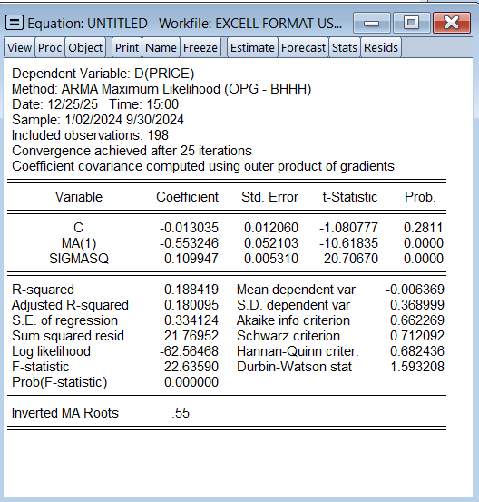

Model Comparison
Model | Sig | Sigmasq | R2 | Akaike | Schwartz
ARIMA(1,1,1) | 0.5 | 1 | 1 | 0 | 0
ARIMA(1,1,0) | 1 | 0 | 0 | 0 | 0
ARIMA(0,1,1) | 1 | 1 | 1 | 1 | 1
Based on Above, ARIMA (0,1,1) is selected

Residual Diagnostics:
1. UNIT ROOT TEST
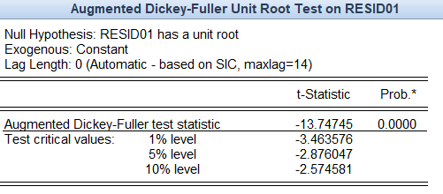
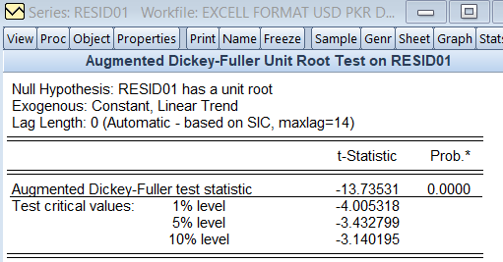
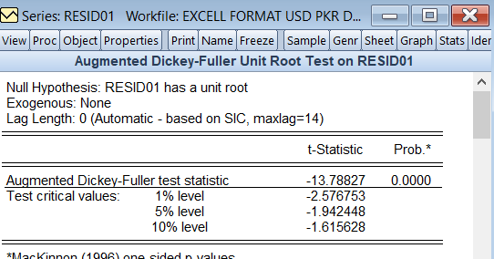

Correllelogram of Residuals
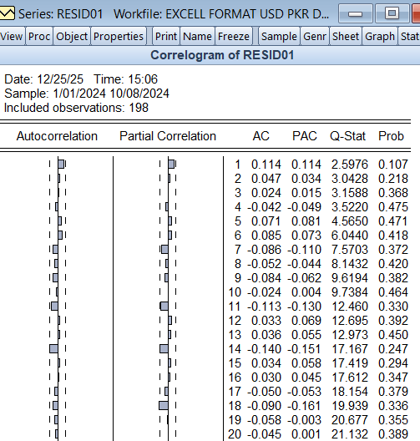

Conclusion:
Residuals have passed Unit Root test and Correllelogram is within the bounds

Prediction:
