

Stock Price Predictor
Using Long-short term memory networks
Epsilon Group | Advance Database Management Systems | Date
Table of Contents
Project Overview 2
Problem Statement 2
Goals 3
Metrics 3
Data Exploration 4
Algorithms & Techniques 5
Benchmark Model 6
Data Preprocessing 7
Implementation 9
Refinement 10
Model Evaluation & Validation 12
Robustness Check 15
Justification 15
Reflection 16
Problems Encountered 17
Improvement 17

Definition

Project Overview
Investment firms, hedge funds and even individuals have been using financial models to better understand market behavior and make profitable investments and trades. A wealth of information is available in the form of historical stock prices and company performance data, suitable for machine learning algorithms to process. Can we actually predict stock prices with machine learning? Investors make educated guesses by analyzing data. They'll read the news, study the company history, industry trends and other lots of data points that go into making a prediction. The prevailing theories is that stock prices are totally random and unpredictable but that raises the question why top firms like Morgan Stanley and Citigroup hire quantitative analysts to build predictive models. We have this idea of a trading floor being filled with adrenaline infuse men with loose ties running around yelling something into a phone but these days they're more likely to see rows of machine learning experts quietly sitting in front of computer screens. In fact about 70% of all orders on Wall Street are now placed by software, we're now living in the age of the algorithm. This project seeks to utilize Deep Learning models, Long-Short Term Memory (LSTM) Neural Network algorithm, to predict stock prices. For data with time-frames recurrent neural networks (RNNs) come in handy but recent researches have shown that LSTM, networks are the most popular and useful variants of RNNs. We will use Keras to build a LSTM to predict stock prices using historical closing price and trading volume and visualize both the predicted price values over time and the optimal parameters for the model.

Problem Statement
The challenge of this project is to accurately predict the future closing value of a given stock across a given period of time in the future. For this project I will use a Long Short Term Memory networks– usually just called “LSTMs” to predict the closing price of the S&P 5002 using a dataset of past prices

Goals
- Explore stcok prices.
- Implement basic model using linear regression.
- Implement LSTM using Keras Library.
- Compare the results.

Metrics
For this project measure of performance will be using the Mean Squared Error (MSE) and Root Mean Squared Error (RMSE) calculated as the difference between predicted and actual values of the target stock at adjusted close price and the delta between the performance of the benchmark model (Linear Regression) and our primary model (Deep Learning).

Analysis

Data Exploration
The data used in this project is of the Alphabet Inc from January 1, 2005 to June 20, 2017, this is a series of data points indexed in time order or a time series. Our goal was to predict the closing price for any given date after training. For ease of reproducibility and reusability, all data was pulled from the Google Finance Python API. The prediction has to be made for Closing (Adjusted closing) price of the data. Since Google Finance already, adjusts the closing prices for us, we just need to make prediction for “CLOSE” price.
Feature | Open | High | Low | Close | Volume
Mean | 382.5141 | 385.8720 | 378.7371 | 382.3502 | 4205707.8896
Std | 213.4865 | 214.6022 | 212.08010 | 213.4359 | 3877483.0077
Max | 1005.49 | 1008.61 | 1008.61 | 1004.28 | 41182889
Min | 87.74 | 89.29 | 86.37 | 87.58 | 521141
We can infer from this dataset that date, high and low values are not important features of the data. As it does not matter at what was the highest prices of the stock for a particular day or what was the lowest trading prices. What matters is the opening price of the stock and closing prices of the stock. If at the end of the day we have higher closing prices than the opening prices that we have some profit otherwise we saw losses. Also volume of share is important as a rising market should see rising volume, i.e, increasing price and decreasing volume show lack of interest, and this is a warning of a potential reversal. A price drop (or rise) on large volume is a stronger signal that something in the stock has fundamentally changed.

Algorithms & Techniques
The goal of this project was to study time-series data and explore as many options as possible to accurately predict the Stock Price. Through my research i came to know about Recurrent Neural Nets (RNN) which are used specifically for sequence and pattern learning. As they are networks with loops in them, allowing information to persist and thus ability to memorize the data accurately. But Recurrent Neural Nets have vanishing Gradient descent problem which does not allow it to learn from past data as was expected. The remedy of this problem was solved in Long-Short Term Memory Networks, usually referred as LSTMs. These are a special kind of RNN, capable of learning long-term dependencies.
In addition to adjusting the architecture of the Neural Network, the following full set of parameters can be tuned to optimize the prediction model:
- Input Parameters
  - Preprocessing and Normalization (see Data Preprocessing Section)
- Neural Network Architecture
  - Number of Layers (how many layers of nodes in the model; used 3)
  - Number of Nodes (how many nodes per layer; tested 1,3,8, 16, 32, 64, 100,128)
- Training Parameters
  - Training / Test Split (how much of dataset to train versus test model on; kept constant at 82.95% and 17.05% for benchmarks and LSTM model)
  - Validation Sets (kept constant at 0.05% of training sets)
  - Batch Size (how many time steps to include during a single training step; kept at 1 for basic LSTM model and at 512 for improved LSTM model)
  - Optimizer Function (which function to optimize by minimizing error; used “Adam” throughout)
  - Epochs (how many times to run through the training process; kept at 1 for base model and at 20 for improved LSTM)

Benchmark Model
For this project i have used a Linear Regression model as its primary benchmark. As one of our goals was to understand the relative performance and implementation differences of machine learning versus deep learning models. This Linear Regressor was based on the error rate comparison MSE and RMSE utilizing the same dataset as the deep learning models.
Train Score: 0.1852 MSE (0.4303 RMSE)
Test Score: 0.08133781 MSE (0.28519784 RMSE)

Methodology

Data Preprocessing
Acquiring and preprocessing the data for this project occurs in following sequence, much of which has been modularized into the preprocess.py file for importing and use across all files:
- Request the data from the Google Finance Python API and save it in google.csv file in the following format.
Date | Open | High | Low | Close | Volume
30-Jun-17 | 943.99 | 945.00 | 929.61 | 929.68 | 2287662
29-Jun-17 | 951.35 | 951.66 | 929.60 | 937.82 | 3206674
- Remove unimportant features(date, high and low) from the acquired data and reversed the order of data, i.e., from january 03, 2005 to june 30, 2005
Item | Open | Close | Volume
0 | 98.80 | 101.46 | 15860692
1 | 100.77 | 97.35 | 13762396

- Normalized the data using MinMaxScalar helper function from Scikit-Learn.
Item | Open | Close | Volume
0 | 0.012051 | 0.015141 | 0.377248
2 | 0.014198 | 0.010658 | 0.325644
3 | 0.009894 | 0.010112 | 0.189820

- Stored the normalized data in google_preprocessed.csv file for future use.
- Splitted the dataset into the training (68.53%) and test (31.47%) dataset for linear regression model. The split was of following shape :
    - x_train (2155, 1)
    - y_train (2155, 1)
    - x_test (990, 1)
    - y_test (990, 1)
- Splitted the dataset into the training (82.95%) and test (17.05%) datasets for LSTM model. The Split was of following shape:
    - x_train (2589, 50, 3)
    - y_train (2589,)
    - x_test (446, 50, 3)
    - y_test (446,)

Implementation
Once the data has been downloaded and preprocessed, the implementation process occurs consistently through all three models as follow:
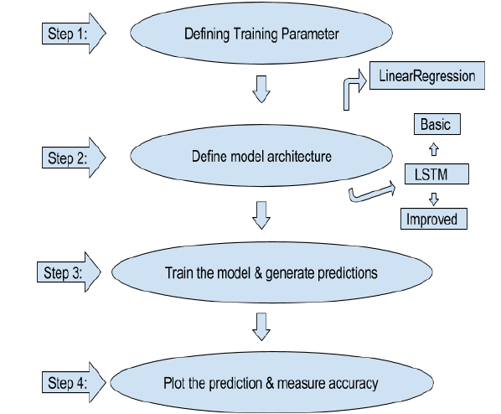

Refinement
For this project we have worked on fine tuning parameters for LSTM to get better predictions. we did the improvement by testing and analyzing each parameter and then selecting the final value for each of them.
To improve LSTM we have done following steps:
- Increased the number of hidden node from 100 to 128.
- Added Dropout of 0.2 at each layer of LSTM
- Increased batch size from 1 to 512
- Increased epochs from 1 to 20
- Added verbose = 2
- Made prediction with the batch size
Thus improved my mean squared error, for testing sets, from 0.01153170 MSE to 0.00093063 MSE.

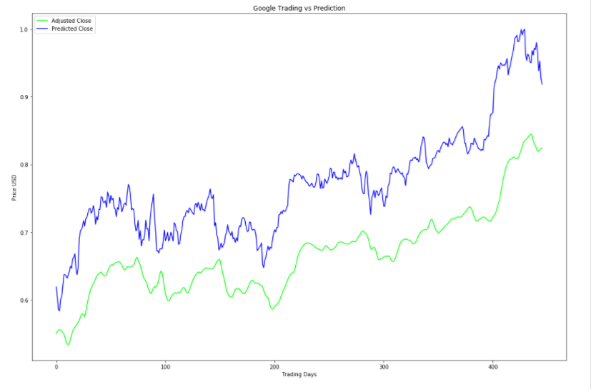
The predicted plot difference can be seen as follows:
Fig: Plot For Adjusted Close and Predicted Close Prices for basic LSTM model
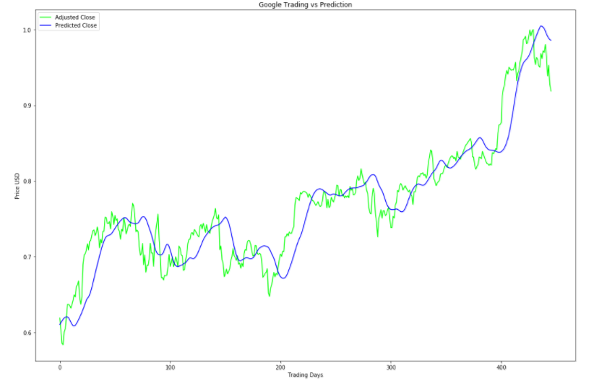

Fig: Plot For Adjusted Close and Predicted Close Prices for improved LSTM model

Result

Model Evaluation & Validation
With each model we have refined and fined tune predictions and have reduced mean squared error significantly.
- For my first model using linear regression model:
  - Train Score: 0.1852 MSE (0.4303 RMSE)
  - Test Score: 0.08133781 MSE (0.28519784 RMSE)
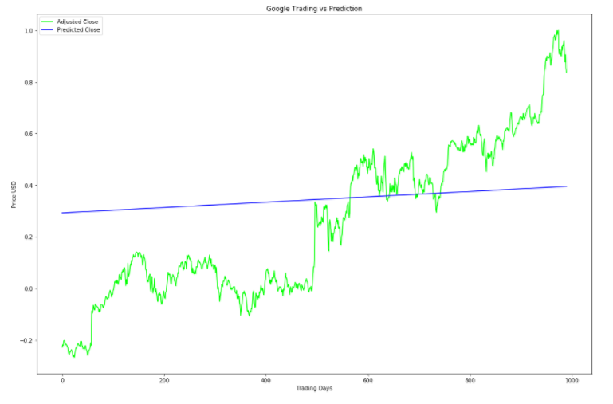
Fig: Plot of Linear Regression Model
- For our second model using basic Long-Short Term memory model:
  - Train Score: 0.00089497 MSE (0.02991610 RMSE)
  - Test Score: 0.01153170 MSE (0.10738577 RMSE)
Fig: Plot of basic Long-Short Term Memory model
- For our third and final model, using improved Long-Short Term memory model:
  - Train Score: 0.00032478 MSE (0.01802172 RMSE)
  - Test Score: 0.00093063 MSE (0.03050625 RMSE)
Fig: Plot of Improved Long-Short Term Memory Model

Robustness Check
For checking the robustness of my final model i used an unseen data, i.e, data of Alphabet Inc. from July 1, 2017 to July 20, 2017. On predicting the values of unseen data we got a decent result for the data. The results are as follows:
Test Score: 0.3897 MSE (0.6242 RMSE)

Justification
Comparing the benchmark model - Linear Regression to the final improved LSTM model, the Mean Squared Error improvement ranges from 0.08133781 MSE (0.28519784 RMSE) [Linear Regression Model] to 0.00093063 MSE (0.03050625 RMSE) [Improved LSTM] This significant decrease in error rate clearly shows that our final model have surpassed the basic and benchmark model.
Also the Average Delta Price between actual and predicted Adjusted Closing Price values was:
Delta Price: 0.000931 - RMSE * Adjusted Close Range
*Which is less than one cent.

Conclusion

Reflection
To recap, the process undertaken in this project:
- Set Up Infrastructure
  - iPython Notebook
  - Incorporate required Libraries (Keras, Tensor flow, Pandas, Matplotlib, Sklearn, Numpy)
- Prepare Dataset
  - Incorporate data of Alphabet Inc company
  - Process the requested data into Pandas Dataframe
  - Develop function for normalizing data
  - Dataset used with a 80/20 split on training and test data across all models
- Develop Benchmark Model
  - Set up basic Linear Regression model with Scikit-Learn
  - Calibrate parameters
- Develop Basic LSTM Model
  - Set up basic LSTM model with Keras utilizing parameters from Benchmark Model
- Improve LSTM Model
  - Develop, document, and compare results using additional labels for the LSMT model 5. Document and Visualize Results
- Plot Actual, Benchmark Predicted Values, and LSTM Predicted Values per time series
- Analyze and describe results for report.
We started this project with the hope to learn a completely new algorithm, i.e, Long-Short Term Memory and also to explore a real time series data sets. The final model really exceeded our expectations and have worked remarkably well.

Problems Encountered
The major problem we faced during the implementation of project was exploring the data. It was toughest task. To convert data from raw format to preprocess data and then to split them into training and test data. All of these steps require a great deal of patience and very precise approach. Also we had to work around a lot to successfully use the data for 2 models, i.e, Linear Regression and Long-Short Term Memory, as both of them have different inputs sizes. We read many research papers to get this final model right.

Improvement
This project though predicts closing prices with very minimum Mean Squared Error, still there are many things that are lagging in this project. Two of most important things are:
- There is no user interaction or interface provided in this project. A UI can be provided where user can check the value for future dates.
- The stocks used for this project are only of Alphabet Inc, we can surely add more S&P 500 in the list so as to make this project more comprehensive.

https://colah.github.io/posts/2015-08-Understanding-LSTMs/
https://colah.github.io/posts/2015-08-Understanding-LSTMs/
https://pypi.python.org/pypi/googlefinance
https://en.wikipedia.org/wiki/Recurrent_neural_network
https://en.wikipedia.org/wiki/Long_short-term_memory

