Mango Tree Purchase System
  - React Native Application Report
This project turns The Blue Tree pricing rules into a simple purchase calculator. The app collects the order details, applies the selected service charge and displays an itemised invoice. Section A explains the interface and development choices; Section B contains the complete main page code.

Section A User Interface

UI components and their purpose
Component | Purpose
Header and pricing | Text and View identify the app and show prices, delivery limits and the planting rate.
Quantity and height | Labelled TextInput fields collect positive whole numbers, with a numeric keyboard on phones.
Service selection | Pressable controls ask about planting first, then delivery if planting is declined.
Calculate Invoice | A Pressable button checks the form and calculates charges. Inline errors explain invalid entries.
Invoice summary | Reusable rows align labels and MYR amounts. A larger green total highlights the amount due.
Responsive screen | SafeAreaView protects native edges. ScrollView supports phones; Flexbox creates two columns on wider screens.

Calculation approach
All trees in an order share one height and unit price. Cash and carry adds no service charge. Delivery alone costs MYR 20 per tree, capped at MYR 100 per order. Planting costs 50% of the tree subtotal and already includes delivery. Prices include tax, so the app does not add tax again. Money is calculated in integer sen.

Planting service input and output
The first process uses the assignment example: four trees at a height of 7 feet. Selecting Yes for planting hides the delivery question and explains that delivery is included. The screenshots below were captured from the running Expo web app at a phone width.
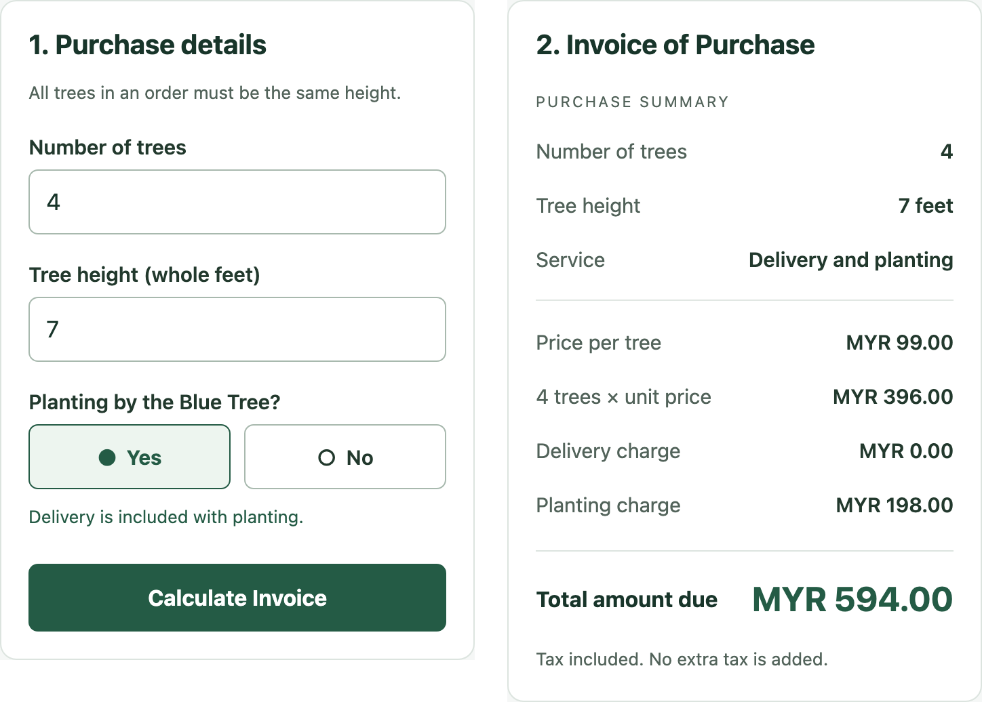
Figure 1 Completed input form on the left and planting invoice on the right
The trees cost 4 × MYR 99 = MYR 396. Planting adds MYR 198, delivery adds MYR 0, and the total is MYR 594.00. Both service charges remain visible so the customer can see exactly what was included.

Delivery only input and output
When planting is declined, the delivery question appears. This order contains six 7-foot trees with delivery selected. Six delivery fees would normally be MYR 120, but the order limit reduces the charge to MYR 100.
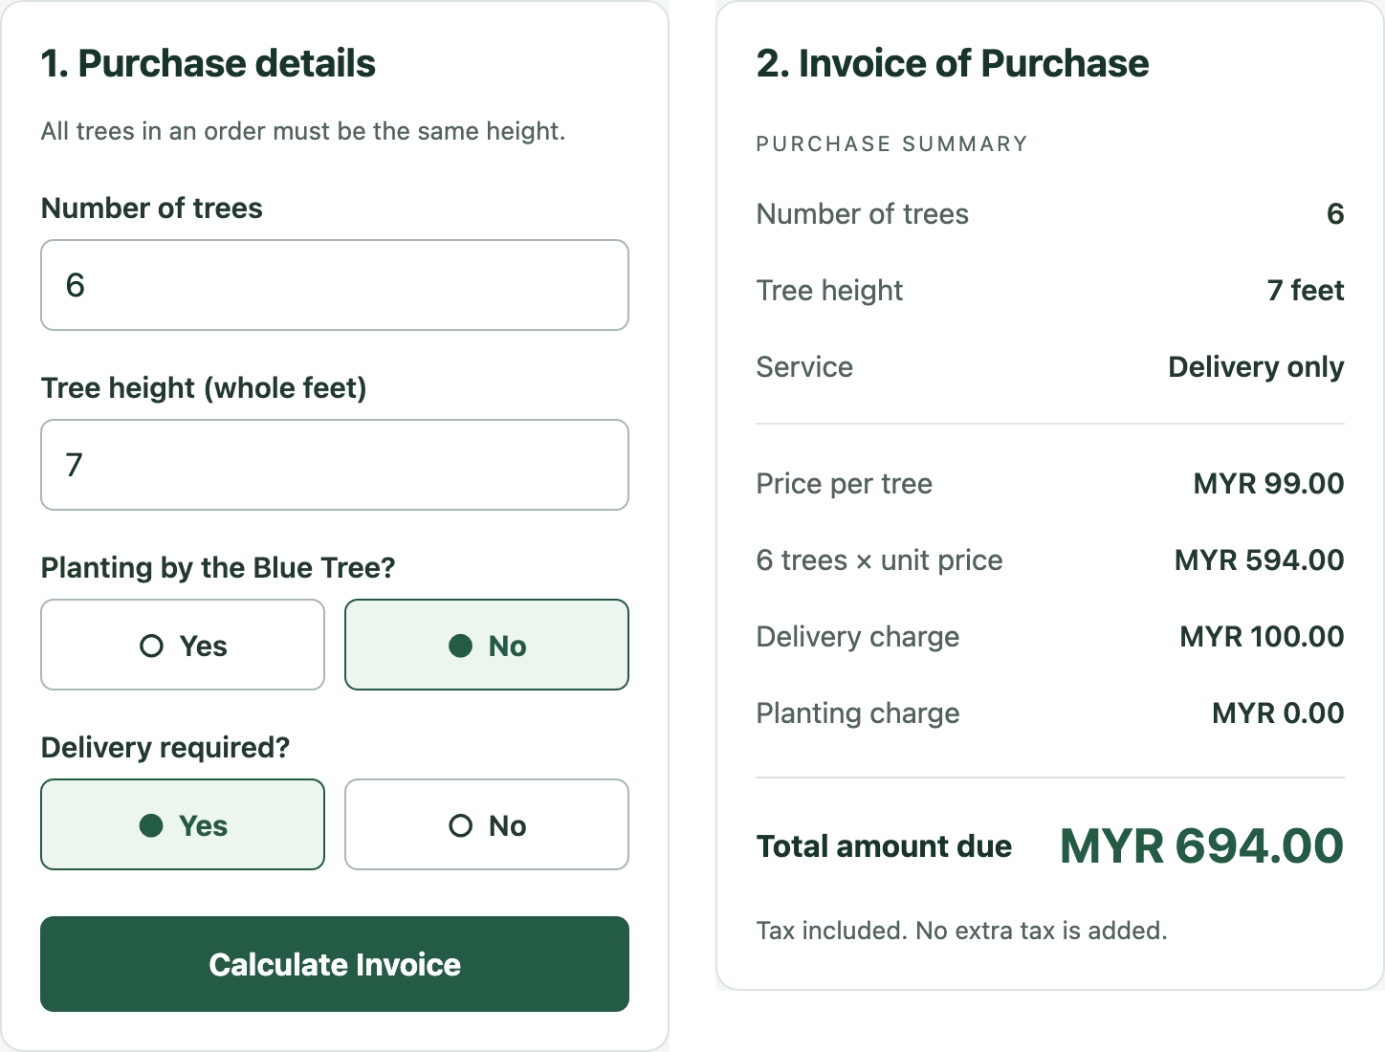
Figure 2 Delivery selection on the left and the capped delivery invoice on the right
The tree subtotal is MYR 594.00, the delivery charge is MYR 100.00 and planting is MYR 0.00. The final amount due is MYR 694.00.

Cash and carry output
Selecting No for both planting and delivery gives a cash and carry order. Four 7-foot trees cost MYR 396.00, with both additional charges shown as zero.
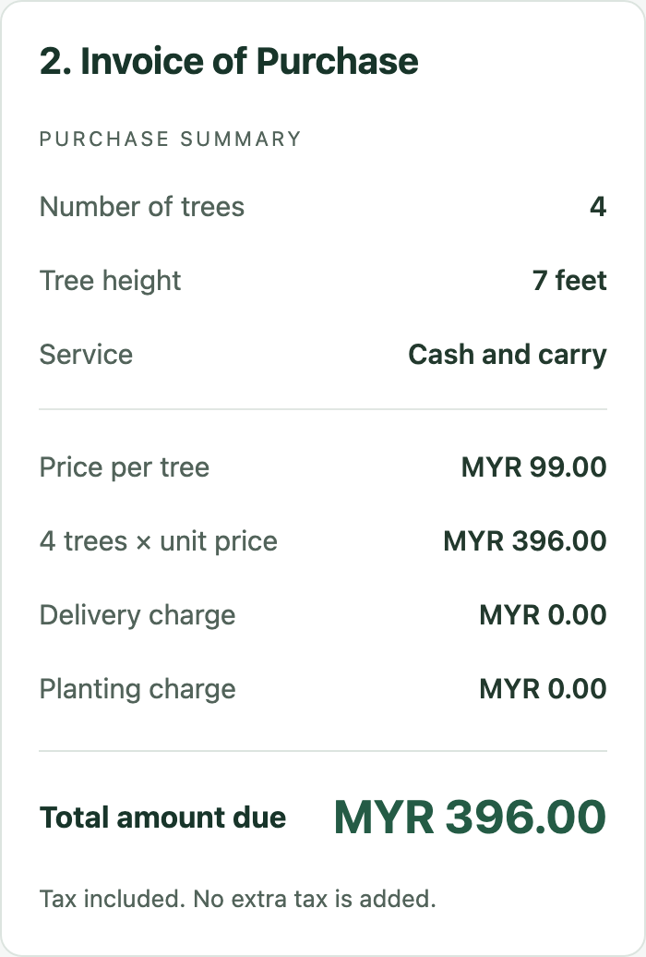
Figure 3 Cash and carry invoice

Project discussion
The trickiest detail was keeping the service choices clear. Planting already includes delivery, so asking both questions all the time could easily lead to charging twice. Showing the delivery question only after No is selected keeps that decision simple. Changing a choice also clears the old invoice, which avoids leaving a believable but outdated total on screen.
The phone layout needed one practical fix: sharing a flexible card style made the invoice overlap the button. Restricting the side-by-side sizing to wider screens solved it. This taught me to check scrolling and button access at phone widths, even when a desktop layout looks right. A sensible next step would be saving or sharing invoices, so customers could keep their quotation without taking a screenshot.

Section B Application Code
The listing below is the complete App.js used by the app. Expo project setup and dependency files are available in the repository. The page uses React state for inputs and the invoice, validates each order, and switches layout at 800 pixels.
Live demo https://abdullahwarrg-png.github.io/blue-tree-mango/
Repository https://github.com/abdullahwarrg-png/blue-tree-mango
import React, { useState } from 'react';
import {
View, Text, TextInput, Pressable, ScrollView,
StyleSheet, useWindowDimensions, Platform,
} from 'react-native';
import { SafeAreaProvider, SafeAreaView }
from 'react-native-safe-area-context';
import { StatusBar } from 'expo-status-bar';

/** @type {[string, number][]} */
const prices = [
['Under 3 feet', 3900], ['3 to 5 feet', 6900],
['6 to 8 feet', 9900], ['Over 8 feet', 19900],
];
const money = (sen) => `MYR ${Math.floor(sen / 100)}.`
+ String(sen % 100).padStart(2, '0');
const positiveInteger = (text) => /^\d+$/.test(text)
&& Number.isSafeInteger(Number(text)) && Number(text) > 0;

function Row({ label, value, total = false }) {
return <View style={[s.row, total && s.total]}>
<Text style={total ? s.totalLabel : s.muted}>{label}</Text>
<Text style={total ? s.totalValue : s.value}>{value}</Text>
</View>;
}

function Choice({ label, value, onChange, error }) {
return <View style={s.question}>
<Text style={s.label}>{label}</Text>
<View style={s.choices} accessibilityRole="radiogroup">
{['Yes', 'No'].map((option) =>
<Pressable key={option} accessibilityRole="radio"
accessibilityLabel={`${label} ${option}`}
accessibilityState={{ checked: value === option }}
onPress={() => onChange(option)}
{...(Platform.OS === 'web' ? {
onKeyDown: (event) => {
const key = event.nativeEvent.key;
if ([' ', 'Enter'].includes(key)) {
event.preventDefault();
onChange(option);
}
},
} : {})}
style={({ pressed }) => [s.choice,
value === option && s.selected, pressed && s.pressed]}>
<Text style={value === option ? s.active : s.value}>
{value === option ? '●' : '○'} {option}
</Text>
</Pressable>)}
</View>
{!!error && <Text role="alert" style={s.error}>{error}</Text>}
</View>;
}

export default function App() {
const [form, setForm] = useState({
quantity: '', height: '', planting: '', delivery: '',
});
const [errors, setErrors] = useState(
/** @type {Record<string, string>} */ ({})
);
const [invoice, setInvoice] = useState(null);
const wide = useWindowDimensions().width >= 800;
const update = (key, value) => {
setForm((previous) => ({ ...previous, [key]: value,
...(key === 'planting' ? { delivery: '' } : {}),
}));
setErrors({});
setInvoice(null);
};

function calculate() {
/** @type {Record<string, string>} */
const next = {};
for (const key of ['quantity', 'height']) {
if (!positiveInteger(form[key]))
next[key] = 'Enter a positive whole number.';
}
if (!form.planting) next.planting = 'Choose Yes or No.';
if (form.planting === 'No' && !form.delivery)
next.delivery = 'Choose Yes or No.';
if (Object.keys(next).length) return setErrors(next);

const quantity = Number(form.quantity);
const height = Number(form.height);
const unit = prices[height < 3 ? 0 : height <= 5
? 1 : height <= 8 ? 2 : 3][1];
const subtotal = quantity * unit;
const planting = form.planting === 'Yes' ? subtotal / 2 : 0;
const delivery = form.planting === 'No'
&& form.delivery === 'Yes' ? Math.min(quantity, 5) * 2000 : 0;
const total = subtotal + planting + delivery;
if (![subtotal, planting, total].every(Number.isSafeInteger))
return setErrors({ quantity: 'This quantity is too large.' });
const service = form.planting === 'Yes'
? 'Delivery and planting' : form.delivery === 'Yes'
? 'Delivery only' : 'Cash and carry';
setErrors({});
setInvoice({ quantity, height, unit, subtotal,
planting, delivery, total, service });
}

return <SafeAreaProvider><SafeAreaView style={s.safe}>
<StatusBar style="dark" />
<ScrollView keyboardShouldPersistTaps="handled"
contentContainerStyle={s.scroll}>
<View style={s.page}>
<View style={s.header}>
<Text style={s.brand}>THE BLUE TREE</Text>
<Text role="heading" aria-level={1} style={s.title}>
Mango Tree Purchase System
</Text>
<Text style={s.muted}>
Choose your trees. We will take care of the rest.
</Text>
</View>
<View style={s.card} testID="pricing">
<Text role="heading" style={s.heading}>
Pricing information
</Text>
{prices.map(([label, price]) =>
<Row key={label} label={label} value={money(price)} />)}
<View style={s.rule} />
<Text style={s.note}>All tree prices include tax.</Text>
<Text style={s.note}>
Delivery only: MYR 20 per tree, up to MYR 100 per order.
</Text>
<Text style={s.note}>
Delivery and planting: 50% of the tree subtotal.
</Text>
</View>
<View style={[s.columns, wide && s.wide]}>
<View style={[s.card, wide && s.column]}
testID="order-form">
<Text role="heading" style={s.heading}>
1. Purchase details
</Text>
<Text style={s.note}>
All trees in an order must be the same height.
</Text>
{['quantity', 'height'].map((key) => {
const label = key === 'quantity'
? 'Number of trees' : 'Tree height (whole feet)';
return <View key={key} style={s.question}>
<Text nativeID={`${key}-label`} style={s.label}>
{label}
</Text>
<TextInput value={form[key]}
onChangeText={(value) => update(key, value)}
accessibilityLabel={label}
aria-labelledby={`${key}-label`}
aria-invalid={!!errors[key]} keyboardType="number-pad"
placeholder={key === 'quantity' ? 'e.g. 4' : 'e.g. 7'}
placeholderTextColor="#718078"
style={[s.input, errors[key] && s.invalid]} />
{!!errors[key] && <Text role="alert" style={s.error}>
{errors[key]}
</Text>}
</View>;
})}
<Choice label="Planting by the Blue Tree?"
value={form.planting} error={errors.planting}
onChange={(value) => update('planting', value)} />
{form.planting === 'Yes' && <Text style={s.hint}>
Delivery is included with planting.
</Text>}
{form.planting === 'No' &&
<Choice label="Delivery required?"
value={form.delivery} error={errors.delivery}
onChange={(value) => update('delivery', value)} />}
<Pressable accessibilityRole="button"
onPress={calculate} style={({ pressed }) =>
[s.button, pressed && s.pressed]}>
<Text style={s.buttonText}>Calculate Invoice</Text>
</Pressable>
</View>
<View style={[s.card, wide && s.column]}
testID="invoice-panel"
accessibilityLiveRegion="polite">
<Text role="heading" style={s.heading}>
2. Invoice of Purchase
</Text>
{!invoice ? <View style={s.empty}>
<Text style={s.emptyTitle}>Your invoice starts here</Text>
<Text style={s.muted}>
Enter your purchase details, choose your service,
then tap Calculate Invoice.
</Text>
</View> : <View testID="invoice">
<Text style={s.receipt}>PURCHASE SUMMARY</Text>
<Row label="Number of trees"
value={String(invoice.quantity)} />
<Row label="Tree height"
value={`${invoice.height} feet`} />
<Row label="Service" value={invoice.service} />
<View style={s.rule} />
<Row label="Price per tree" value={money(invoice.unit)} />
<Row label={`${invoice.quantity} trees × unit price`}
value={money(invoice.subtotal)} />
<Row label="Delivery charge"
value={money(invoice.delivery)} />
<Row label="Planting charge"
value={money(invoice.planting)} />
<Row label="Total amount due" total
value={money(invoice.total)} />
<Text style={s.note}>Tax included. No extra tax is added.</Text>
</View>}
</View>
</View>
<Text style={s.footer}>
The Blue Tree · Mango trees, made simple.
</Text>
</View>
</ScrollView>
</SafeAreaView></SafeAreaProvider>;
}

const s = StyleSheet.create({
safe: { flex: 1, backgroundColor: '#f5f7f6' },
scroll: { flexGrow: 1, padding: 20 },
page: { width: '100%', maxWidth: 1040, alignSelf: 'center', gap: 20 },
header: { gap: 10, paddingVertical: 16 },
brand: { color: '#245b45', fontSize: 12,
fontWeight: '700', letterSpacing: 2 },
title: { fontSize: 29, fontWeight: '700', color: '#18352a' },
heading: { fontSize: 20, fontWeight: '700',
color: '#18352a', marginBottom: 14 },
card: { backgroundColor: '#fff', borderRadius: 12, padding: 20,
borderWidth: 1, borderColor: '#dce4df' },
column: { flex: 1 },
columns: { gap: 20, alignItems: 'stretch' },
wide: { flexDirection: 'row', alignItems: 'flex-start' },
row: { flexDirection: 'row', justifyContent: 'space-between',
alignItems: 'center', gap: 12, paddingVertical: 9 },
muted: { color: '#52635a', fontSize: 15,
lineHeight: 22, flexShrink: 1 },
value: { color: '#22392d', fontSize: 15,
fontWeight: '600', flexShrink: 1, textAlign: 'right' },
note: { color: '#52635a', fontSize: 13, lineHeight: 21 },
rule: { height: 1, backgroundColor: '#e1e7e3', marginVertical: 10 },
question: { marginTop: 20, gap: 8 },
label: { color: '#22392d', fontSize: 15, fontWeight: '600' },
input: { borderWidth: 1, borderColor: '#a8b9ae',
borderRadius: 7, padding: 12, fontSize: 17,
color: '#18352a', minHeight: 48 },
invalid: { borderColor: '#ac2424' },
error: { color: '#ac2424', fontSize: 13, lineHeight: 20 },
choices: { flexDirection: 'row', gap: 10 },
choice: { flex: 1, borderWidth: 1, borderColor: '#a8b9ae',
borderRadius: 7, minHeight: 48, alignItems: 'center',
justifyContent: 'center', padding: 10 },
selected: { backgroundColor: '#edf5ef', borderColor: '#245b45' },
active: { color: '#245b45', fontSize: 15, fontWeight: '700' },
pressed: { opacity: 0.7 },
hint: { color: '#245b45', fontSize: 13,
lineHeight: 21, marginTop: 10 },
button: { backgroundColor: '#245b45', borderRadius: 7,
padding: 16, alignItems: 'center', marginTop: 24 },
buttonText: { color: '#fff', fontSize: 16, fontWeight: '700' },
empty: { paddingVertical: 28, gap: 10 },
emptyTitle: { fontSize: 17, fontWeight: '600', color: '#22392d' },
receipt: { color: '#52635a', fontSize: 11,
letterSpacing: 1.5, marginVertical: 10 },
total: { borderTopWidth: 1, borderColor: '#dce4df',
marginTop: 14, paddingVertical: 20, flexWrap: 'wrap' },
totalLabel: { fontSize: 16, fontWeight: '700', color: '#18352a' },
totalValue: { fontSize: 25, fontWeight: '700', color: '#245b45' },
footer: { color: '#617269', fontSize: 12,
textAlign: 'center', paddingVertical: 8 },
});

