KLUST Campus Store
  - React Native mobile shopping application
Project platform Expo SDK 58 with React Native and TypeScript
Verification environment Mobile-sized Chromium preview using React Native Web

Contents
1 Project Overview 3
1.1 Introduction 3
1.2 Purpose 3
1.3 Scope and Limitations 3
2 Application Design and Functionality 4
2.1 Identification of Important Processes 4
2.2 Process and Behavior Definition 5
2.3 Page Connections and Navigation Flow 8
3 Technical Implementation 10
3.1 UI Layout Components Used 10
3.2 State Management and Data Structure 11
3.3 Verification and Results 12
4 Visual Documentation Sample Screens 14
4.1 Shop 14
4.2 Product Details 15
4.3 Checkout 16
5 Development Challenges and Solutions 17
5.1 Key Difficulties Faced 17
5.2 Implemented Solutions 17
6 Conclusion and Future Work 18
6.1 Conclusion 18
6.2 Future Improvements Suggested 18
Screen captures show the running web preview at 390 × 900 CSS pixels. They show the temporary catalog illustrations and the refreshed interface design. The screenshot descriptions explain controls that are visible immediately and controls reached by scrolling.

1 Project Overview

1.1 Introduction
We developed KLUST Campus Store as a mobile shopping demonstration for students, staff, and alumni who want university merchandise. The objective was to make the journey from discovering a product to reviewing a saved order feel complete, while keeping the code understandable enough for an academic project.
The application demonstrates React Native layout, reusable components, typed navigation, conditional interfaces, form validation, and shared state management. It also demonstrates local persistence, integer-based money calculations, and testing of both shopping logic and the connected user flow.

1.2 Purpose
The main goal was to let a guest browse a focused collection, understand the available options, and place a simulated campus pickup order without creating an account. Keeping the shopping bag and past orders on the device makes the experience usable across app reloads.
We also wanted the university identity to be visible through the blue interface and the crest on the merchandise. Clear naming, predictable actions, and a shared theme help the six screens behave like one application.

Pickup and upcoming collections
The configured pickup point is Block 9 Foyer. It appears on Shop, Bag, Checkout, and Receipt through a shared location constant. Pens and Caps are selectable preview categories labelled Coming soon, with no release dates or purchasable products. Browse available items returns to the twelve-product catalog. Orders remain simulated and do not reserve a collection.

1.3 Scope and Limitations
The agreed product scope contains two university merchandise types: eight T-shirt designs and four mug designs. This is broader than a single-product-type exercise, but both categories share the same shopping flow. T-shirts add a required size choice; mugs show a fixed capacity. Across the catalog, 25 locally bundled 1200 × 1200 product images represent the available colour variants.
Included capability | Current boundary
Six functional and connected screens | Shop, Product Details, Cart, Checkout, Order Receipt, and Orders
Discovery and product options | Search, category filters, price sorting, colours, quantities, and T-shirt sizes S to XXL
Campus pickup checkout | Validated guest contact details and a demonstration receipt
Device persistence | Cart and orders stored locally through AsyncStorage
Product names, prices, materials, and images are project examples. The configured pickup point is Block 9 Foyer, but this demo creates no real reservation, payment, email, or inventory change. It has no backend, accounts, cross-device sync, or delivery flow. Local records are removed when browser or app data is cleared.

2 Application Design and Functionality

2.1 Identification of Important Processes
Product discovery The Shop screen combines a two-column product list with a search field, category buttons, and sorting. We chose these controls because shoppers need to narrow the collection quickly while still seeing product images and prices together. A no-results state offers a reset action so a narrow search does not become a dead end.
Product evaluation and selection Product Details presents the design, description, price, colours, and category-specific options. The image changes with the selected colour, and a row of variant thumbnails shows every colour at a glance. T-shirt sizing is deliberately required before an item is added, since an unspecified size would make even a demonstration order incomplete.
Bag management The bag lets users review variants, increase or decrease quantities, remove a line, and check the total before checkout. Variants are important here: a Cloud size M tee must not be treated as the same item as a Navy size L tee. Matching variants combine, with a limit of ten units per line.
Contact validation and order placement Checkout gathers a name, email address, and phone number for a simulated campus pickup. Errors appear beside the relevant fields. We included validation because the final action should demonstrate a meaningful form process rather than accepting any input and showing a success page.
Order review The receipt shows what was ordered and the amount recorded at checkout. Orders keeps a device-local history and opens the same receipt screen for previous purchases. This closes the shopping loop and gives the user a way to inspect an order after leaving the success screen.
Recovery and persistence Saved shopping data loads before the shopping controls become available. Invalid stored entries are discarded safely. If an order cannot be saved, the bag remains available and the user can retry. These behaviors matter because a convincing shopping experience must handle interruptions as well as the happy path.

Design priorities
Royal blue identifies primary actions and prices, navy marks the selected filter or size, and white surfaces keep the product imagery prominent. Each product photo sits on a soft studio backdrop chosen for its colour: light garments on cool blue-grey and dark garments on warm off-white, so every variant stays legible. Rounded pill-shaped chips and badges, a shared radius scale, and body text of at least 11 to 14 points make the screens consistent and easy to read on a phone. Shared buttons, spacing, and typography reduce visual inconsistency. The interface uses a mobile layout, fixed bottom navigation for the main destinations, and a visible checkout action beneath scrollable content.
Guest checkout and campus pickup keep the functional scope manageable. We did not add simulated accounts or reviews, since they would introduce extra screens without improving the core processes required for this project.

2.2 Process and Behavior Definition

2.2.1 Shop
Process Definition Users discover merchandise, compare prices, and select a product to inspect. The initial catalog contains eight T-shirts and four mugs. The page also provides direct access to the bag and order history.
Behavior Definition A FlatList renders product cards in two columns. Each card contains a framed product photo with an optional badge such as Bestseller, colour dots overlaid on the photo, a category label, the product name, the formatted MYR price in brand blue, and a count of available colours. A TextInput updates the search query as the user types. Filtering uses the product name, collection, and category terms; it is case-insensitive and ignores extra spaces around the query.
The All items, T-shirts, and Mugs Pressable controls update the category filter. The Featured sorting control expands three choices: featured order, price low to high, and price high to low. Search, category, and sorting are applied together without changing the original catalog order. When nothing matches, the page displays a message and a reset control.
Selecting a card opens Product Details using only the product ID. The promotional Shop the collection control scrolls directly to the catalog. A row beneath the campaign highlights free campus pickup, the official crest, and sizes S to XXL. The top shopping-bag icon opens Cart, while the bottom tabs switch between Shop, Bag, and Orders. The product list scrolls independently of the tab bar.

2.2.2 Product Details
Process Definition Users inspect a product and configure the exact variant and quantity they want to add to the bag.
Behavior Definition The screen resolves the product ID from the catalog and displays its collection, image, name, unit price, description, and care or material details. The large square product photo is followed by a strip of tappable variant thumbnails, and colour swatches appear again beside the options. Selecting either updates the selected colour and replaces the main image with the matching local asset.
T-shirts display S, M, L, XL, and XXL size buttons, with no initial size selected. An attempted add without a size shows a clear error; selecting a size clears it. Mugs display their capacity instead and never request a clothing size. Quantity controls keep the value between one and ten.
Add to bag sends the product, colour, optional size, and quantity to the shared store. Matching variants merge and the bag badge updates. Feedback reports how many units were actually added, including when the ten-unit limit restricts the request. View bag returns to the existing Cart tab. The back arrow returns to the previous screen. An invalid product ID produces a recovery view instead of a broken product page.

2.2.3 Cart
Process Definition Users review their selected products, correct quantities or variants through removal and reselection, and confirm the total before moving to checkout.
Behavior Definition Each bag line shows the product image, name, colour, optional size or mug capacity, quantity, and line total. The minus and plus Pressable controls update that specific line and disable at the one-unit and ten-unit limits. A separate trash icon removes the line, avoiding accidental deletion when decreasing from one.
The subtotal is derived from catalog prices multiplied by quantities in integer sen. Pickup is complimentary, so the total equals the subtotal. All displayed values use a shared MYR formatter. Continue shopping returns to Shop. Continue to checkout opens the Checkout stack screen with the current bag available through context.
When the final line is removed, the bag displays an empty state with an Explore the collection button. There is no checkout button in this state. If Checkout is reached with no items, it also offers a return to Shop rather than accepting an empty order.

2.2.4 Checkout
Process Definition Users enter their contact details, review the campus pickup arrangement and order summary, and submit a demonstration order.
Behavior Definition Three TextInput fields collect full name, email address, and phone number. Names need at least two trimmed characters. Email uses a basic structure check. Phone input permits spaces, parentheses, plus signs, and hyphens, but must contain nine to fifteen digits after these separators are removed.
Submitting invalid details displays field-specific messages and focuses the first invalid input. Text-entry settings supply suitable keyboard types and autocomplete hints. A KeyboardAvoidingView handles the iOS keyboard layout, while the ScrollView allows the form and summary to remain reachable. Entering a corrected value clears the corresponding error.
The pickup card and order summary explain the collection method, items, and total. Place demo order starts a guarded save operation. During saving, the button shows a loading indicator and additional submissions are blocked. The order is persisted before the bag is cleared. Success replaces Checkout with Order Receipt; a write failure displays a retry message and retains the bag. The interface states that no payment or real reservation occurs.

2.2.5 Order Receipt
Process Definition Users confirm the contents of a completed demonstration order or review the same receipt later from order history.
Behavior Definition The screen receives an order ID and finds the saved order in shared state. It displays the reference, date, customer details, item names, selected variants, quantities, total, and simulated campus pickup summary. A confirmation graphic gives a clear visual endpoint to checkout.
The line prices and total come from the stored order snapshot. They do not depend on the current catalog, so a later price change cannot rewrite a previous receipt. Each receipt is explicitly marked as a demonstration, and the page explains that no payment was taken, no email was sent, and no real collection was reserved.
Keep exploring resets navigation to Shop. View my orders resets it to Orders. This prevents the checkout form from becoming the destination of the next back action. The receipt header also returns to Orders. If the order ID cannot be found on the device, a recovery screen links to the history page.

2.2.6 Orders
Process Definition Users find previous demonstration purchases and open their details without placing the same order again.
Behavior Definition A FlatList shows saved orders with the most recent first. Each record contains its reference, date, first item name, an indication of additional distinct lines, total, and demonstration status. The page states that the records are stored on this device.
Selecting an order passes its ID to the same Order Receipt screen used after checkout. It does not create a new order or clear the current bag. If no history exists, an empty state explains when orders will appear and provides a Find your first favourite button linking to Shop.

Shared interaction behavior
The main tabs are consistently labelled Shop, Bag, and Orders. The code names the Bag route Cart to make its shopping purpose explicit. Primary actions use a shared Button component built from Pressable and Text, with common loading and disabled styling. Pressable controls expose accessibility roles or labels, and selected options expose their state.
Scrollable content keeps long product descriptions, bag lines, and order summaries accessible on smaller screens. These provisions improve usability, but do not replace native keyboard, screen-reader, and physical-device testing, which remain future verification tasks.

2.3 Page Connections and Navigation Flow
The root navigator contains Main, Product, Checkout, and Receipt. Main contains the Shop, Cart, and Orders bottom tabs. This separates persistent shopping destinations from the focused tasks of configuring a product or completing a checkout.
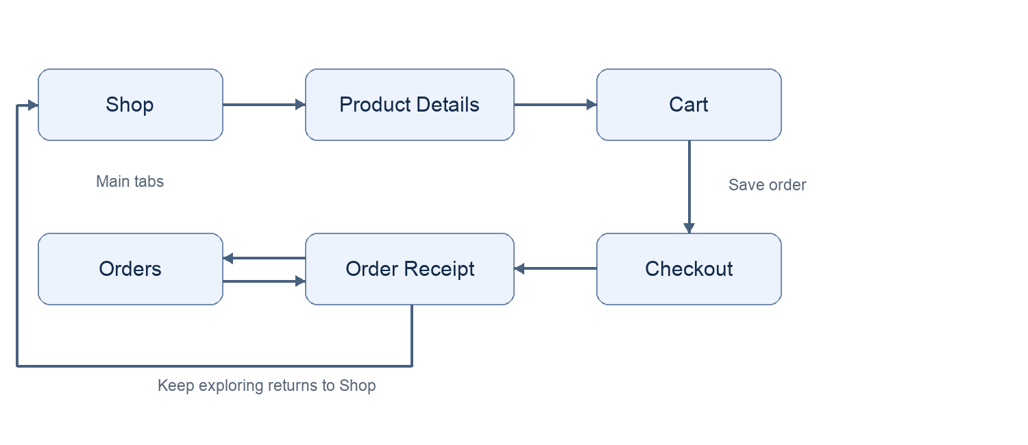
Figure 1 Main shopping sequence and access to previous receipts

Data sharing between screens
Navigation parameters carry identifiers rather than full mutable shopping objects. Product Details receives productId; Order Receipt receives orderId. Each screen resolves the identifier from the catalog or shared order state. Cart and Checkout read the same cart through useShop, so changing a quantity is reflected in the next screen without copying route data.
Navigation action | Data and result
Shop → Product Details | productId selects the catalog record and its available options.
Product Details → Cart | The shared add action records the variant; returning to Main reuses the existing Cart tab.
Cart → Checkout | The latest cart and derived total come from context, not a separate route snapshot.
Checkout → Order Receipt | A successful persisted order supplies orderId; Checkout is replaced.
Orders → Order Receipt | The selected saved order supplies orderId; no order is created.
Receipt → Shop or Orders | Navigation resets to the chosen main tab to avoid returning to a submitted form.
The top bag icon and bottom tabs provide shorter routes to the same shared state. Back navigation from Product Details preserves the discovery screen. Cart offers Continue shopping as a clear way to return to the catalog.

3 Technical Implementation

3.1 UI Layout Components Used
We used core React Native components for the page layouts and wrapped recurring patterns in small reusable components. The application does not use the core Button component; its shared Button is built with Pressable and Text so all primary actions share the same appearance and behavior.
Component | Purpose and reason for use
View | Groups sections, product rows, option controls, headers, cards, and action areas. Flexbox supports the mobile layouts.
Text | Displays titles, descriptions, prices, errors, and captions. The Label and Eyebrow wrappers apply consistent typography while forwarding accessibility props.
Image | Shows the bundled crest and matching product colour images. The shared ProductImage component crops each photo to the product, centres it consistently, and places it on a colour-aware backdrop. Local static assets avoid image loading dependencies during a demonstration.
Pressable | Handles product selection, filters, sorting, navigation actions, size and colour choices, bag edits, and order submission. Supports custom pressed, selected, disabled, and accessible states.
TextInput | Collects search text and checkout contact details. Controlled values make filtering and validation predictable.
FlatList | Renders the two-column catalog and order history. Stable keys identify products and saved orders.
ScrollView | Allows product details, cart contents, the checkout form, and receipts to extend beyond the viewport without hiding lower sections.
KeyboardAvoidingView | Adjusts the checkout layout with padding on iOS when the keyboard appears. Native keyboard behavior still needs device verification.
ActivityIndicator | Indicates font loading, saved-state loading, and order submission. Prevents an unexplained blank or inactive state.
StatusBar | Sets the native status bar to a dark-content appearance that suits the light page headers.
SafeAreaProvider and useSafeAreaInsets | Provide device inset values for headers, bottom actions, and the tab bar, keeping controls away from system areas.
NavigationContainer and navigators | Connect the typed native stack and bottom tabs. React Navigation manages transitions and destination state.
Lucide icon components | Render consistent shopping, navigation, pickup, and confirmation symbols using react-native-svg.
StyleSheet stores readable named styles. The theme centralizes colours and font names. ProductImage, ProductCard, CartLine, PageHeader, QuantityControl, PickupCard, and EmptyState keep repeated presentation separate from screen-specific tasks. The theme also defines a radius scale and the studio backdrop for each colour.

3.2 State Management and Data Structure

Product and shopping models
The catalog is a typed array in src/data/products.ts. Product uses a discriminated union: a T-shirt has sizes, while a mug has capacity. Both share an ID, name, collection, integer price, description, details, and colours. Each colour points to a statically required local image. This structure makes the difference between clothing and mugs explicit instead of filling every record with unrelated fields.
CartItem stores productId, colour, optional size, quantity, and a stable key derived from those variant fields. For example, heritage-tee:Cloud:M identifies one line. Adding that combination again increases its quantity; selecting another size creates a different key. The ten-unit limit applies to each variant line.
Order stores an ID, creation time, customer details, item snapshots, and a total. Each item snapshot also retains its product name, category, and unit price. This is why a receipt remains readable even if a product is later removed from the current catalog.

Shared state and local interaction state
ShopProvider uses React Context and useReducer for the shared cart and order history. Screens access it through useShop. The provider exposes addItem, setQuantity, removeItem, and placeOrder, along with totals and counts. Pure reducer and calculation functions live in src/utils/shop.ts, where they can be tested without rendering a phone interface.
useState keeps short-lived screen choices local: the query, category, sort menu, selected colour, size, quantity, form values, and validation messages. useMemo derives the filtered catalog. Refs guard repeated submissions and manage input focus without turning those operational details into shopping data.

Persistence and order integrity
AsyncStorage stores a versioned JSON object under @klust/campus-store/v1. The provider reads it before exposing the main screens. restoreState checks the saved shape, verifies cart variants against the catalog, rejects invalid quantities, and accepts only internally consistent receipts. Missing, unsupported, or malformed data recovers to an empty state.
Updates are written through a serial promise queue, so an older asynchronous cart save cannot overwrite a newer order. Checkout builds a complete next state and awaits its save before dispatching success. If persistence fails, it reports the failure and retains the bag for a retry. A submission guard and duplicate order-ID check protect against repeated placement.
All prices remain integer sen until display. For example, two RM 49.00 tees and one RM 29.00 mug are calculated as 2 × 4900 + 2900 = 12700 sen, then displayed as RM 127.00. No floating-point currency accumulation is needed.

Implementation examples
The store configuration keeps presentation-only upcoming categories separate from the purchasable T-shirt and mug models. The following declaration is used by the shared pickup card and Shop screen.
export const PICKUP_LOCATION = 'Block 9 Foyer';
Checkout confirms durable storage before clearing the cart. The provider applies the completed state only after the queued save resolves.
await save(next);
current.current = next;
dispatch({ type: 'hydrate', state: next });
return id;

Web deployment
The public browser demo is hosted with GitHub Pages at https://abdullahwarrg-png.github.io/klust-campus-store/. GitHub Actions checks types, lint, formatting, and tests before exporting and deploying the web app. The deployment sets EXPO_PUBLIC_BASE_URL to /klust-campus-store so bundled images, scripts, and fonts load from the repository path. Local development uses an empty base path. Browser records remain local to the visitor’s device.

3.3 Verification and Results
TypeScript strict checks, ESLint, formatting, all 19 logic tests, and 13 Chromium browser scenario groups passed. Expo exported web, Android, and iOS bundles. The browser walkthrough covered upcoming categories, variant identity, persisted shopping, contact validation, failed-save recovery, repeated submission, receipts, pickup information, narrow screens, desktop layout, and keyboard focus. Native bundle exports do not establish physical-device behavior.
Verification area | Scenario and observed result
Discovery | Mug filtering produced four items. Ascending price order began with The Daily Mug and ended with The Two Tone Mug. An unmatched search showed a reset action.
Product configuration | A T-shirt could not be added without a size. Mugs showed their capacity and no clothing-size controls. Colour selection changed the chosen variant.
Bag behavior | Matching variants merged. Different sizes and colours remained separate. Quantity edits and removal recalculated the total correctly.
Persistence | Reloading restored the bag. A completed order remained available after another reload through Orders.
Checkout validation | Missing fields, an invalid email, and a short phone number were rejected. Corrected inputs allowed another submission.
Save failure | An injected local storage write failure created no order and preserved the two bag lines. Restoring storage allowed a successful retry.
Repeated submission | Repeated taps created exactly one saved order. The purchased bag was cleared only after the successful write.
Navigation and receipts | Order history reopened the existing receipt. Receipt actions returned to the selected main tab.
Small screens and runtime | The 320 × 760 check found no horizontally clipped visible controls. The browser walkthrough recorded no runtime exceptions.

Concrete checkout example
The browser walkthrough ordered two Cloud Heritage Tees in size M at RM 49.00 each and one Blue Campus Mug at RM 29.00. The confirmed total was RM 127.00. Additional size and colour entries were added and removed earlier in the test, so the final value also checked that removal did not leave stale totals.

Verification boundaries
Browser verification used the production React Native Web export in Chromium at 390 × 900, with a 320 × 760 overflow check and a desktop keyboard-focus check. The repository includes reproducible scenarios and results. Native devices, simulators, screen readers, and hardware Back were not tested.

4 Visual Documentation Sample Screens

4.1 Shop
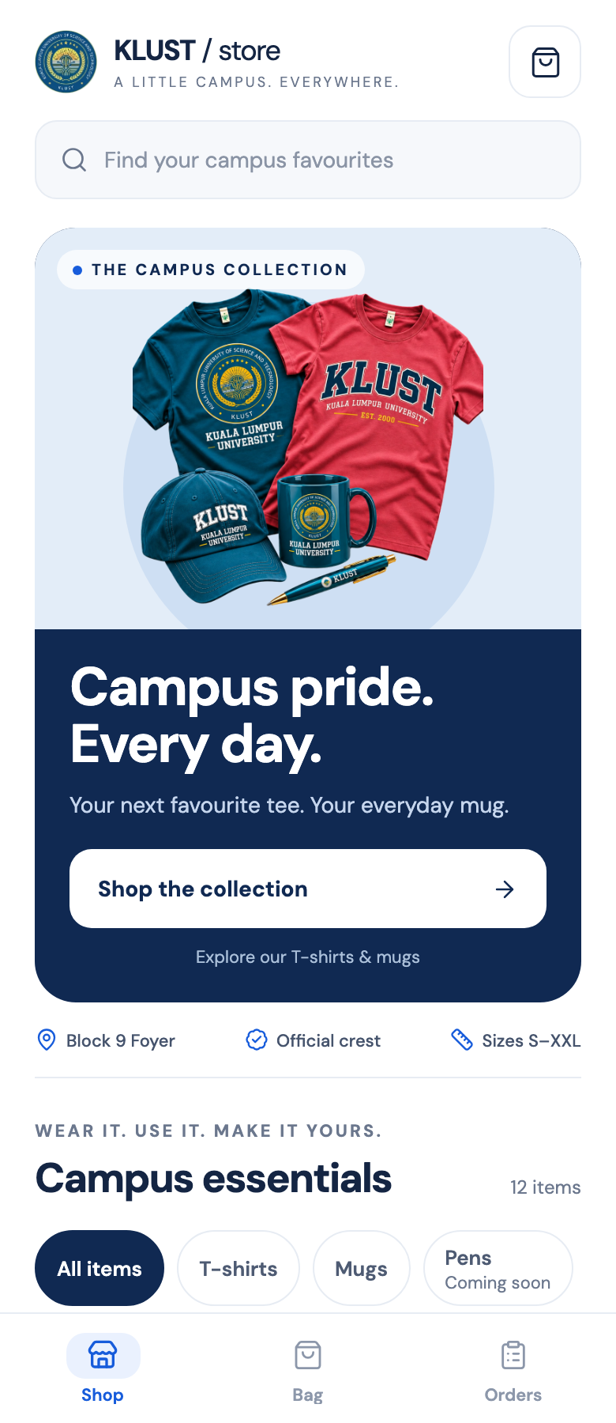
Figure 2 Shop screen in the running mobile-sized web preview
Process Discover university merchandise before choosing a product. The screenshot shows the campaign banner, Block 9 Foyer pickup information, available category filters, and upcoming Pens and Caps previews. Scroll to browse the twelve-product collection.
Behavior 1. Enter a query in the search TextInput to narrow the displayed FlatList. 2. Tap an All items, T-shirts, or Mugs Pressable to choose an available category. Pens and Caps show Coming soon and offer Browse available items. 3. Tap Featured and select a sort option to reorder the matching results. 4. Scroll the two-column list and tap a product card to inspect its design and options. An unmatched query offers Reset search and filters.
Connection A product card opens Product Details with its product ID. The shopping-bag icon opens Cart. The bottom tabs switch to Bag or Orders, and Shop the collection on the campaign banner scrolls to this grid.
Capture environment: React Native Web, Chromium, 390 × 900 CSS pixels. The capture shows the Shop landing page; the catalog continues below the category controls.

4.2 Product Details
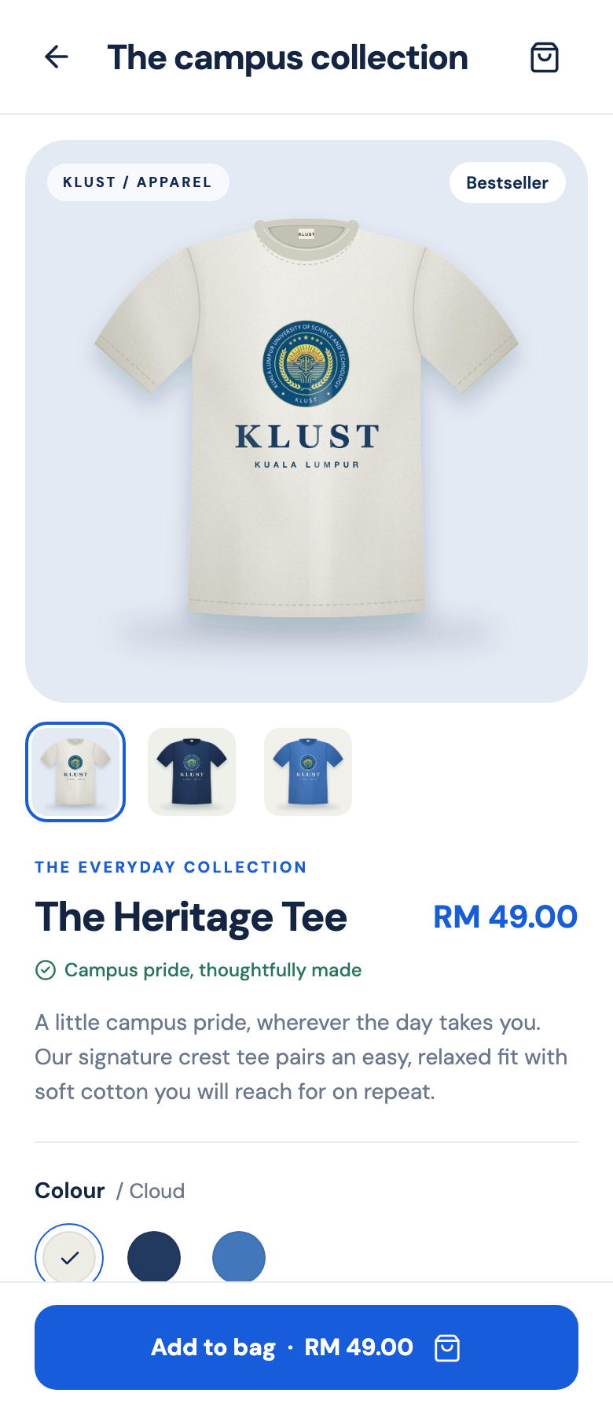
Figure 3 Heritage Tee product details with Cloud selected
Process Choose the exact product variant and add it to the shopping bag. The screenshot shows the product image and colour selection; the required T-shirt size controls are reached by scrolling.
Behavior 1. Review the Image, price, and description in the ScrollView. 2. Tap a variant thumbnail below the photo, or a colour swatch, to change the variant image. 3. Tap a size Pressable; The walkthrough selects M after scrolling to the size controls. If no size is selected, Add to bag displays an error. 4. Scroll slightly to reach the QuantityControl and adjust the count if needed. 5. Tap the fixed Add to bag button. Confirmation feedback appears and the bag count updates. Mugs replace the size buttons with a capacity label.
Connection Add to bag updates shared cart state while keeping the user on Product Details. The feedback provides View bag, which returns to the existing Cart tab. The header bag icon opens the same tab, and the back arrow returns to the previous screen.
Capture environment: React Native Web, Chromium, 390 × 900 CSS pixels. Content below the fixed action area remains reachable by scrolling; the sample shows one viewport rather than the complete page.

4.3 Checkout
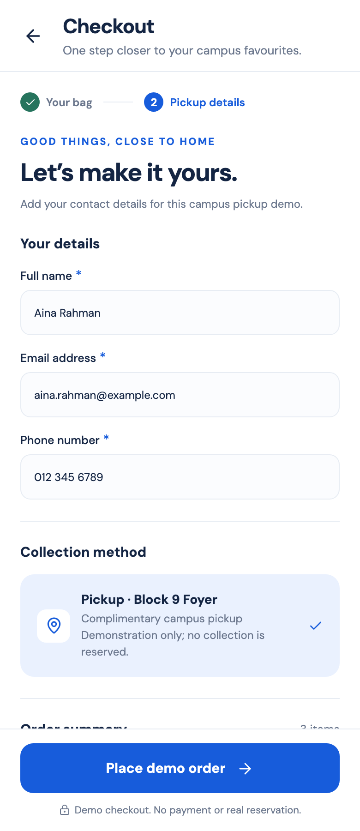
Figure 4 Checkout with fictional contact details and campus pickup selected
Process Provide contact details, review the pickup arrangement at Block 9 Foyer, and complete a demonstration order without payment.
Behavior 1. Enter a name in Full name, an email in Email address, and a phone number in Phone number. The TextInput fields show validation messages for missing or invalid values. 2. Review the selected campus pickup card. 3. Scroll to inspect the order summary and total; the verified example totals RM 127.00. 4. Tap Place demo order. The button displays a loading indicator during the save, and repeat submissions are blocked.
Connection After the order is saved locally, Checkout is replaced by Order Receipt and the purchased bag is cleared. If the save fails, the form shows a retry message and the bag remains intact. Receipt actions lead to Shop or Orders. No payment, email, or real collection reservation is created.
Capture environment: React Native Web, Chromium, 390 × 900 CSS pixels. The displayed name and contact details are fictional demonstration inputs.

5 Development Challenges and Solutions

5.1 Key Difficulties Faced
The trickiest parts were not the individual screens. They were the small details that had to stay consistent when we moved between them. A tee in one size needed to remain separate from another size, and a quick second tap at checkout could not turn into a second order. We also needed the saved data to agree with what the user had just seen.
The visuals were another challenge. The first product images looked flat, were small inside their frames, and cream garments almost disappeared against the beige cards. Several labels were also too small to read comfortably on a phone, and the screens lacked a clear visual hierarchy.
There were a few practical technical snags too. The first checks caught React Native ref typing errors and accessibility properties that our text wrapper was not forwarding. Later, TypeScript crashed after an export because it was trying to analyse the generated bundle in dist. A navigation walkthrough also exposed duplicate main navigation screens when we opened the bag from a product.

5.2 Implemented Solutions
Keeping the bag predictable We gave each cart line a key based on product, colour, and size. That made the merge rule easy to explain and test. We kept removal separate from the minus button, so reducing a quantity to one never unexpectedly deletes an item.
Saving before celebrating We queued storage writes and waited for the completed order to save before clearing the bag. We tested a deliberate storage failure rather than assuming it would work. The bag stayed available, the error explained what happened, and retrying created one order. That was a much more useful check than only testing a successful button tap.
Improving the image handoff We rebuilt all 25 product images at 1200 × 1200 pixels with realistic garment proportions, fabric and glaze shading, stitching, soft contact shadows, and larger, design-specific crest prints. A ProductImage component now crops every photo to the product and places it on a colour-aware backdrop, so thumbnails in the grid, bag, and checkout are large and consistent. We then refreshed the interface with pill-shaped filters and badges, a variant gallery on Product Details, and larger type throughout. Because filenames were kept, none of the shopping screens or variant logic had to change.
Fixing the tooling and navigation issues We corrected the component ref types, passed accessibility props through Label, and limited TypeScript to the actual source and tests. We changed the product-to-bag action to return to the existing tab navigator. The browser walkthrough then checked that the user could keep shopping, reopen the bag, and reach old receipts normally.
Keeping the scope realistic We concentrated on guest shopping and campus pickup instead of adding accounts, delivery, or real payments. That left time to verify the full flow and write the report against actual results. Native device checks are still a clear next step, rather than a feature we claim to have completed.

6 Conclusion and Future Work

6.1 Conclusion
The project met its core local-demo objectives. We produced a connected six-screen shopping application with a twelve-product catalog, category-specific options, a persistent bag, validated guest checkout, and saved receipts. The refreshed blue theme, rebuilt product images, and shared controls give the screens a polished and consistent university-store identity, while the separated code structure makes the shopping rules easier to follow.
The work reinforced how closely interface design and data behavior are connected. A colour swatch must select the right image and cart variant. A receipt must preserve the price that was ordered. A success message must follow a successful save. Testing those relationships gave us more useful confidence than judging the screens by appearance alone.
Verification passed at the logic, static-check, browser-flow, and bundle-export levels. The remaining limits are native device verification and the backend services required for any real store.

6.2 Future Improvements Suggested
New functional requirements A backend could manage real inventory, pickup status, and durable order records across devices. Optional accounts could let returning users recover their history. A payment provider and server-verified checkout would make paid orders possible, while pickup notifications would explain when and where to collect. Each addition would need real campus operational details alongside the configured Block 9 Foyer location and demonstration ordering flow.
UI and UX improvements Add on-model photography and pinch-to-zoom product inspection, a useful T-shirt size guide, and usability testing with students. Test text scaling, screen readers, contrast, and native keyboards on actual phones. These improvements would make product choices more confident and the app easier to use for a wider range of shoppers.
Technical improvements Move inventory and final pricing validation to a server, protect customer data, and test native navigation and keyboards. Continuous integration now checks types, lint, formatting, and tests before web deployment. Any future local schema change should include versioned migrations.

References and asset credits
KLUST official website and logo: https://klust.edu.my/ and https://klust.edu.my/wp-content/uploads/2026/03/logo-klust.png (accessed 3 November 2026). The logo is used on the project's merchandise images; the university is not represented as operating this demo store.
Implementation libraries: Expo SDK 58, React Native 0.88, React Navigation 7, AsyncStorage 2.2, React Native Web, Lucide icons, and DM Sans. Screenshots and validation results were produced from the implemented application. Product specifications, prices, collection names, and product images are project sample content.

