**Question no 1:**

**What is Git?**

Git is software for tracking changes in any set of files, usually used for coordinating work among programmers collaboratively developing source code during software development. A Git repository is a virtual storage of your project. It allows you to save versions of your code, which you can access when needed.

Git helps you in following

* Creating/initializing new git repository
* Versioning project with new git repository
* Cloning existing git repository
* Saving changes to the repository

**Question no 2:**

**What are git workflows?**

Some common Git workflow are following

* Centralized workflow
* Feature Branching
* Gitflow workflow
* Forking workflow

**1)Centralized Workflow**

There is one central repository. Each developer clones the repo, works locally on the code, creates a commit with changes, and pushes it to the central repository for other developers to pull and use in their work.Centralized Workflow uses a central repository to serve as the single point-of-entry for all changes to the project.

**How it works?**

Developers start by cloning the central repository. In their own local copies of the project, they edit files and commit changes, however, these new commits are stored locally. To publish changes to the official project, developers "push" their local repository to the central repository.

The central repository represents the official project, so its commit history should be treated as sacred and immutable. If a developer’s local commits diverge from the central repository, Git will refuse to push their changes because this would overwrite official commits.

**Example**

With this fundamental workflow model, a master branch contains all active development. Contributors will need to be especially sure they pull the latest changes before continuing development, for this branch will be changing rapidly. Everyone has access to this repo and can commit changes right to the master branch.

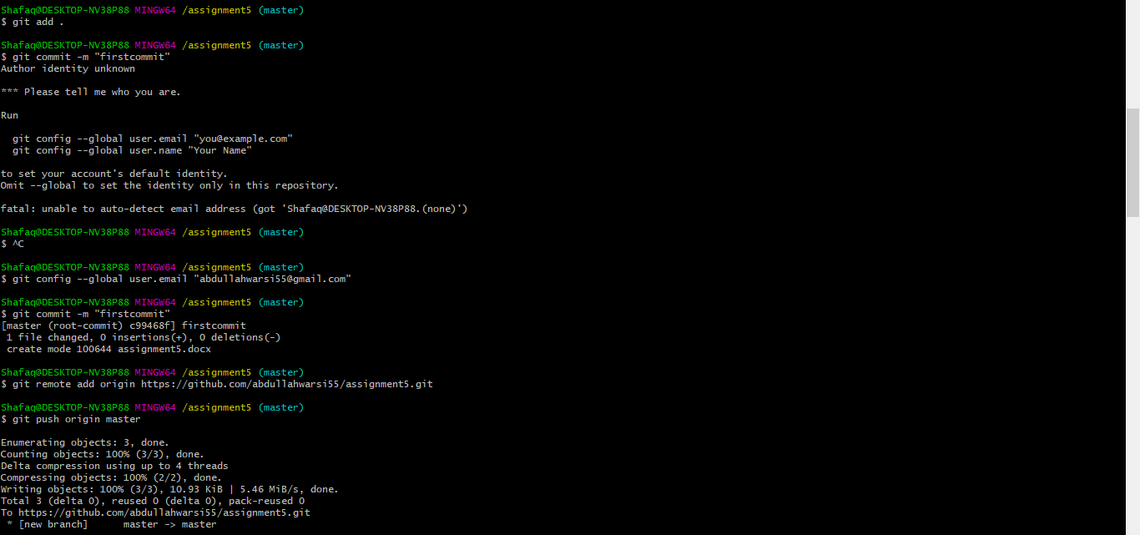

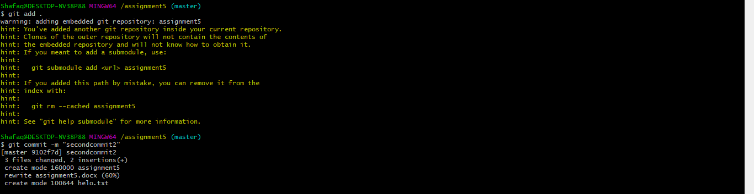

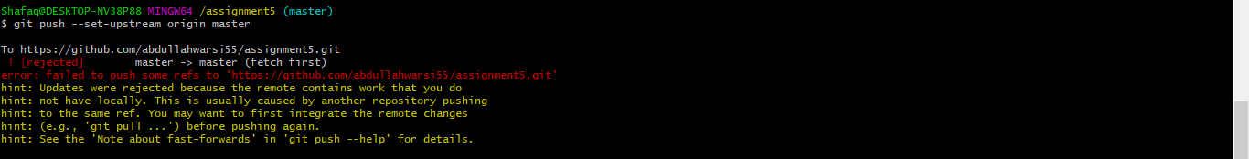

**Simple push, clone and pull**

