**Software Process Model**

The software process model that will be adopted for this project will be the Agile-based Scrum framework. We will be carrying out **five one-week** long sprints to address the four core milestones of this project. These sprints will be used to carry out tasks related to the planning, modelling, development, deployment and documentation of classrook. Refer to the Project Plan for the exact timeline of the different milestones for each product feature that are planned to be implemented.  
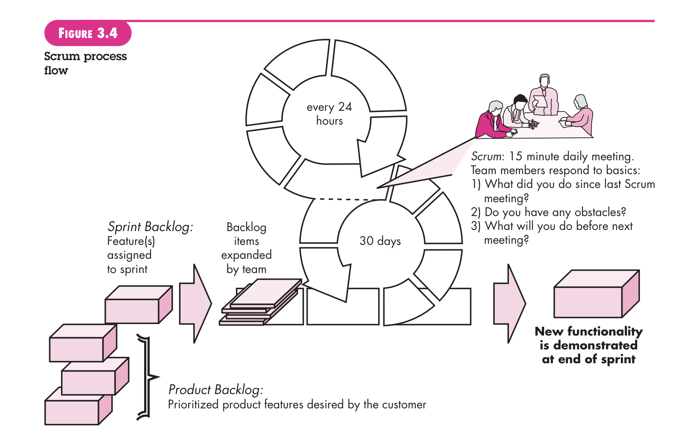

Justification: There are many software process models. However, we have decided to use an Agile/Scrum approach. There are multiple reasons why scrum is preferred for this project and they have been outlined below:

1) The team developing the project is **small** (four members), and since scrum provides a framework that allows for close collaboration and teamwork, it will prove to be optimal given the development team.

2) The needs of the clientele (i.e the student population) would be **subject to change** depending on how they decide to interact with the different material related to courses. Hence, we require a framework that allows for the greatest deal of flexibility.

3) We need a framework that allows us to rapidly prototype different components of our application and **see how the end-users respond to it**. Hence, an agile methodology would allow us to do this.

4) Agile works best when the team members are competent and able to complete tasks by taking initiative. The team working on classrook fits this category and would result in more efficient operation  
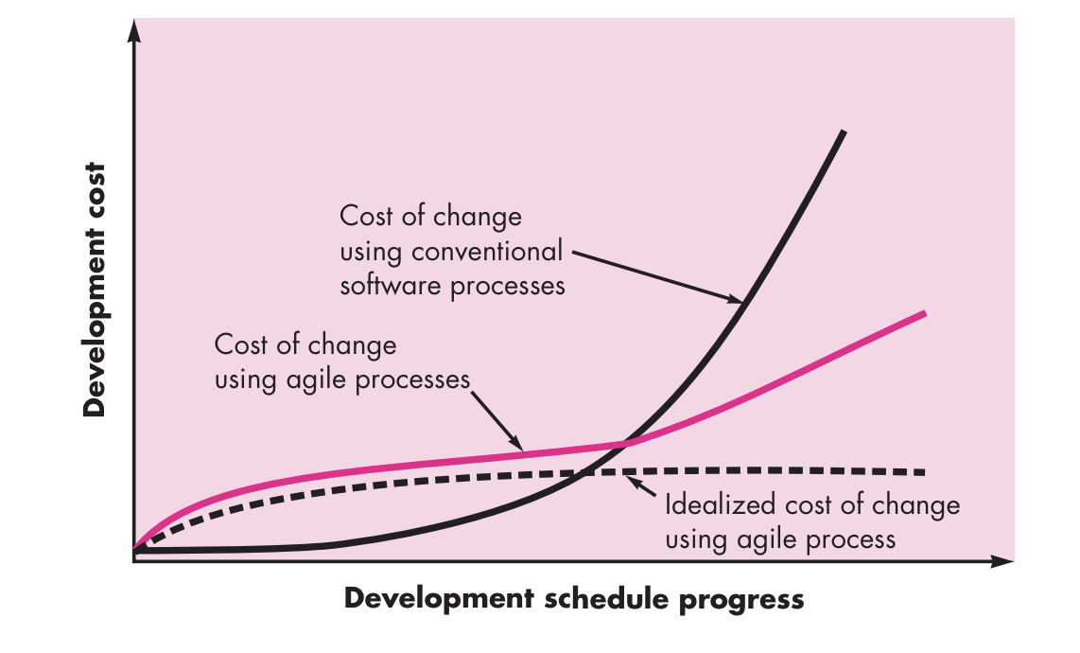

As we can see from the above chart, by utilizing an agile/scrum framework, we would be able to break down our ever-evolving feature set of our project and approach it in a evolving manner. This would enable us to adapt to changes with a lower cost, especially as classrook progresses, and the business demands evolve.