

**An-Najah National University**

**Computer Information System**

**Abdullah Rayyan**

**Ali Tammam**

**Supervisor: Dr-Mai Abusir**

**Smart Waiter Robot System**

Contents

Chapter 1: 2

1.1 Introduction: 2

1.2 Purpose: 2

1.3 Scope: 2

1.4 Motivation: 3

1.5 References: 4

1.6 Overview of Document: 4

Chapter 2: Overall Description: 4

2.1 Description: 4

2.2 System Architecture: 5

2.3 Product perspective 6

2.4 Hardware: 7

2.4.1 Arduino Mega: 7

2.4.2 IR Sensor: 8

2.4.3 HC-SR04 Ultrasonic Sonar:. 9

2.4.4 H-BRIDGE: 10

2.4.5 DC-MOTOR: 10

2.4.6 Robot Plastic Tire Wheel: 11

2.5 System Overview: 11

2.6 Software: 17

Chapter 3: Code Sequence: 21

3.1 Flowchart: 21

3.2 Code Explanation: 21

Chapter 4: Result Analysis: 25

Chapter 5: Conclusion and Future Scope: 27

# Chapter 1:

## Introduction:

### In today's world, advances in scientific methods and technological innovation have increased the ability to apply autonomy from traditional robots to the application of specific robots. The value of the work hour is likely to rise. With the global IT sector exploding, there is no need for children and youth to work as a hotel waiter and fast food chains. The workforce is still a problem in the industry, with workers being inefficient and sometimes not present. They will still need training and push-drain. We also estimate that, in the longer term, robots will be cheaper to pay the minimum wages for workers. Restaurants can hire fewer employees and fewer problems.

## Purpose:

## The purpose of this document is to present a detailed description of the Waiter Robot System. It will explain the purpose and features of the system, the interfaces of the system, what the system will do, the constraints under which it must operate and how the system will react to external stimuli.

## Scope:

The smart waiter robot system is a software and hardware application, the smart waiter robot follows a specific path towards the custom robot after giving the seat numbers on the console attached to the robot. When they reach a certain seat, and when the order is prepared, the robot walks to the customer and submits the order. Then, after the guests get their food from the tray, the robot returns to its place. Additional sensors can be connected to allow the robot to detect obstacles, bypass them if possible and return to the line. In other words, he should be able to predict the line that crosses the obstacle.

Robots run along light-sensitive strips on the ground. They can carry food trays, receive customers and deliver the customer to the seat they want. Thanks to optical or magnetic sensors, robots can know exactly where to stop at the restaurant, and return to their place when the food is delivered.

The microcontroller on the robot will be able to receive instructions from the central unit - the microcontroller in the kitchen about where to deliver the food. You will digest this information and determine the path of the robot. The microcontroller in the kitchen also displays the tables that are served. Due to time constraints, we have appointed a large design laboratory and seats (supposed to emulate a restaurant) in our program.

## Motivation:

Regarding the problems observed in Palestine with regard to the problem in question, we began to search for solutions to this problem and finally reached the answers that we were looking for. We have successfully discovered that at Harbin Restaurant in Heilongjiang Province in China, there is a restaurant called "Robot Restaurant" that has an automatic waiting table crew. [1] These robots are able to travel through sensors in a certain path and are able to serve 30 different dishes and have a battery life of four to five hours. [1]

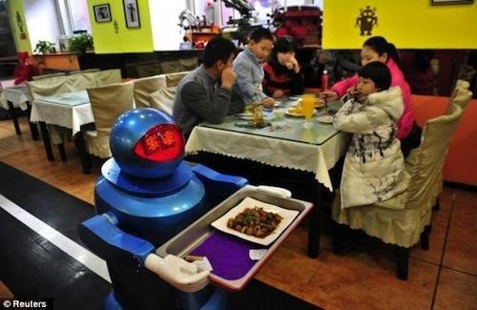

Fig.1 Robots used in restaurants abroad

Implementing robots in commercial industries and many other companies has proven to provide a very promising future for advanced robots. We can understand its impact on the industrial market only by seeing how much effort and financial support a particular company provides in making robots like a robot bartender. Harbin Haohai Robot has invested a total of 5 million yuan in the mass production of these robots, and each robot costs around 200,000 to 300,000 yuan. [1] Based on the details of this result, we decided that a similar project could be implemented in Palestine in a cost-effective manner. By collecting industrial and marketing facts, this project can then be improved and implemented in a more accurate and beneficial way. Thus, the waiter inspiration gave us hope to turn an innovative idea into a possible reality.

## References:

[1] “Restaurant in China Employs Robotic Wait Staff & Chefs,” [*http://www.designnews.com/author.asp?section_id=1386&doc_id=258859&dfpPParams=ind_182,aid_258*](http://www.designnews.com/author.asp?section_id=1386&doc_id=258859&dfpPParams=ind_182,aid_258859&dfpLayout=blog&dfpPParams=ind_182,aid_258859&dfpLayout=blog)[*859&dfpLayout=blog&dfpPParams=ind_182,aid_258859&dfpLayout=blog*](http://www.designnews.com/author.asp?section_id=1386&doc_id=258859&dfpPParams=ind_182,aid_258859&dfpLayout=blog&dfpPParams=ind_182,aid_258859&dfpLayout=blog) ,Feb 5, 2015

## Overview of Document:

The second chapter is the Overall Description section, provides more details of the system Description in and its functionality. This chapter also introduces different types of stakeholders and their interaction with the system. Further, the section also mentions the system constraints and assumptions about the product. The third chapter provides the requirements specification in detailed terms and a description of the different system interfaces.

# Chapter 2: Overall Description:

## 2.1 Description:

This section will provide an overview of the whole system. The system will be explained in its context and show basic functionality of it. It will also describe what type of stakeholders that will use the system and what functionality is available for each type.

The system architecture shown in the figure above provides a quick overview of how each system interacted with each other. As we can imagine, the controller (ATMega2560) receives the table number as input from the chef's disk when the request is completed as destination information is communicated via the Bluetooth chip. It then indicates the engine control units to start the engine with respect to the infrared sensor and ultrasound sensor values ​​received, respectively. Using these values, the microcontroller detects if there is any obstacle in the path and also decides whether the robot has reached its intended destination. Once it reaches its correct position, it indicates the motor to deviate from its idle position and establish contact with the linear motor allowing it to serve the meal.

## 2.2 System Architecture:

Fig: Block Diagram of entire System

The system architecture shown in the figure above provides a quick overview of how each system interacted with each other. As we can imagine, the controller (ATMega2560) receives the table number as input from the chef's disk when the request is completed as destination information is communicated via the Bluetooth chip. It then indicates the engine control units to start the engine with respect to the infrared sensor and ultrasound sensor values ​​received, respectively. Using these values, the microcontroller detects if there is any obstacle in the path and also decides whether the robot has reached its intended destination. Once it reaches its correct position, it indicates the motor to deviate from its idle position and establish contact with the linear motor allowing it to serve the meal.

## 2.3 Product perspective

#### In the smart waiter system, the customer will place the order on the tablet that is placed in each table. On each tablet, the welcome screen appears first followed by the menu screen for selecting food. According to their requirements, food can be added using an easy-to-use "mobile application", in parallel, it also calculates the price of the desired food. This request will be displayed in the supervisor section, the corresponding food is prepared and placed on the waiter robot tray and the table is chosen by the supervisor. The waiter robot used in the smart restaurant uses the phenomenon of following the line. It uses two IR sensors installed below that are used for the next line and for keeping the robot in line. The same infrared sensors are used to get to know the table. The infrared sensor is used as a feedback component to keep the robot in line according to where the robot is moving, whether on the black line or outside it. According to the inputs of this sensor, Arduino will drive the gear motor through the motor drive according to the programmer directed. The waiter robot uses an ultrasound scanner to detect obstacles. The waiter robot starts to move toward the specified table and stops when it reaches the concerned table, then waits for the robot until the customer takes food. After food is taken out, the robot will return to the reception section. The most important part of the smart restaurant is the mobile app. The tablet was launched in every schedule with the mobile app. This application allows access to the menu.

#### The system combined of hardware components and software components.

#### Basic hardware components:

* Arduino Mega.
* IR sensor (#2)
* HC-SR04 Ultrasonic Sonar.
* DUAL H-BRIDGE MOTOR DRIVER L298N
* Dc motor GA37RG 12V dc gear motor (#4)
* Plastic Tire Wheel (#4).

## 2.4 Hardware:

### 2.4.1 Arduino Mega:

Arduino is an open-source physical computing platform based on a simple i/o board and a development environment that implements the Processing/Wiring language. Arduino can be used to develop stand-alone interactive objects or can be connected to software on your computer (e.g. Flash, Processing, MaxMSP). The open-source IDE can be downloaded for free (currently for Mac OS X, Windows, and Linux).

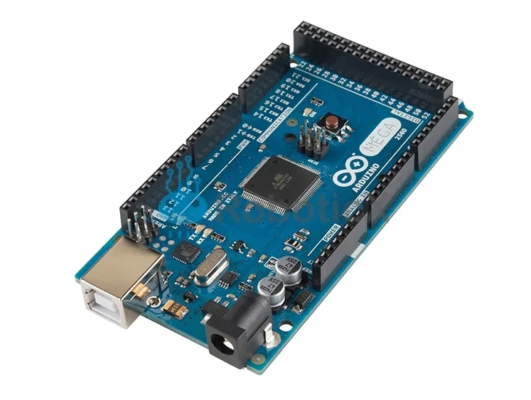

The Arduino Mega is a microcontroller board based on the ATmega2560. It has 54 digital input/output pins (of which 14 can be used as PWM outputs), 16 analog inputs, 4 UARTs (hardware serial ports), a 16 MHz crystal oscillator, a USB connection, a power jack, an ICSP header, and a reset button. It contains everything needed to support the microcontroller; simply connect it to a computer with a USB cable or power it with a AC-to-DC adapter or battery to get started. The Mega is compatible with most shields designed for the Arduino Duemilanove or Decimal.

### 2.4.2 IR Sensor:

An infrared (IR) sensor is an electronic device that measures and detects infrared radiation in its surrounding environment. There are two types of infrared sensors: active and passive. Active infrared sensors both emit and detect infrared radiation. Active IR sensors have two parts: a light emitting diode (LED) and a receiver. When an object comes close to the sensor, the infrared light from the LED reflects off of the object and is detected by the receiver. Active IR sensors act as proximity sensors, and they are commonly used in obstacle detection systems (such as in robots).

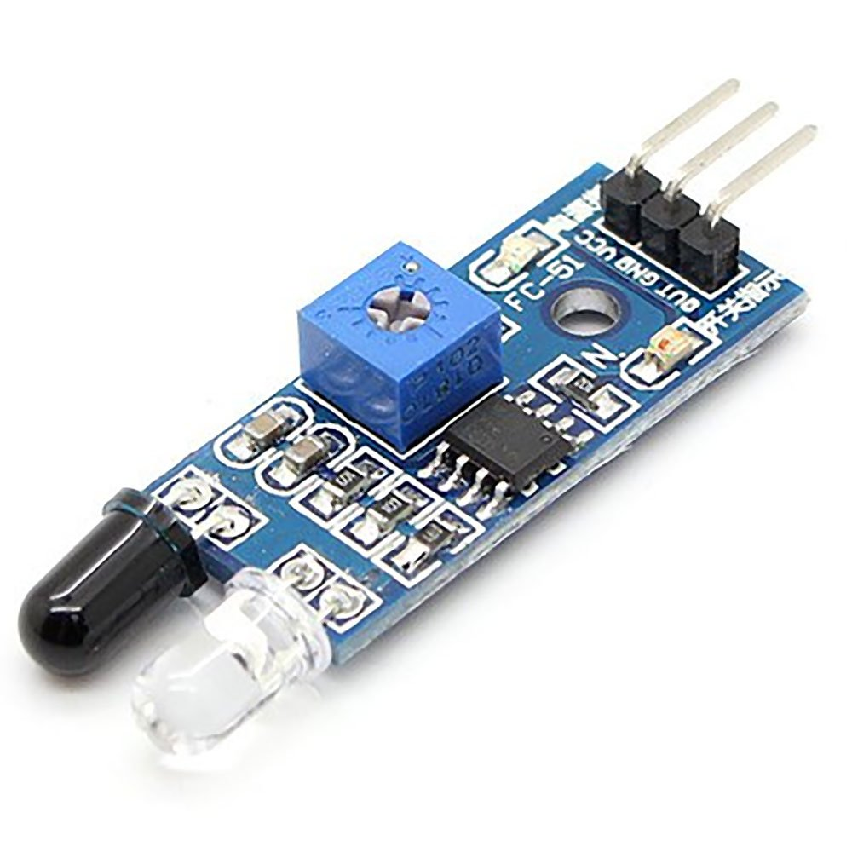

### 2.4.3 HC-SR04 Ultrasonic Sonar: Ultrasonic distance sensor determines the distance to an object by measuring the time taken by the sound to reflect back from that object. The frequency of the sound is somewhere in the range of ultrasound, this ensures more concentrated direction of the sound wave because sound at higher frequency dissipates less.

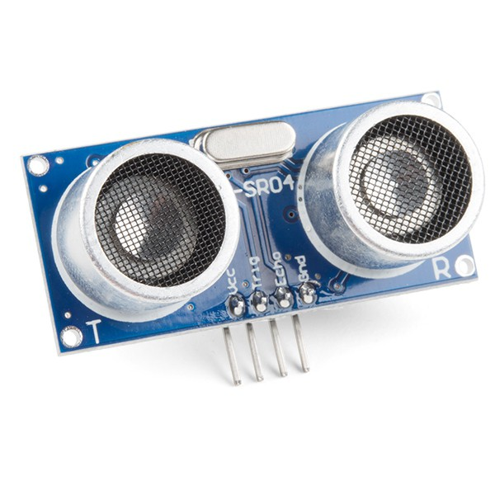

in the environment. A typical ultrasonic distance sensor consists of two membranes. One membrane produces sound, another catches reflected echo. Basically they are speaker and microphone. The sound generator generates short ultrasonic impulses and triggers the timer. Second membrane registers the arrival of the sound impulse and stops the timer. From the timers time it is possible to calculate the distance traveled by the sound. The distance to the object is half of the distance traveled by the sound wave.[5]

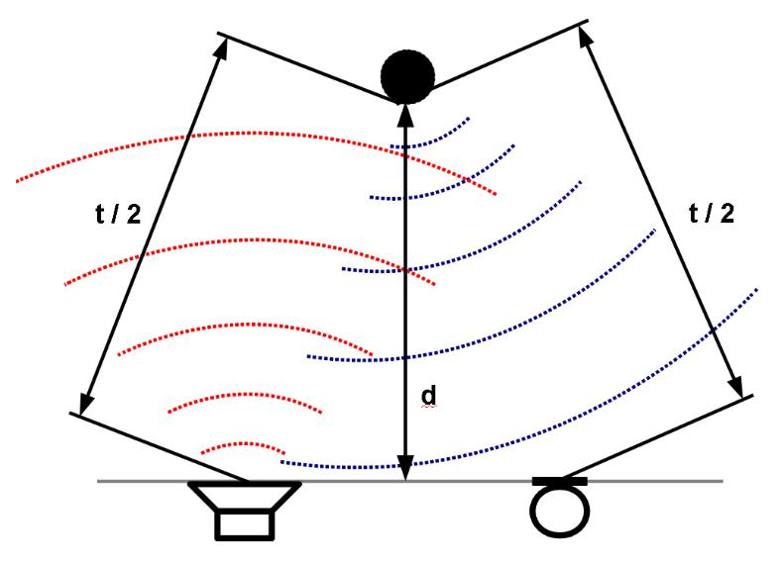

Fig. Ultrasonic Working Principle [5] In the picture above, a clear working principle of the ultrasonic sensor is shown. One membrane is the transmitter of ultrasound and the other is the receiver. These two units work together in making the ultrasonic sensor work in its own efficiency. The time taken for the ultrasonic wave to transmit and reach the object is half the time it takes to travel and come back to the receiver membrane. Using ultrasonic sensors in any robot allows the users the cutting edge technology to detect and avoid obstacles accordingly. Let us see how to we have connected the ultrasonic sensor to the arduino.

### 2.4.4 H-BRIDGE: This is the popular L298N Dual H-Bridge Motor Controller, typically used to control motor speed and rotation direction. It can also be used for other products such as with LED arrays, relays, and solenoids, etc. It's a powerful little motor driver with a heavy-duty heat sink. Capable of powering 5-35V motors with a max of 2A.

### 2.4.5 DC-MOTOR: FEATURE: The motor is made of metal gear, wear-resisting, avoid tooth breaking, so with long serving life, this motor is adopted of pure copper wire coil, with low heat and low loss. D SHAPED OUTPUT SHAFT: Using high hardness steel, good toughness, impact resistance, the quality of the bearing and the service life of the gear motor are improved, extremely durable. PARAMETER: Rated power is 60W, Rated voltage is12 V, rated current is 0.32 (A), rated speed is 12000 (RPM).

### 2.4.6 Robot Plastic Tire Wheel:

This Robot Plastic Tire Wheel is match for 4mm shaft diameter gear motors and stepper motors.

### 

## 2.5 System Overview:

Line follower Robot is a machine which follows a line, either a black line or white line. Basically, there are two types of line follower robots: one is black line follower which follows black line and second is white line follower which follows white line. Line follower actually senses the line and run over it.

**Concepts of Line Follower:**

Concept of working of line follower is related to light. We use here the behavior of light at black and white surface. When light fall on a white surface it is almost full reflected and in case of black surface light is completely absorbed.

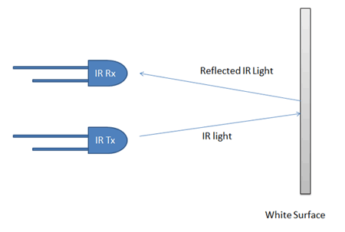

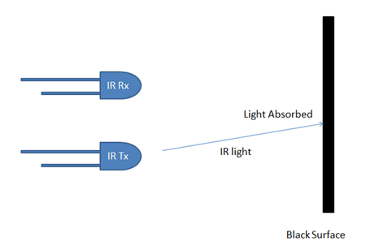

In this Arduino based line follower robot we have used IR Transmitters and IR receivers also called photo diodes. They are used for sending and receiving light. IR transmits infrared lights. When infrared rays fall on white surface, it’s reflected back and catched by photodiodes which generates some voltage changes. When IR light falls on a black surface, light is absorbed by the black surface and no rays are reflected back, thus photo diode does not receive any light or rays.

Here in this Arduino line follower robot when sensor senses white surface then Arduino gets 1 as input and when senses black line Arduino gets 0 as input.

**Circuit Explanation:**

The whole Arduino line follower robot can be divided into 3 sections: sensor section, control section and driver section.

**Sensor section:**

This section contains IR diodes, potentiometer, Comparator (Op-Amp) and LED’s. Potentiometer is used for setting reference voltage at comparator’s one terminal and IR sensors are used to sense the line and provide a change in voltage at comparator’s second terminal. Then comparator compares both voltages and generates a digital signal at output. Here in this line follower circuit we have used two comparators for two sensors. LM 358 is used as comparator. LM358 has inbuilt two low noise Op-amps.

**Control Section:**

Arduino Pro Mini is used for controlling whole the process of line follower robot. The outputs of comparators are connected to digital pin number 2 and 3 of Arduino. Arduino read these signals and send commands to driver circuit to drive line follower.

**Driver section:**

Driver section consists motor driver and two DC motors. Motor driver is used for driving motors because Arduino does not supply enough voltage and current to motor. So we add a motor driver circuit to get enough voltage and current for motor. Arduino sends commands to this motor driver and then it drive motors.

**Working of Line Follower Robot using Arduino:**

Working of line follower is very interesting. Line follower robot senses black line by using sensor and then sends the signal to Arduino. Then Arduino drives the motor according to sensors' output.

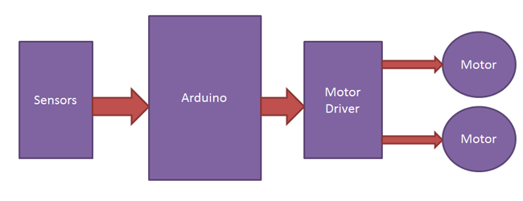.

**Case 1:** Here in this project we are using two IR sensor modules namely left sensor and right sensor. When both left and right sensor senses white then robot move forward.

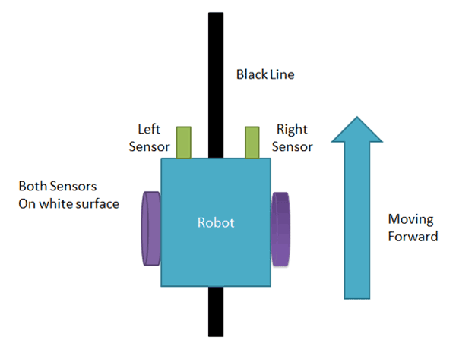

**Case 2:** If left sensor comes on black line then robot turn left side.

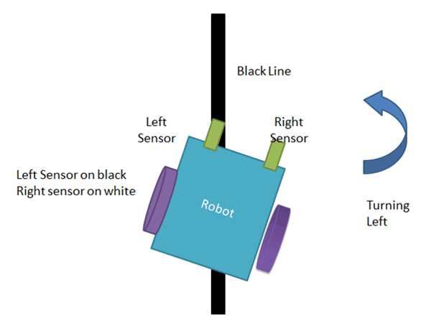

**Case 3:** If right sensor sense black line then robot turn right side until each sensor comes at white surface. When white surface comes robot starts moving on forward again.

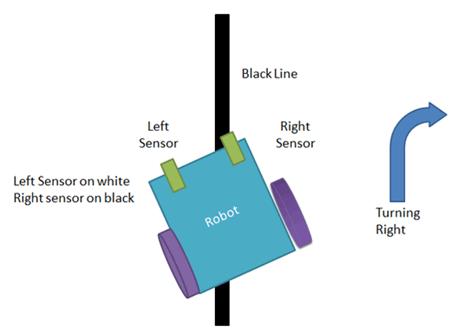

**Case 4**: If both sensors comes on black line, robot stops.

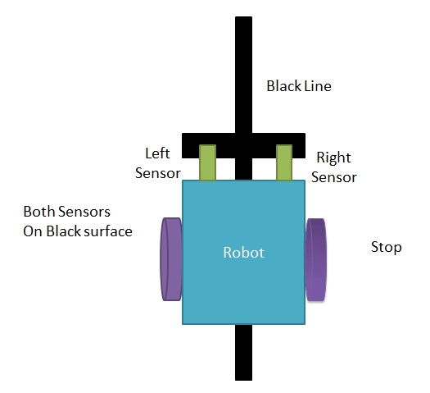

## 2.6 Software:

In this section. We will explain the process when the user enters the restaurant until he gets the order.

As mentioned earlier, tablets will be on restaurant tables.

was developing and designing application to end user ability choose order food via screens clear and easy appropriate for different customers and all persons. This was done by careful focus on (UI / UX) mainly in this mobile application.

After welcoming, user can be select category food from this screen, followed by the price of each category food and calculates the final price of the order. User can choose any category he wants from this screen, when click send the order will appear at the order supervisor in the kitchen, taking into account the priority of requests for each table.

**Screenshots**

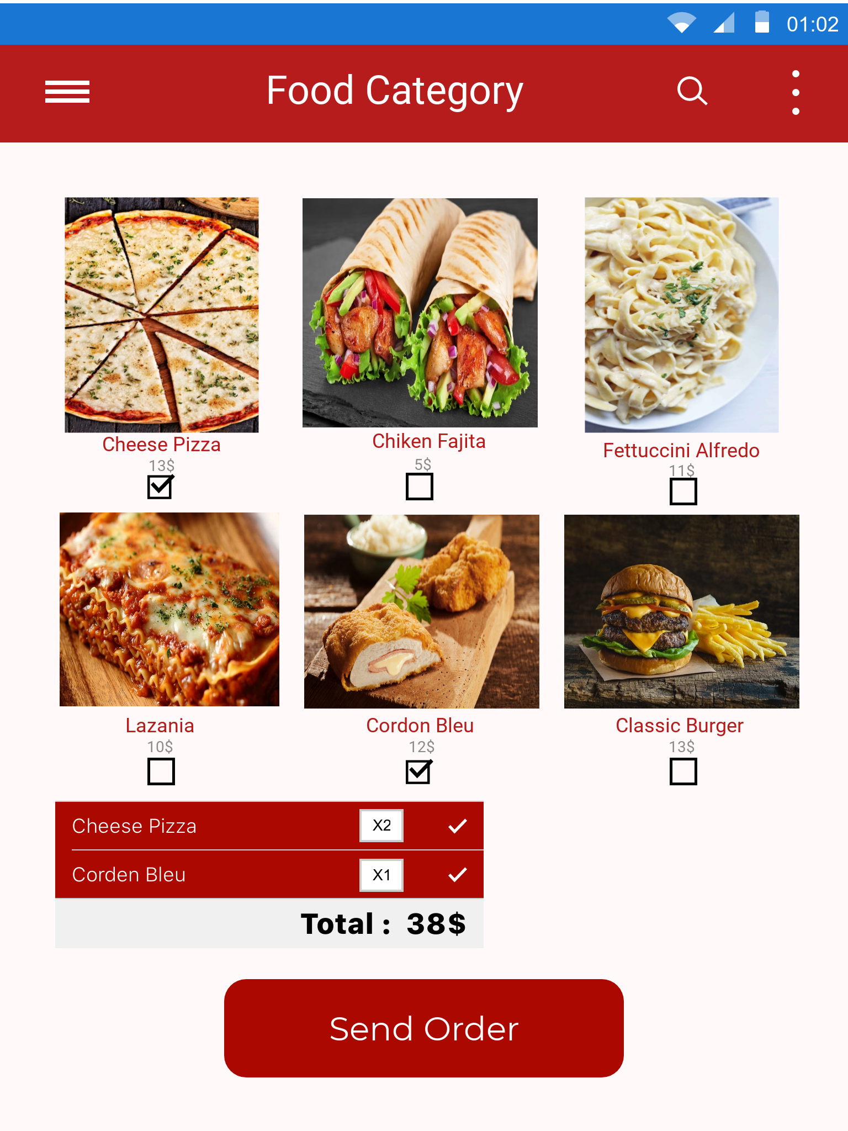

The customer selects order by click at check box below the food item icon chosen, where the items appear as a separate menu indicating the type, quantity and price. (Client)

When click send request, its stored in database and transferred to kitchen. (Server)

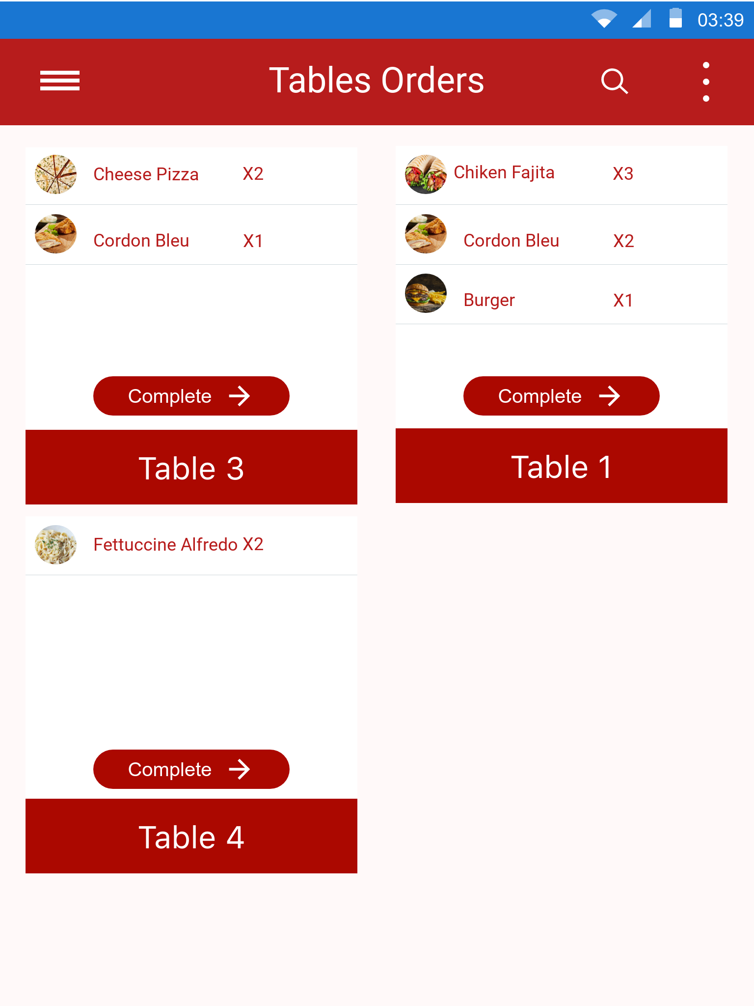

The chef receives requests according to the priority of time. When chief finished the table order he put order on the robot and click complete button on his tablet then robot go to selected table.

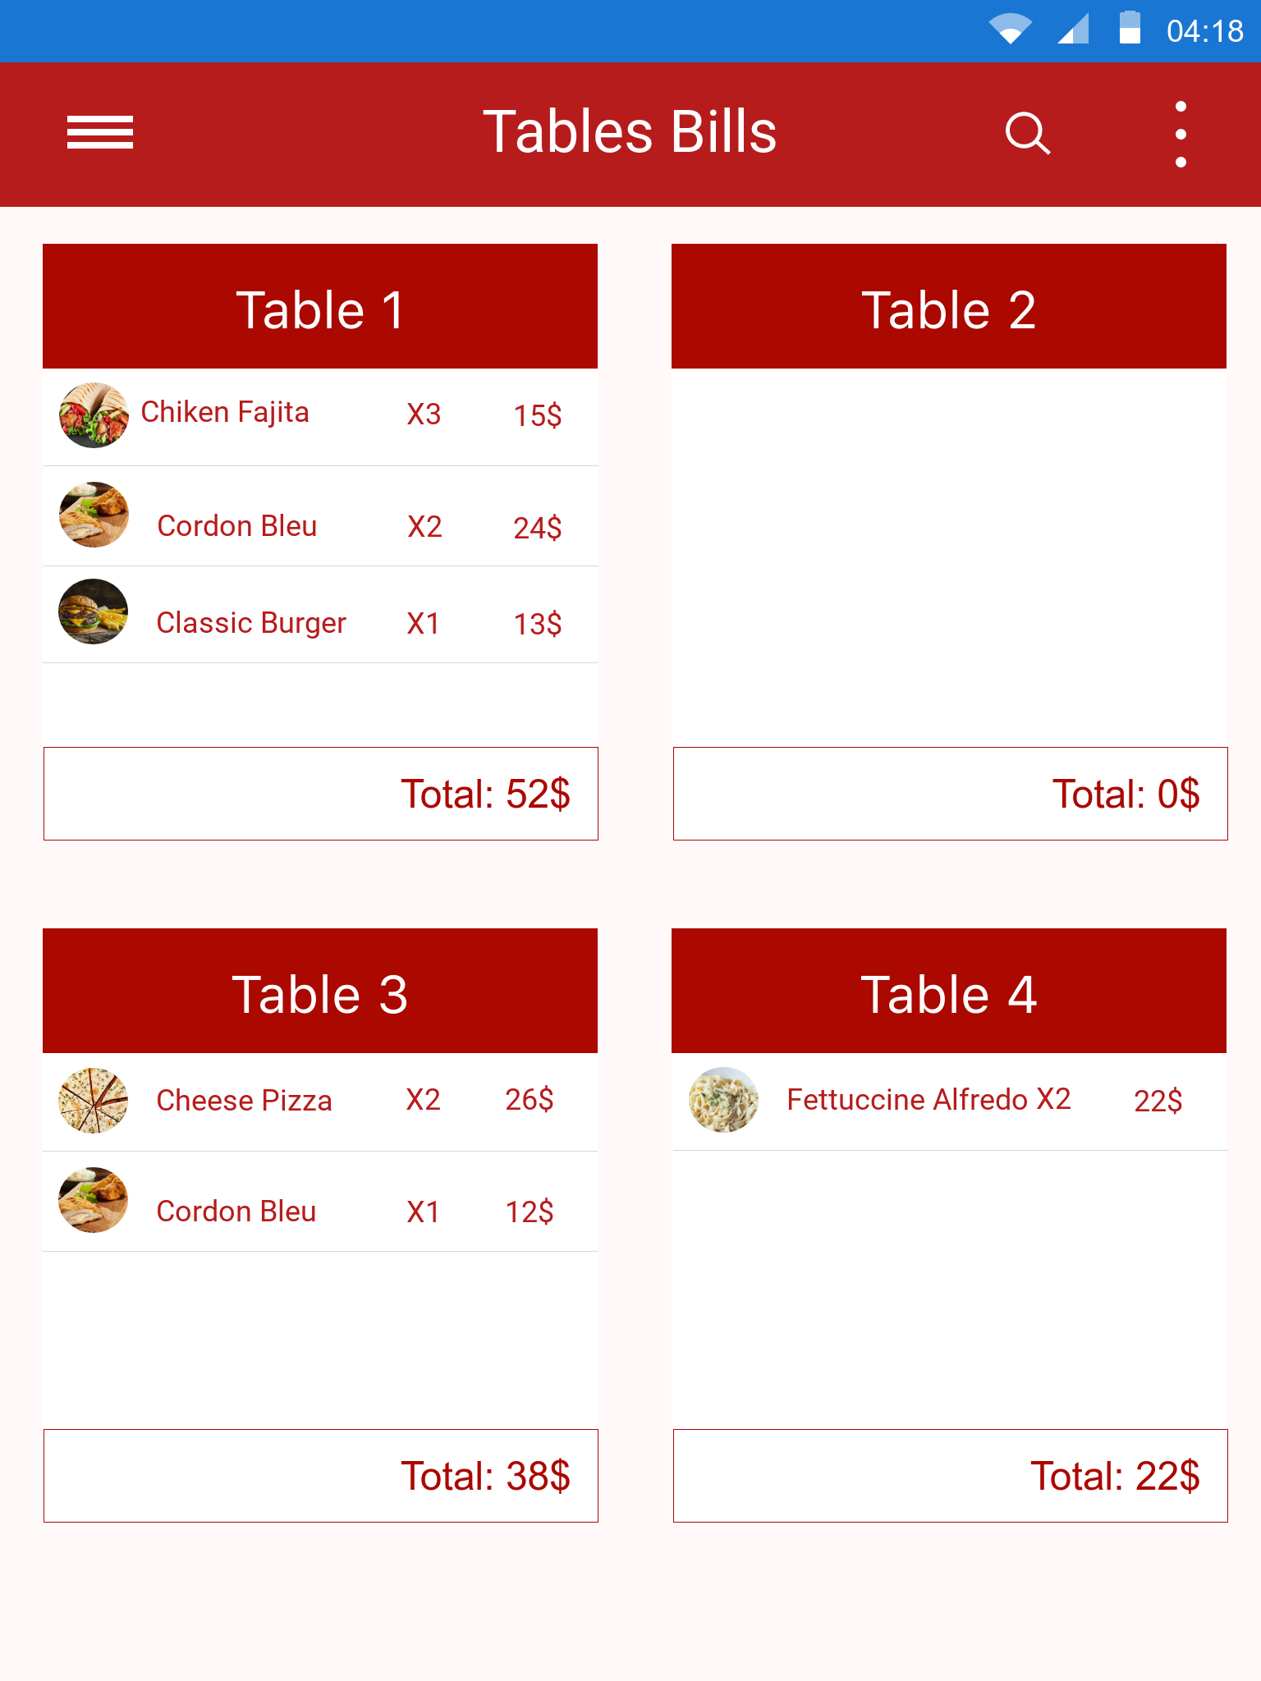

An extra screen showing how table bills are paid and displayed to the cashier by simple and clear way. Payment is separate from the robot operations, and we hope later that development on the robot so that it performs similar and more complex operations.

# Chapter 3: Code Sequence:

## 3.1 Flowchart:

## 3.2 Code Explanation:

The robot has a few connected program modules on various computing boards.  
We use C on IAR ARM to program an STM32 microcontroller (control of engines and distance sensors. C on Arduino IDE is used to program (Lidar management and measuring preparation). C++ on MSVC is used for Windows OS (of the robot tablet computer and the operator’s work tool) programing.

**volatile unsigned int temp = 0;**

**const int IN1 = 7;**

**const int IN2 = 6;**

**const int IN3 = 5;**

**const int IN4 = 4;**

**const int ENA = 9;**

**const int ENB = 10;**

**const int IRL = A0;**

**const int IRR = A1;**

**int LEFT_SENSOR = 1000;**

**int RIGHT_SENSOR = 1000;**

**int thresholdIR = 50;**

**int program = 0;**

**int moveNum = 0;**

**void setup() {**

**Serial.begin (9600);**

**pinMode (IN1, OUTPUT);**

**pinMode (IN2, OUTPUT);**

**pinMode (IN3, OUTPUT);**

**pinMode (IN4, OUTPUT);**

**pinMode (ENA, OUTPUT);**

**pinMode (ENB, OUTPUT);**

**pinMode(IRL, INPUT); // initialize Right sensor as an inut**

**pinMode(IRR, INPUT); // initialize Left sensor as as input**

**delay(300);**

**analogWrite(ENA, 200);**

**analogWrite(ENB, 200);**

**T1();**

**}**

**void T1() {**

**if (program == 0) {**

**LEFT_SENSOR = analogRead(IRL);**

**RIGHT_SENSOR = analogRead(IRR);**

**if (RIGHT_SENSOR < thresholdIR && LEFT_SENSOR < thresholdIR) //FORWARD**

**{**

**moveForward();**

**}**

**else if (RIGHT_SENSOR > thresholdIR && LEFT_SENSOR < thresholdIR) //LEFT**

**{**

**moveLeft();**

**}**

**else if (RIGHT_SENSOR < thresholdIR && LEFT_SENSOR > thresholdIR) //RIGHT**

**{**

**moveRight();**

**}**

**else if (RIGHT_SENSOR > thresholdIR && LEFT_SENSOR > thresholdIR) //BACK**

**{**

**mstop();**

**delay(3000);**

**while(RIGHT_SENSOR < thresholdIR || LEFT_SENSOR < thresholdIR){**

**LEFT_SENSOR = analogRead(IRL);**

**RIGHT_SENSOR = analogRead(IRR);**

**moveBack();**

**delay(2000);**

**mstop();**

**}**

**}**

**}**

**}**

**void loop() {**

**T1();**

**delay(100);**

**}**

**void moveForward() {**

**digitalWrite(IN1, HIGH);**

**digitalWrite(IN2, LOW);**

**digitalWrite(IN3, LOW);**

**digitalWrite(IN4, HIGH);**

**}**

**void moveBack() {**

**digitalWrite(IN1, LOW);**

**digitalWrite(IN2, HIGH);**

**digitalWrite(IN3, HIGH);**

**digitalWrite(IN4, LOW);**

**}**

**void moveLeft() {**

**digitalWrite(IN1, LOW);**

**digitalWrite(IN2, LOW);**

**digitalWrite(IN3, HIGH);**

**digitalWrite(IN4, LOW);**

**}**

**void moveRight() {**

**digitalWrite(IN1, LOW);**

**digitalWrite(IN2, HIGH);**

**digitalWrite(IN3, LOW);**

**digitalWrite(IN4, HIGH);**

**}**

**void mstop() {**

**digitalWrite(IN1, LOW);**

**digitalWrite(IN2, LOW);**

**digitalWrite(IN3, LOW);**

**digitalWrite(IN4, LOW);**

**}**

# Chapter 4: Result Analysis:

In this chapter we will see precisely how the waiter-robot performed and how much success rate it has achieved. Based on the number of trials executed from the beginning of the project implementation, a record of each success and each failure were noted. With the help of this data we were able to create a bar chart which shows us exactly how many times the project was a success and how many times the project was a failure out of a total number of trials. The bar chart is given below.

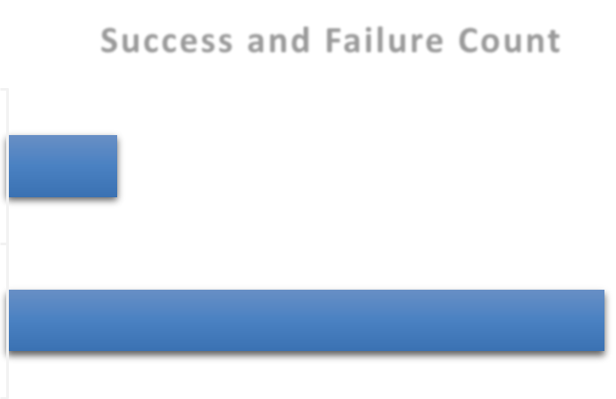 Fig. Success and Failure Count

As you can see from the bar chart, it is clear that out of a trail of 150 times, we were able to achieve a success of 111 times and have also confronted with a failure of 39 times. To be more elaborate, the first 11 to 16 trails were a continuous failure. This was because at the beginning of the project we were unable to make the robot detect the line itself. The IR sensor values used in the code were not right and the distance between the IR sensor array and the ground was not proper. This particular issue was solved after a long monotonous but careful process of tuning. By now the robot was somewhat capable of detecting white line and black line with quite legitimate accuracy. None the less, the robot was not able to stop at the right place at the right time. This is because the motor speed was initially high and it took the robot some time to come to a complete stop. By the time it did, it used to stop just a bit front of the respective table. This was due to inertia of motion of the robot as the robot had a considerable amount of weight. Thus the next few trials were also mixed with a bit of success but more failures. As a result the motor speed had to be calibrated according to our necessity and the robot was tuned to perfection. Finally, towards the end of the trials the robot functioned flawlessly without the requirement of further tuning. A pie chart of the total percentage of success and the total percentage of failures is provided below.

Fig. Success and Failure Percentage

As you can see, the pie chart above gives us an estimate of the precision and accuracy of the waiter-bot. after extreme hard work and relentless trial and error procedures we were successfully able to generate a success rate of 74% with the waiter-robot.

# Chapter 5: Conclusion and Future Scope:

The introduction of the waiter-bot in the markets of Palestine will bring about a drastic change in the standard of our country to its neighboring countries. Not only that, it will also get a worldwide technological recognition. In the particular field and business, this project is the first and may have a high probability to become an influential aspect towards an economic boost. Palestine business is a rapid expanding market in its own way. If, with a strong patience, this project is tested on the field directly for a couple of months and the results on the market situation and the business status is analyzed, then an even better conclusion may be driven from its effects on marketing strategy. It is guaranteed that a particular restaurant with an automated staff will attract a lot of customers within its domain. People will seem to simply prefer that particular restaurant just to see the automated staff in action. With hard work and creativity, a particular restaurant such as this may turn into a tourist spot for many foreigners. A lot of side business may take a hold in the market due to the influence of automated restaurants in the near future. If so as more and more restaurants become automated the basic revenue from each of these restaurants will surely provide an extreme economic boost to the nation. Besides the business and marketing advantages, there is more to the waiter-bot than what it seems like. The use of waiter-bot will reduce human effort and create a comfortable lifestyle new. Never the less, it will ignite the vision of complete automation in the near future if the youngsters of this generation and the next are introduced to this particular simple yet new technological implementation.