Transfer Learning for Phosphene-Based Object Recognition

in Cortical Visual Prostheses
Abdulla Shahzan
Department of Computer Science, King Khalid University, Abha, Saudi Arabia

Abstract
Cortical visual prostheses restore some degree of sight to blind individuals by stimulating the visual cortex electrically, producing perceived spots of light called phosphenes. Because the number of stimulating electrodes is orders of magnitude smaller than the photoreceptor count in a healthy eye, the resulting visual field is severely degraded. Intelligent image-processing systems that can infer object identity from these sparse, noisy patterns are therefore essential to making prosthetic vision practically useful. This paper examines whether convolutional neural networks pre-trained on large natural-image datasets can transfer their learned representations to the task of recognising objects in phosphene-simulated imagery. We constructed a six-stage phosphene simulation pipeline and applied it to CIFAR-10, then fine-tuned EfficientNet-B0 in two conditions: initialised with ImageNet weights (transfer learning) and initialised randomly (training from scratch). After ten epochs, the transfer-learning model reached 69.21% test accuracy against 62.31% for the from-scratch baseline—a 6.90 percentage-point improvement. Per-class analysis shows the gains are consistent across all ten categories, with the largest single improvement of 14.80 points on the cat class. These results suggest that low- and mid-level visual features learned from natural images survive the severe degradation imposed by phosphene simulation and remain useful for downstream classification.
Index Terms—cortical visual prosthesis, bionic eye, phosphene simulation, transfer learning, EfficientNet, deep learning, object recognition.

INTRODUCTION
Blindness affects hundreds of millions of people globally. Retinal prostheses such as the Argus II have already demonstrated that electrical stimulation of the visual pathway can restore rudimentary sight, but the more ambitious goal of bypassing a damaged retina entirely through direct cortical stimulation has only recently become practically feasible. Systems like the Orion Visual Cortical Prosthesis (Cortigent), the Illinois Intracortical Visual Prosthesis (ICVP), and Neuralink's Blindsight project are now in various stages of human testing, each implanting electrode arrays directly onto or into the tissue of the primary visual cortex [1]–[3].
The fundamental limitation of all current devices is electrode count. A healthy human eye contains roughly one million photoreceptors; existing cortical implants provide between 60 and approximately 3,000 stimulation sites. Each active electrode evokes a phosphene—a localised percept of light whose position, brightness and size depend on stimulation parameters and cortical retinotopy. The composite pattern of phosphenes that a user perceives is therefore an extremely sparse, dot-like rendering of the visual scene, far removed from what a sighted person would see [4].
One approach to compensating for this sensory impoverishment is to move computational intelligence upstream, having the device's external camera and processor recognise objects and present only the most decision-relevant phosphene patterns to the user. This raises a concrete machine-learning question: can a neural network trained on ordinary photographic images learn representations that remain useful after the image has been degraded to resemble phosphene vision? Transfer learning—the practice of initialising a model with weights obtained from training on a large related dataset—is the standard tool for adapting deep networks to new domains [5], [6]. Whether it helps when the target domain involves such severe visual degradation is not obvious a priori.
This paper makes the following contributions. First, we describe a phosphene simulation pipeline that converts any RGB image into a representation resembling what a cortical implant user might perceive. Second, we report a controlled comparison between EfficientNet-B0 fine-tuned from ImageNet weights and the same architecture trained from random initialisation on phosphene-processed CIFAR-10. Third, we analyse per-class performance to identify which object categories benefit most from pre-trained features. The results provide empirical support for the hypothesis that transfer learning is beneficial even under extreme domain shift caused by phosphene simulation.

BACKGROUND AND RELATED WORK

Cortical Visual Prostheses
Unlike retinal implants, which require an intact optic nerve, cortical prostheses stimulate the visual cortex directly and can in principle restore sight even when the entire visual pathway anterior to the cortex is damaged. Brindley and Lewin performed the first cortical stimulation experiments in 1968 [7]; modern systems have progressed from single electrodes to implantable arrays with hundreds of contacts. The ICVP

uses a wireless 400-electrode array and has sustained stimulation for over two years in human volunteers [3]. Neuralink's Blindsight device, which received FDA Breakthrough Device designation in 2024, targets approximately 3,000 electrodes and aims at broader visual field coverage [2].

Phosphene Perception and Simulation
Phosphenes evoked by cortical stimulation vary in appearance depending on electrode location, current amplitude, pulse width and frequency. They have been described as round or elongated blobs of light, sometimes with colour or flickering, and their spatial arrangement roughly follows the retinotopic map of V1 [4], [8]. Computational models of phosphene appearance have been developed to predict perceptual outcomes without requiring human participants [9]. For the purposes of this study we adopt a simplified simulation (Section III-A) that captures the essential properties—low resolution, dot-like discrete elements, and stochastic noise—without attempting to model every electrode's spread function individually.

Deep Learning for Prosthetic Vision
Several groups have explored deep learning in the context of visual prostheses. Martel et al. [10] proposed an AI-augmented pipeline in which a scene-understanding network selects and prioritises visual information before it is encoded as a stimulation pattern. Computational virtual patient models based on deep neural networks have been used to simulate the perceptual consequences of different electrode configurations [9]. Vision Transformers have also been investigated as a potential encoder architecture [15]. To our knowledge, however, no prior work has directly compared transfer learning against random initialisation under phosphene-simulated input degradation using a controlled benchmark.

Transfer Learning
The canonical finding in transfer learning is that convolutional features trained on ImageNet—particularly early-layer detectors for edges, colours and textures—generalise broadly across vision tasks [5], [11]. Yosinski et al. showed that transferability degrades for layers that are further from the input but that even high-level features often transfer better than random initialisation [5]. EfficientNet, introduced by Tan and Le [12], scales network depth, width and input resolution simultaneously along an empirically derived compound coefficient. EfficientNet-B0 is the smallest member of the family and offers a favourable accuracy-to-parameter ratio that makes it practical for edge devices—an important consideration for wearable prosthetic systems.

METHODOLOGY

Phosphene Simulation Pipeline
We implemented a differentiable phosphene simulation transform composed of six sequential operations applied to each training and test image before it is passed to the network:
  - Grayscale conversion — the RGB image is reduced to a single luminance channel using the ITU-R BT.601 weighting.
  - Gaussian blur — a blur with standard deviation σ = 2.0 pixels is applied to mimic the lateral current spread that occurs when a cortical electrode is activated.
  - Downsampling — the blurred image is resized to a 64 × 64 grid representing the phosphene array, with each cell corresponding to one potential stimulation site.
  - Binary thresholding — pixel values above a fixed threshold are set to full brightness, producing the discrete high-contrast appearance of phosphene dots.
  - Noise injection — each pixel is independently zeroed with probability 0.10, simulating electrode failures and biological variability.
  - RGB replication — the single-channel result is broadcast to three channels so it can be processed by architectures that expect RGB input.
The output is a visually sparse image in which object shape is represented only by the arrangement of active phosphene dots. Figure 1 illustrates the effect of the pipeline on representative CIFAR-10 samples across several categories. The severity of the degradation is immediately apparent: fine texture, colour and mid-frequency spatial detail are entirely lost, leaving only coarse binary structure.

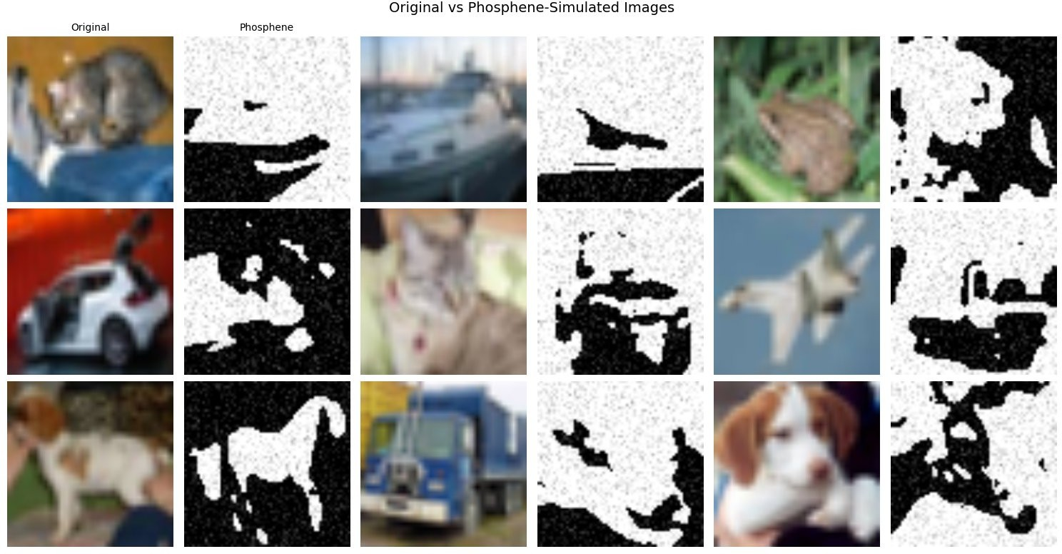
Fig. 1. Original CIFAR-10 images (left of each pair) alongside their phosphene-simulated counterparts (right). Each phosphene image is produced by the six-stage pipeline described in Section III-A. Colour, texture and fine spatial detail are eliminated; only coarse binary structure remains.

Dataset
We used CIFAR-10 [13], a standard benchmark comprising 60,000 colour images at 32 × 32 pixels across ten balanced classes: airplane, automobile, bird, cat, deer, dog, frog, horse, ship and truck. The training split contains 50,000 images and the test split contains 10,000. All images were resized to 224 × 224 to match EfficientNet-B0's expected input dimensions. Channel-wise ImageNet normalisation (μ = [0.485, 0.456, 0.406], σ = [0.229, 0.224, 0.225]) was applied in both conditions to ensure the comparison isolates weight initialisation.

Model Architecture
EfficientNet-B0 [12] has approximately 5.3 million parameters and achieves strong performance on ImageNet at relatively low computational cost. We replaced the original 1,000-class classification head with a single linear layer mapping the 1,280-dimensional penultimate representation to ten output logits. In the transfer-learning condition, all layers including the new head were fine-tuned; no layers were frozen. This full fine-tuning strategy was chosen because the phosphene domain is sufficiently different from natural images that intermediate feature maps may also benefit from adaptation.

Training Protocol
Both models were trained with AdamW optimisation [18] and an initial learning rate of 1 × 10−4, scheduled with cosine annealing over the full training run. Cross-entropy loss was used throughout. Batch size was 32 and training ran for ten epochs. The same random seed was set at the start of each run to control for stochastic variation. No data augmentation beyond the phosphene simulation was applied; we wanted to isolate the effect of weight initialisation rather than conflate it with augmentation strategy.
TABLE I TRAINING HYPERPARAMETERS

Hyperparameter | Value
Framework | PyTorch
Optimiser | AdamW
Learning rate | 1 × 10■■
LR schedule | Cosine annealing
Batch size | 32
Epochs | 10
Loss function | Cross-entropy
Phosphene grid | 64 × 64

RESULTS

Overall Accuracy and Loss
Table II summarises the final-epoch performance of both models. The transfer-learning model reached a test accuracy of 69.21% with a test loss of 0.9387, while the from-scratch model achieved 62.31% at a test loss of 1.0837. The absolute improvement of 6.90 percentage points is consistent and meaningful given the task difficulty: recognising objects in images that have been reduced to sparse binary dot patterns.
TABLE II FINAL-EPOCH PERFORMANCE COMPARISON

Model | Train Acc. | Test Acc. | Test Loss
Transfer Learning (ImageNet) | 79.03% | 69.21% | 0.9387
From Scratch (random init.) | 62.99% | 62.31% | 1.0837
Improvement | +16.04 pp | +6.90 pp | −0.1450

Training Dynamics
Figure 2 shows the training and test loss and accuracy curves across all ten epochs for both models. The left panel makes clear that the from-scratch model begins with substantially higher loss values (approximately 1.95 on the training set at epoch 0 vs. 1.40 for transfer learning) and descends more slowly throughout training. Both models' test losses stabilise after roughly epoch 4, suggesting that the networks are not still actively learning new generalisable features in later epochs—a pattern consistent with the plateau in test accuracy visible in the right panel.
The accuracy curves reveal the most telling aspect of the comparison: at epoch 1, the transfer-learning model's test accuracy is already 60.92%, while the from-scratch model reaches only 40.25%—a 20.67-point gap. The gap closes steadily to 6.90 points by epoch 10, indicating that the from-scratch model can partially recover given sufficient training, but never fully closes the deficit within the ten-epoch budget.
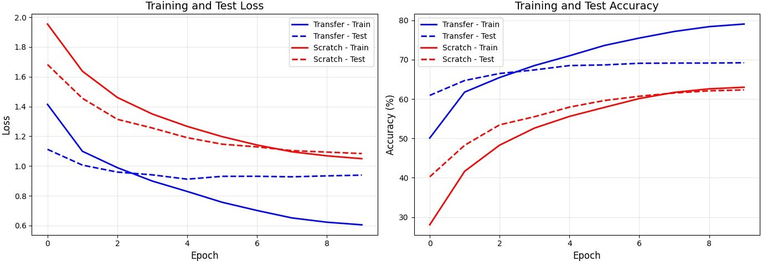
Fig. 2. Training and test loss (left) and accuracy (right) over ten epochs for both models. Blue lines: transfer learning. Red lines: training from scratch. Solid: training set. Dashed: test set. The large initial gap in accuracy (20.67 pp at epoch 1) narrows progressively, closing to
6.90 pp by epoch 10.

TABLE III TEST ACCURACY PER EPOCH

Epoch | Transfer Acc. | Scratch Acc. | Gap
1 | 60.92% | 40.25% | +20.67 pp
2 | 64.70% | 48.26% | +16.44 pp
3 | 66.48% | 53.44% | +13.04 pp
4 | 67.39% | 55.51% | +11.88 pp
5 | 68.49% | 57.94% | +10.55 pp
6 | 68.66% | 59.62% | +9.04 pp
7 | 69.07% | 60.70% | +8.37 pp
8 | 69.12% | 61.53% | +7.59 pp
9 | 69.13% | 62.08% | +7.05 pp

10 | 69.21% | 62.31% | +6.90 pp

Per-Class Analysis
Figure 3 and Table IV break down test accuracy by class. Transfer learning outperforms the from-scratch baseline on every single category without exception. The magnitude of the improvement varies considerably across classes. Cats showed the largest absolute gain (+14.80 pp), followed by airplanes (+9.70 pp) and deer (+9.40 pp). Vehicles—automobiles (+3.40 pp) and ships (+3.30 pp)—along with frogs (+3.50 pp) showed the smallest gains, though they were also among the strongest-performing classes overall.
This pattern is interpretable in terms of visual discriminability under phosphene simulation. Vehicles and large animals such as horses and trucks have distinctive global silhouettes that remain recognisable even in severely degraded binary images, so a network starting from random weights can discover these cues with relatively modest training data. Animals with similar body plans—cats, dogs, deer and birds—are harder to separate on the basis of coarse shape alone; the richer prior over part configurations and textures encoded in ImageNet weights appears to compensate for this inter-class similarity.
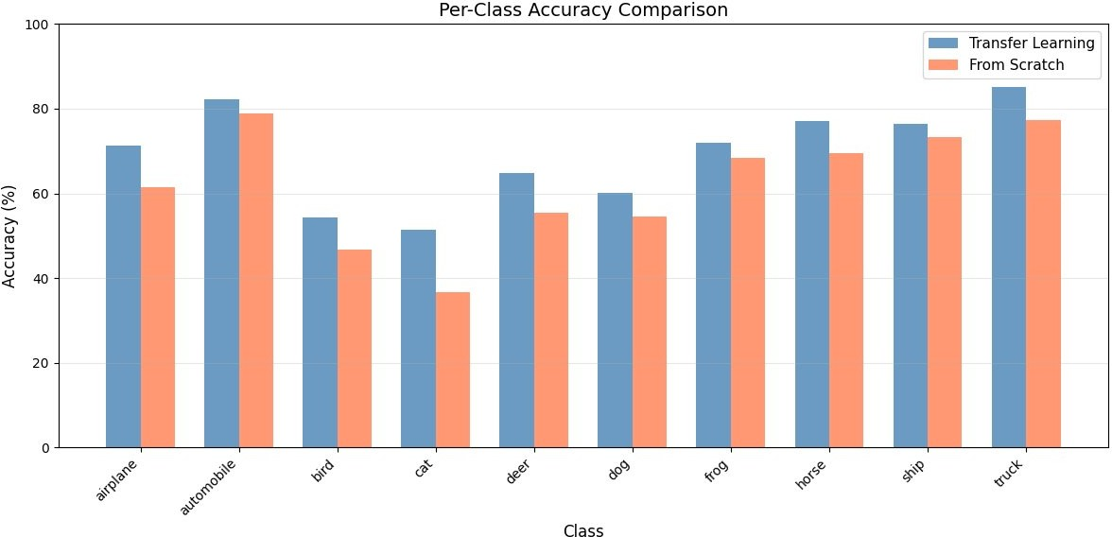
Fig. 3. Per-class test accuracy for transfer learning (blue) and training from scratch (orange) across all ten CIFAR-10 categories. Transfer learning outperforms the baseline in every class. The largest gains occur for semantically ambiguous animal categories (cat, deer, airplane) where coarse phosphene shape alone is insufficient for reliable discrimination.

TABLE IV PER-CLASS TEST ACCURACY

Class | Transfer | Scratch | Improvement
Airplane | 71.20% | 61.50% | +9.70 pp
Automobile | 82.20% | 78.80% | +3.40 pp
Bird | 54.40% | 46.80% | +7.60 pp
Cat | 51.40% | 36.60% | +14.80 pp
Deer | 64.80% | 55.40% | +9.40 pp
Dog | 60.20% | 54.50% | +5.70 pp
Frog | 71.90% | 68.40% | +3.50 pp
Horse | 77.00% | 69.60% | +7.40 pp
Ship | 76.50% | 73.20% | +3.30 pp
Truck | 85.20% | 77.40% | +7.80 pp
Mean | 69.48% | 62.16% | +7.32 pp

DISCUSSION

Why Pre-Trained Features Transfer

The phosphene simulation deliberately strips away colour, fine texture and mid-frequency spatial detail. What remains are the coarsest spatial structures: the outline of an object, the relative positions of its major parts, and whatever binary contrast survives the downsampling and thresholding stages. ImageNet-trained convolutional networks are known to develop edge and boundary detectors in their early layers [11], and these are precisely the features that phosphene images still carry. The finding that the transfer advantage is largest at epoch 1—a 20.67-point gap before any domain-specific gradient updates—supports this interpretation: the pre-trained network arrives already equipped to detect the structural primitives present in phosphene images, whereas the from-scratch model must discover them from degraded data alone.
The progressive narrowing of the gap across epochs is also informative. It shows that, given sufficient training iterations, a network can learn phosphene-relevant features even without a natural-image prior—but at a cost in data efficiency. In prosthetic applications, data efficiency matters acutely: collecting labelled phosphene data from actual prosthesis users is expensive and ethically constrained. Transfer learning substantially reduces the number of gradient steps required to reach a given accuracy level, which translates directly to less simulated or real prosthetic training data required.

Implications for System Design
From a practical standpoint, these results suggest that the image-processing component of a cortical visual prosthesis should be initialised from a large natural-image pre-training run rather than trained exclusively on prosthetic or simulated data. Current state-of-the-art pre-trained models—including larger EfficientNet variants, ResNets and Vision Transformers—are freely available and could be fine-tuned for the prosthetic setting with modest additional computation. EfficientNet-B0's small parameter count (~5.3 M) makes it attractive for deployment on wearable processors where power and latency budgets are tight.
The per-class results also have implications for the design of the visual presentation layer. Classes where recognition accuracy remains low—birds (54.40%) and cats (51.40%)—might benefit from task-specific training strategies such as focal loss or targeted data augmentation. Alternatively, the prosthetic system could adopt a hierarchical approach: first classify coarse categories (animal vs. vehicle) before attempting fine-grained identification, reducing the chance of presenting a user with a confidently wrong label.

Limitations
Several limitations should be acknowledged. CIFAR-10 contains small, centred, relatively uncluttered images; real visual scenes involve objects at varying scales and locations against busy backgrounds. The phosphene simulator is a simplified model: actual phosphene appearance depends on electrode-specific spread functions, cortical magnification, perceptual adaptation and individual differences in cortical organisation, none of which are captured by a uniform Gaussian blur and a fixed threshold. Training was limited to ten epochs; it is possible that the from-scratch model would close the gap further with longer training, though the plateau visible from epoch 8 onwards suggests diminishing returns. Finally, we tested only one architecture and one phosphene resolution, limiting the generalisability of the conclusions.

FUTURE WORK
Several directions would strengthen and extend these findings.
- Architecture sweep — testing EfficientNet-B3 or B5, ResNet-50, and Vision Transformer variants would clarify whether the transfer advantage generalises across architectural families.
- Phosphene resolution ablation — varying the downsampling grid from 16 × 16 to 128 × 128 would reveal how the transfer advantage scales with electrode count, providing guidance for future implant designs.
- Richer datasets — applying the same methodology to ImageNet subsets or object-detection benchmarks such as MS-COCO would test generalisation to more realistic visual scenes.
- Domain adaptation — adversarial domain adaptation or self-supervised pre-training on unlabelled phosphene data could further narrow the distribution gap between natural images and prosthetic percepts.
- Clinical validation — the simulation pipeline should ultimately be validated against perceptual reports from actual prosthesis users to confirm it captures the relevant aspects of phosphene appearance.
- Personalisation — individual differences in cortical organisation mean that the same stimulation pattern produces different percepts in different users. Fine-tuning a shared base model to individual perceptual maps is a natural and clinically important next step.

CONCLUSION
We have shown that transfer learning from ImageNet provides a measurable and consistent benefit for object recognition in phosphene-simulated visual data. Using EfficientNet-B0 on CIFAR-10 processed through a six-stage phosphene simulation pipeline, pre-trained weights yield a 6.90 percentage-point improvement in test accuracy (69.21% vs. 62.31%) and a 0.1450-point reduction in test loss relative to random initialisation after ten training epochs. The advantage is most pronounced at the very start of training—a 20.67-point gap at epoch 1—consistent with the hypothesis that early-layer edge detectors learned from natural images transfer directly to the sparse structural features preserved in phosphene images. Per-class results show that animal categories with visually similar body plans benefit most from the richer prior encoded in ImageNet weights.

The practical implication is clear: the external processing unit of a cortical visual prosthesis should incorporate a model pre-trained on natural images rather than trained exclusively on prosthetic or simulated data. Given EfficientNet-B0's efficiency, this approach is compatible with the power and latency constraints of wearable devices. We release the simulation code and training scripts to facilitate reproduction and extension of this work.

REFERENCES

- E. Fernandez et al., "Development of a cortical visual neuroprosthesis for the blind: the relevance of structure-function mappings," J. Neural Eng., vol. 18, no. 2, 2021.
- Neuralink Corp., "Blindsight: Restoring visual perception," neuralink.com, 2024. [Online]. Available: https://neuralink.com/blindsight
- P. R. Troyk, "The intracortical visual prosthesis project," IEEE Trans. Neural Syst. Rehabil. Eng., vol. 25, no. 10, pp. 1888-1895, 2017.
- M. Beyeler, D. Nanduri, J. D. Weiland, A. Rokem, G. M. Boynton, and I. Fine, "A model of ganglion axon pathways accounts for percepts elicited by retinal implants," Sci. Rep., vol. 9, no. 1, p. 9199, 2019.
- J. Yosinski, J. Clune, Y. Bengio, and H. Lipson, "How transferable are features in deep neural networks?" in Proc. Adv. Neural Inf. Process. Syst. (NeurIPS), 2014.
- M. Long, Y. Cao, J. Wang, and M. I. Jordan, "Deep transfer learning with joint adaptation networks," in Proc. Int. Conf. Mach. Learn. (ICML), 2015.
- G. S. Brindley and W. S. Lewin, "The sensations produced by electrical stimulation of the visual cortex," J. Physiol., vol. 196, no. 2, pp. 479-493, 1968.
- J. S. Pezaris and R. C. Reid, "Demonstration of artificial visual percepts generated through thalamic microstimulation," Proc. Natl. Acad. Sci., vol. 104, no. 17, pp. 6670-6675, 2007.
- M. Beyeler et al., "pulse2percept: A Python-based simulation framework for bionic vision," in Proc. SciPy, 2017.
- J. N. P. Martel et al., "Toward a smart bionic eye: AI-powered artificial vision," arXiv preprint arXiv:2103.10938, 2021.
- J. Deng, W. Dong, R. Socher, L.-J. Li, K. Li, and L. Fei-Fei, "ImageNet: A large-scale hierarchical image database," in Proc. IEEE Conf. Comput. Vis. Pattern Recognit. (CVPR), 2009.
- M. Tan and Q. V. Le, "EfficientNet: Rethinking model scaling for convolutional neural networks," in Proc. Int. Conf. Mach. Learn. (ICML), 2019.
- A. Krizhevsky, "Learning multiple layers of features from tiny images," Univ. of Toronto, Tech. Rep., 2009.
- K. He, X. Zhang, S. Ren, and J. Sun, "Deep residual learning for image recognition," in Proc. IEEE Conf. Comput. Vis. Pattern Recognit. (CVPR), 2016.
- A. Dosovitskiy et al., "An image is worth 16x16 words: Transformers for image recognition at scale," in Proc. Int. Conf. Learn. Represent. (ICLR), 2021.
- J. D. Weiland and M. S. Humayun, "Retinal prosthesis," IEEE Signal Process. Mag., vol. 31, no. 2, pp. 82-94, 2014.
- Cortigent Inc., "Orion Visual Cortical Prosthesis System," cortigent.com, 2024. [Online]. Available: https://www.cortigent.com
- I. Loshchilov and F. Hutter, "Decoupled weight decay regularization," in Proc. Int. Conf. Learn. Represent. (ICLR), 2019.
- L. N. Smith, "Cyclical learning rates for training neural networks," in Proc. IEEE Winter Conf. Appl. Comput. Vis. (WACV), 2017.
- C. Gwendalen et al., "Deep learning approaches for visual prostheses," J. Neural Eng., vol. 21, no. 1, 2024.

