

**Green University of Bangladesh**

**Department of Computer Science and Engineering (CSE)**

**Faculty of Sciences and Engineering**

**Semester: (Fall, Year:2022), B.Sc. in CSE (Day)**

**LAB PROJECT PROPOSAL**

**Course Title: Data Structure Lab**

**Course Code: CSE 106 Section: 221 D7**

**Student Details**

**1.**

|  |  |
| --- | --- |
| **Name** | **ID** |
| **Abdullha Hill Oneir** | **221002044** |
|  |  |

**Submission Date** **: 06 DECEMBER, 2022**

**Course Teacher’s Name** **: MS. BABE SULTANA**

**[For Teachers use only: Don’t Write Anything inside this box]**

|  |  |  |  |
| --- | --- | --- | --- |
| **Project Proposal Status** | | |  |
| **Marks:……………………………** |  |  | **Signature:.....................** |
| **Comments: ..............................................** | | | **Date: ..............................** |
|  |  |  |  |

**1. TITLE OF THE PROJECT PROPOSAL**

**Data Structure Tree (DST)**. The purpose of Data Structure Tree to give an exposer to the data structure. DST can help us to understand how data structure are implemented in programs, and how it effects the program.

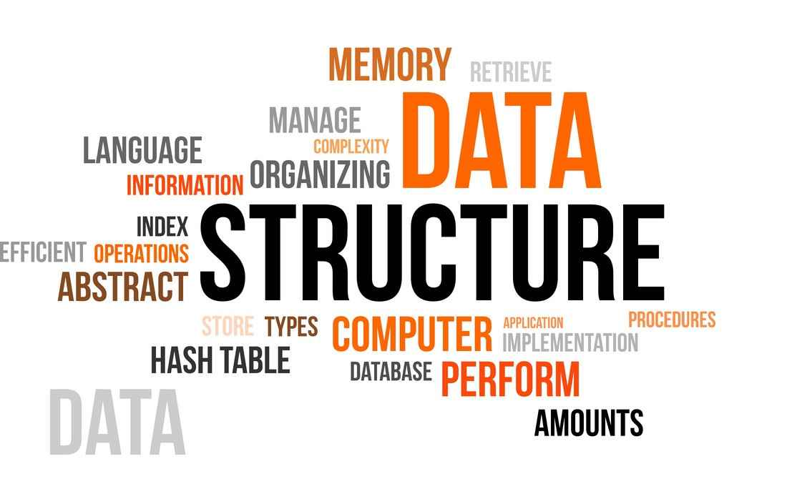

And show the time complexity, algorithm of the data structure in sequence. This program can be a good education medium for students at the same time it can be a good example of how data structures algorithm works.

**2. PROBLEM DOMAIN & MOTIVATIONS**

There are many problems

There isn’t enough good way to study Data Structure with good practical implement.

And there isn’t good combined compact program where data structure can be learned efficiently.

Those problems motivated me to work on this project and make it real.

**3. OBJECTIVES/AIMS**

**Data Structure Tree (DST)** is one of the important software solutions that can help with everything from admissions to student success to learn about data structure with nicely arranged data.

There are some key features that motivates me to make this project -

To make a program that can easily demonstrate data structure with proper details.

To make a good education medium about Data Structure with practical implement.

Efficient utilization of human resource.

1. **TOOLS & TECHNOLOGIES**

For develop this system I will be using

C language

Code blocks IDE 20.03 (mingw)



1. **CONCLUSION**

By using a Data Structure Tree (DST), it is helpful to understand Data Structure with how the algorithm works. Provides easy, accurate access to all the variants of data structures combined also the comparison of variants.