

**Green University of Bangladesh**

**Department of Computer Science and Engineering (CSE)**

**Faculty of Sciences and Engineering**

**Semester: (Fall, Year:2022), B.Sc. in CSE (Day)**

**Course Title: Data Structure Lab**

**Course Code: CSE 106 Section: 221 D7**

**Lab Project Name: Data Structure Tree**

**Student Details**

|  |  |  |
| --- | --- | --- |
| **Name** | | **ID** |
| **1.** | **Abdullha Hill Oneir** | **221002044** |

**Submission Date : 03 January, 2023**

**Course Teacher’s Name : Babe Sultana**

**[For Teachers use only: Don’t Write Anything inside this box]**

|  |
| --- |
| **Lab Project Status**  **Marks: ………………………………… Signature: .....................**  **Comments: .............................................. Date: ..............................** |

Table of Contents

Chapter 1 Introduction 3-4

1.1 Introduction 3

1.2 Design Goals/Objective 4

Chapter 2 Design/Development/Implementation of the Project 5-17

2.1 Section (Development) 5

2.2 Section (Implementation) 17

Chapter 3 Performance Evaluation 18-24

3.1 Section (Development Tools) 19

3.2 Results and Discussions 24

Chapter 4 Conclusion 25-26

4.1 Introduction 25

4.1 Practical Implications 25

4.2 Scope of Future Work 26

References 26

# 

# Chapter 1 Introduction

## Introduction

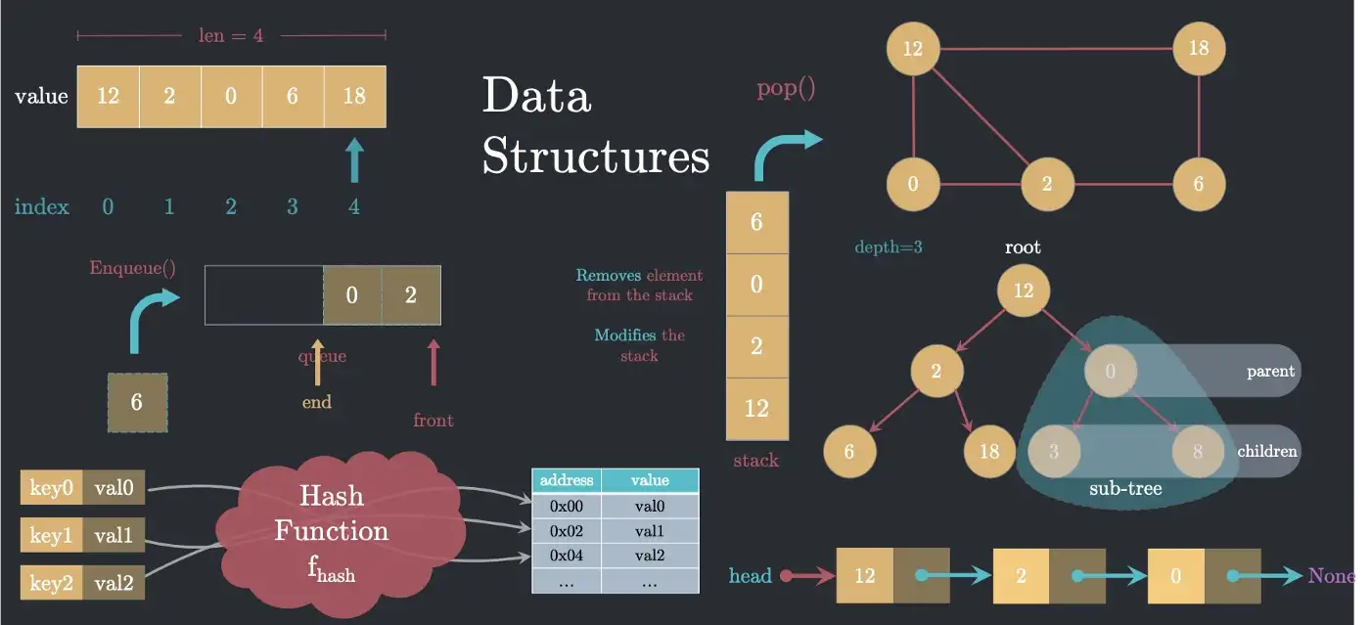**DATA STRUCTURE TREE** program can be very useful in a school, college while studying the data structure. Data Structure is a specialized format of organizing, processing, retrieving and storing data and there are several basic and advanced types of data structure that is used in programs. So, this program can play an important role because this program helps the students with lot of information about data structure, how it works and the algorithms that these data structure types come with. This program comes with a lot of data structure types of programs with practical implementation. Also, it has real life code implementation using data structure.

## Design Goals/Objective

**Design Goals**

Data Structure Tree can be called as (DST) is an educational program. This program, helps to ease the learning gap between student and the internet in all-in-one compact way. This system exists to simplify information tracking for both students and administrative persons.

**Objectives**

* User-Friendly Educational System where data of Data Structure types are stored in details.
* To make a system where learning can be easy and time efficient and easier to maintain.

# 

# Chapter 2

# Design/Development/Implementation of the Project

## Section(Development)

For develop this system I have used

* **Language C**
* **Code Blocks**

## Section (Implementation)

## Source Code

## 

## 

## 

## 

## 

## 

## 

## 

# 

# 

# 

# 

# 

# 

# 

# 

# 

# 

# 

# 

# 

# 

# 

# Chapter 3

# Performance Evaluation

## Section (Development Tools)

For Develop this system I used C Language. Codeblocks IDE used for writing the C language

**3.1.1. Introduce with C language**

C is a procedural programming language with a static system that has the functionality of structured programming, recursion, and lexical variable scoping. C was created with constructs that transfer well to common hardware instructions. It has a long history of use in programs that were previously written in assembly language.

****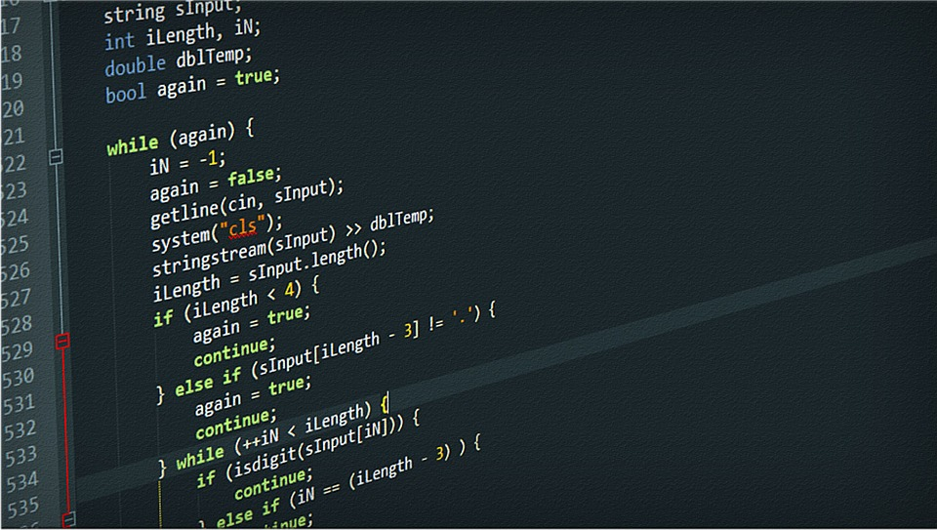

**3.1.2. Introduce with CodeBlocks**

Code::Blocks is a free, open-source cross-platform IDE that supports multiple compilers including GCC, Clang and Visual C++. It is developed in C++ using wxWidgets as the GUI toolkit. Using a plugin architecture, its capabilities and features are defined by the provided plugins

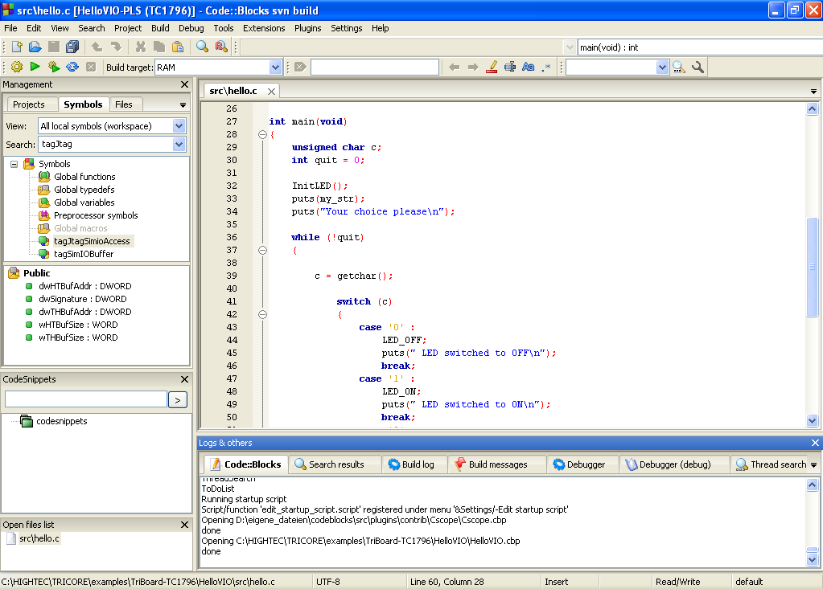

## Results and Discussions

* + 1. **Results**

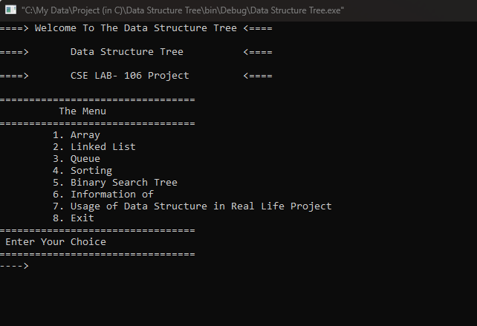

Figure: Home page

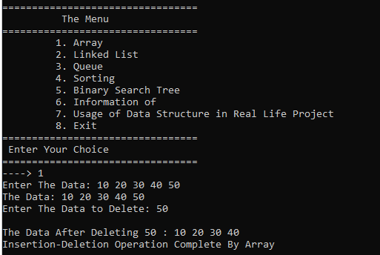

Figure: Choosing Task 1

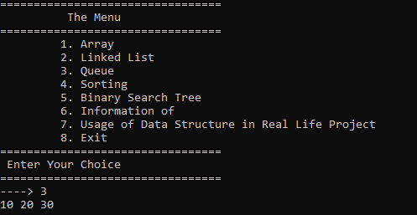

Figure: Queue (Task 3)

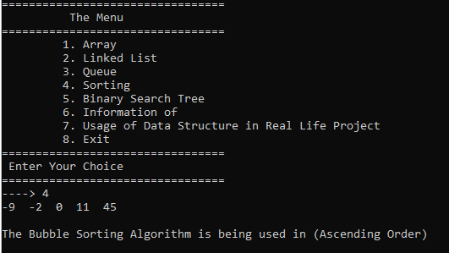

Figure: Sorting (Task 4)

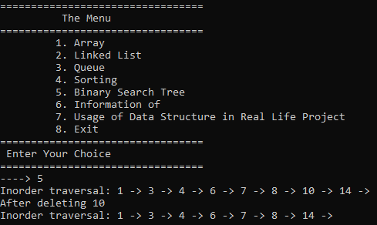

Figure: Binary Search Tree (Task 5)

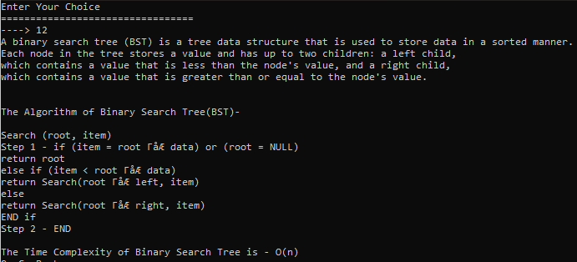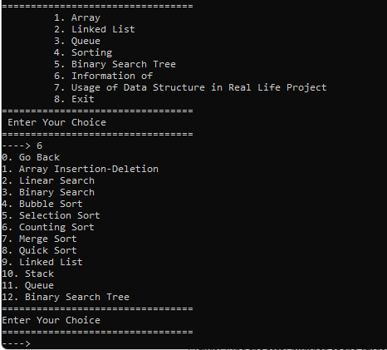

Figure: Information of (Task 6)

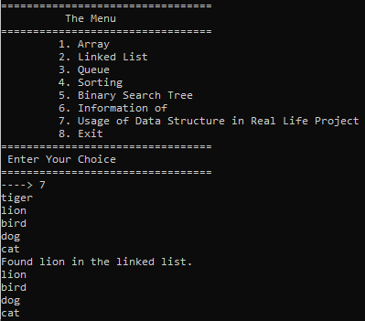

Figure: Usage of Data Structure in Real Life Project (Task 7)

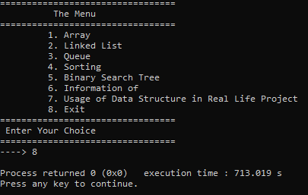

Figure: Exit (Task 8)

* + 1. **Analysis and Outcome**

After running the source code, we can see that in the console it’s running properly, and it’s running like a management system. The system is taking input and shows output to the user. This program has more than 10 data for different types of Data Structure with 7 practical implementation of these Data Structure algorithm in real life programs.

# Chapter 4 Conclusion

## Introduction

The project I have worked on is Data Structure Tree and its purpose was to make data input more accessible and included with lots of information. And it could take a lot of data, modify it, delete it without a problem.

## Practical Implications

## User friendly interface

## easy access to data"

## less error

## Search facility

## Scope of Future Work

* + Adding Time Counting Capability of the functions execution time.
  + More Organization.
  + Graphical User Interface(GUI).

# References

1. Wikipedia.com
2. Google.com
3. Programiz.com