



**SRI KRISHNA COLLEGE OF ENGINEERING AND TECHNOLOGY**

**(**AN AUTONOMOUS INSTITUTION)

AFFILIATED TO ANNA UNIVERSITY, CHENNAI

ACCREDITED NBA-AICTE AN ISO 9001-2008 CERTIFIED INSTITUTION

**PLACEMENT PREP**

Submitted by

**Keerthana P**

**Register No: 16EPMC517**

Under the guidance of

**Dr.JAYASUDHA SUBBURAJ M.C.A; ME, M Phil, PhD**

in partial fulfillment for the award of the degree

of

***MASTER OF COMPUTER APPLICATIONS***

**DEPARTMENT OF COMPUTER APPLICATIONS**

**SRI KRISHNA COLLEGE OF ENGINEERING AND TECHNOLOGY Kuniamuthur, Coimbatore-641008**

**MARCH-2018**

**SRI KRISHNA COLLEGE OF ENGINEERING AND TECHNOLOGY**

**Kuniamuthur, Coimbatore-641008**

**Department of Computer Applications**

**PROJECT WORK**

**MARCH-2018**

This is to certify that the main project entitled

**PLACEMENT PREP**

is a bonafide record of project work done by

**keerthana p**

**Reg No: 16EPMC517**

Of Master of Computer Applications during the year 2015-2018

------------------------ --------------------------

Project Guide Head of the Department

Submitted for the Main Project Viva-Voce examination held on

___________________

**-----------------------**

Internal Examiner

**DECLARATION**

I affirm that the main project work titled **“PLACEMENT PREP”** being submitted in partial fulfillment for the award of **MASTER OF COMPUTER APPLICATIONS** is the original work carried out by me. It has not formed the part of any other project work submitted for award of any degree or diploma, either in this or any other University.

Signature of the candidate

I certify that the declaration made above by the candidate is true

Signature of the Guide

**ACKNOWLEGEMENT**

I humbly submit all the glory and thanks to almighty for showering the blessings up on me and giving me the necessary wisdom for accomplishing this project work.

I wish my sincere thanks to **Dr. J, Janet Ph.D.,** Principal, Sri Krishna College of Engineering and Technology, Coimbatore for having offered this golden opportunity to do the project work in this prestigious institution.

Our department has been of immense help for us throughout entire endeavor. I take pleasure in acknowledging our Head of the Department **Dr. U.K. Sridevi Ph.D.,** Department of Computer Applications, Sri Krishna College of Engineering and Technology, Coimbatore for her support, encouragement to undertake the project.

I express my sincere thanks to **Ms. Latha Maheswari,** Assistant professor, Department of Computer Applications, Sri Krishna College of Engineering and Technology, Coimbatore for providing the opportunity to undertake the project work and being as my Internal Guide & also being my project coordinator.

I also want to express my appreciation to my classmates and friends who helped me in one way or another during the course of developing this project.

Finally, I would like to enunciate my sincere thanks to my parents, friends, non-teaching staff members who have directly and indirectly contributed to the success of my project work.

**ABSTRACT**

The project titled **Placement Prep** is a web portal which is done and implemented in PHP domain. This project is helpful for students to prepare for their placements. This project will help the students to get practiced to the online examination method by taking mock tests from the web portal. The Placemt Prep portal is implemented in three modules Admin, Instructor and Student module. Admin module will add multiple coursers under differenet branches so students can easily know about tets details. The instructor module can validate the performances of the students and take necessary actions. The student module students ought to register with application and choose interested course and participate the online test.

Major areas where companies give tests are on Aptitude, Logical reasoning, Verbal ability and Technical knowledge.

Once logged in to the portal with the credentials, there is provision to prepare based on company wise questions, topical wise questions. Students themselves will be able to check in which topics they are strong and where they need to improve.

Solving company based questions will not only help them getting accustomed to their test pattern but also improve their confidence level. If the student feel stuck at some question, there is an option to ask for expert advice, where various trainers of face are willing to help.

Thus, the portal helps to bring out the best in students and make them ready for the placement drives.

**TABLE OF CONTENTS**

|  |  |  |
| --- | --- | --- |
| **CHAPTER NO.** | **TITLE** | **PAGE NO.** |
|  | **Introduction** | 7 |
|  | **System Analysis**   * 1. Existing System   2. Proposed System   3. scope   4. Feasibility study | 8  8  9  10 |
|  | **System Specification**   * 1. Hardware Specification   2. Software Specification | 12  12 |
|  | **Software Description**   * 1. Front End and Features | 13 |
|  | **Project Description**   * 1. Overview of the Project   2. Module Description   3. Database Design   4. Data Flow Diagram   5. Input design   6. Output Design | 26  27  30  32  34  36 |
|  | **Project plan and Scheduling** | 38 |
|  | **System Testing**   * 1. White box Testing   2. Black box Testing   3. Unit Testing   4. User acceptance Testing | 40  42  43  45 |
|  | **Risk Identification** | 46 |
|  | **Conclusion & Future Enhancements**   * 1. Conclusion   2. Future Enhancements | 48  48 |
|  | Appendix 1   * 1. Sample Codes | 49 |
|  | Appendix 2   * 1. Screen Shots | 52 |
|  | **References** | 58 |

**INTRODUCTION**

Placement prep examinations contents providers to focus on creating effective assessment questions and focusing on exam’s feedback delivery to students. In the paper we present techniques that are pertinent to the elements of assessment process: answers submission, computerized grading, and feedback after submission.

As the modern organizations are automated and computers are working as per the instructions, it becomes essential for the coordination of human beings, commodity and computers in a modern organization.

The administrators ,Instructor, Students who are attending for online placement preparation examination can communicate with the system through this projects, thus facilitating effective implementation and monitoring of various activities of Online placement preparation Examinations like conducting Exams as per scheduled basis and delivering result to that particular use or student. And the details of students who attempted Online placement preparation Examination are maintained at administrator.

**SYSTEM ANALYSIS**

**1. Existing System**

Existing system is a manual one in which users are maintaining books to store the information like Student Details,Instructor Details,Schedule Details and feedbacks about students who attempted placement preparation exam as per schedule.. It is very difficult to maintain historical data.

DISADVANTAGES:

The following drawbacks of existing system emphasize the need for computerization:

1. A lot of copies of question papers have to be made

2. A lot of correction work hence delay in giving the results

3. A lot of tabulation work for each subject results

**2. Proposed System**

This application is used to conduct online placement preparation examination. The students can sit at individual terminals and login to write the exam in the given duration. . The questions have to be given to the students.This application will perform correction, display the result immediately and also store it in database. This application provides the administrator with a facility to add new exams.This application provides the Instructor add questions to the exam, modify questions in the exam in a particular exam. This application takes care of authentication of the administrator,Instructor as well as the student.

.

**2.3 Scope of the System**

“Software scope describes the data and control to be processed, function, performance, user management, access control management”

➢ **Data and Control**

The input data to the system will be customer detail, as well as document detail for order. The output data will be different reports and reports usable in order and inquiry analysis. With the help of various reports, easy to make any needed decision.

➢ **Functions**

Basic functions of the system authenticate the user and user inputs document details, customer details and inquiry details as needed. It processes the input data to make the output information presented as reports.

➢ **Performance**

The performance of the system requires the project to take low resources from Server and present more information in smallest memory utilization.

➢ **User Management**

Each user should have its own password to log in to the system and based on the rolls and rights allocated to the user by the administrator of the system, user will be allowed to open the different forms and perform required operations.

2.4 **Feasibility Study**

A feasibility study is a preliminary study undertaken to determine and document a project's viability. The results of this study are used to make a decision whether to proceed with the project, or table it. If it indeed leads to a project being approved, it will - before the real work of the proposed project starts - be used to ascertain the likelihood of the project's success.

It is an analysis of possible alternative solutions to a problem and a recommendation on the best alternative. A feasibility study could be used to test a new working system, which could be used because:

The current system may no longer suit its purpose.

Technological advancement may have rendered the current system

The business is expanding, allowing it to cope with extra work load.

Customers are complaining about the speed and quality of work the usiness it provides.

Competitors are now winning a big enough market share due to an effective integration of a computerized system.

**Operational Feasibility:**

Operational Feasibility measures how well the solution will work in the organization and how will end user and management feels about the system. On studying the operational feasibility of the project, following could be derived:

Aspects of Operational Feasibility

Is the problem worth solving? Will the solution serve problem.

Political acceptability.

Computerized system for searching in the database will provide all the necessary information to employees and users in timely and efficient manner and in useful format.

**Technical Feasibility:**

This involves questions such as whether the technology needed for the system exists, how difficult it will be to build, and whether the firm has enough experience using that technology. The assessment is based on an outline design of system requirements in terms of Input, Output, Fields, Programs, and Procedures. This can be qualified in terms of volumes of data, trends, frequency of updating, etc.

**Economical Feasibility:**

This involves questions such as whether the firm can afford to build the system, whether its benefits should substantially exceed its costs, and whether the project has higher priority and profits than other projects that might use the same resources. This includes whether the project is in the condition to fulfil all the eligibility criteria and the responsibility of both sides

in case there are two parties involved in performing any project.

**SYSTEM SPECIFICATION**

**3.1 HARDWARE SPECIFICATION**

The hardware of the computer consists of physical components such as Input devices, Storage devices, Processing & Control units and Output devices. Computer includes external storage unit to store data in programs. The popular external storage mediums are DVD, Flash Drives etc..

The Hardware Configuration involved in this project is:

**Processor** : Intel® Core™ i3- 5500U CPU @2.40GHz.

**RAM** : 4.00 GB.

**Speed** : 2.40 GHz.

**System Type** : 32/64 bit Operating System.

**Hard Disk** : 160 GB

**Keyboard & Mouse** : USB 2.0 or later

**3.2 SOFTWARE SPECIFICATION**

Software is a group of programs that computers need to do a particular task. It is an essential requirement of a Computer System.

The Software used to develop the project is:

**Operating System** : Windows 7,8,10

**Front end** : HTML, XML,CSS

**Scripting Languages** : PHP, JavaScript, JQuery

**Database** : MySQL,MongoDB, Graph DB

**IDE** : Sublime

**Domain** : WebTechnology

**SOFTWARE DESCRIPTION**

This section describes the tools and technologies that are used in the project and a brief description about each of them.

**4.1 FRONT END**

**4.1.1 HTML**

Hypertext Markup Language (HTML) is the standard markup language for creating web pages and web applications. With Cascading Style Sheets (CSS) and JavaScript, it forms a triad of cornerstone technologies for the World Wide Web. Web browsers receive HTML documents from a web server or from local storage and render them into multimedia web pages. HTML describes the structure of a web page semantically and originally included cues for the appearance of the document.

HTML elements are the building blocks of HTML pages. With HTML constructs, images and other objects, such as interactive forms, may be embedded into the rendered page. It provides a means to create structured documents by denoting structural semantics for text such as headings, paragraphs, lists, links, quotes and other items. HTML elements are delineated by tags, written using angle brackets. Tags such as <img /> and <input /> introduce content into the page directly. Others such as <p>...</p> surround and provide information about document text and may include other tags as sub-elements. Browsers do not display the HTML tags, but use them to interpret the content of the page.

HTML can embed programs written in a scripting language such as JavaScript which affect the behavior and content of web pages. Inclusion of CSS defines the look and layout of content. The World Wide Web Consortium (W3C), maintainer of both the HTML and the CSS standards, has encouraged the use of CSS over explicit presentational HTML since 1997.

In 1980, physicist Tim Berners-Lee, a contractor at CERN, proposed and prototyped ENQUIRE, a system for CERN researchers to use and share documents. In 1989, Berners-Lee wrote a memo proposing an Internet-based hypertext system.[5] Berners-Lee specified HTML and wrote the browser and server software in late 1990. That year, Berners-Lee and CERN data systems engineer Robert Cailliau collaborated on a joint request for funding, but the project was not formally adopted by CERN. In his personal notes from 1990 he listed "some of the many areas in which hypertext is used" and put an encyclopedia first.

The first publicly available description of HTML was a document called "HTML Tags", first mentioned on the Internet by Tim Berners-Lee in late 1991. It describes 18 elements comprising the initial, relatively simple design of HTML. Except for the hyperlink tag, these were strongly influenced by SGMLguid, an in-house Standard Generalized Markup Language (SGML)-based documentation format at CERN. Eleven of these elements still exist in HTML 4.

HTML is a markup language that web browsers use to interpret and compose text, images, and other material into visual or audible web pages. Default characteristics for every item of HTML markup are defined in the browser, and these characteristics can be altered or enhanced by the web page designer's additional use of CSS. Many of the text elements are found in the 1988 ISO technical report TR 9537 Techniques for using SGML, which in turn covers the features of early text formatting languages such as that used by the RUNOFF command developed in the early 1960s for the CTSS (Compatible Time-Sharing System) operating system: these formatting commands were derived from the commands used by typesetters to manually format documents. However, the SGML concept of generalized markup is based on elements (nested annotated ranges with attributes) rather than merely print effects, with also the separation of structure and markup; HTML has been progressively moved in this direction with CSS.

**Features:**

1. First advantage it is widely used.

2. Every browser supports HTML language.

3. Easy to learn and use.

4. It is by default in every windows so you don't need to purchase extra software.

5. Easy to create webpages.

6. Most development tools support HTML.

**4.1.1 XML**

Every software or application to be designed needs a user interface. XML is used for layout designing. xml helps you to design your app , how it will look , how components like buttons , text view etc. will be placed and their styling. xml is also used for parsing data either from database or server into your android app.

Xml helps organize and visualize the layouts very clearly. XML uses XML elements or tags to define document structure. By defining the document structure, you can then use outside processes such as style sheets to manipulate and reuse content. XML is very helpful when you publish in more than one language and when  you publish different types of documents from the same page on source. By using this xml you can easily build UI of any applications and you can understand easily.

**Features:**

* Excellent for handling data with a complex structure or atypical data
* Data described using mark-up language
* Text data description
* Human- and computer-friendly format
* Handles data in a tree structure having one-and only one-root element
* Excellent for long-term data storage and data reusability

**4.1.3 CSS**

Cascading Style Sheets (CSS) is a style sheet language used for describing the presentation of a document written in a markup language. Although most often used to set the visual style of web pages and user interfaces written in HTML and XHTML, the language can be applied to any XML document, including plain XML, SVG and XUL, and is applicable to rendering in speech, or on other media. Along with HTML and JavaScript, CSS is a cornerstone technology used by most websites to create visually engaging webpages, user interfaces for web applications, and user interfaces for many mobile applications. CSS is designed primarily to enable the separation of presentation and content, including aspects such as the layout, colors, and fonts. This separation can improve content accessibility, provide more flexibility and control in the specification of presentation characteristics, enable multiple HTML pages to share formatting by specifying the relevant CSS in a separate .css file, and reduce complexity and repetition in the structural content.

Separation of formatting and content makes it possible to present the same markup page in different styles for different rendering methods, such as on-screen, in print, by voice (via speech-based browser or screen reader), and on Braille-based tactile devices. It can also display the web page differently depending on the screen size or viewing device. Readers can also specify a different style sheet, such as a CSS file stored on their own computer, to override the one the author specified.

**Features:**

1. Easier to maintain and update
2. Greater consistency in design
3. More formatting options
4. Lightweight code
5. Faster download times
6. Search engine optimization benefits
7. Ease of presenting different styles to different viewers
8. Greater accessibility
9. Browser compatibility
10. Good Style

**4.2 CLIENTSIDE SCRIPTING**

**4.2.1 JAVASCRIPT**

**JavaScript** is a high-level, dynamic, un typed, and interpreted programming language. It has been standardized in the ECMA Script language specification. Alongside HTML and CSS, it is one of the three essential technologies of World Wide Web content production; the majority of websites employ it and it is supported by all modern Web browsers without plug-ins. JavaScript is prototype-based with first-class functions, making it a multi-paradigm language, supporting object-oriented,imperative, and functional programming styles.It has an API for working with text, arrays, dates and regular expressions, but does not include any I/O, such as networking, storage, or graphics facilities, relying for these upon the host environment in which it is embedded.

**Advantages**

* JavaScript is executed on the client side where the code is executed on the user's processor instead of the web server thus saving bandwidth and strain on the web server.
* JavaScript is a relatively easy language to learn. It uses the DOM model that provides plenty of prewritten functionality to the various objects on pages making it a breeze to develop a script to solve a custom purpose.
* JavaScript is relatively fast to the end user as the code is executed on the user's computer, results and processing is completed almost instantly depending on the task as it does not need to be processed in the site's web server and sent back to the user consuming local as well as server bandwidth.
* Versatility - JavaScript plays nicely with other languages and can be used in a huge variety of applications. Unlike PHP or SSI scripts, JavaScript can be inserted into any web page regardless of the file extension. JavaScript can also be used inside scripts written in other languages such as Perl and PHP.

**4.3 SERVER SIDE SCRIPTING**

**4.3.1 PHP**

**Hypertext Pre-Processor (PHP**) is a server-side scripting language designed for web development. It is also used as a general-purpose programming language. PHP code is interpreted by a web server with a PHP processor module, which generates the resulting webpage. PHP commands can be embedded directly into an HTML source document rather than calling an external file to process data. PHP code may be embedded into HTML code, or it can be used in combination with various web template systems, web content management systems, and web frameworks. PHP code is usually processed by a PHP interpreter implemented as a module in the web server or as a Common Gateway Interface (CGI) executable. The web server combines the results of the interpreted and executed PHP code, which may be any type of data, including images, with the generated web page.

**Features**

* Open Source means it is readily available and absolutely free.
* Cross-Platform, it enables operation across various operating systems. It works excellently on LINUX, UNIX and Windows platforms.
* Support : There are a number of references and guidelines available on the net. One can also find many support groups, forums, and teams supporting PHP. There is always enough online support available for PHP.
* High Returns is a feature of PHP which often enables people to create dynamic websites. This ensures more visitor participation and thereby better returns.
* Embedding, PHP can be easily embedded into HTML. This makes it very easy for one to convert an already existing static website, into a bold and new dynamic one.

**4.4 BACKEND**

**4.4.1 MySQL**

MYSQL Server is a powerful database management system. It supports GUI features and an entire programming language, PhpMyAdmin which can be used to develop richer and more developed application. We can create places to store our data build tools that make it easy to read and modify a database contents, and ask questions of your data. The MySQL database can act as a back end database for PHP and supports the user with its powerful database management function. The MySQL server has built-in support for SQL statements to check, optimize and repair tables. MySQL is popular because of many good reasons:

* MySQL is a very powerful program in its own right. It handles a large subset of the functionality of the most expensive and powerful database packages.
* MySQL is a very friendly to PHP, the most appreciated language for web development.
* MySQL is customizable. The open-source GPL license allows programmers to modify the MySQL software to fit their own specific requirements.

**4.4.2 Mongo DB**

**Mongo DB** is a [cross-platform](https://en.wikipedia.org/wiki/Cross-platform) [document-oriented database](https://en.wikipedia.org/wiki/Document-oriented_database). Classified as a [NoSQL](https://en.wikipedia.org/wiki/NoSQL) database, Mongo DB eschews the traditional table-based [relational database](https://en.wikipedia.org/wiki/Relational_database) structure in favor of [JSON](https://en.wikipedia.org/wiki/JSON)-like documents with dynamic [schemas](https://en.wikipedia.org/wiki/Database_schema) (Mongo DB calls the format [BSON](https://en.wikipedia.org/wiki/BSON)), making the integration of data in certain types of applications easier and faster. MongoDB is developed by [Mongo DB Inc.](https://en.wikipedia.org/wiki/MongoDB_Inc.) 

**Features:**

* General purpose database, almost as fast as the key:value NoSQL type.
* High availability.
* Scalability (from a standalone server to distributed architectures of huge clusters). This allows us to shard our database transparently across all our shards. This increases the performance of our data processing.
* Aggregation: batch data processing and aggregate calculations using native MongoDB operations.
* Load Balancing: automatic data movement across different shards for load balancing. The balancer decides when to migrate the data and the destination Shard, so they are evenly distributed among all servers in the cluster. Each shard stores the data for a selected range of our collection according to a partition key.
* Native Replication: syncing data across all the servers at the replica set.
* Security: authentication, authorization, etc.
* Advanced users management.
* Automatic failover: automatic election of a new primary when it has gone down.

**4.4.3 Graph DB**

In [computing](https://en.wikipedia.org/wiki/Computing), a graph database is a [database](https://en.wikipedia.org/wiki/Database) that uses [graph structures](https://en.wikipedia.org/wiki/Graph_(data_structure)) for [semantic queries](https://en.wikipedia.org/wiki/Semantic_query) with nodes, edges and properties to represent and store data. Most graph databases are [NoSQL](https://en.wikipedia.org/wiki/NoSQL) in nature and store their data in a [key-value store](https://en.wikipedia.org/wiki/Key-value_store) or [document-oriented database](https://en.wikipedia.org/wiki/Document-oriented_database). In general terms, they can be considered to be key-value databases with the additional relationship concept added.

Neo4j is a [graph database](https://en.wikipedia.org/wiki/Graph_database) management system developed by Neo Technology, Inc. Described by its developers as an [ACID](https://en.wikipedia.org/wiki/ACID)-compliant transactional database with native graph storage and processing, Neo4j is the most popular graph database according to db-engines.com.

**Features:**

* It is very easy to represent connected data.
* It is very easy and faster to retrieve/traversal/navigation of more Connected data.
* Neo4j CQL query language commands are in humane readable format and very easy to learn.
* It uses simple and powerful data model.
* It does NOT require complex Joins to retrieve connected/related data as it is very easy to retrieve it's adjacent node or relationship details without Joins or Indexes

**4.4.4 JSON**

JSON (JavaScript Object Notation) is a lightweight data-interchange format. It is easy for humans to read and write. It is easy for machines to parse and generate. It is based on a subset of the [JavaScript Programming Language](http://javascript.crockford.com/). JSON is a text format that is completely language independent but uses conventions that are familiar to programmers of the C-family of languages, including C, C++, C#, Java, JavaScript, Perl, Python, and many others. These properties make JSON an ideal data-interchange language.

JSON is built on two structures:

A collection of name/value pairs. In various languages, this is realized as an object, record, struct, dictionary, hash table, keyed list, or associative array. These are universal data structures. Virtually all modern programming languages support them in one form or another. It makes sense that a data format that is interchangeable with programming languages also be based on these structures.

In JSON, they take on these forms:

* An object is an unordered set of name/value pairs. An object begins with { (left brace) and ends with } (right brace). Each name is followed by : (colon) and the name/value pairs are separated by , (comma).
* An array is an ordered collection of values. An array begins with [ (left bracket) and ends with ] (right bracket). Values are separated by , (comma).
* A value can be a string in double quotes, or a number, or true or false or null, or an object or an array. These structures can be nested.
* A string is a sequence of zero or more Unicode characters, wrapped in double quotes, using backslash escapes. A character is represented as a single character string. A string is very much like a C or Java string.

**4.4.5 JQUERY**

JQuery is a cross-platform JavaScript library designed to simplify the client-side scripting of HTML. It is free, open-source software using the permissive MIT License. Web analysis indicates that it is the most widely deployed JavaScript library by a large margin. JQuery's syntax is designed to make it easier to navigate a document, select DOM elements, create animations, handle events, and develop Ajax applications. JQuery also provides capabilities for developers to create plug-ins on top of the JavaScript library. This enables developers to create abstractions for low-level interaction and animation, advanced effects and high-level, theme able widgets. The modular approach to the JQuery library allows the creation of powerful dynamic web pages and Web applications.

The set of JQuery core features—DOM element selections, traversal and manipulation—enabled by its selector engine (named "Sizzle" from v1.3), created a new "programming style", fusing algorithms and DOM data structures. This style influenced the architecture of other JavaScript frameworks like YUI v3 and Dojo, later stimulating the creation of the standard Selectors API. Microsoft and Nokia bundle JQuery on their platforms. Microsoft includes it with Visual Studio for use within Microsoft's ASP.NET AJAX and ASP.NET MVC frameworks while Nokia has integrated it into the Web Run-Time widget development platform.

The principles of developing with JQuery are:

* Separation of JavaScript and HTML: The JQuery library provides simple syntax for adding event handlers to the DOM using JavaScript, rather than adding HTML event attributes to call JavaScript functions. Thus, it encourages developers to completely separate JavaScript code from HTML markup.
* Brevity and clarity: JQuery promotes brevity and clarity with features like chainable functions and shorthand function names.
* Elimination of cross-browser incompatibilities: The JavaScript engines of different browsers differ slightly so JavaScript code that works for one browser may not work for another. Like other JavaScript toolkits, JQuery handles all these cross-browser inconsistencies and provides a consistent interface that works across different browsers.
* Extensibility: New events, elements, and methods can be easily added and then reused as a plugin.

**PROJECT DESCRIPTION**

This application is used to conduct online placement preparation examination. The students can sit at individual terminals and login to write the exam in the given duration. . The questions have to be given to the students.This application will perform correction, display the result immediately and also store it in database. This application provides the administrator with a facility to add new exams.This application provides the Instructor add questions to the exam, modify questions in the exam in a particular exam. This application takes care of authentication of the administrator,Instructor as well as the student

The administrators ,Instructor, Students who are attending for online placement preparation examination can communicate with the system through this projects, thus facilitating effective implementation and monitoring of various activities of Online placement preparation Examinations like conducting Exams as per scheduled basis and delivering result to that particular use or student. And the details of students who attempted Online placement preparation Examination are maintained at administrator.

**5.2 Module Description**

PLACEMENT PREP MODULES

1:ADMIN MODULE

2.INSTRUCTOR MODULE

3.STUDENT MODULE

**1.ADMIN MODULE:**

1.:REGISTER

2.LOGIN

3.CHANGE PASSWORD&FORGOTPASSWORD

4.STUDENT -MODIFING DETAILS

5.DEPARTMENTS-ENTERING/MODIFYING DETAILS

6.INSTRUCTOR DETAILS-MODIFYING DETAILS

1.REGISTER:To be authenticated firest have to be registered.

2.LOGIN:The Registered User Can be Allowed to view inner details for which he

Permitted

3.CHANGE PASSWORD&FORGOTPASSWORD:User has rights to modify his login details& also be informed through mails if he is unable to login.

4.STUDENT -MODIFING DETAILS:User can be modified to change status of

each User.

5.DEPARTMENTS-ENTERING/MODIFYING DETAILS:New departments adding and old departmentd deletions are spend by this user.

6.INSTRUCTOR DETAILS-MODIFYING DETAILS:According to staff he can add or delete Instructors for specific platforms.

2**.INSTRUCTOR MODULE:**

1.REGISTER

2. LOGIN

3CHANGE PASSWORD&FORGOT PASSWORD

4.ADD QUESTIONS-DEPARTMENTS VERIFING.

5.UPDATE QUESTIONS -DEPARTMENTS VERIFING

6.CREATE EXAMS

7.UPDATE EXAMS

8.VIEW EXAM DETAILS- VIEW NO OF REGISTERED STUDENTS VIEW NO OF ATTENDED STUDENT

9.EVALUATE QUESTION:MULTIPLE CHOICE TRUE/FALSE

1.REGISTER:To be authenticated firest have to be registered.

2.LOGIN:The Registered User Can be Allowed to view inner details for which he

Permitted

3.CHANGE PASSWORD&FORGOTPASSWORD:User has rights to modify his loging details& also be informed through mails if he is unable to login

4.ADD QUESTIONS-DEPARTMENTS VERIFING:According to flow of questions & Technology he can add questions into the database.

5.UPDATE QUESTIONS -DEPARTMENTS VERIFING:If any corrections in data of questions he can modify them

6.CREATE EXAMS:He will be prepared schedule for exams periodically.

7.UPDATE EXAMS:He has rights to modify exam schedule.

8.VIEW EXAM DETAILS- VIEW NO OF REGISTERED STUDENTS,

VIEW NO OF ATTENDED STUDENTS:Can view at attended students who has registered.

9.EVALUATE QUESTION:MULTIPLE CHOICE

TUE/FALSE:Evaluation of marks based on his initiations when

adding questions

3. **STUDENT DETAILS:**

1. REGISTER

2. LOGIN

3 TAKE EXAM- MULTIPLE CHOICE(TRUE/FALSE)

4. SEE EXAM RESULTS

5. LOGOUT

1. REGISTER:To be authenticated firest have to be registered
2. LOGIN:The Registered User Can be allowed to view inner details for which he Permitted
3. TAKE EXAM- MULTIPLE CHOICE, TRUE/FALSE:The registred student allowed to start the exam
4. SEE EXAM RESULTS:After Completion of exam he can view at his result.

**5.3 Table design**

**Admin**

|  |  |  |
| --- | --- | --- |
| **Table fields** | **Datatype** | **Constraints** |
| Id | Int | Primary Key NOT NULL AUTO_INCREMENT |
| Loginid | Varchar(20) | NOT NULL |
| Pass | Varchar(20) | NOT NULL |

**Questions**

|  |  |  |
| --- | --- | --- |
| **Table fields** | **Datatype** | **Constraints** |
| que_id | int | Primary Key NOTNULL |
| Test_id | int | NOTNULL |
| Que_desc | Varchar(150) | NOTNULL |
| Ans1 | Varchar(50) | NOTNULL |
| Ans2 | Varchar(50) | NOTNULL |
| Ans3 | Varchar(50) | NOTNULL |
| Ans4 | Varchar(50) | NOTNULL |
| True_ans | Int(1) | NOTNULL |

**result**

|  |  |  |
| --- | --- | --- |
| **Table fields** | **Datatype** | **Constraints** |
| Login | Varchar(20) | NOTNULL |
| Test_id | Int(5) | Primary Key NOTNULL |
| Test_date | date | NOTNULL |
| Score | Int(3) | NOTNULL |

**subject**

|  |  |  |
| --- | --- | --- |
| **Table fields** | **Datatype** | **Constraints** |
| Sub_id | Int(5) | Primary Key NOTNULL |
| Sub_name | Varchar(25) | NOTNULL |

**test**

|  |  |  |
| --- | --- | --- |
| **Table fields** | **Datatype** | **Constraints** |
| Test_id | Int(5) | PrimaryKey NOTNULL |
| Sub_id | Int(5) | NOTNULL |
| Test_name | Varchar(30) | NOTNULL |
| Total_que | Int | NOTNULL |

**user**

|  |  |  |
| --- | --- | --- |
| **Table fields** | **Datatype** | **Constraints** |
| User_id | Int(5) | Primary key NOTNULL |
| Login | Varchar(20) | NOTNULL |
| Pass | Varchar(20) | NOTNULL |
| Username | Varchar(20) | NOTNULL |
| Address | Varchar(20) | NOTNULL |
| City | Varchar(20) | NOTNULL |
| Phone | Int(10) | NOTNULL |
| Email | Varchar(30) | NOTNULL |

**User_answer**

|  |  |  |
| --- | --- | --- |
| **Table fields** | **Datatype** | **Constraints** |
| Sess_id | Varchar(20) | Primary Key NOTNULL |
| Test_id | Int(11) | NOTNULL |
| Que_des | Varchar(200) | NOTNULL |
| Ans1 | Varchar(50) | NOTNULL |
| Ans2 | Varchar(50) | NOTNULL |
| Ans3 | Varchar(50) | NOTNULL |
| Ans4 | Varchar(50) | NOTNULL |
| True_ans | Int(11) | NOTNULL |
| Your_ans | Int(11) | NOTNULL |

5.4 Data Flow Diagrams

**Level 0 DFD**

Admin

DB

Instructor

Student

LEVEL 1 DFD

Admin

Admin

Users

Add,update,delete users

Post

Add,update,delete posts

Category

Add,update,delete category

Form

Add,update,delete forms

**Level 1 DFD**

Student

**Level 1 DFD**

Instructor

**5.5 INPUT DESIGN**

The input design is the process of converting the user-oriented inputs in to the computer-based format. The goal of designing input data is to make the automation as easy and free from errors as possible. For providing a good input design for the application easy data input and selection features are adopted.

The input design requirements such as user friendliness, consistent format and interactive dialogue for giving the right message and help for the user at right time are also considered for the development of the project.

In this project all the textboxes are validated. If any field is not filled then it will display the message” enter the details”. The dialogue boxes are used to guide the user while giving inputs. The list boxes are used to select the options. The following design guidelines will result in a friendly and efficient interface.

The project uses various user input forms like admin login, students login, instructor login and inputs name, login credentials.

**OUTPUT DESIGN**

Presenting the data processed by a computer-based information system in an attractive and usable form has become very essential these days‟ success and acceptance of a system to some extent depends on good presentation.

Therefore, system analyst must know fully how to design output report in an attractive way. Many new output devices are being introduced in the market because of recent development in computer technology.

System analyst must be aware of these new technologies and try to use these new output devices if possible. Currently, excellent graphic displays are widely available. Speech output systems are also fast emerging.

There are three main reasons why outputs from the computer are required. They are:

• For communication to the persons concerned.

• For re-input to the computer for being connected with other data and further processing.

• For permanent storage.

**Types of Output:**

Outputs of a system can take different forms. The most common are reports, displays on screen, printed forms etc. the outputs also vary in terms of their contents, type of stationery. Frequency and timing etc. besides, due consideration also need to be given as to who will use the output and for what purpose. All these points must be kept in mind while designing outputs so that the objectives of the system are met in the best possible way.

Outputs of a data-processing system can be placed into two categories:

• Application Output

• Operating Output

**Application Output**

These are the outputs desired out of the system to meet its objectives. These are of three types:

•  Output as a basis for decision-making. This type of output is generally required by management for decision-making purposes.

• Output as a requirement to meet a functional objective. Invoices,

Excise Gate Pass, Purchase Orders are the examples of such output.

•  Statutory outputs: All organization is required to produce a certain amount of reports and forms as required by law

**Project Plan & Scheduling**

The waterfall model is a popular version of the systems development life cycle model for software engineering. Often considered the classic approach to the systems development life cycle, the waterfall model describes a development method that is linear and sequential.

Waterfall development has distinct goals for each phase of development. Imagine a waterfall on the cliff of a steep mountain.

Once the water has flowed over the edge of the cliff and has begun its journey down the side of the mountain, it cannot turn back. It is the same with waterfall development. Once a phase of development is completed, the development proceeds to the next phase and there is no turning back.

The advantage of waterfall development is that it allows for departmentalization and managerial control. A schedule can be set with deadlines for each stage of development and a product can proceed through the development process like a car in a carwash, and theoretically, be delivered on time.

Development moves from concept, through design, implementation, testing, installation, troubleshooting, and ends up at operation and maintenance. Each phase of development proceeds in strict order, without any overlapping or iterative steps. The disadvantage of waterfall development is that it does not allow for much reflection or revision.

Once an application is in the testing stage, it is very difficult to go back and change something that was not well thought out in the concept stage. This is the classical system development model. It consists of discontinuous phases:

1. Concept

2. Requirements

3. Architectural design

4. Detailed design

5. Coding and development

6. Testing and implementation

**Strengths**

Minimizes planning overhead since it can be done up front.

Structure minimizes wasted effort, so it works well for technically weak or inexperienced staff.

**Weaknesses**

Inflexible

Only the final phase produces a non-documentation deliverable. Backing up to address mistakes is difficult.

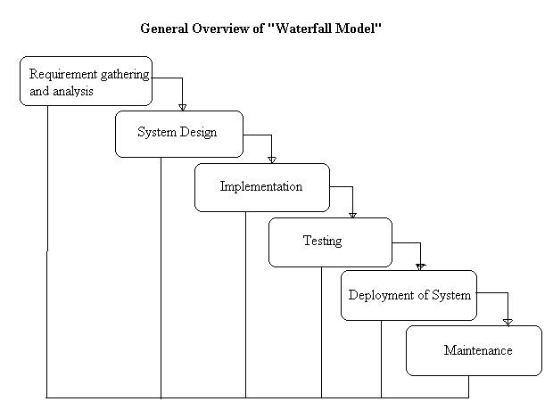

Project Plan

The project plan sets out the resources available to the project, the work breakdown and a schedule for carrying out the work. This is the plan which we have been following through the development of our products i.e. Document Management System.

The planning process starts with an assessment of the constraints affecting the project. This is carried out in conjunction with as estimation of project parameters such as its structure, size and distribution of functions. The project milestones and deliverables are then defined. The process then enters a loop.

A schedule for the project is drawn up and the activities defined in the schedule are initiated or given permission to continue. After sometime, progress is reviewed and discrepancies noted. Because initial estimates of

project parameters are tentative, the plan will always need to be modified

**SYSTEM TESTING**

**TESTING**

Testing is the process of executing a program with the intent of finding an error. A good test is one that has a high probability of finding an as yet undiscovered error .A successful test one that uncovers as yet undiscovered errors. The objective is to design test that systematically uncover different classes of errors and demonstrate that software function appeared to be working according to specification.

**7.1 WHITE BOX TESTING**

It is also known as glass box, structural, clear box and opens box testing. White Box Testing is a software testing technique whereby explicit knowledge of the internal workings of the item being tested is used to select the test data. Unlike black box testing, white box testing uses specific knowledge of programming code to examine outputs. The test is accurate only if the tester knows what the program is supposed to do. The user can then see if the program diverges from its intended goal. White box testing does not account for errors caused by omission and all visible code must also be readable. For a complete software examination, both white box and black box tests are required..This is basically done to ensure that the logic applied is correct and to check where the code fails. This is done knowing the logical flow of the functionality and implementation. White box testing is used because:

* Logic errors and incorrect assumptions most likely to be made when coding for "special cases". Need to ensure these execution paths are tested.
* May find assumptions about invalid execution paths and so make design errors. White box testing can find these errors.

|  |  |  |  |  |
| --- | --- | --- | --- | --- |
| **S. No** | **Test Case Description** | **Expected Output** | **Actual Output** | **Result** |
| 1. | The Successful API hit to fetch data from the Database. | The Data from database must be fetched through successful API hit. | The Data from database is fetched through successful API hit. | PASS |

**Table White Box Test Cases**

Every execution path in the application and service code was individually tested for logical perfection as shown in the Table 6.1. A code coverage test was also done to avoid unreachable code fragments. The different routes in the path that lead to different scenarios were documented prior to coding to make this 50 task easier. So a check was made with the document if all the routes were coded and thus the logic was tested.

**7.2BLACK BOX TESTING**

The functionality of the application was tested with the requirements specification. This is done to ensure that the functionality expected is captured as per the requirements specified. Black Box Testing is a software testing technique whereby the internal workings of the item being tested are not known by the tester. For example, in a black box test on software design, the tester only knows the inputs and what the expected outcomes should be and not how the program arrives at those outputs. The tester does not ever examine the programming code and does not need any further knowledge of the program other than its specifications. A sample of test case is shown in the Table

The advantages of black box testing include

* The tester does not need knowledge of any specific programming languages.
* The test is done from the point of view of the user, not the designer.
* Test cases can be designed as soon as the specifications are complete.

The disadvantages of black box testing includes

* The test can be redundant if the software designer has already run a test case.
* The test cases are difficult to design.

Testing every possible input stream is unrealistic because it would take an inordinate amount of time, therefore many program paths will go untested.

|  |  |  |  |  |
| --- | --- | --- | --- | --- |
| **S. No** | **Test Case Description** | **Expected Output** | **Actual Output** | **Result** |
| 1.  2. | Upload of static content in AWS S3 and other content in database.  Retrieval of content from the database using AWS CloudFron. | Upload Successful.  Retrieval  Successful. | Upload Successful.  Retrieval  Successful. | PASS  PASS |

**Table Black Box Test Cases**

**7.3 UNIT TESTING**

Unit testing is the primary level of testing a product. Unit testing involves individually testing each small unit of code to ensure that it works on its own, independent of other units. It tells the developers that an application’s pieces are working as designed.

|  |  |  |  |  |
| --- | --- | --- | --- | --- |
| **S. No** | **Test Case Description** | **Expected Output** | **Actual Output** | **Result** |
| 1. | Topic display. | Topics under a category must be listed in the order of topic weightage related to the logged in user. | Topics under a category are listed in the order of topic weightage related to the logged in user. | PASS |

**Table Unit testing Test case**

Unit testing was performed for each and every module of the system and the outputs were verified. As the system consisted of modules, each needs to be tested individually, so that they could be integrated. Unit test cases were prepared for each module and used for verification of apt results from each module.

Static analysis is used to investigate the structural properties of source code. Dynamic test cases are used to investigate the behavior of source code by executing the program on the test data. This testing was carried out during programming stage itself. After testing each every field in the modulus, the modulus of the project is tested separately. Unit testing focuses verification efforts on the smallest unit of software design and field. This knows as field-testing. The Table 6.3 depicts the sample Unit testing test case.

**7.4 USER ACCEPTANCES TESING**

Once the application is ready to be released, the crucial step is the User Acceptance Testing. In this step a group representing a cross section of end users tests the application. The user acceptance testing was done using real world scenarios and perceptions relevant to the end users. This helped to identify how far the functional requirements have been met after completion of the project.

|  |  |  |  |  |
| --- | --- | --- | --- | --- |
| **S. No.** | **Test Case Description** | **Expected Output** | **Actual Output** | **Result** |
| 1 | Login to the NETBANKING using a valid user credentials. | Login Successful | Login Successful. | PASS |

**Table User Acceptance Test Case**

The end users for the project are the users who are pursuing a personalized content. The users will not be aware of the technical details of the project and will have only a business perspective. The main goal of user acceptance testing is to make sure that the project satisfies all the functional requirements which were provided by the users during the requirement gathering phase.

User Acceptances testing are the key factor for the success of any system. The system under consideration is tested for user acceptance by constantly keeping in touch with prospective system users at the time of developing and making changes whenever required.

Risk Identification

**8.1 RISK IDENTIFICATION**

1. Technology risks.

2. People risks.

3. Organizational risks.

4. Requirements risks.

5. Estimation risks.

**Technology Risks:**

The database used in the system cannot process as many transactions per second as expected. Software components that should be reused contain defects that limit their functionality.

**People Risks:**

It is impossible to recruit staff with the skills required. Key staff is ill and unavailable at critical times. Required training for staff is not available.

**Organizational Risks:**

The organization is restructured so that different management is responsible for the project. Organizational financial problems force reductions in the project budget. Tools the code generated by CASE tools is inefficient. CASE tools cannot be integrated.

**Requirements Risks:**

Changes to requirements that require major design rework are proposed. Customers fail to understand the impact of requirements changes.

**Estimation Risks:**

The time required to develop the software is underestimated. The rate of defect repair is underestimated. The size of the software is underestimated.

**Risk Analysis:**

Assess the likelihood and consequences of these risks. Assess probability and seriousness of each risk.

Probability may be very low, low, moderate, high or very high.

Risk effects might be catastrophic, serious, tolerable or insignificant.

**Risk Planning:**

Draw up plans to avoid or minimize the effects of the risk. Consider each risk and develop a strategy to manage that risk.

**Risk Monitoring:**

Assess each identified risks regularly to decide whether or not it is becoming less or more probable. Also assess whether the effects of the risk have changed. Each key risk should be discussed at management

progress meetings.

**Conclusion & Future Enhancement**

The package was designed in such a way that future modifications can be done easily. The following conclusions can be deduced from the development of the project.

* + Automation of the entire system improves the efficiency
  + It provides a friendly graphical user interface which proves to be better when compared to the existing system.
  + It gives appropriate access to the authorized users depending on their permissions.
  + It effectively overcomes the delay in communications.
  + Updating of information becomes so easier.
  + System security, data security and reliability are the striking features.
  + The System has adequate scope for modification in future if it is necessary.

9.1 Future Enhancement

This application avoids the manual work and the problems concern with it. It is an easy way to obtain the information regarding the different scheduled examinations information that are

Currently issued.

Well I and my team members have worked hard in order to present an improved website better than the existing one’s regarding the information about the various activities. Still ,we found out that the project can be done in a better way. Primarily, when we request information about a particular schedules it just shows the exam date and platform. So, after getting the information we can get access to the onlineexam.The enhancement that we can add the searching option. We can directly search to the particular student details from this site

**APPENDIX 1**

**Sample coding**

**Signup.php**

**<!DOCTYPE HTML PUBLIC "-//W3C//DTD HTML 4.01 Transitional//EN" "http://www.w3.org/TR/html4/loose.dtd">**

**<html>**

**<head>**

**<title>New user signup </title>**

**<script language="javascript">**

**function check()**

**{**

**if(document.form1.lid.value=="")**

**{**

**alert("Plese Enter Login Id");**

**document.form1.lid.focus();**

**return false;**

**}**

**if(document.form1.pass.value=="")**

**{**

**alert("Plese Enter Your Password");**

**document.form1.pass.focus();**

**return false;**

**}**

**if(document.form1.cpass.value=="")**

**{**

**alert("Plese Enter Confirm Password");**

**document.form1.cpass.focus();**

**return false;**

**}**

**if(document.form1.pass.value!=document.form1.cpass.value)**

**{**

**alert("Confirm Password does not matched");**

**document.form1.cpass.focus();**

**return false;**

**}**

**if(document.form1.name.value=="")**

**{**

**alert("Plese Enter Your Name");**

**document.form1.name.focus();**

**return false;**

**}**

**if(document.form1.address.value=="")**

**{**

**alert("Plese Enter Address");**

**document.form1.address.focus();**

**return false;**

**}**

**if(document.form1.city.value=="")**

**{**

**alert("Plese Enter City Name");**

**document.form1.city.focus();**

**return false;**

**}**

**if(document.form1.phone.value=="")**

**{**

**alert("Plese Enter Contact No");**

**document.form1.phone.focus();**

**return false;**

**}**

**if(document.form1.email.value=="")**

**{**

**alert("Plese Enter your Email Address");**

**document.form1.email.focus();**

**return false;**

**}**

**e=document.form1.email.value;**

**f1=e.indexOf('@');**

**f2=e.indexOf('@',f1+1);**

**e1=e.indexOf('.');**

**e2=e.indexOf('.',e1+1);**

**n=e.length;**

**if(!(f1>0 && f2==-1 && e1>0 && e2==-1 && f1!=e1+1 && e1!=f1+1 && f1!=n-1 && e1!=n-1))**

**{**

**alert("Please Enter valid Email");**

**document.form1.email.focus();**

**return false;**

**}**

**return true;**

**}**

**</script>**

**<link href="quiz.css" rel="stylesheet" type="text/css">**

**</head>**

**<body>**

**<?php**

**include("header.php");**

**?>**

**<table width="100%" border="0">**

**<tr>**

**<td width="132" rowspan="2" valign="top"><span class="style8"><img src="images/connected_multiple_big.jpg" width="131" height="155"></span></td>**

**<td width="468" height="57"><h1 align="center"><span class="style8">New User Signup</span></h1></td>**

**</tr>**

**<tr>**

**<td><form name="form1" method="post" action="signupuser.php" onSubmit="return check();">**

**<table width="301" border="0" align="left">**

**<tr>**

**<td><div align="left" class="style7">Login Id </div></td>**

**<td><input type="text" name="lid"></td>**

**</tr>**

**<tr>**

**<td class="style7">Password</td>**

**<td><input type="password" name="pass"></td>**

**</tr>**

**<tr>**

**<td class="style7">Confirm Password </td>**

**<td><input name="cpass" type="password" id="cpass"></td>**

**</tr>**

**<tr>**

**<td class="style7">Name</td>**

**<td><input name="name" type="text" id="name"></td>**

**</tr>**

**<tr>**

**<td valign="top" class="style7">Address</td>**

**<td><textarea name="address" id="address"></textarea></td>**

**</tr>**

**<tr>**

**<td valign="top" class="style7">City</td>**

**<td><input name="city" type="text" id="city"></td>**

**</tr>**

**<tr>**

**<td valign="top" class="style7">Phone</td>**

**<td><input name="phone" type="text" id="phone"></td>**

**</tr>**

**<tr>**

**<td valign="top" class="style7">E-mail</td>**

**<td><input name="email" type="text" id="email"></td>**

**</tr>**

**<tr>**

**<td>&nbsp;</td>**

**<td><input type="submit" name="Submit" value="Signup">**

**</td>**

**</tr>**

**</table>**

**</form></td>**

**</tr>**

**</table>**

**<p>&nbsp; </p>**

**</body>**

**</html>**

**APPENDIX 11**

**Screenshots**

**Index.php**

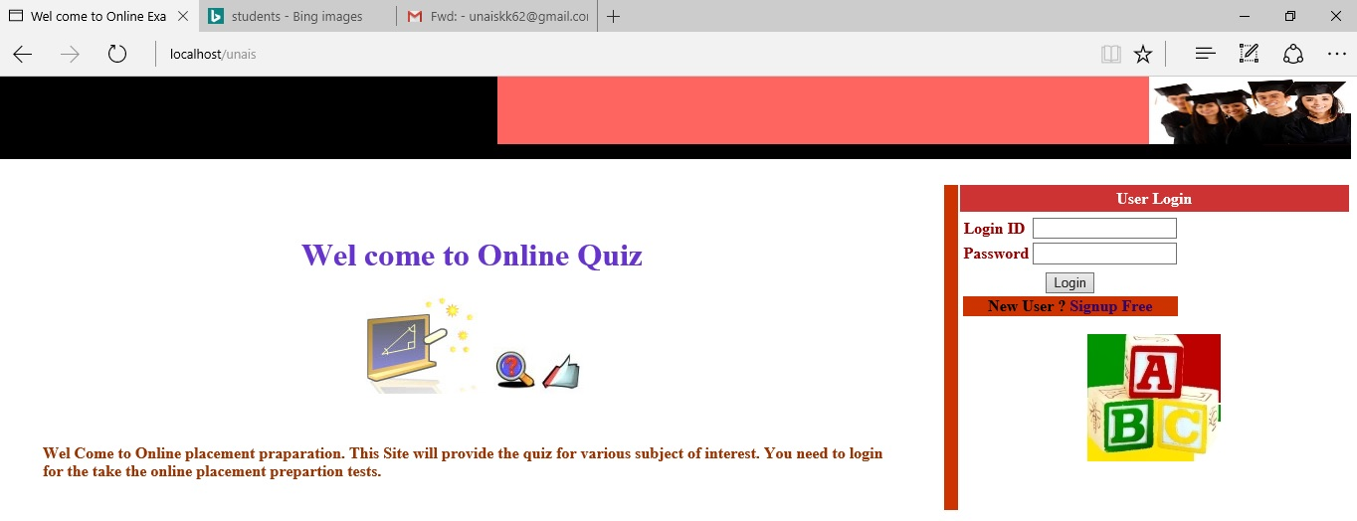

**Index2.php**

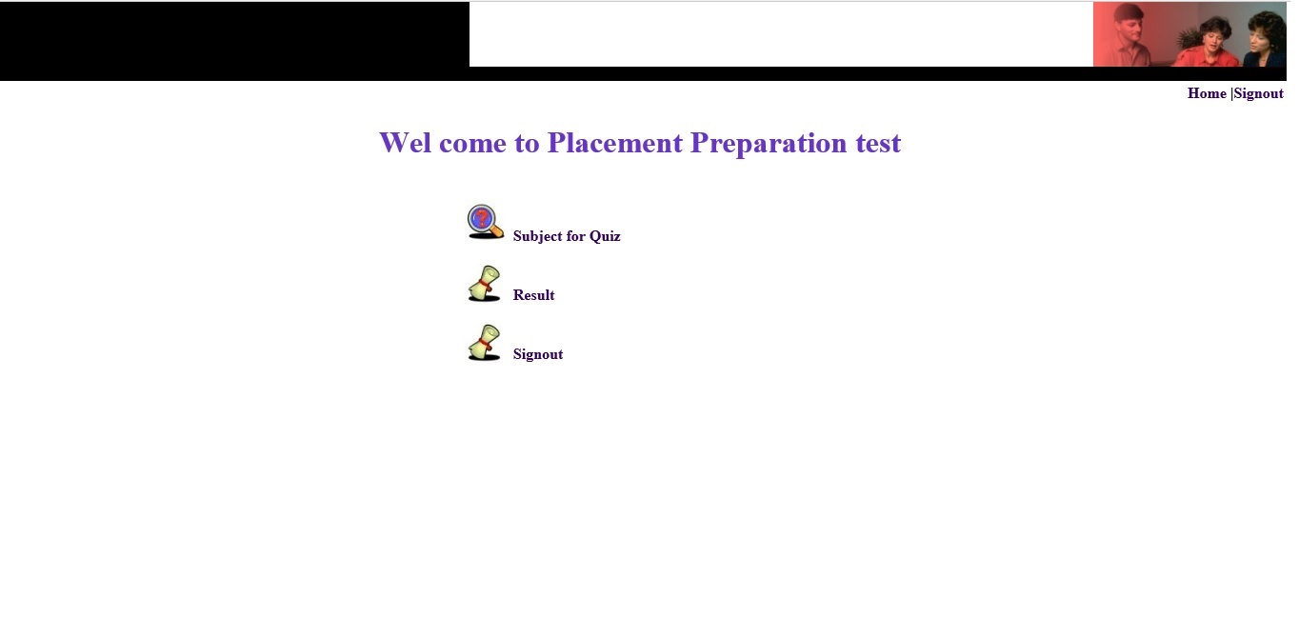

**Add_ques.php**

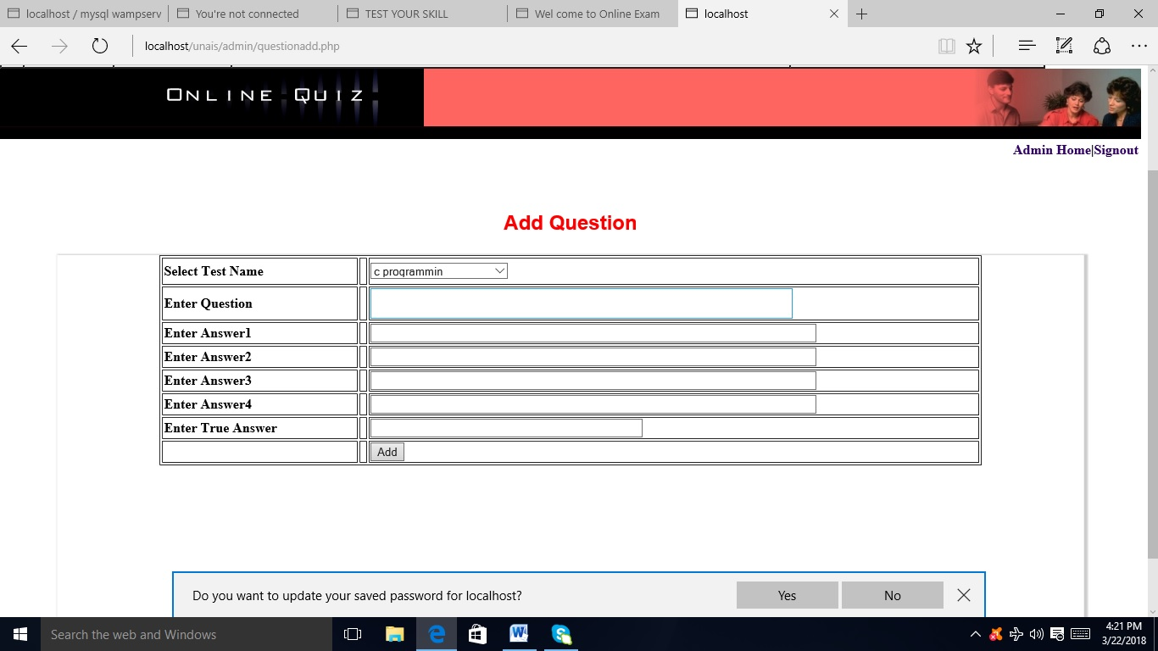

**Quiz.php**

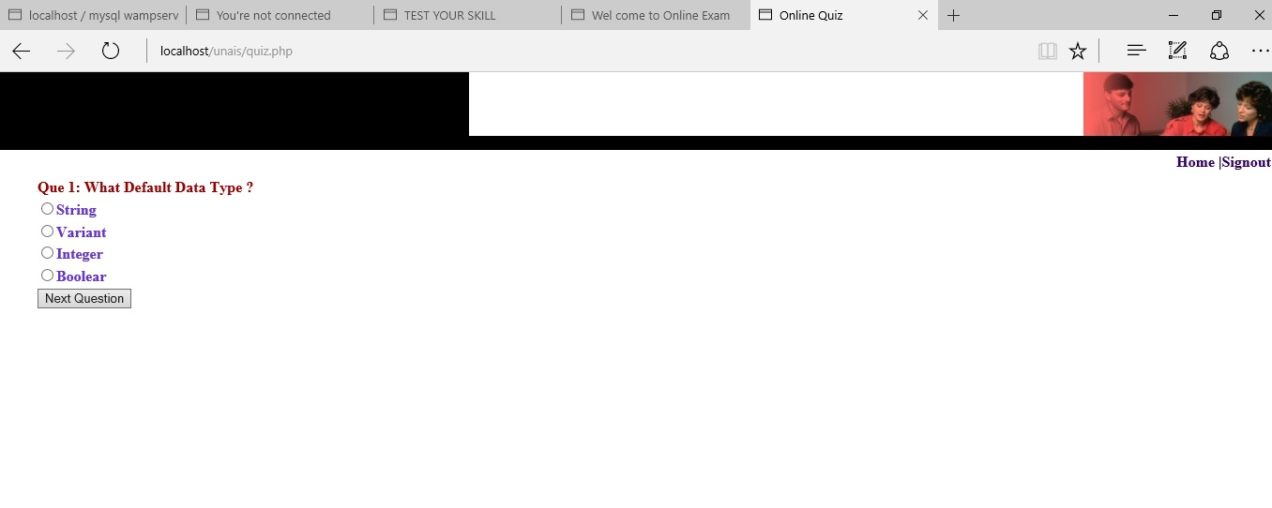

**Result.php**

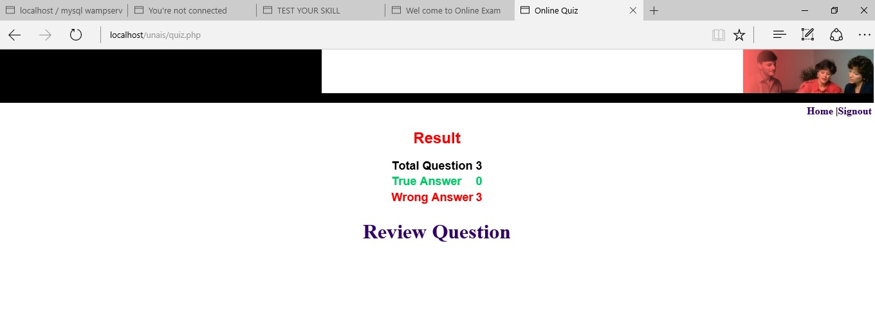

**Review.php**

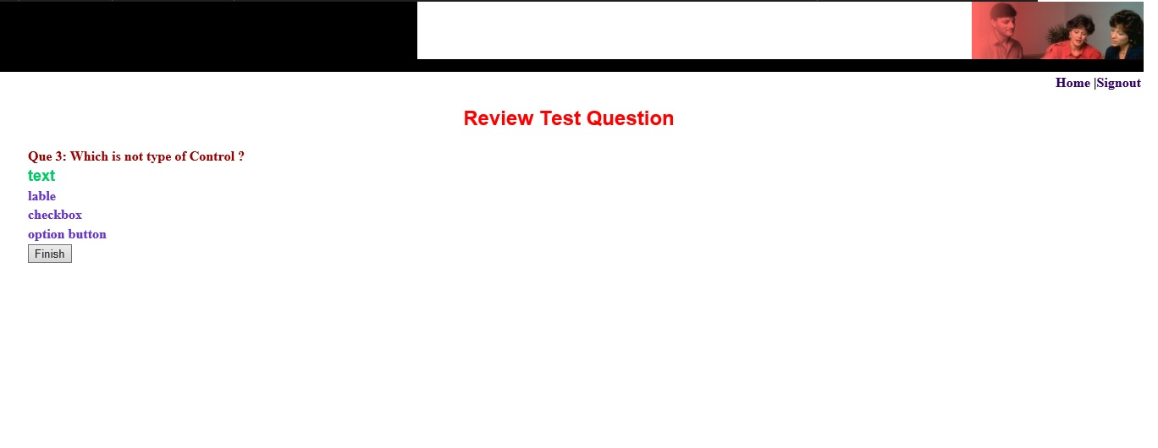

**Select_quiz**

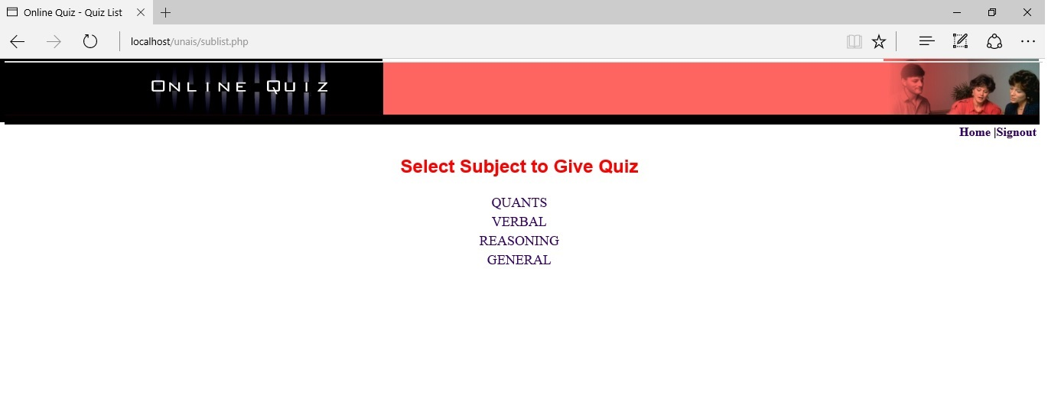

**User_signup**

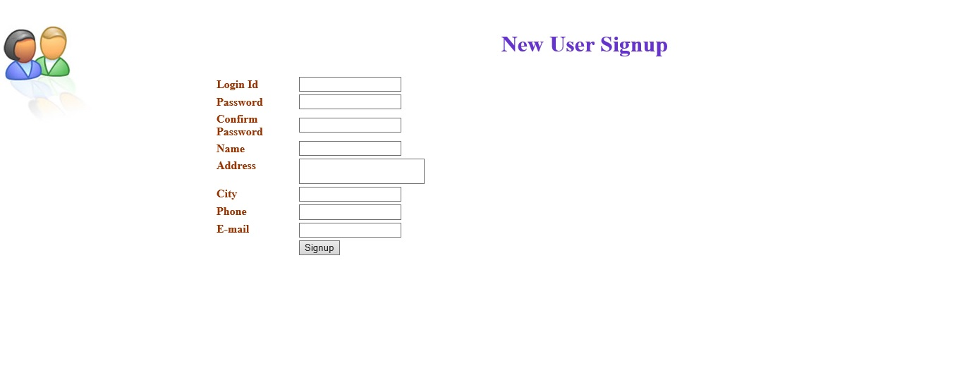

**Question_add.php**



**Admin.php**

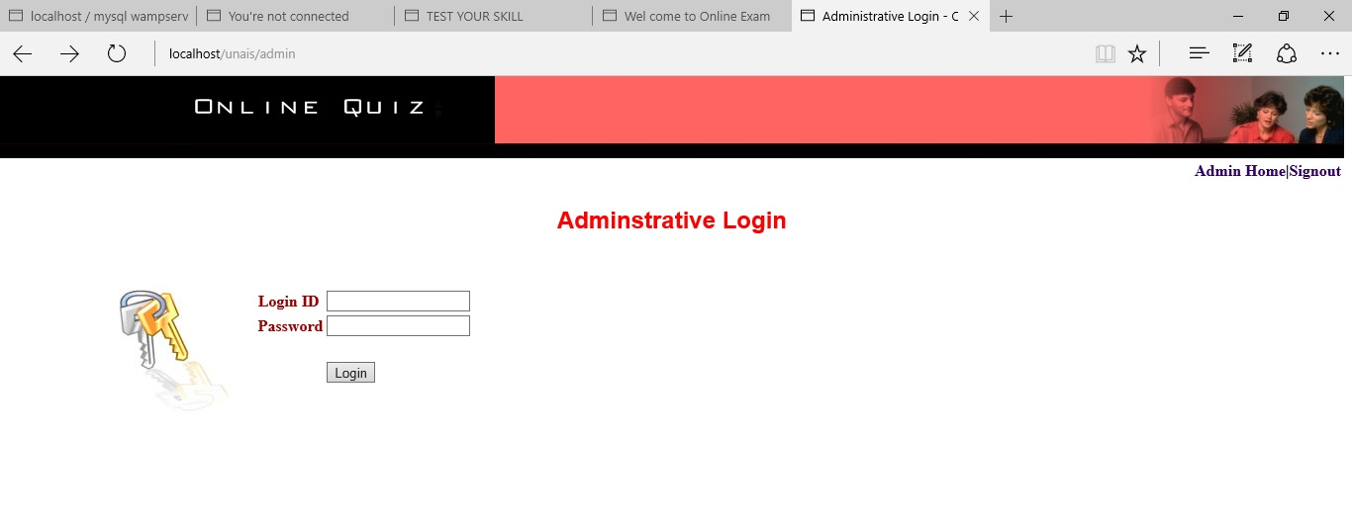

**BIBLIOGRAPHY**

The following books were referred during the analysis and execution phase of the project

* **Books Referred:**
* BEGINNING PHP 5 ---DAVE MERCER
* BLACK BOOK HTML ---WILEY DREAMTECH
* PHP AND MYSQL WEB DEVELOPMENT --- LUKEWELLING,LAURA
* MICROSOFT SQL SERVER-2000 ---RANKIN, PAUL & JENSEN
* SQL SERVER-2000 ---DUSAN PETKOVIC
* PHP IN A NUTSHELL --- PAUL HUDSON
* **Websites Referred:**
* **W3schools**